ICAT3.3 Authorisation Specification
Shoaib Sufi (Devigo)
Version: 1.0
Date: 08/08/08

Glossary

EH Element Hierarchy; path of connected elements in schema which are the targets for role-actions in the authorisation scheme devised here.

Role/ADMIN does the user had admin rights on the EH
Role/CREATOR does the user have create rights on the EH
Role/READER does the user have read rights on the EH
Role/UPDATER does the user have update rights on the EH
Role/DELETER does the user have delete rights on the EH
Role/ICAT_ADMIN does the user have the right to create and administer an EH
Role/DOWNLOAD does the user have the right to download data in the EH (needed as the READER role does not have download permission on data in the EH)
Role/SUPER does the user have the right to create and administer all EH’s in the catalog.

Action/Insert – user can insert a new child of the element
Action/Select – user can select anything in the EH
Action/Download- user can download any relevant entities in the EH (e.g. datafiles)
Action/Update – user can update anything in the EH
Action/Delete – user can mark as deleted any child element of the EH but not the root
Action/Remove – user can remove/permanently any child element of the EH but not the root
Action/Root_Insert user can create a new EH
Action/Root_Remove user can remove/permanently delete an EH
Action/Set_FA user can set and unset FACILITY_AQUIRED in any of the EH
Action/Manage_Users user can add or remove users from the EH (but not other ICAT_ADMIN’s they did not create)

Action/Super user can theoretically do anything that one could do with direct access to the ICAT system e.g. via SQL. In practice this is limited to the maximum available functionality of the ICAT API. Also note could be dangerous and leave ICAT in an inconsistent state, thus this facility should only be used where necessary (e.g. when correcting misfiled data with the correct investigation in the situation where the user did not put in their run number)

IAS ICAT Authorisation specification (i.e. this document).

Introduction

This document details the ICAT3 Authorisation Specification (IAS).

This version of the IAS cover ICAT 3.3. In ICAT 3.3 the IAS support only explicit permissions for investigations and datasets, datafile permissions are inherited from (i.e. part of) the dataset permissions this was agreed and decided for optimisation reasons. The table in the schema ICAT_AUTHORISATION is the single point of access for all authorisation related information checked by the ICAT API. This includes experimenters, facility scientists, data registration users such as ISIS_GUARDIAN, the SUPER_USER and the ANY user signifying public access to the investigations and datasets. Note public here is defined as any registered user of the facility i.e. someone who has a federal_id (e.g. STFC Active directory login).

Specification of Roles and Actions

Authorisation in ICAT3 is ROLE based.

A specified role maps onto a set of actions which that role is permitted to perform subject to some context/environmental constraints. I.e. some actions are suppressed in special circumstances (these are detailed in section 4), e.g. in some cases where the create_id user and mod_id user are different the create_id user takes preference, also data marked as facility_acquired=’Y’ is suppresses certain delete actions.

The Actions are performed on Element Hierarchies (EH).

Element Hierarchies are trees or paths of joined elements which are grouped together.

There are currently only two EH’s :

- Investigation – i.e. everything linked to and dependent upon Investigation except Dataset
- Dateset – i.e. everything linked to and dependent upon Dataset including Datafile and all things linked to and dependent upon that.

Each EH has to have it’s own record in ICAT_AUTHORISATION for permissions, e.g. an instrument scientist would have to have a record in ICAT_AUTHORISATION for each investigation done at his instrument and a row for each dataset attached to each of these investigations.

The reason that the permissions are not inherited is that a strong requirement from the facilities was an experimenter on an experiment registering analysed data into their investigation record in ICAT with the explicit understanding that only they and not all of the experimental team could see this data.

In future versions of ICAT efficient inheritance mechanisms for decreasing the number of entities (i.e. records in ICAT_AUTHORISATION) should be explored, however any solution should still allow the above scenario to be modelled. Posix ACL permissions may help inform decisions made during any rework.

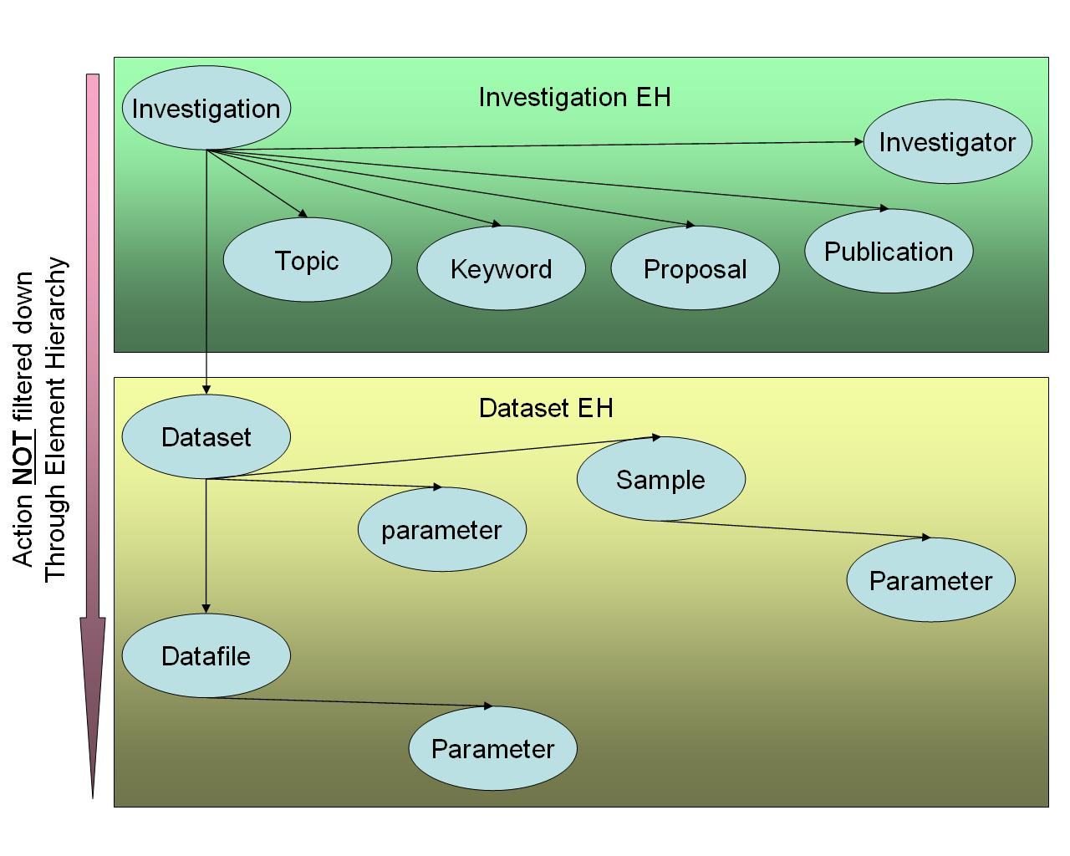
Figure 1: Entity Hierarchy - permission not inherited

User Stories for Authorisation

These are the user stories whose requirements were (unless noted below) taken into consideration during the design of the Authorisation system for ICAT 3.3.

Installation

User story: Installation needs to load data from the facility spreadsheet such that up to data information about the facility is in the installed ICAT instance.

Note: This is NOT done via the ICAT API at the moment and done directly to the data base. Future version of ICAT may decide to re-examine whether API support is needed or not.

Business System

User story: Business System to ICAT link needs to ingest data into ICAT such that ICAT has up to date information about proposed experiments.

Proposers & Experimenters

User story: Users associated with the experiment need to have access to the raw data they have created such that experimenters can have access to their data on and off site and off site Principal investigators can have access to the data as and when it is catalogued.

Users Post Experiment

User story: Users associated with experiments can upload simulated/reduced/final data such that the whole inception, proposal, data capture, analysis and data publication cycle is more fully supported for the user.

Note- If the users are adding data to an existing investigation then the permissions to access analysed files should not be inherited, i.e. they should have exclusive access to the data unless they choose to add others from the experimental team.

Registration

User story: Registration processes can ingest investigations and datasets into ICAT with the correct permissions and by acting on the behalf of users such that correct ingestion can take place even though the users connected to the data may no longer have active sessions with the facility.

Super user

User story: A Super user should be able to fix cataloguing errors and replacing other facility acquired information such that logical errors that come up during the operation of the ICAT can be fixed.

Facility Scientists

User story: Facility Scientists need access to all experiments performed at their instrument such that they can audit the data at their instrument/beamline and be a point of access for users for accessing their data if they do not have a federal-id.

Any Registered User

User story: Any registered user should have access to experiments that are older then the exclusive period specified in the facility data policy such that underlying data to publications can be viewed by others and data can be open to re-analysis.

Role-Action configuration and semantics

When an ICAT_ADMIN put an EH or part thereof it should normally be set to FACILITY_AQUIRED = ‘Y’ if the authoritative source of the information is another system, for example DLS or CLF/ISIS Business system or Facility Specific Parameter information from the facility Spreadsheet).

X – means the Role does have the ability to perform the Action

Role↓ | Action→ | Insert | Select | Download | Update | Delete | Remove | Root_remove | Root_insert | Set_FA | Super
ADMIN |  | X | X | X | X¹ | X¹ | X^{1,2}
CREATOR |  | X | X | X | X¹ | X¹
READER |  |  | X
DOWNLOADER |  |  | X | X
UPDATER |  |  | X | X | X¹
DELETER |  |  | X | X | X¹ | X¹
ICAT_ADMIN |  | X | X | X | X¹ | X¹ | X^{1,2} | X^{1,2} | X | X²
SUPER |  | X | X | X | X | X | X | X | X | X | X

1 – Action is only permitted for elements in the EH which are new or do not have FACILITY_AQUIRED set to ‘Y’
2 – Action is only permitted on pre-existing elements in the EH if MOD_ID is an ICAT_ADMIN and the same as CREATE_ID, for example data distribution system records should not be modified by an ICAT_ADMIN other than the data distribution system.

Authorisation related TABLES in ICAT3

The IAS is serialised in the ICAT 3.3.x schema via two tables, ICAT_AUTHORISATION and ICAT_ROLE.

ICAT_ROLE specifies the permitted actions of any given role. Note if new actions are required then not only does a column have to be added to ICAT_ROLE table but the logic of this new action needs to be integrated into dependent system. In this first instance the ICAT API would have to change to accommodate this new action. Adding a new action is non-trivial.

ICAT_AUTHORISATION holds the actual authorisation information for users. It stored which user has which role against which investigation EH or dataset EH. There also are special rows with null element_id’s specifying who can create investigations and create datasets for a given investigation.

For example of records in ICAT_AUTHORISATION please see the batch migration specification.

ICAT_Authorisation Table

COLUMN | DESCRIPTION
ID | Key of the ICAT AUTHORISATION entry.
USER_ID | This is the user identifier used for authentication with the ICAT system:  A users federal id, ’ANY’ for any registered,  <facility> GUARDIAN for the process which adds data on behalf of the facility or SUPER_USER for the super user
ROLE | ROLE from the ICAT ROLE table.
ELEMENT_TYPE | Can be INVESTIGATION or DATASET.
ELEMENT_ID | If null then this has special meaning .If this is null and element_type is ‘DATASET’ this means that the user can create datasets for the linked investigation if the user has a role which permits this. If this is null and the element_type is ‘INVESTIGATION’ this means that the user can create investigations; in practice only two records like this should exist in ICAT, one for the <facility>_GUARDIAN and one for the SUPER_USER. Otherwise this is the key of the ELEMENT TYPE.
PARENT_ELEMENT_TYPE | Needed if element type is a DATASET to give context to the parent investigation.
PARENT_ELEMENT_ID | Key of parent element for this record.
USER_CHILD_RECORD | This is an optimisation. This connects a child record where the ELEMENT ID is null and ELEMENT TYPE is DATASET indicating that the user in that case can create datasets in the investigation with the actual parent investigation. This makes it easier for the ICAT API to quickly check if a user has ‘create’ privileges on a particular investigation.

ICAT_Role Table

Note some of the _weight columns are missing in the definition below these are documented in the ICAT 3.3 data dictionary.

Column | Description
ROLE | Name of Role e.g. ICAT_ADMIN
ACTION_INSERT | ‘Y’ or ‘N’ specifying whether ROLE can do this action
ACTION_SELECT | See glossary for definition
ACTION_UPDATE | See glossary for definition
ACTION_DELETE | See glossary for definition
ACTION_REMOVE | See glossary for definition
ACTION_ROOT_REMOVE | See glossary for definition
ACTION_ROOT_INSERT | See glossary for definition
ACTION_SET_FA | See glossary for definition
ACTION_SUPER | See glossary for definition

How ICAT_AUTHORISATION is populated.
The following is a short synopsis of how the ICAT_AUTHORISATION system is populated details of the actual functions of the triggers and procedures are in the batch migration spec with further modification via e-mail (hence it is a case of reading the actual code for the functions for the final answer) and in the ICAT API system.

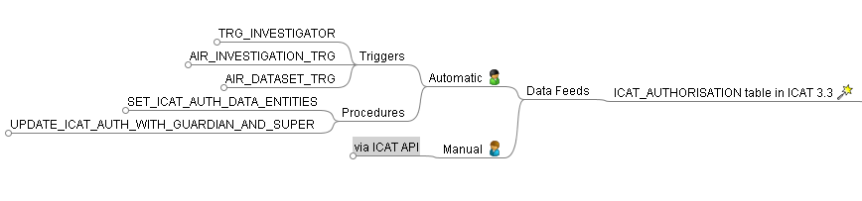
Figure 2: ICAT_AUTHORISATION data feed map

Automatic Processes

Triggers
Name | Short Description
TRG_INVESTIGATOR | Sets privileges for experimenters, the super user and the guardian user for new investigations and any existing associated datasets.
AIR_INVESTIGATION_TRG | Set privileges for facility instrument scientists in ICAT_AUTHORISATION for newly created investigations that apply to their instrument.
AIR_DATASET_TRG | Set privileges for facility instrument scientists in ICAT_AUTHORISATION for newly created datasets that apply to their instrument.

Procedures
Name | Short Description
SET_ICAT_AUTH_DATA_ENTITIES | Experiments are made public after a set number of days defined by the facility. This procedure creates public ‘ANY’ access records in ICAT_AUTHORISATION for experiment which meet the correct criteria with regards to age.
UPDATE_ICAT_AUTH_WITH_GUARDIAN_AND_SUPER | Sets privileges for the ICAT SUPER_USER for  entries (e.g. ISIS back catalog entries) where investigators are not known for the investigation and thus the logic for TRG_INVESTIGATOR is not run. All ISIS GUARDIAN and SUPER_USER privilege creation should be moved to this procedure in a future version of ICAT.

Manual

via ICAT API
Systems which use the ICAT API for ingestion of investigations and datasets into ICAT will have privileges for the associated user added to ICAT_AUTHORISATION. The user can them programmatically check who the other users are on the experiment and add those manually.

Useful information at http://www.bresink.com/osx/193281/Docs-en/ACL.html and http://www.suse.de/~agruen/acl/linux-acls/online/main.html
https://esc-cvs.dl.ac.uk/svn/dl/metadata/icat/trunk/documentation/batch-processes-specification/icat-3.3-batch-processes-specification.doc
https://esc-cvs.dl.ac.uk/svn/dl/metadata/icat/trunk/documentation/schema/data_dictionary.pdf

