ICAT Web Service Tutorial

- Import the WSDL file to generate the client stubs.
  - Alpha release user location
    - https://volga.dl.ac.uk:8181/ICATService/ICAT?wsdl
  - This contains all the available methods in one WSDL file

- The import needs to be done with the wsimport utility
  - https://jax-ws.dev.java.net/jax-ws-ea3/docs/wsimport.html
  - I use Netbeans 6.1, which does the importing for you.

- Download the keystore containing volga’s glassfish’s public key
  - Ill email it you when needed.

- Add the java environment variable:
  - -Djavax.net.ssl.trustStore=location of downloaded keystore
  - -Djavax.net.ssl.trustStorePassword=changeit

- Log on to the system with your federal username and password with something like this: (They are encrypted)
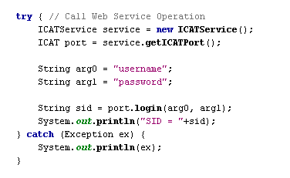
- All examples are located in examples.zip.

- Hints:

All searches and some of the get methods have overridden methods with InvestigationIncludes and DatasetIncludes as arguments. This is to allow the caller to define what they want returned in the results.

E.g. searchByKeywords(sid, keywords);

Will return all the investigations that the users can select but with no Investigators, Keywords, Datasets, Role, Publications or samples.

searchByKeywordsInclude(sid, keywords, InvestigationInclude.KEYWORDS_ONLY);

Will return all the investigations that the users can select and with a collection of keywords.

searchByKeywordsInclude(sid, keywords, InvestigationInclude.ALL);

Will return all the investigations that the users can select but with all the Investigators, Keywords, Datasets, Role, Publications or samples

searchByKeywordsInclude(sid, keywords, InvestigationInclude. ALL_EXCEPT_DATASETS_DATAFILES_AND_ROLES);

Will return all the investigations that the users can select but with all the investigation information except Datasets, Datafile and Role.

NB: The role is your role for the investigation, dataset or datafile.

You will want to limit the amount of data that is searches as more information you ask to be sent back the slower the search will be.

ICAT Admin Web Service Tutorial

- Import the WSDL file to generate the client stubs.
  - Alpha release admin location
    - https://volga.dl.ac.uk:8181/ICATAdminService/ICATAdmin?wsdl
  - This contains a method loginAdmin(String username) in which you specify the user you wish to log in as into ICAT API

- This is protected using HTTP Basic Authentication so to make the Web Service call you need to provide it with a Username and Password.

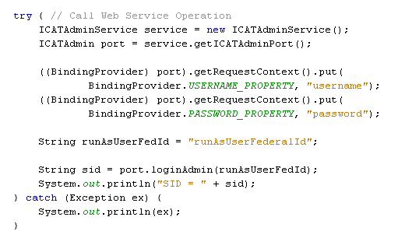
- Ill will provide you with the username and password when needed.

