Test Case # 1: Test the input validation for symbols. Input the wrong character instead of x or o.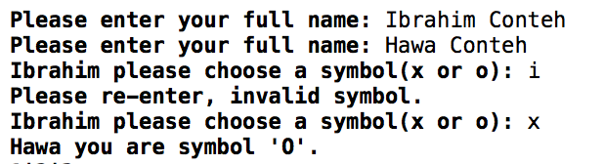

Justification: To make sure that the user can only choose the validated symbols, x and o. Any other case will prompt the user to enter again. If this part of the program does not work it breaks the rest of the program.

Test Case # 2: Test the input for board changing. Use an input that is outside the range that is given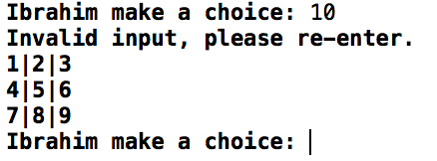

Justification: To make sure that the player enters a value that is valid to change the game board. Also to test the input validation that regulates the game board and helps avoid array exceptions.

Test Case # 3: Test board choices. Select an occupied space and check the error message.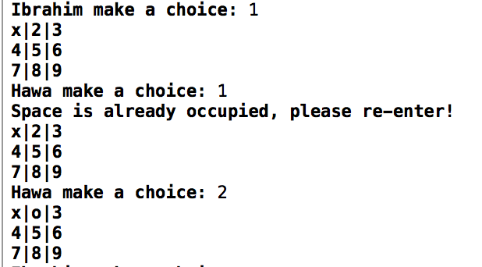

Justification: To make sure that two users cannot edit the same space that one user has already claimed. This makes sure that the game is not broken.

Test Case #4: Test the full program to see the correct results.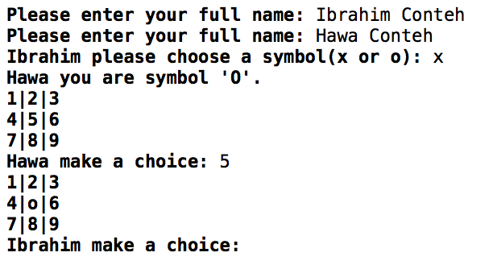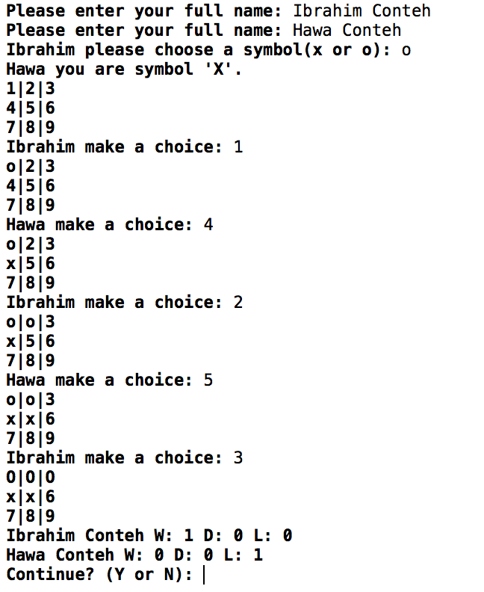

Justification: To test the full program to make sure it returns the proper output.

Test Case # 5: Test the input validation for names. Enter invalid values and check the error message.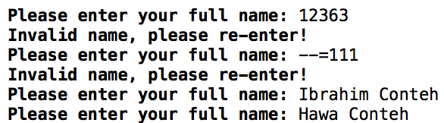

Justification: To test the input validation for the name so the user doesn’t input an invalid name.