CI & CD for Connected Technologies

CI (Semaphore) –

* Create a new project in semaphore
* Provide the repo name and select the branch that you would like to use.
* Select gormasamune as the owner of the project
* Once a job has been created, click on the project settings and customize following parameters

1. Build Settings

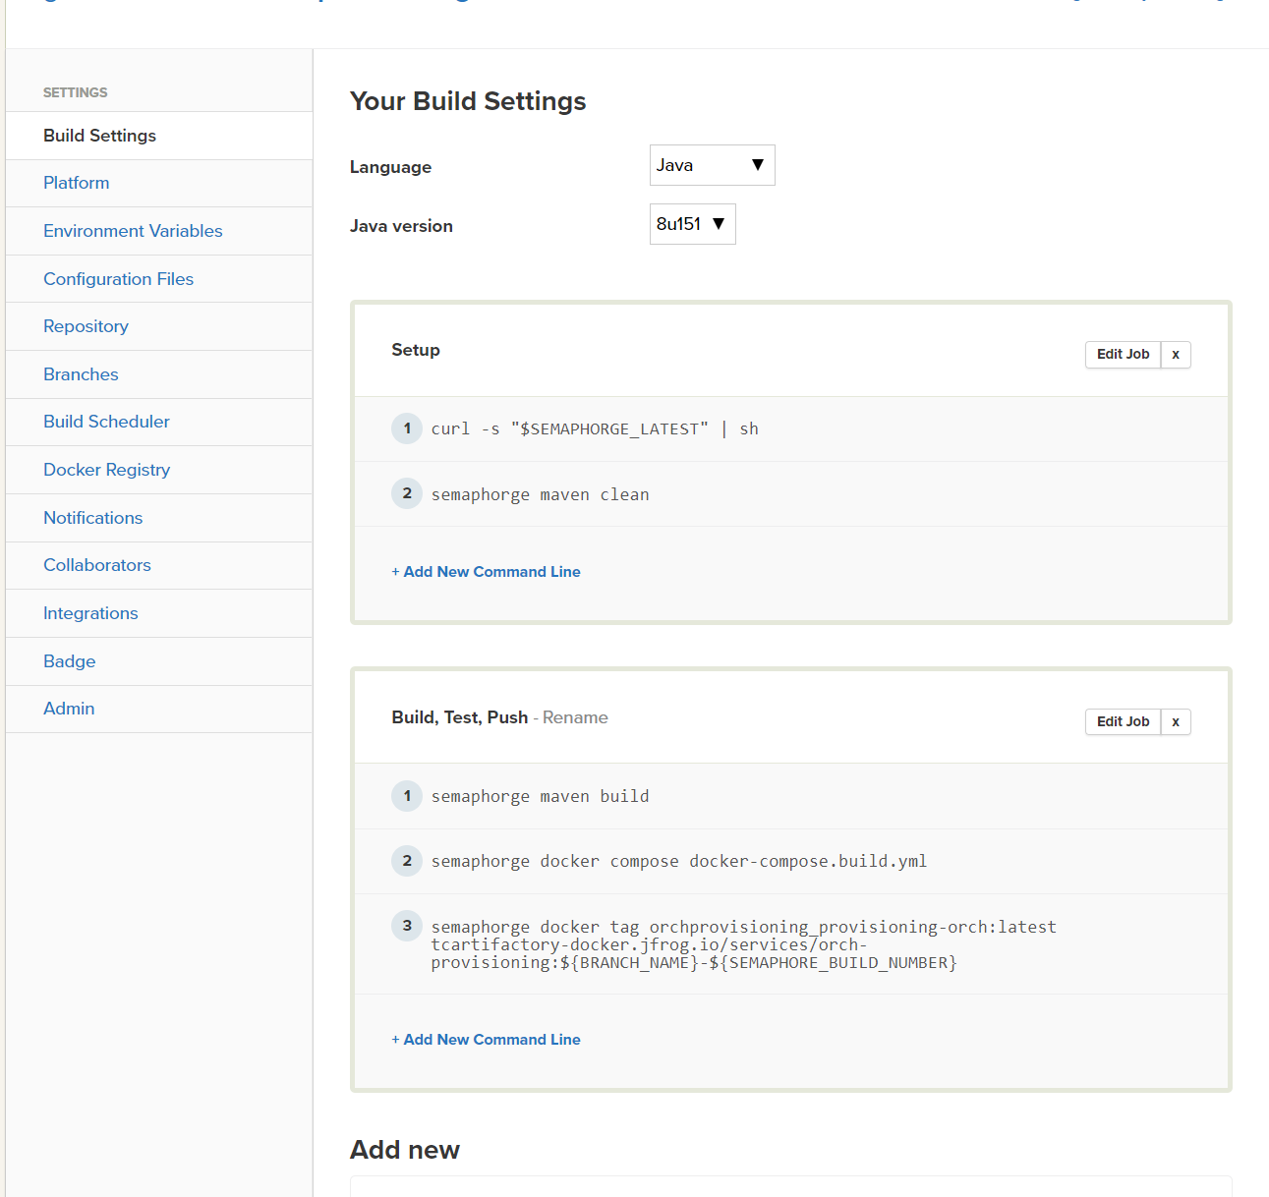

* Copy and match these settings from an existing job of similar type
* In the Build, Test, Push step make sure to change the name of the service name and project name.

1. For Platform, choose the Docker (Native) image. Latest supported one is Ubuntu 14.04 LTS v1805.1
2. Environment Variables can be same as existing job of similar type.

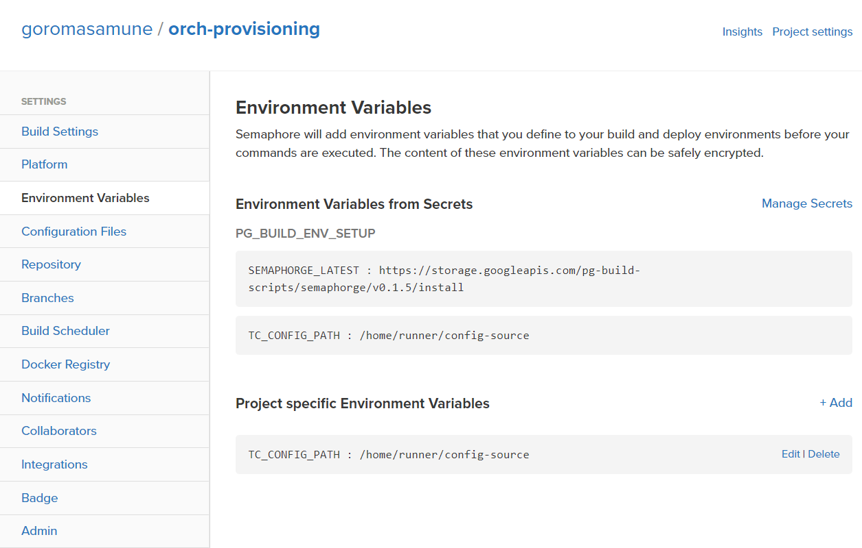

1. Configuration files – Configuration Files from Secrets – Click Manage Secrets, PG_BUILD_ENV_SETUP, edit it and select the service name for the job.

* Project specific Configuration Files – Healthcheck needs to be configured at this step. Healthcheck script from an existing project can be used but confirm and double check the healthcheck port and update the script accordingly.

Also, make sure the path to the healthcheck.sh has been modified as per the new application

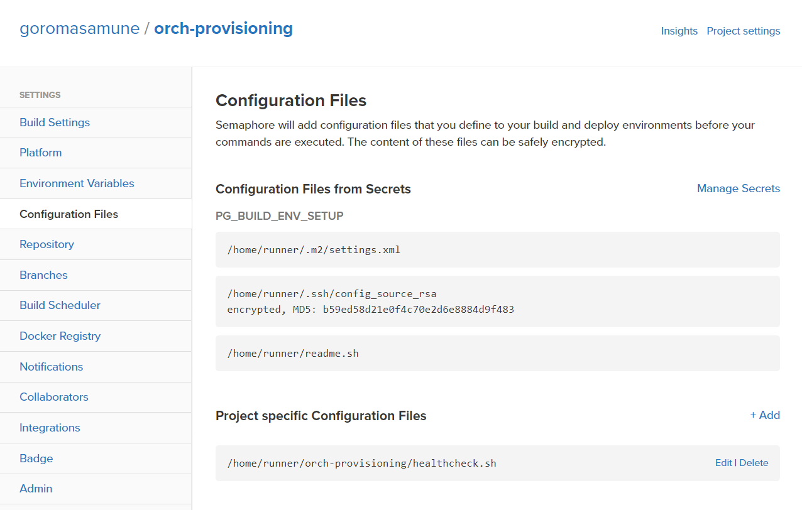

1. Docker Registry – Click the “Custom Container Registry” and configure it for this job
2. Notification (Optional) – Slack hook can be configured to fetch any build related messages.

CD (Spinnaker)

All changes are to be done in pg-service-bootstrap <https://github.com/toyota-connected/pg-service-bootstrap>. Create a branch, make changes and open a pull request adding TC (Samir, Preston) as the reviewer. Once it is merged, it will be get automatically deployed later.

Two steps need to be completed for onboarding any application into Spinnaker/K8’s

1. **Ingres Rules**

* Edit config\Registration (this is the config file for Registration namespace)
* Namespace should match the name of the service for example if the service name is zuoraservice, it should be same here.

1. **For Pipelines**

* Go to Pipelines\Registration. There's a sub-folder for each environment
* In each sub-folder dev, qa, stg - create a file per new microservice. The name of the file should be same as the application name used in Ingress rules
* Change image name in the file and make sure pods and pipeline names are as per convention based on the environment
* Create the application name manually in Spinnaker. Once the PR has been merged, the manually created application will start showing the pipelines.

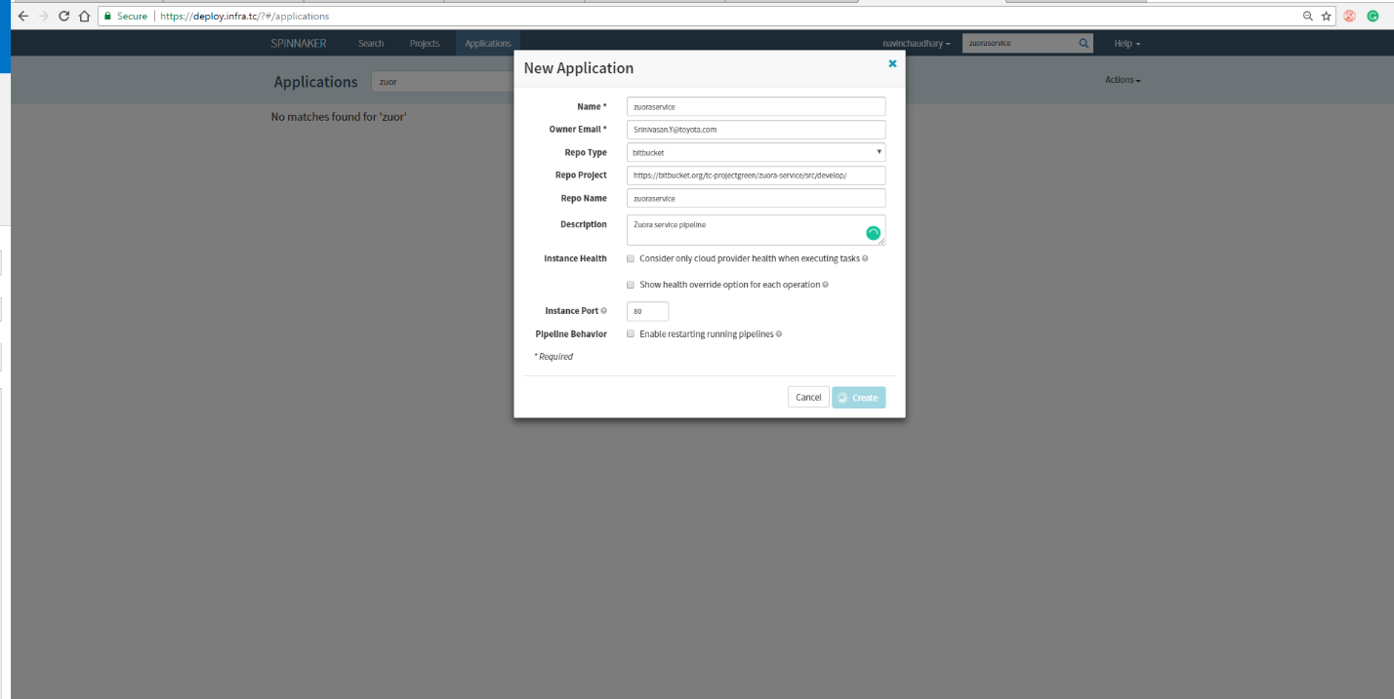

Pod numbers –

Dev – am560

Stage – am 360