**Author: Abhishek Kakkerla**

1. Download config service from bitbucket

<https://bitbucket.sdlc.toyota.com/projects/CTP/repos/ctp-spring-config-service/browse>

1. Download config source from bitbucket

<https://bitbucket.sdlc.toyota.com/projects/CTP/repos/ctp_config_source/browse>

1. Start the application “ctp-spring-config-service “ on port 8888
2. (optional) if you want to point your local config server to your local config source

* Open application.yml in ctp-spring-config-service/src/main/resources
* Change the uri for config source as below …

“uri: <file:///C:/workspaces/git/ctp_config_source/>”

* Restart the application “ctp-spring-config-service “

1. Download your application from bitbucket
2. Remove application.yml or comment out the contents
3. Create/open bootstrap.yml file
4. To point to the local config server, change the uri to “http://localhost:8888”

spring:

application:

name: ocpr

profiles: default, dev, qa, staging, prod

profiles.active:

- dev

cloud:

config:

#uri: https://ctp-config-service.preprod.ctdevops.com/

uri: http://localhost:8888

retry:

initialInterval: 5000

maxAttempts: 5

1. Set the environment for your application in your IDE settings

* Open run configurations
* Select your application and set active profiles  
  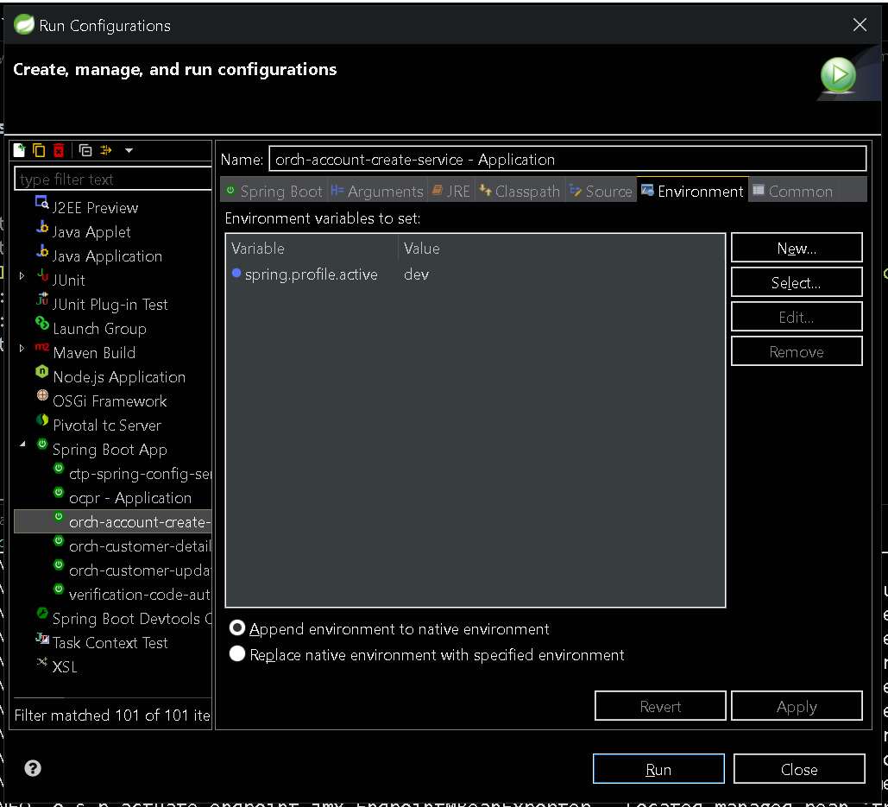

1. If your application uses AWS SSM to store secrets

* Download AWS CLI
* Follow instructions on below link to configure AWS CLI with your access key/secret

<https://docs.aws.amazon.com/cli/latest/userguide/cli-chap-getting-started.html>

1. Add related dependencies.
2. If you do not have AWS SSM credentials …

* Set aws.paramstore.failFast : false in your application
* Hard code the secrets “ctp_config_source”
* Point your local config server to use local config source