**HXF CTP - Jenkins CICD & Deployment Pipeline**

(Version – 0.1)

**This document outlines the steps to create a new CICD and deployment pipeline in the new HXF Jenkins AWS platform**

**CICD Steps**

1. **This step should be considered & completed before creating a job**. All Jenkins jobs pickup pipeline parameters, build stages from the Jenkins file.

Jenkins file should be part of the source code/repo. Provided is the link to a sample job file that was used to create sample pipeline for the zuora-service.

It can be utilized but will have to be customized appropriately for any requirements. <https://bitbucket.sdlc.toyota.com/projects/CTP/repos/ctp-zuora-service/browse/Jenkinsfile?at=refs%2Fheads%2Fdevelop>

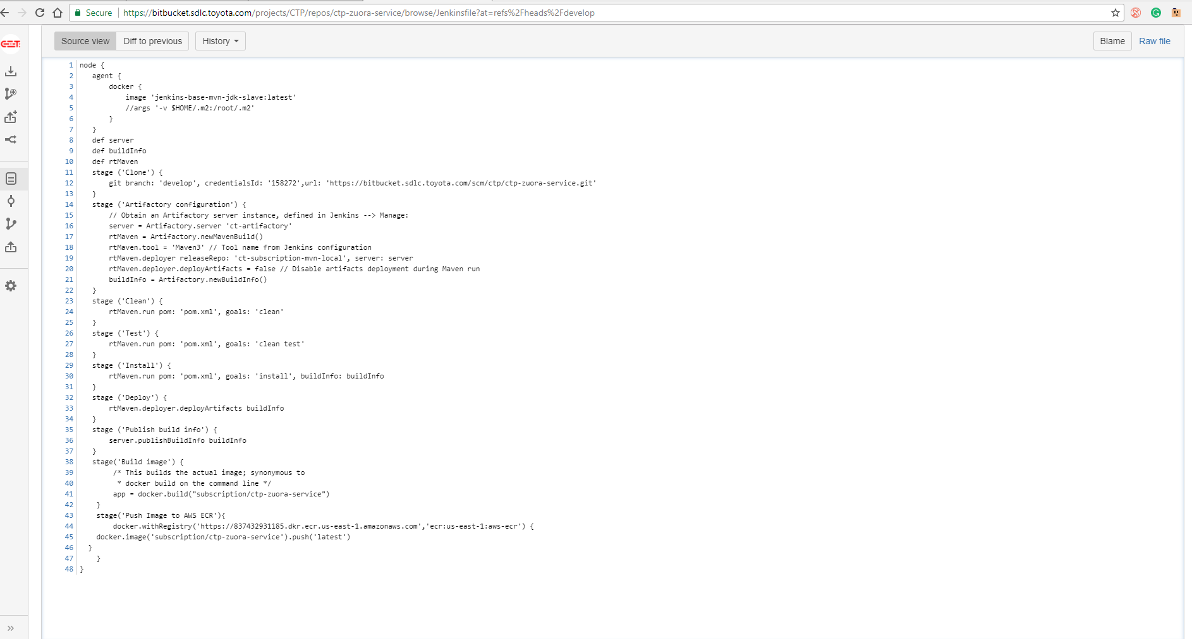

1. Create a new Folder in Jenkins for a new project, for ex. Account-Management. Do not create one in case the project already exists for ex. CVS, or Subscription.

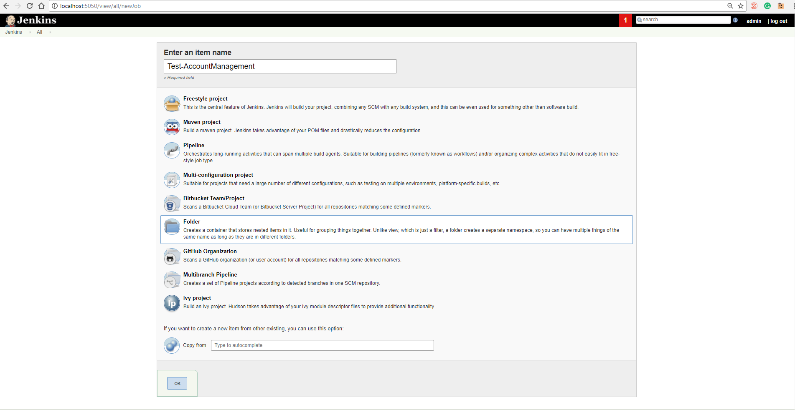

1. Inside the project folder, create another folder for the service name. for ex. **zuora-service** under the Subscription project.
2. Now, inside the service folder create individual folders for Dev, QA, Stage and Prod as shown below

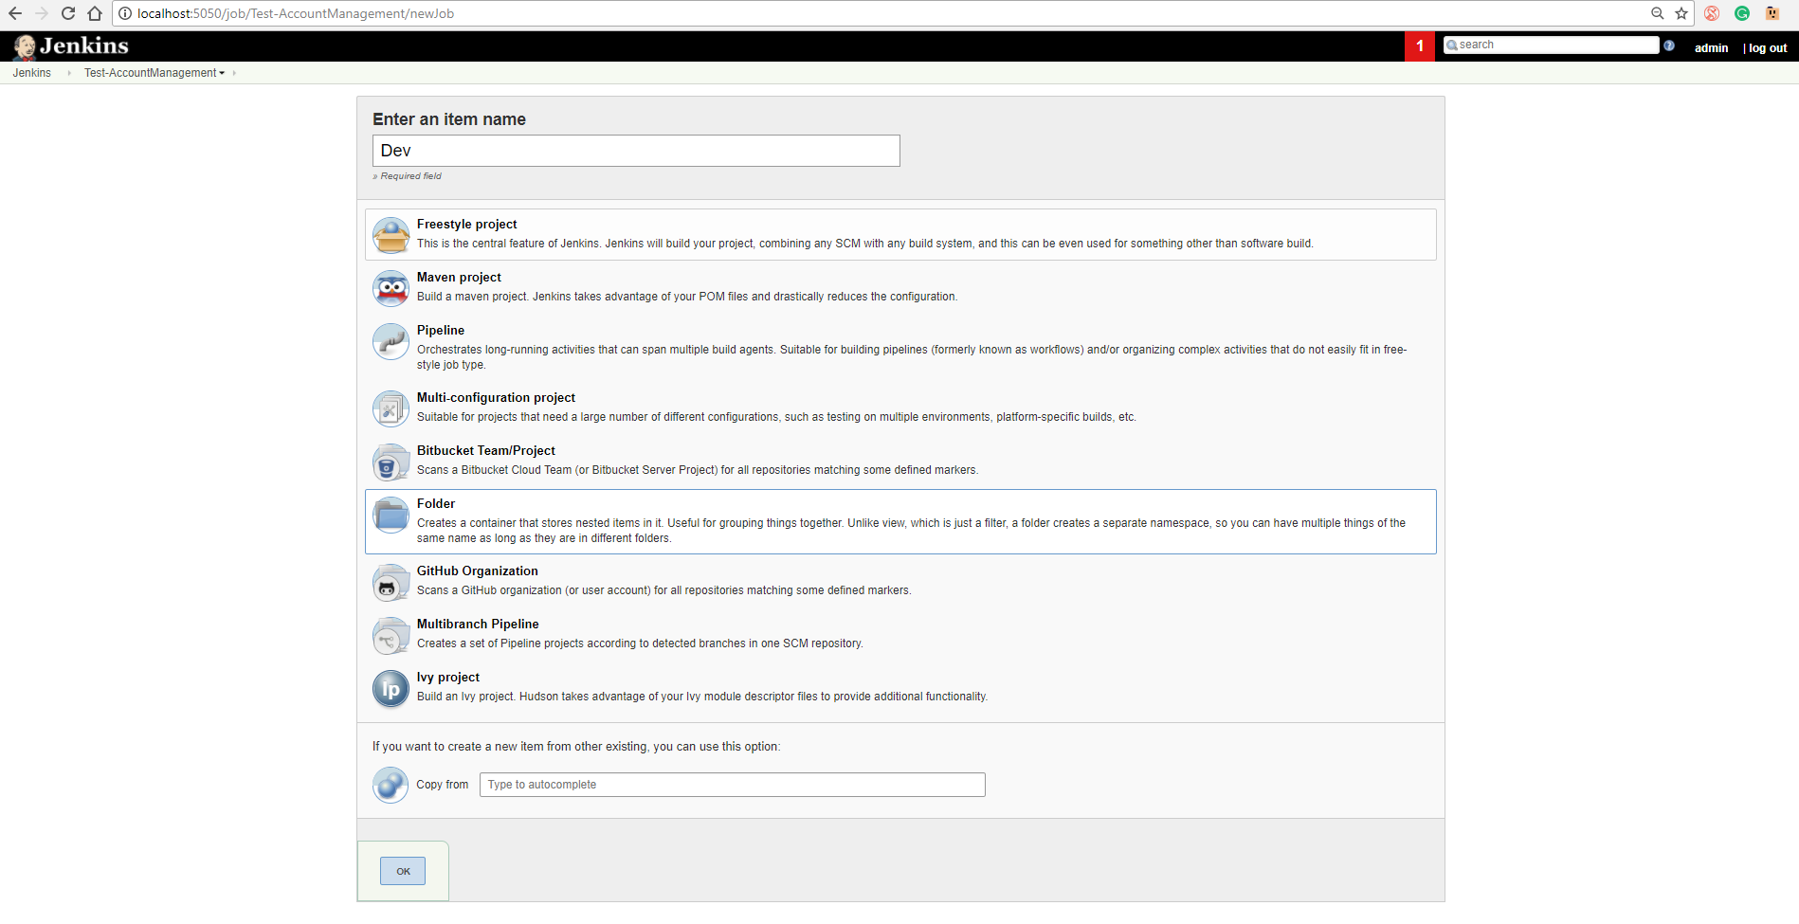

1. Create a new job by clicking on “New Item” and select the freestyle job. Fill in the required parameters as shown below.

Dev Build

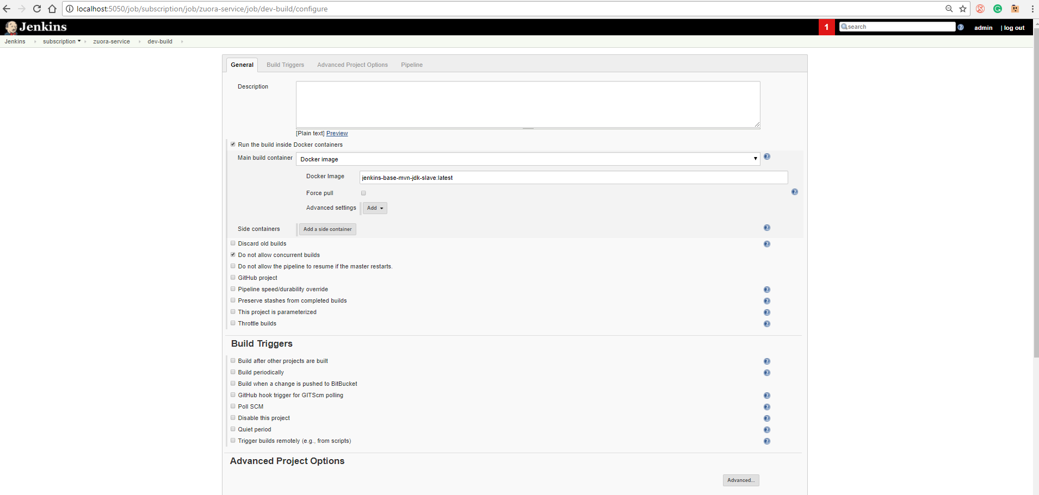

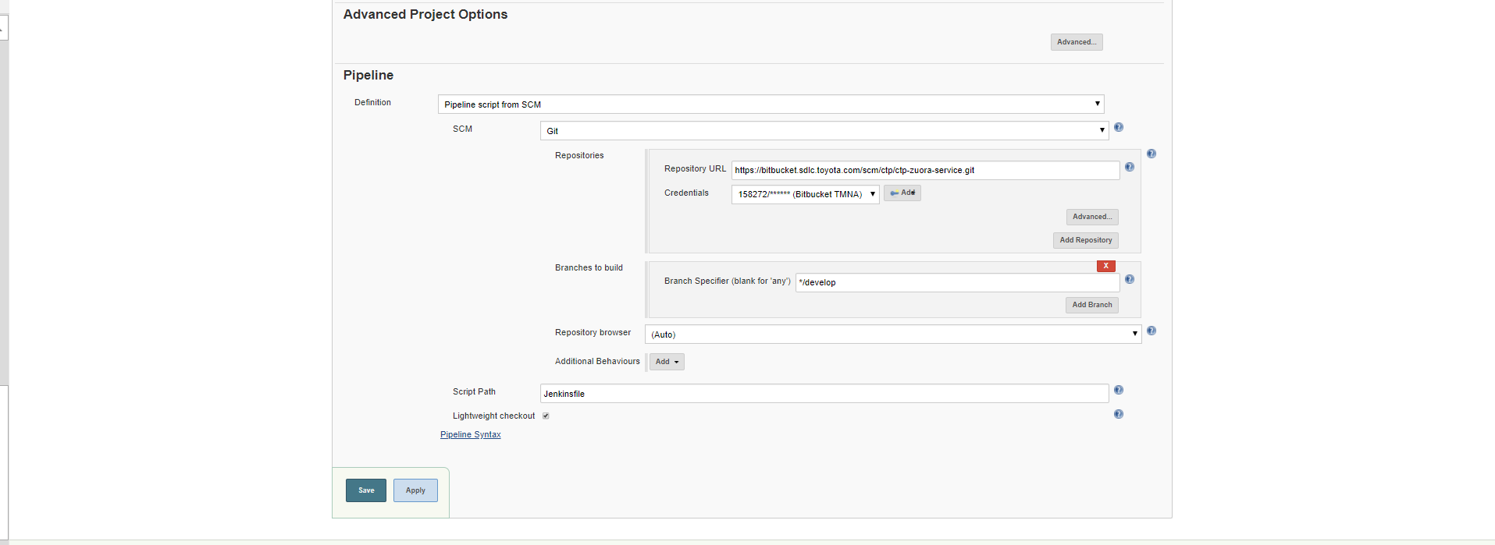

1. Once the job has been configured properly, it should execute the CICD pipeline like this

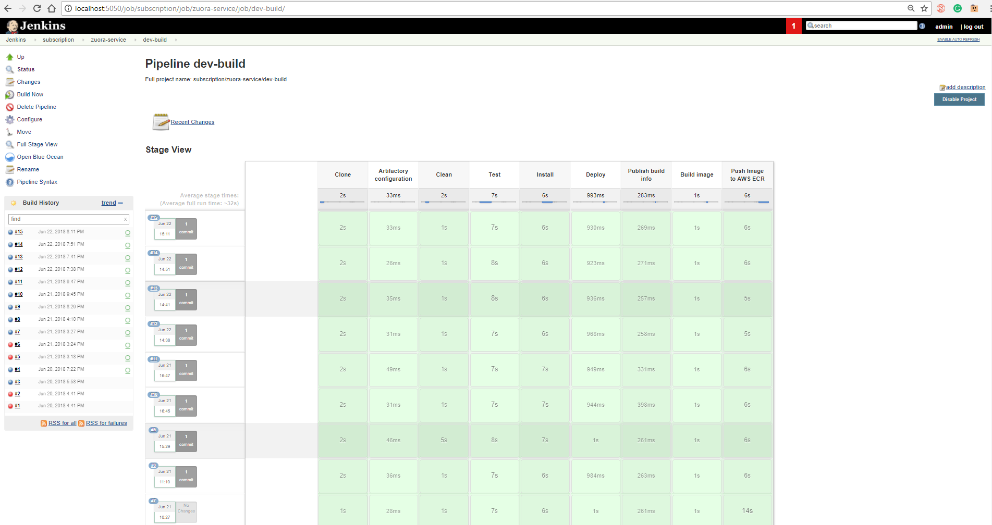

**Deployment Steps (Fargate ECS)**

1. Create a new task definition in AWS ECS

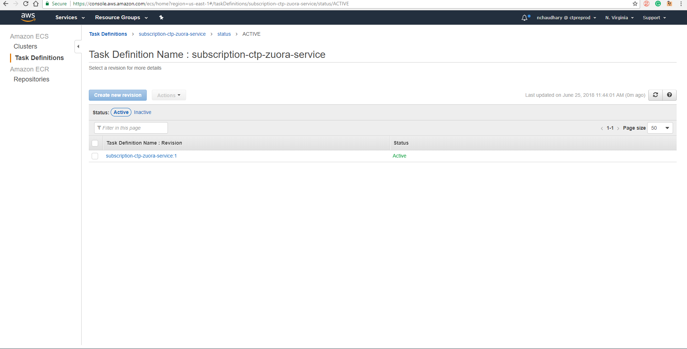

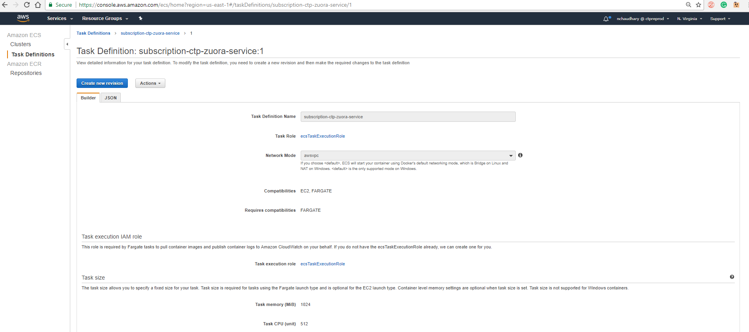

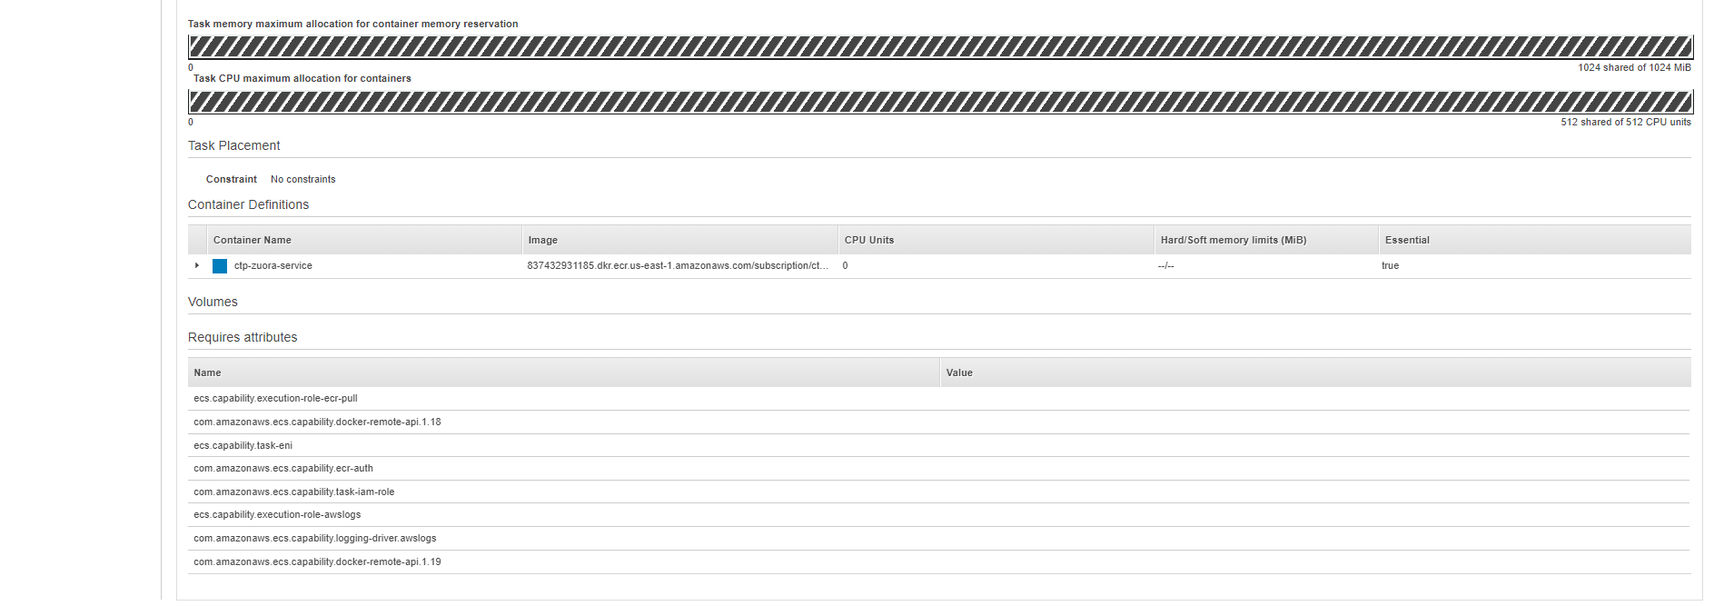

2. Create a new cluster in AWS and select the Fargate ECS cluster type

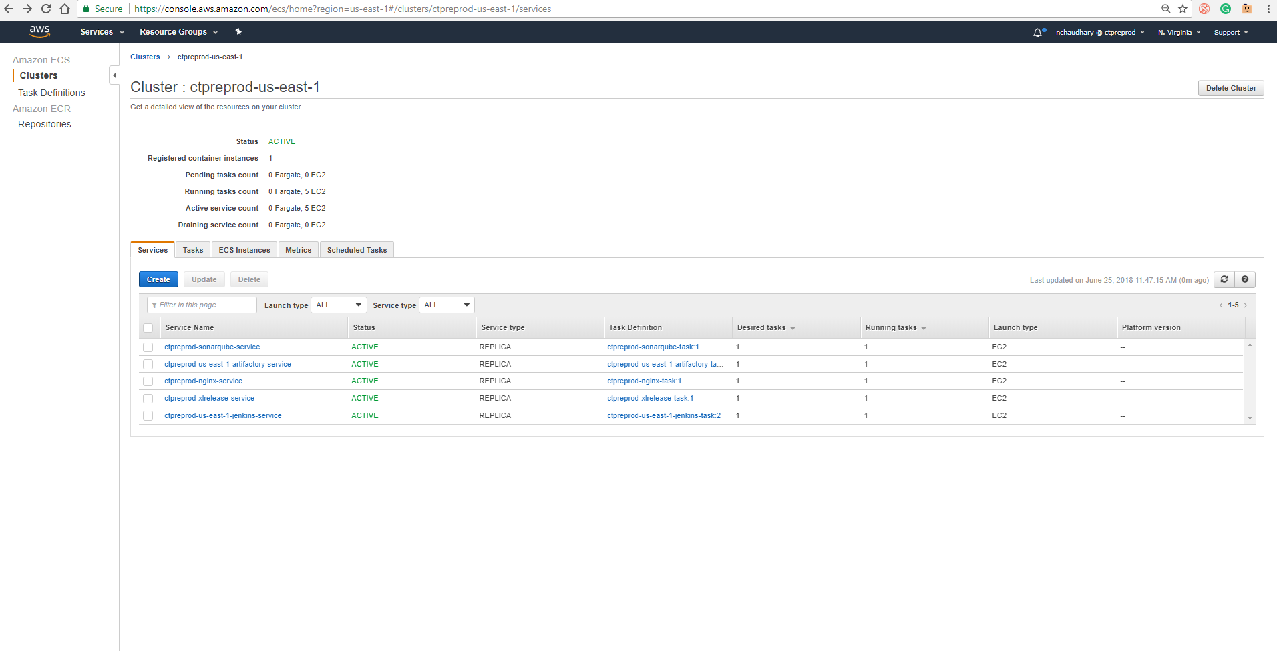

3. Create a new Task inside the cluster from step 3.

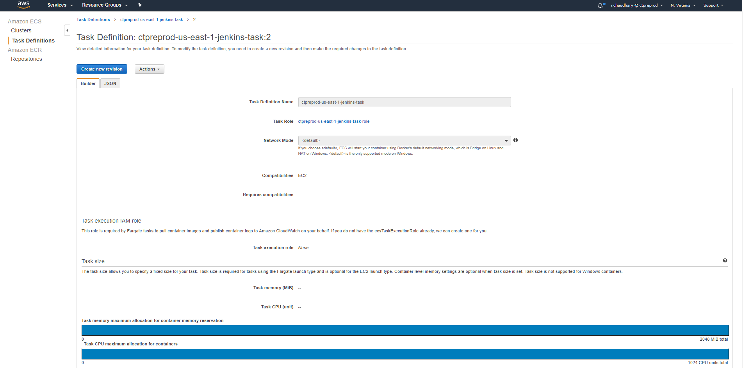

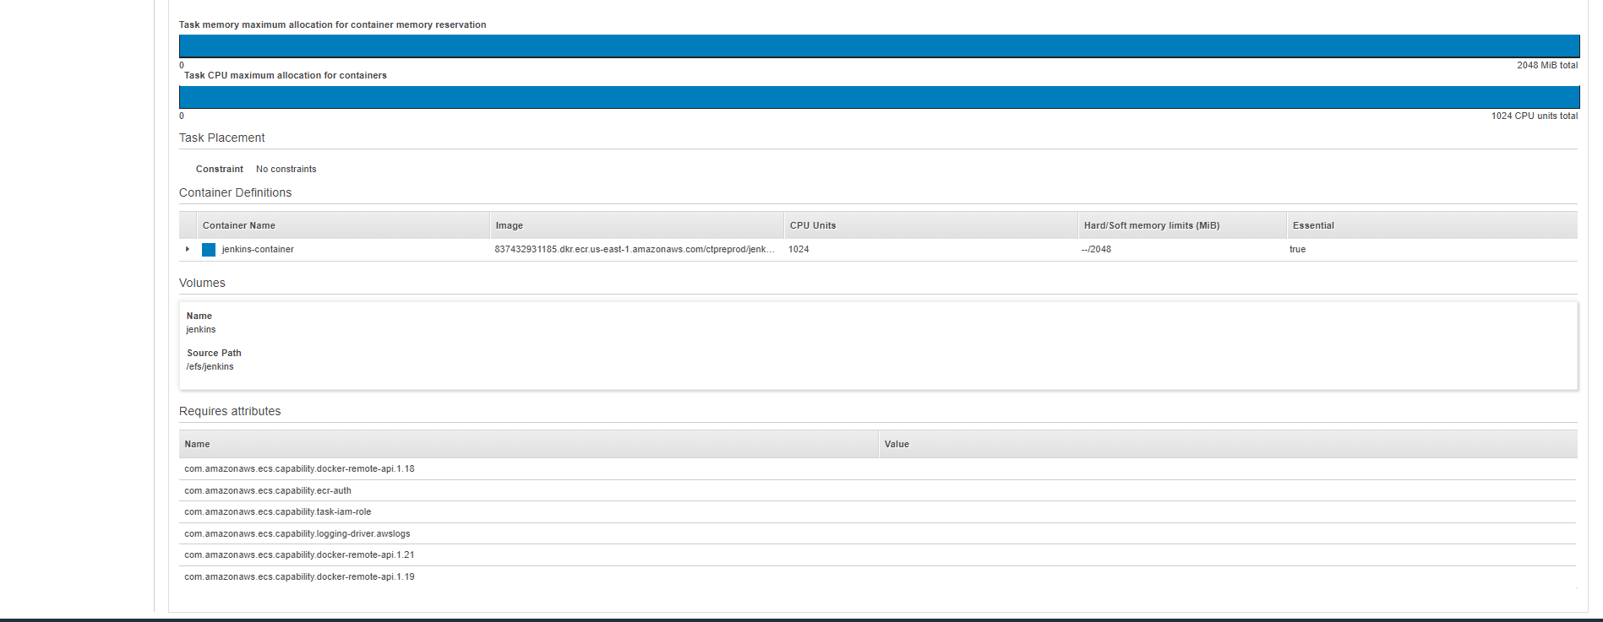

4. After successful configuration, ECS will deploy the task.