**Objective:**

**Slave Setup In aws Instance and Adding Dependencies In Slave Machine (ubuntu) For CTP serverless NodeJS lambda Application Build**

**Step 1: Choose an Amazon Machine Image (AMI)**

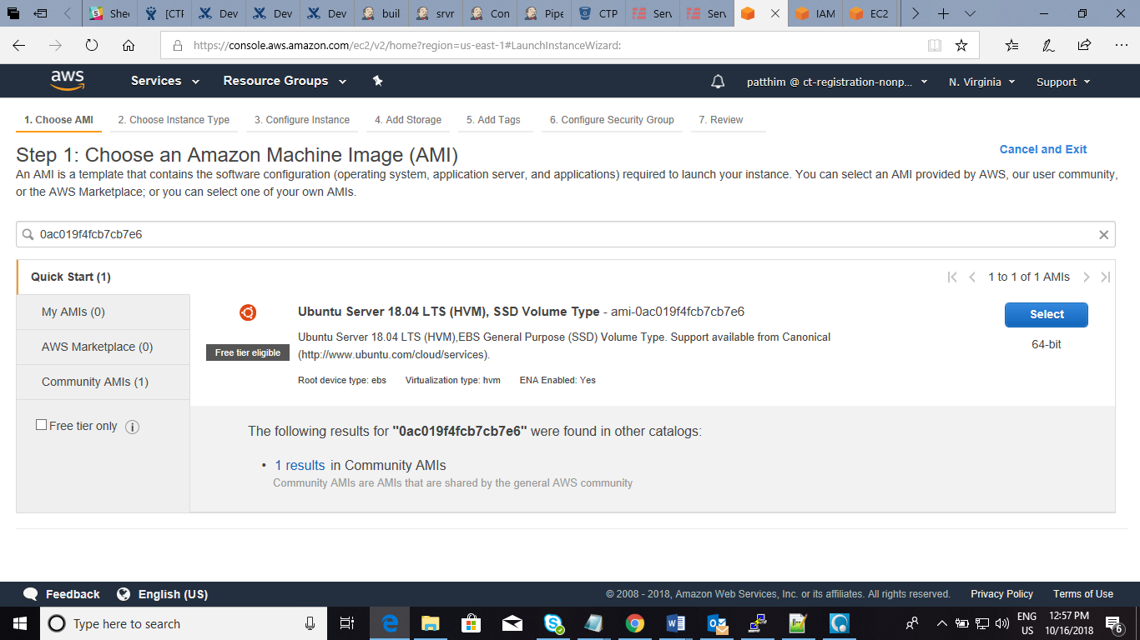

**Step 2: Choose an Instance Type & click Next Configure Instance**

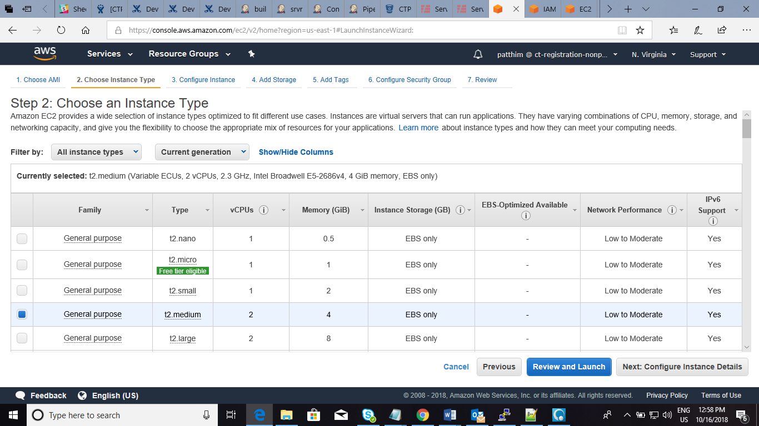

**Step 3: Configure Instance Details & click next add storage**

* same VPC & subnet that launched the Jenkins master.

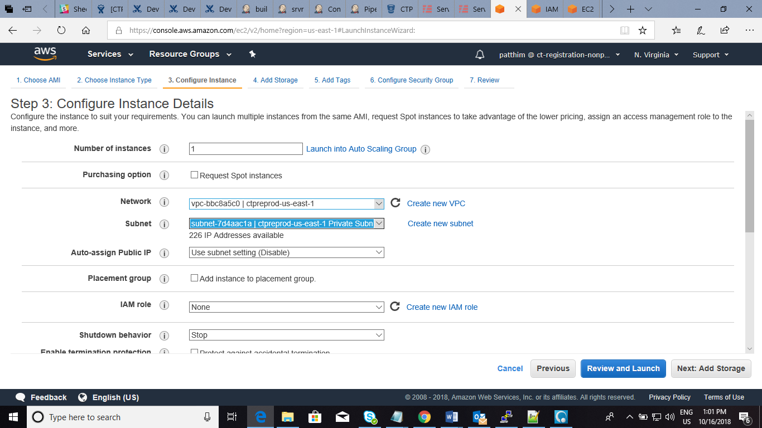

**Step 4: Add Storage**

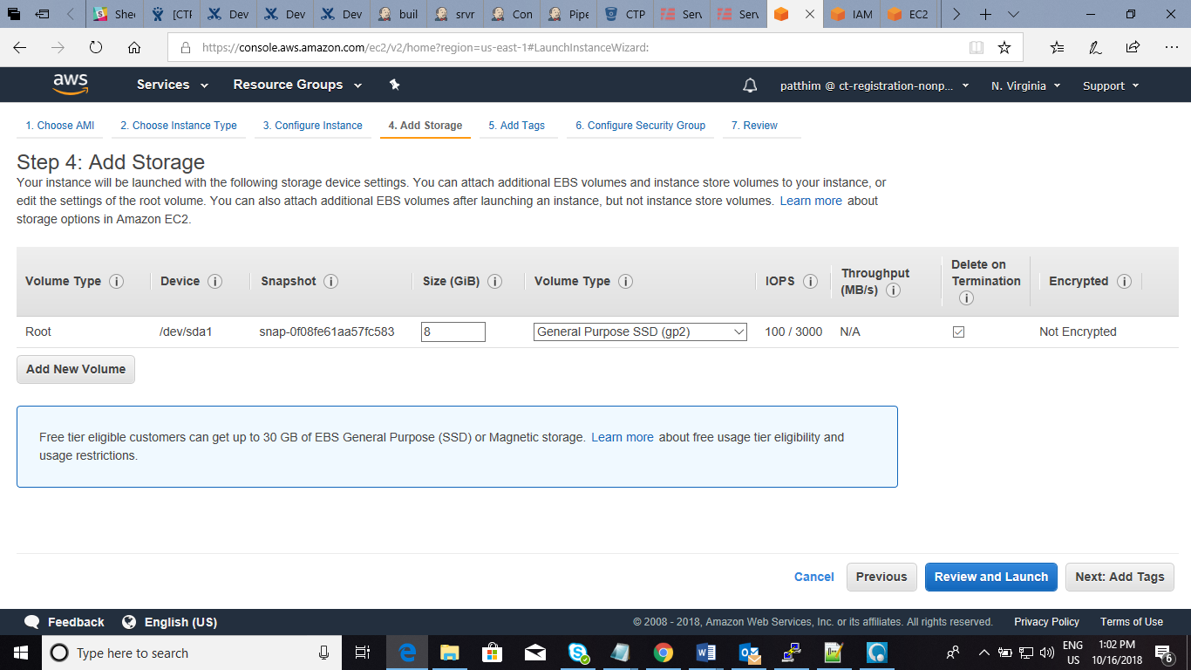

**Step 5: Add Tags**

* Name and Key Value

**Step 6: Configure Security Group**

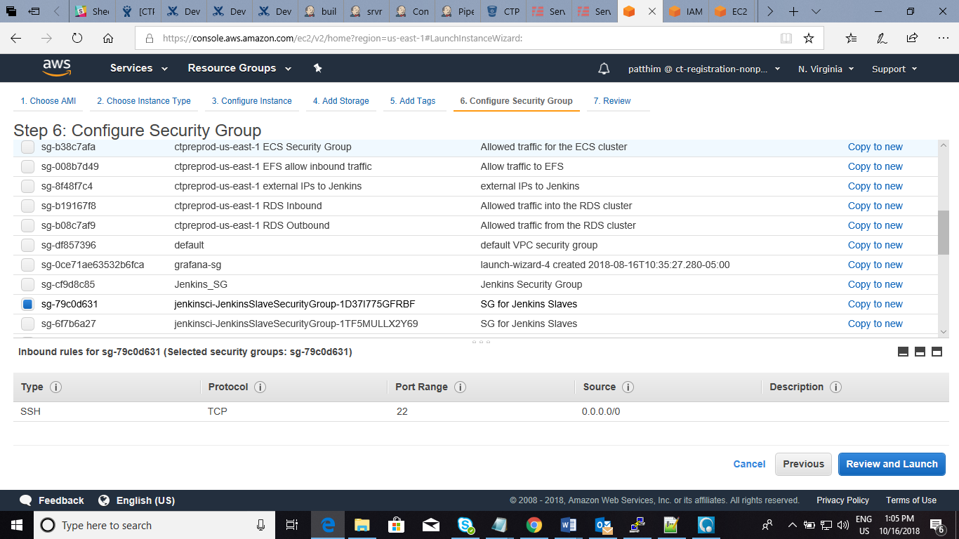

**Step 7: Review Instance Launch**

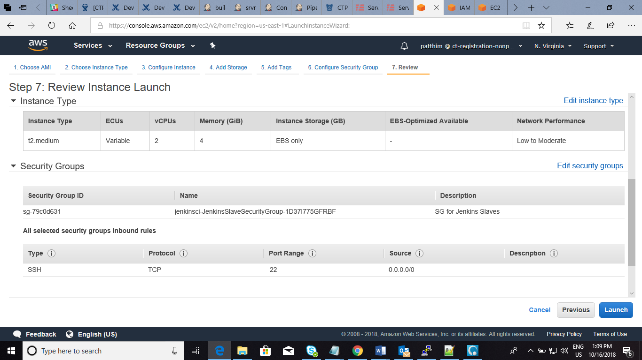

|  |  |
| --- | --- |
|  | **Select an existing key pair or create a new key pair** |

**Launch & Connect Through Putty**

* Setup and launching new instance in the aws for slave.
* launch & coennecting putty with public ip of Bastion then Connecting into salve with .pem file of slave Instances

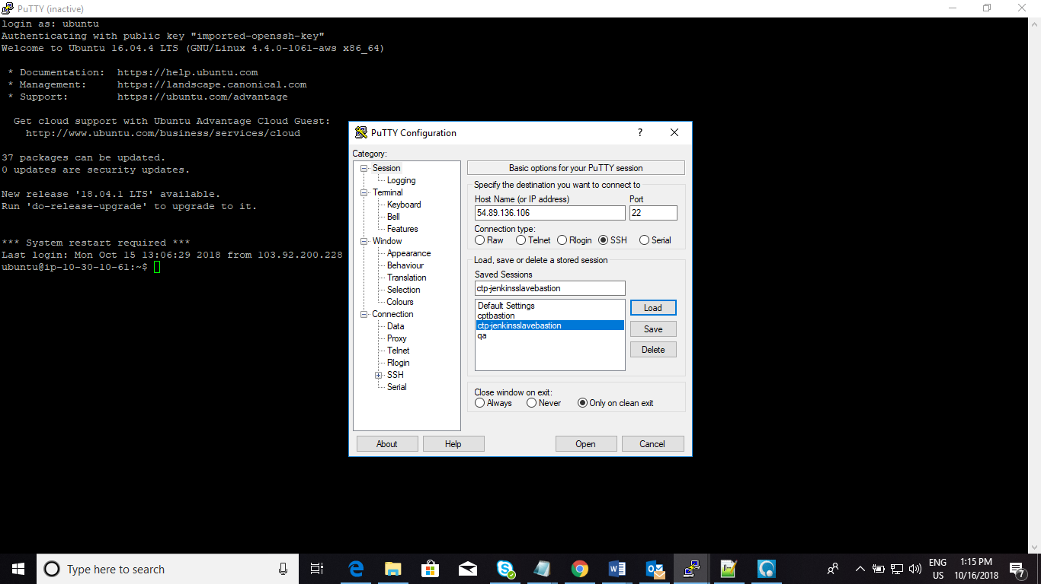

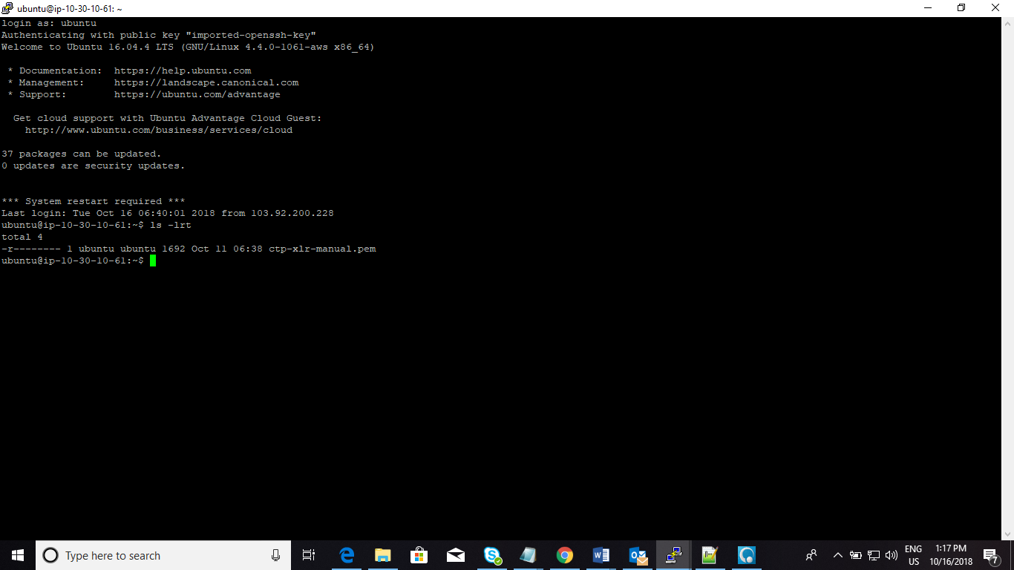

**Connecting Slave Instance Through putty**

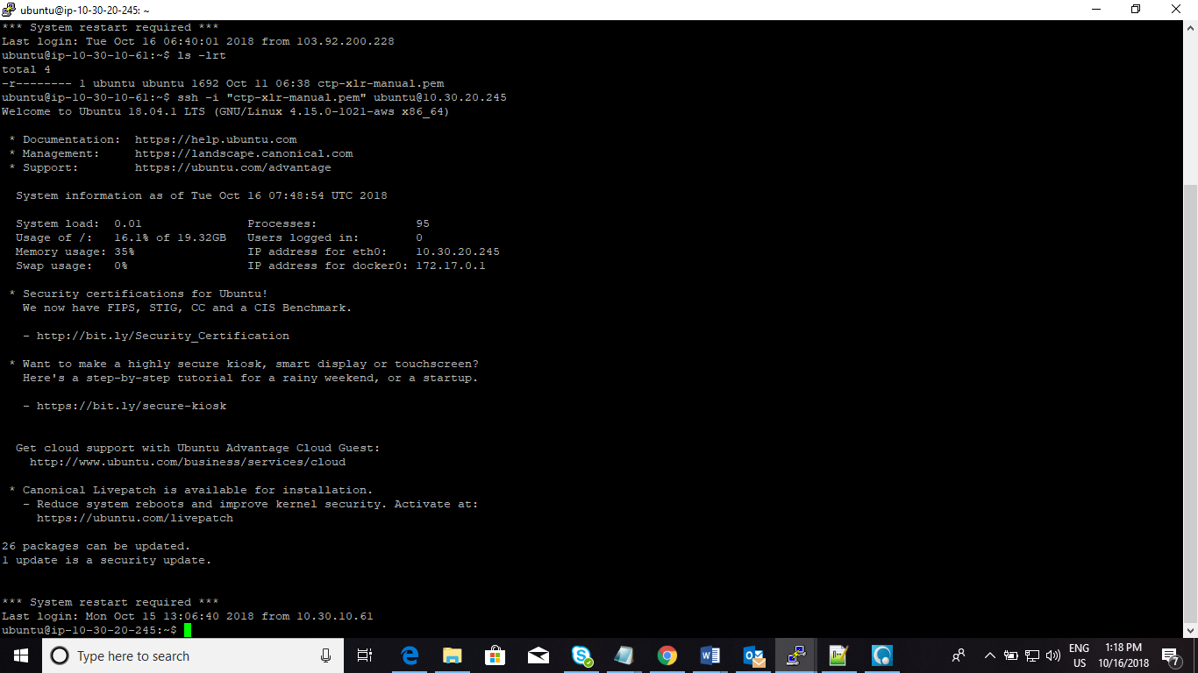

**Install all dependencies in slave machine**

sudo apt-get install node

sudo apt-get install python

python --version

sudo apt install curl

curl -sL https://deb.nodesource.com/setup_10.x | sudo bash -

curl -sL https://deb.nodesource.com/setup_8.10 | sudo bash -

curl -sL https://deb.nodesource.com/setup_8.x | sudo bash -

sudo apt-get install -y nodejs

sudo apt-get install gcc g++ make

curl -sL https://dl.yarnpkg.com/debian/pubkey.gpg | sudo apt-key add -

echo "deb https://dl.yarnpkg.com/debian/ stable main" | sudo tee /etc/apt/sources.list.d/yarn.list

sudo apt-get update && sudo apt-get install yarn

sudo apt install git

git

ls

ls -lrt

ifconfig

ls

pwd

mkdir prjs

cd prjs

git clone https://bitbucket.sdlc.toyota.com/scm/ctp/hum-messages-lambda.git

cd hum-messages-lambda/

npm install

sudo apt-get install default-jre git

cd

sudo useradd -m jenkins

sudo -u jenkins mkdir /home/jenkins/.ssh

sudo -u jenkins vim /home/jenkins/.ssh/authorized_keys2

pwd

ls -lrt

cd /home/jenkins/

ls

pwd

ifconfig

sudo chown jenkins /home/jenkins

sudo chmod 775 /home/jenkins

sudo chmod 777 /home/jenkins/

**Launch Slave In Jenkins**

* + Once the configuration done in the slave machine in Jenkins
  + choose Manage Jenkins, then Manage Nodes then New Node

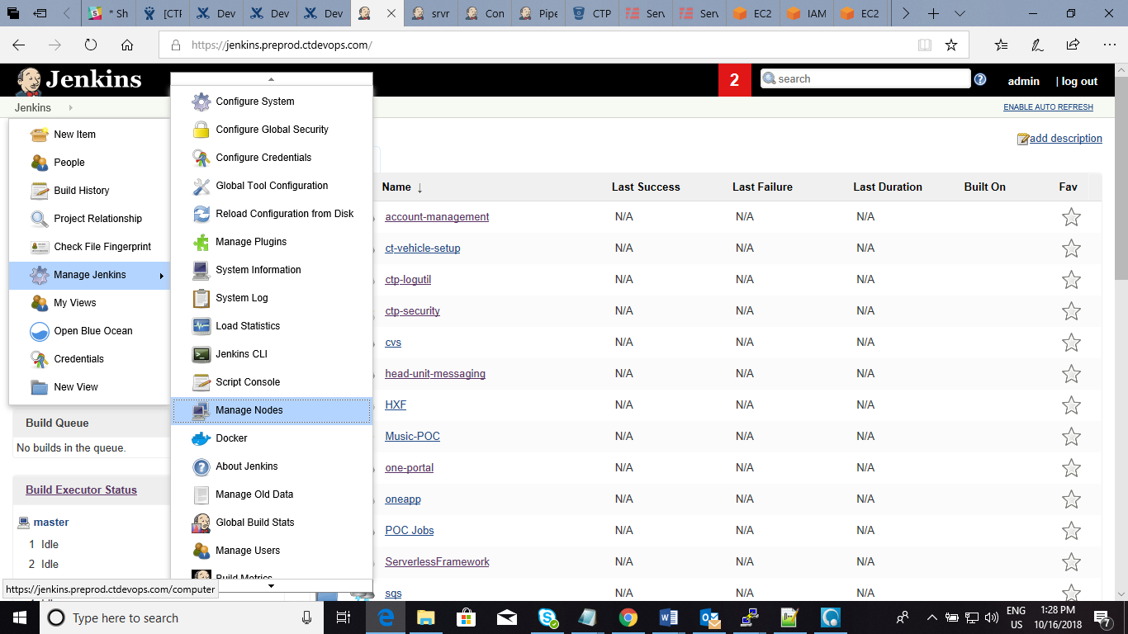

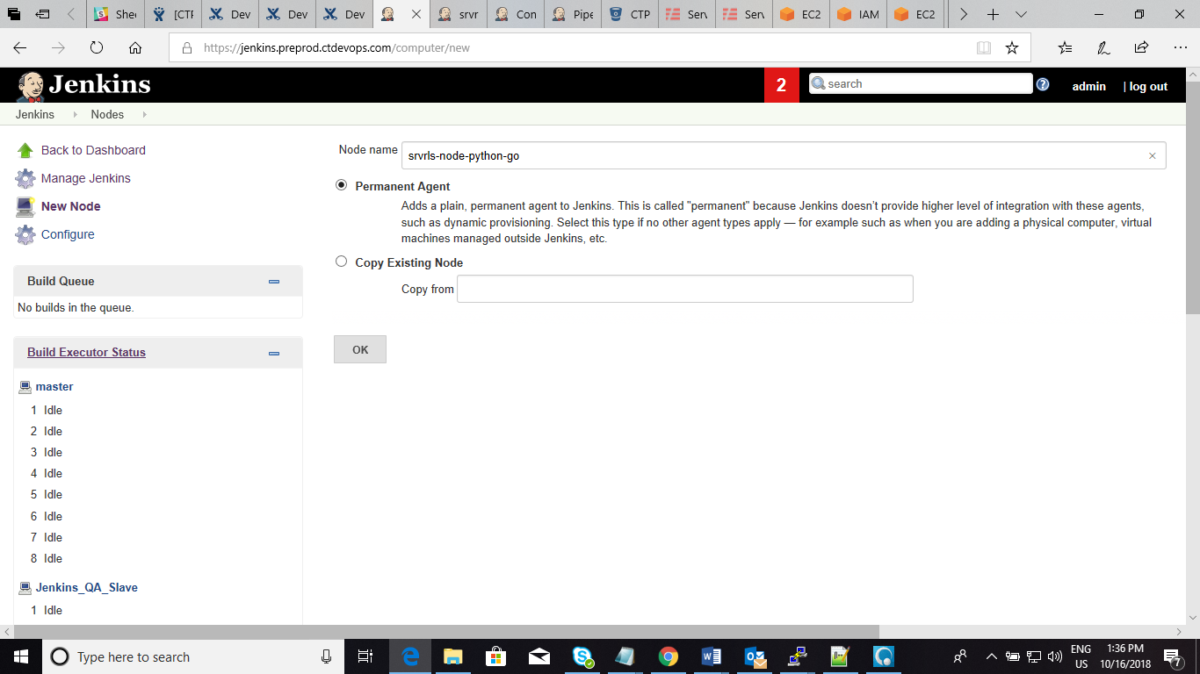

* + Give the Node Name and Configure all the fields
  + Set Remote Root Directory to an absolute path, such as /home/Jenkins
  + For the launch method, choose Launch slave agents on Unix machines via SSH and set the host to the private IP address of your worker node.
  + Add your credentials by choosing Add, then SSH Username with private key.
  + Set Availability Keep this agent as much as possible
  + Apply & Save

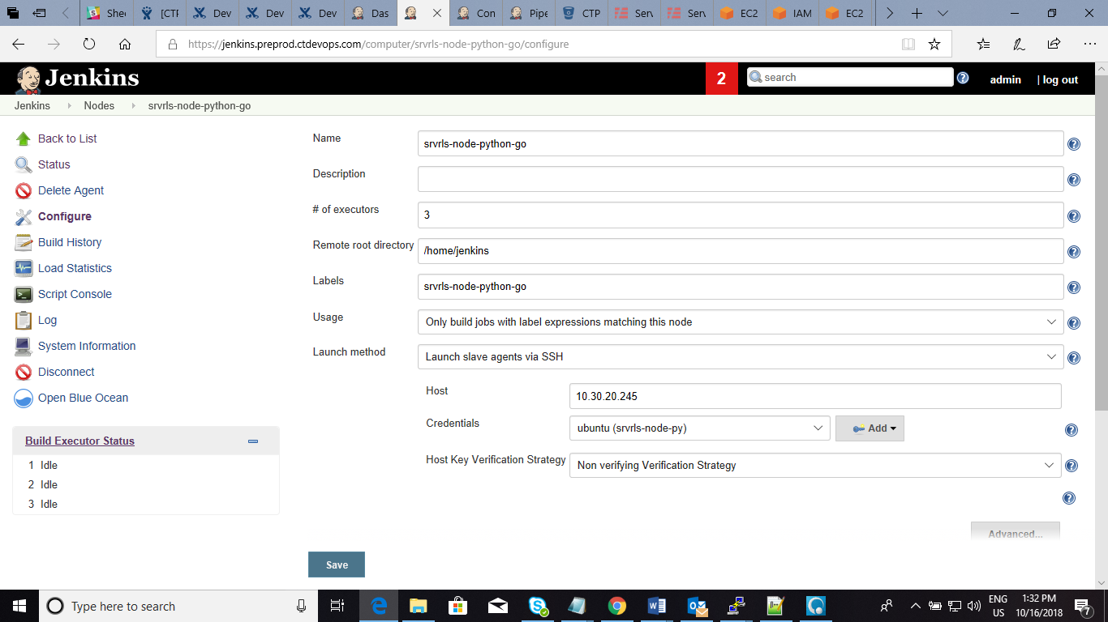

Check it In Jenkins-Manage Jenkins-Managenodes-Nodes

