**Object**:AWS Lambda deployment abilities to build steps and post build actions In Jenkins for HUM Services

**Jenkins master-Slave Setup for build And deployment**

**Ref:** https://confluence.sdlc.toyota.com/display/CTP/Build+Jenkins+slave+for+building+nodejs+lambdas+while+getting+the+dependencies+from+CT+Artifactory

Install and configure the Jenkins plugins For Deployment

**PlugIns:**

From the Jenkins dashboard select **Manage Jenkins** and click **Manage Plugins**. On the Available tab, search Then Install

* [AWS Lambda Plugin](https://wiki.jenkins-ci.org/display/JENKINS/AWS+Lambda+Plugin)
* [NodeJS Plugin](https://wiki.jenkins-ci.org/display/JENKINS/NodeJS+Plugin)
* [Github plugin](https://wiki.jenkins-ci.org/display/JENKINS/Github+Plugin)

Aws Iam user creation & Policies:

* Create One IAM user
* Save AWS access key & Secreat Access key For IAM USER aceess From jenkins
* For deployment you'll need access to the GetFunction, CreateFunction, UpdateFunctionCode and UpdateFunctionConfiguration Lambda commands.
* You'll also need access to iam:PassRole to attach a role to the Lambda function.

**Sample Syntax :**

{

    "Version": "2012-10-17",

    "Statement": [

        {

            "Sid": "Stmt1432812345671",

            "Effect": "Allow",

            "Action": [

                "lambda:GetFunction",

                "lambda:CreateFunction",

                "lambda:UpdateFunctionCode",

                "lambda:UpdateFunctionConfiguration"

            ],

            "Resource": [

                "arn:aws:lambda:REGION:ACCOUNTID:function:FUNCTIONNAME"

            ]

        },

        {

            "Sid": "Stmt14328112345672",

            "Effect": "Allow",

            "Action": [

                "iam:Passrole"

            ],

            "Resource": [

                "arn:aws:iam::ACCOUNTID:role/FUNCTIONROLE"

            ]

        }

    ]

}

AWS Lambda function deployment:

Create New job for Intigration,build & deployment

* Go to Bitbucket Project
* Clone It

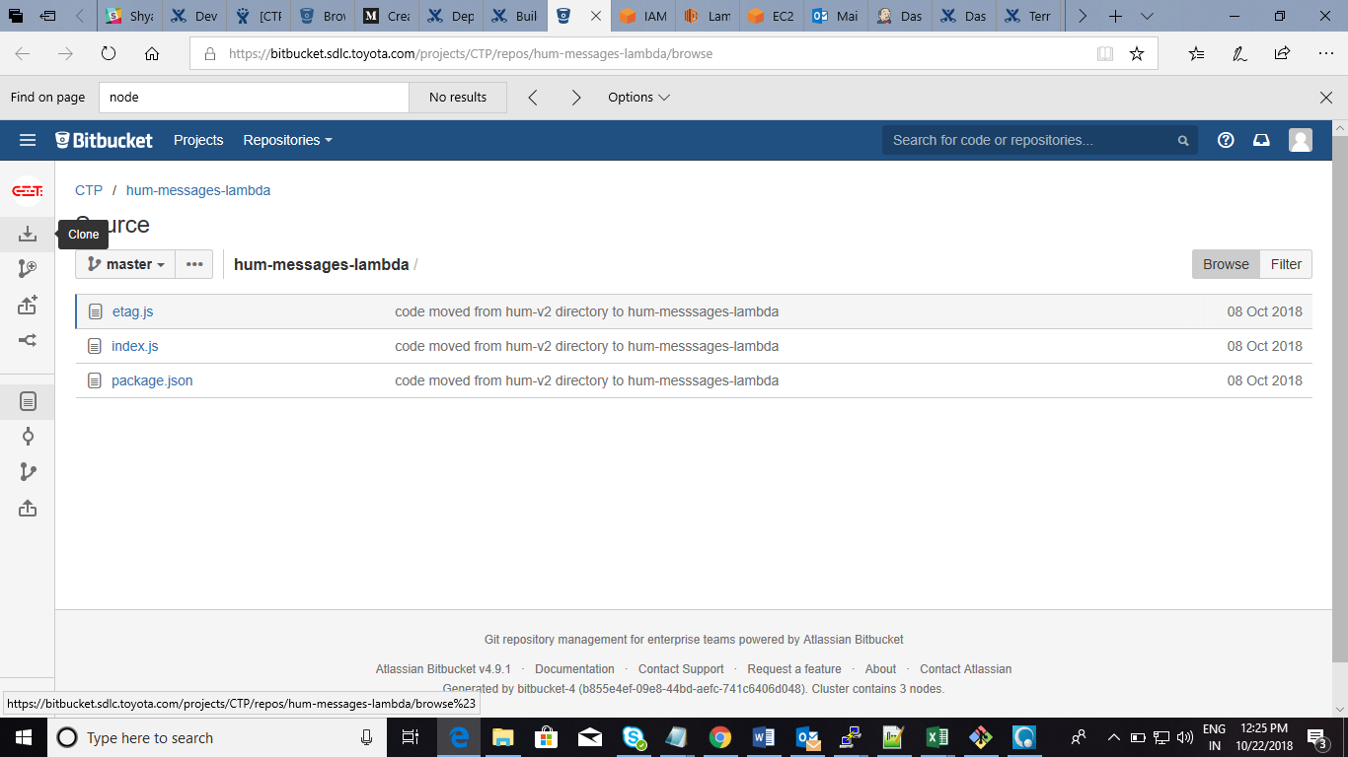

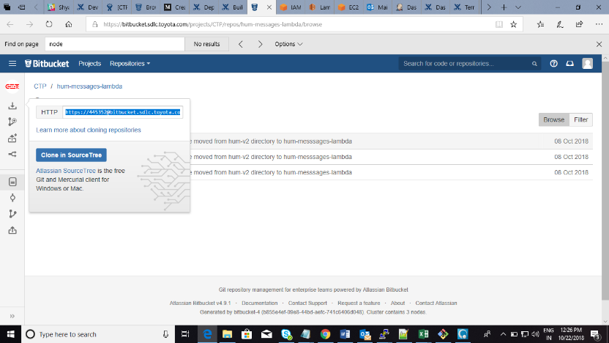

Jenkins Job Setup:

* Go to Jenkins dashboard
* Create New item

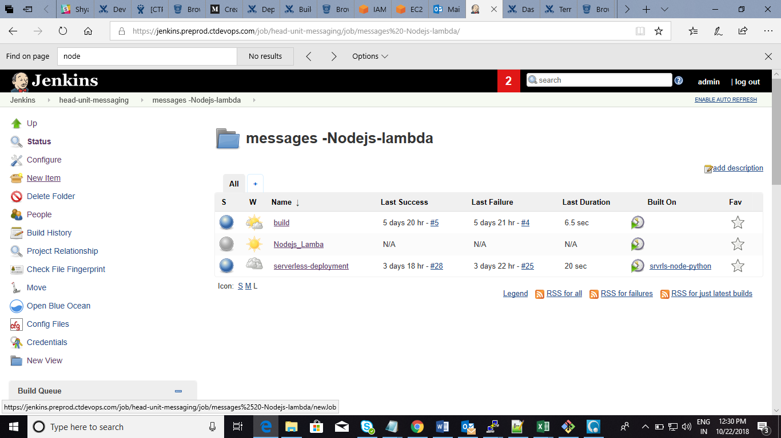

* Select Free style & Given Job Name Then Ok

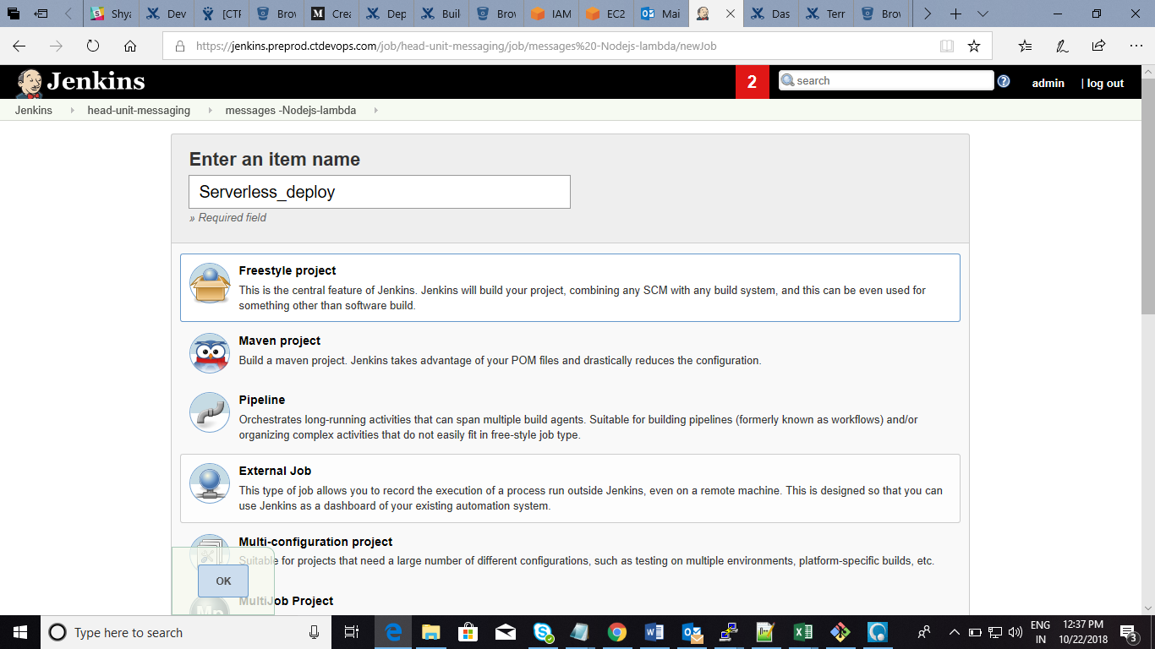

* Go to Source code management Then Give The bitbucket url which we have cloned previously & Credentials of Bitbucket

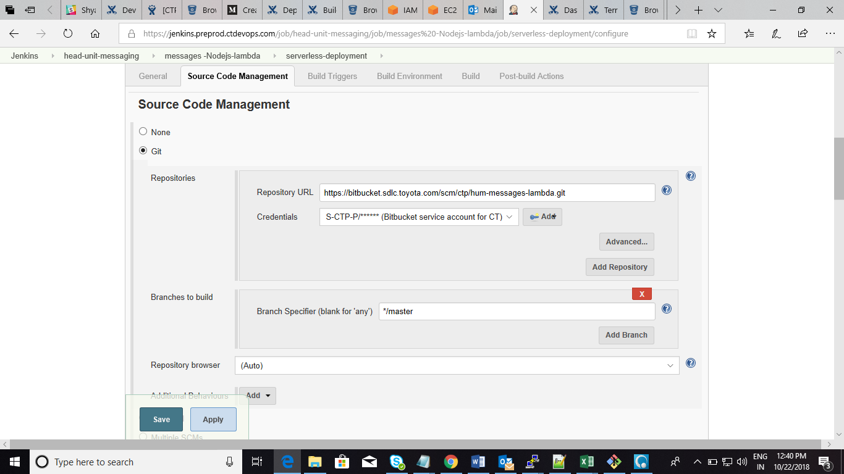

* Go to Build Section Click add build & select Excute Shell

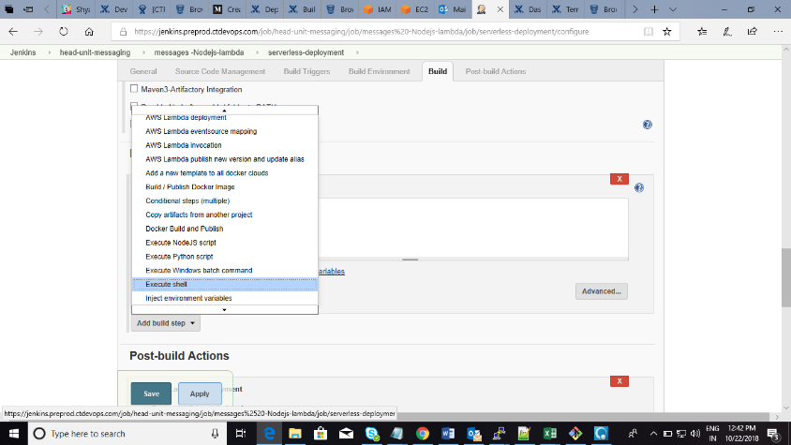

* Then Give “npm Install”

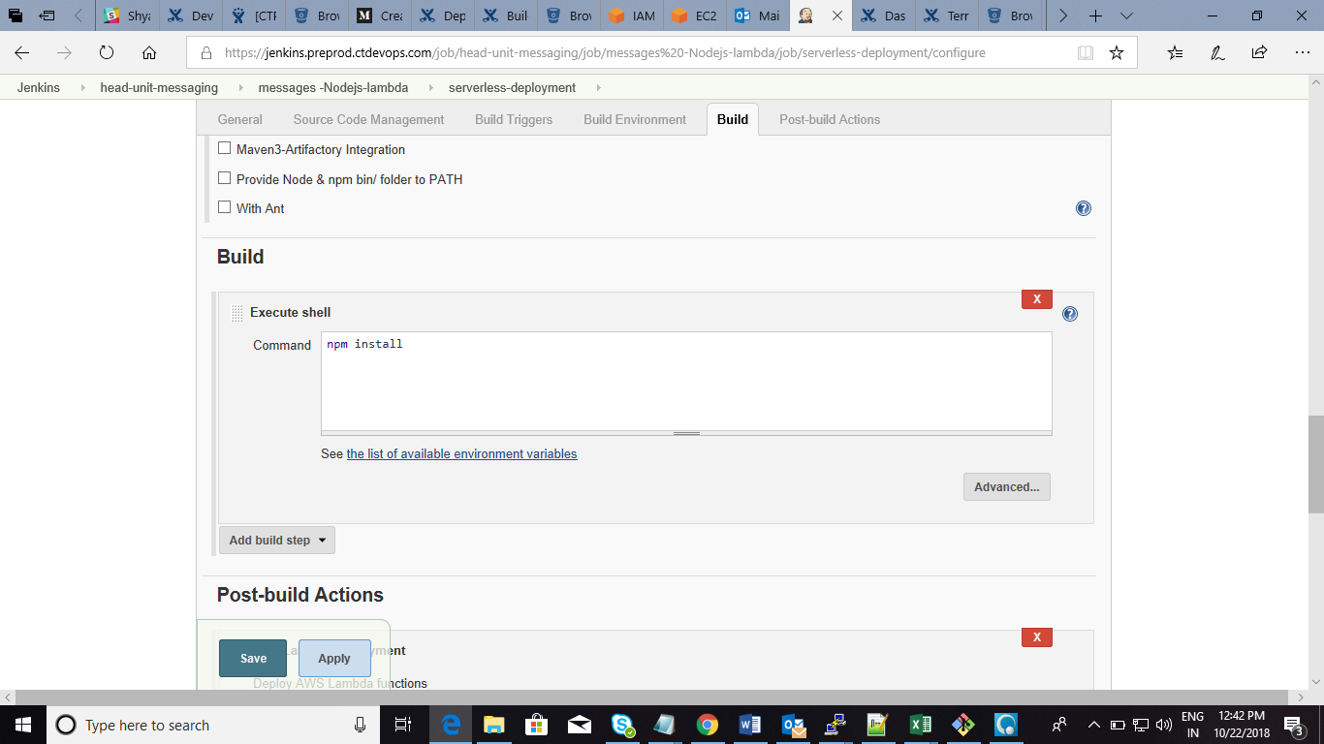

* Goto post Build In Jenkins Job & Select AWS lambda deployment

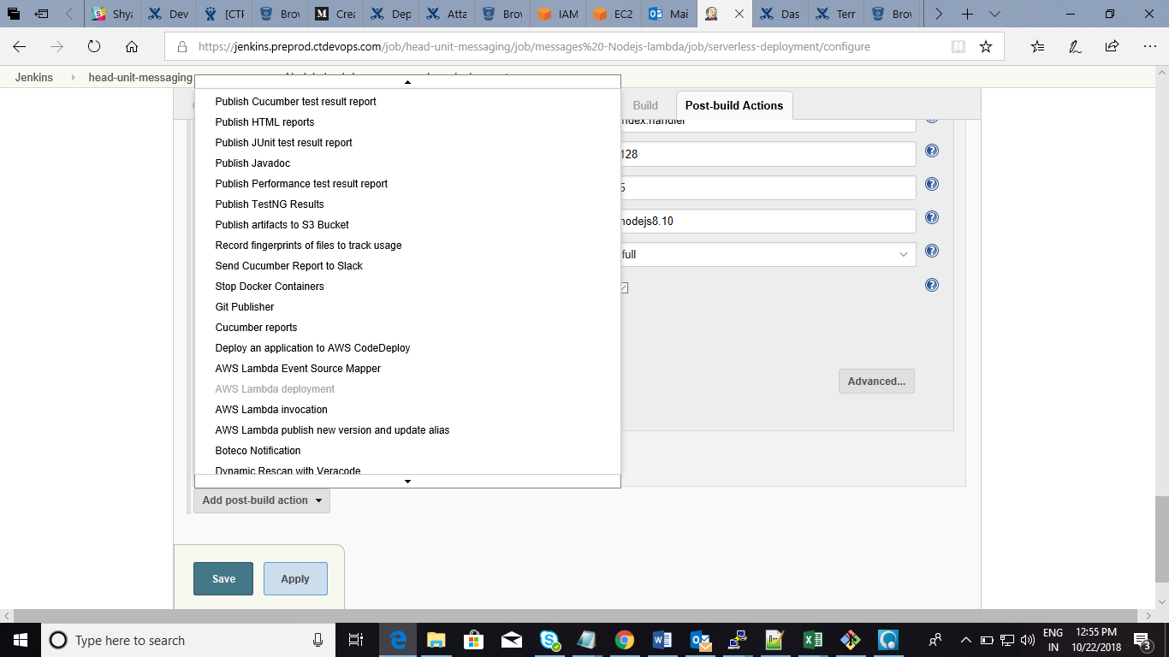

Fill the all Fields Information

* Add the AWS Access Key Id, AWS Secret key for IAM User Access

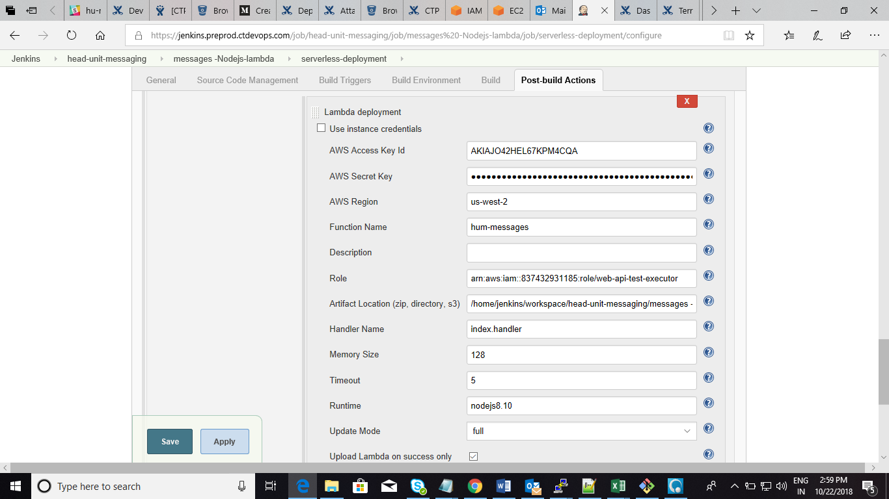

**Stpes for Post build deployment**

* Give aws region which is in where lambda function exist
* Give lambda function name

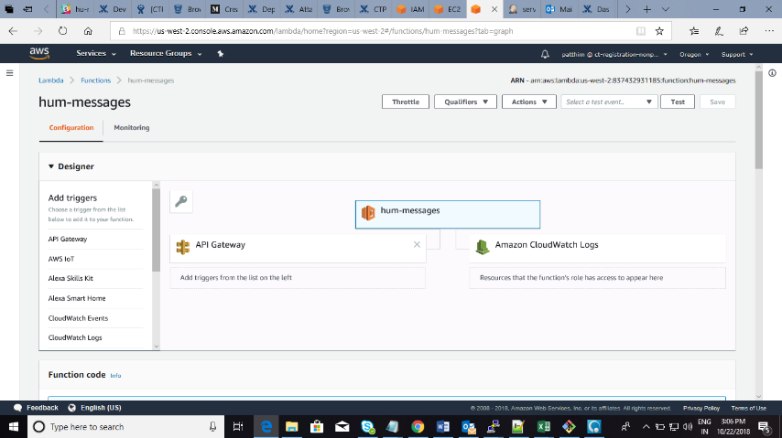

* Give the role resource arn which is In IAM ROLE section

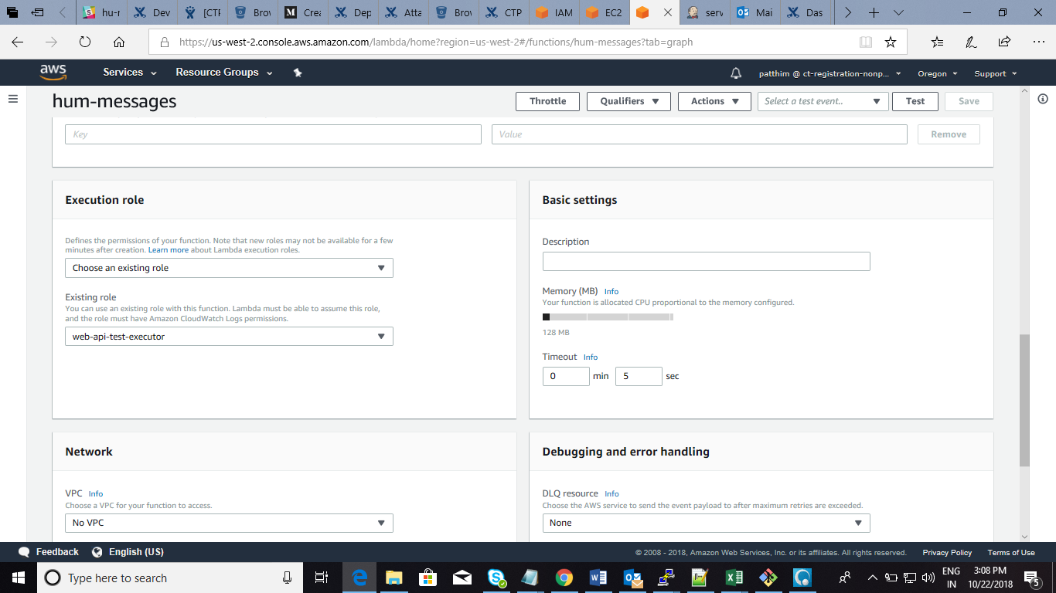

* Give the slave Working directory which is in Jenkins slave machine

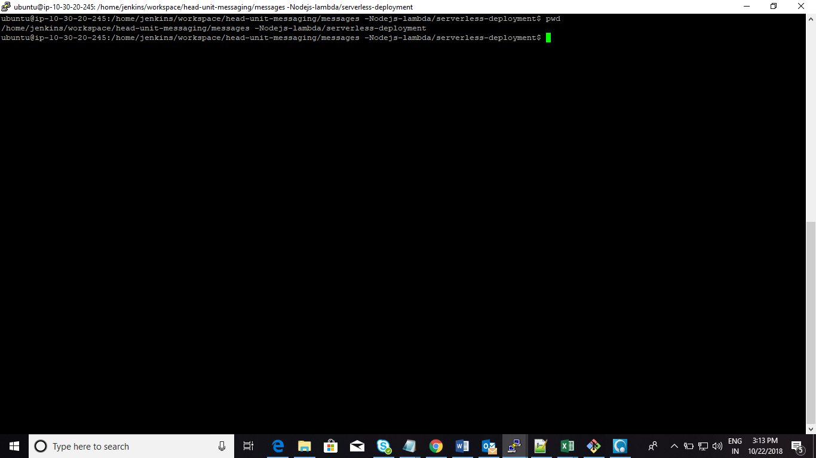

* Give handler name which is aws lamda function

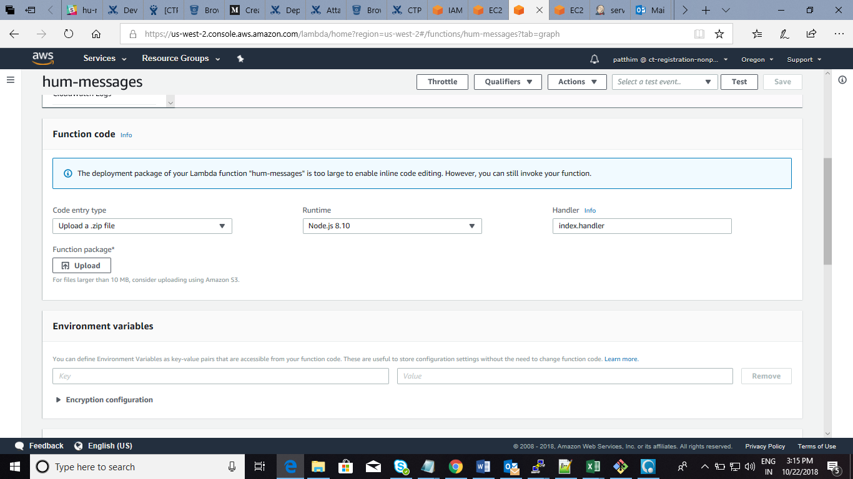

* Memory size and timeout You can give based on deployment
* Runtime is Nodejs8.10 (based on version)
* Apply & save
* Click on Build Now

