

Technical Memorandum
To: Business Owner, Project Manager
From: Owen Bjørnstad
CC: Ali Nayak
Date: May 2, 2008
Re: (Name of App Here) NAR Results
Network Effect:
✖FAIL or ●(PASS) - WAN - (depending on transaction type - see text)
User Experience:
▲User Alert Required - Campus or WAN use

Network Effect - Certain transactions of the APP application could have a significant negative effect on the Toyota Network WAN Infrastructure to Regions & Parts Centers, including Toyota de Puerto Rico, due to the amount of data generated for certain of the transaction steps.
This conclusion is specific to the steps associated with "Ad-Hoc Reporting" with the Hyperion Intelligence Tool.
APS "Ad-Hoc Reporting" is NOT CLEARED for Remote Offices, or over RAS connections
If the existing mechanism to govern the amount of data generated is adjusted significantly for those reports, we can revisit this conclusion.
Those steps which pull down prepopulated "canned" reports to users, such as was tested for certain reports for Puerto Rico, should not have a negative effect on the WAN
APS Pre-Populated Reports are CLEARED for Regions
Use of APS on the Toyota Torrance Campus would likely not have adverse effects to the infrastructure - APS is CLEARED for Campus use.

User Experience - Users will need to be informed that certain transaction steps will involve some significant wait times, well over a minute in many cases, even for Campus users. For users at regional offices, certain steps should be of particular note. The first is the Login to the application, which will be well over 23 seconds for most users, more if they are logging on to the application for the first time, or after the cache on their browser has been cleared - users should be informed that logging in to APP will take time and to be patient.
The second is the download of the Java necessary for Hyperion Intelligence - even if this is a one-time experience, users should be warned that this will take some time to download.
Certain other transactions which involve complex and/or high data volume queries to the Hyperion database will also involve significant wait times - users should be made aware that such queries will involve relatively long wait times (sometimes well in excess of 3 minutes).
Data Volumes:
The following table shows the traffic volumes for sample transactions within APS:
Where appropriate, approximate predicted response times for remote users have been supplied.
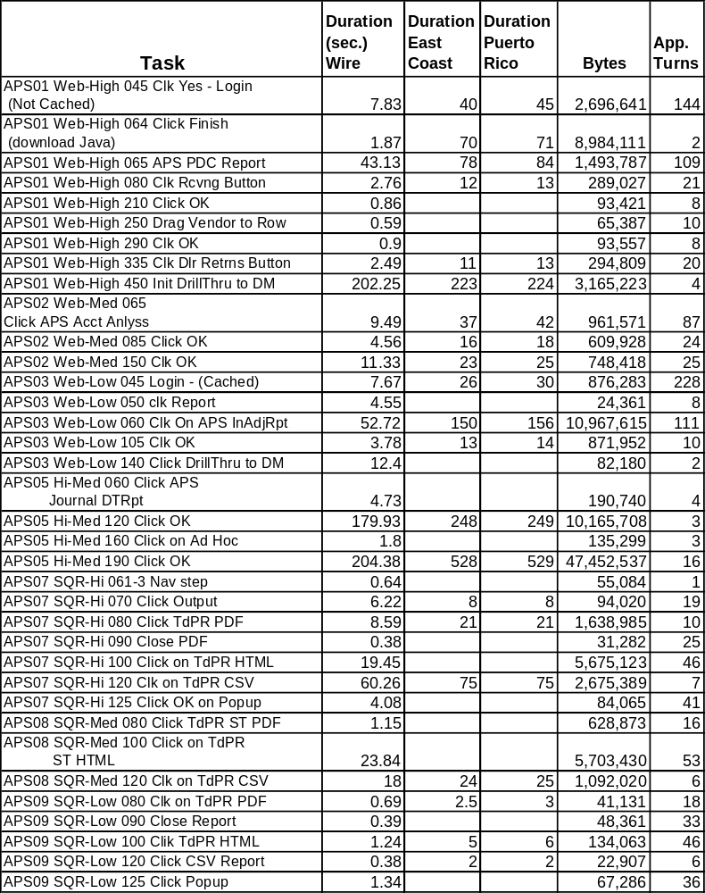

User Response Times:

Login:

Non Cached Login to APS:
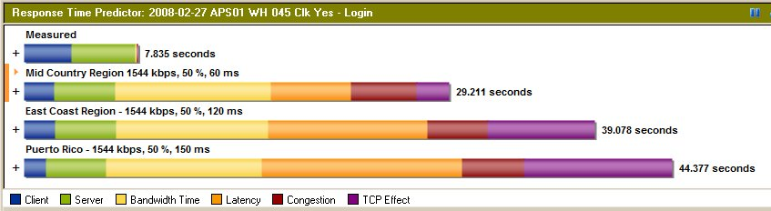

Cached Login to APS:
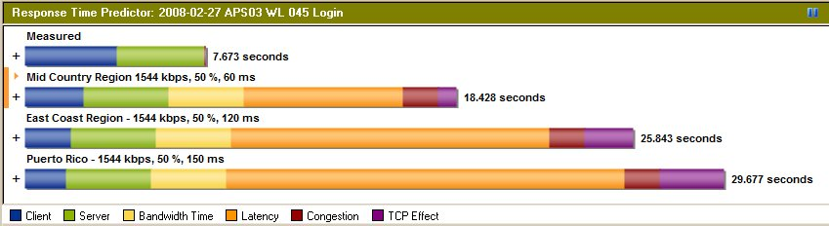

Other Selected Response time Graphs:

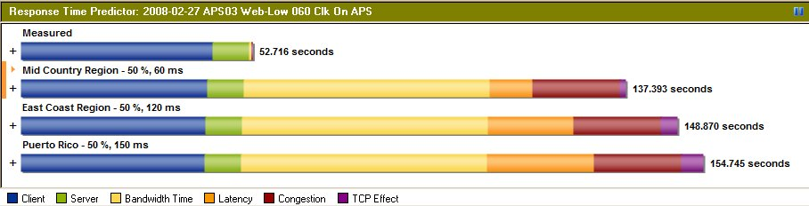

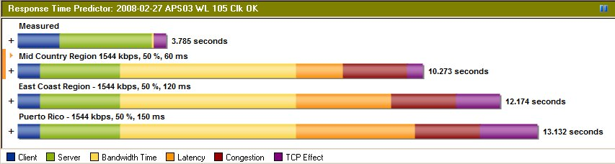
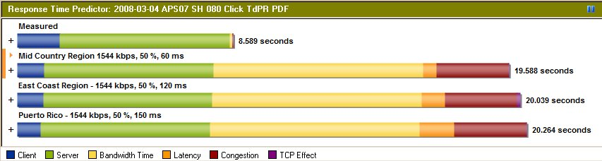

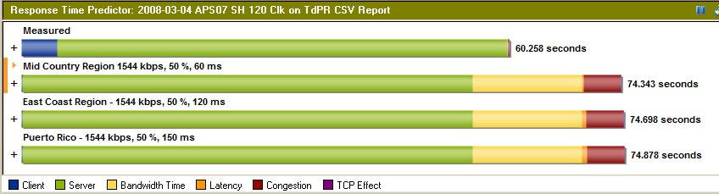

Scripts:

01-Web-High

Test Script | PDC Activity
 | 01-Web-High
INIT | Client setup tasks: start browser, Setup right version of JVM
10 | Start IE browser | 0.00
20 | Enter URL of login page, Click Enter | 3.29
20 | Enter URL of login page, Click Enter | 3.03
30 | Select TMS user and Type Username/Password | 0.00
40 | Click Login button | 0.78
45 | Click click yes to continue Login | 9.39
50 | Navigate Folder Financial Transactions-  >Parts>Ad-Hoc->PDC
60 | Double click on APS PDC Activity Report | 9.39
62 | Install Java - JVM 1.5.0_09 must be installed (S/b installed)
63 | Click Accept > | 144.42
64 | Click Finish | 19.18
65 | Hyperion Security Box - do you want to run the application [get report]
70 | Drill-down on the Period dimension in each section of the report down to the date level | 2.61
72 | Drill-down on the Period dimension in each section of the report down to the date level | 1.68
74 | Drill-down on the Period dimension in each section of the report down to the date level | 1.54
76 | Drill-down on the Period dimension in each section of the report down to the date level | 1.88
77 | Drill-down on the Period dimension in each section of the report down to the date level | 2.00
78 | Drill-down on the Period dimension in each section of the report down to the date level | 2.94
80 | Click on Receiving button | 3.88
90 | Set Date Type radio button to TRANSACTION DATE.
100 | Set the Time Analytics filter to Input. | 0.00
110 | Set Year filter to 2010 | 0.00
120 | Set the PDC filter to All US PDCs | 2.20
130 | Double click on Total Year | 1.06
140 | Keep Only on Quarter 3 | 2.84
150 | Double click on Quarter 3 | 1.72
160 | Click on the Cube Navigator button | 0.72
170 | Drag Product to Row | 1.88
180 | Click the "+" sign next to Product on the Product Browser screen to expand.
190 | Check All Products | 0.00
200 | Click OK | 1.75
210 | Click OK | 1.75
220 | Right click on All Products and select Search
230 | Type "5211902902" for Member; click the radio button for Mode = Both; click the radio button for Range = Product; click the radio button for Option = Beginning  Click OK
240 | Click on the Cube Navigator button | 1.11
250 | Drag Vendor to Row | 1.34
260 | Click the "+" sign next to Vendor on the Vendor Browser screen to expand.
270 | Check All Vendors | 0.00
280 | Click OK | 1.30
290 | Click OK | 1.78
300 | Double click on a column value which has drill through sign to open drill-through report
310 | Highlight the report above and press the  green arrow key to initiate drill thru  query to data mart
320 | Close the drill through dialog | 5.03
325 | Close the drill through report | 0.89
330 | Click on PDC Activity Tab | 1.05
335 | Click on Dealer Returns button | 3.61
340 | Set Date Type radio button to TRANSACTION DATE.
350 | Set the Time Analytics filter to Input. | 0.00
360 | Set Year filter to 2010 | 0.00
370 | Set the PDC filter to All US PDCs | 2.13
380 | Double click on Total Year | 1.23
390 | Keep Only on Quarter 3 | 0.80
400 | Double click on Quarter 3 | 1.16
410 | Keep Only on November | 0.86
420 | Right click on All Products and select Search
430 | Type "S999" for Member; click the radio button for Mode = Both; click the radio button for Range = Product; click the radio button for Option = Beginning  Click OK
440 | Double click on a column value which has drill through sign to open drill-through report
450 | Highlight the report above and press the green arrow key to initiate drill thru query  to data mart
460 | Close the drill through dialog | 1.72
460 | Close all the reports | 9.70
470 | Click Logout | 0.00

02-Web-Med
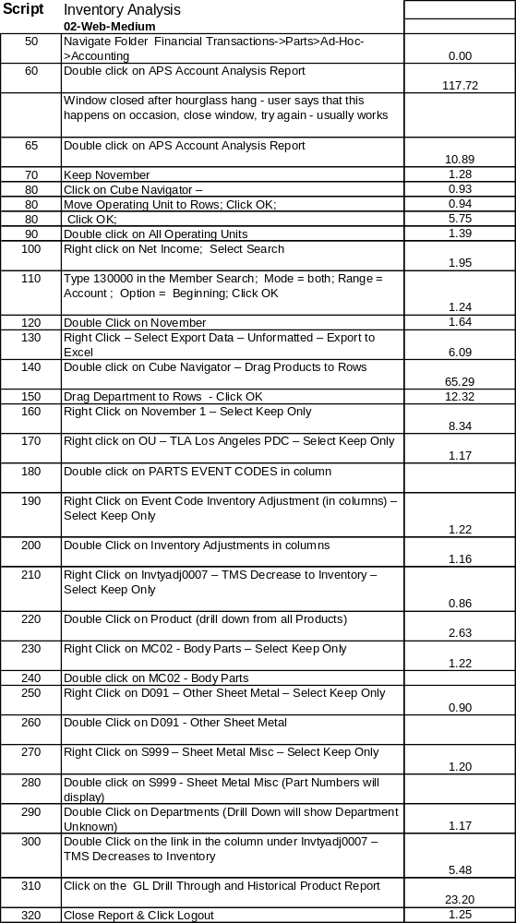
03-Web-Low
Test Script | Inventory Analysis | Yes
 | 03-Web-Low
20 | Enter URL of login page, Click Enter | 2.20
20 | Security dialog | 1.45
30 | Select TMS user and Type Username/Password | 0.00
40 | Click Login button | 0.71
45 | Click Login button | 8.53
50 | Navigate Folder Financial Transactions->Parts>Ad-Hoc->Adjustments
60 | Double click on APS Inventory Adjustment Report
70 | Keep on December | 0.94
80 | Drill Up (Quarter 3 will appear) | 1.44
90 | Double click on Quarter 3 | 1.50
102 | Click on Cube Navigator – Move PDC to Rows; Click OK
104 | Click on Cube Navigator – Move PDC to Rows; Click OK
105 | Click on Cube Navigator – Move PDC to Rows; Click OK
110 | Double click on PDC | 1.19
120 | Keep on All US PDC’s ; | 1.27
120 | Double Click on All US PDC | 2.07
130 | Double click on the drill thru indicator for Lexus-Jacksonville/October | 6.06
140 | Highlight the report above and press the green arrow key to initiate drill thru query to data mart | 13.36
260 | Close dialog box | 0.86
260 | Close report | 1.25
260 | Exit WebAnalysis Studio | 1.30
05-Hi-Med
Test Script |  | APS Journal Detail Transaction | Yes
 |  | 05-HI-Medium
60 |  | Double click on APS Journal Detail Transaction Report
70 |  | Click on Query section | 0.92
80 |  | Drag Account Number to Filter line
90 |  | Set Account Number filter and click OK | 0.94
100 |  | Click process query button | 0.80
110 |  | Set Journal Date filter and click OK | 0.80
120 |  | Set Post Date filter and click OK | 186.75
130 |  | Close report with X in top right corner
140 |  | Click No | 0.88
150 |  | Navigate Folder Financial Transactions->Parts>Ad-Hoc->Royalty
160 |  | Double click on APS Royalty Ad Hoc
170 |  | Click process query button | 0.80
180 |  | Click ignore button | 0.59
190 |  | Set Royalty Date filter and click OK | 244.00
195 |  | Set Royalty Date filter and click OK | 222.97
200 |  | Click OK on Query Truncated Dialog
210 |  | Close report with X in top right corner
220 |  | Click No | 0.48
06-Hi-Low
Test Script | APS Inventory Adjustment | Yes
 | 06-HI-Low
INIT | Client setup tasks: start browser, Setup right version of JVM
10 | Start IE browser | 0.00
20 | Enter URL of login page, Click Enter | 0.00
30 | Select TMS user and Type Username/Password | 0.00
40 | Click Login button | 0.00
50 | Navigate Folder Financial Transactions->Parts>Ad-Hoc->Adjustments
60 | Double click on APS Inventory Adjustment Report
70 | Click Query section of report | 0.92
80 | Click process query button | 1.23
90 | Click Ignore button | 0.44
100 | Set Adjustment Date filter and click OK | 0.69
110 | Click Ignore button | 4.84
120 | Close report with X in top right corner
130 | Click No | 0.00
07-SQR-High
Test Script | TDPR Receipts Monthly Report
 | 07-SQR-High
INIT | Client setup tasks: start browser, Setup right version of JVM
10 | Start IE browser | 0.00
20 | Enter URL of login page, Click Enter | 0.00
30 | Select TMS user and Type Username/Password | 0.00
40 | Click Login button | 0.00
50 | Navigate Folder Financial Transactions->Parts->Batch->Monthly
60 | Arrange the Reports by Latest published date
70 | Double click on >APS TDPR Receipts Output
80 | Double click on TDPR Receipts PDF Report
90 | Close the report | 1.63
100 | Double click on TDPR Receipts HTML Report
110 | Close the report | 4.41
120 | Double click on TDPR Receipts CSV Report
125 | Click ok on dialog box | 11.08
130 | Close the report | 1.48
260 | Click Logout | 0.00
08-SQR-Med
Test Script | Scrap MTD Report
 | 08-SQR-Medium
INIT | Client setup tasks: start browser, Setup right version of JVM
10 | Start IE browser | 0.00
20 | Enter URL of login page, Click Enter | 0.00
30 | Select TMS user and Type Username/Password | 0.00
40 | Click Login button | 0.00
50 | Navigate Folder Financial Transactions->Parts->Batch->Month-to-Date
60 | Arrange the Reports by Latest published date
70 | Double click on >APS Scrap Transaction Output
80 | Double click on Scrap Transaction PDF Report
90 | Close the report | 1.42
100 | Double click on Scrap Transaction HTML Report
110 | Close the report | 2.51
120 | Double click on PScrap Transaction CSV Report
125 | Click ok on pup up | 2.57
130 | Close the report | 1.14
09-SQR-Low
Test Script | Royalty Quarterly Report | Yes
 | 09-SQR-Low
INIT | Client setup tasks: start browser, Setup right version of JVM
10 | Start IE browser | 0.00
20 | Enter URL of login page, Click Enter | 0.00
30 | Select TMS user and Type Username/Password | 0.00
40 | Click Login button | 0.00
50 | Navigate Folder Financial Transactions->Parts>Batch->Quarterly
60 | Arrange the Reports by Latest published date
70 | Double click on APS Royalty Payments Summary Output
80 | Double click on Royalty Payment Summary PDF Report
90 | Close the report | 1.11
100 | Double click on Royalty Payment Summary HTML Report
110 | Close the report | 0.89
120 | Double click on Royalty Payment Summary CSV Report
125 | Click ok on pup up | 2.09
130 | Close the report | 1.30

