Albacore MSE

Laurie

05/04/2015

=================== 2011 ===================  
  
=================== 2014 ===================  
  
=================== 2017 ===================  
  
=================== 2020 ===================  
  
=================== 2023 ===================  
  
=================== 2026 ===================  
  
=================== 2029 ===================  
  
=================== 2032 ===================  
  
=================== 2035 ===================  
  
=================== 2038 ===================

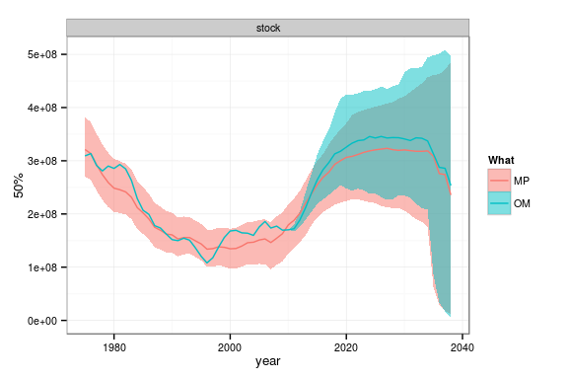

**Figure 1** HCR