Albacore MSE

Laurie

05/04/2015

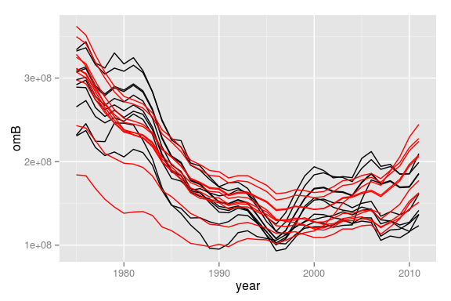

**Figure 1** Deterministic comparison between OM and MP.

[1] "1 1.5 "  
[1] "2 1.5 "  
[1] "3 1.5 "  
[1] "4 1.5 "  
[1] "5 1.5 "  
[1] "6 1.5 "  
[1] "7 1.5 "  
[1] "8 1.5 "  
[1] "9 1.5 "  
[1] "10 1.5 "

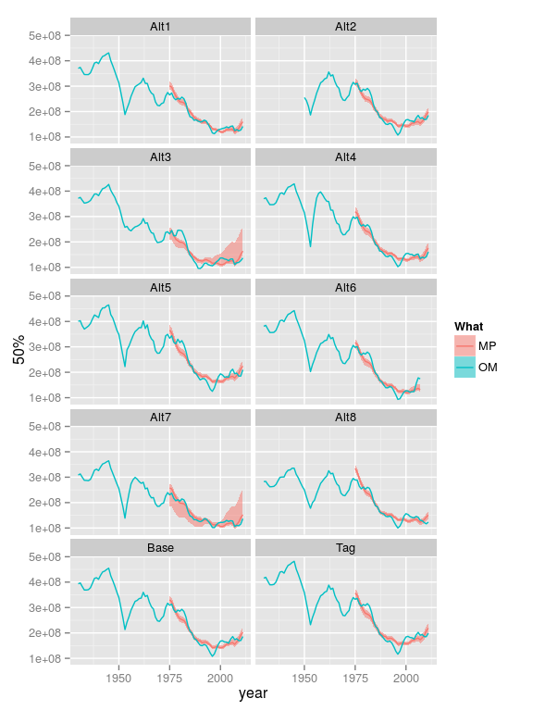

**Figure 2** Comparison of stochastic CPUE MP and deterministic OM.

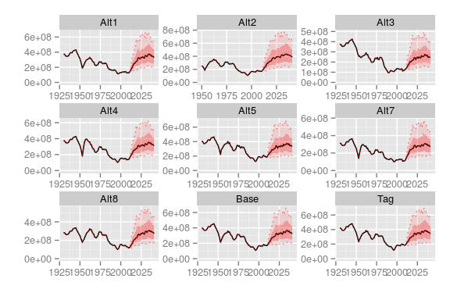

**Figure 3** Counterfactual OM stock, i.e. perfect FMSY

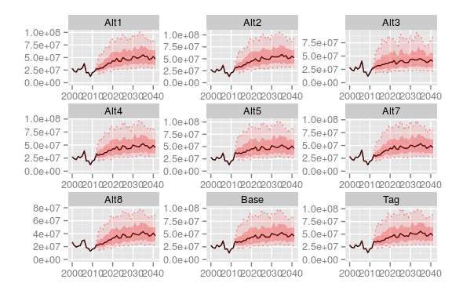

**Figure 4** Counterfactual OM catch, i.e. perfect FMSY