Albacore MSE

Laurie

05/04/2015

function (x)   
{  
 n = length(x)  
 if (!is.numeric(x[-1]) || !is.numeric(x[-n]))   
 return(NULL)  
 res1 = sum(abs(x[-1] - x[-n]))  
 res2 = sum(x[-n])  
 return(res1/res2)  
}  
<environment: namespace:diags>

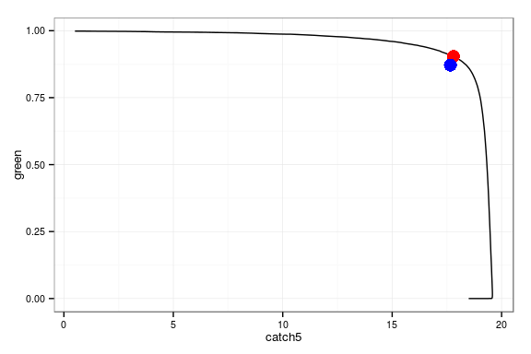

**Figure 1** Pareto

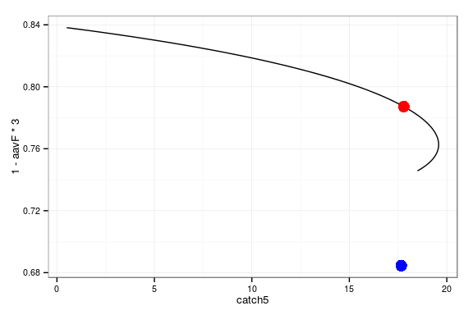

**Figure 2** Pareto

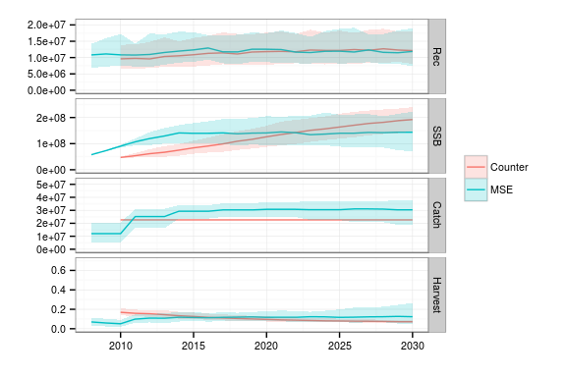

**Figure 3** Counterfactual for F=70%FMSY and MSE