Albacore MSE

Laurie

05/04/2015

Warning: replacing previous import by 'ggplot2::%+%' when loading 'biodyn'

Warning: replacing previous import by 'reshape::expand' when loading  
'biodyn'

Warning: replacing previous import by 'reshape::cast' when loading 'biodyn'

# Shape of production function known

## Truncate data at 1975

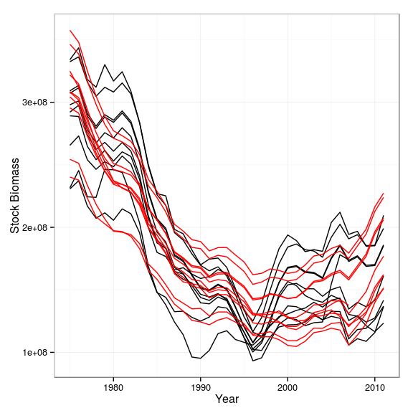

**Figure 1a** Deterministic comparison of biomass assessment in MP and OM, for p known and truncated time series.

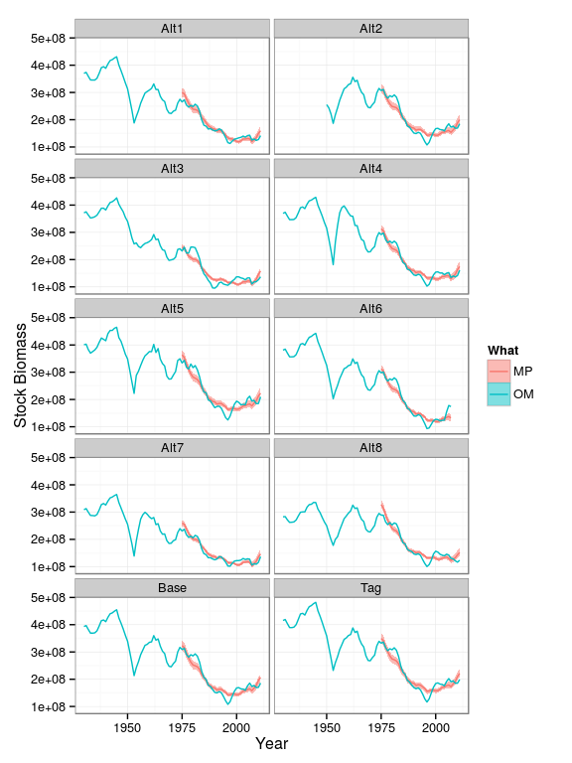

**Figure 1b** Stochastic comparison of biomass assessment in MP and OM, for p known and truncated time series.

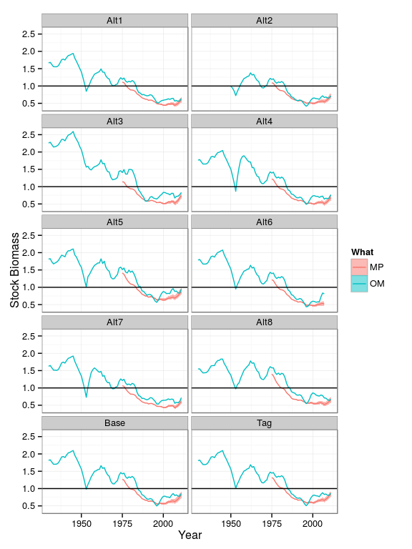

**Figure 1c** Stochastic comparison relative to BMSY of biomass assessment in MP and OM, for p known and truncated time series.

## Truncate data at 1950

Warning in sqrt(diag(cov.bounded)): NaNs produced

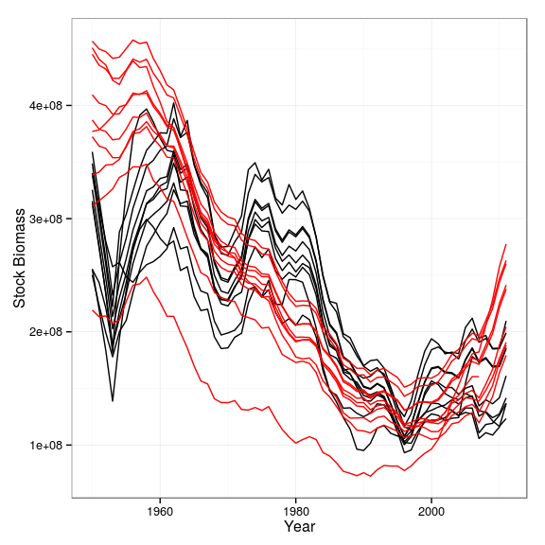

**Figure 2a** Deterministic comparison of biomass assessment in MP and OM, for p known and time series starting in 1950.

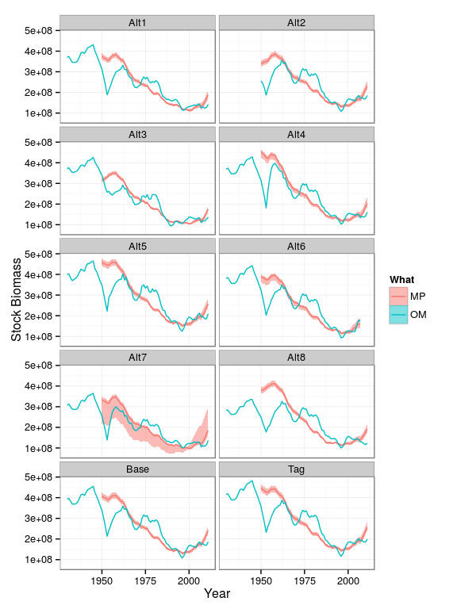

**Figure 2b** Stochastic comparison of biomass assessment in MP and OM, for p known and time series starting in 1950.

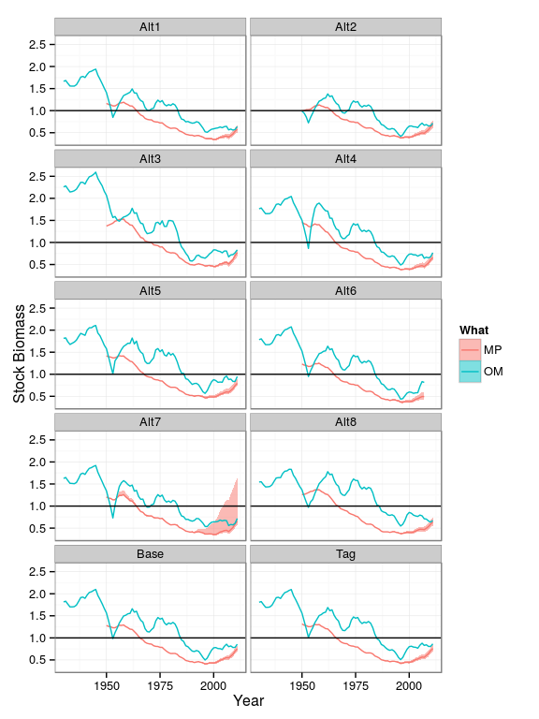

**Figure 2c** Stochastic comparison relative to BMSY of biomass assessment in MP and OM, for p known and time series starting in 1950.

# Shape of production assumed to be equal to 1 (i.e. logistic)

## Truncate data at 1975

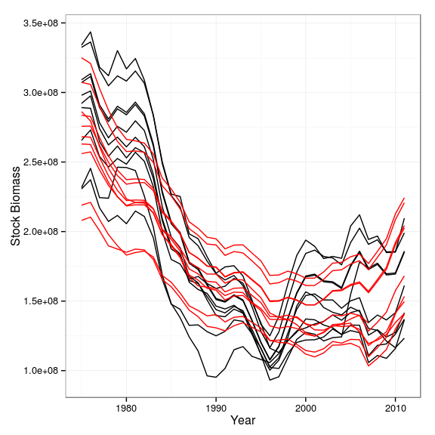

**Figure 3a** Deterministic comparison of biomass assessment in MP and OM, for p=1 and truncated time series.

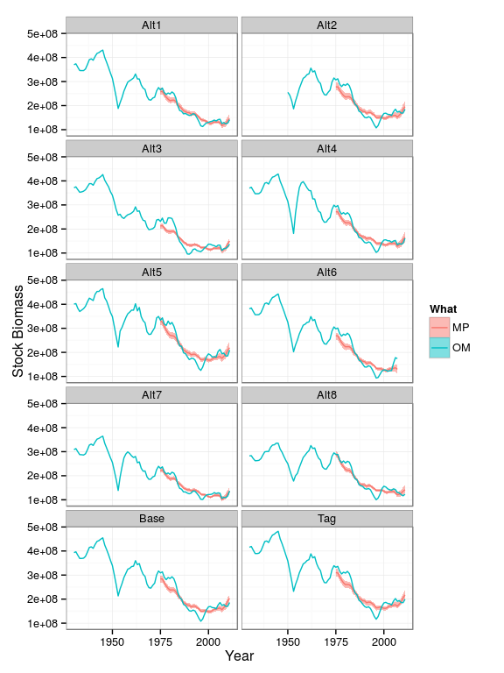

**Figure 3b** Stochastic comparison of biomass assessment in MP and OM, for p=1 and truncated time series.

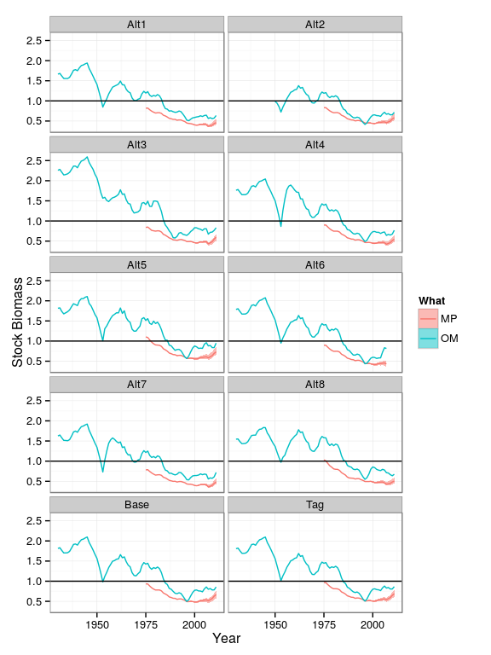

**Figure 3c** Stochastic comparison relative to BMSY of biomass assessment in MP and OM, for p=1 and truncated time series.

## Truncate data at 1950

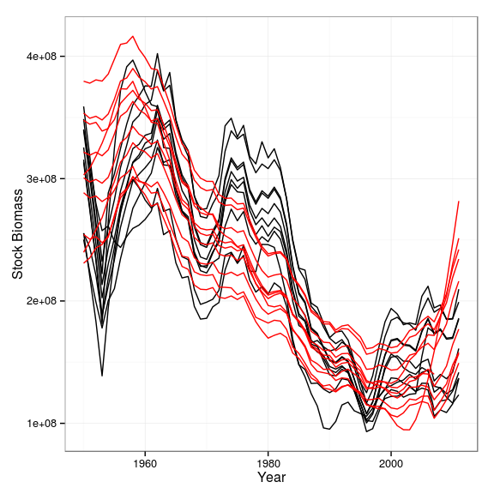

**Figure 4a** Deterministic comparison of biomass assessment in MP and OM, for p=1 and time series starting in 1950.

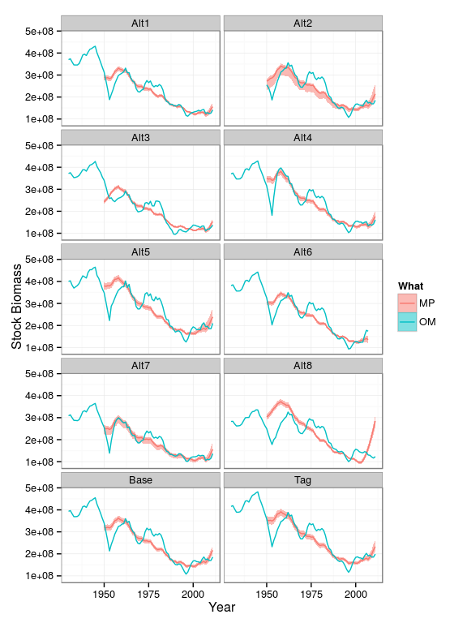

**Figure 4b** Stochastic comparison of biomass assessment in MP and OM, for p=1 and time series starting in 1950.

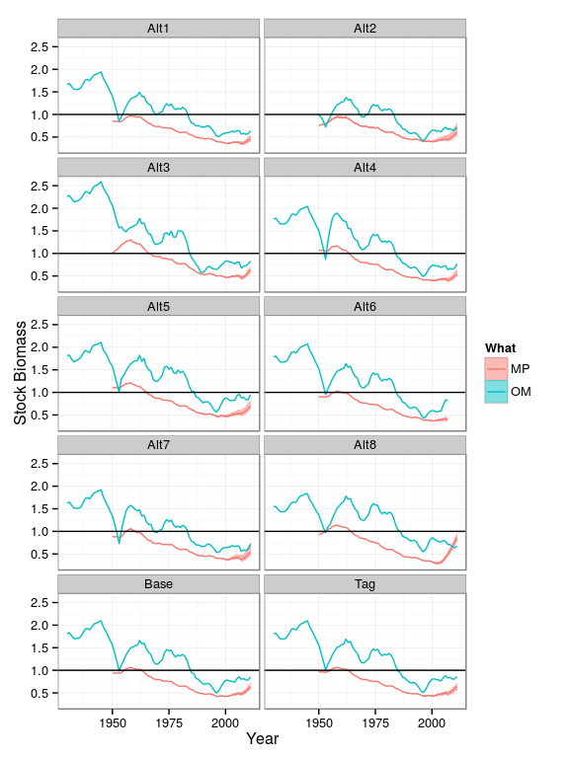

**Figure 4c** Stochastic comparison relative to BMSY of biomass assessment in MP and OM, for p=1 and time series starting in 1950.