**Specific Contract No. 8**

**Specific Contract on the Establishment of reference points and harvest control rules in the Framework of the International Commission for the Conservation of Atlantic Tunas (ICCAT)**

FRAMEWORK CONTRACT – MARE/2012/21 - Scientific advice for fisheries beyond EU waters

**Deliverable 4.1 (N-ALB)- Reference points and probabilities to be used for the ongoing MSE for North Atlantic albacore**

Introduction 2

Assessing the robustness of RPs and HCRs 3

1. Management objectives 3

2. Selection of hypotheses 4

a. Recruitment: 4

b. Biological parameters: 4

3. Operating Models 4

a. Models used in the latest Stock Assessment. 4

b. Projections with perfect knowledge and control 6

4. Management Procedure 8

a. Observation model 9

b. Stock Assessment method 9

c. Harvest Control Rules 10

5. Simulations with HCRs as feedback control 10

6. Summary and interpretation of results 11

**D4.1 - Reference points and probabilities to be used for the ongoing MSE for North Atlantic albacore**

## Introduction

In this deliverable we explore the impact that the establishment of pre-agreed Harvest Control Rules (HCR) would have on the North Atlantic albacore stock and fishery. In order to do this a Management Strategy Evaluation framework is being used, we describe the framework, including a description of the operating model and management procedures (SCRS/2013/33,34,35).

In the 2013 stock assessment of North Atlantic albacore, the stock was diagnosed as being overfished but not undergoing overfishing. A drop in stock biomass between 1930 and 2000 was followed by an increasing trend. During the assessment, the albacore working group recommended to further develop the MSE framework to permit a better characterization of uncertainty1.

During the assessment, a range of time-frames and probability levels of achieving the Commission’s goals established in Rec. 11-13 were also provided noting that longer time frames provide more options for choice of HCRs to achieve the commission objectuves, with a range of probabilities, of being in the green quadrant of the Kobe plot. These estimates were obtained using projections without feedback control, i.e. the impact of HCRs was investigated by projecting current status and parameters into the future for alternative values of Ftar, Blim and Bpa. In this deliverable we carry out a similar study but with feedback between Operating Models (OM) and the Management Procedure (MP) using the Management Strategy Evaluation framework (MSE) in order to assess the effects of the potential application of a series of HCR for the management of this stock. The feedback loop between the MP and the OMs is a fundamental aspect of MSE and is the particular feature which distinguishes MSE from risk assessments where the impact of alternative regulations are evaluated through projections2.

MSE involves using simulation to compare the relative effectiveness for achieving management objectives of different combinations of data collection schemes, methods of analysis and subsequent process leading management actions2, i.e. different MPs. Here, MSE is used to identify which of three alternative HCRs used in combination with a simple stock assessment method would allow achieving a series of conservation and fisheries performance objectives. For this, we use an MSE framework following a series of guidelines and best practices2,3, including the basic steps needed to be followed when conducting an MSE2:

1. Identification of **management objectives**: Here, we assume that the management objectives are inherent to ICCAT fisheries, i.e. to maintain the highest long-term average catch with a high probability of being in the green quadrant (the target) and a low probability of being outside biological limits (the limit)4.
2. **Selection of hypotheses** of system dynamics. A range of hypotheses concerning data, biological information, environmental impact or any other factor that may be considered a source of uncertainty in relation to system dynamics will be included in this section.
3. **Constructing OMs**: These provide a mathematical representation of the system that is being managed (fish and fisheries). The impact of the management measures decided through the HCRs in the MP will be evaluated in the OMs. In this study, the OMs are the alternative Mutifan-CL model runs and specifications that were used to provide diagnosis on stock status in the 2013 stock assessment5.
4. **Defining MPs**: A population-model-based framework within which the data obtained from the fishery are analysed and the current status, productivity and RPs of the fishery are estimated through a stock assessment model3. The outputs of this are fed into a HCR that, in combination with RPs, provides recommendation for management action. In this study, the MP is composed by an observation model that feeds a surplus production model, MSY-based RPs and three alternative HCRs that represent different views towards fisheries management. The combination between the estimator (stock assessment model) and HCR provides the feedback between MP and OM, here assumed to happen every three years.
5. **Simulation** of the application of each of the HCRs and the surplus production model to manage the complex “true” dynamics represented by the OMs. In other words, if the “true” system was represented by the dynamics of the OMs, how efficient would be a fisheries management system (composed by a non-perfect observation scheme, a surplus production model and a set of HCRs) to achieve the management objectives of ICCAT.
6. **Summary and interpretation** of performance statistics: In this study, we use two conservation indicators (Sustainability and Safety) and three fisheries performance indicators (Catch, interannual variability of catch and interannual variability of effort). The candidate HCRs (and MP) providing the best trade-off between conservation and fisheries performance is selected as the most appropriate3.

Each one of the components of a generic MSE framework and their use in this study are explained in detail throughout this document.

## Assessing the robustness of RPs and HCRs

### Management objectives

Fisheries management needs to be supported by clear objectives to be expressed by policy makers through a specific decision-making process6. The overall management intention in ICCAT is to maintain the highest long-term average catch with a high probability of being in the green quadrant (the target) and a low probability of being outside biological limits (the limit)4. In the 5th session of IOTC’s working group on methods, a series of management objectives and performance statistics are suggested for the evaluation of management procedures:

1. Stock status: maximize probability of maintaining stock in the green zone of the Kobe plot.
2. Safety: maximize the probability of the stock remaining above the biomass limit.
3. Catch: maximize catches across regions and gears.
4. Abundance: maximize catch rates to enhance fishery profitability.
5. Stability: maximize stability in catches to reduce commercial uncertainty.

These objectives can be used by ICCAT managers for guidance and their preferred objectives and indicators can be incorporated in the MSE framework developed in this study. However, as a first step, we have chosen a set of objectives and indicators of performance to evaluate how MPs perform:

1. Stock:
   1. Sustainability: maximize probability of being in the green zone.
   2. Safety: maximize probability of the stock being above the BLRP.
2. Fisheries:
   1. Annual average catch after 20 years.
   2. Interannual variability of catch.
   3. Interannual variability of effort.

All the above can be re-designed or modified by other indicators at the request of managers.

### Selection of hypotheses

1. Recruitment: Alternative hypotheses on the biological characteristics of this stock, including stock recruitment parameters and the existence of regime shifts can be explored within this framework. However, to the moment, we consider that the relation between spawning stock biomass and recruitment of North Atlantic albacore has not undergone through any regime shift. This hypothesis can be re-evaluated in the future.
2. Biological parameters:The biological parameters used in this study are the same used in the latest stock assessment of this species1.

### Operating Models

Operating Models are representations of the “true” dynamics of the system and may include a set of most plausible hypotheses or unlikely but not impossible situations4. In MSE frameworks the OMs are the system that has to be managed through MPs, i.e. the “true” system, that is observed, analysed and managed through data collection systems, stock assessment models and a decision making process. The capacity of alternative components of the MP to manage the system described by OMs is evaluated through MSE frameworks. The OMs in this study are set ups of the age structured model used in the assessment of this stock.

#### Models used in the latest Stock Assessment.

In the latest SA, the stock status of North Atlantic albacore was provided using Multifan-CL, a size structured model that was built using catch and standardized catch per unit of effort series. Their results were used to condition the OMs used in this MSE framework. The alternative Multifan-CL runs were alternative combinations of abundance indexes used, hypotheses on fish growth parameters and the inclusion of tagging information. The conditioned OMs using the output from the 10 runs of Multifan-CL are shown in Figure 1.

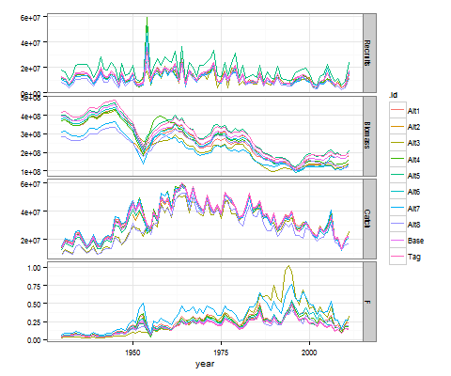

Figure 1. Operating Models for North Atlantic albacore: Recruits, Biomass (kg), Catch (kg) and Fishing mortality (F).

The 10 OMs have their production functions that can be used to estimate a series of potential RPs:

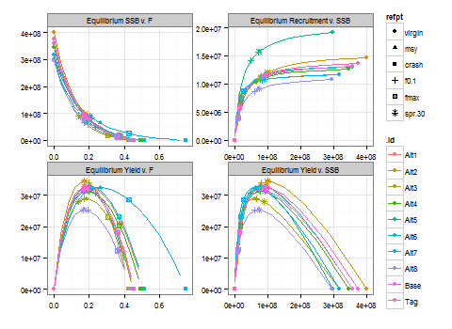

Figure 2. Equilibrium states of the OMs used for North Atlantic albacore and RPs. SSB is Spawning Stock Biomass (kg), Fishing mortality (F) and Recruitment.

#### Projections with perfect knowledge and control

The operating models can be projected into the future with different levels of fishing mortality or catch. In this case, we project forward the OM conditioned with the results of the Base case run of the Multifan-CL scenario in the 2013 stock assessment for different levels of F. For example, Fig 3 shows the Base case OM projected into the future with a constant FMSY.

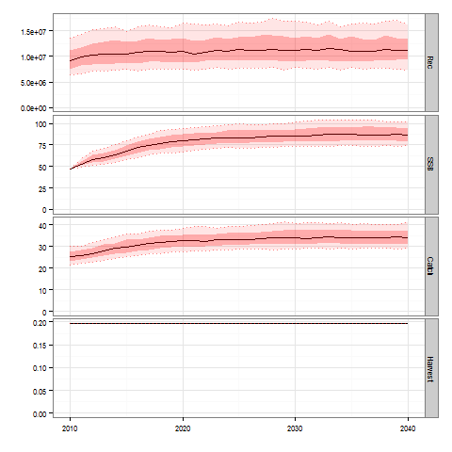

Figure 3. Projection of Base OM to 2040 using FMSY. SSB is spawning stock biomass and catch (th tonnes), harvest rate is F.

Figure 3 represents what would be the dynamics of this fishery if we had perfect knowledge and perfect control on the fishing mortality applied to the system. In this case, the “true” system would be fluctuating around the MSY RP, due to the recruitment variability considered (CV=0.3), and the probability of being in the green quadrant of the Kobe plot would be 0.25. Figure 4 shows the different probability of being the in the green zone for the Base OM projection with different levels of F, expressed as fractions of FMSY, and the average annual catch that would be fished by the end of the projection (in 2040). This figure is interesting because it shows the trade-off between conservation and exploitation management objectives in the hypothetical situation where we had perfect knowledge and control of the system, the trajectory shows the best we can achieve for a system that is described by the Base OM. Figure 4 shows that in the absence of fishing, with the variability considered in our OM, the probability of the stock being in the green zone is 1. As soon as we increase our F, the average annual catch also increases quickly but without reducing the probability of being in the green zone significantly. When the F is around 0.7, catch starts to reduce its increasing trend and at higher levels of F, the probability of being in the green zone decreases sharply. At FMSY, as expected, the probability of being in the green zone is 25%, the fishery would be fluctuating around the centre of the Kobe diagram, with 50% probability of B>BMSY and another 50% of being at F<FMSY. According to this, probabilities of 80-90% of the stock being kept in the green zone can be combined with levels of catch slightly lower than MSY.

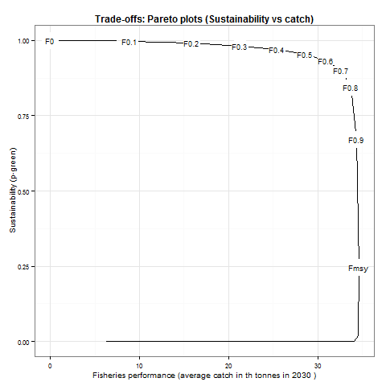

Figure 4. Pareto frontiers calculated by projecting one OM(Base) in a 30 year simulation. The trajectory drawn describes the best possible trade-off between two management objectives (p-Green and Catch) for a series of Ftargets, expressed as fractions of FMSY, i.e. F0.2 is 0.2xFMSY.

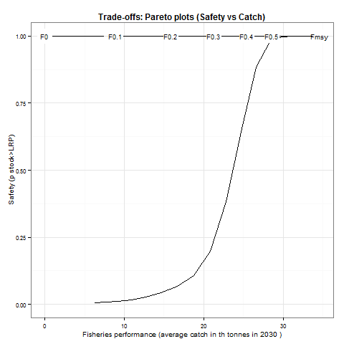

Figure 5. Pareto frontiers calculated by projecting one OM(Base) in a 30 year simulation. The trajectory drawn describes the best possible trade-off between management objectives (pB>BLRP and Catch) for a series of Ftargets. BLRP is 0.4xBMSY.

Figure 5 shows the expected probability of the stock being within safe limits (B>BLRP) and average annual catch in 2040. As it is seen, the stock is within safe limits for fishing mortality levels equal or below FMSY with a 100% probability, with the recruitment variability used in this study.

However, it is important to stress that this is a projection, assuming perfect control and perfect knowledge of the system, which is far from what is expected from the understanding and management of any natural resource. These figures do not include any loop feedback between the MP. In the MSE developed in the following, we will evaluate how a simpler stock assessment model, in combination with a series of HCRs could be effective in driving the system, the Base OM, to the desired situation of high catch and high probability of being in the green zone and low probability of being below BLRP.

### Management Procedure

Management Procedure models represent how the true dynamics underlying fisheries exploitation are represented through stock assessment and controlled through fisheries management. A candidate MP is the framework within data from the fishery, the “true” fishery or OM, are obtained, analysed through a stock assessment model to estimate the current status of the fishery. Related outputs are then fed into a HCR to provide recommendation and management action3. In this MSE framework, these four components are automatized, i.e., an observation model collects information from the OM (catch and cpue), with an observation error, these series feed a stock assessment model and output RPs and stock status, which in combination with HCRs produces recommended quotas, which are fed back to the OM. The four components are explained in detail in this section:

#### Observation model

Eight different indexes of CPUE were used in this stock’s assessment. GAM were used to standardize these and used to fit a surplus production model. A detailed analysis of these cpue series is provided in two ICCAT technical papers7,8. A comprehensive observation model, which translates the biomass trajectory from the OM to the MP with an error is yet to be developed. In the current set up of this MSE framework, we assume that the cpue series that will fit the stock assessment model is proportional to the biomass of the OM multiplied by a log normal error, which was considered to be 0.2, i.e. cpueobs,t=stock(OMt)*LN(1, 0.2). This model is expected to be further developed during the next stages of this project.

#### Stock Assessment method

The SA model used in the MP of the MSE is a surplus production model. This model was not capable of estimating the significant peaks estimated by the Multifan-CL model at the beginning of the time series and therefore, we fitted the surplus production model to the biomass index of the OM since 1975. Figure xx shows how the 10 OMs trajectories (black) are reproduced by the simpler surplus production model (red).

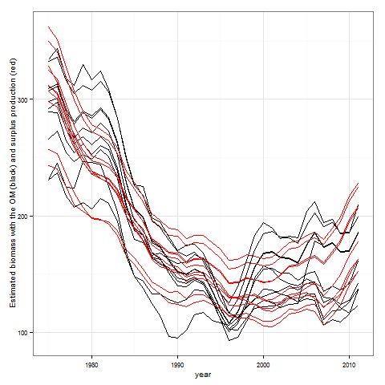

#### Harvest Control Rules

### Simulations with HCRs as feedback control

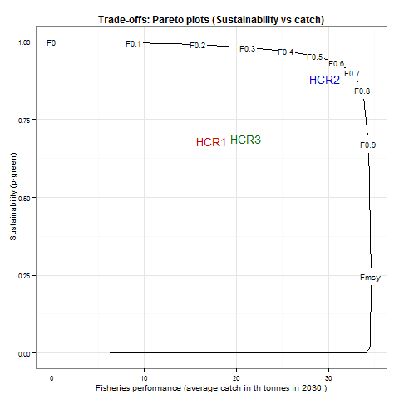

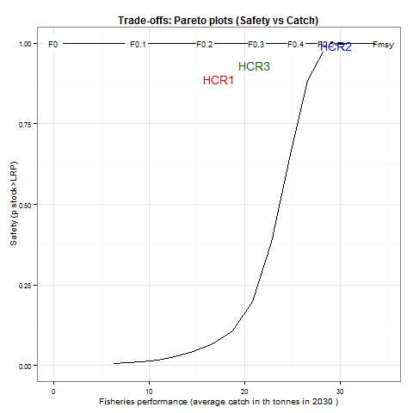

### Summary and interpretation of results

A series of performance indicators allow assessing if ICCAT’s objectives are achieved:

1. Sustainability: Probability of being in the green zone of the Kobe diagram. In order to achieve management objectives, this probability will be high.
2. Safety: Probability of biomass being above the biological LRP, i.e. p(B > Blim).
3. Fisheries performance:
   1. Discounted catch (5%). Discounted average catch expected from the fishery.
   2. Stability of catch: 1-3 iaav Catch. (iaav=interannual variability)
   3. Stability of fishing effort: 1-3 iaav Effort.

**More bullet points**

In summary, Management Strategies include monitoring, stock assessment, harvest control rules, reference points and management actions. Currently, ICCAT is making substantial progress to identify and test the key elements of management strategies, such as reference points (target and limit) and harvest control rules4. We have reviewed the current status of these elements into the decision making process by ICCAT, especially for a set of stocks of priority for DG-Mare. In particular, we report on the most recent developments in the simulation based Management Strategy Evaluation framework developed for Northern albacore (and…) which we expect will facilitate European Commissions participation in the subsequent meetings of the Standing Working Group between Scientists and Managers created in ICCAT.

to evaluate the impact of the main sources of uncertainty inherent to the system being managed and alternative options for TRP, LRP and HCR and the required probabilities of TRP to be achieved and LRP to be avoided. It has been recognized that MSE helps identify management strategies that are robust to uncertainties in the stock assessment.

Within this process, managers and stakeholders should provide guidance on terms such as acceptable time lines and probability levels.

The quantification of the **high probability** and the period considered **as short as possible** will be based on stakeholders’ criteria.

Antonio Cervantes en la reunion de Diálogo de Barcelona: “In this context, the different scenarios derived from the use of MSY as either a limit or as a target reference point as well as the probability levels that should be associated to them were explained”.

*From ICCAT 2012. Report for Biennial Period 2010-11, Part II, vol II.*

During this project we will review the structure of the Management Procedures currently used in ICCAT, which include reference points (RP) and stock assessment models (SA), and the potential impact of using predefined rules of action or Harvest Control Rules (HCR) applied for alternative reference points estimated with alternative SA models. In the default sets, MSY benchmarks are used to assess the state of exploitation of fish stocks, which are re-estimated from the SA models each time these are re-run in simulated stock assessment sessions. To do this, in the first part of this work we review the RPs currently in use in ICCAT and the SA models. Thereafter, we evaluate the impact of alternative HCRs, used in combination of a set of SA models to achieve management objectives of conservation, production and stability with high probability. Finally, we will recommend combinations of models, reference points and HCRs for the management of specific stocks within ICCAT.

REFERENCES

1 ICCAT. Report of the 2013 ICCAT North and South Atlantic albacore stock assessment meeting, Sukarrieta (Spain), 114pp. (2013).

2 Punt, A., Butterworth, D. D. S., de Moor, C. L., De Olveira, A. A. & Haddon, M. Management strategy evaluation: best practices. *Fish and Fisheries*, doi:10.1111/faf.12104 (2014).

3 Rademayer, R. A., Plaganyi, E. E. & Butterworth, D. S. Tips and tricks in designing management procedures. *ICES Journal of Marine Science* **64**, 618-625 (2007).

4 ISSF. Report of the 2013 ISSF Stock Assessment Workshop: Harvest Control Rules and Reference Points for Tuna RFMOs. ISSF Technical Report 2013-03. International Seafood Sustainability Foundation, Washington, D.C., USA. (2013).

5 Kell, L. *et al.* An example of conditioning an Operating Model using Multifan-CL. ICCAT, SCRS/2013/34 Technical Paper. (2013).

6 ICCAT. First meeting of the Standing Working Group to Enhance Dialogue Between Fisheries Scientists and Managers (SWGSM), Barcelona (Spain), 26-28 May. (2014).

7 Merino, G., De Bruyn, P., Kell, L. & Scott, G. A preliminary stock assessment of the albacore tuna (Thunnus alalunga) stock in the Northern Atlantic Ocean using a non-equilibrium production model. ICCAT, SCRS/2013/56 Technical Paper. (2013).

8 Merino, G., De Bruyn, P., Kell, L. & Arrizabalaga, H. A preliminary stock assessment for Northern albacore using the fully integrated stock assessment model, Multifan-CL. ICCAT, SCRS/2013/58 Technical Paper. (2013).