**CONDITIONING AN OPERATING MODEL FOR NORTH ATLANTIC ALBACORE.**

Laurence Kell[1], Haritz Arrizabalaga[2], Gorka Merino2 and Paul De Bruyn1

*SUMMARY*

*When conducting a Management Strategy Evaluation a major step is to condition an Operating Model, that represents the simulated versions of reality, on data and knowledge for a range of hypotheses about resource dynamics. There are many alternative ways to do this. One way is to use the current stock assessment model. In this paper we summarise an Operating Model developed for North Atlantic albacore conditioned using Multifan-CL. It was found that variability in recruitment drove fluctuations in productivity and that FMSY was not a good index of the productivity of the stock. Also that the production function was asymmetric, i.e. BMSY<50% B0*

*KEYWORDS*

*Albacore, Conditioning, Management Strategy Evaluation, Operating Model, Stock Assessment, Multifan-CL*

# Introduction

When conducting a Management Strategy Evaluation it is necessary to condition an Operating Model (OM), that represents the simulated version of reality, on data and knowledge, for a range of hypotheses about resource dynamics. There are many alternative ways to do this. One way is to use the current stock assessment model. Although use of the assessment model as the OM seems to imply that assessment models describe nature almost perfectly, if a Management Procedure (MP) cannot perform well when reality is as simple as implied by an assessment model, it is unlikely to perform adequately for more realistic representations of uncertainty about resource dynamics. Basing an OM on the current assessment model also has arguably the lowest demands for knowledge and data.

In this paper we describe the development of an OM for North Atlantic albacore based on the integrated stock assessment model Multifan-CL (Fournier et al., 1998). An OM is a mathematical statistical model used to describe the actual resource dynamics in simulation trials and to generate resource monitoring data when projecting forward to simulation test a MP. Where a MP is a combination of pre-defined data, together with an algorithm to which such data are input to provide a value for a TAC or effort control measure.

Conducting a Management Strategy Evaluation (MSE) requires six steps (after Punt and Donovan,2007); namely i) identification of management objectives; ii) selection of hypotheses for the OM; iii) conditioning the OM based on data and knowledge, and possible weighting and rejection of hypotheses; iv) identifying candidate management strategies; v) running the Management Procedure (MP) as a feedback control in order to simulate the long-term impact of management; and then vi) identifying the MPs that robustly meet management objectives.

Developing the OM is mainly concerned with steps ii and iii; and there are many alternative ways to condition an OM (see Kell et al., 2006). As pointed out by Kolody et al. (2009) the stock assessment process often appears to involve a haphazard search for a few model specifications which appear to be plausible, consistent with the data, and a priori expectations. In a stock assessment, the objective is often to find a ‘best‘ model, while when conditioning an OM the objective is to characterise what we don’t know about resource dynamics. Therefore when conditioning an OM, generally many scenarios need to be run.

# Material and Methods

***Methods***

*Operating Model*

When fitting assessment models, there is often insufficient contrast in the data to estimate parameters for important population processes (e.g. Lee et al., 2012, 2011; Pepin, 2015). Different data sets (e.g. CPUE, catch and length distributions) may show conflicting signals. Therefore, a variety of scenarios need to be run to reflect scepticism about the capacity of the model to estimate key parameters. Scenarios are generally developed by evaluating the effect of fixing some parameters, assuming alternative functional forms for processes, or by down weighting datasets (e.g. SCRS/2016/014).

In the last North Atlantic Multifan-CL assessment (Anon. 2014), 10 scenarios were considered (**Table 1**). The scenarios investigated the impact of the different datasets (size frequency and CPUEs), changing the start and end dates of the model, incorporating tagging data and alternative natural mortality (M) vectors.

***Analysis***

Firstly, the estimated time series and reference points are summarised and then the dynamics are discussed.

# Results

***Time Series***

Time series of recruits, SSB, biomass, Fbar , Fapex, harvest rate and catch are shown by scenario in **Figure 1**. In general, trends are similar across scenarios and quantities. The main differences are seen between the alternative methods used for calculating exploitation; Fapex (the highest F by age as used by the SCRS) is much more variable than using Fbar (the mean F across reference ages as used by ICES).

***Stock Recruitment Relationship***

A Beverton and Holt stock recruitment relationship (Beverton and Holt, 1993) was fitted to the recruit and SSB time series. The fit to the Base Case and a suite of diagnostics based on the residuals are shown in **Figure 2**; each plot type is then repeated for all scenarios as a separate figure.

The fits are shown in **Figure 3**; there is little evidence for a reduction in recruitment as population size declines. Recruitment quickly saturates as spawning stock biomass (S) increases due to strong density dependence (i.e. compensatory dynamics).

Next, the residuals (on the log scale) are plotted to check for systematic patterns that may suggest that assumptions may be violated. The residuals are plotted against SSB in **Figure 4** to check for evidence that the Beverton and Holt stock recruitment relationship may not be appropriate, and against year in **Figure 5** to check for stationarity. Recruitment appears to be highest at medium biomass levels, which could suggest over compensation, however, the plots of residuals against year suggest that there may be a year effect as expected recruitment was higher in the 1960s. It is therefore difficult to say whether recruitment is driven by SSB or environmental factors.

The residuals are plotted against the fitted values to check the variance function (**Figure 6**); there is a suggestion that variance may increase with recruitment, i.e. that assuming a log normal error structure may not be appropriate. Therefore quantile-quantile plots are shown in **Figure 7** to check the assumed error model. To check for autocorrelation, residuals are plotted with a lag of 1 in **Figure 8**. The residuals appear to be log normally distributed (as they lie along the y=x line) while the regression of residualt+1 against residualt has a slope close to 0 and so there is no significant auto-correlation.

***Production Functions***

The assumed biological parameters and the estimated selection patterns are plotted in **Figure 9**; these were combined with the stock recruitment relationships to derive age based equilibrium production curves **Figure 10**. The age based production function for the Base Case is compared with the corresponding Pella-Tomlinson production function, and the stock/yield trajectory, in **Figure 11**. The curves of the two production functions are very similar, although population growth rate at small population sizes is slightly underestimated by the biomass function. A simulation was conducted using the biomass production function equivalent to that of the Base Case in **Figure 12**; harvest rate is capped at 0.3. The estimated production is insufficient to explain the catch as the population decreases so the stock collapses. This is partly due to the large amount of process error, modelled as recruitment variation in Multifan-CL, in the age based model that is ignored by the biomass production function.

***Stationarity***

Variability in the time series of recruitment (**Figure 13**) and production (**Figure 14**) is evaluated using a sequential t-test algorithm for regime shifts (the STARS algorithm Rodionov, 2004). The boxes show the means and ±1 standard deviations. For recruitment there appears to be three regimes, with recruitment higher and more variable in the middle period. Surplus production is far more variable than recruitment and is driven mainly by strong year classes.

Absolute of estimates, quantities, population parameters and reference points are plotted in **Figures 16** and relative time series are plotted in **Figures 16**. Variability between scenarios is greatest for the absolute estimates, and low for the relative values. The biggest variability across time is seen for FMSY, due to mixing exploitation level and selectivity. In contrast the production function parameters (r, k and p) derived from the age based production function do not change much.

The expected values of surplus production as estimated by the age based model are shown in **Figure** **17** (red is the production function with time varying selectivity and recruitment, and black is assuming only time varying recruitment), points are the values by year. The production function is estimated using a moving average (using a 5 year window) for selection pattern and recruitment. Including time varying selection has little effect.

The distributions of the estimates of annual surplus production are plotted in **Figures 18** and **19**. The latter figure plots the residuals (i.e. observed-expected) and there appears to be a positive bias.

***Stock Status***

Harvest rate relative to FMSY is plotted in **Figure 20** and stock biomass relative to BMSY in **Figure 21,**  by scenario. Kobe Phase Plots are shown in **Figure 22** with the 2011 status indicated by the blue point.

***Power Spectra***

For each OM scenario three levels of fishing mortality (FMSY times 0.1, 1 and 2), recruitment, SSB, yield, stock biomass, juvenile biomass and surplus production and their power spectra are plotted in **Figures 23, 24, 25, 26, 27 and 28**. The spectral analysis shows even though recruitment is a sequence of serially uncorrelated random variables with zero mean and finite variance (white noise) the time series of SSB, yield, stock biomass and juvenile biomass are dominated by low frequencies (i.e. long-term variations). This results from the propagation of stochastic recruitment into the age-classes and leads to a smoothing of the SSB (i.e. cohort resonant effects). Productivity in comparison is dominated by medium frequencies, presumably due to the transient effect of a large recruitment.

**Discussion**

The scenarios all showed similar trends and estimates of current stock status, production functions and reference points. The dynamics of the time series are also similar, and are driven by variations in recruitment.

Although there was no auto-correlation in the recruitment deviates, there is evidence for changes in the mean level of recruitment and large recruitments cause an increase in surplus production. Process error in Multifan-CL is modelled as random recruitment. This translates into changes in surplus production and long-term fluctuations in biomass and catches. This will have consequences for the MP, e.g. since catches may be driven by process error rather than the expected production.

Using the stock assessment as the OM helps in ensuring estimates of historical and current stock status are consistent with recent advice. Which in turn makes it easier to make the transition from the Kobe Framework (Kell et al., 2015) based on showing alternative management options to the use of a HCR. Choices still have to be made, however, about simulation of uncertainty into the future and around current status.

# References

R. Beverton and S. Holt. On the dynamics of exploited fish populations, volume 11. Springer, 1993.

D. A. Fournier, J. Hampton, and J. R. Sibert. MULTIFAN-CL: a length-based, age-structured model for fisheries stock assessment, with application to south pacific albacore, thunnus alalunga. Canadian Journal of Fisheries and Aquatic Sciences, 55(9):2105–2116, 1998.

L. Kell, J. A. De Oliveira, A. E. Punt, M. K. McAllister, and S. Kuikka. Operational management procedures: an introduction to the use of evaluation frameworks. Developments in Aquaculture and Fisheries Science, 36:379–407, 2006.

L. Kell, D. C. Levontin, P., S. Harley, D. Kolody, M. Maunder, I. Mosqueira, G. Pilling, and R. Sharma. Fisheries management science: an introduction to simulation based methods. In C. Edwards and D. Dankel, editors, Fisheries management science: an introduction to simulation based methods. 2015.

D. Kolody, M. Herrera, and J. Million. 2009 indian ocean skipjack tuna stock assessment (stock synthesis). Technical report, IOTC-2011-WPTT-14 (Rev1), 2009.

A. Punt and G. Donovan. Developing management procedures that are robust to uncertainty: lessons from the International Whaling Commission. ICES Journal of Marine Science: Journal du Conseil, 64(4):603–612, 2007.

S. N. Rodionov. A sequential algorithm for testing climate regime shifts. Geophysical Research Letters, 31(9), 2004.

# **Figures**

1. **Figure 1.** Time series of recruits, SSB, biomass, , , harvest rate and catch by OM scenario.

## Stock Recruitment Relationship

1. 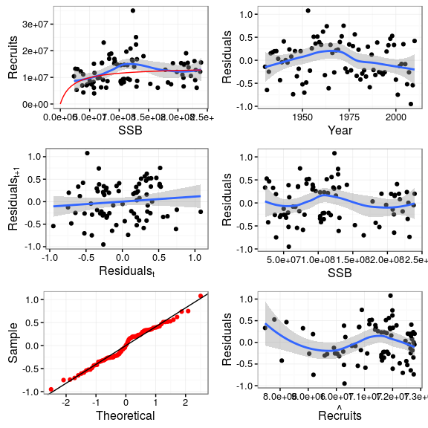
2. **Figure 2.** Stock recruitment fit with diagnostics for the Base Case.
3. 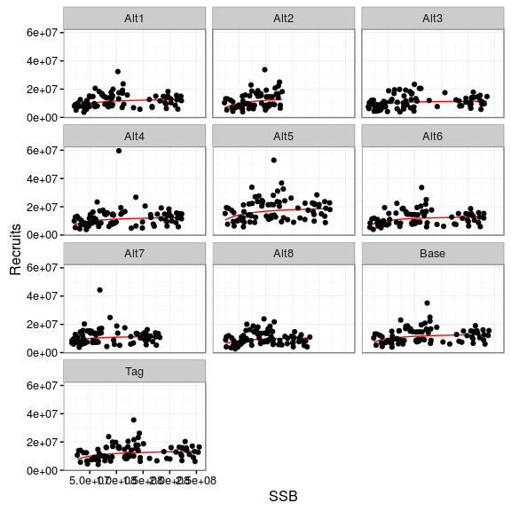
4. **Figure 3.** Stock recruitment fits to observations by scenario.
5. 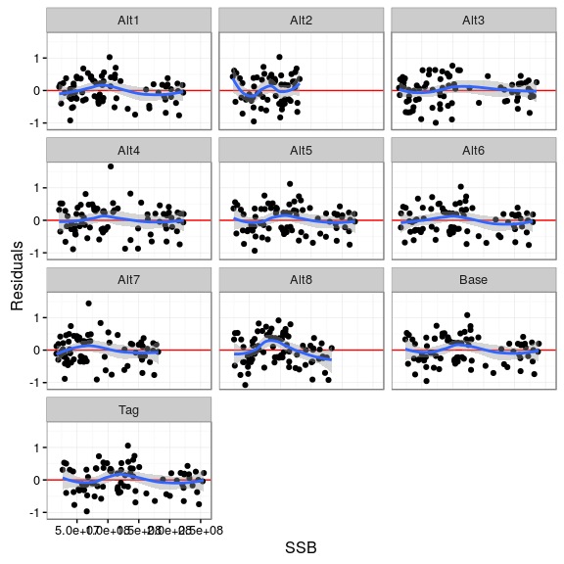
6. **Figure 4.** Residuals plotted against SSB by scenario to check for systematic patterns.
7. 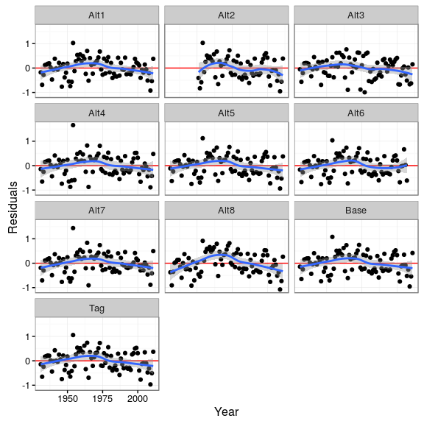
8. **Figure 5.** Residuals plotted against year by scenario to check for systematic patterns.
9. 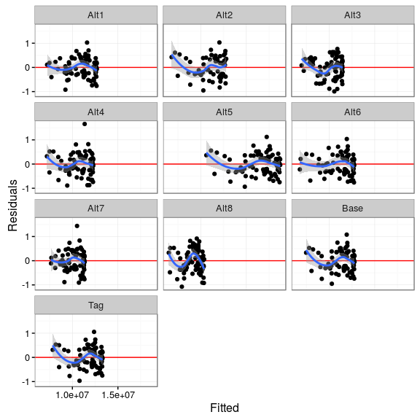
10. **Figure 6.** Residuals plotted against fitted by scenario to check variance function.
11. 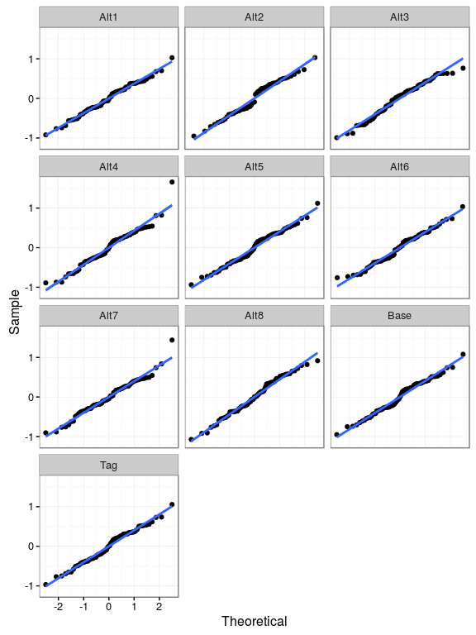
12. **Figure 7.** Quantile-quantile plot by scenario to check error model.
13. 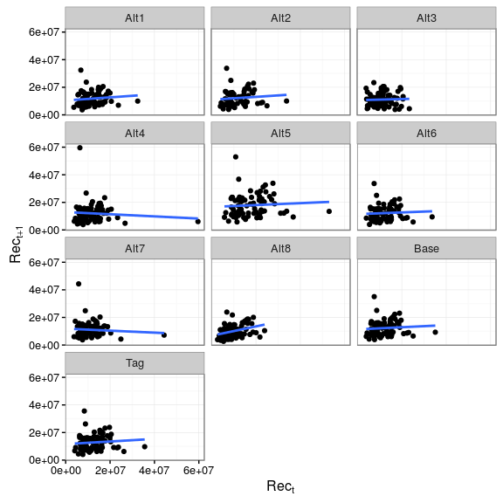
14. **Figure 8.** Plot of lagged recruitment residuals by scenario to check auto-correlation.

## 

1. **Figure 9.** Biological parameters by scenario.

## 

1. **Figure 10.** Equilibrium curves derived from stock recruitment relationships and per recruit analysis.
2. 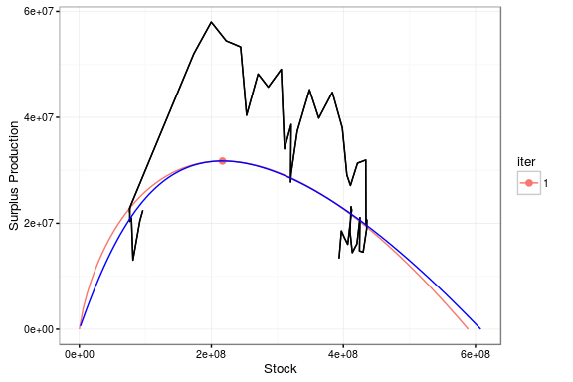
3. **Figure 11.** Comparison of age (red) and biomass (blue) based production functions for the Base Case; the track is the estimated stock yield trajectory.
4. 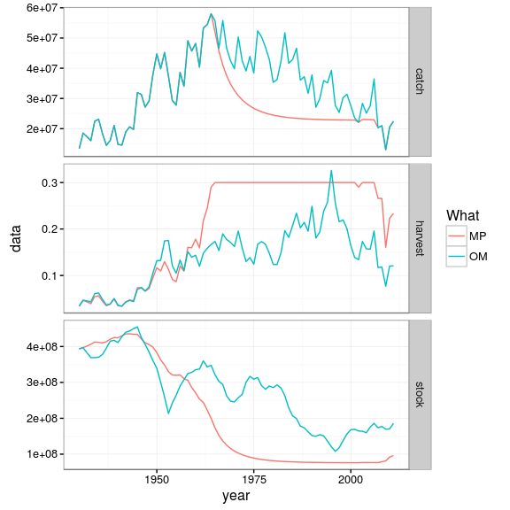
5. **Figure 12.** Simulation of a biomass production function with parameters equivalent to the Base Case OM; harvest rate capped at 0.3.
6. 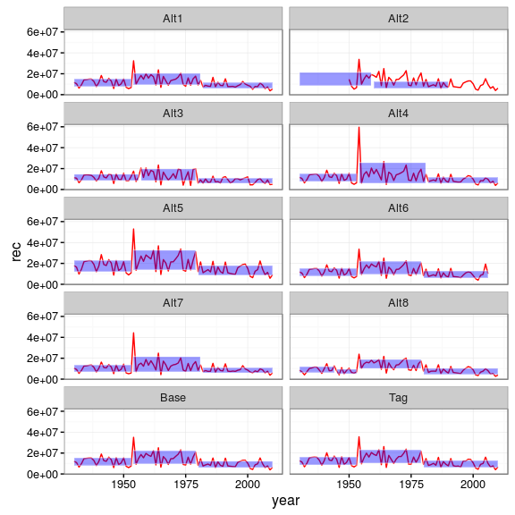
7. **Figure 13.** Time series of recruitment by scenario, with means and standard deviations as estimated by the STARS algorithm.
8. 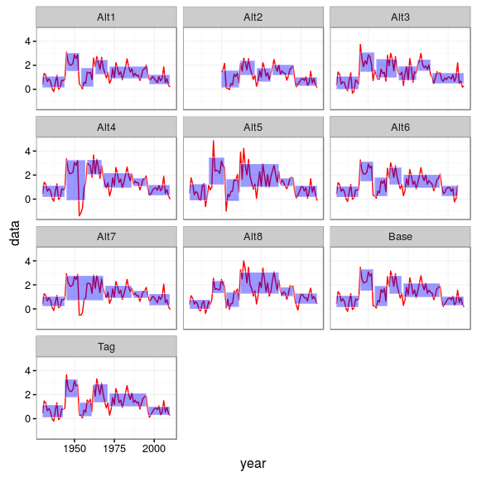
9. **Figure 14.** Time series of production by scenario, with means and standard deviations as estimated by the STARS algorithm.
10. 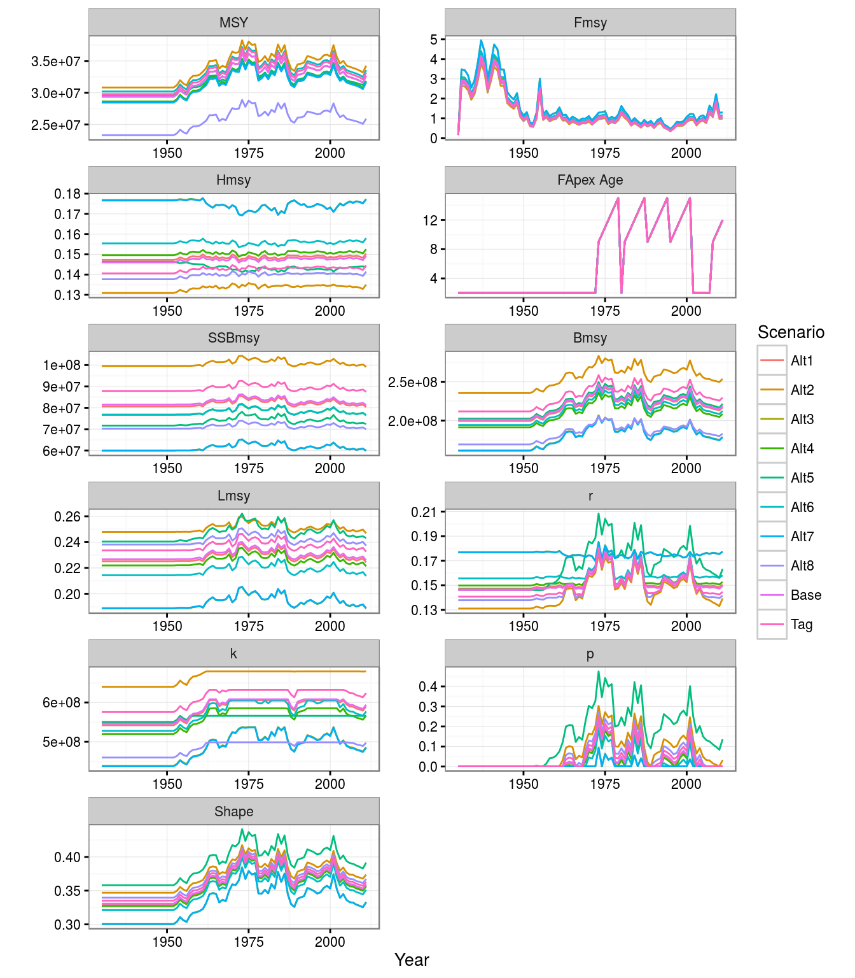
11. **Figure 15.** Time series of derive quantities, population parameters and reference points for all scenarios.
12. 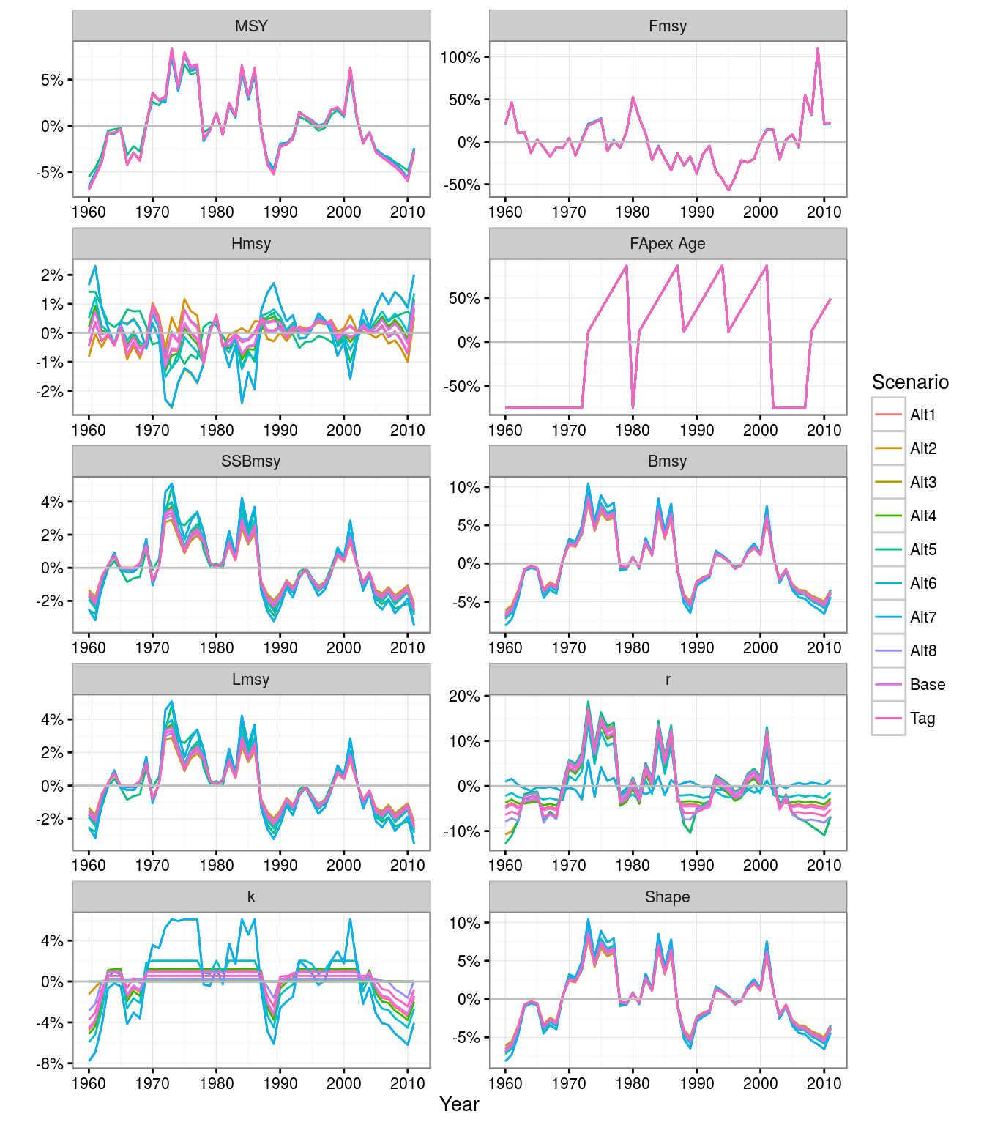
13. **Figure 16.** Time series scaled by means within a scenario of derive quantities, population parameters and reference points.
14. 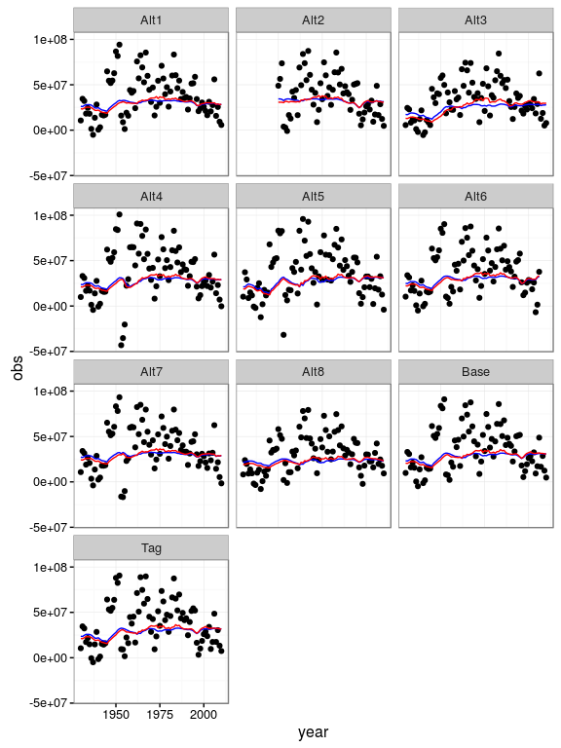
15. **Figure 17.** Surplus production as estimated by age based model, lines are expected values, red is the production function allowing for change in selection pattern.
16. 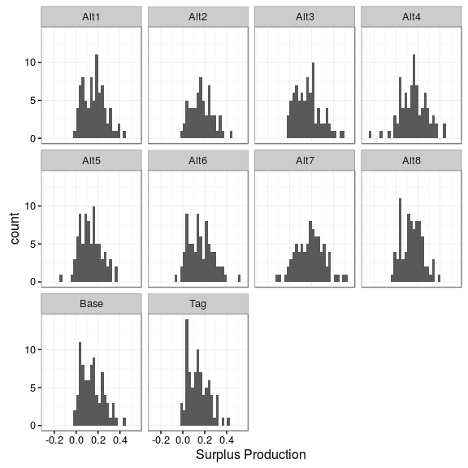
17. **Figure 18.** Conditional population growth rate distributions by scenario.
18. 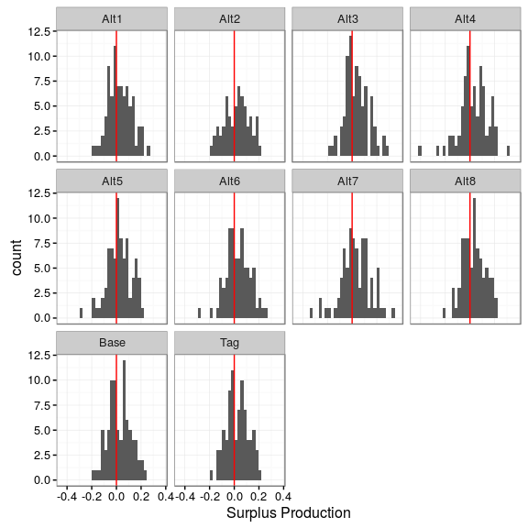
19. **Figure 19.** Conditional population growth rate residuals (observed-expected) by scenario.
20. 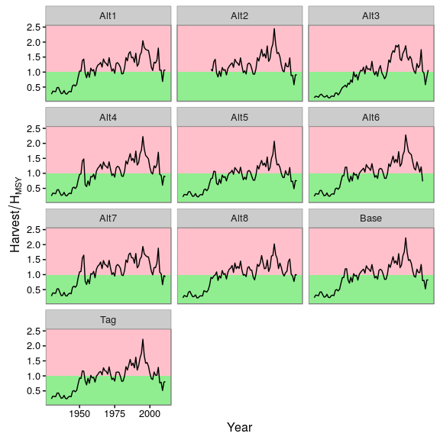
21. **Figure 20.** Harvest rate relative to by scenario.
22. 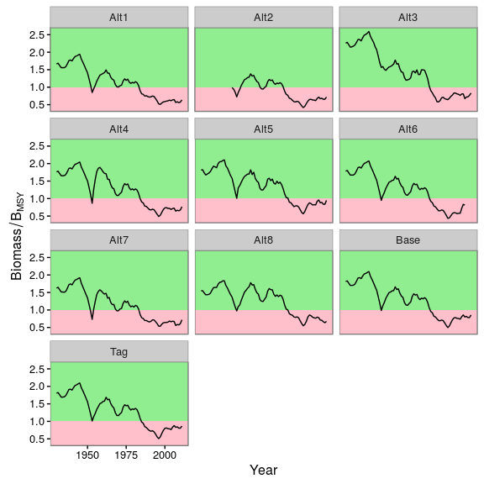
23. **Figure 21.** Stock biomass relative to by scenario.
24. 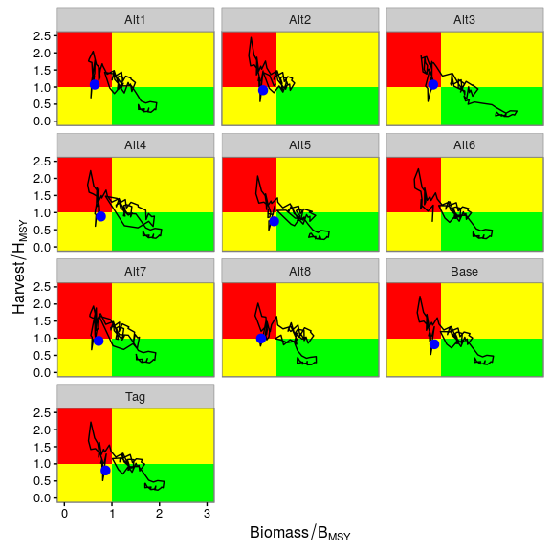
25. **Figure 22.** Kobe Phase Plots, with 2011 status (blue point) by scenario
26. 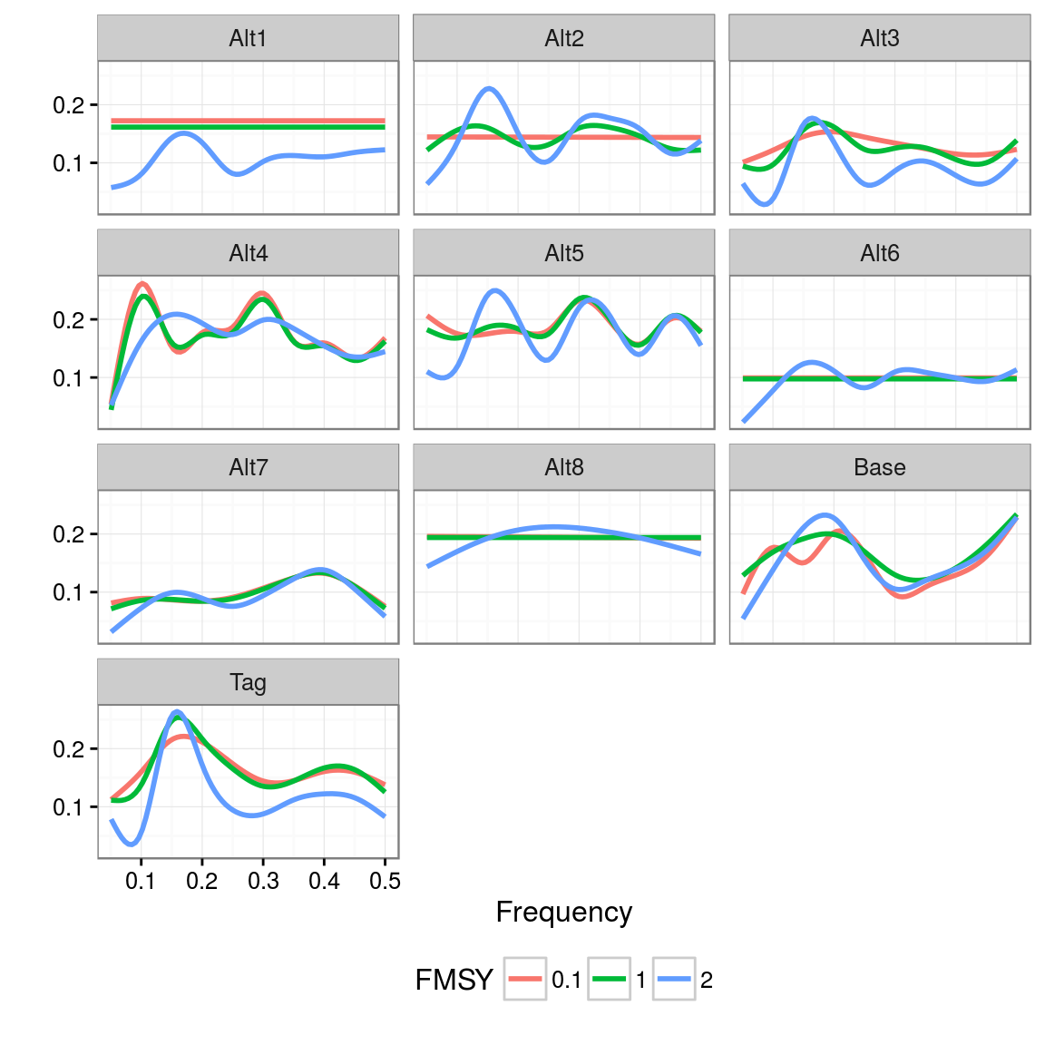
27. **Figure 23.** Power spectra of recruitment; simulations for eachOperating Model scenario and three levels of fishing mortality ( times 0.1, 1 and 2).
28. 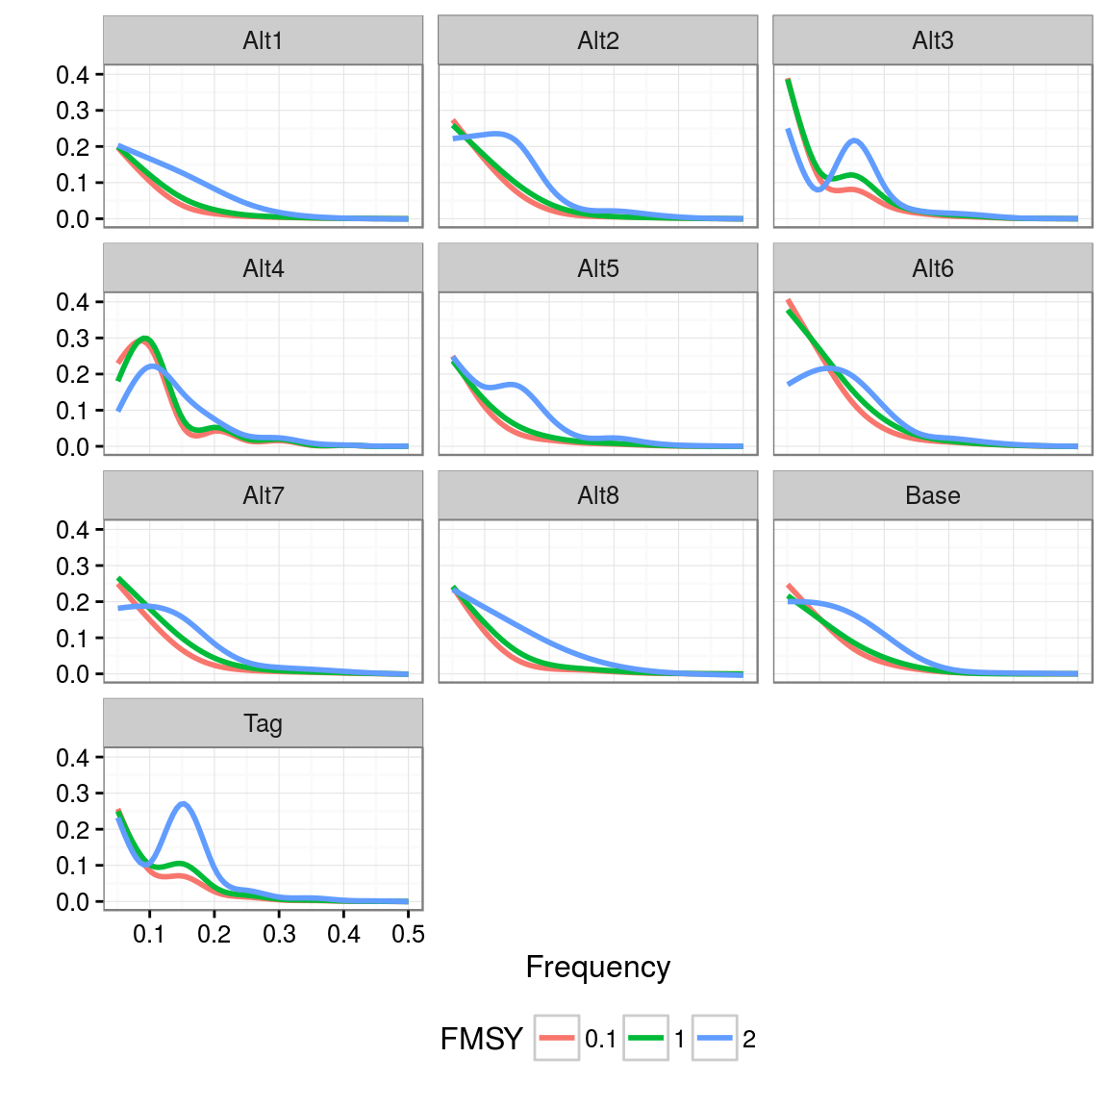
29. **Figure 24.** Power spectra of SSB; simulations for each Operating Model scenario and three levels of fishing mortality ( times 0.1, 1 and 2).
30. 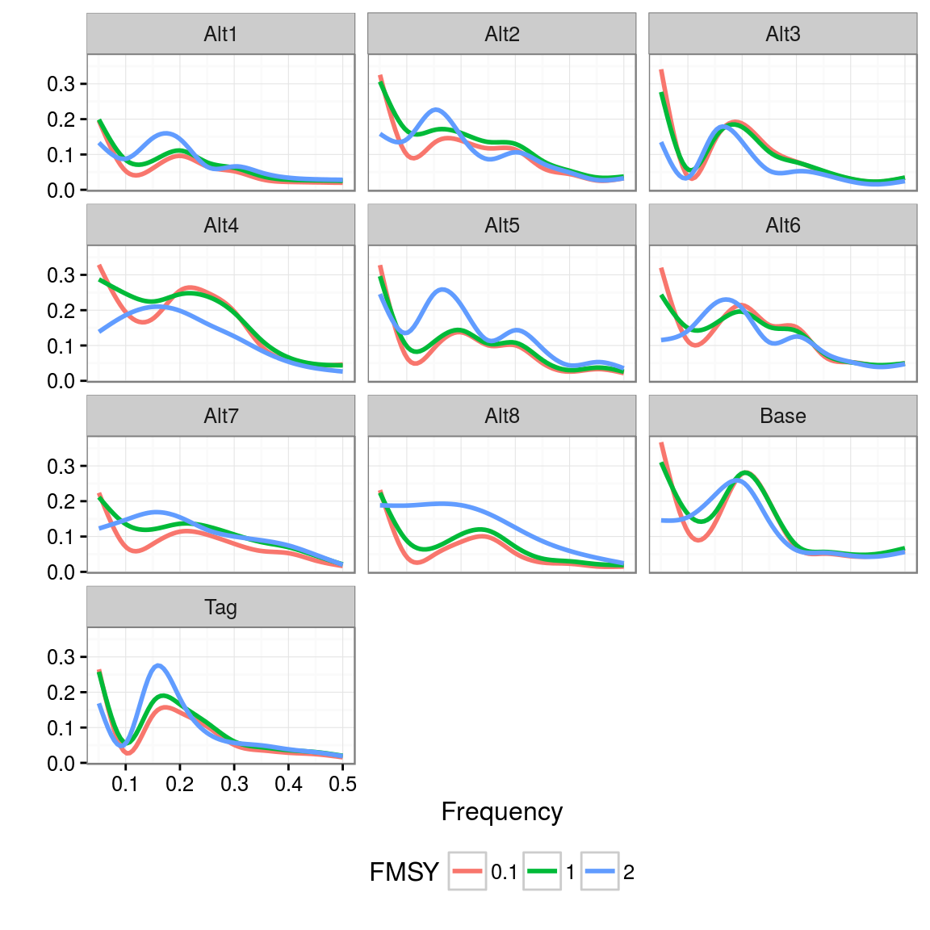
31. **Figure 25.** Power spectra of yield; simulations for each Operating Model scenario and three levels of fishing mortality ( times 0.1, 1 and 2).
32. 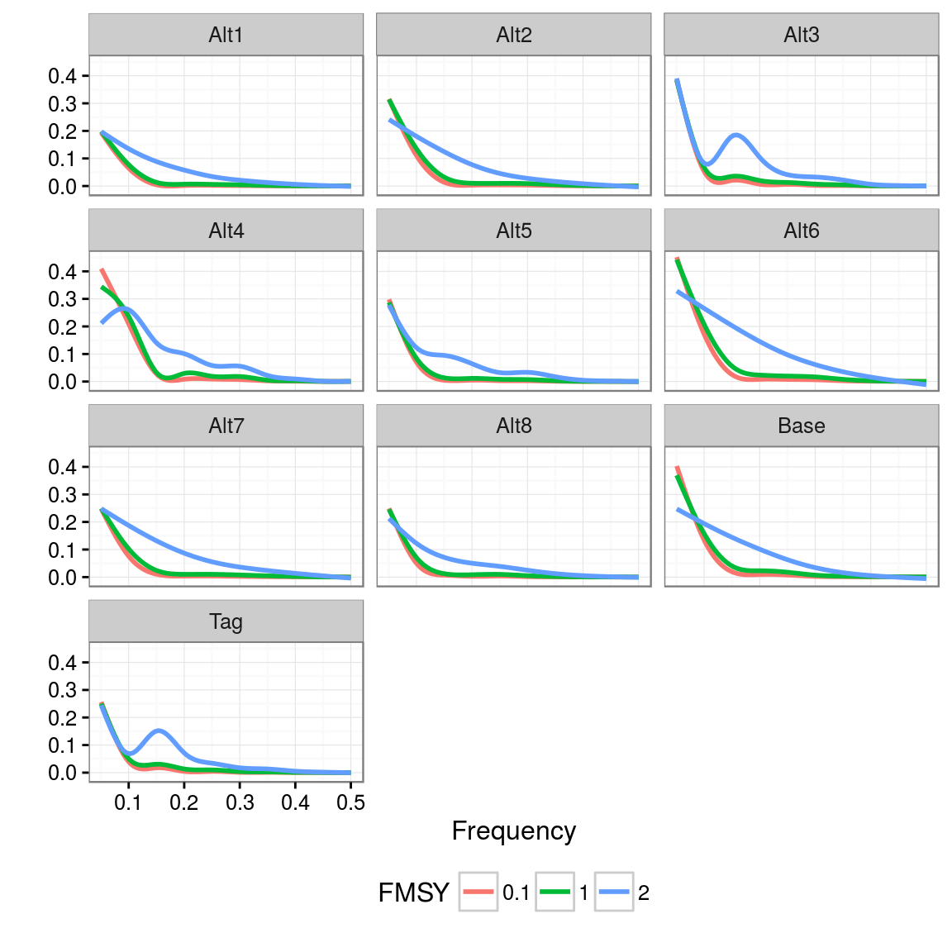
33. **Figure 26.** Power spectra of stock biomass; simulations for each Operating Model scenario and three levels of fishing mortality ( times 0.1, 1 and 2).
34. 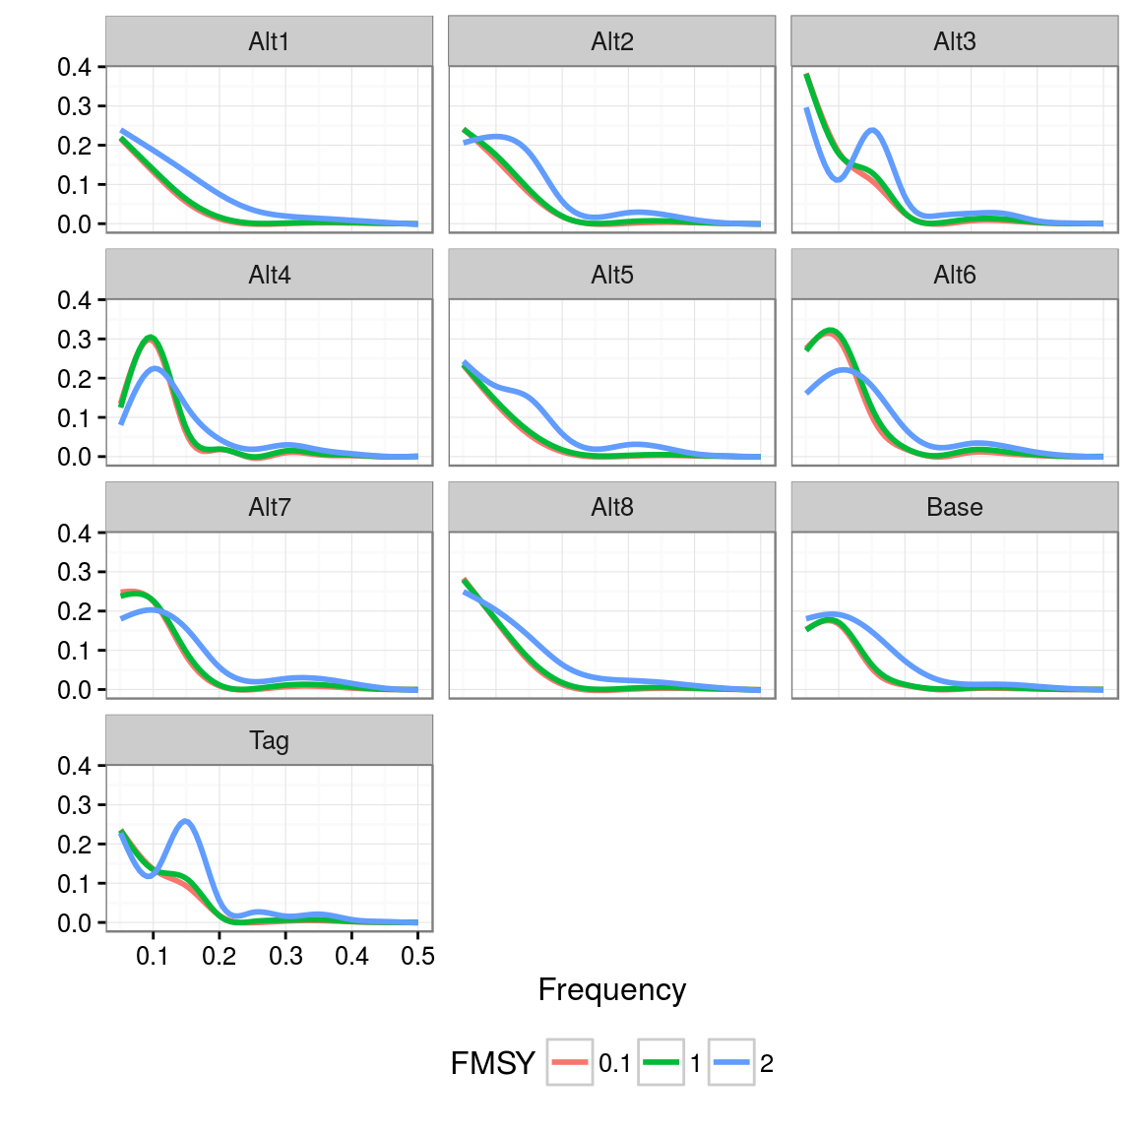
35. **Figure 27.** Power spectra of juvenile biomass; simulations for each Operating Model scenario and three levels of fishing mortality ( times 0.1, 1 and 2).
36. 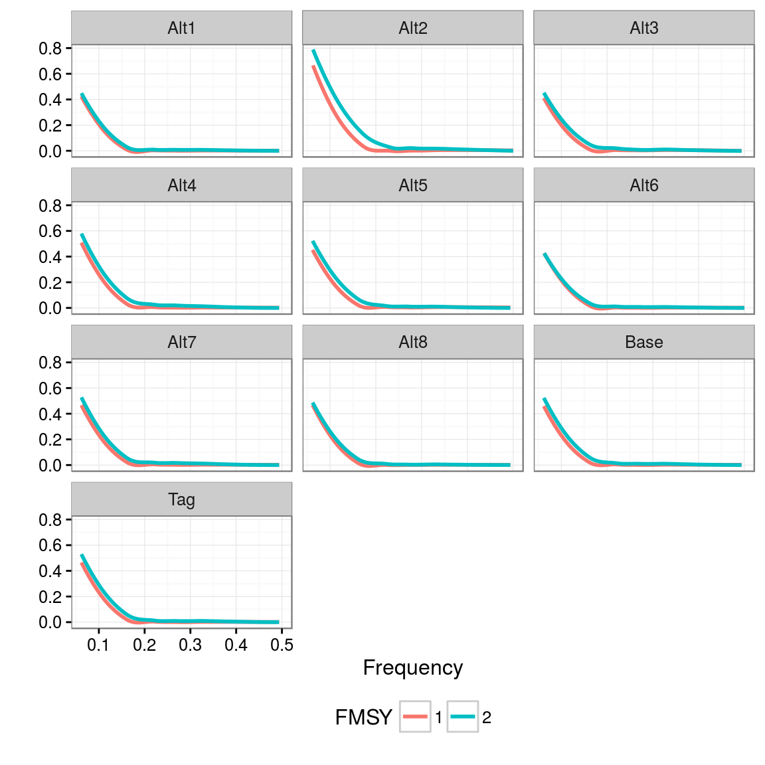
37. **Figure 28.** Power spectra of surplus production; simulations for each Operating Model scenario and three levels of fishing mortality ( times 0.1, 1 and 2).

1. ICCAT Secretariat, C/Corazón de María, 8. 28002 Madrid, Spain; Laurie.Kell@iccat.int; Phone: +34 914 165 600  Fax: +34 914 152 612.
2. AZTI -Tecnalia, Herrera Kaia Portualdea, 20110, Pasaia, Spain; gmerino@azti.es.