**AN OBSERVATION ERROR MODEL FOR NORTH ATLANTIC ALBACORE.**

Laurence Kell[1], Haritz Arrizabalaga[2], Gorka Merino2 and Paul De Bruyn1

*SUMMARY*

*In this paper we describe the development of an Observation Error for North Atlantic albacore. When conducting Management Strategy Evaluation an Operating Model is used to simulate resource dynamics in simulation trials in order to evaluate the performance of a Management Procedure, where the Management Procedure is the combination of pre-defined data, together with an algorithm to which such data are input to provide a value for a management control measure. To link the Operating Model and the Management Procedure it is necessary to develop an Observation Error Model to generate fishery-dependent or fishery-independent resource monitoring data. The Observation Error reflects the uncertainties between the actual dynamics of the resource and the perceptions arising from observations and assumptions by modelling the differences between the measured value of a resource index and the actual value in the Operating Model. We show how an analysis of catch per unit effort data and hypotheses about fisher behaviour can be used to parameterise an Observation Error Model .*

*KEYWORDS*

*Albacore, Observation Error Model, Operating Model, Management Strategy Evaluation, Measurement Error, Uncertainty*

# Introduction

In Management Strategy Evaluation (MSE) an Operating Model (OM) is used to simulate resource dynamics in simulation trials in order to evaluate the performance of a Management Procedure (MP). Where the MP is the combination of pre-defined data, together with an algorithm to which such data are input to provide a value for a management control measure. To link the OM and the MP it is necessary to develop an Observation Error Model (OEM) to generate fishery-dependent or fishery-independent resource monitoring data. The OEM reflects the uncertainties, between the actual dynamics of the resource and perceptions arising from observations and assumptions by modelling the differences between the measured value of a resource index and the actual value in the OM. In this paper we describe the development of an OEM for North Atlantic albacore for use in MSE.

The OM is based upon the Multifan-CL assessment conducted during the 2013 ICCAT North Atlantic Albacore stock assessment (SCRS/2016/023). We first summarise the characteristics of the CPUE series to allow CPUEs with different propoerties to me simulated then provide example simulations under a variety of assumptions.

**Operating Model**

Ten scenarios were considered when fitting Multifan-CL, the scenarios are described and the results summarised in SCRS/2016/023.

When fitting the albacore stock assessments commercial catch per unit effort (CPUE) is used as a proxy for relative abundance. The CPUE series (per fleets) used in the Multifan-CL assessment are summarised in **Table 1**.

It has long been recognised, however, that time series of CPUE may not accurately reflect trends in population abundance (e.g. Beverton and Holt, 1993; Maunder et al., 2006; McKechnie et al., 2013; Polacheck, 2006). Particularly since changes can occur in in the spatial distribution of populations and the allocation of effort in response to management. In the latter case economic drivers can affect catch and effort independent of stock abundance (e.g. Paloheimo and Dickie, 1964; Tidd et al., 2011). Furthermore Interactions between changes in oceanographic conditions and exploitation can drive spatial and temporal dynamics (Fromentin et al., 2013). In addition, technological developments can produce bias on the relation between stock abundance and fleet’s CPUE. Therefore CPUE may not be proportional to stock abundance (Hilborn et al., 1992). For example CPUE may be hyperstable where catches remain high as a population declines (Erisman et al., 2011) or hyperdepletion may occur where catches decline faster than the population.

**CPUE Series**

First the selection patterns of the fleets and the error structure of the CPUEs are explored. Then, simulations are conducted to evaluate the bias and uncertainties for different assumptions. The selection patterns for the 10 CPUE series are plotted in **Figures 1 and 2**. The residuals are plotted to check the error model and to look for systematic patterns that may suggest that some assumptions are violated. In **Figure 3** the residuals are plotted (on the log scale) against year to check for systematic patterns over time. The residuals are then plotted against the fitted values to check the variance function (**Figure 4)**. Figure 5 plots residuals with 1 year lag to check for auto-correlation, and quantile-quantile plots to check for error assumptions are provided in **Figure 6**.

**Simulations**

Eight simulations were conducted corresponding to different assumptions about the potential error structure and biases in the CPUE series, the index was based on biomass in all but one case, a lognormal error with a CV of 30%. The index is simulated using the Multifan-CL Base Case estimates of numbers-at-age (SCRS/2016/013).

The simulations were i) unbiased, ii) hyperstability, iii) trend in catchability, iv) auto-correlation, v) a decrease in variance with time, vi) an index based on juvenile age-classes, vii) index based on mature age-classes, and viii) index based on numbers. The simulated CPUE series are shown in Figure 7, the ribbons show the 50th and 80th percentiles. Two individual simulations are also shown (red and cyan), the blue line an unbiased index and the black line the median of the simulated series. The unbiased index captures the stock trends although individual CPUE series show a wide variation. The same random deviates were used for all simulated series and therefore in all cases, but for auto-correlation, the peaks of the indices coincide. For a trend in catchability and hyperstability the trend in the index underestimates the true decline. For a decrease in variance no bias was seen. The scenario based on a juvenile index showed more variability, due to the effect of year class strength, using an index based on the mature biomass alone or numbers provided results similar to the unbiased index with slightly more variation.

**Summary**

The residual patterns in the fits of the CPUE series could be used to simulate alternative hypotheses about processes that could affect catch and effort. The properties of the indices, e.g. ages selected, catchability, availability or vulnerability could also be used simulated hypotheses about the processes to be implemented as scenarios in an MSE. The impact of using alternative simulated CPUE series to plug into a Management Procedure need to be evaluated through Management Strategy Evaluation (see paper SCRS/2016/026).

# References

Canty, A. J., Davison, A. C., Hinkley, D. V., and Ventura, V. (2006). Bootstrap diagnostics and remedies. Canadian Journal of Statistics, 34(1):5–27.jack-knife,

R. Beverton and S. Holt. On the dynamics of exploited fish populations, volume 11. Springer, 1993.

B. E. Erisman, L. G. Allen, J. T. Claisse, D. J. Pondella, E. F. Miller, J. H. Murray, and C. Walters. The illusion of plenty: hyperstability masks collapses in two recreational fisheries that target fish spawning aggregations. Canadian Journal of Fisheries and Aquatic Sciences, 68(10):1705–1716, 2011.

J.-M. Fromentin, G. Reygondeau, S. Bonhommeau, and G. Beaugrand. Oceanographic changes and exploitation drive the spatio-temporal dynamics of atlantic bluefin tuna (thunnus thynnus). Fisheries Oceanography, 2013.

R. Hilborn, C. J. Walters, et al. Quantitative fisheries stock assessment. choice, dynamics and uncertainty. Reviews in Fish Biology and Fisheries, 2(2):177–178, 1992.

M. N. Maunder, J. R. Sibert, A. Fonteneau, J. Hampton, P. Kleiber, and S. J. Harley. Interpreting catch per unit effort data to assess the status of individual stocks and communities. ICES Journal of Marine Science: Journal du Conseil, 63(8):1373–1385, 2006.

S. McKechnie, S. Hoyle, and S. Harley. Longline CPUE series that account for changes in the spatial extent of fisheries. Technical report, WCPFC-SC9-2013/SA-IP-05, 2013.

J. Paloheimo and L. Dickie. Abundance and fishing success. Rapports et Proces-Verbaux des Runions du Conseil International pour lExploration de la Mer, 155, 1964.

T. Polacheck. Tuna longline catch rates in the indian ocean: Did industrial fishing result in a 90% rapid decline in the abundance of large predatory species? Marine Policy, 30(5):470–482, 2006.

A. N. Tidd, T. Hutton, L. Kell, and G. Padda. Exit and entry of fishing vessels: an evaluation of factors affecting investment decisions in the north sea english beam trawl fleet. ICES Journal of Marine Science: Journal du Conseil, 68(5):961–971, 2011.

**Tables**

**Table 1.** Catch per unit effort series used in the 2013 assessment.

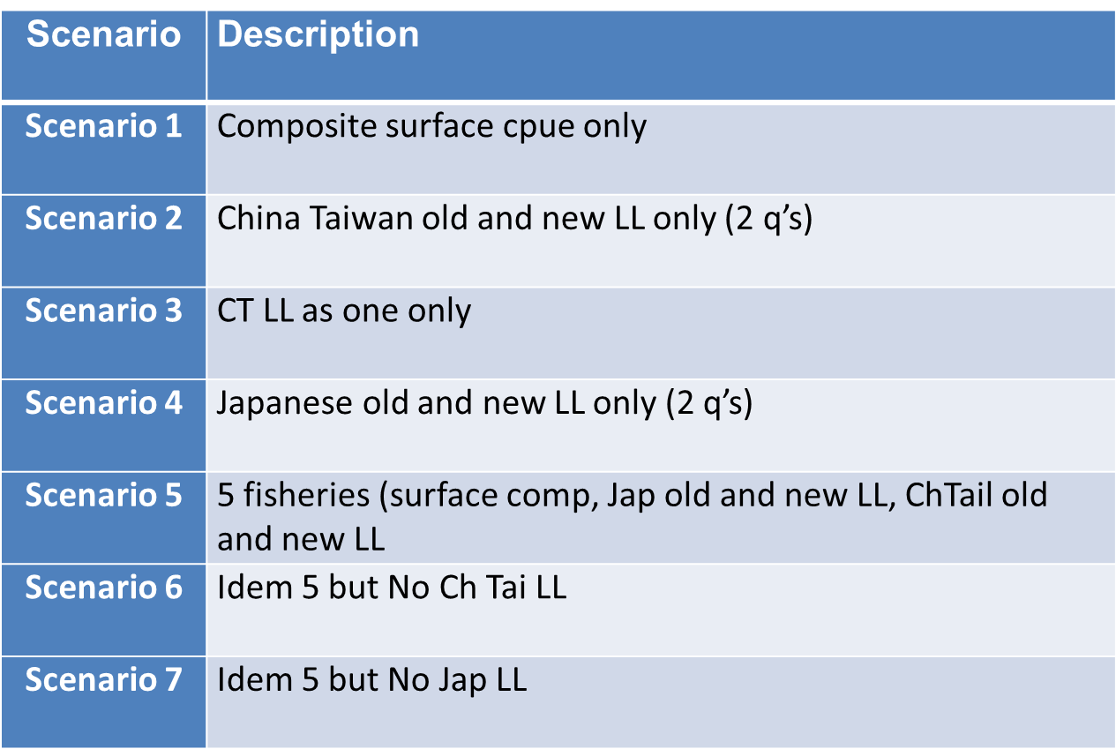

**Figures**

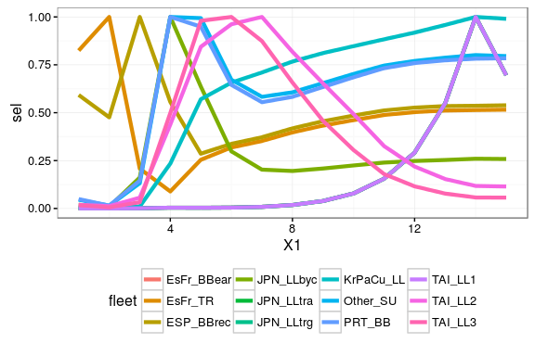

**Figure 1.** A comparison of fleet selection patterns.

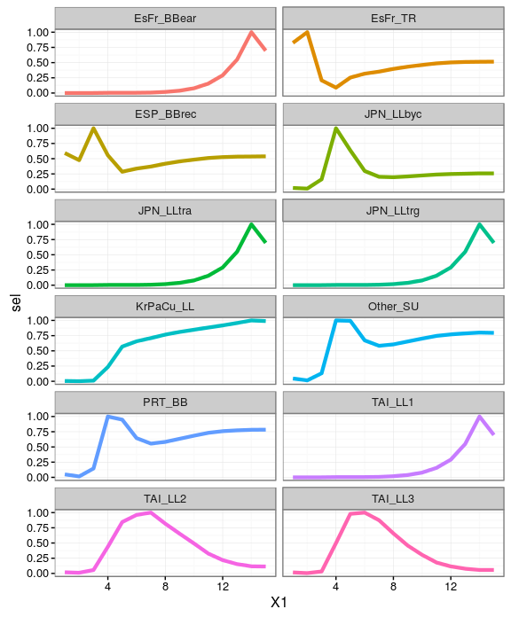

**Figure 2.** Selection patterns by fleet.

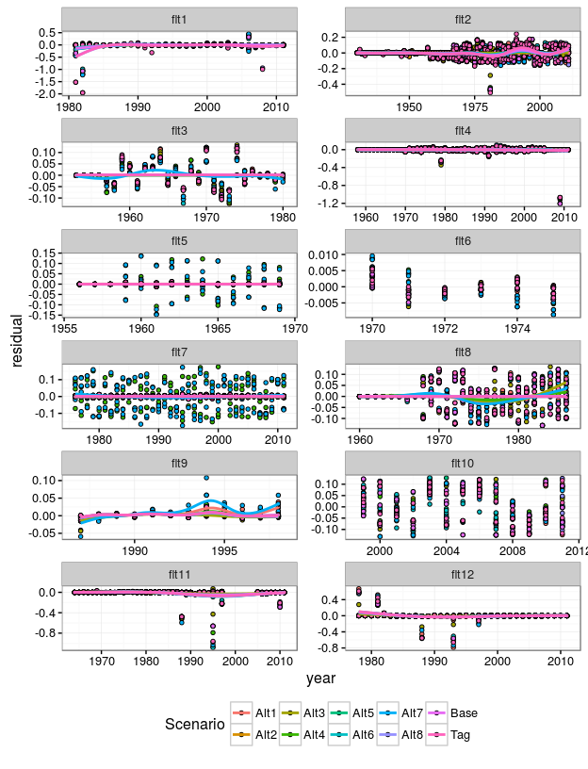

**Figure 3.** Plots of residuals against year to check for systematic patterns.

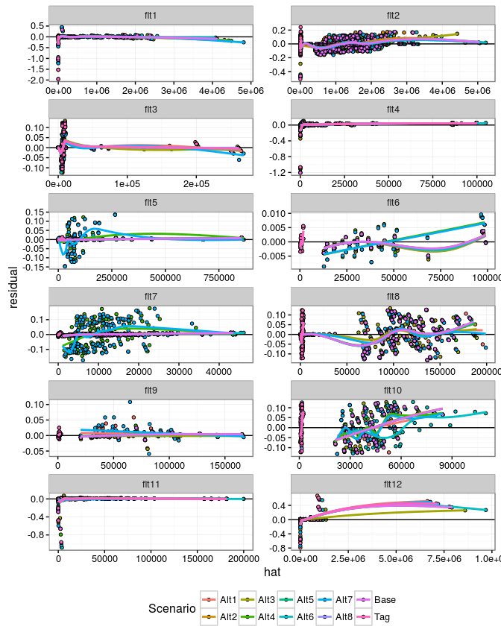

**Figure 4.** Plots of residuals against fitted values to check variance function.

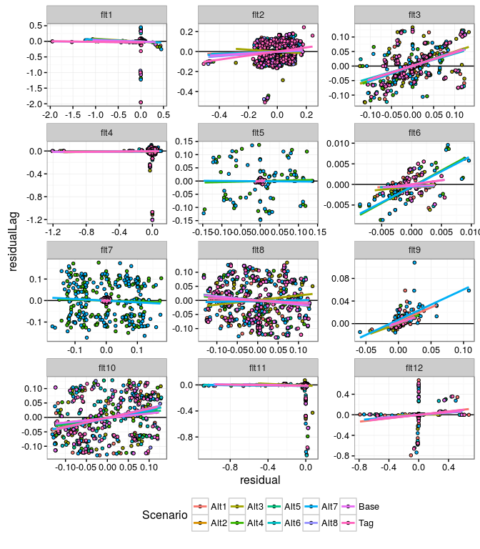

**Figure 5.** Plots of residuals with 1 year lag to check for auto-correlation.

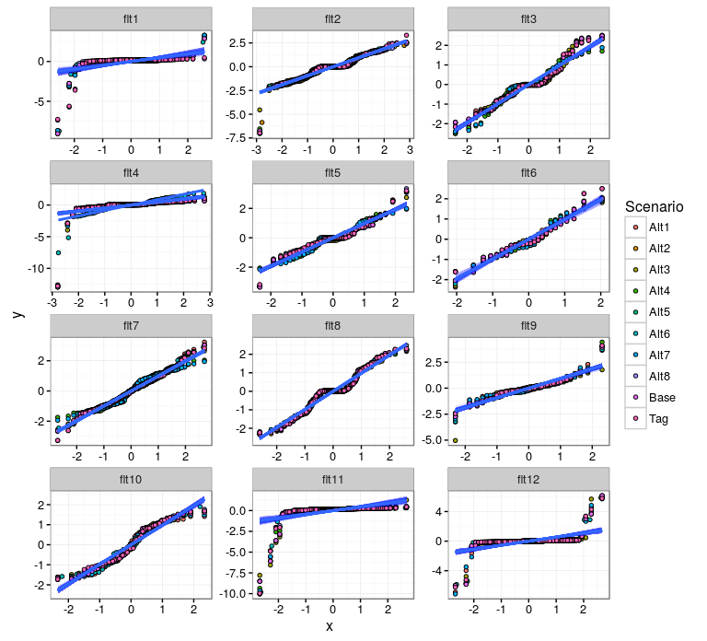

**Figure 6.** Quantile-quantile plots to check for normal error.

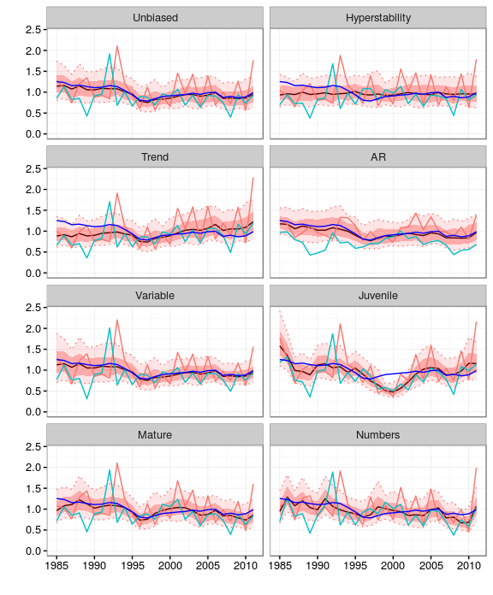

**Figure 7.** Simulated CPUE series

1. ICCAT Secretariat, C/Corazón de María, 8. 28002 Madrid, Spain; Laurie.Kell@iccat.int; Phone: +34 914 165 600  Fax: +34 914 152 612.
2. AZTI -Tecnalia, Herrera Kaia Portualdea, 20110, Pasaia, Spain; gmerino@azti.es.