**THE IMPLICIT NORTH ATLANTIC ALBACORE MANAGEMENT PROCEDURE**

Laurence Kell[1], and

*SUMMARY*

*Management Strategy Evaluation simulation tests a Management Procedure, using an Operating Model. The Operating Model is a simulation model used to describe the actual resource dynamics in simulation trials and to generate resource monitoring data when projecting forward. The Management Procedure is the combination of pre-defined data, together with an algorithm (e.g. a stock assessment procedure) to which such data are input to provide a value for a management control measure. The intention is to demonstrate, through simulation trials, robust performance of the Management Procedure in the presence of uncertainties. This requires identifying candidate management strategies and coding these as an MP and then to identify the MPs that robustly meet management objectives. In this paper we describe an implicit Management Procedure for North Atlantic albacore based on the Kobe Advice Framework. An implicit Management Procedure is a procedure that contains all the elements of a Management Procedure, but has not yet been evaluated through simulation trials. The commission has requested that the new assessment of the stock should be taken into account to ensure that there is a connection between the MSE and assessment processes. Particular since simulation testing the MP has shown how to develop a more robust biomass assessment procedure and this will have to be re-evaluated as part of an MSE.*

*KEYWORDS*

*Albacore, Biomass Dynamic, Kobe framework, Management Strategy Evaluation, Management Procedure, Stock Assessment.*

# Introduction

# When conducting a Management Strategy Evaluation (MSE) it is necessary to identifying candidate management strategies and code these up as a Management Procedure (MP). An MP is the combination of pre-defined data, together with an algorithm, e.g. to estimate stock status and reference points from the data to set management (e.g. TAC). An Operating Model (OM), a mathematical model used to simulate the resource dynamics is then projected forward using the MP as a feedback controller in order to simulate the long-term impact of management. The performance of alternative MPs are evaluated by comparing performance with respect to management objectives.

# If a MP has not been specified, MSE can be used to test an implicit MP. An implicit MP is a set of rules for management of a resource that contains all the elements of an MP, but has not yet been evaluated through simulation trials. Even if it is not intended to manage the stock using an MP as an autopilot, MSE can be used to evaluate the current advice framework as an implicit MP (e.g. Kell et al., 2005). Evaluating an implicit MP can help identify short comings of current procedures. For example how robust is the current practice for fixing difficult to estimate parameters, or for selecting data sets to use in the assessment.

The commission has recommended that the HCR, specified in Rec[15-04] should be evaluated by the SCRS through the management strategy evaluation process The commission has also requested that the new assessments of the stock should be taken into account in this process to ensure that there is a connection between the MSE and assessment processes. In this paper we describe an implicit MP, based on Rec-15-04 and show how it can be implemented in code for use in MSE. The software used was a biomass production model implemented as a package in R, which allows it to be used with a variety of other packages for plotting, summarizing results and for simulation testing, e.g. as part of the FLR tools for management strategy evaluation (Kell et al ., 2007).

1. **Management Framework**

# For North Atlantic albacore (see Kell et al., 2013b, 2012) advice is provided in the form of a Kobe II Strategy Matrix (K2SM). In the last assessment a Harvest Control Rule (HCR) was used for projection to generate the K2SM using a biomass dynamic model. MSE has not been used to simulation test an MP. Therefore two of the elements of an MP exist, the assessment algorithm and the HCR. Work has already been conducted on a preliminary MSE to evaluate the robustness of the current implicit MP. An OM based on Multifan-CL has been agreed (Kell et al., 2013a) and run (SCRS/2016/023), an Observation Error Model (OEM) to simulate resource monitoring data described (SCRS/2016/024) and the assessment algorithm tested (SCRS/2106/026, SCRS/2106/027). In this paper we describe the remaining step; the HCR.

# *Management Objectives*

# The management objectives for the northern albacore stock are given in Rec-15-04 and are

# *to maintain the stock in the green zone of the Kobe plot, with at least a 60% probability, while maximizing long-term yield from the fishery, and*

# *where the spawning stock biomass (SSB) has been assessed by the SCRS as below the level capable of producing MSY (SSBMSY), to rebuild SSB to or above SSBMSY, with at least a 60% probability, and within as short time as possible, by 2020 at the latest, while maximizing average catch and minimizing inter-annual fluctuations in TAC levels.*

***Harvest Control Rule***

*Specifications*

The elements of a HCR are also specified in Rec-15-04, i.e.

* If the average spawning stock biomass (SSB) level is less than SSBLIM (*i.e., SSB<SSBLIM*), the Commission shall adopt severe management actions immediately to reduce the fishing mortality rate, including measures that suspend the fishery and initiate a scientific monitoring quota to be able to evaluate stock status. This scientific monitoring quota shall be set at the lowest possible level to be effective. The Commission shall not consider re-opening the fishery until the average SSB level exceeds SSBLIM with a high probability. Further, before reopening the fishery, the Commission shall develop a rebuilding program in order to ensure that the stock returns to the green zone of the Kobe plot.
* If the average SSB level is equal to or less than SSBTHRESHOLD and equal to or above SSBLIM (*i.e., SSBLIM ≤ SSB ≤* *SSBTHRESHOLD*) and F is above the level specified in the HCR, the Commission shall take steps to reduce F as specified in the HCR to ensure F is at a level that will rebuild SSB to SSBMSY or above that level.
* If the average SSB is above SSBTHRESHOLD but F exceeds FTARGET (*i.e., SSB>SSBTHRESHOLD and F>FTARGET*), the Commission shall immediately take steps to reduce F to FTARGET.
* Once the average SSB level reaches or exceeds SSBTHRESHOLD and F is less or equal than FTARGET (*i.e., SSB > SSBTHRESHOLD and F ≤ FTARGET*), the Commission shall assure that applied management measures will maintain F at or below FTARGET.

*Coding*

The tasks of the SCRS are to evaluate the HCRs that come up as different combinations of reference points, i.e. SSBTHRESHOLD, SSBLIM and FTARGET. The SCRS has already described a hockey stick HCR, where if the stock is above SSBTHRESHOLD the TAC is set equivalent to a fishing mortality of FTARGET. If the stock falls below SSBTHRESHOLD then F is linearly decreased until SSBLIM is reached, at which point the fisheries would be closed. It is seldom possible to prevent all fishing on a stock, e.g. due to bycatch and so it is assumed that even after closure of the fisheries there will still be some fishing mortality (i.e. Flim).

Important elements that need to be agreed as part of the HCR are the time scales, and how quickly TACs and effort should be reduced or allowed to increase.

# As an illustration, a HCR is simulated for single choices of reference points. In practice when conducting an MSE a variety of choices for the reference points would be evaluated and the HCR chosen that best meets management objectives. A process called tuning, (similar to making adjustments to a musical instrument) is carried out until the best performance is achieved.

# Results

# 

# Figure 1 presents an example of the “one off” application of a harvest control rule. The stock is originally overexploited, then in year 30 a HCR is applied and the stock fished at the level determined by such HCR until year 47. Fishing mortality is initially above FTARGET so is reduced by application of the HCR. This results in an initial decline in yield, followed by an increase as the stock recovers.

# Next the same HCR is simulated showing the effect of 5% bounds on inter-annual changes in F (or effort) and catches. This is purely an example and not proposed as a management option. The stock, harvest rate and yield trajectories are shown relative to BMSY, FMSY and MSY respectively in Figure 2, 3 and 4. The grey lines are BTHRESHOLD andFTARGET and the red lines are BLim and Fmin. The HCR is shown in the corresponding Kobe Phase Plot (K2PP) in Figure 5. The F set by the HCR is less than FTARGET since when the HCR was applied B was less than BTHRESHOLD.

A harvest control rule was applied in year 30 but then reapplied every three years; **Figures 6, 7** and **8** show stock, harvest rate and yield trajectories relative to BMSY, FMSY and MSY and **Figure 9** the K2PP. The application of the TAC bound results in oscillations in biomass and yield.

**Discussion**

Simulating a HCR also allows important details to be fine-tuned, e.g. how fast to reduce catches or effort. It also allows behaviour that may not have been expected, to be seen, e.g. the oscillation of catches by applying a bound on inter-annual variation in catches.

The software used in this example can be used to simulate an MP as using the OM described in SCRS/2016/023 and SCRS/2016/024. However, outstanding issues are the data to use in the MP and the choices made when running the stock assessment algorithm. SCRS/2016/027 showed that the current procedure used to select data and to estimate parameters when running the biomass dynamic model was problematic. SCRS/2016/026 performed a cross-test to evaluate the robustness of those procedures and SCRS/2016/028 proposed a procedure to help ensure that future assessments are reliable.

# References

J. Deroba, D. Butterworth, R. Methot, J. De Oliveira, C. Fernandez, A. Nielsen, S. Cadrin, M. Dickey-Collas, C. Legault, J. Ianelli, et al. Simulation testing the robustness of stock assessment models to error: some results from the ices strategic initiative on stock assessment methods. ICES Journal of Marine Science: Journal du Conseil, 72(1):19–30, 2015.

L. Kell, I. Mosqueira, P. Grosjean, J. Fromentin, D. Garcia, R. Hillary, E. Jardim, S. Mardle, M. Pastoors, J. Poos, et al. Flr: an open-source framework for the evaluation and development of management strategies. ICES Journal of Marine Science: Journal du Conseil, 64(4):640, 2007.

L. Kell, G. Pilling, G. Kirkwood, M. Pastoors, B. Mesnil, K. Korsbrekke, P. Abaunza, R. Aps, A. Biseau, P. Kunzlik, et al. An evaluation of the implicit management procedure used for some ICES roundfish stocks. ICES Journal of Marine Science: Journal du Conseil, 62(4):750–759, 2005.

L. Kell, I. Mosqueira, P. De Bruyn, and A. Magnusson. An evaluation of limit and target reference points as part of a harvest control rule: An atlantic swordfish example. ICCAT Collect. Vol. Sci. Pap., 68 (195):1630–1644, 2012.

L. Kell, G. Merino, P. De Bruyn, J.-M. Ortiz de Urbina, H. Arrizabalaga, J. Santiago, and H. Murua. An example of conditioning an operating model using multifan-cl. ICCAT Collect. Vol. Sci. Pap., 69 (34):xxx–xxx, 2013a.

L. Kell, J. Ortiz de Urbina, and P. De Bruyn. Kobe II strategy matrices for north atlantic swordfish based on catch, fishing mortality and harvest control rules. ICCAT Collect. Vol. of Sci. Pap., (70):2009–2016, 2013b.

**Figures**

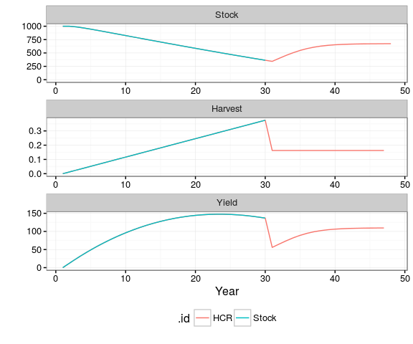

**Figure 1.** Example of the “one off” application of a harvest control rule. The stock is originally overexploited, then in year 30 a HCR is applied.

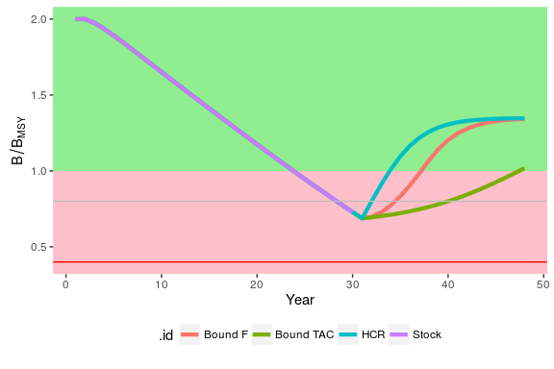

**Figure 2.** Stock relative to $B_{MSY}$ for the “one off” application of a harvest control rule. Grey horizontal line is the $B_{Threshold}$ and red line is the $B_{\text{Lim}}$

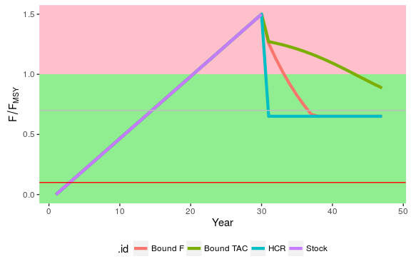

**Figure 3.** Harvest rate relative to $F_{MSY}$ for the “one off” application of a harvest control rule. Grey horizontal line is the $F_{Target}$ and red line is the $F_{min}$.

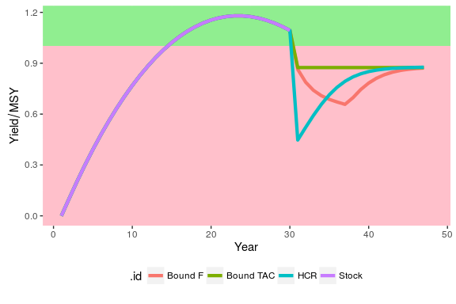

**Figure 4.** Yield relative to $MSY$ for the “one off” application of a harvest control.

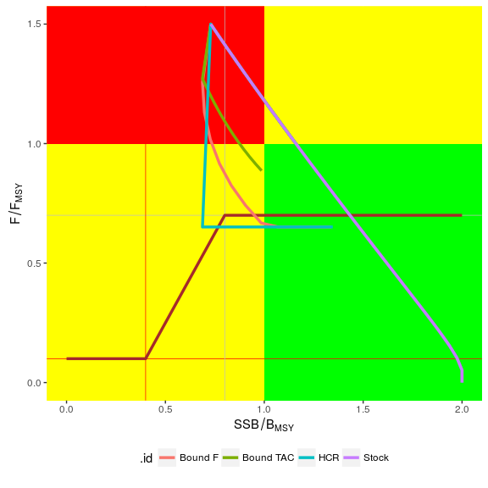

**Figure 5.** Kobe phase plot for the “one off” application of a harvest control rule (brown hockey stick). The vertical grey line is the $B_{Threshold}$ and vertical red line is the $B_{\text{Lim}}$. The horizontal grey line is the $F_{Target}$ and the horizontal red line is the .

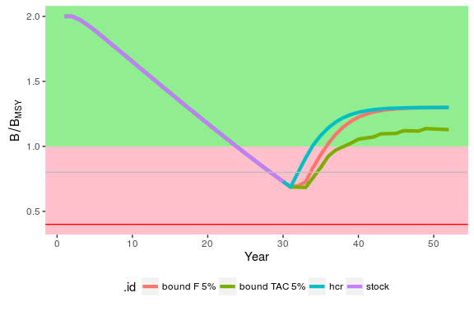

**Figure 6.** Stock relative to $B_{MSY}$ for a harvest control applied every three years. The horizontal grey line is the $B_{Threshold}$ and the horizontal red line is the $B_{\text{Lim}}$.

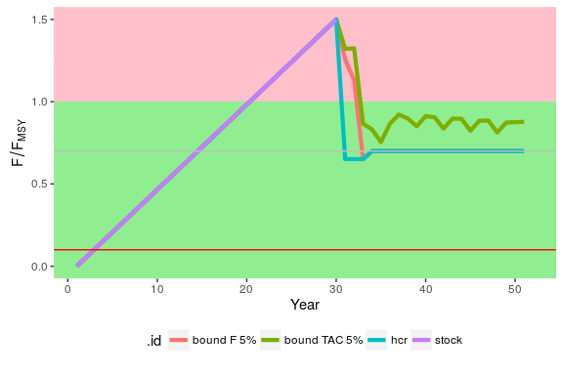

**Figure 7.** Harvest rate relative to $F_{MSY}$ for a harvest control applied every three years. The horizontal grey line is the $F_{Target}$ and horizontal red line is the $F_{min}$.

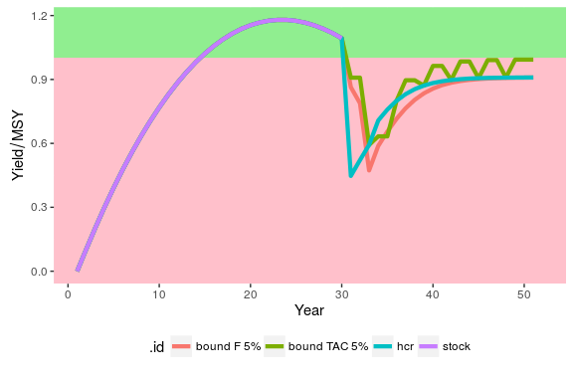

**Figure 8.** Yield relative to $MSY$ for a harvest control applied every three years.

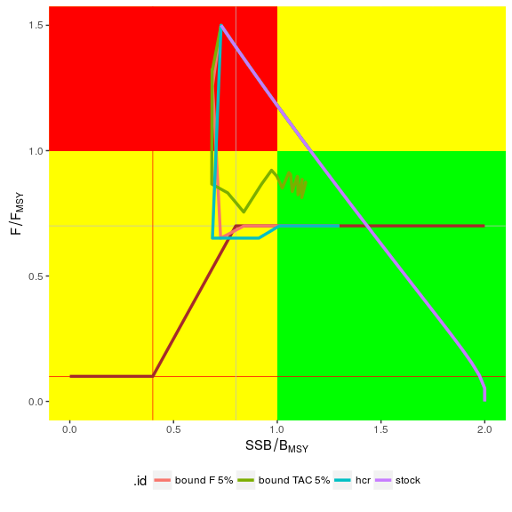

**Figure 9.** Kobe phase plot for a harvest control applied every three years. The vertical grey line is the $B_{Threshold}$ and the vertical red line is the $\begin{aligned}\lim_{}{} \\ B_{}\end{aligned}$. The horizontal grey line is the $F_{Target}$ and horizontal red line is the $F_{min}$**.**

1. ICCAT Secretariat, C/Corazón de María, 8. 28002 Madrid, Spain; Laurie.Kell@iccat.int; Phone: +34 914 165 600  Fax: +34 914 152 612.