**CROSS TESTING OF A BIOMASS STOCK ASSESSMENT PROCEDURE**

Laurence Kell[1], Haritz Arrizabalaga[2], Gorka Merino2 and Paul De Bruyn1 [3]

*SUMMARY*

*A cross-test of a biomass dynamic stock assessment procedure is performed to evaluate the robustness of alternative model assumptions and data sets. In a cross test, a model is first fitted to data and used to generate pseudo data that are then used for fitting a different model. The estimates can then be compared with the original model fit to identify bias. To generate the data we used the North Atlantic albacore integrated assessment based on Multifan-CL.These data are fitted with a biomass dynamic model. Results suggest that the biomass dynamic model is able to capture the general stock trends. Using the entire time series, however, can cause bias if variations in productivity are large, e.g. due to resonant cohort effects or regime shifts. A juvenile index performs as well as a index of the entire stock, as it provides an index of future year class strength. In comparison an index of mature fish performed poorly.*

*.*

*KEYWORDS*

*Albacore, Biomass Dynamic, Cross-Test, Multifan-CL, Stock Assessment*

# Introduction

The main objective of Management Strategy Evaluation (MSE) is to evaluate alternative Management Procedures (MPs), where a Management Procedure is the combination of predefined data, together with an algorithm to estimate stock status and reference points from the data, to set management. An important part of the MP is the algorithm used to estimate stock relative to reference points. In the case of the North Atlantic Albacore assessment, advice on the total allowable catch (TAC) is provided using a biomass dynamic model. Furthermore, for each model, alternative fitting options are available, which can improve a models’ estimates.

A cross test can be performed to evaluate the robustness of the different choices that have to be made when fitting a model*.* In a cross test, a model is fitted to data and then the fit is used to generate pseudo data that are used for fitting a different model. The estimates can then be compared to identify bias. To generate the data we use the North Atlantic albacore integrated assessment based on Multifan-CL (SCRS/2016/023).

The example is not extensive but we discuss how the method could be extended to evaluate the robustness of choices made when conducting a stock assessment or setting up an MP for testing. With this work we aim to provide advice regarding the initial model structure and model options for the biomass production model that will be used in the coming 2016 assessment of North Atlantic albacore.

# Material and Methods

A biomass dynamic model is fitted to a time series of total catch biomass and indices of relative abundance, e.g. catch per unit effort (CPUE). We conduct the cross test by generating indices of abundance from the Multifan-CL. We then fit the biodyn biomass dynamic model to these data and compare the time series obtained from the two assessment procedures.

To do this the OM described in SCRS/2016/023 is used in non-feedback mode to generate pseudo data, namely three CPUE series corresponding to i) total catch/effort; ii) juvenile catch/effort; and iii) mature catch of mature/effort. No measurement error was simulated.

The structure of the biomass dynamic model was the same as used by the 2013 WG, i.e. a logistic production curve was assumed. Alternatively, a known shape value (calculated from the Multifan-CL fit) was used. The initial value of biomass was set to the OM value at the beginning of the series.

# Results

The simulated CPUE series are shown **Figure 1**. The index based on total biomass show low frequency fluctuations, which are also present in the mature series. The juvenile series show higher frequency variability. This is because in Multifan-CL, variability in production is driven by recruitment.

This paper is only intended to be an example and so few cross tests were run. **Figure 2** compares the biomass dynamic model fits (red) to the Multifan-CL OM (black) using two different abundance indices; individual lines correspond to the OM scenarios. Since no process error is modelled in the biomass dynamic assessment model the trends are smoother. The assessment procedure captures the main trends but not the large changes every ten years, driven by incoming cohorts.

The differences between using a juvenile or total biomass index are not large.

Figure 3 shows the fits of the biodyn model to alternative CPUE series and estimation options. Reasonable fits are obtained when truncating the time series (starting in 1975), since the problem of adjusting to biomass fluctuations driven by recruitment episodes is avoided (Figure 2). No major differences are seen when fitting with a known shape and using (or not) priors for the intrinsic growth rate (r).

# Summary

The analysis presented was limited to few examples, based on indices with different selection patterns. The juvenile index performed nearly as well as an index that represented the entire catch biomass. A reason for this is that the juvenile series provides an index of future biomass, i.e. if the total biomass is dominated by fish of age six and the juvenile index is composed of fish of age 4, the index will provide an estimate of biomass in 2 years time. In a MP, a juvenile index may be ideal as it could provide forewarning of a potential crash. In comparison, using a mature index would only tell you what you already knew, i.e. the stock had declined. This illustrates the importance of simulation of feedback in an MP.

The same procedure could be used to evaluate other sources of uncertainty, such as alternate forms of the production function and to non-stationarity.

A major uncertainty in a biomass dynamic stock assessment model is the shape of the production function, i.e. is it skewed to the left? A biomass dynamic model simplifies recruitment, growth and natural mortality into a single function, and life history arguments have been used to show that the Schaefer production model is probably not appropriate for tunas (Maunder, 2003). The Pella-Tomlinson form (Pella and Tomlinson, 1969) where BMSY<0.5B0 is probably more realistic due to high steepness. A cross test could be used to evaluate the robustness of the logistic production function compared to using a Pella-Tomlinson form.

Non-stationarity was identified in the OM in SCRS/2016/023, one option for dealing with this is to truncate the time series. Our results suggest that truncating the time series in 1975 performs relatively well.

Running a cross-test is a useful step when setting up an MSE, as it may allow MP options that will not perform well to be excluded from the full simulation trails.

# References

M. N. Maunder. Is it time to discard the schaefer model from the stock assessment scientists toolbox? Fish. Res., 61(1):145–149, 2003.

J. Pella and P. Tomlinson. A generalized stock production model. Inter-American Tropical Tuna Commission, 1969.

**Figures**

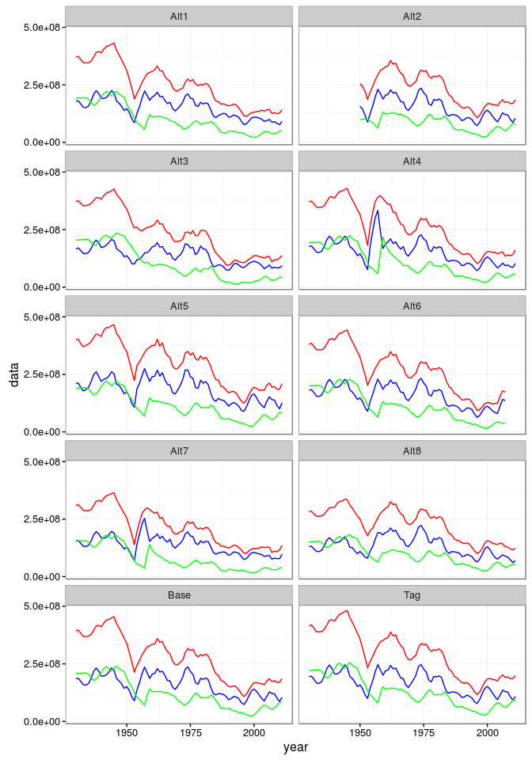

**Figure 1.** Simulated CPUE Series: all (red), juvenile (blue) and mature (green) biomass.

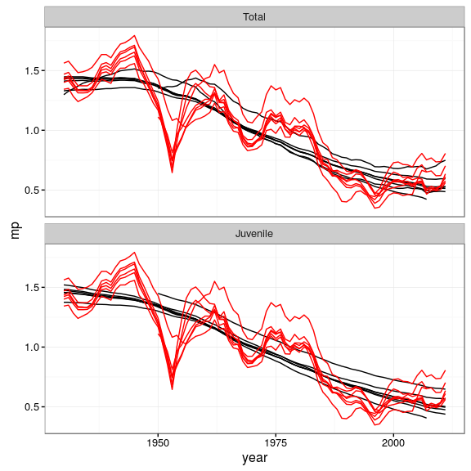

**Figure 2.** Cross test comparing biomass dynamic model fits (black) with Multifan-CL (red) by scenario (as in SCRS/2016/023).

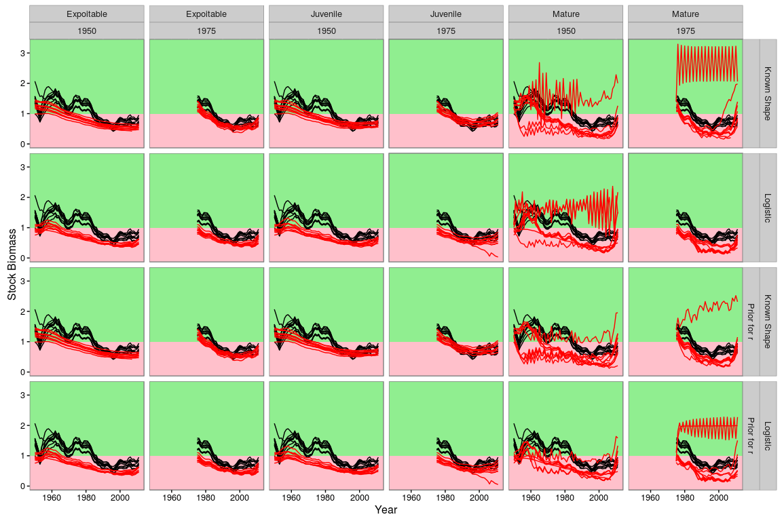

Figure 3. Cross test of biodyn (red) using Multifan-CL (black). Time series of stock biomass relative to BMSY are shown. Columns represent index characteristics and rows stock assessment options.

1. ICCAT Secretariat, C/Corazón de María, 8. 28002 Madrid, Spain; Laurie.Kell@iccat.int; Phone: +34 914 165 600  Fax: +34 914 152 612.
2. AZTI -Tecnalia, Herrera Kaia Portualdea, 20110, Pasaia, Spain; gmerino@azti.es.
3. ICCAT Secretariat, C/Corazón de María, 8. 28002 Madrid, Spain; Laurie.Kell@iccat.int; Phone: +34 914 165 600  Fax: +34 914 152 612.