 

**I. BASICS OF THE “DHIS2 REPORTING MODULE” …....................................................... 2**

A. Installing the DHIS2 OMOD ….............................................................................................. 2

B. Starting with the DHIS2 Report Module ….......................................................................... 4

**II. FEATURES OF THE “DHIS2 REPORTING MODULE” …................................................. 5**

A. Importing the Report Definitions …...................................................................................... 5

B. Configuring the DHIS2 Connection ….................................................................................. 5

C. Reports: Preview …............................................................................................................... 6

D. Reports: Post to DHIS …...................................................................................................... 7

**III. GENERATING THE REPORT ON THE DHIS2 …............................................................... 10**

A. Login to the DHIS2 Instance …............................................................................................ 10

B. Generating the Report …...................................................................................................... 10

C. View the Generated Report …............................................................................................. 11

**IV. SETTING THE OPENMRS’ LOCATION AND DHIS2’s ORGANISATION UNIT …....... 13**

A. Getting the code of the Organisational Unit …................................................................... 13

B. Setting the Location in the OpenMRS Database ….......................................................... 14

**V. CREATING/CUSTOMIZING THE XML FILE …...................................................................... 15**

A. Preparing the required data elements ….............................................................................. 17

B. Preparing the required disaggregations …............................................................................ 17

C. Formulating the reportTemplate …......................................................................................... 18

**VI. MORE XML SAMPLES ….......................................................................................................... 23**

**I. BASICS OF THE “DHIS2 REPORTING MODULE”**

**A. Installing the DHIS2 OMOD:**

1. Make sure you have the following:

(a) OpenMRS instance

(b) DHIS2 omod: “dhisreport-1.0-SNAPSHOT.omod”

(c) DHIS2 URL, Username, Password (for the connection to the DHIS2 server)

(d) XML file containing the report definition

2. Open the OpenMRS’ Administration [tab].

3. Select “Manage Modules” (below the Modules).

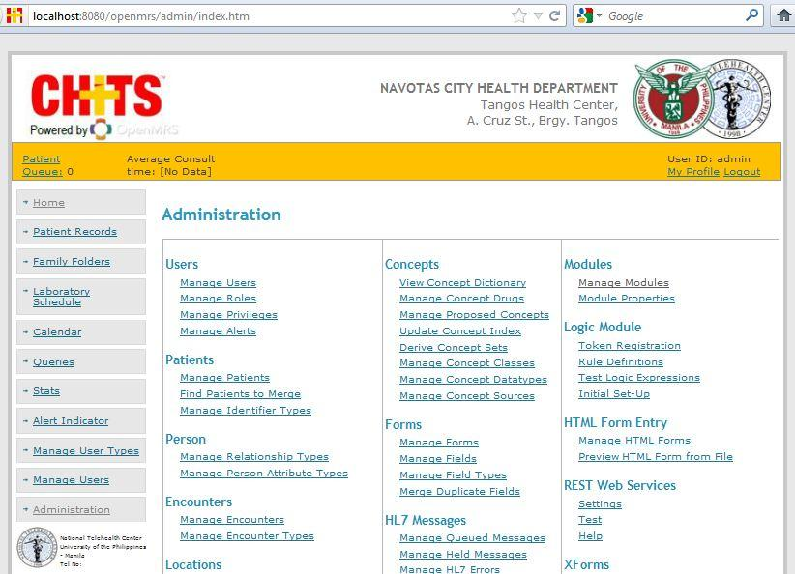

4. Click “Add or Upgrade Module” (button)

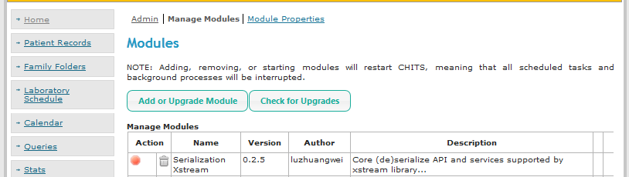

5. Add the “omod” into the OpenMRS:

(a) Click “Browse” under the “Add Module” title

(b) Select the ‘dhisreport’ omod file.

(c) Click “Upload” (button).

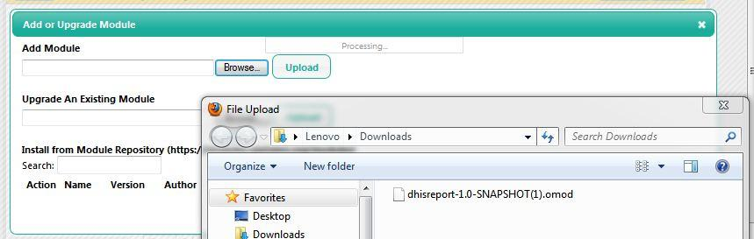

6. Once loaded, the “DHIS2 Reporting Module” will be found in the Manage Modules table.

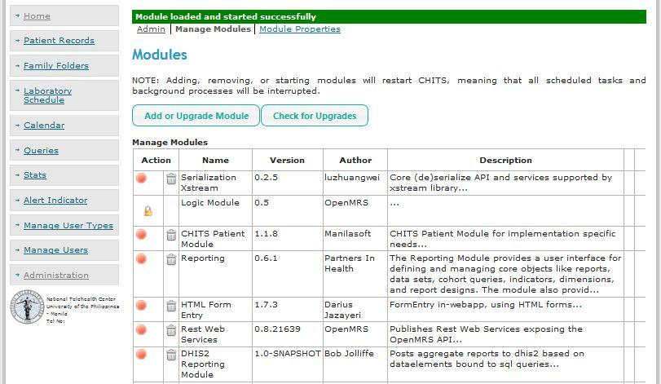

7. Going back to the “Administration” (tab), you will be able to see the “DHIS2 Reporting Module”.

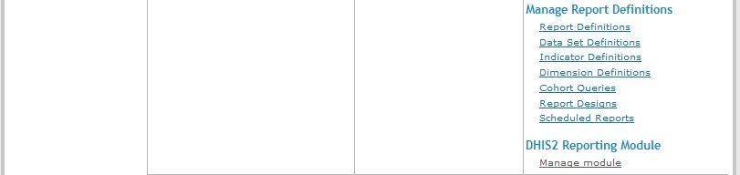

**B. Starting with the DHIS2 Report Module**

1. Open the OpenMRS’ “Administration” (tab)

2. Click the “Manage module” under the listed “DHIS2 Reporting Module”.



3. There would be three options available:

a. **Import/Export report definitions’ “link”** - to upload the xml file to create the report definition.

b.  **Configure DHIS2 connection’s “link”** - to set the URL and username/password to access the DHIS2 server.

c. **Reports’ “link”** - to show the available reports;

- will only display those defined from the “Import/Export report definitions”’ “link”

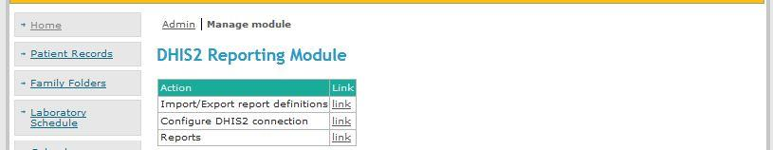

4. Usually, the flow would be:

(1) Import report definitions (uploading the customized xml file that will handle the data messages)

(2) Configure DHIS2 connection (setting the connection to the DHIS2 server, so the uploaded xml file will be sent to the DHIS2 instance). You may also opt to set the connection first before uploading the xml.

(3) Reports (to view and check the reports generated in the DHIS2 instance).

Although the step-by-step will be discussed later.

**II. FEATURES OF THE “DHIS2 REPORTING MODULE”**

**A. Importing the Report Definitions**

1. Go to the DHIS2 Reporting Module. [DHIS2 Reporting Module>Manage module]

2. Click the “Import/Export report definitions’ “link”.



3. Upload the XML file:

(a) Click “Browse” [button].

(b) Select the xml file to be uploaded. i.e. templates_philippines.xml

(c) Click “Upload” [button].

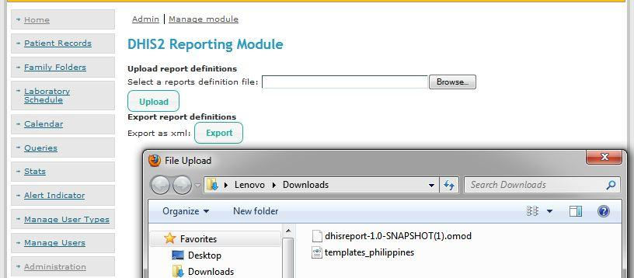

**B. Configuring the DHIS2 Connection**

1. Go to the DHIS2 Reporting Module. [DHIS2 Reporting Module>Manage module]

2. Click the “Configure DHIS2 connection”’ “link”.



3. Set the connection to the DHIS2 server:

(a) Enter the needed URL, your username and password .

(b) Click “Save” [button].

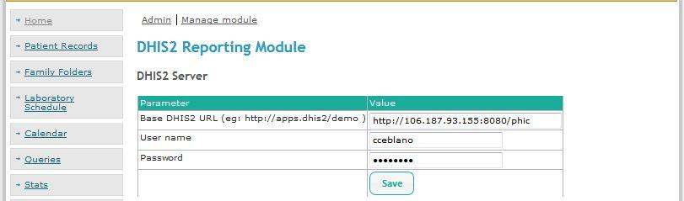

**C. Reports: Preview**

1. Go to the DHIS2 Reporting Module. [DHIS2 Reporting Module>Manage module]

2. Click the “Reports”’ “link”.



3. Click the “link” (of the created form).

i.e. link of the PCB Form A2

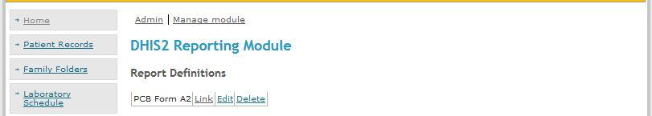

Note: If you follow the steps in “Importing the Report Definitions” with a valid xml file, you should be able to view the table for that particular report form.

(i.e. importing the file of “template_philippines.xml” will generate the “PCB Form A2” link)

4. Fill-up the parameters of the report to be generated:

(a) Enter the date for that report. Optional: The default action is “Preview”.

(b) Click Generate.

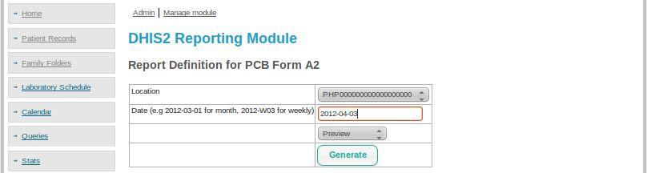

**Warning**: If you are unable to change the location and it is displayed as “Unknown Location” or any default location. Then, your OpenMRS database may not contain the needed value for the location.name . In that case, although you will be able to preview the report result, you will not be able to import the data to the DHIS2.

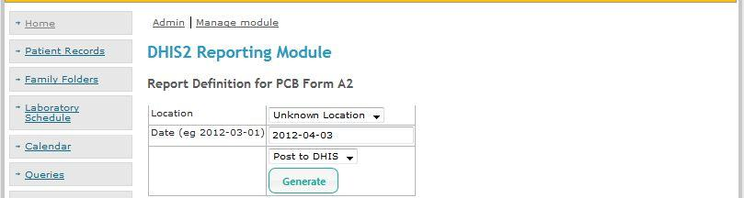

**Solution**:

If you encounter this problem, check the code of the preferred “Organizational Unit” (i.e. Philippines) in the DHIS2 instance.

Use that code (i.e. 12345678) to update the OpenMRS database’ location [table] name in one of the location_id.

*( The step-by-step with screenshot will be shown in the last part of this document. )*

(c) The details and status of the report will be displayed. Note that since you merely selected the “Preview”, the data will not yet be passed to the actual DHIS2 server.

**D. Reports: Post to DHIS**

1. Go to the DHIS2 Reporting Module. [DHIS2 Reporting Module>Manage module]

2. Click the “Reports”’ “link”. 

3. Click the “link” (of the created form).

i.e. link of the PCB Form A2



Note: If you follow the steps in “Importing the Report Definitions” with a valid xml file, you should be able to view the table for that particular report form.

(i.e. importing the file of “template_philippines.xml” will generate the “PCB Form A2” link)

4. Fill-up the form to “Post to DHIS” the report

(a) Enter the date for that report. Optional: Select the location and the action; the default location is “Unknown Location” and the action is “Preview”.

(b) Instead of preview, change the action to “Post to DHIS”.

(c) Click “Generate” (tab).

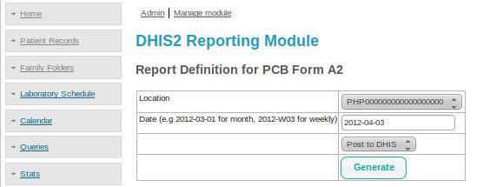

**Warning**: If the configuration to connect to the server is wrong, an error will be displayed.

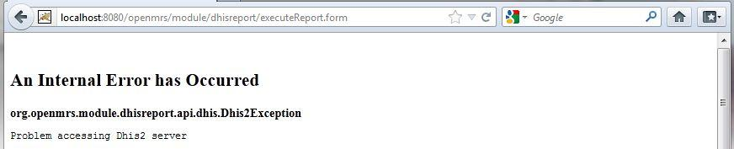

Result: if you successfully imported the xml file, the details and status of the report will be displayed.

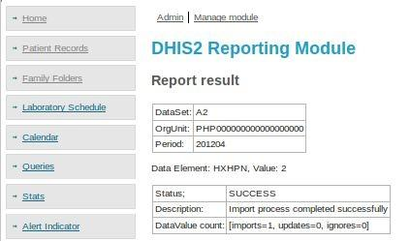

If you repeat the same process that you also imported last time, instead of “imports = 1”, the datavalue count: would only show “updates=1”. Hence, no double entry would happen.

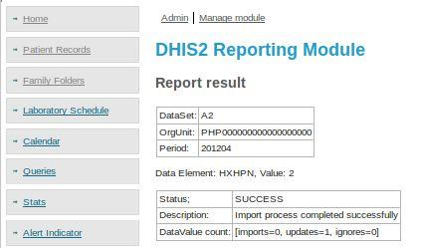

**III. GENERATING THE REPORT ON THE DHIS2**

**A. Login to the DHIS2 Instance**

1. Navigate to the DHIS2 site.

2. Login using your username and password for that DHIS2.

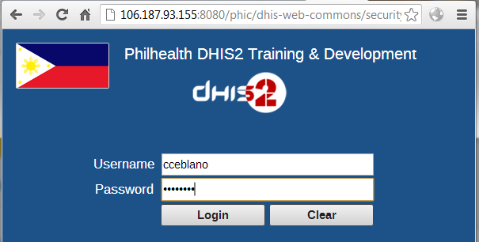

**B. Generating the Report**

1. Go to “Services” (top menu).

2. Select “Reports” (dropdown).

3. Click to “Dataset Report” (left side menu).

4. Fill-up the form to create the “Dataset Report”.

(a) Select the Dataset (similar to the <name></name> in the xml file.

(b) Report Period (same as the xml’s <periodType>)

(c) Specify the data or period; the organization unit. Tick the checkbox if for selected unit only.

(d) Click “Get report” [button]

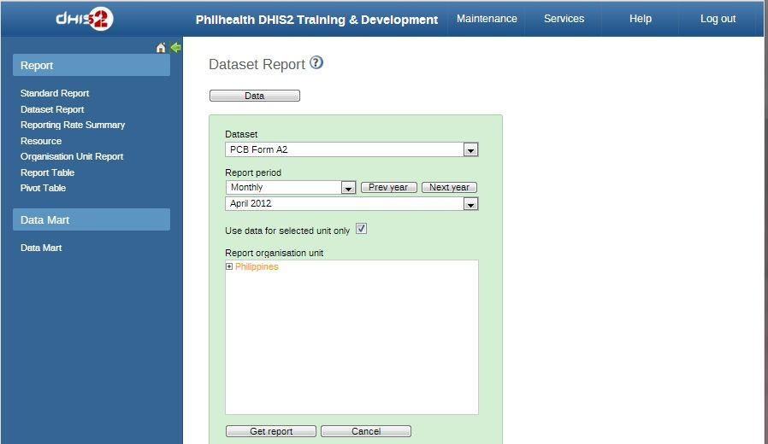

**C. View the Generated Report**

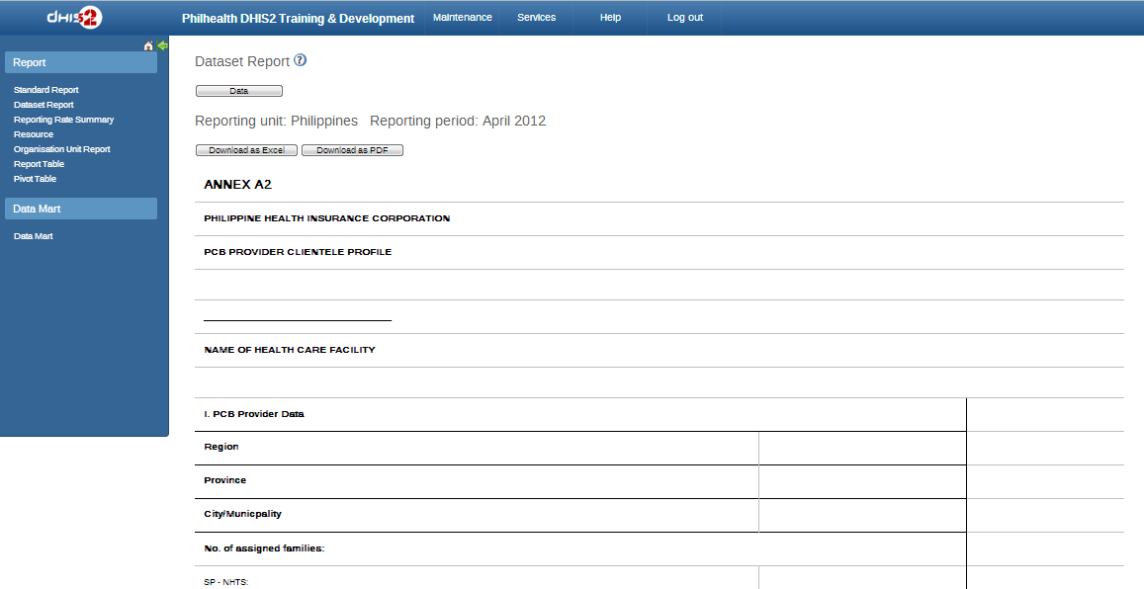

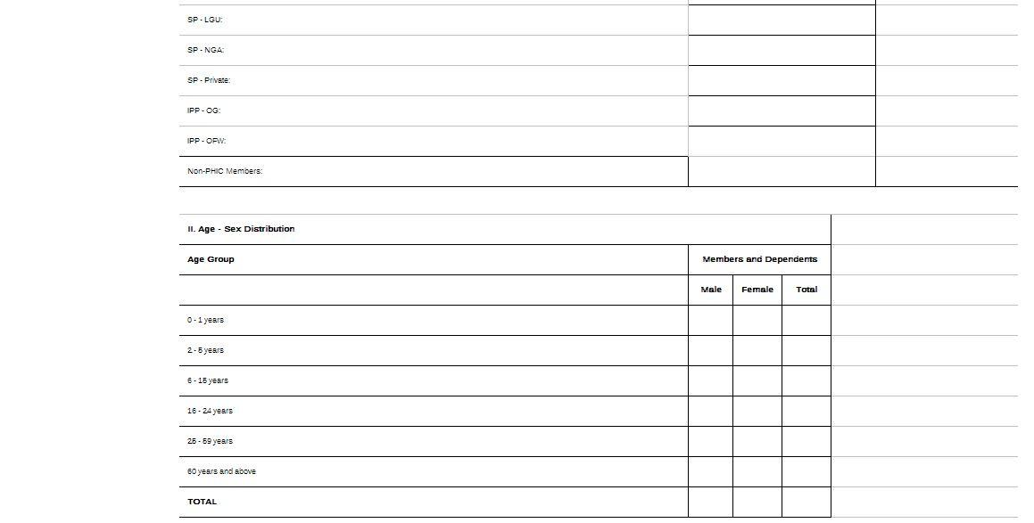

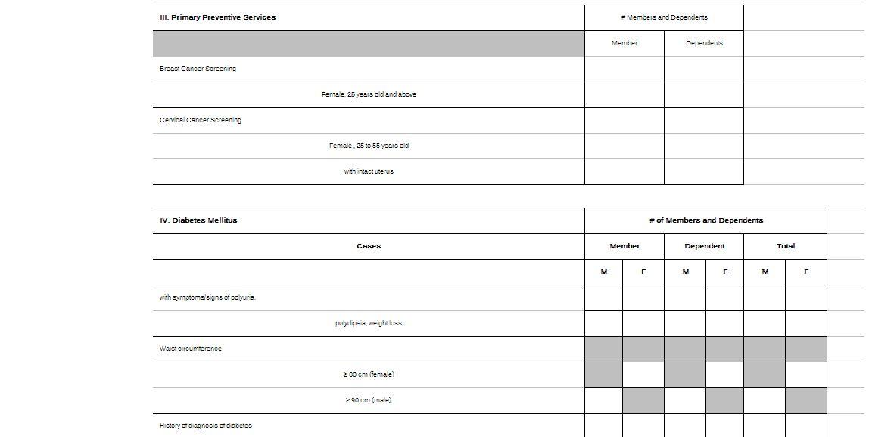

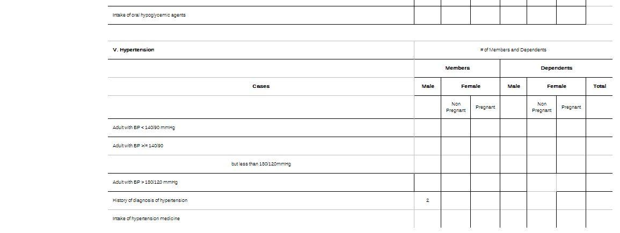

**Successful**: The aggregated data (report result of 2) from the database is now reflected in the DHIS2 “Dataset Report”. *(i.e. exactly displayed on the cell for the data element of “history of diagnosis of hypertension” and the disaggregation of “male, uncategorized, member” as defined in the xml)*

<Note that 2 is really the result from the database query, since it’s just a sample.>

**IV. SETTING THE OPENMRS’ LOCATION**

**AND DHIS2’s ORGANISATION UNIT**

**A. Getting the code of the Organisational Unit**

1. Navigate to the DHIS2.

2. Go to “Maintenance” (top menu).

3. Select “Organisation Units” (dropdown).

4. Click to “Organisation Unit” (central area).

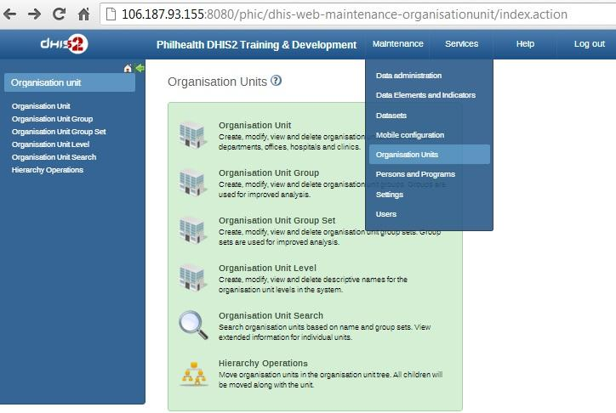

5. Select the organization unit by:

(a) Use the Left menu’s expanding list to display your preferred organisation unit (i.e. + Philippines [left menu])

<use the + or - to display of the hierarchy of the existing organisation units)

(b) Optional: Double click that particular organization unit [left menu]

(c) Click the “edit icon” of that organisation unit.

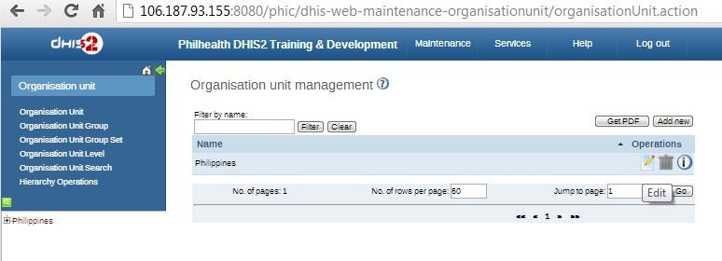

6. Copy the value of the “Code” in the “Edit Organisation Unit” section [central area].

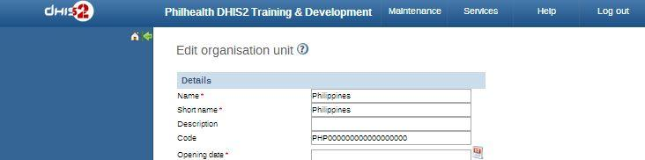

**B. Setting the Location in the OpenMRS Database**

1. Open your OpenMRS database





*mysql -u root -p*

*SHOW DATABASES;*

*USE openmrs;*

*UPDATE location SET name = 12345678 WHERE location_id = 1*

// or whatever name and location_id you wish to update

you should also insert other location for each organizational units.

Note: Make sure that your obs table has location_id that is available in the location table.

**V. CREATING/CUSTOMIZING THE XML FILE**

The xml file should be available or made even before anything else.

The sample format:

|  |
| --- |
| <?xml version="1.0"?>  <reportTemplates xmlns:d2="http://dhis2.org/schema/dxf/2.0">    <dataElements>  <dataElement uid="nkOlqRCq8J9" code="HXHPN" name="hx_hypertension" type="int"/>  </dataElements>  <disaggregations>  <disaggregation uid="Gb0BGTbfg19" code="Gb0BGTbfg19" name="male_uncategorized_member"/>  </disaggregations>    <reportTemplate>  <name>PCB Form A2</name>  <uid>bazOE3Zgw8O</uid>  <code>A2</code>  <periodType>Monthly</periodType>  <dataValueTemplates>  <dataValueTemplate dataElement="HXHPN" disaggregation="Gb0BGTbfg19">  <annotation>  select count(distinct p.person_id)  from person p  inner join obs o on o.person_id = p.person_id  where p.voided = 0 and o.voided = 0  and o.concept_id = 31  and o.obs_datetime >= :startOfPeriod  and o.obs_datetime &lt;= :endOfPeriod  and o.location_id = :locationId  </annotation>  </dataValueTemplate>  </dataValueTemplates>  </reportTemplate>  </reportTemplates> |

Note that the DHIS2 report XML code has:

1 - xml version <?xml version="1.0"?>

2 - reportTemplates <reportTemplates xmlns:d2="<http://dhis2.org/schema/dxf/2.0>">

</reportTemplates>

The reportTemplates is divided into three: (1) dataElements, (2) disaggregations, and (3) reportTemplate.

|  |  |
| --- | --- |
| 1 - **dataElements**  (list all the needed “data elements” like “history of diagnosis of hypertension”;  there may be several dataElement inside the dataElements) | <dataElements>  <dataElement uid="nkOlqRCq8J9" code="HXHPN" name="hx_hypertension" type="int"/>  </dataElements> |
| 2 - **disaggregation**  (list all the needed “category optioncombos” or “categorycombos” like “male_uncategorized_member”; there may be multiple disaggregation tag inside the disaggregations) | <disaggregations>  <disaggregation uid="Gb0BGTbfg19" code="Gb0BGTbfg19" name="male_uncategorized_member"/>  </disaggregations> |
| 3 - **reportTemplate**  (may have multiple entries, depending on the number of different types of reports needed to be produced)  3.1 - name  3.2 - uid  3.3 - code  3.4 - periodType  3.5 - dataValueTemplates  3.5.1 - dataValueTemplate  3.5.2 - annotation | <reportTemplate>  <name>PCB Form A2</name>  <uid>bazOE3Zgw8O</uid>  <code>A2</code>  <periodType>Monthly</periodType>  <dataValueTemplates>  <dataValueTemplate dataElement="HXHPN" disaggregation="Gb0BGTbfg19">  <annotation>  select count(distinct p.person_id)  from person p  inner join obs o on o.person_id = p.person_id  where p.voided = 0 and o.voided = 0  and o.concept_id = 31  and o.obs_datetime >= :startOfPeriod  and o.obs_datetime &lt;= :endOfPeriod  and o.location_id = :locationId  </annotation>  </dataValueTemplate>  </dataValueTemplates>  </reportTemplate> |

Legend:

red = entity or attribute that needs to be changed depending on the specified data for the a DHIS2 report

**A. Preparing the required data elements**

1. Go to: <dhis2site>/api/dataElements

i.e. localhost:8080/phic/api/dataElements

2. Search for the data element you need from the displayed list.

3. Click the html opposite the data element preferred.

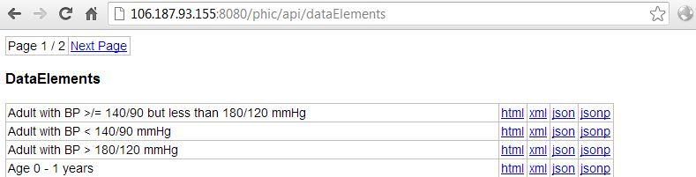

4. Assign the value of the id, code, and type of that data set (based on the html shown) to the xml attributes.

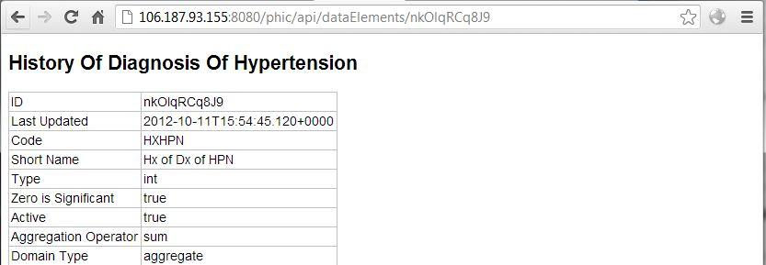

For instance, for the history of hypertension: the uid (ID) would be “nkOlqRCq8J9“; the code would be “HXHPN”; the name may be “history of diagnosis of hypertension” (you may also shorten the name); and the type would be “int”.

5. Follow the format of the existing DHIS2 report xml by changing the values in red color. Thus, in the xml code, the format would be:

<dataElements>

<dataElement uid="nkOlqRCq8J9" code="HXHPN" name="hx_hypertension" type="int" />

</dataElements>

6. If you would like to add more data element, simply add another <dataElement … /> inside the <dataElements>.

<dataElements>

<dataElement uid="nkOlqRCq8J9" code="HXHPN" name="hx_hypertension" type="int"/>

<dataElement uid="<id>" code="<code>" name="<name>" type="<type>"/>

</dataElements>

**B. Preparing the required disaggregations**

1. Go to: <dhis2site>/api/categoryOptionsCombos

or <dhis2site>/api/categoryCombos or <dhis2site>/api/categoryOptions

i.e. localhost:8080/phic/api/categoryOptionCombos

2. Search for the disaggregation that you need.

3. Click the html opposite the data element preferred.

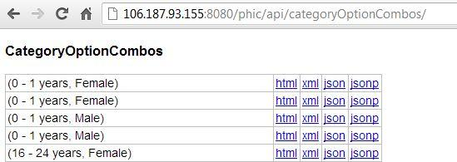

4. Assign the value of the id, and code (based on the html shown) of the disaggregation selected to the xml attributes.

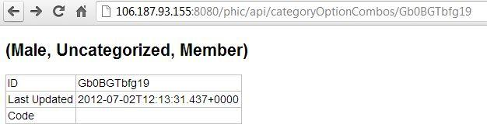.

For instance, for the disaggregation needing that of “male, uncategorized, member”: the uid (ID) would be “Gb0BGTbfg19“. You may simply copy the uid for the code if it is not existing so code will also be ““Gb0BGTbfg19” (similar to the pattern for the ‘templates_ethiopia.xml’) ; the name may be “male_uncategorized_member” (you may also shorten it).

5. Follow the format of the existing DHIS2 report xml by changing the values in red color. Thus, in the xml code, the format would be:

|  |
| --- |
| <disaggregations>  <disaggregation uid="Gb0BGTbfg19" code="Gb0BGTbfg19" name="male_uncategorized_member" />  </disaggregations> |

6. If you would like to add more disaggregation, simply add another <disaggregation … /> inside the <disaggregations>.

|  |
| --- |
| <disaggregations>  <disaggregation uid="Gb0BGTbfg19" code="Gb0BGTbfg19" name="male_uncategorized_member" />  <disaggregation uid="<uid>" code="<code>" name="<name>" />  </disaggregations> |

**C. Formulating the reportTemplate**

1. Go to: <dhis2site>/api/dataSets

2. Search for the dataSet that you need.

3. Click the html opposite the data element preferred.

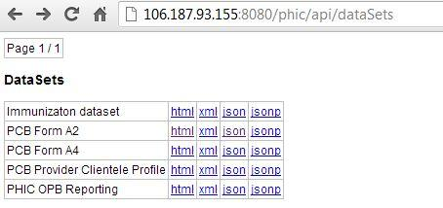

4. Assign the value of the id, and code (based on the html shown) of the reportTemplate for the xml file.

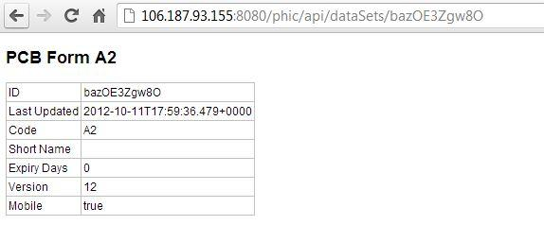

For instance, for the reportTemplate of “PCB Form A2”: the <name> would be “PCB Form A1” , <uid> (ID) would be “bazOE3Zgw8O“, <code> (code) would be A2.

**-----------------------------------------------------------------------------------------------------------------**

**IMPORTANT:**  The “Code” for the Dataset is required!! (unlike in the disaggregate or CategoryOptionCombo). Thus, if there is no existing code yet, you need to enter a new code for that dataset by editing it in the dataelement.

a. Go to DHIS2

b. Click the Maintenance [top menu]

c. Select the Data Elements and Indicators [dropdown]

d. Click the Data Element [central area]

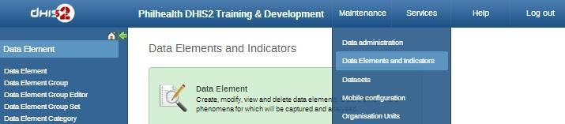

e. Edit Icon of the needed data element (i.e. Age - Sex Distribution edit icon)

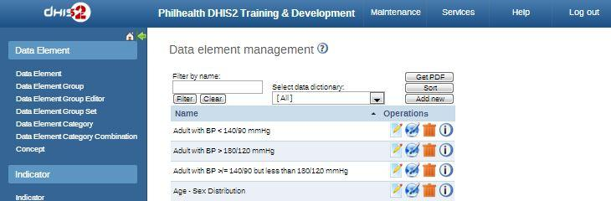

f. Enter the new code, which will then be used for (and reflected in) the dataset.

g. Click Save.

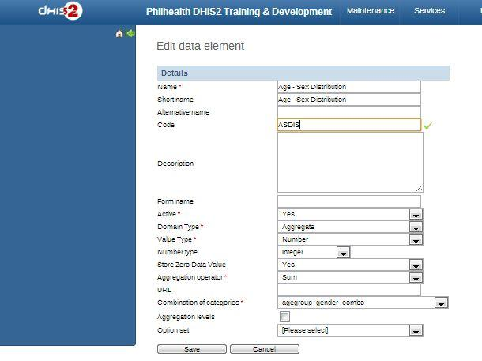

---------------------------------------------------------------------------------------------------

5. To check for the <periodType>, you need to go to the DHIS2 > Maintenance > Dataset > Edit Datasets

(a) Navigate to the DHIS2 site.

(b) Select the “Maintenance” (top menu) > “Datasets” (dropdown) > “Data set” (central area)

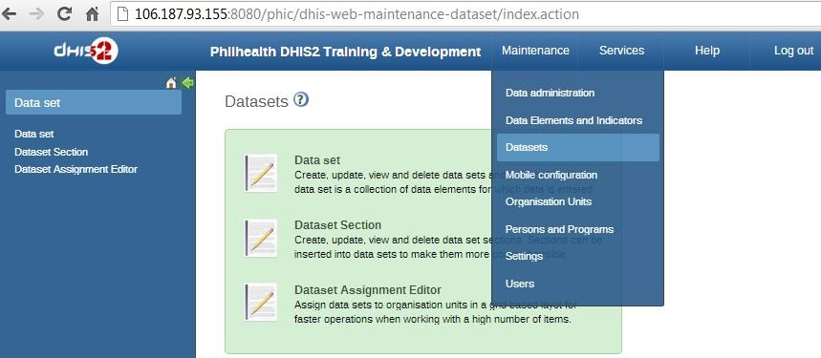

(c) Click the “edit” (icon) for the preferred dataset (i.e. edit for PCB Form A2)

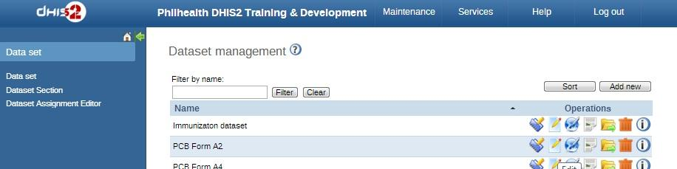

(d) Assign the value for the “Frequency” to the <periodType>.

Actually, the name, and the code can also be found here. However the edit dataset do not contain the “id”.

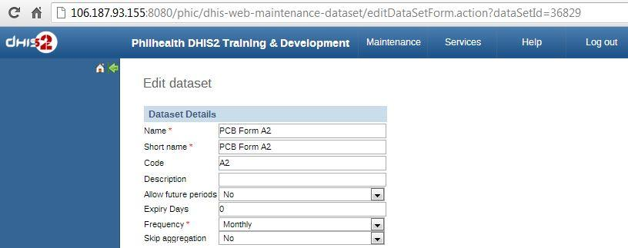

Hence, for the reportTemplate of the “PCB Form A2”: the <name>(“Name”) would be “PCB Form A2“, uid would be “bazOE3Zgw8O”, the <code>(“Code”) would be “A2”, and the <periodType>(“Frequency”) would be “Monthly”.

6. For the <dataValueTemplate>, you will need to set the value of the dataElement and disaggregation similar to the “code” of the required dataset and the disaggregation respectively (which are already declared in the upper part of the xml file).

From previous example, the code for the dataset “history of hypertension” is “HXHPN”, and the code for the disaggregation/categoryOptionCombo “male, uncategorized, member” is “Gb0BGTbfg19”.

7. For the annotation, this would pertain to the SQL query you want from the OpenMRS database.

Here, the mapping of the OpenMRS’ concept with the DHIS2’s data set would play an important role.

For example, since your dataset specified is “history of diagnosis of hypertension”

select count(distinct p.person_id)

from person p

inner join obs o on o.person_id = p.person_id

where p.voided = 0 and o.voided = 0

and o.concept_id = 31

and o.obs_datetime >= :startOfPeriod

and o.obs_datetime &lt;= :endOfPeriod

and o.location_id = :locationId

depending on your needed sql query statement, you may also add other conditions like... AND o.value_numeric >= 140

8. Follow the format of the existing DHIS2 report xml by changing the values in red color. Thus, in the xml code, the format would be:

|  |
| --- |
| <reportTemplate>  <name>PCB Form A2</name>  <uid>bazOE3Zgw8O</uid>  <code>A2</code>  <periodType>Monthly</periodType>  <dataValueTemplates>  <dataValueTemplate dataElement="HXHPN" disaggregation="Gb0BGTbfg19">  <annotation>  select count(distinct p.person_id)  from person p  inner join obs o on o.person_id = p.person_id  where p.voided = 0 and o.voided = 0  and o.concept_id = 31  and o.obs_datetime >= :startOfPeriod  and o.obs_datetime &lt;= :endOfPeriod  and o.location_id = :locationId  </annotation>  </dataValueTemplate>  </dataValueTemplates>  </reportTemplate> |

**VI. MORE XML SAMPLES**

**A. ONE REPORT WITH TWO DATA VALUE TEMPLATES**

Example:

**--- PCB FORM A2 --**

1. dataElement: History Of Diagnosis Of Hypertension (integer) nkOlqRCq8J9

categoryOptionCombo: Male, Uncategorized, Member Gb0BGTbfg19

2. dataElement: Age - Sex Distribution (integer) nkOlqRCq8J9

categoryOptionCombo: 0 - 1 Years, Female Gb0BGTbfg19

|  |
| --- |
| <?xml version="1.0"?>  <reportTemplates xmlns:d2="http://dhis2.org/schema/dxf/2.0">    <dataElements>  <dataElement uid="nkOlqRCq8J9" code="HXHPN" name="hx_hypertension" type="int"/>  <dataElement uid="NCq15lhqnuo" code="ASDIS" name="age_sex_distribution" type="int"/>  </dataElements>  <disaggregations>  <disaggregation uid="Gb0BGTbfg19" code="Gb0BGTbfg19" name="male_uncategorized_member"/>  <disaggregation uid="[hg8g7zrmTun](http://106.187.93.155:8080/phic/api/categoryOptionCombos/YDEW3nm5WC7)" code="[hg8g7zrmTun](http://106.187.93.155:8080/phic/api/categoryOptionCombos/YDEW3nm5WC7)" name="zero_one_years_female"/>  </disaggregations>    <reportTemplate>  <name>PCB Form A2</name>  <uid>bazOE3Zgw8O</uid>  <code>A2</code>  <periodType>Monthly</periodType>  <dataValueTemplates>  <dataValueTemplate dataElement="HXHPN" disaggregation="Gb0BGTbfg19">  <annotation>  select count(distinct p.person_id)  from person p  inner join obs o on o.person_id = p.person_id  where p.voided = 0 and o.voided = 0  and o.concept_id = 31  and o.obs_datetime >= :startOfPeriod  and o.obs_datetime &lt;= :endOfPeriod  and o.location_id = :locationId  </annotation>  </dataValueTemplate>  <dataValueTemplate dataElement="ASDIS" disaggregation="[hg8g7zrmTun](http://106.187.93.155:8080/phic/api/categoryOptionCombos/YDEW3nm5WC7)">  <annotation>  select count(distinct p.person_id)  from person p  inner join obs o on o.person_id = p.person_id  where p.voided = 0 and o.voided = 0  and o.concept_id = 28  and o.obs_datetime >= :startOfPeriod  and o.obs_datetime &lt;= :endOfPeriod  and o.location_id = :locationId  </annotation>  </dataValueTemplate>  </dataValueTemplates>  </reportTemplate>  </reportTemplates> |

**REPORTS: PREVIEW**

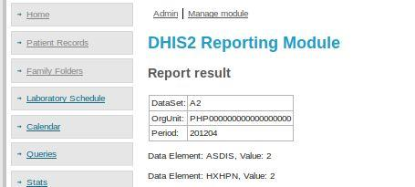

**REPORTS: POST TO DHIS**

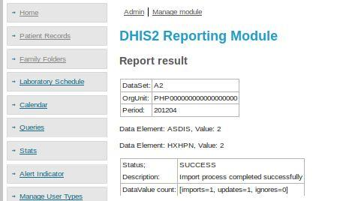

**REPORTS: DHIS2**

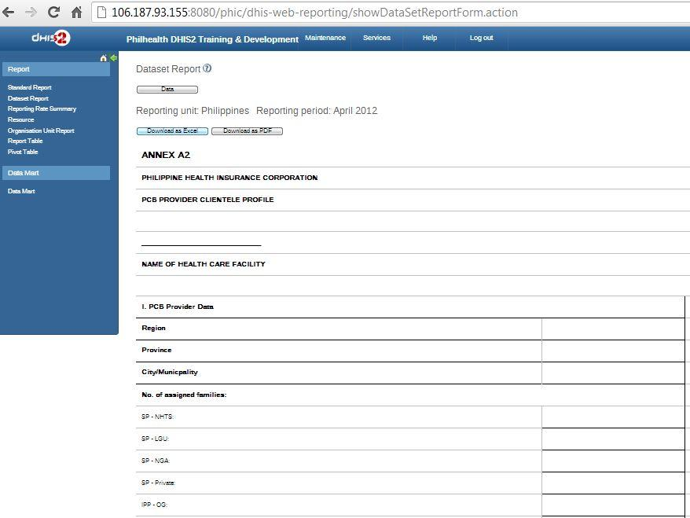

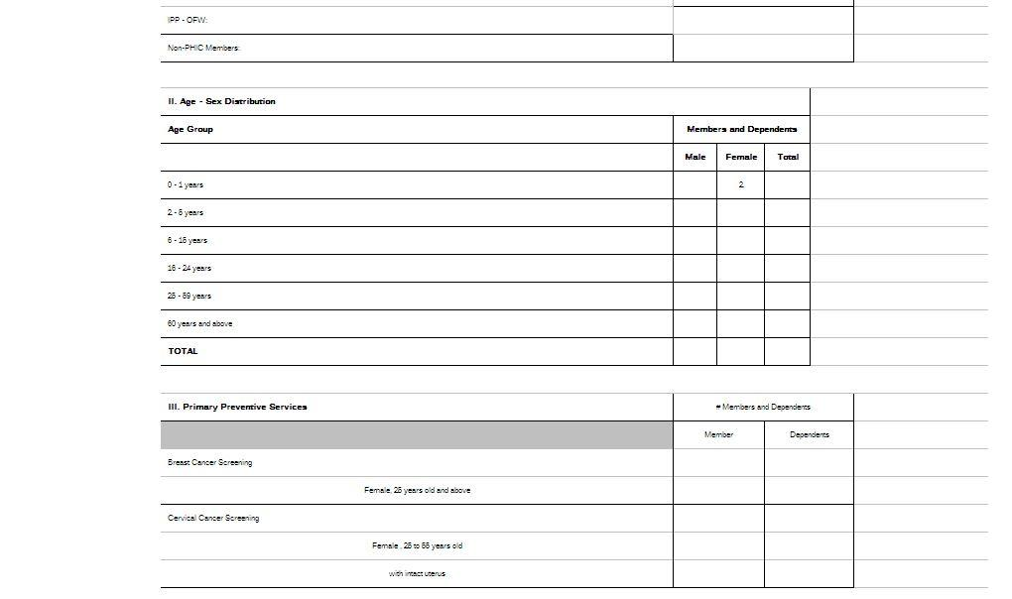

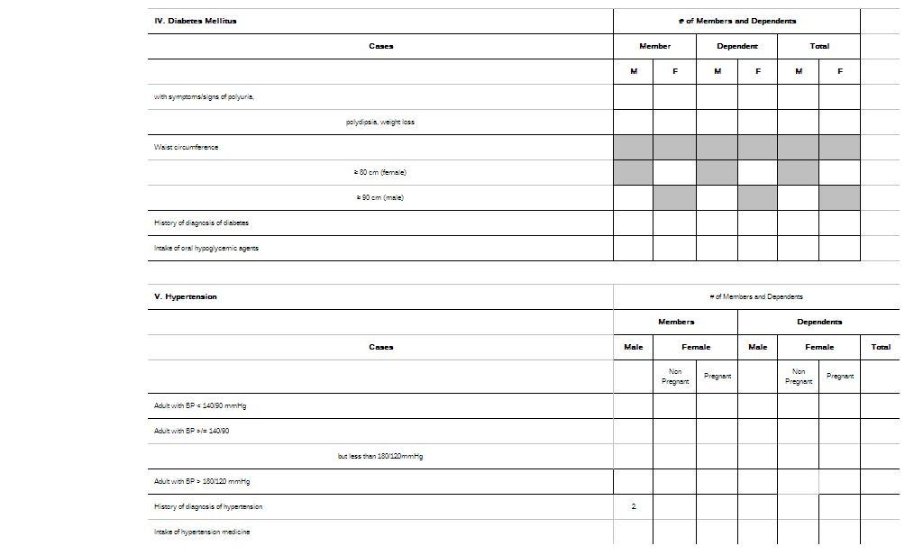

**Successful**: The aggregated data are now reflected in the DHIS2 “Dataset Report”.

*(i.e. exactly displayed on the cell for the ff.:*

1. data element of “Age - Sex Distribution” and the disaggregation of “0 - 1 Years, Female”

*2. data element of “history of diagnosis of hypertension” and the disaggregation of “male, uncategorized, member” as defined in the xml*)