Appendix A: Glossary
- Admin - A User with administrative abilities. There are two kinds: Teacher and Teacher Assistant.
- Application - the software package to be installed by a host machine.
- Browser - A Web Browser, an application like Internet Explorer, Firefox, and Safari to download an interpret web pages.
- Core [modules] - The central part of the software managing authorization of users, database connection, external modules etc.
- Exported Statistics - A list of classes or students the teacher wishes to save to another format on his or her computer.
- Features - Actions that the system can take with data. Features can only be requested from users with appropriate permissions.
- Host Machine - The computer in which software is installed and run.
- Interface - Also known as a Graphical User Interface (GUI). The graphical, non-functional side of the system.
- Metrics - Statistical representations of Grades. for instance, means and modes.
- Module - Package of code designed for a or a few related features.
- OS - Acronym for Operating System.
- Roster - A list of students in a single class.
- Software - The final package of code that was produced which can be installed in separate instances.
- System - The local instance of the Software and all of it's stored data. It does not include its users.
- Unregistered User - A human who attempts to access the system without any permissions.
- User - Any human with an Account within the System.
- Valid – a quality of an attribute when it exists on the system as defined by the Data Dictionary.

Appendix B: Data Dictionary

Account = Username
+ Name
+ Password
+ Permission
+ User Type
+ Email Address

Username = *A string of user's login name, maximum length of 40 characters*

Name = *A string of item's full name. The maximum string length is 200 characters.*

Password = *A password that grants access to a user. It is at least 6 characters long and
encrypted*

Permission = *An array of booleans indicating what following features a user is permitted to
use: Sending Emails, Upload Files, View Own Grades, Manage Classes, Manage Metrics,
Manage Grades, Manage Rosters, Manage Announcements and Manage Users.*

Email Address = *A email address format, represented by a string of 321 characters. that each
user has that can be contacted by. The name of the address, the part before the @ sign, must be
no longer than 65 characters and the domain, the part after the @ sign, must be no longer than
255 characters. *

User Type = ["Teacher" | "Teacher Assistant" | "Student"]

Teacher Assistant = *A User type that has permissions equal to or less than a Teacher and
more than a Student*

Teacher = 1:5{Course}
+ 1:100{Announcement}
+ Files

Course = 1:200{Student}
+ 0:10{Teacher Assistant}
+ Grading Rules
+ Course Title
+ Course Section
+ Course Number

Course Title = *A string of 100 characters indicating the title of class, such as
"Introduction to Welding"*

Course Section = *A positive integer indicating the section number of the class, if the
integer is single digit than a leading zero is displayed. *

Course Number = *A string of 32 characters indicating the short class name,
"CSC308"*

Grading Rules = Percentages
+ Course Curve

Course Curve = *Five numbers indicating the minimum Total Grade required to
obtain an A, B, C, and D*

Percentages = * An array of integers indicating the percentage of the Total Grade
different types of Assignment Grade make up. There are 6 numbers, each for
Homework, Test, Quiz, Final, Participation and Other. All numbers in the array
have a sum of 100*

Announcement = Announcement Title
+ Announcement Text
+ Announcement Date

Announcement Date = *A date and time in the default date and time format on the
Host computer when the Announcement was published*

Announcement Text = *A long string of 10,000 characters that indicated text body of
announcement post*

Announcement Title = *A string of 200 characters that indicates the title of the
announcement

Files = *A list that stores up to 100 files the user has uploaded onto the system*

Student = 1:100{Assignment Grade}
+ Total Grade
+ Files

Total Grade = *A calculated floating point number, the total score of Assignment
Grades, and a character, representing the letter grade, based on the Assignment Grade*

Assignment Grade = Assignment
+ Assignment Score

Assignment Score = *A floating point number and letter grade, represented by a char,
depicting the score of the assignment.*

Assignment = [Test | Quiz | Homework | Participation | Other]
+ Due Date
+ Name
+ Assignment Total

Due Date = *The date, using the host machine default for time and date, when the
Assignment must be turned in to the Teacher*

Assignment Total = *A floating point number and a char depicting the total
possible score points on this Assignment*

Email = Email Body
+ Email Title
+ Email Attachment
+ Email Recipients

Email Body = *A string of text written by a user that acts as the body of the email. It holds a
maximum of 10,000 characters.*

Email Title = *A string of 100 characters for the title of email*

Email Attachment = *A string address of file to be uploaded and sent. It is no longer than
255 characters*

Email Recipients = *A list of email addresses of the destinations. Each list item is a string of
321 characters.*

Appendix C: Analysis Models

Survey
Name:

Date:

Are you a teacher or student?

How many weeks have you been using GooGrade for? (round to nearest whole number)

Please rate your overall experience with GooGrade on a 1-10 scale (1 = poor, 10 = excellent)

Please rate the GooGrade's features list on a 1-10 scale (1 = poor, 10 = excellent)

Please rate the ease of use of GooGrade on a 1-10 scale (1 = difficult, 10 = easy)

Please rate the GooGrade's graphical user interface on a 1-10 scale (1 = poor, 10 = excellent)

Storyboards

C-1: Student Home screen


C-2: Student View Announcement

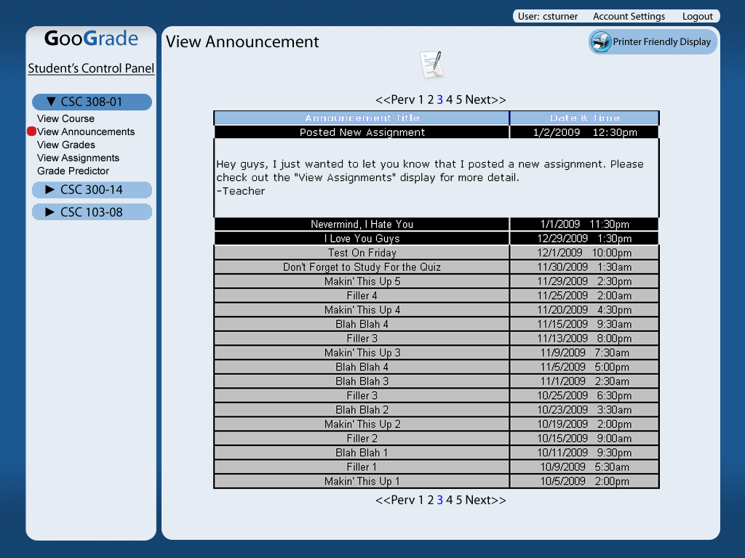
C-3: Student View Assignments

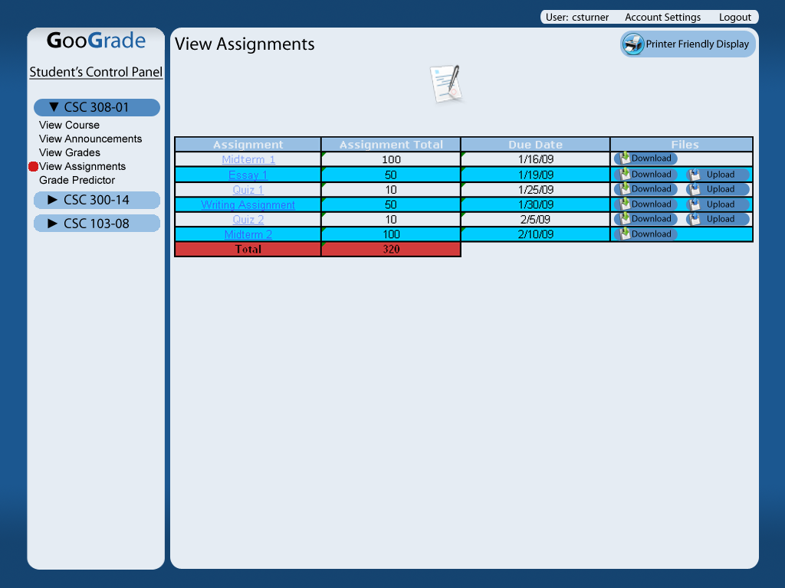
C-4: Student View Grades

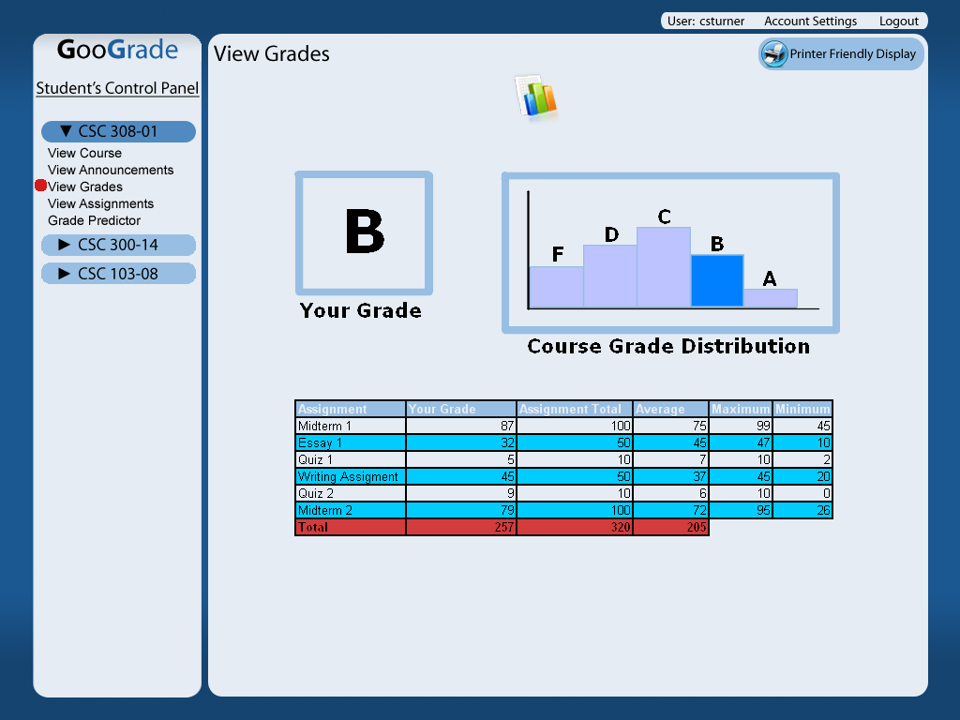
C-5: Student Grade Predictor

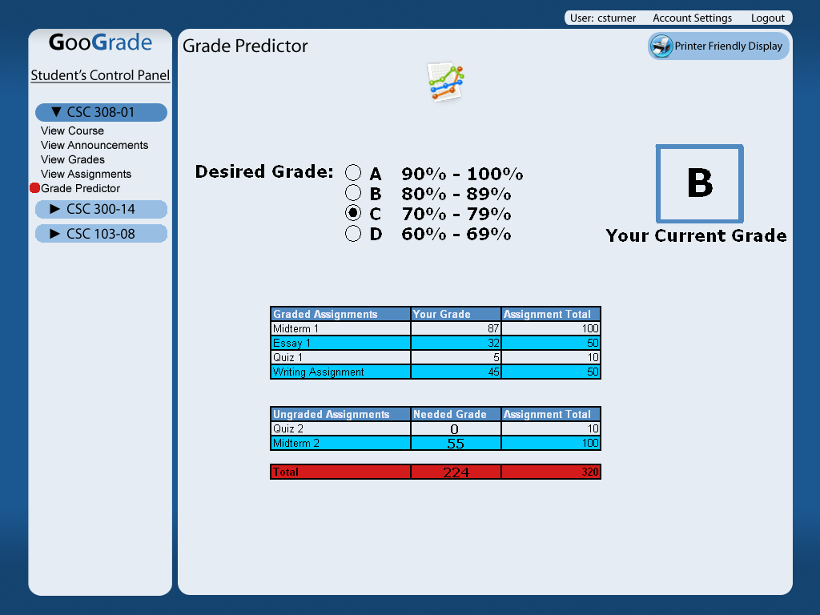
C-6: Edit My Account

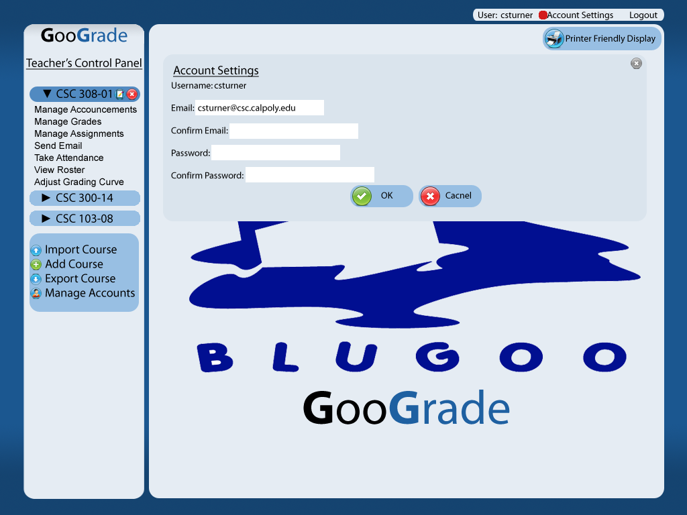
C-7: Edit My Account Error

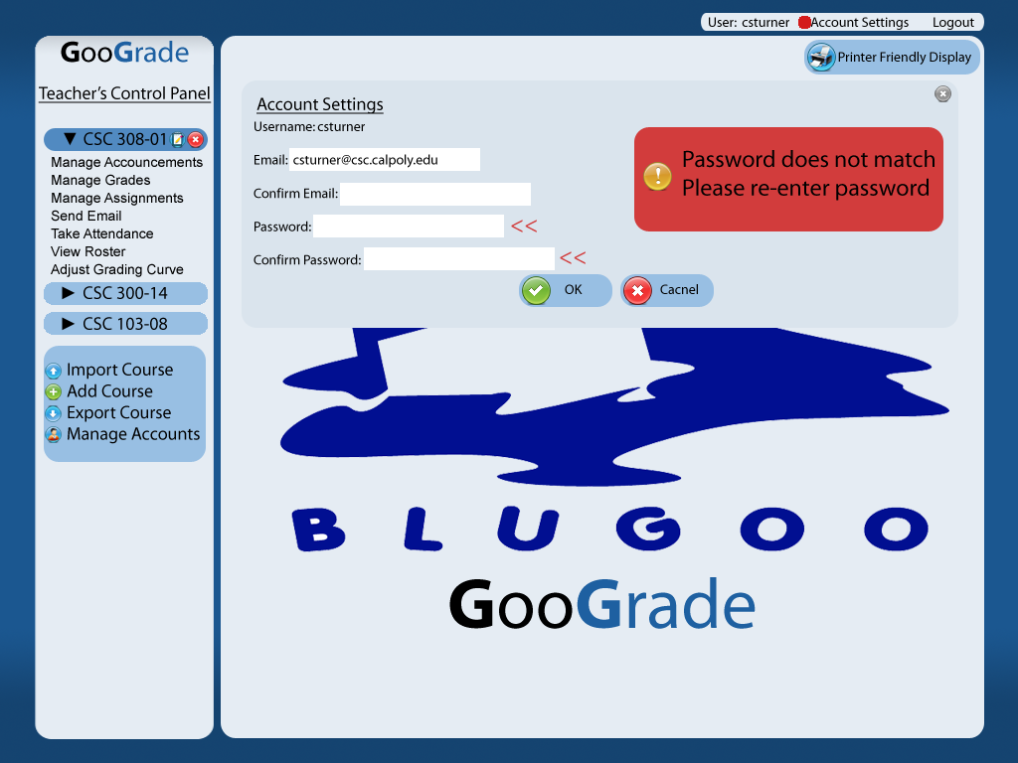
C-8: Teacher Home screen

C-9: Teacher Manage Announcement

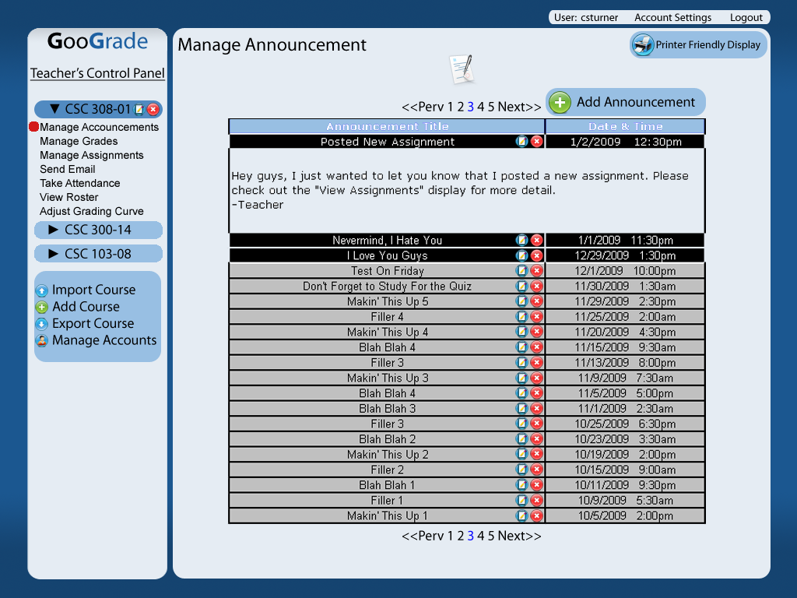
C-10: Teacher Manage Announcement Error

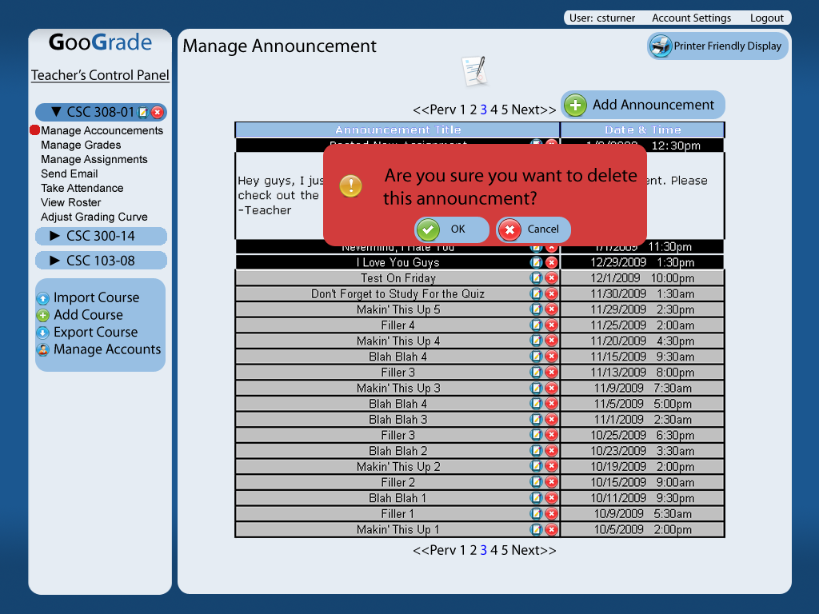
C-11: Add Announcement

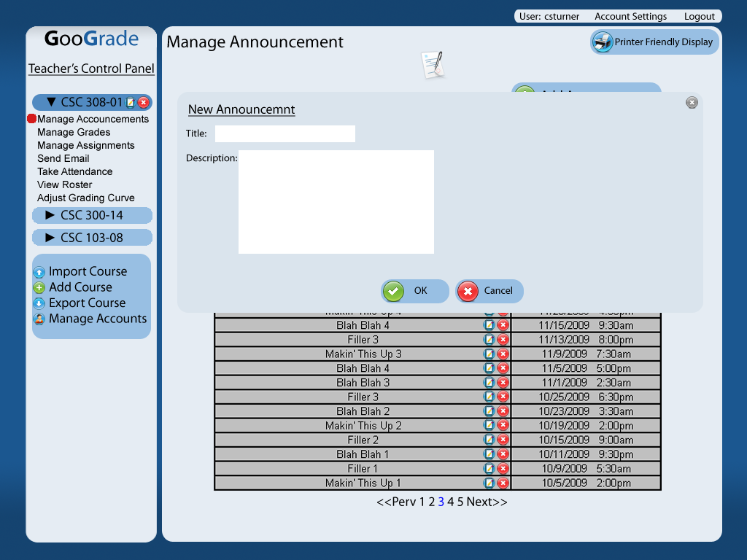

C-12: Add Announcement Error
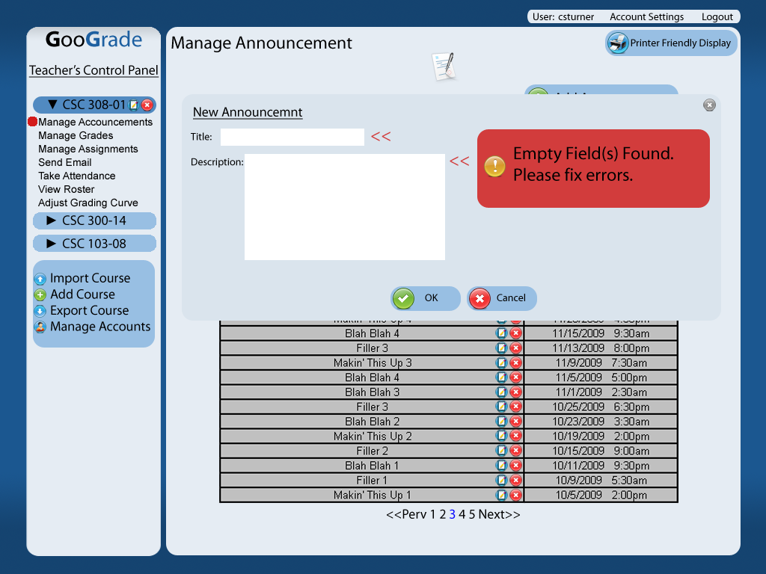

C-13: Teacher Manage Assignments

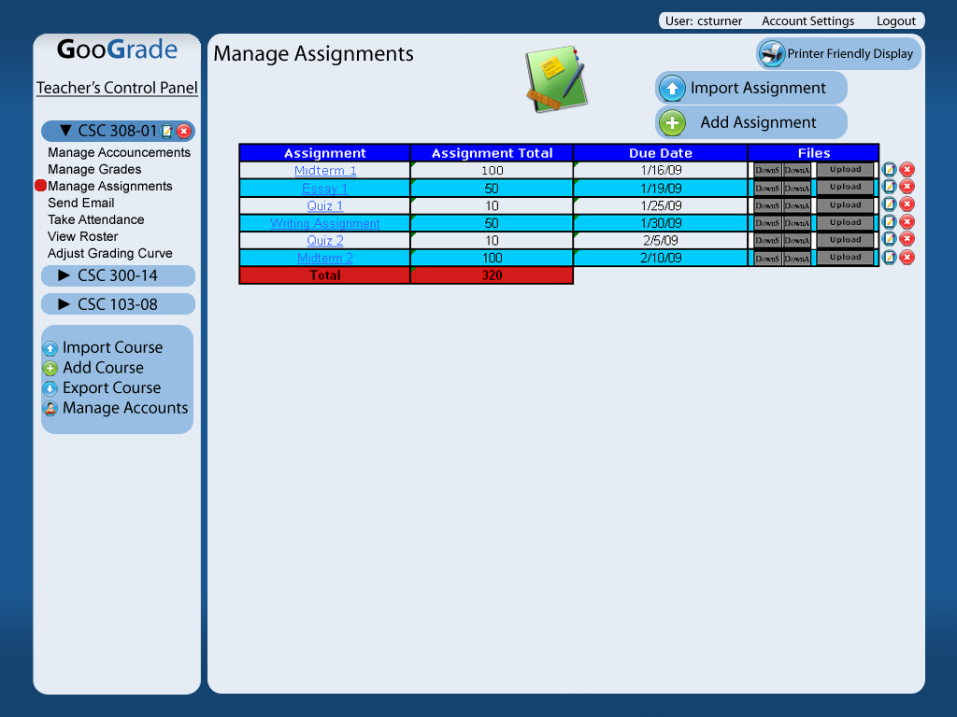
C-14: Teacher Manage Assignments Add

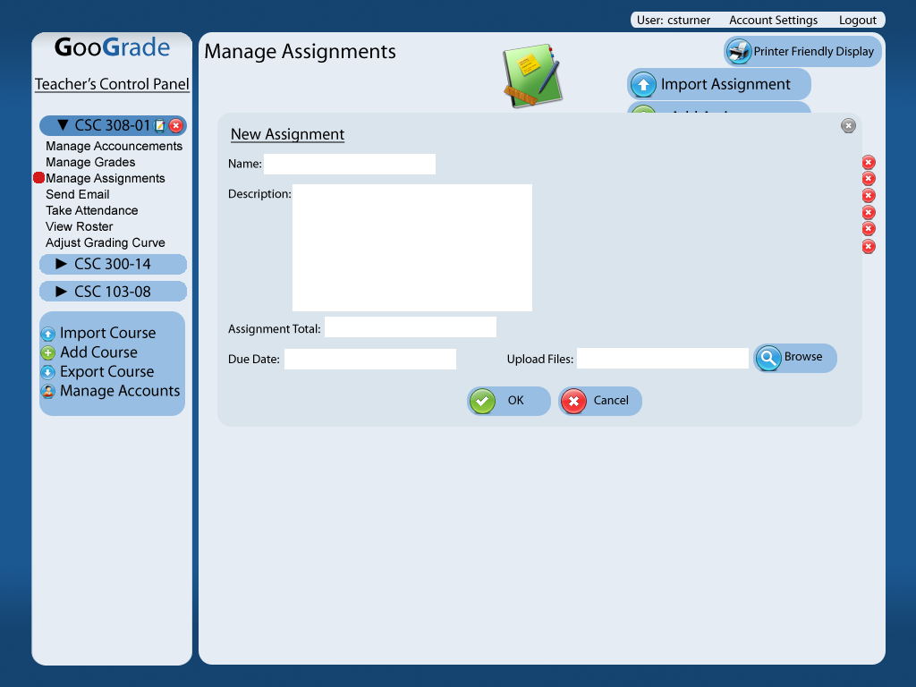
C-15: Manage Assignment Delete

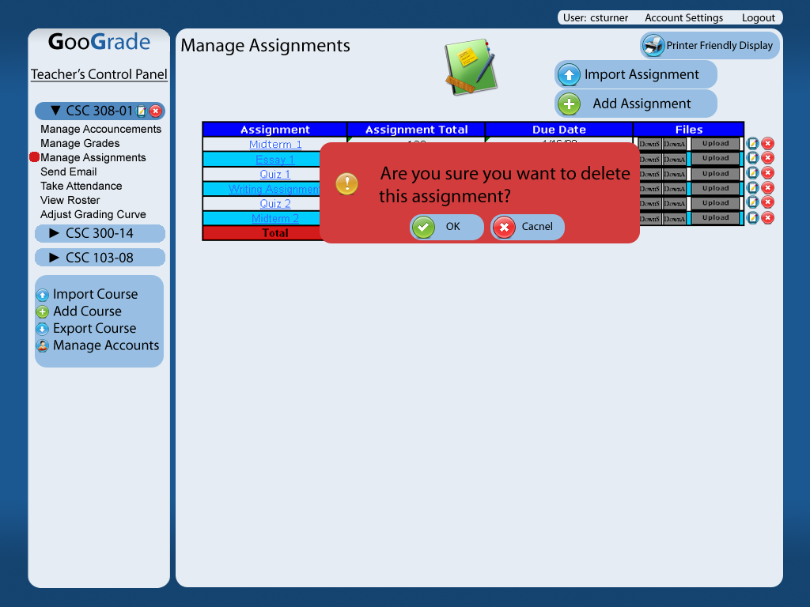

C-16: Manage Assignment Error

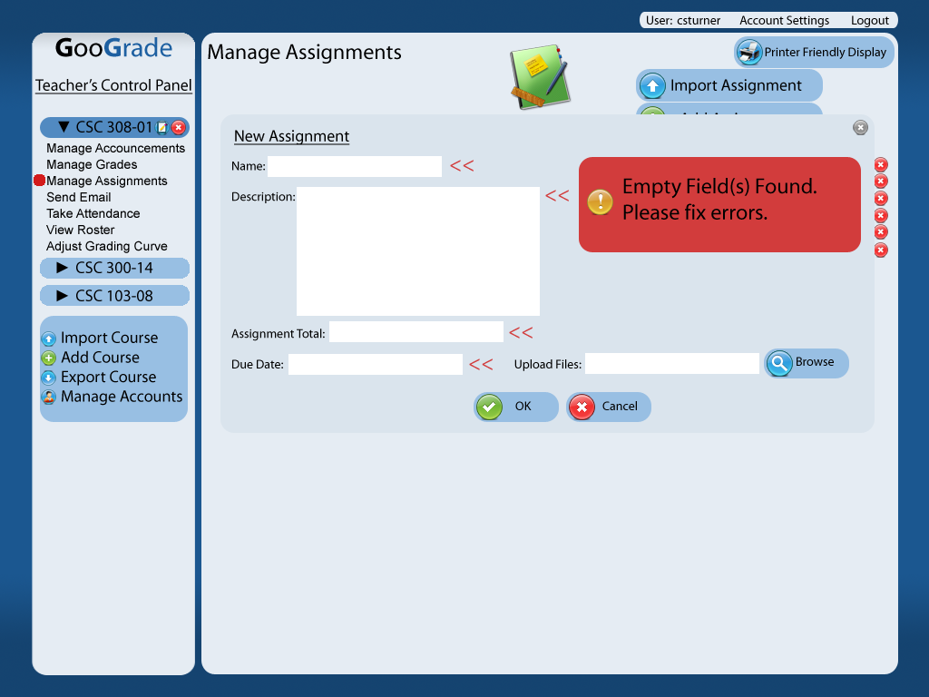

C-17: Teacher Manage Grades

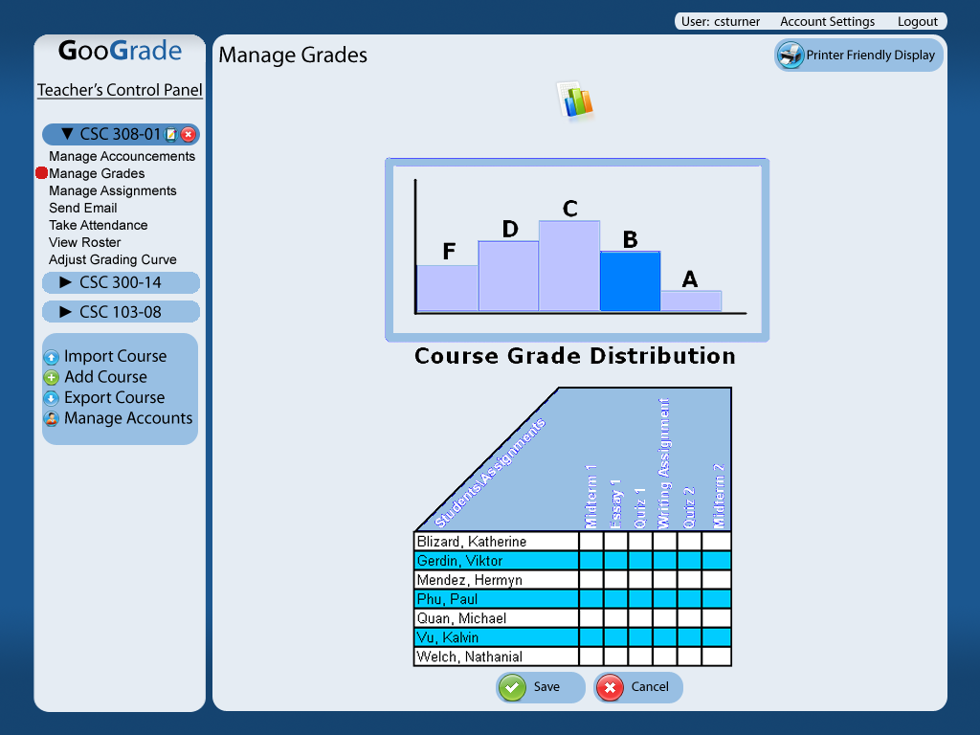
C-18: Teacher Manage Accounts

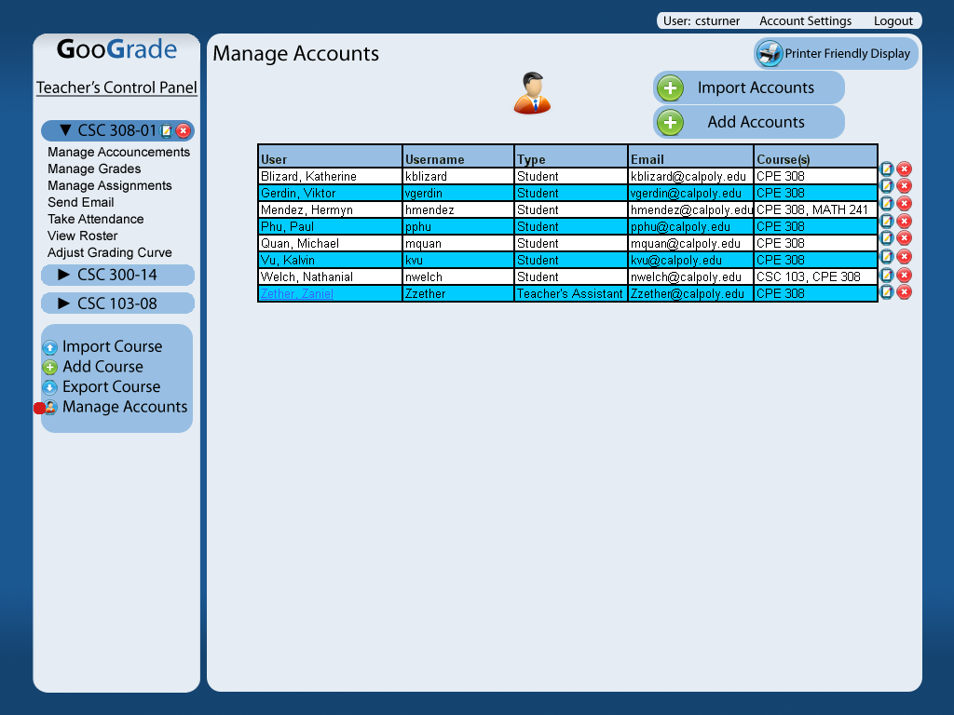

C-19: Add Account
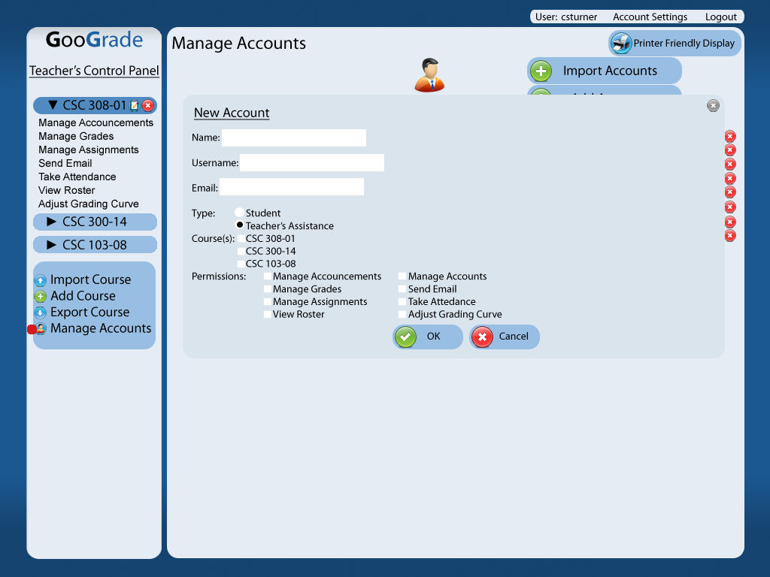

C-20: Add Account Error

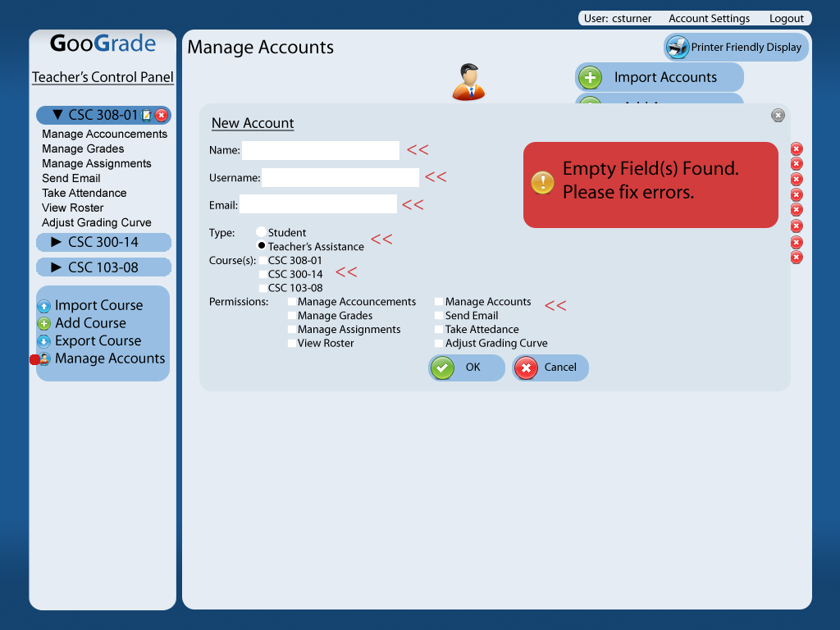

C-21: Take Attendance

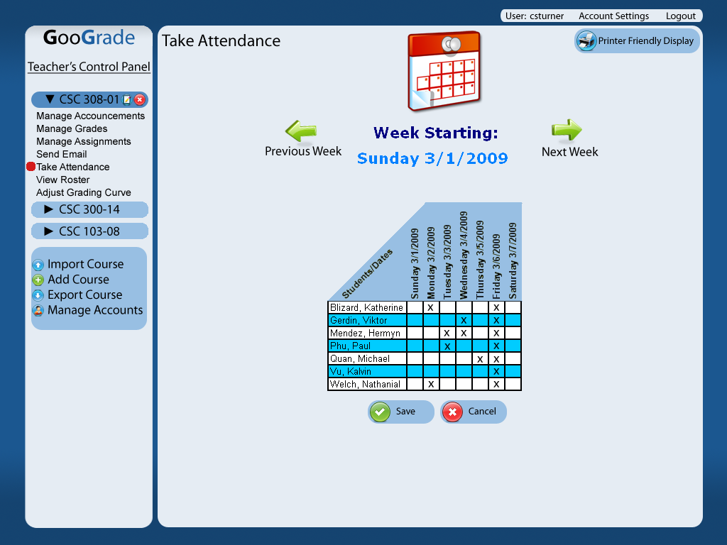

C-22: Teacher Adjust Grading Curve

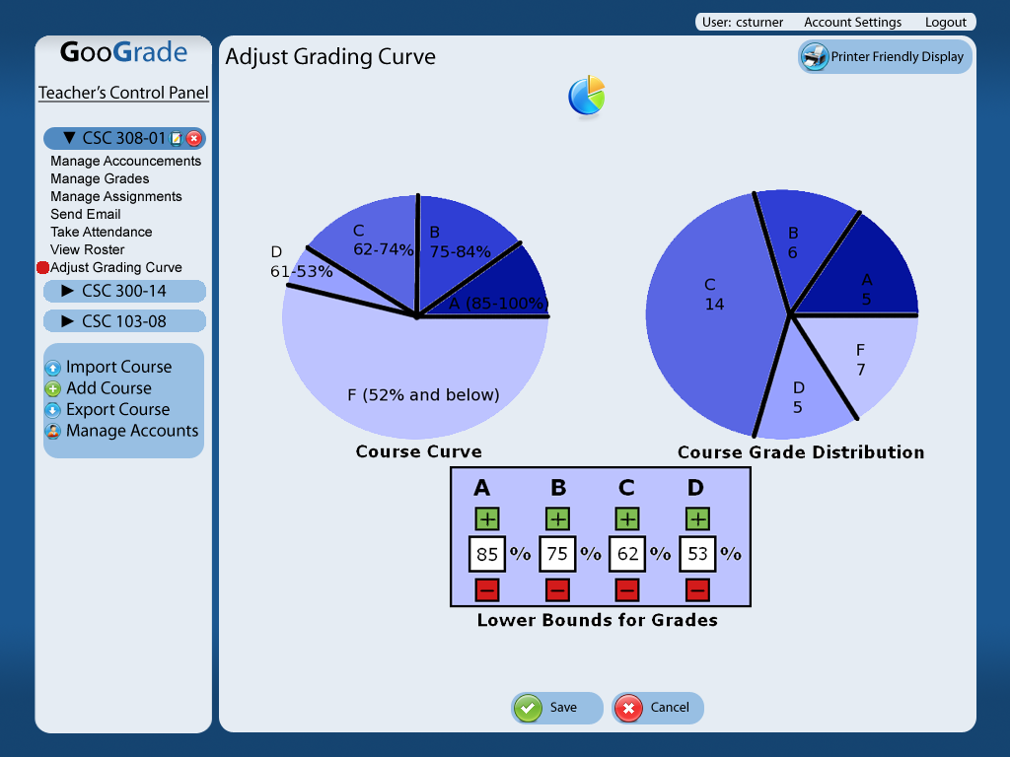

Appendix D: Issues List
Issue-1: File-size limitations on uploads
Issue-2: File format support
Issue-3: Use case document format
Issue-4: Review nonfunctional requirements

Appendix E: Use Cases

Use Cases for GooGrade are located in the attached document labeled Use Cases.

Appendix F: Test Cases

Test Cases for GooGrade are located in the attached document labeled Test Cases.

Appendix G: System Architecture

The Architecture for GooGrade is in the attached document labeled Architecture.

