Iconic University
Sokoto Nigeria
Smart Government Service Delivery Platform
CivicFlow

Project Monitoring and Evaluation Records
Weekly reporting sprint controls and contribution evidence
Group 1
MIT 820 Software Development Project I
Group member | Registration number
Aminu Idris | 2630802400002
Saidu Mustapha Suleman | 2630802400001
Bolaji Watson | 2630802400009
John Ojuekaiye Mayowa | 2630802400008
Egbue Odira Celestine | 2630803400003
Document version 1.1 Application baseline 1.0.4 23 October 2026
Final presentation 28 November 2026
Portal submission 29 November 2026 before 11:59 p.m. WAT

1 Recording and review procedure
This pack provides the records required to monitor Group 1 against MIT 820. Bolaji maintains the registers, while each member supplies evidence for their own work. Enter actual meeting dates, decisions, completed work and review results. The prepared fields and proposed backlog are planning records until completed and reviewed.
The repository contains editable Markdown templates and CSV registers alongside this printable pack. Link actual GitHub issues, commits and pull requests after the repository is uploaded. Each weekly report includes work completed, work planned, blockers and the current live-build link.

2 Weekly progress report form
Reporting period ____________________ Report number ______________
Prepared by ________________________ Date ________________________
Current live build URL and release __________________________________
Independent access check and date __________________________________

Work completed and evidence
________________________________________________________________
________________________________________________________________

Work planned for the next period
________________________________________________________________
________________________________________________________________

Blockers and support required
________________________________________________________________
________________________________________________________________

Risks or scope changes
________________________________________________________________
________________________________________________________________

Supervisor feedback and next review
________________________________________________________________
________________________________________________________________

3 Supervisor meeting minutes form
Meeting date and time WAT _________________________________________
Meeting mode or location __________________________________________
Attendees and apologies ___________________________________________
Agenda and relevant requirement or gate ____________________________
Decision and approval conditions __________________________________
Next review date __________________________________________________
Action | Owner | Due date | Evidence and status
________________ | ____________ | __________ | ________________
________________ | ____________ | __________ | ________________
________________ | ____________ | __________ | ________________

4 Sprint plan and review
Sprint | Dates in 2026 | Review focus
1 | 23 October to 1 November | Scope, SRS, architecture, models and repository baseline.
2 | 2 to 15 November | Integration, security boundaries, usability and defect correction.
3 | 16 to 27 November | Hosted acceptance, recovery, final documents and rehearsal.
The proposed backlog totals 79 points. An estimate is a planning unit rather than a duration or assessment mark. At sprint planning the group confirms scope and capacity. A done item must have linked evidence and review. Preserve the original estimate and record scope changes separately so the remaining-work history is intelligible.
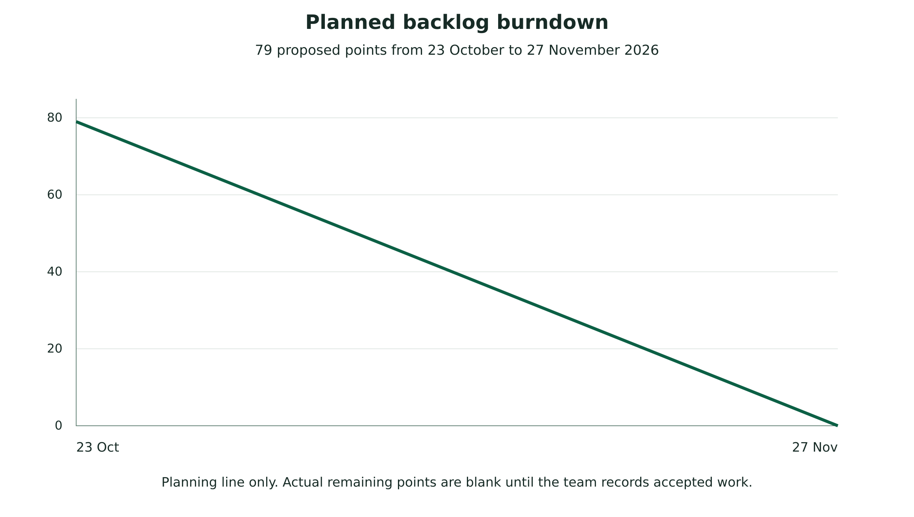
Figure 4.1 Planned backlog burndown
Sprint review date and attendees __________________________________
Accepted items and evidence _______________________________________
Unfinished items and reason ________________________________________
Retrospective action owner and due date ____________________________

5 Risk and issue register
ID and risk | Owner | Treatment | Review evidence
R01 Approval evidence missing | Bolaji | Obtain dated proposal record and conditions. | ________________
R02 Hosted system inaccessible | Aminu | Independent access check and local contingency. | ________________
R03 Private records exposed | Aminu | Repeat permission, upload and protected-path tests. | ________________
R04 Scope or provider delay | Bolaji | Prioritise core workflow and record provider dependencies. | ________________
R05 Insufficient quality evidence | John | Complete browser, capacity and recovery records. | ________________
R06 Contribution history incomplete | All members | Link actual commits, reviews and peer assessment. | ________________

6 Individual contribution and peer assessment
Member and registration | Allocated responsibility | Evidence and reviewer
Aminu Idris  2630802400002 | Development | Commit or PR __________________  Artifact _______________________  Reviewer ______________________
Saidu Mustapha Suleman  2630802400001 | Documentation | Commit or PR __________________  Artifact _______________________  Reviewer ______________________
Bolaji Watson  2630802400009 | Project management | Commit or PR __________________  Artifact _______________________  Reviewer ______________________
John Ojuekaiye Mayowa  2630802400008 | Development | Commit or PR __________________  Artifact _______________________  Reviewer ______________________
Egbue Odira Celestine  2630803400003 | Documentation | Commit or PR __________________  Artifact _______________________  Reviewer ______________________
Each member records the problem addressed, files or artifacts changed, test or review evidence and the corresponding issue or pull request. Peer assessment should describe the actual contribution and collaboration observed. Do not reconstruct Git commits or backdate records to imply work that the repository history does not contain.

7 Consent and usability observation
Explain the purpose, tasks, voluntary participation, information recorded, storage period and contact person before a usability session. Use an approved consent process. Permit withdrawal, avoid recording passwords or private cases, and use an anonymised participant ID. Obtain separate permission for any audio or screen recording and follow the university supervisor’s requirements.
Field | Observation
Participant ID and consent reference | ____________________________
Task and environment | ____________________________
Completion and assistance required | ____________________________
Error, time and participant comment | ____________________________
Action, owner and review date | ____________________________

8 Hosted test and recovery record
Environment URL and application release ____________________________
Database and PHP version __________________________________________
Test date checker and evidence ____________________________________
Workload method and response-time result ___________________________
Backup reference and restore environment ___________________________
Measured recovery point and recovery time __________________________
Failures defects and release decision ______________________________

9 Final defence and submission record
Confirm the approved proposal, reviewed SRS and ADD, current report, manuals, tests, code and independent live access before defence. Keep the evaluation password in the agreed private channel. Rehearse the workflow and questions with all five members. After the 28 November presentation, record the panel’s corrections and complete the portal submission before 11:59 p.m. WAT on 29 November.
Defence build and independent checker ______________________________
Panel feedback and correction owner ________________________________
Submission file list and final review _______________________________
Portal submission date time and receipt reference __________________
Project manager sign off __________________________________________

