System Design and Data Dictionary
  - Entity relationships architecture and workflow diagrams
Group 1 MIT 820 Application 1.0.4 Document 1.1 23 October 2026
This design document links the CivicFlow 1.0.4 application to its architecture, record relationships, workflow and permission decisions. The diagrams provide separate views to keep the 21-table schema readable. All columns and declared foreign keys appear in the dictionary. Dashed diagram links identify logical associations that are not database foreign keys.

1 Notation and data boundaries
PK denotes a primary key, FK a declared foreign key and UNIQUE a uniqueness constraint. A 1:M label means one to many. A solid relationship line represents a declared association shown in that view. Some repeated actor/uploader references appear as FK labels without an additional crossing line; the complete foreign-key table is authoritative. Optional fields are nullable. A logical reference is enforced by application behaviour without a declared database FK.
The citizen owns a request, the selected service supplies its default department, and current routing may change the processing department. The optional assignee is a staff user. Request versions guard concurrent edits. Templates and outbox messages retain distinct identities so a later template change does not rewrite queued content.

2 Architecture and diagrams

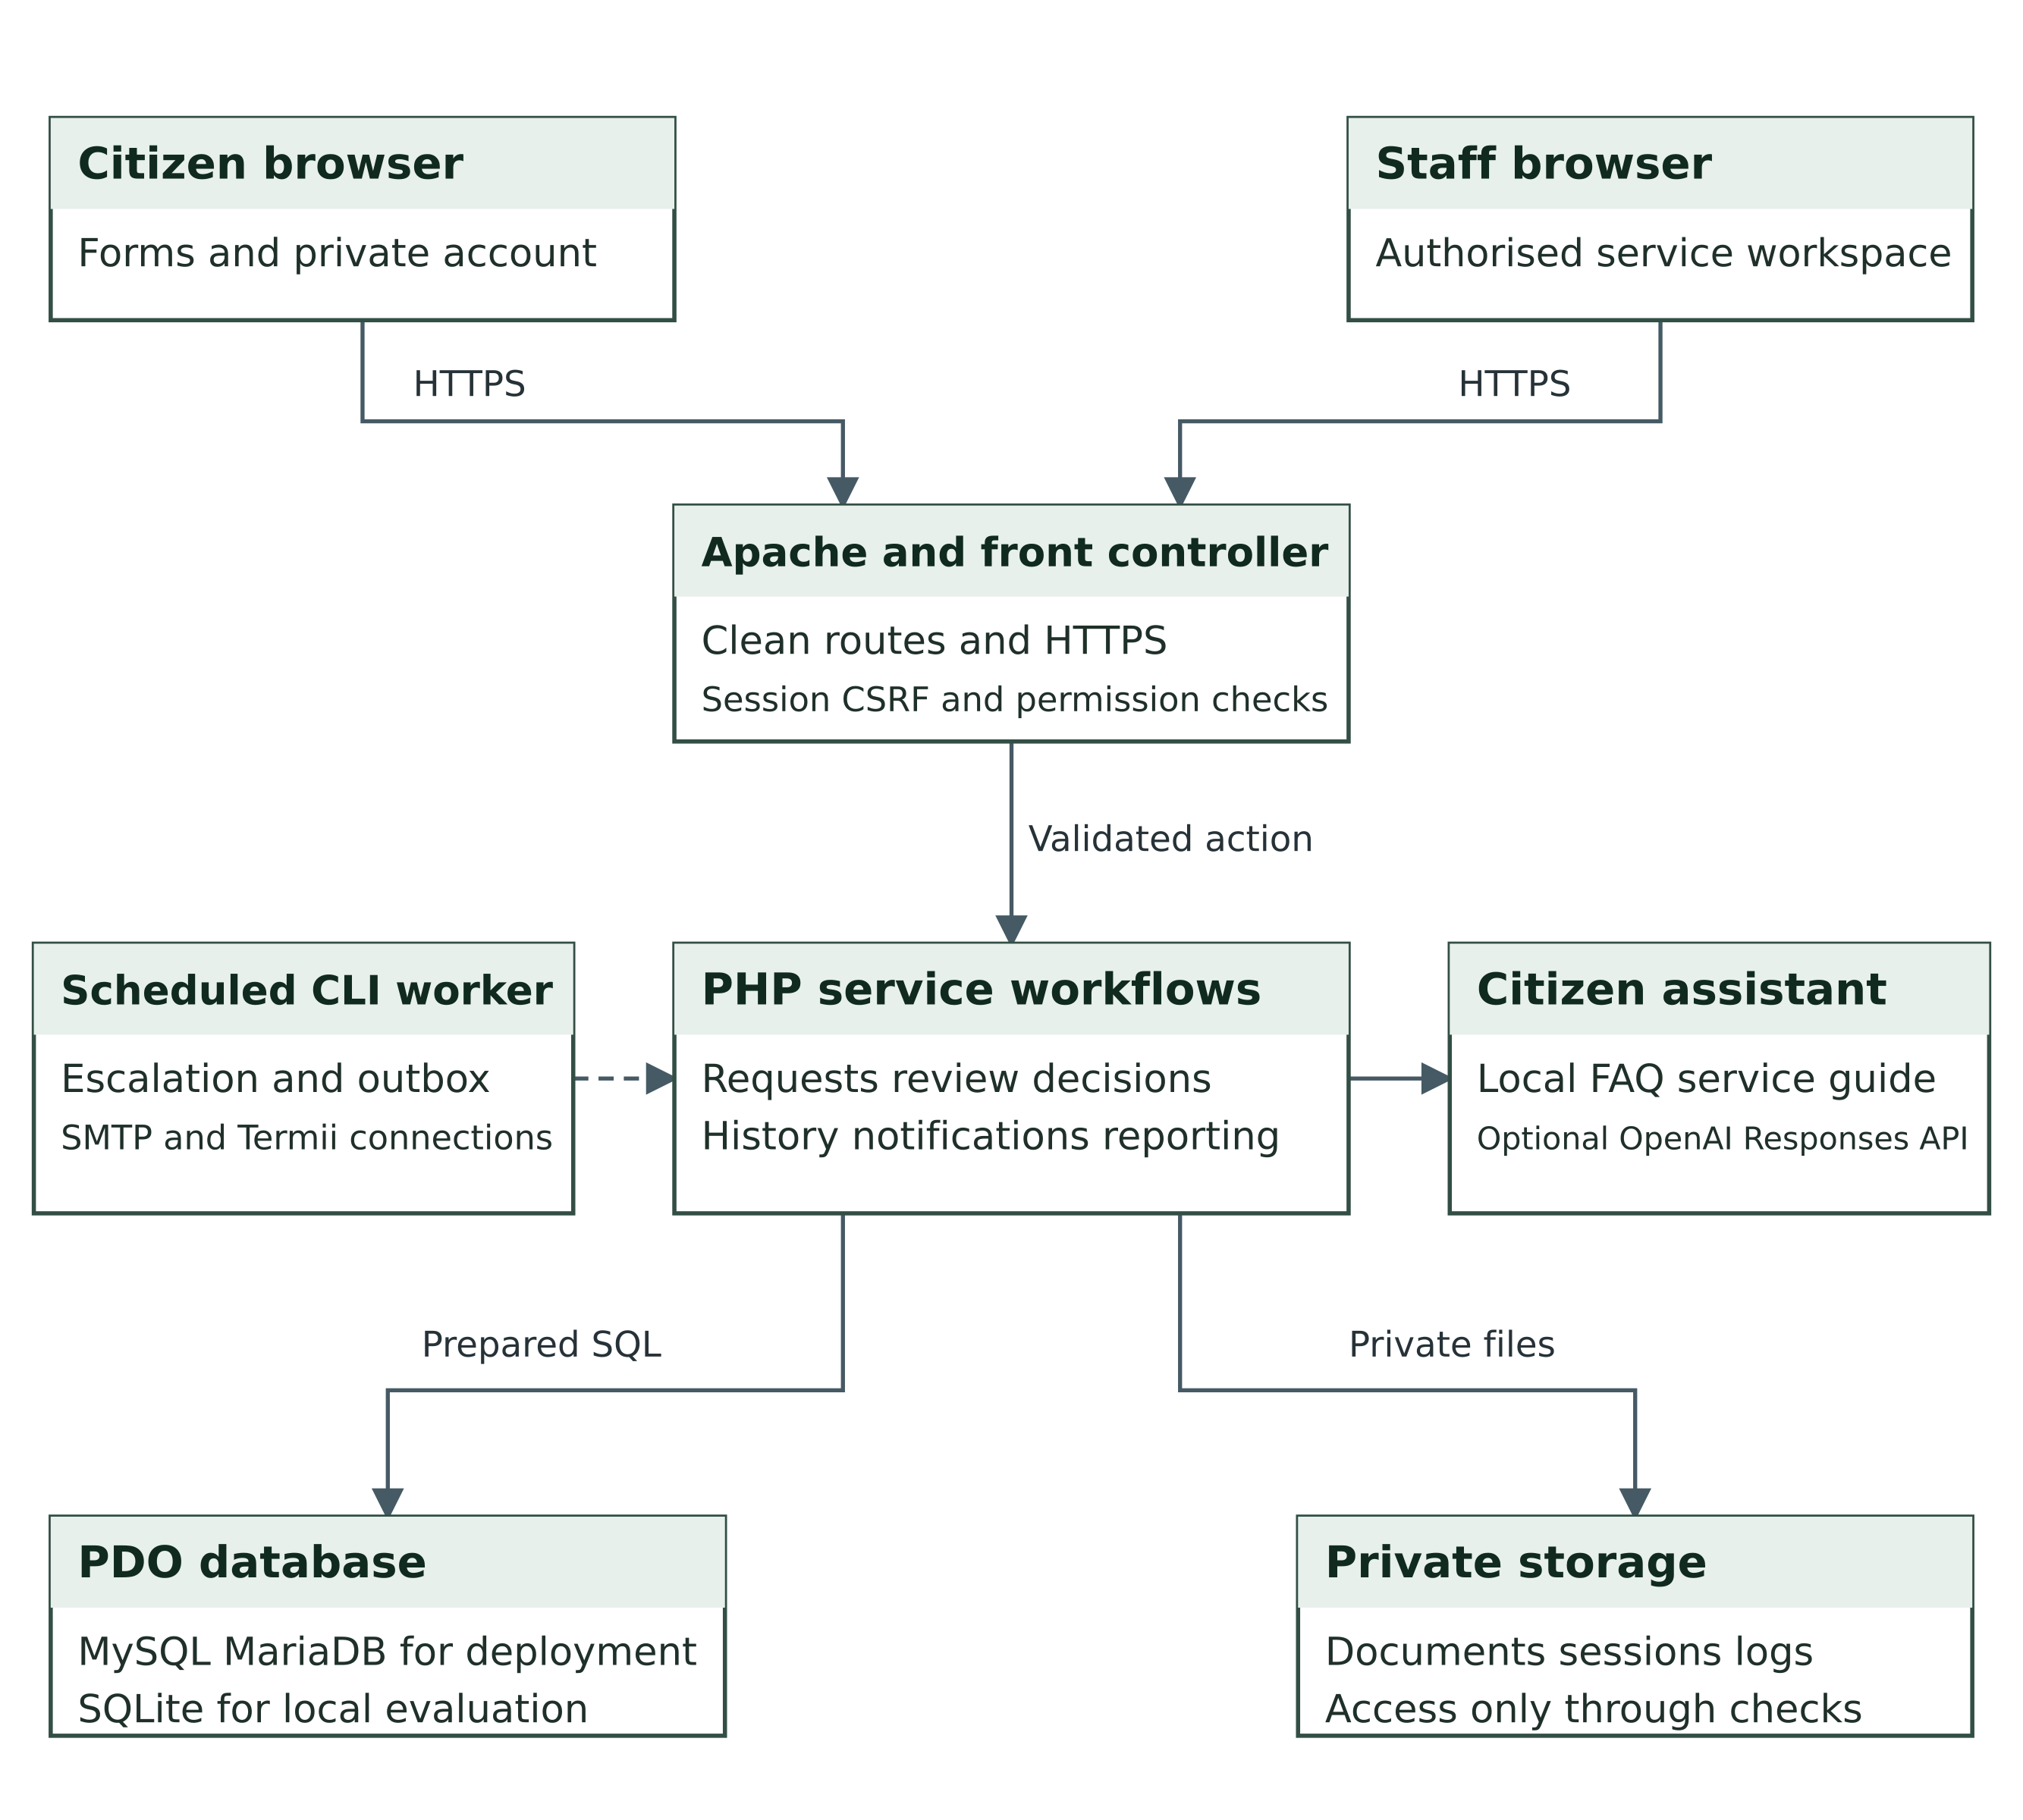
Figure D1 Application architecture
Source: Project implementation and system design for release 1.0.4.

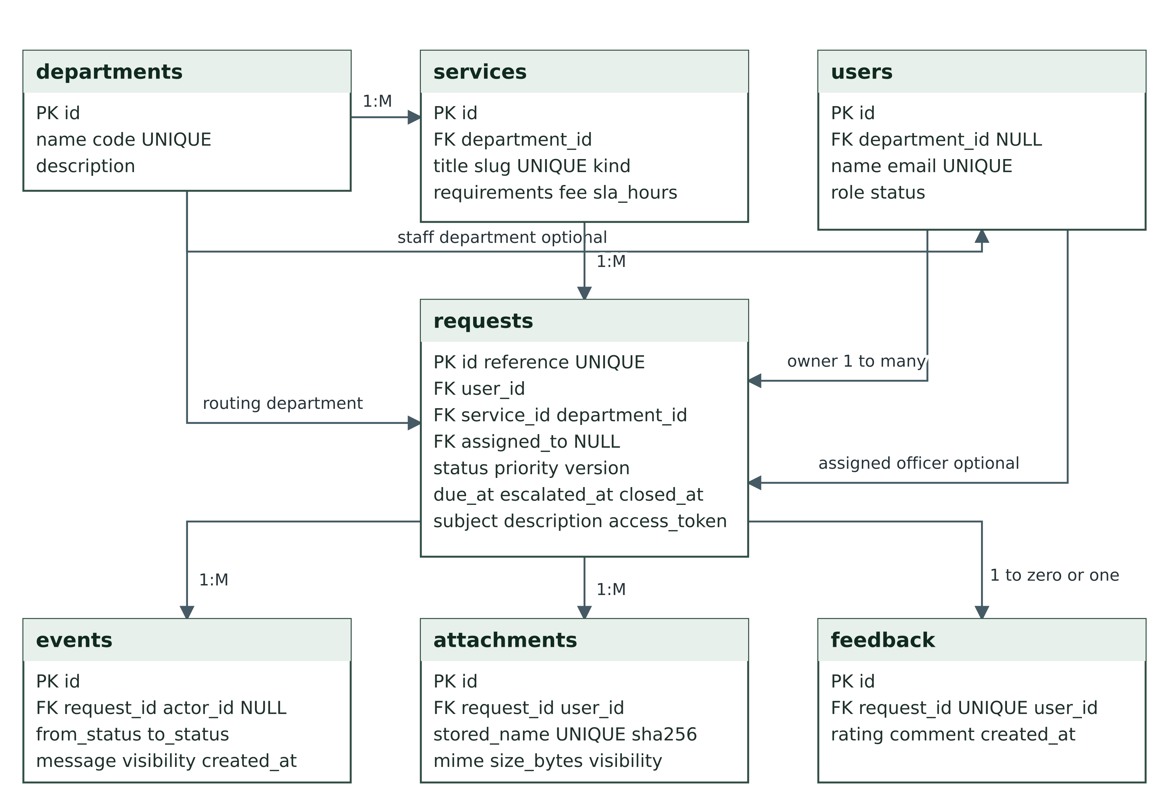
Figure D2 Core service entity relationships
Source: Project implementation and system design for release 1.0.4.

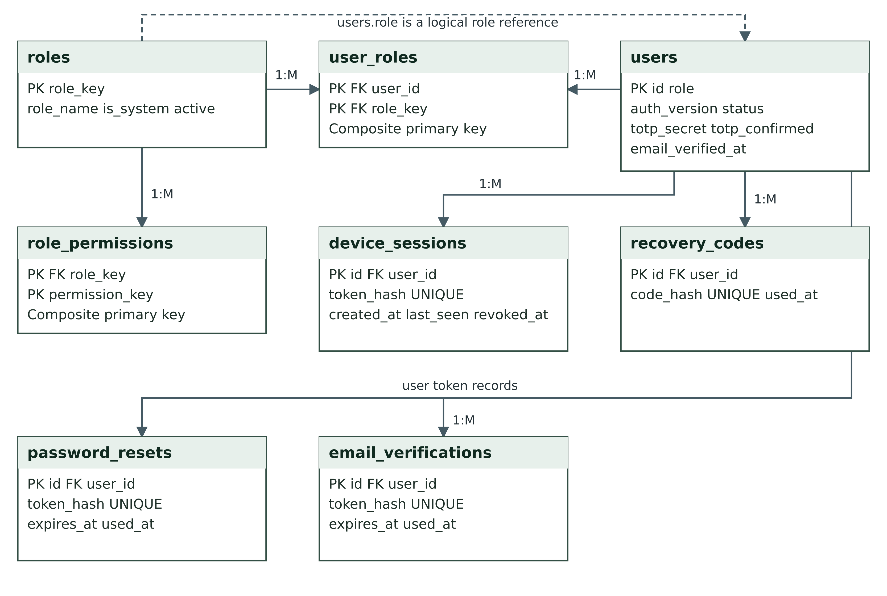
Figure D3 Identity and permission relationships
Source: Project implementation and system design for release 1.0.4.

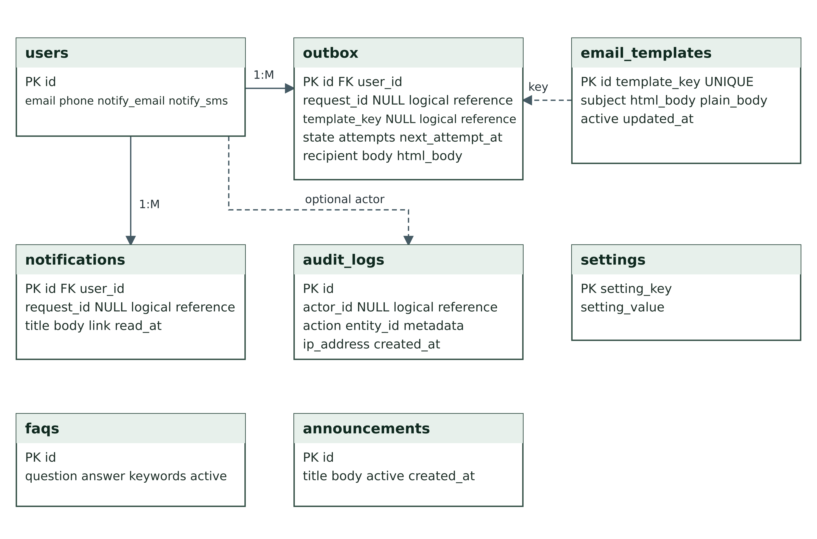
Figure D4 Communication and workspace relationships
Source: Project implementation and system design for release 1.0.4.

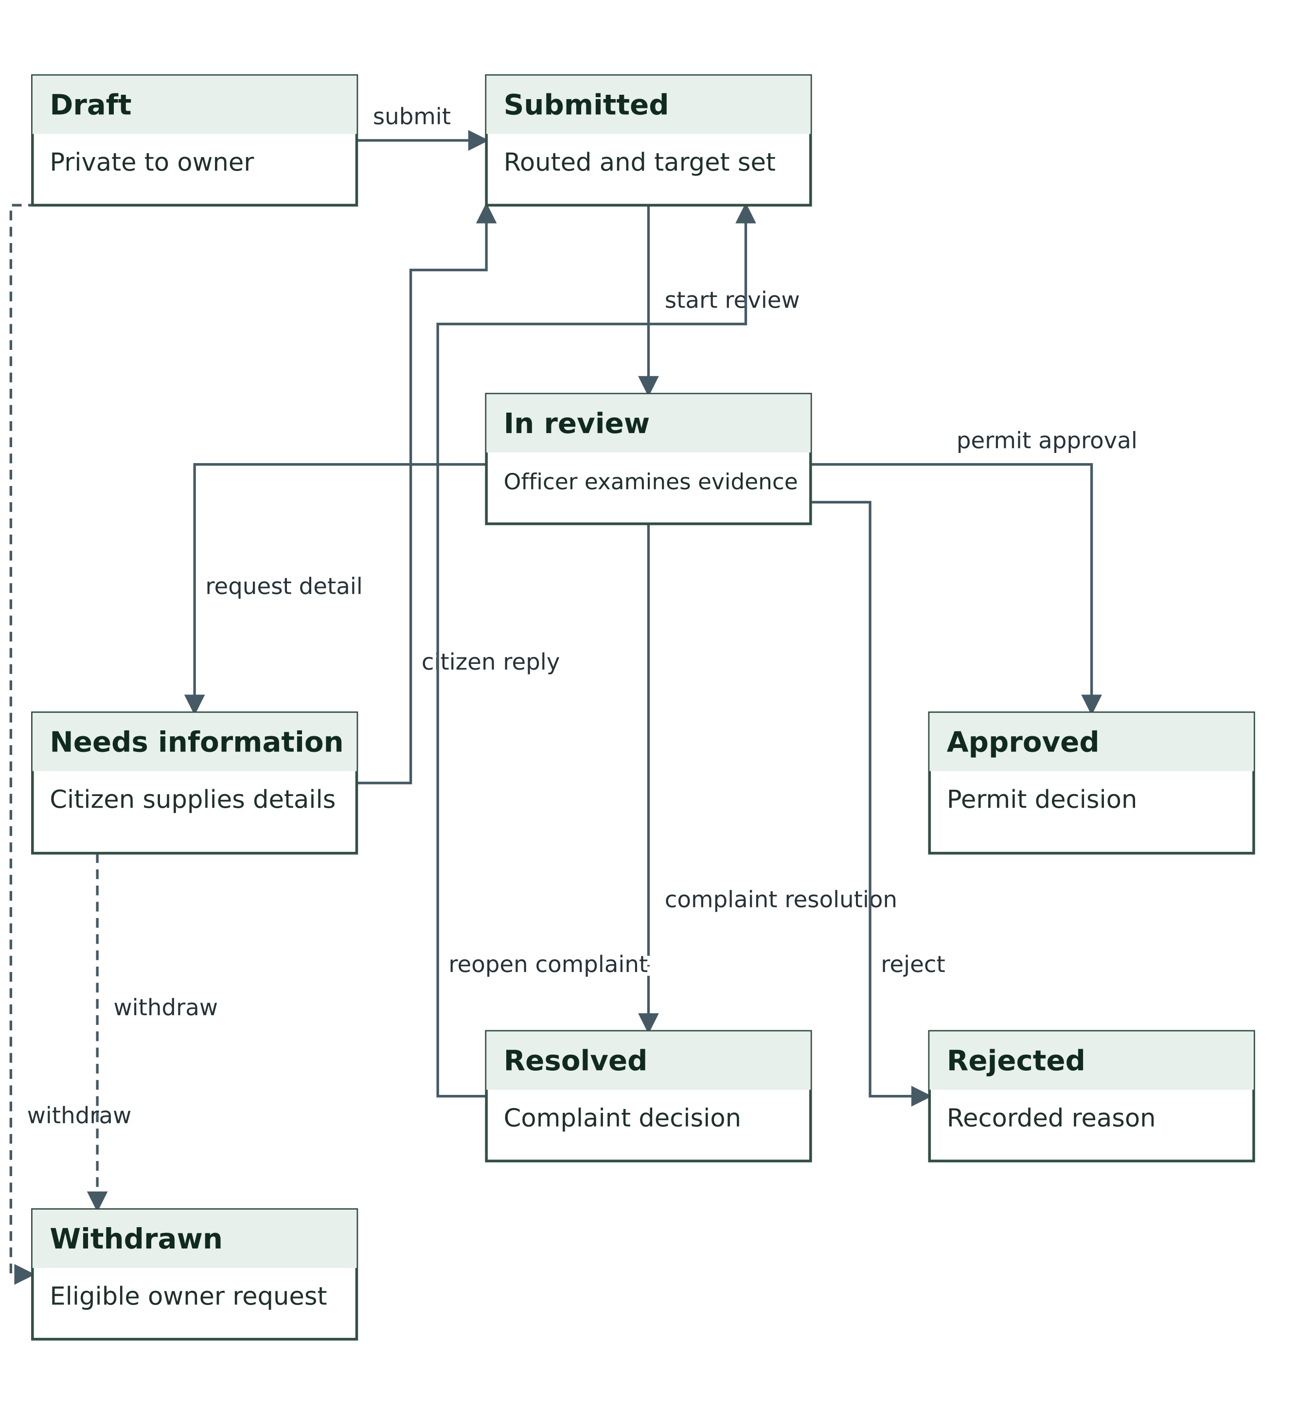
Figure D5 Complaint and permit lifecycle
Source: Project implementation and system design for release 1.0.4.

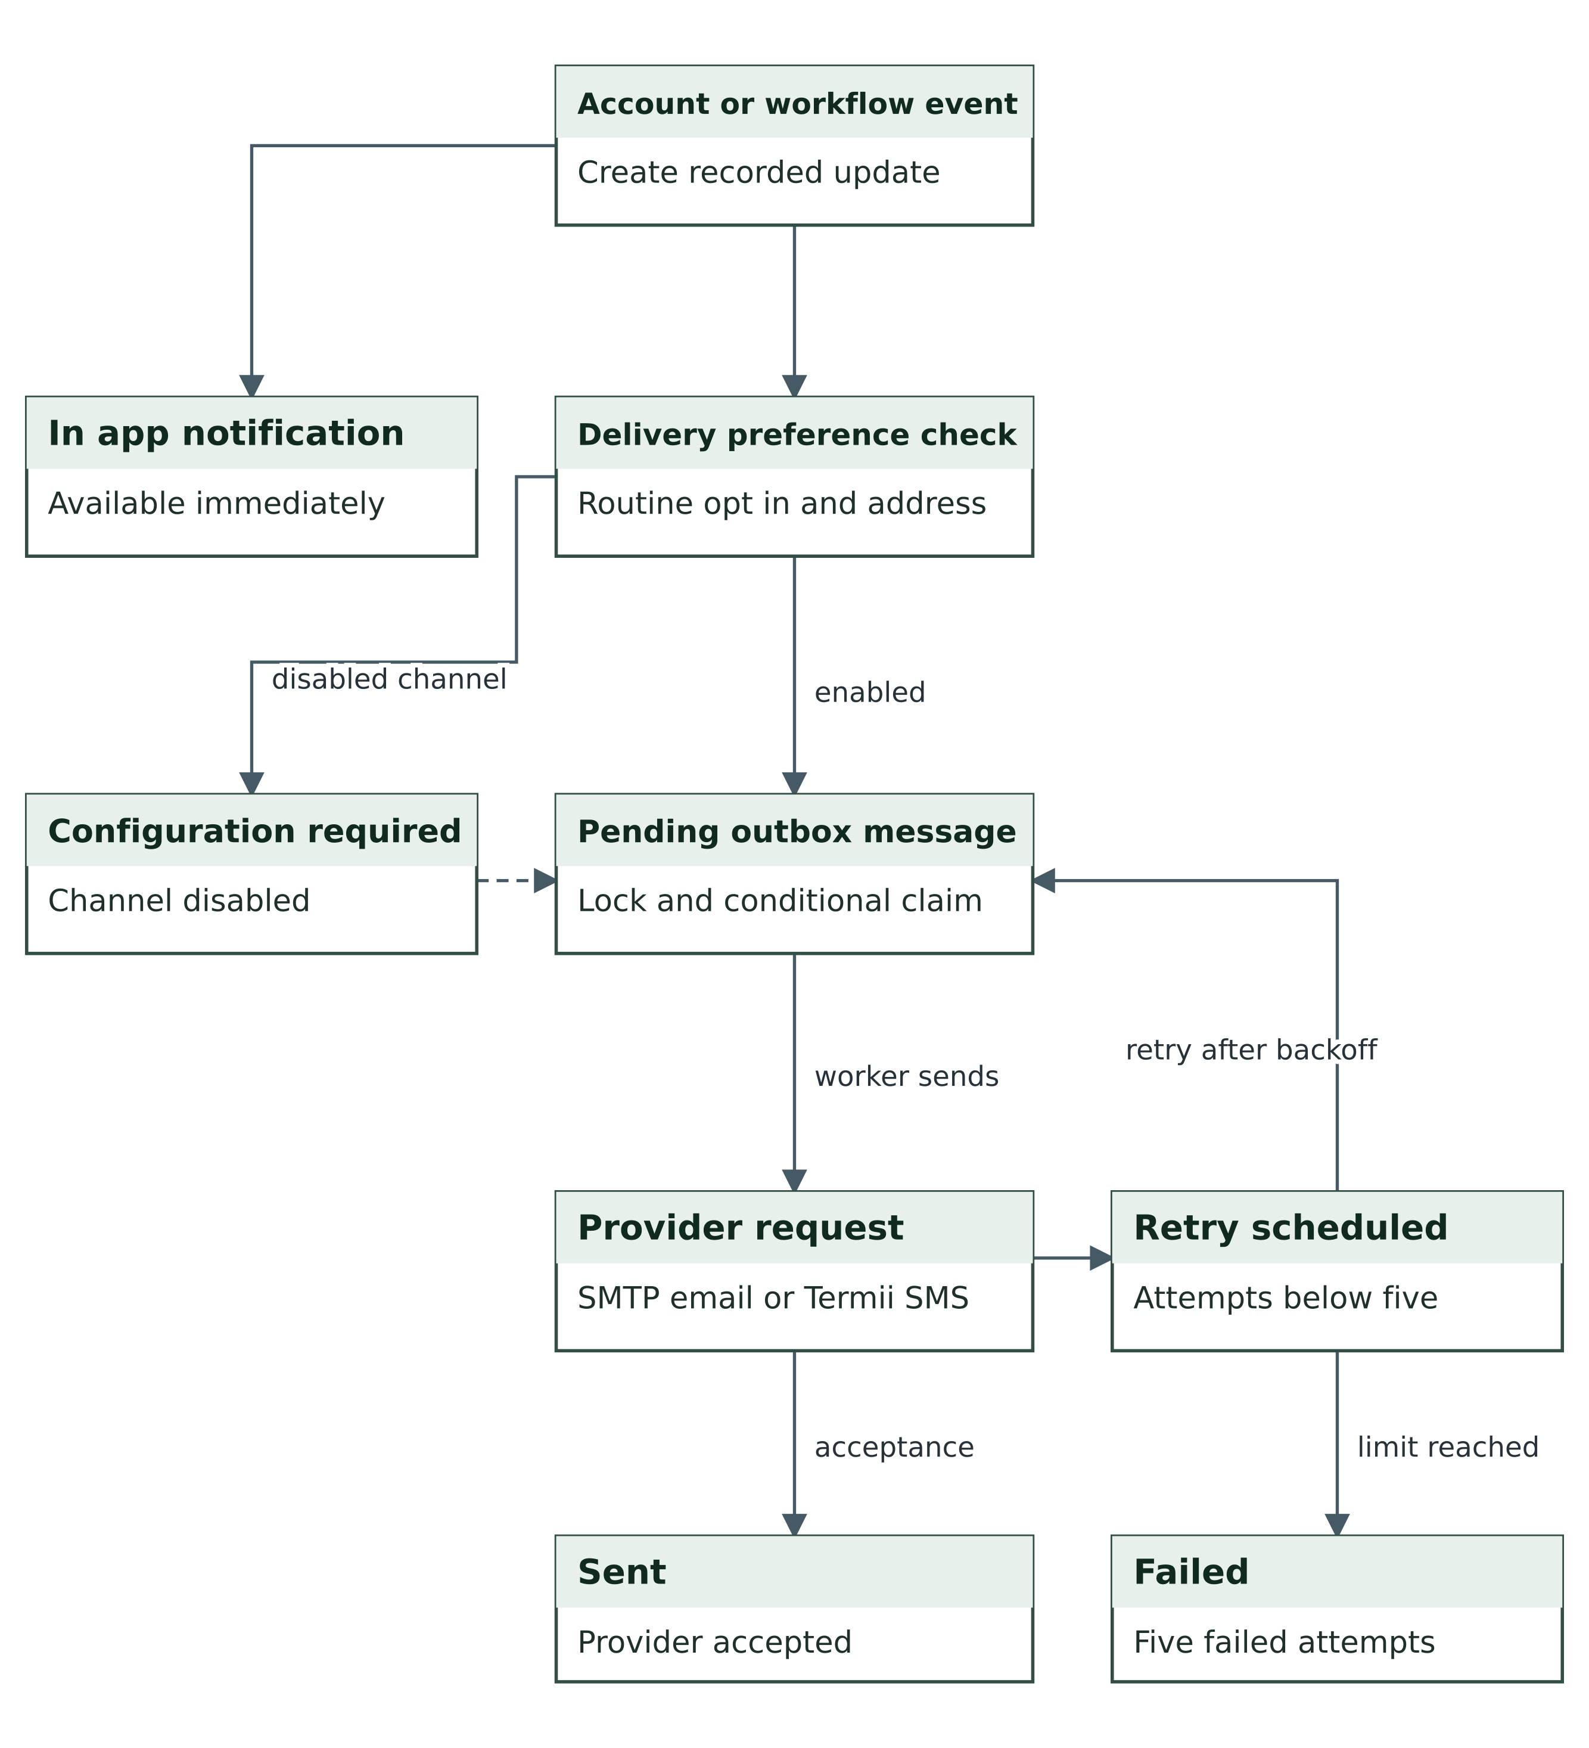
Figure D6 Delivery and retry workflow
Source: Project implementation and system design for release 1.0.4.

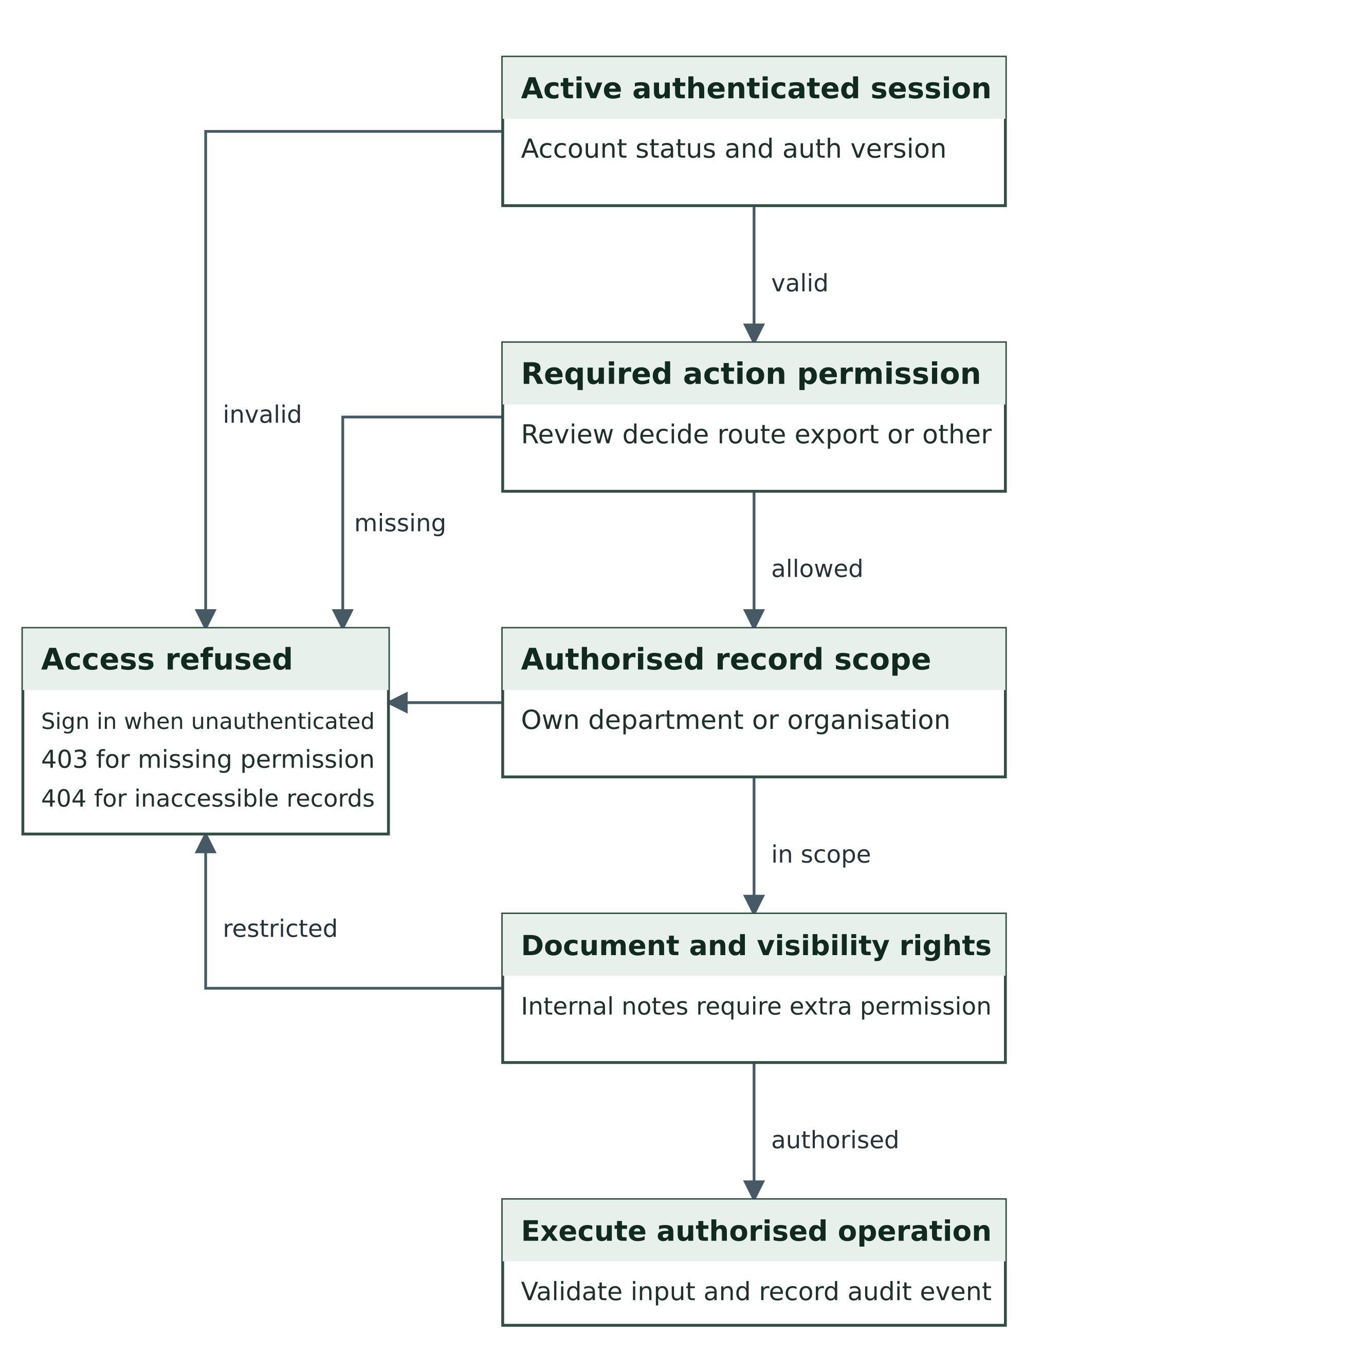
Figure D7 Server side access decision
Source: Project implementation and system design for release 1.0.4.

3 Complete schema data dictionary
The following tables list the declared columns and database foreign keys from the schema used by the source release. INTEGER primary identifiers use automatic numbering appropriate to the selected engine. The SQL schema remains the source for complete uniqueness and default-expression syntax. Operational permissions are defined in application code and role-permission records.

departments
Column | Type | Declared constraints
id | INTEGER | PK; Required
name | VARCHAR(140) | Required
code | VARCHAR(20) | Required
description | TEXT | Required

services
Column | Type | Declared constraints
id | INTEGER | PK; Required
department_id | INTEGER | Required; FK departments.id
title | VARCHAR(180) | Required
slug | VARCHAR(100) | Required
kind | VARCHAR(20) | Required
description | TEXT | Required
requirements | TEXT | Required
fee | DECIMAL(12,2) | Required; Default 0
sla_hours | INTEGER | Required; Default 72
active | INTEGER | Required; Default 1

roles
Column | Type | Declared constraints
role_key | VARCHAR(50) | PK; Required
role_name | VARCHAR(100) | Required
description | TEXT | Required
is_system | INTEGER | Required; Default 0
active | INTEGER | Required; Default 1

role_permissions
Column | Type | Declared constraints
role_key | VARCHAR(50) | PK composite; Required; FK roles.role_key
permission_key | VARCHAR(100) | PK composite; Required

users
Column | Type | Declared constraints
id | INTEGER | PK; Required
name | VARCHAR(140) | Required
email | VARCHAR(190) | Required
phone | VARCHAR(25) | Required; Default ''
password_hash | VARCHAR(255) | Required
role | VARCHAR(50) | Required; Default 'citizen'
department_id | INTEGER | Nullable; FK departments.id
status | VARCHAR(20) | Required; Default 'active'
email_verified_at | DATETIME | Nullable
notify_email | INTEGER | Required; Default 1
notify_sms | INTEGER | Required; Default 0
auth_version | INTEGER | Required; Default 1
totp_secret | TEXT | Nullable
totp_confirmed | INTEGER | Required; Default 0
created_at | DATETIME | Required

user_roles
Column | Type | Declared constraints
user_id | INTEGER | PK composite; Required; FK users.id
role_key | VARCHAR(50) | PK composite; Required; FK roles.role_key

email_templates
Column | Type | Declared constraints
id | INTEGER | PK; Required
template_key | VARCHAR(60) | Required
name | VARCHAR(140) | Required
subject | VARCHAR(180) | Required
html_body | TEXT | Required
plain_body | TEXT | Required
active | INTEGER | Required; Default 1
updated_at | DATETIME | Required

device_sessions
Column | Type | Declared constraints
id | INTEGER | PK; Required
user_id | INTEGER | Required; FK users.id
token_hash | VARCHAR(64) | Required
ip_address | VARCHAR(64) | Required
user_agent | VARCHAR(250) | Required
created_at | DATETIME | Required
last_seen | DATETIME | Required
revoked_at | DATETIME | Nullable

recovery_codes
Column | Type | Declared constraints
id | INTEGER | PK; Required
user_id | INTEGER | Required; FK users.id
code_hash | VARCHAR(64) | Required
used_at | DATETIME | Nullable

requests
Column | Type | Declared constraints
id | INTEGER | PK; Required
reference | VARCHAR(50) | Required
access_token | VARCHAR(64) | Required
user_id | INTEGER | Required; FK users.id
service_id | INTEGER | Required; FK services.id
department_id | INTEGER | Required; FK departments.id
assigned_to | INTEGER | Nullable; FK users.id
kind | VARCHAR(20) | Required
subject | VARCHAR(180) | Required
description | TEXT | Required
location | VARCHAR(200) | Required; Default ''
state_name | VARCHAR(60) | Required; Default ''
organisation | VARCHAR(180) | Required; Default ''
priority | VARCHAR(20) | Required; Default 'normal'
status | VARCHAR(30) | Required
due_at | DATETIME | Nullable
escalated_at | DATETIME | Nullable
closed_at | DATETIME | Nullable
version | INTEGER | Required; Default 1
created_at | DATETIME | Required
updated_at | DATETIME | Required

events
Column | Type | Declared constraints
id | INTEGER | PK; Required
request_id | INTEGER | Required; FK requests.id
actor_id | INTEGER | Nullable; FK users.id
from_status | VARCHAR(30) | Required; Default ''
to_status | VARCHAR(30) | Required; Default ''
message | TEXT | Required
visibility | VARCHAR(20) | Required; Default 'public'
created_at | DATETIME | Required

attachments
Column | Type | Declared constraints
id | INTEGER | PK; Required
request_id | INTEGER | Required; FK requests.id
user_id | INTEGER | Required; FK users.id
original_name | VARCHAR(200) | Required
stored_name | VARCHAR(100) | Required
mime | VARCHAR(100) | Required
size_bytes | INTEGER | Required
sha256 | VARCHAR(64) | Required
visibility | VARCHAR(20) | Required; Default 'public'
created_at | DATETIME | Required

notifications
Column | Type | Declared constraints
id | INTEGER | PK; Required
user_id | INTEGER | Required; FK users.id
request_id | INTEGER | Nullable
title | VARCHAR(180) | Required
body | TEXT | Required
link | VARCHAR(250) | Required
read_at | DATETIME | Nullable
created_at | DATETIME | Required

outbox
Column | Type | Declared constraints
id | INTEGER | PK; Required
user_id | INTEGER | Required; FK users.id
request_id | INTEGER | Nullable
channel | VARCHAR(15) | Required
recipient | VARCHAR(190) | Required
subject | VARCHAR(180) | Required
body | TEXT | Required
html_body | TEXT | Nullable
template_key | VARCHAR(60) | Nullable
state | VARCHAR(30) | Required; Default 'pending'
attempts | INTEGER | Required; Default 0
next_attempt_at | DATETIME | Nullable
sent_at | DATETIME | Nullable
last_error | VARCHAR(250) | Required; Default ''
provider_id | VARCHAR(150) | Required; Default ''
created_at | DATETIME | Required

settings
Column | Type | Declared constraints
setting_key | VARCHAR(100) | PK; Required
setting_value | TEXT | Required

password_resets
Column | Type | Declared constraints
id | INTEGER | PK; Required
user_id | INTEGER | Required; FK users.id
token_hash | VARCHAR(64) | Required
expires_at | DATETIME | Required
used_at | DATETIME | Nullable

email_verifications
Column | Type | Declared constraints
id | INTEGER | PK; Required
user_id | INTEGER | Required; FK users.id
token_hash | VARCHAR(64) | Required
expires_at | DATETIME | Required
used_at | DATETIME | Nullable

audit_logs
Column | Type | Declared constraints
id | INTEGER | PK; Required
actor_id | INTEGER | Nullable
action | VARCHAR(100) | Required
entity_id | INTEGER | Nullable
metadata | TEXT | Required
ip_address | VARCHAR(64) | Required
created_at | DATETIME | Required

feedback
Column | Type | Declared constraints
id | INTEGER | PK; Required
request_id | INTEGER | Required; FK requests.id
user_id | INTEGER | Required; FK users.id
rating | INTEGER | Required
comment | TEXT | Required
created_at | DATETIME | Required

faqs
Column | Type | Declared constraints
id | INTEGER | PK; Required
question | VARCHAR(220) | Required
answer | TEXT | Required
keywords | VARCHAR(250) | Required
active | INTEGER | Required; Default 1

announcements
Column | Type | Declared constraints
id | INTEGER | PK; Required
title | VARCHAR(180) | Required
body | TEXT | Required
active | INTEGER | Required; Default 1
created_at | DATETIME | Required

4 Declared foreign key register
Referencing column | Referenced primary key
services.department_id | departments.id
role_permissions.role_key | roles.role_key
users.department_id | departments.id
user_roles.role_key | roles.role_key
user_roles.user_id | users.id
device_sessions.user_id | users.id
recovery_codes.user_id | users.id
requests.assigned_to | users.id
requests.department_id | departments.id
requests.service_id | services.id
requests.user_id | users.id
events.actor_id | users.id
events.request_id | requests.id
attachments.user_id | users.id
attachments.request_id | requests.id
notifications.user_id | users.id
outbox.user_id | users.id
password_resets.user_id | users.id
email_verifications.user_id | users.id
feedback.user_id | users.id
feedback.request_id | requests.id

5 Logical reference register
Field | Application relationship
users.role | Primary role key in roles, without a database FK.
outbox.request_id | Optional service request link, without a database FK.
outbox.template_key | Optional template key retaining the queued message provenance.
notifications.request_id | Optional service request link, without a database FK.
audit_logs.actor_id | Optional user actor link, without a database FK.

6 Diagram source files
Each diagram is included as a high-resolution PNG and editable SVG. The source architecture/workflow document also provides Mermaid definitions. The field dictionary and SQL references resolve any detail omitted from the selected diagram lines. Diagram files are design models, not screenshots or proof of a hosted deployment.

7 Additional formal and deployment views
The Architecture Design Document provides the architectural alternatives, decisions, threat considerations and single-instance deployment assumptions. The diagram collection adds a UML-style use case view and submission sequence, a deployment topology and two interface wireframes. PNG files provide ready-to-display images; SVG and Mermaid sources remain editable. Wireframes are design views, not evidence of a live browser test.
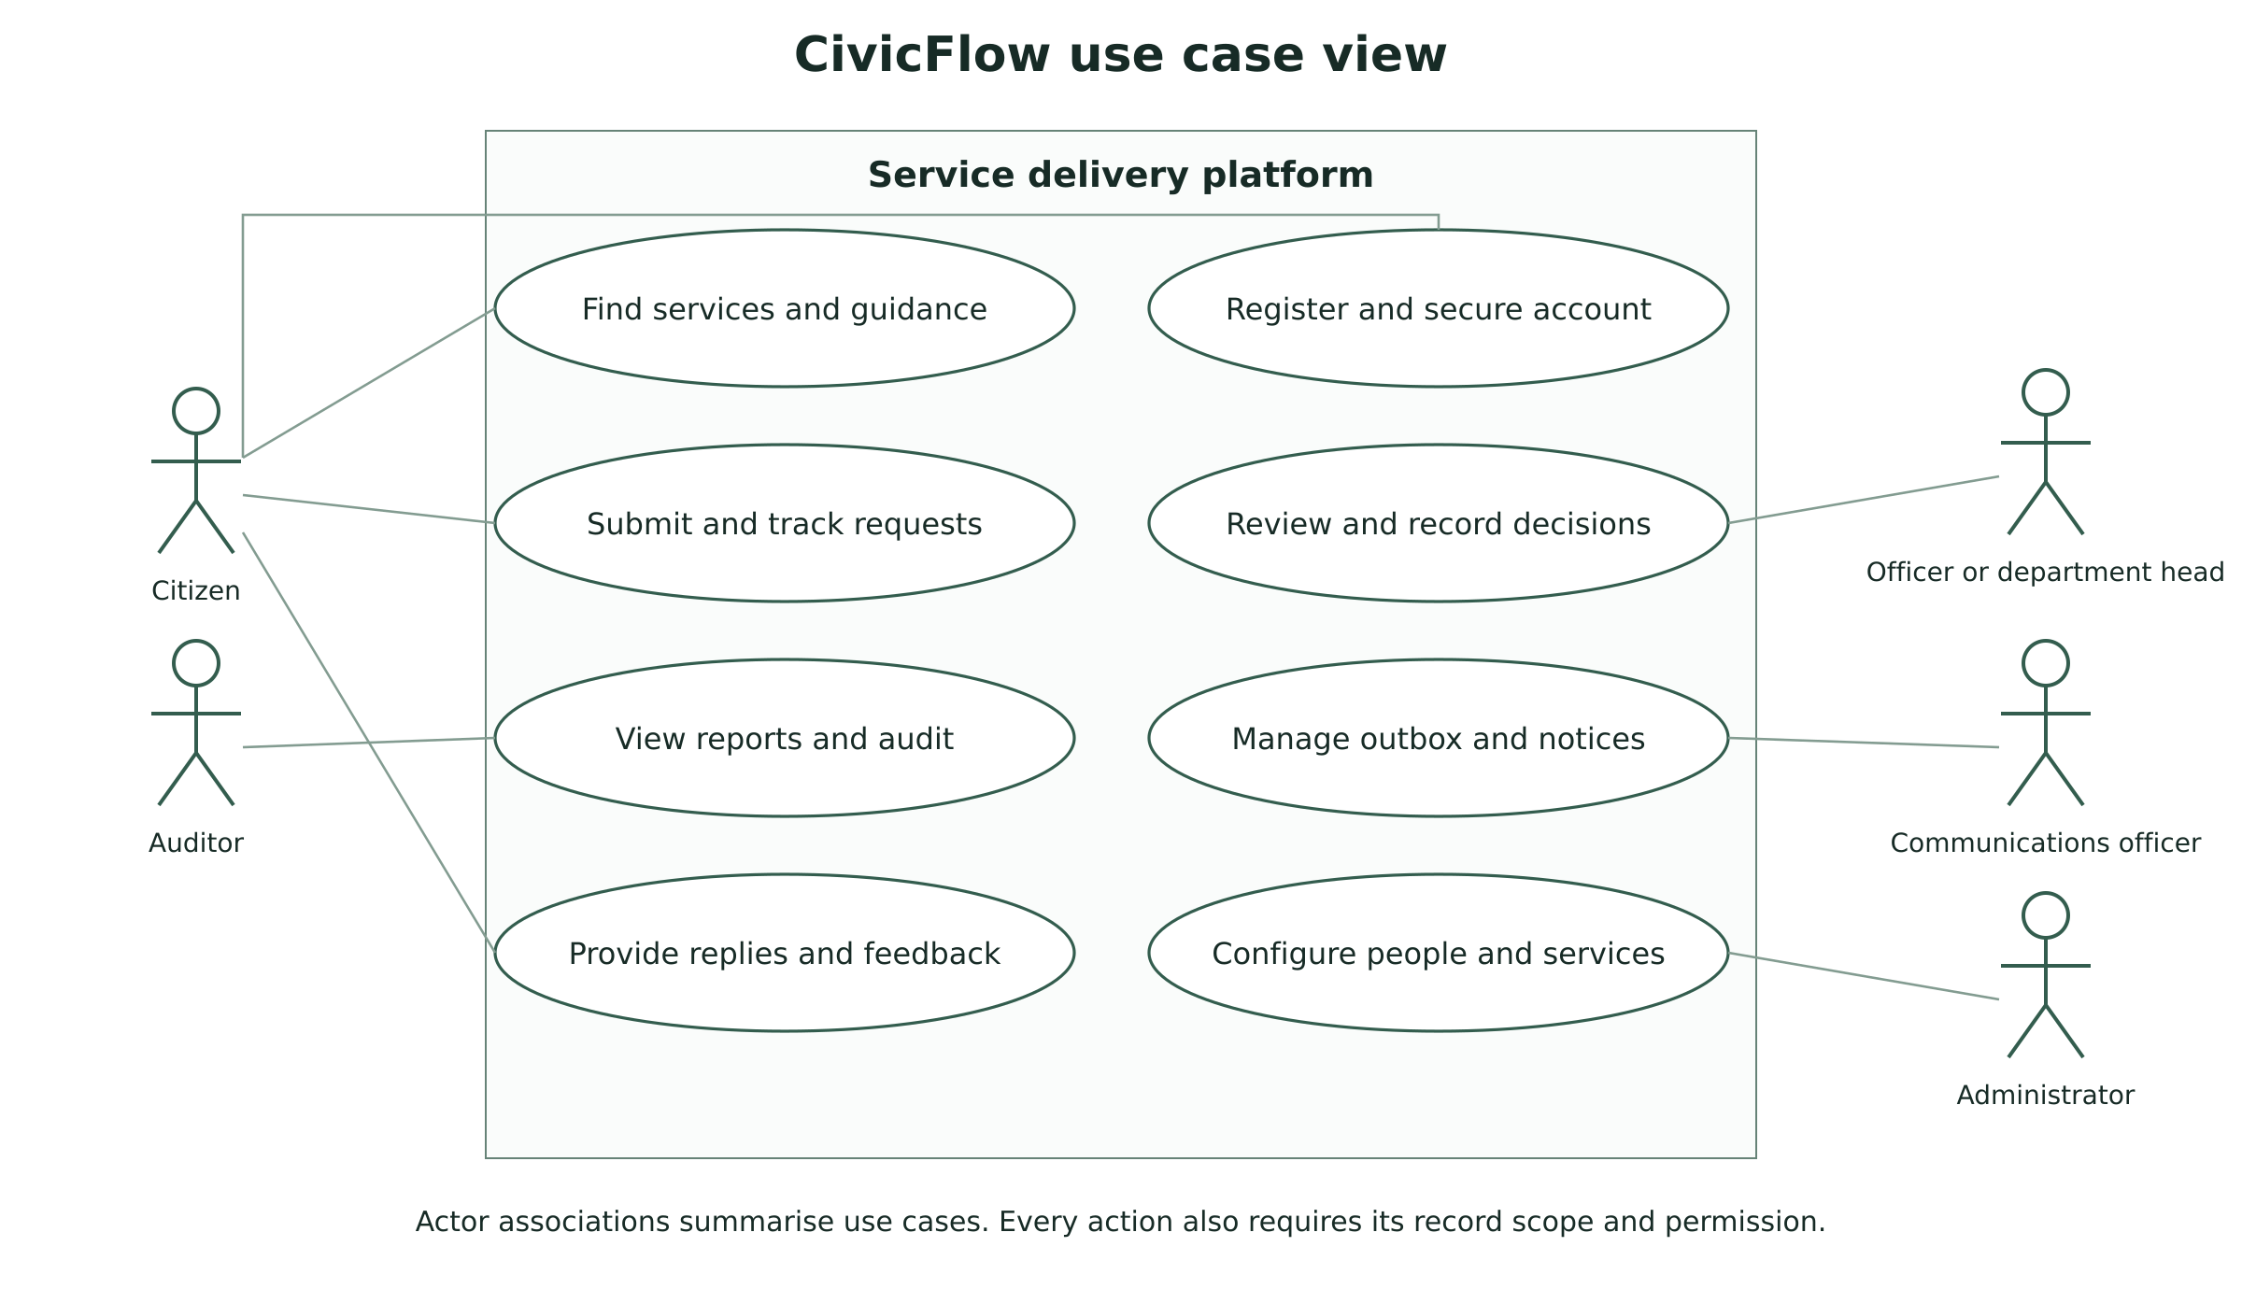
Figure 7.1 Principal actors and use cases
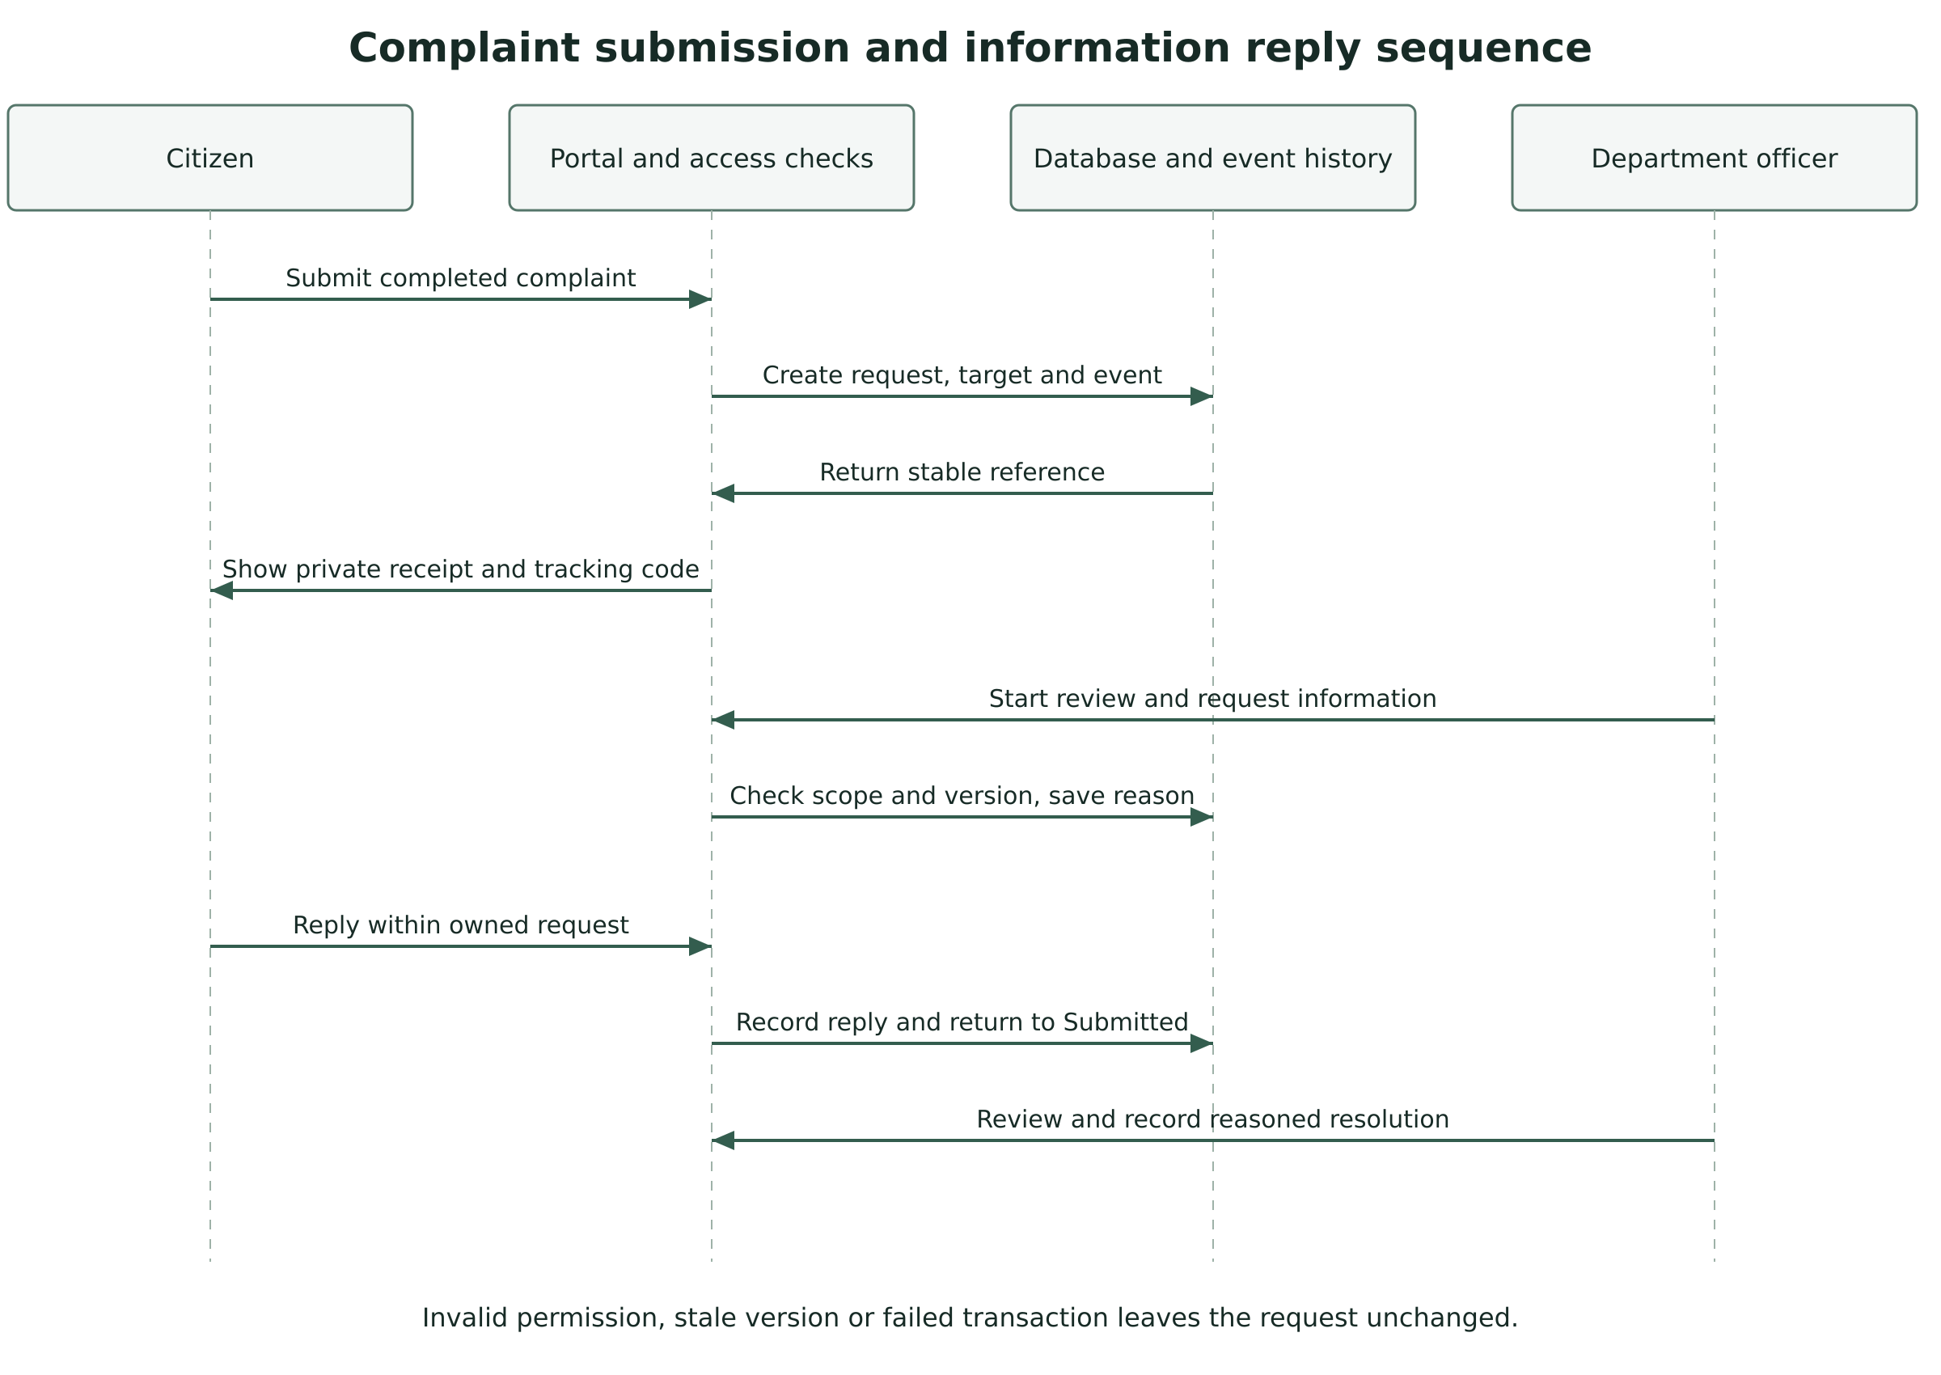
Figure 7.2 Submission and information reply sequence
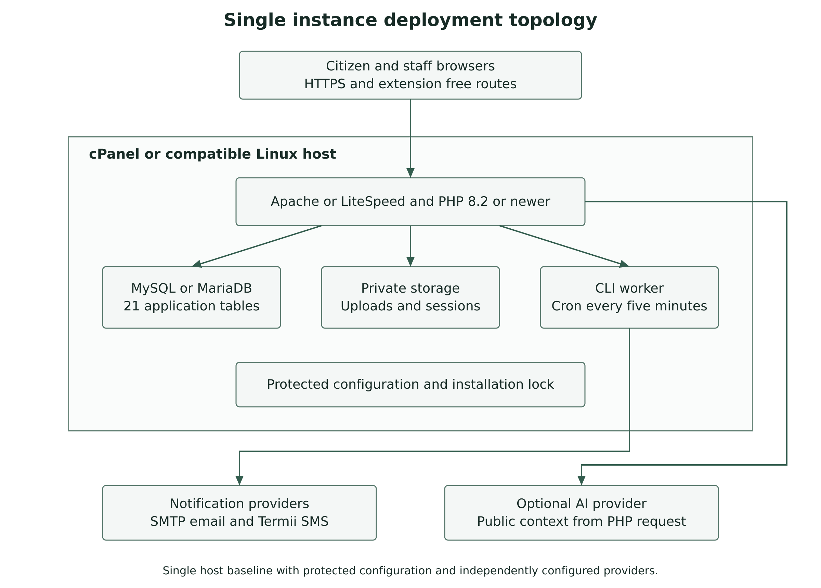
Figure 7.3 Single instance deployment topology

