**Fork Friendly App – Project Iteration 0**

**Team - Amazing Warriors**

* **Team roles:**
  + Scrum Master/ Developer 1: Sai sankeerth Nomula
  + Product Owner/ Developer 2: Chibuikem Okoro
  + Developer3:  Binghan Li
  + Developer4:  Mounima Sai
  + Developer 5: Rameshwar Sai Devarakonda
* **Customer meeting date/time/place**:
  + Met the customer:
    - On Monday (09/25/2017) – 4:45PM
    - At her hospital- St Joseph. Hospital
  + Her availability for a meeting will be known only on the Mondays of every week
* **Summary:**
  + Customer needs an application which enables her patients to get suggestions regarding various food choices and availability in various restaurants/groceries based on their dietary restrictions. Currently, Dr.Linda has dietary suggestions in book format and also database in excel format. But as in current scenario, as the new groceries stores/restaurant gets added or menu in the stores gets changed she needs to print new books and current users will not have that updated information. So, she needs an online application where a user will have access to various updated information and can easily surf through various stores. This application is very much useful for any user who has pre-existing health conditions and need food suggestions. As application also has the database regarding where they can get those food items, it tries to meet the user's expectations with the correct restaurant/grocery store without creating much hassle for user to do extensive search online.
* In the current application user can create his personalized profile account with his dietary requirements and his pre-existing conditions which will be stored in the database. A pre-existing user can log into the application any time to get access to the various restaurants and grocery stores. Based on user’s profile, application will search within the database to provide assistance to the user to select food items. To be user friendly application, we will be adding few features like password retrieval, choice menu.
* **Video:**
  + Below is the link to video interview with the Dr. Linda Kapusniak

<https://www.youtube.com/watch?v=23ZAKH5xxBc>

* **GitHub Repo:**
  + Below is the link to Git Repo with legacy code to the Fork friendly app:

<https://github.tamu.edu/okorokem/ForkFriendly.git>

* **Pivotal Tracker:**
  + Given access to the professor and TA.
  + Project name: Fork Friendly App
  + https://www.pivotaltracker.com/n/projects/2113916
* **User Stories:**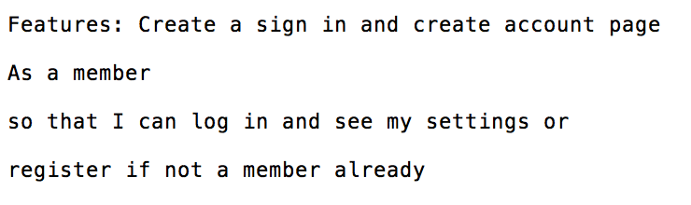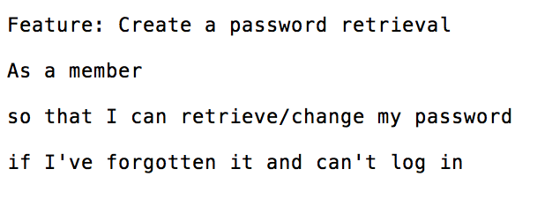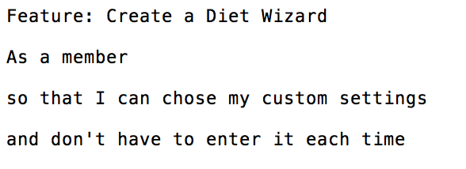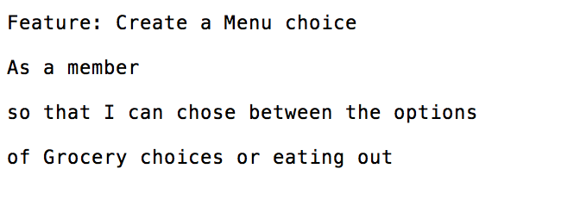
* **User Interface  
    
  Feature**: Create a login and create account page

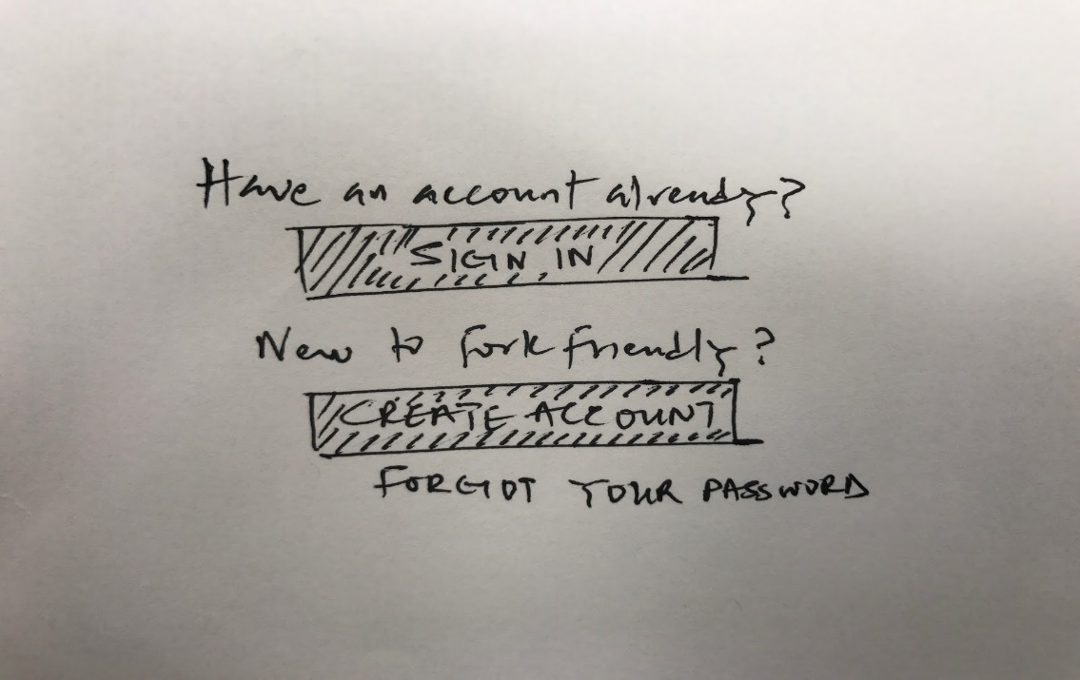  
  
  
**Feature**: Create password retrieval

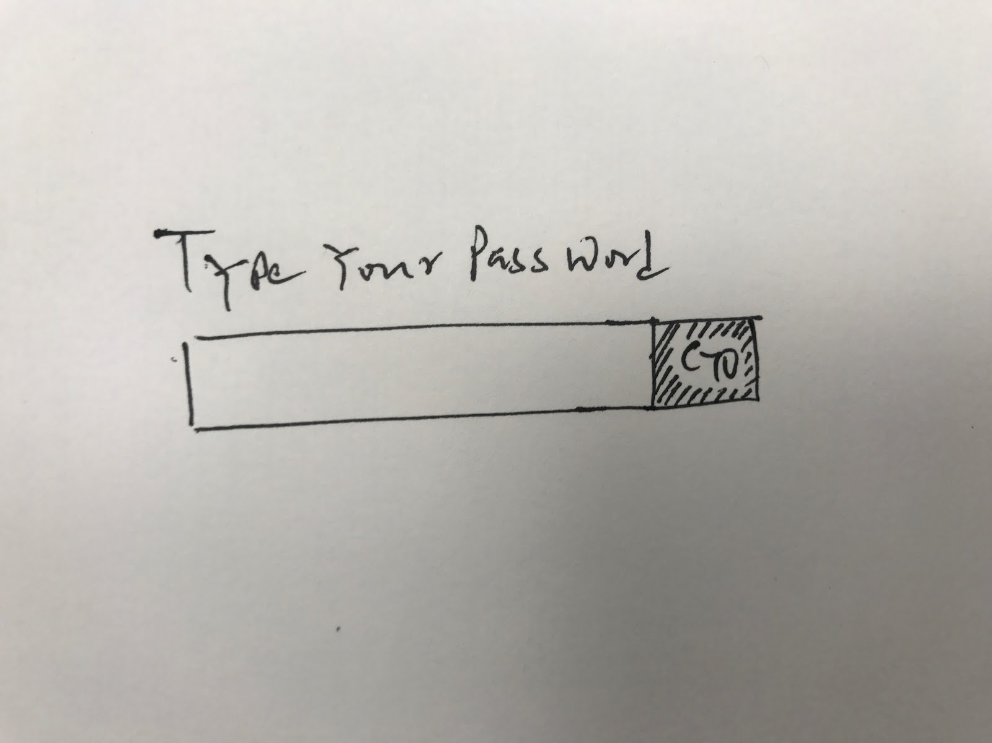

**Feature**: Create a diet wizard  
  
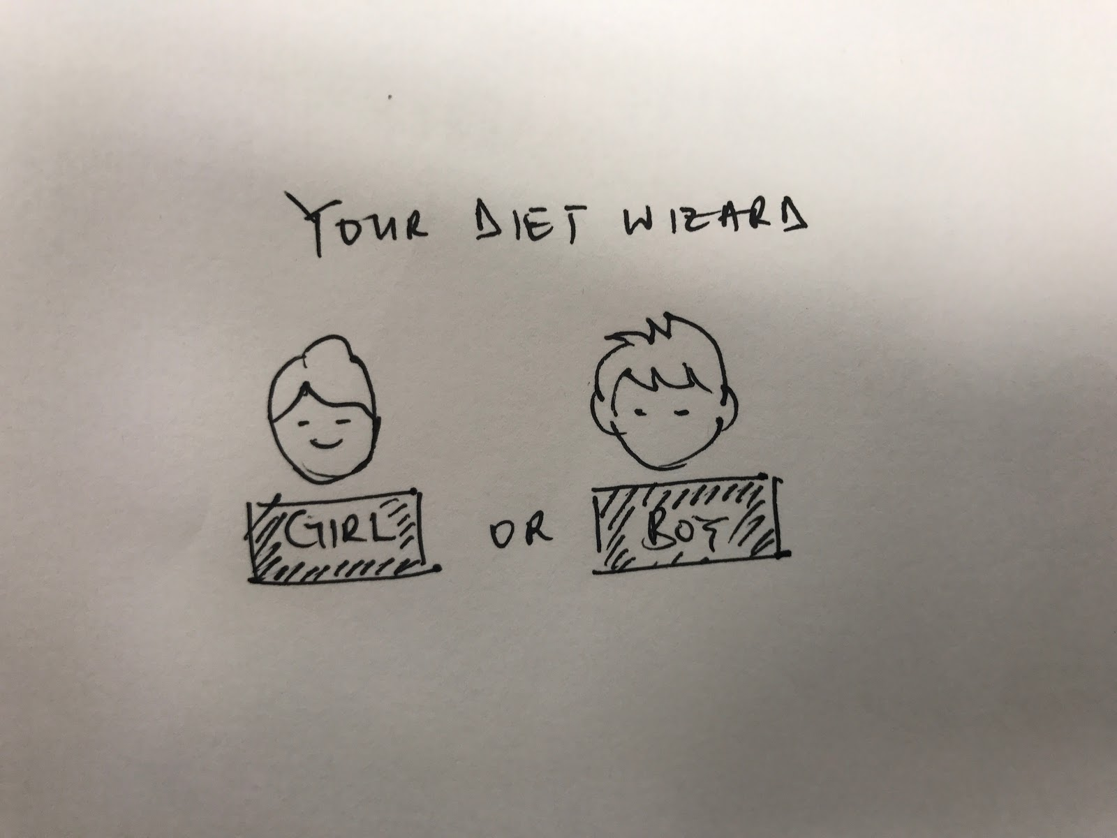  
  
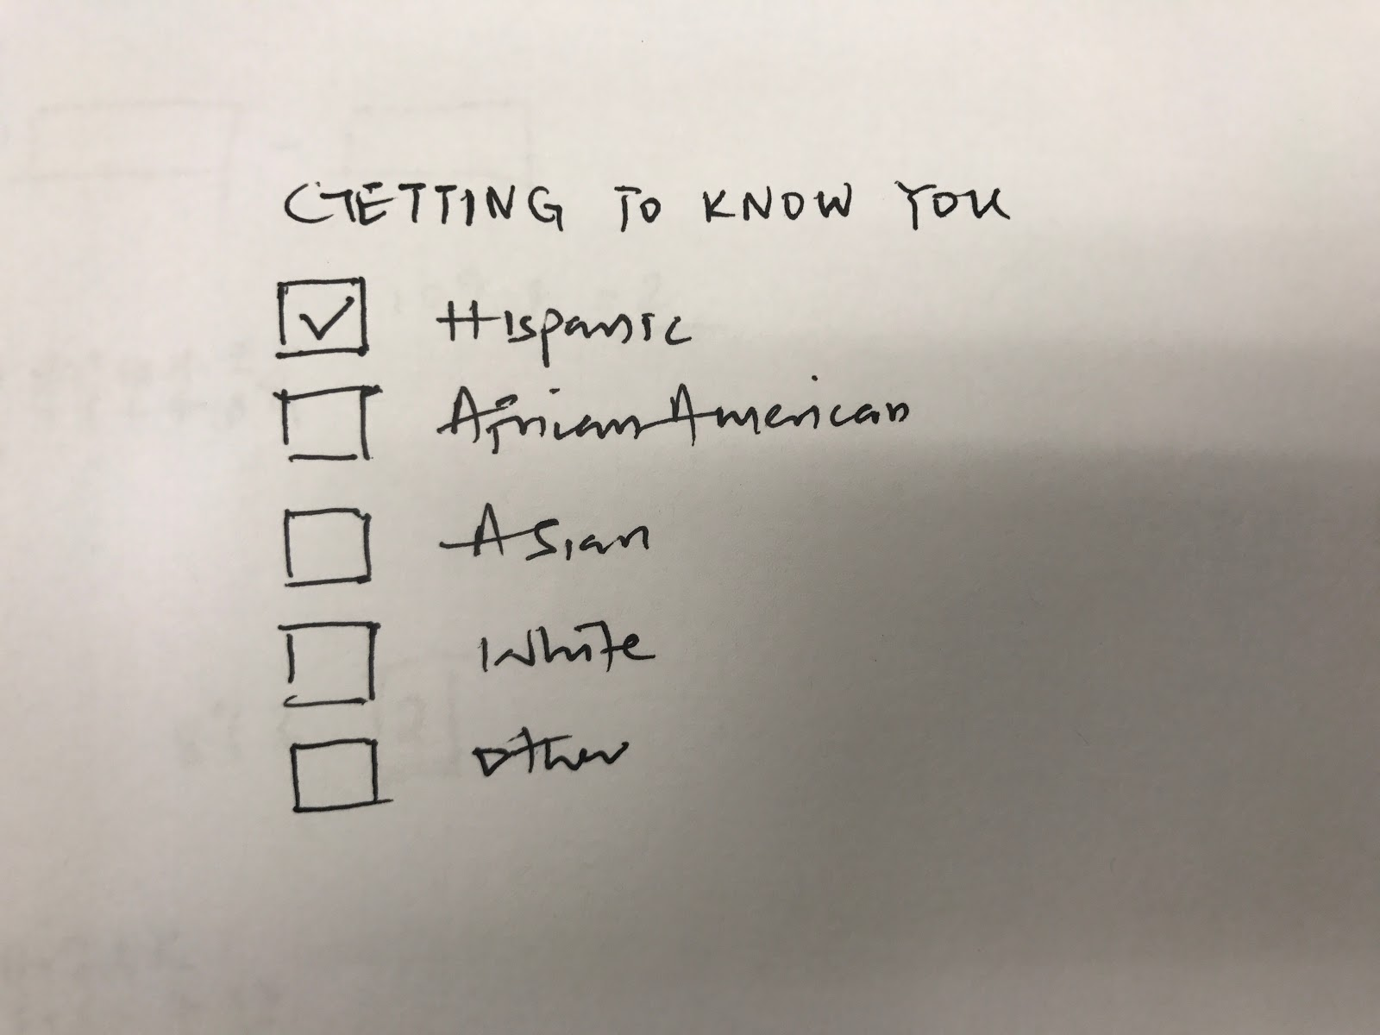

**Feature**: Create a menu choice

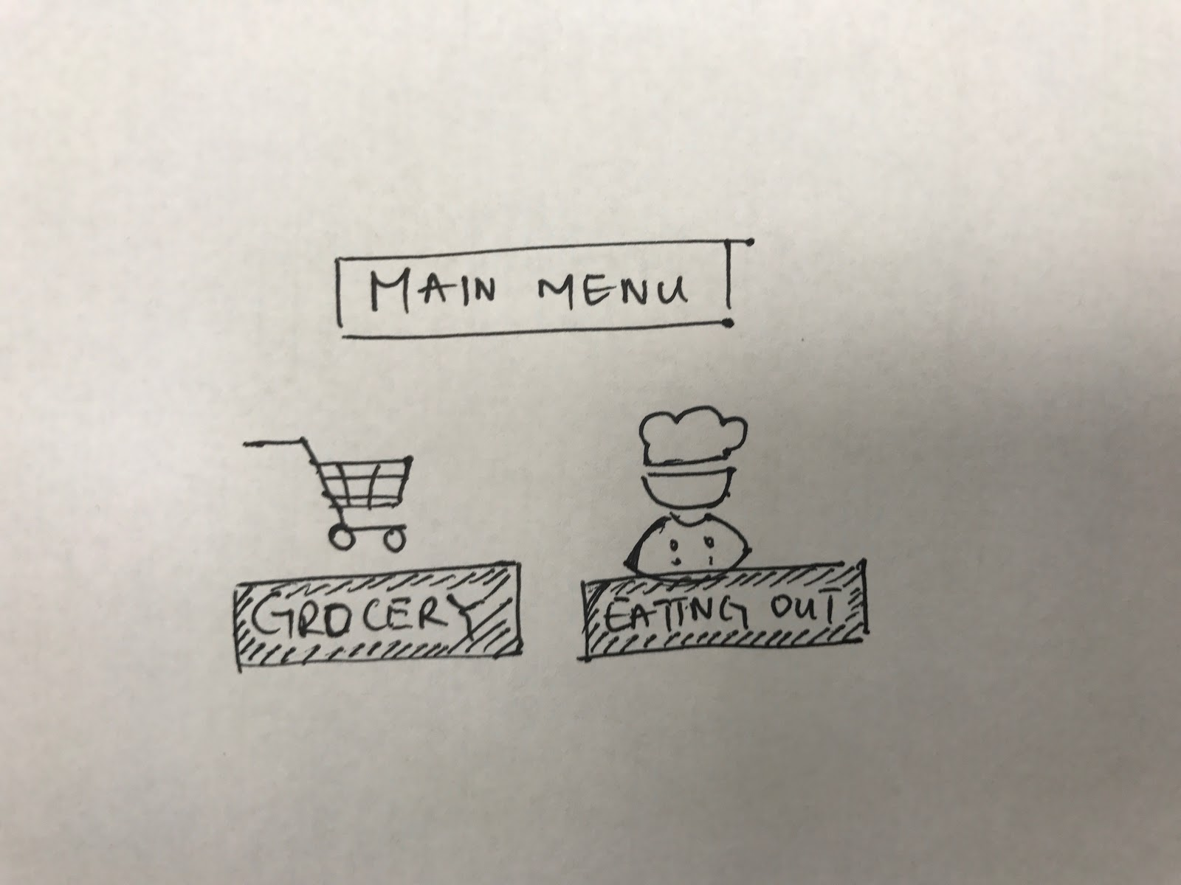

**Legacy code:**

The main aim of choosing this legacy project is to add some value to the customer experience not only by adding new features, but also with bug fixing for the legacy code. We plan to educate the customer with the use cases or any simple changes in features which later the user can do by themselves without any dependency.

Strategy for learning the prior code:

* As we are working on the already existing application, we have decided to understand the current legacy code structure. Then based on the code style it was written, we will try to break up the code base into multiple sub modules to allocate few of many modules to each member within the team. After each team member understands their owned modules, they get to present to entire team highlighting the functionality of module and existing possible bugs. At the end presenter will receive various feed backs from the team regarding the module development

Strategy for improving the prior code:

* Currently database has information only regarding user credentials. We will be implementing a new database structure to store more detailed information about user for instance to store user’s pre-existing health restrictions so that he need not to enter every time he logs into his account.
* Based on our preliminary understanding of the code, we found out that UI is not working properly which needs to debugged and fixed prior to implementing new use cases and features.