Database Design SOFT7022

Project 1

Ice Ybanez

R00176611

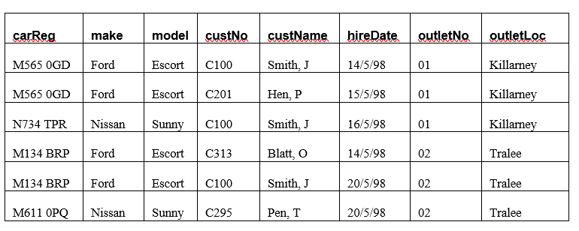
(snipped from assignment document)

- Stage of Development
The above table is currently in 1NF or First Normal Form.
This is because there is no repeating data/there are no repeating groups in the rows and each row and column has an atomic value.

- Anomalies
An insertion anomaly could occur if, for example, a new outlet location (e.g. Waterford) would be added to the table. There would be no way to add it unless there is a car registered to it.
Another insertion anomaly could occur if a new customer registers with the company but hasn’t rented a car yet. Similarly, this new customer would need to be associated to a car to be inserted to the table.

A deletion anomaly could occur if the only car registered and rented by a customer was deleted, the customer’s information would also be deleted from the system, as they are associated with the car. (Example below)
Another deletion anomaly instance could be if customer J Smith (C100) rented car M134 BRP on 20/5/98 and this information/record was deleted.
The record of Smith having rented the car on that date would be lost, even though Smith would probably have rented other cars or still is an active customer.

An update anomaly could occur if an outlet (e.g. outletNo 01) changed location (to Kilkenny). The change would need to be applied on all rows the outlet is associated with and failing to do so would lead to inconsistencies with the data.

Another update anomaly could occur due to human error. If a typo is made, for example, on the customer’s name, every record associated with that customer would need updating and this can lead to inefficiency and invaluable use of time.

- Transformation from First Normal Form to BCNF

Step 1: Identify Functional Dependencies

carReg -> make, model, outletNo
The car registration determines the make and model of the car, as well as where it is registered.

custNo -> custName
Customer number is associated with the customer’s name.

outletNo -> outletLoc
Outlet number is associated with the outlet location.

carReg, hireDate -> custNo, outletNo
Car registration and hire date both determine the customer number and outlet where the car is registered and hired from.

Step 2: Move from 1NF to 2NF (Second Normal Form)

To get to 2NF, there must be no partial dependencies.
In the table table, (carReg, hireDate) is the composite key as they uniquely identify each record in the table.

Partial dependencies in the table above include:

- custNo depends on carReg and hireDate as without both information, there would be no record on the customer hiring a registered car at a given date.
- custName, make, model, outletNo and outletLoc also depend on carReg.

To remove these partial dependencies, we split the table into relations.
Table 1: Car information (the car registration, make, model and outlet it’s stored)
Table 2: Car hire information (the car to be hired, hire date and customer hiring)
Table 3: Customer information (unique customer number and customer name)

Table 1: Car information
carReg | make | model | outletNo
M565 0GD | Ford | Escort | 01
N734 TPR | Nissan | Sunny | 01
M134 BRP | Ford | Escort | 02
M611 0PQ | Nissan | Sunny | 02

Table 2: Car hire information
carReg | hireDate | custNo
M565 0GD | 14/5/98 | C100
M565 0GD | 15/5/98 | C201
N734 TPR | 16/5/98 | C100
M134 BRP | 14/5/98 | C313
M134 BRP | 20/5/98 | C100
M611 0PQ | 20/5/98 | C295

Table 3: Customer information
custNo | custName
C100 | Smith, J
C201 | Hen, P
C313 | Blatt, O
C295 | Pen, T
Step 3: Move from 2NF to 3NF (Third Normal Form)
To get to 3NF, there must be no transitional dependencies.
- There is a transitional dependency in Table 1: Car information where the outlet number (outletNo) determines the outlet location (outletLoc).
- The objective is to have all the non-key attributes to be fully dependent on the primary key as to have no transitional dependencies.
- A new table or sub-table is created so this transitional dependency is avoided.
Table 1a: Car information (stays as is)
Table 1b: Outlet information (outlet number and outlet location)

Table 1a: Car information
carReg | make | model | outletNo
M565 0GD | Ford | Escort | 01
N734 TPR | Nissan | Sunny | 01
M134 BRP | Ford | Escort | 02
M611 0PQ | Nissan | Sunny | 02

Table 1b: Outlet information
outletNo | outletLoc
01 | Killarney
02 | Tralee

Step 4: Move from 3NF to BCNF
Step 2 transitioned the original table from 1NF to 2NF. Step 3 transitioned the original table from 2NF to 3NF and in 3NF, the tables are already in BCNF as all candidate keys are determined. Also, there are no partial or transitional dependencies.

Identify the primary and foreign keys in the final BCNF relations
Table 1: Car information (Primary Key: carReg)
carReg (Primary Key) | make | model | outletNo (Foreign Key)

Table 2: Car hire information (Composite Key: carReg, hireDate)
carReg (Foreign Key) | hireDate (Primary Key) | custNo (Foreign Key)

Table 3: Customer information (Primary Key: custNo)
custNo (Primary Key) | custName

Table 1b: Outlet information (Primary Key: outletNo)
outletNo (Primary Key) | outletLoc

- Entity-Relationship model – Visual Paradigm

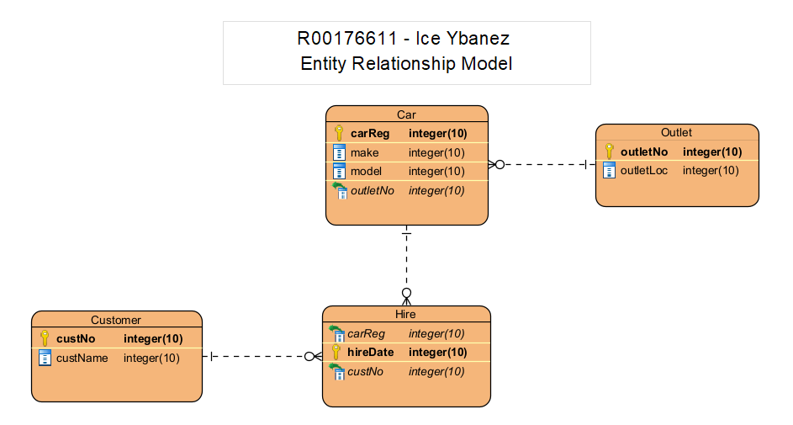
- There is a one-to-many relationship between the customer and hire entity.
- There is a one-to-many relationship between the car and the hire entity.
- There and a many-to-one relationship between the car and outlet entity.

