Database Design SOFT7022

Project 2

Ice Ybanez

R00176611

- Identify and list the entities, relationships and multiplicities for the MTU Thoroughbreds clinic chain.

Entities include:

Clinic

Staff

Owner

Horse

Consultation

Treatment

ConsultationTreatment (entity for linking consultation to treatments)

Relationships include:

Clinic – Staff
A clinic employs multiple staff members; a member of staff manages at most one clinic (but not all staff manage clinics).

Clinic – Horse
A clinic registers multiple horses; each horse can only register with one clinic.

Owner – Horse
An owner owns multiple horses, each horse has only one owner.

Horse – Consultation
A horse undergoes multiple consultations; each consultation is linked to one horse

Staff – Consultation
A staff member can do multiple consultations; each consultation is done by one staff member.

Consultation – Treatment
A consultation can result in multiple treatments; a treatment can be used in multiple consultations.

Multiplicities include:

Clinic – Staff
1..* (one-to-many)
1 clinic to many staff

Clinic – Horse
1..* (one-to-many)
1 clinic to many horses

Owner – Horse
1..* (one-to-many)
1 owner to many horses

Horse – Consultation
1..* (one-to-many)
1 horse to many consultations

Consultation – Staff
*..1 (many-to-one)
Many consultations to 1 staff

Consultation – Treatment
*..* (many-to-many)
Many consultations to many treatments
In this case, we use ConsultationTreatment as a linking entity for Consultation and Treatment.
Many ConsultationTreatment to 1 Consultation
Many ConsultationTreatment to 1 Treatment
- List and associate all attributes with the appropriate entities and relationships. Include all primary and foreign keys.
Clinic (entity)
Attributes:
- clinicNo(Primary Key = PK),
- cAddress,
- cPhoneNo

Staff (entity)
Attributes:
- staffNo(PK),
- fName,
- lName,
- sAddress,
- sDOB,
- salary,
- position,
- clinicNo(Foreign Key = FK)

Owner (entity)
Attributes:
- ownerNo(PK),
- oName,
- oAddress,
- oPhoneNo

Horse (entity)
Attributes:
- horseID(PK),
- hName,
- hDOB,
- hColour,
- ownerNo(FK),
- clinicNo(FK)

Consultation (entity)
Attributes:
- consultNo(PK),
- date,
- time,
- horseID(FK),
- staffNo(FK)

Treatment (entity)
Attributes:
- treatNo(PK),
- tName,
- description

ConsultationTreatment (entity for linking consultation to treatments)
Attributes:
- consultNo(PK, FK) links treatment to specific consultation
- treatNo(PK, FK) links consultation to specific treatment

- Using your answers to parts (a) & (b) attempt to represent the data requirements of the MTU Thoroughbreds Clinics as a single ER diagram. You could use a diagram tool like Visual Paradigm to complete this task. Incorporate an image of the diagram into your assignment submission.

MTU Thoroughbreds Clinics

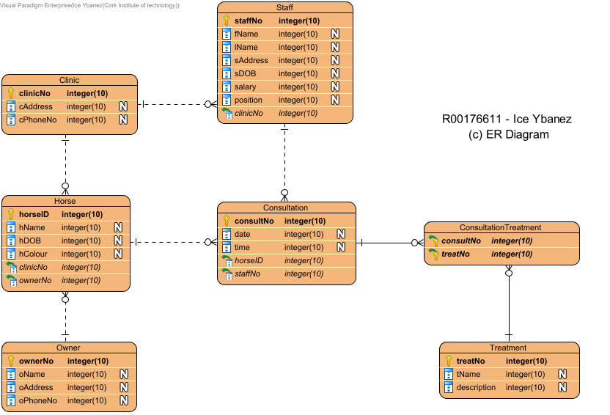

- Verify that the ER model drawn in part (c) adheres to the process of Normalisation through its various stages to BCNF. Clearly identify the correct stage of normalization for each table. You should also carry out normalization that may be necessary to ensure all tables are in BCNF.

Clinic:
- There are no repeating groups therefore it is in 1NF
- There are no partial dependencies therefore it is in 2NF
- There are no transitional dependencies therefore it is in 3NF
- All candidate keys are determined therefore it is in BCNF
Staff:
- There are no repeating groups therefore it is in 1NF
- There are no partial dependencies therefore it is in 2NF
- There are no transitional dependencies therefore it is in 3NF
- All candidate keys are determined therefore it is in BCNF
Owner:
- There are no repeating groups therefore it is in 1NF
- There are no partial dependencies therefore it is in 2NF
- There are no transitional dependencies therefore it is in 3NF
- All candidate keys are determined therefore it is in BCNF
Horse:
- There are no repeating groups therefore it is in 1NF
- There are no partial dependencies therefore it is in 2NF
- There are no transitional dependencies therefore it is in 3NF
- All candidate keys are determined therefore it is in BCNF
Consultation:
- There are no repeating groups therefore it is in 1NF
- There are no partial dependencies therefore it is in 2NF
- There are no transitional dependencies therefore it is in 3NF
- All candidate keys are determined therefore it is in BCNF
Treatment:
- There are no repeating groups therefore it is in 1NF
- There are no partial dependencies therefore it is in 2NF
- There are no transitional dependencies therefore it is in 3NF
- All candidate keys are determined therefore it is in BCNF
ConsultationTreatment:
- There are no repeating groups therefore it is in 1NF
- There are no partial dependencies therefore it is in 2NF
- There are no transitional dependencies therefore it is in 3NF
- The composite key is the only candidate key and since that’s determined, this table is in BCNF

- Once you are satisfied with your design in part (c) & (d), write SQL CREATE TABLE statements to create each table in the MySQL DBMS with all constraints included. You should complete this as ONE SQL script. Once the tables are created, write ONE SQL script that inserts at least TWO records into each table.
CREATE SCRIPT:

-- create database
CREATE DATABASE horseClinic;
USE horseClinic;

-- create Clinic table
CREATE TABLE Clinic (
clinicNo varchar(3) PRIMARY KEY,
cAddress VARCHAR(60) NOT NULL,
cPhoneNo VARCHAR(15) NOT NULL
);

-- create Staff table
CREATE TABLE Staff (
staffNo VARCHAR(3) PRIMARY KEY,
fName VARCHAR(15) NOT NULL,
lName VARCHAR(15) NOT NULL,
sAddress VARCHAR(100) NOT NULL,
sDOB DATE NOT NULL,
salary DECIMAL(10, 2) NOT NULL,
position VARCHAR(30) NOT NULL,
clinicNo VARCHAR(3),
FOREIGN KEY (clinicNo) REFERENCES Clinic(clinicNo)
);

-- create Owner table
CREATE TABLE Owner (
ownerNo VARCHAR(3) PRIMARY KEY,
oName VARCHAR(30) NOT NULL,
oAddress VARCHAR(100) NOT NULL,
oPhoneNo VARCHAR(15) NOT NULL
);

-- create Horse table
CREATE TABLE Horse (
horseID VARCHAR(3) PRIMARY KEY,
hDOB DATE NOT NULL,
hName VARCHAR(30) NOT NULL,
hColour VARCHAR(15) NOT NULL,
clinicNo VARCHAR(3),
ownerNo VARCHAR(3),
FOREIGN KEY (clinicNo) REFERENCES Clinic(clinicNo),
FOREIGN KEY (ownerNo) REFERENCES Owner(ownerNo)
);

-- create Consultation table
CREATE TABLE Consultation (
consultNo VARCHAR(4) PRIMARY KEY,
date DATE NOT NULL,
time TIME NOT NULL,
horseID VARCHAR(3),
staffNo VARCHAR(3),
FOREIGN KEY (horseID) REFERENCES Horse(horseID),
FOREIGN KEY (staffNo) REFERENCES Staff(staffNo)
);

-- create Treatment table
CREATE TABLE Treatment (
treatNo VARCHAR(3) PRIMARY KEY,
tName VARCHAR(100) NOT NULL,
description TEXT NOT NULL
);

-- create ConsultationTreatment table
CREATE TABLE ConsultationTreatments (
consultNo VARCHAR(4),
treatNo VARCHAR(3),
PRIMARY KEY (consultNo, treatNo),
FOREIGN KEY (consultNo) REFERENCES Consultation(consultNo),
FOREIGN KEY (treatNo) REFERENCES Treatment(treatNo)
);

INSERT INTO Script:

-- write ONE SQL script that inserts at least TWO records into each table

-- insert records into Clinic table
INSERT INTO Clinic (clinicNo, cAddress, cPhoneNo)
VALUES ('C01', '875 North Drive', '0219658466'),
('C02', '998 Riverview', '0214567894');

-- insert records into Staff table
INSERT INTO Staff (staffNo, fName, lName, sAddress, sDOB, salary, position, clinicNo)
VALUES ('S01', 'John', 'Doe', '789 Oak St', '1990-05-10', 50000, 'Manager', 'C01'),
('S02', 'Jane', 'Smith', '321 Pine St', '1985-12-20', 45000, 'Veterinary', 'C02');

-- insert records into Owner table
INSERT INTO Owner (ownerNo, oName, oAddress, oPhoneNo)
VALUES ('O01', 'John McClain', '986 Kildara Heights', '0875684475'),
('O02', 'Robert Thames', '087 Pinegrew', '0876679584');

-- insert records into Horse table
INSERT INTO Horse (horseID, hDOB, hName, hColour, clinicNo, ownerNo)
VALUES ('H01', '2012-01-22', 'Elend', 'White', 'C01', 'O01'),
('H02', '2013-08-01', 'Vin', 'Black', 'C02', 'O02');

-- insert records into Consultation table
INSERT INTO Consultation (consultNo, date, time, horseID, staffNo)
VALUES ('CT01', '2024-11-28', '15:30:00', 'H01', 'S01'),
('CT02', '2024-11-29', '14:15:00', 'H02', 'S02');

-- insert records into Treatment table
INSERT INTO Treatment (treatNo, tName, description)
VALUES ('T01', 'Omeprazole', 'Treatment for gastric ulcer'),
('T02', 'Antimycotic Antiseptic', 'Treatment for ringworm');

-- insert records into ConsultationTreatments table
INSERT INTO ConsultationTreatments (consultNo, treatNo)
VALUES ('CT01', 'T01'),
('CT02', 'T02');

