Replication
Ice Ybanez
R00176611

Task:
1.
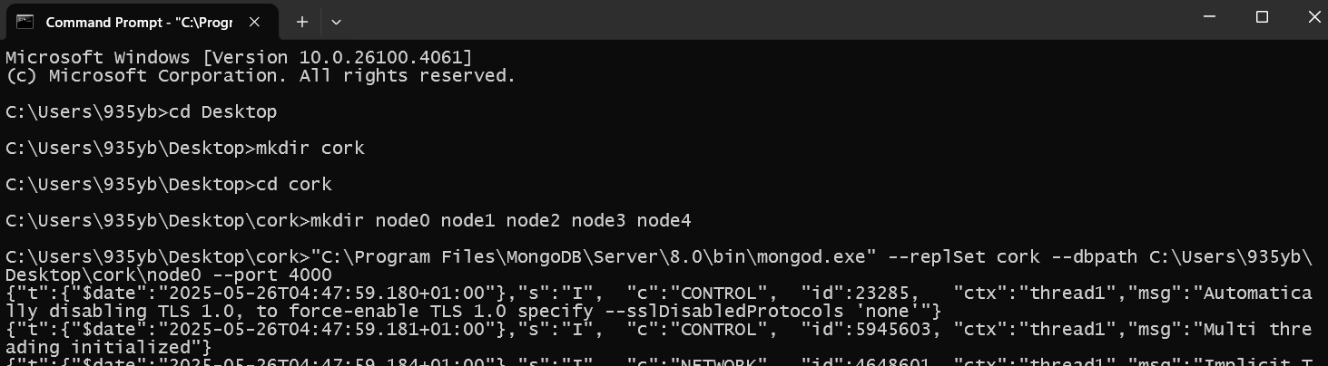
Creating directories for nodes
Setting up master, slaves and arbiter nodes:
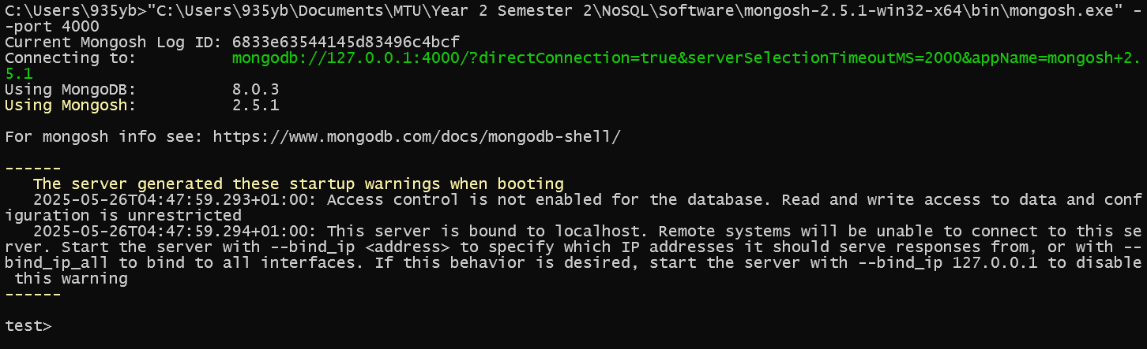
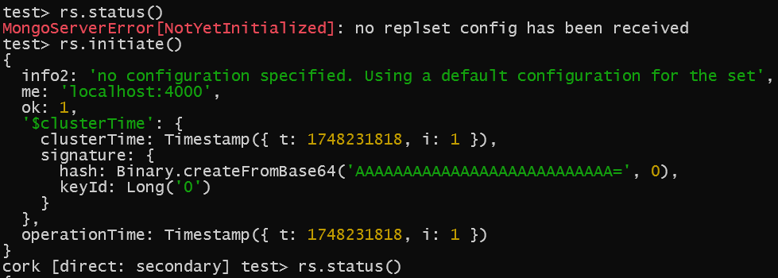
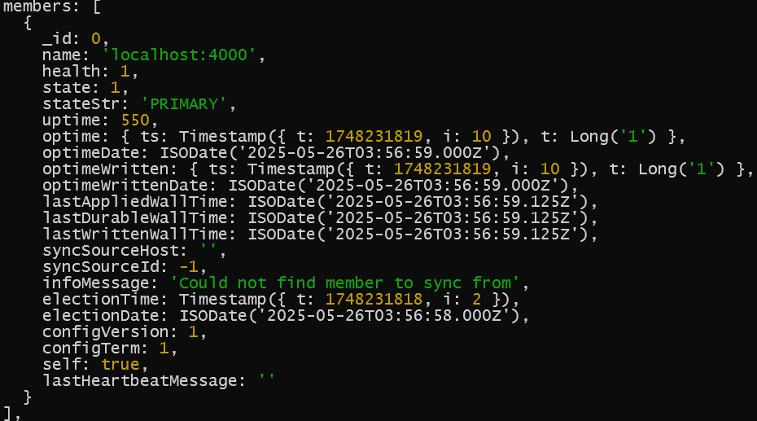
localhost:4000 is PRIMARY/master node
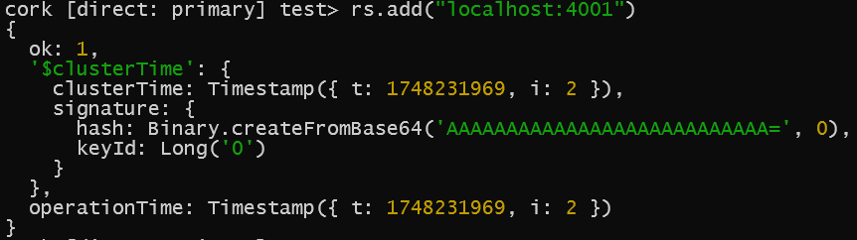
Adding slave node
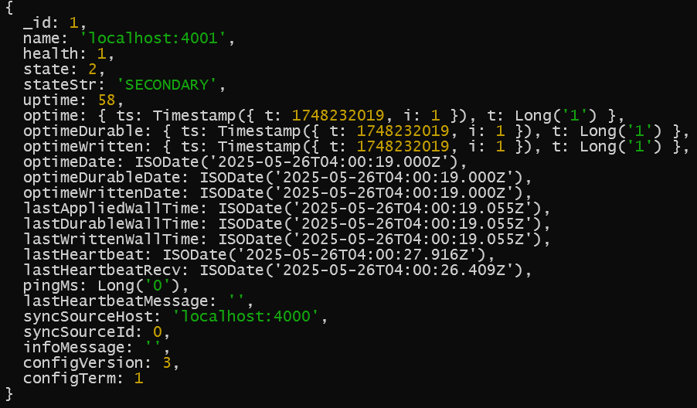
localhost:4001 which is node1 is a SECONDARY/slave node

Will add 2 more secondary/slave nodes:
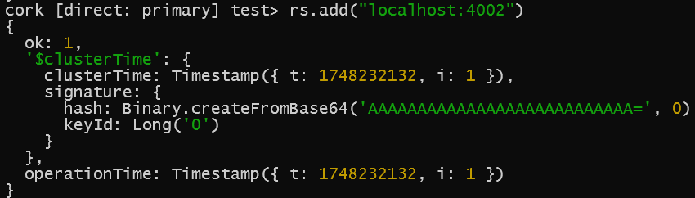
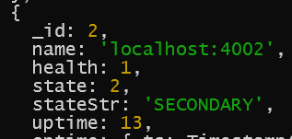
localhost:4002 is SECONDARY/slave node
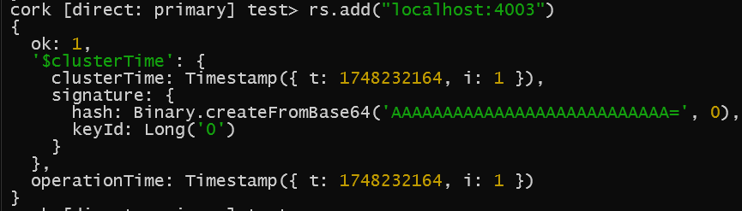
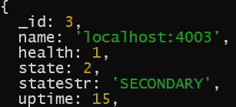
localhost:4003 is SECONDARY/slave node

Now adding arbiter node:
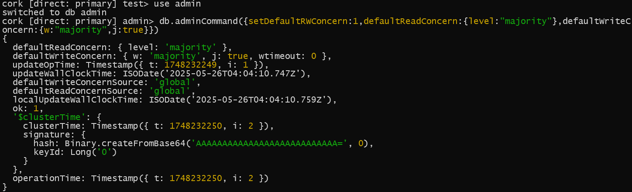
Configuring default read/write concern, default read concern at majority and the same for default write concern, journaling is on.
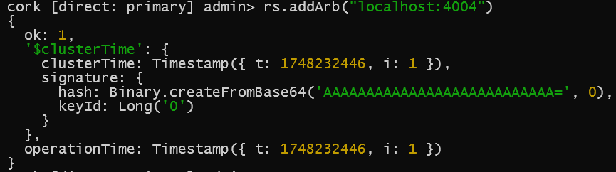
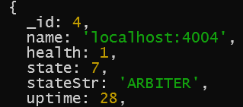
localhost:4004 is arbiter node
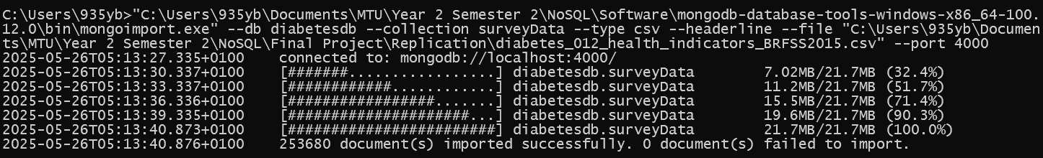
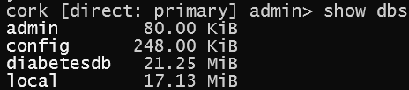
Importing dataset into primary node --port 4000 & confirming
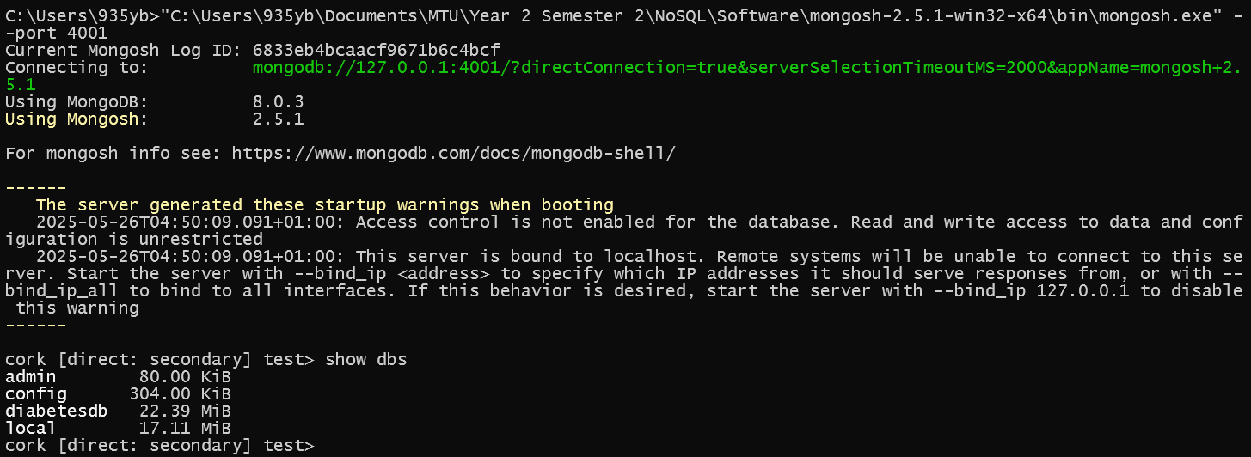
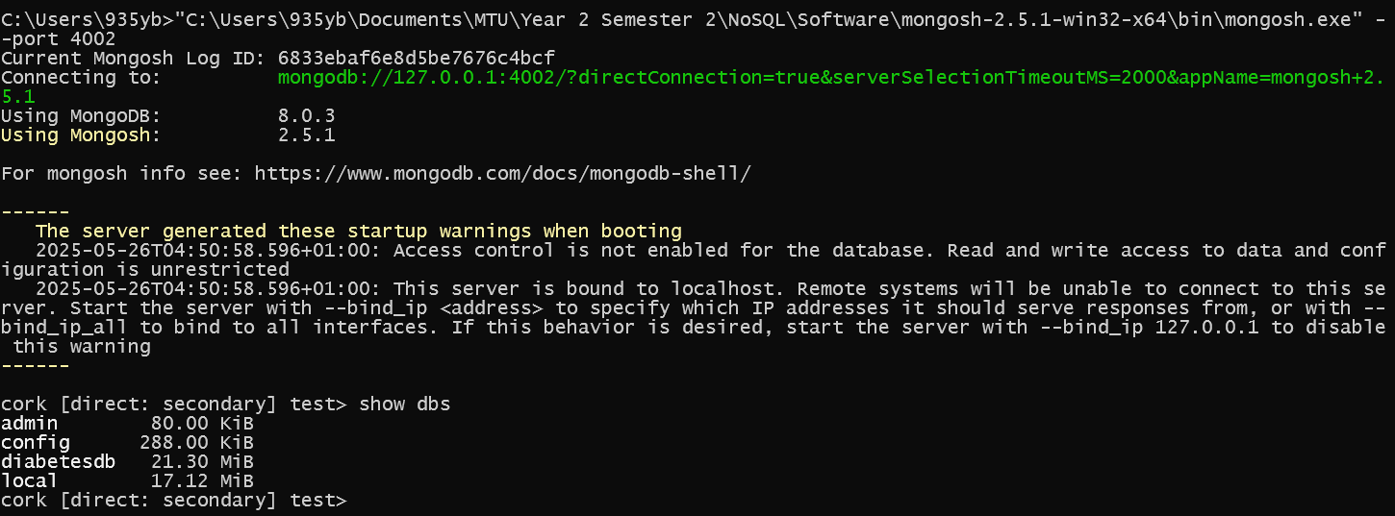
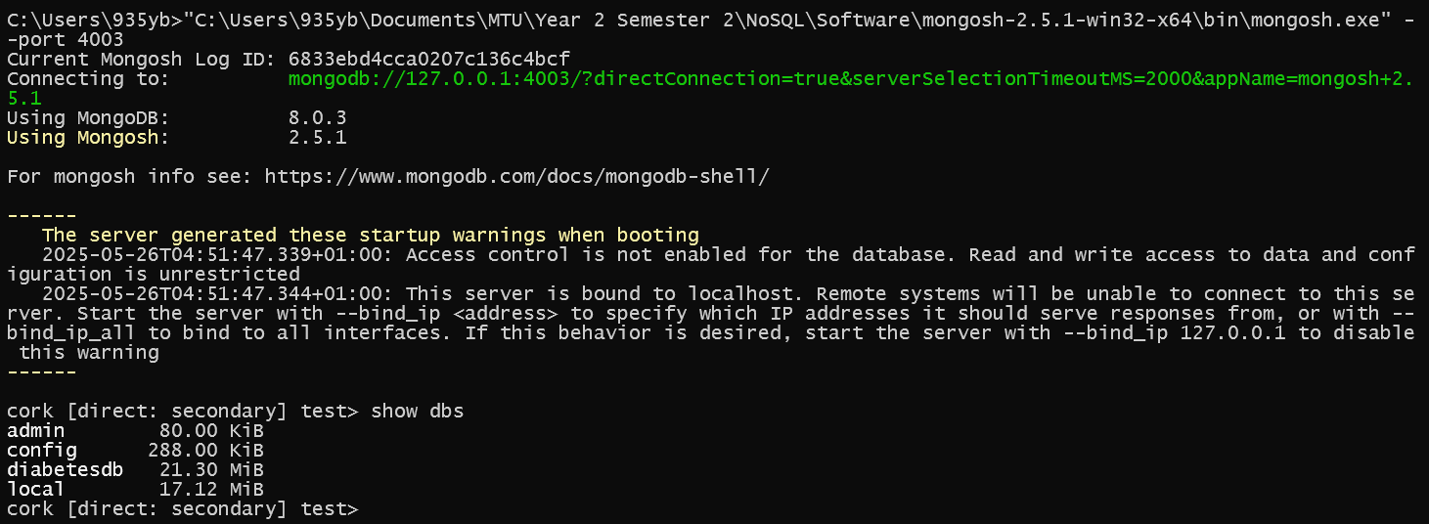
Shows database in slave nodes already
2.
If primary localhost:4000 goes down, a secondary node, either localhost:4001, localhost:4002 or localhost:4003 is promoted to primary automatically.
The arbiter localhost:4004 participates in voting but doesn’t hold any data
Default write concern was configured to “majority” to elect a new primary.
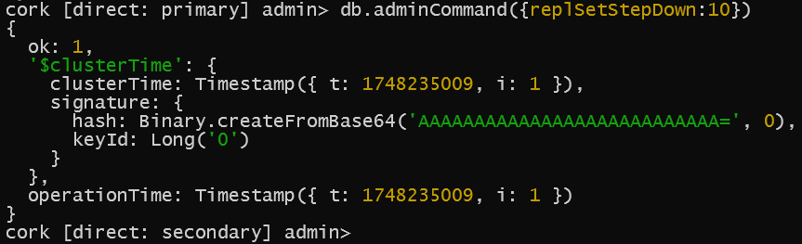
After db.adminCommand({replSetStepDown:10}) direct: primary changed to direct: secondary

localhost:4001, localhost:4002 and localhost:4003 were initially slave nodes
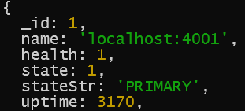
Now, localhost:4001 is PRIMARY/master
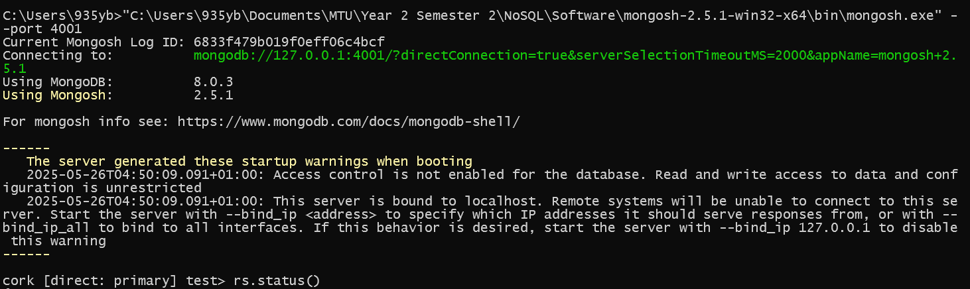
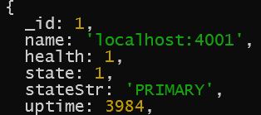
To confirm on Mongo Shell --port 4001 rs.status() shows localhost:4001 is PRIMARY/master node
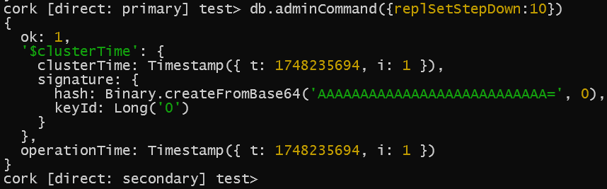
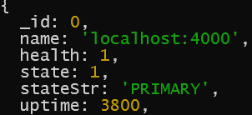
localhost:4000 becomes PRIMARY again

To show automated failover:
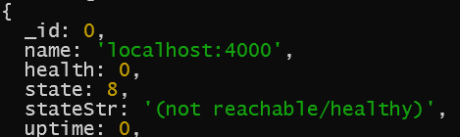
Shutdown localhost:4000
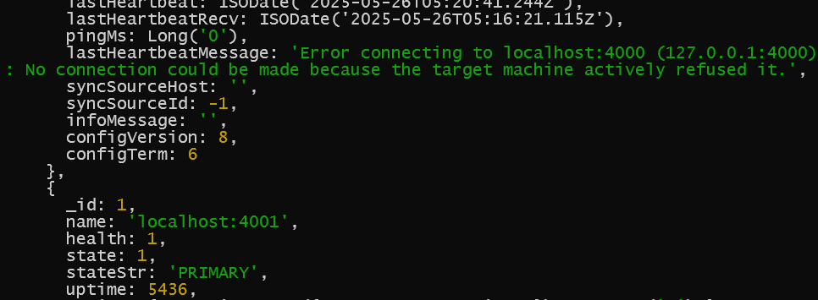
Check if there is a new primary/master
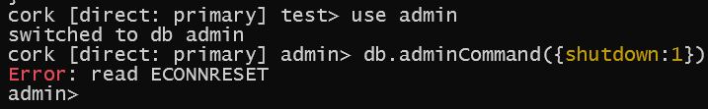
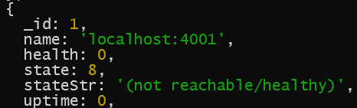
Shutdown new primary/master
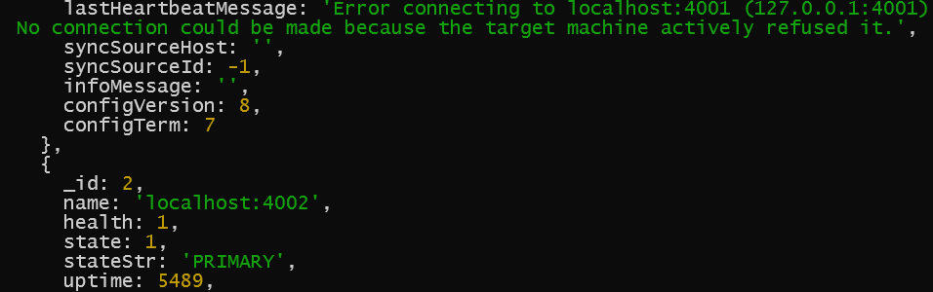
Check again if there is a new one
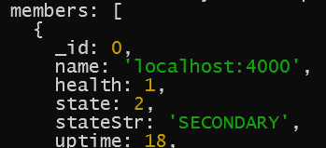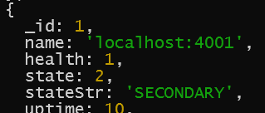
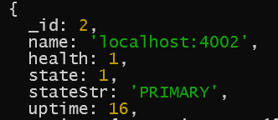
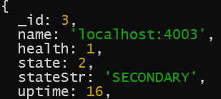
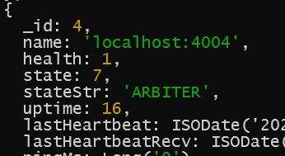
Bring everything back to life and check rs.status()
localhost:4002 is now the PRIMARY
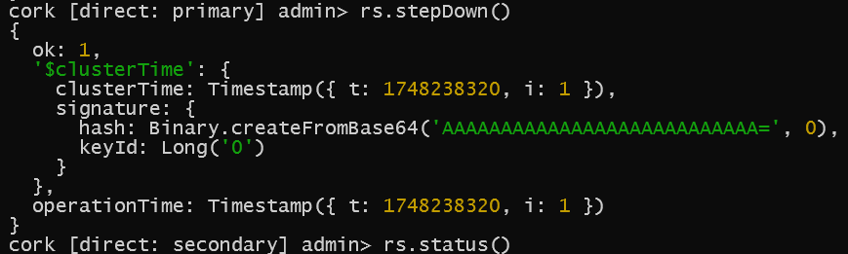
stepDown() and check new PRIMARY (should be localhost:4000 again)
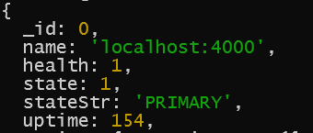
localhost:4000 is back to being the master node
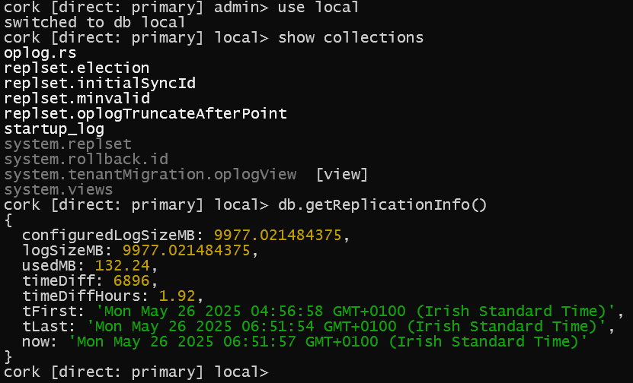
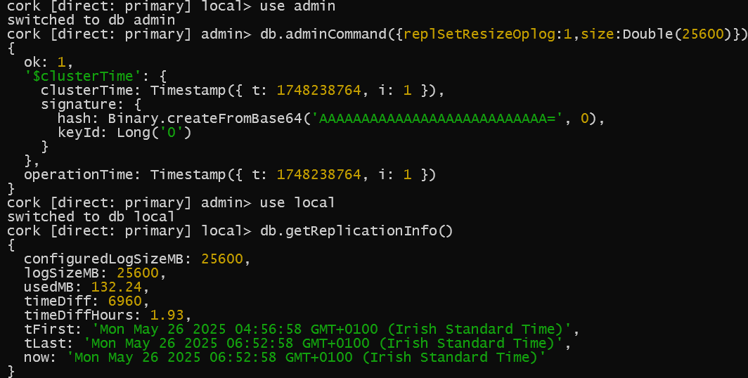
Increasing size of each oplog to 25GB for localhost:4000
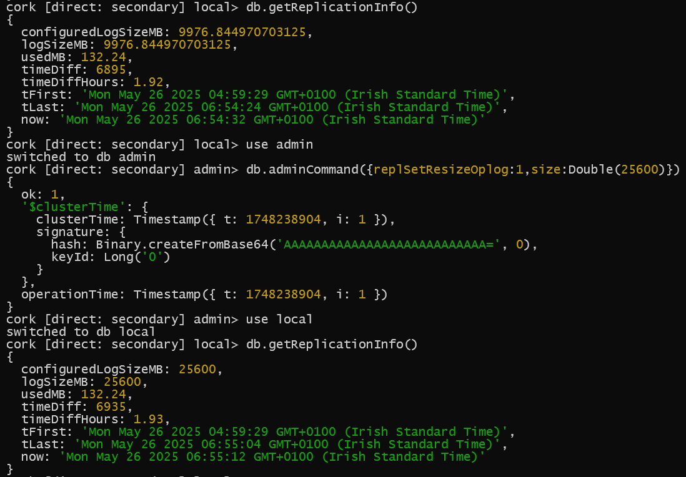
For localhost:4001
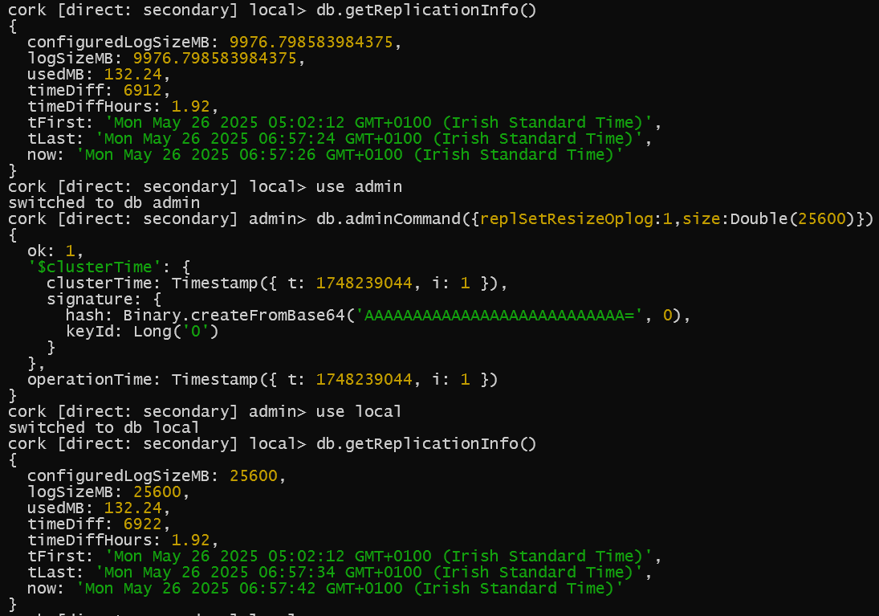
For localhost:4002
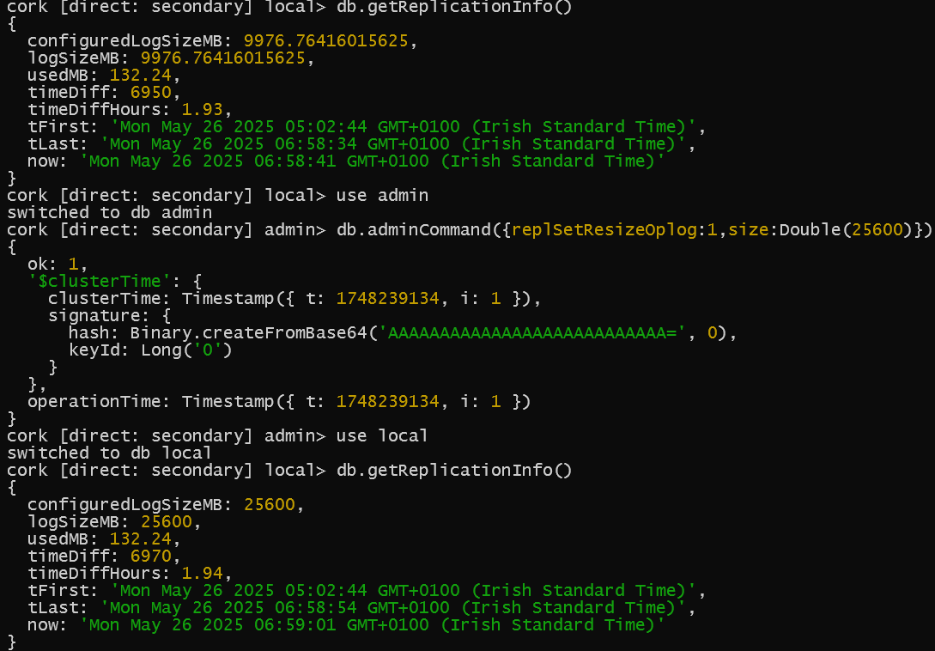
For localhost:4003

No need to do it for Arbiter node as it doesn’t contain any data.

3.
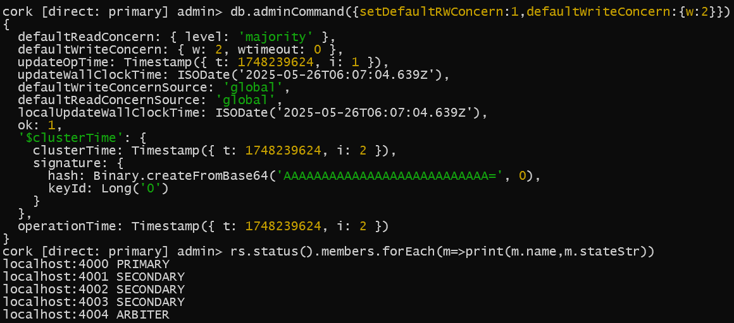
Globally reconfigure write operation so it’s completed with two data-bearing members before returning
According to Rubric:
“Can you verify and reconfigure the write operation so that it is completed by most voting members before returning?”
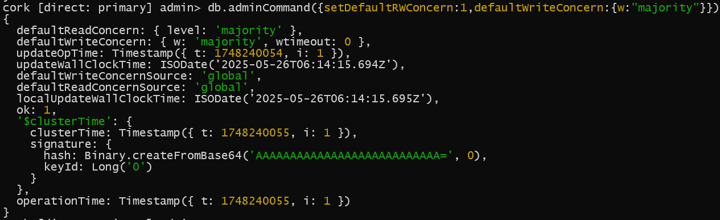
Answering rubric question {w:”majority”}
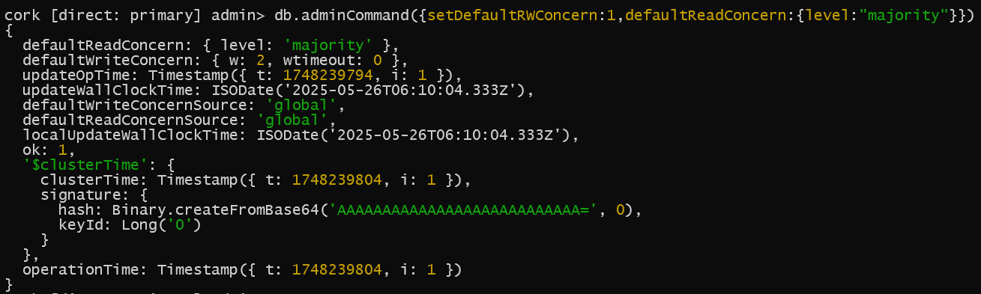
All read operations across the replica set returns the most recent data

4.
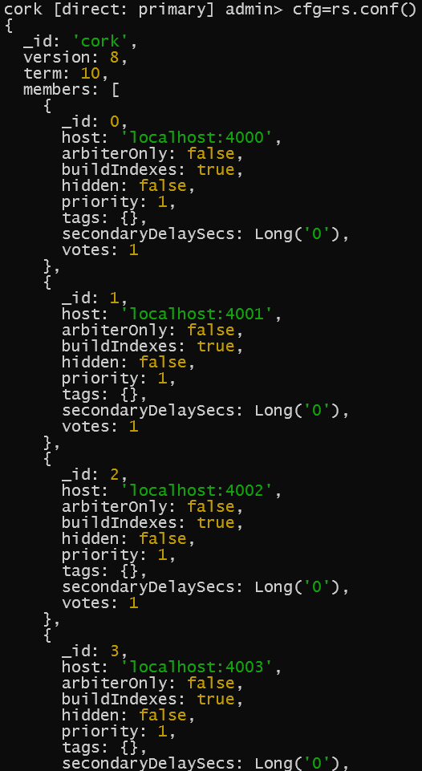
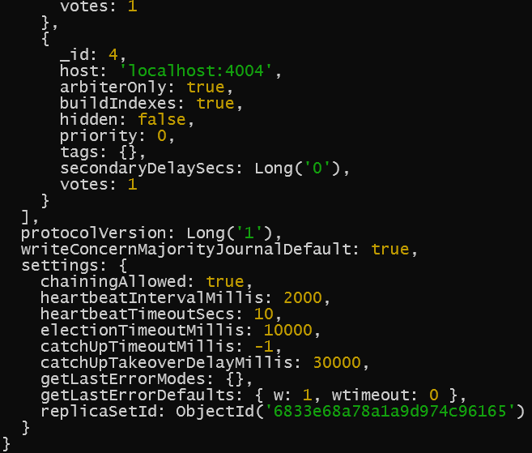
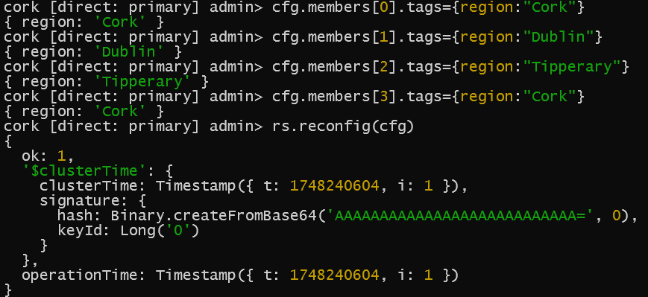
Modifying and reconfiguring replica set - tagging members by region
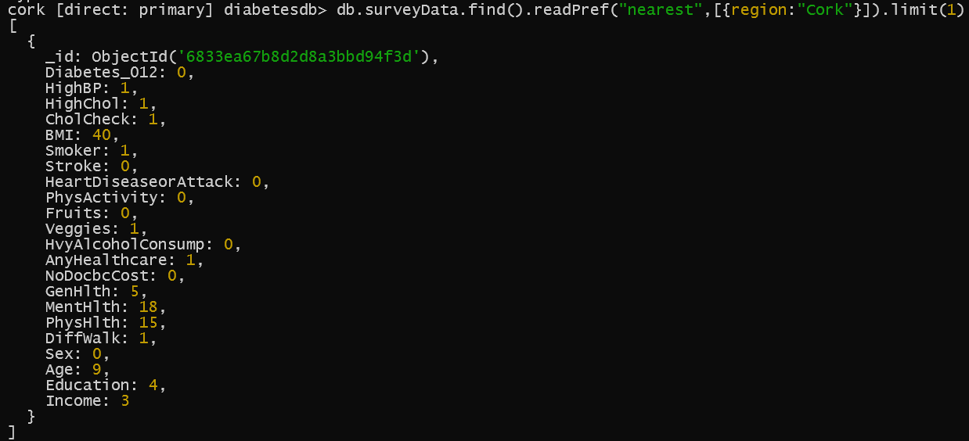
readPref from Cork
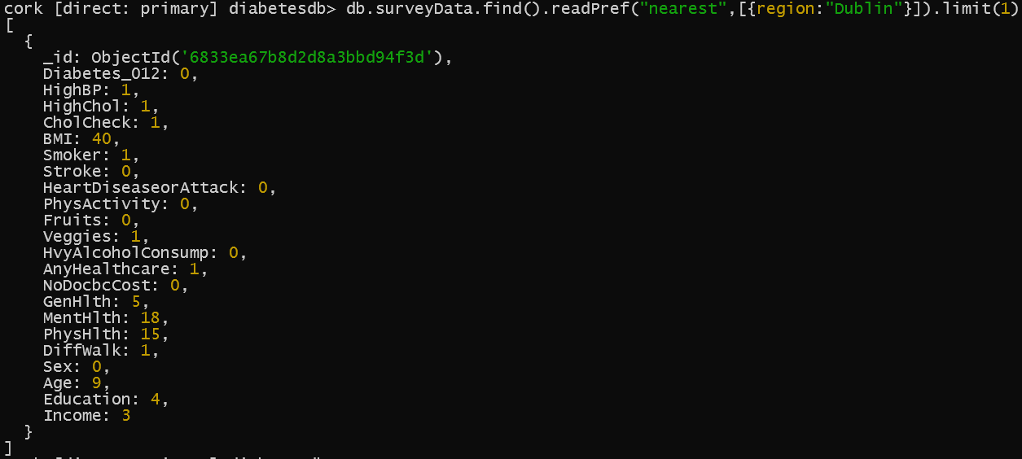
readPref from Dublin
5.
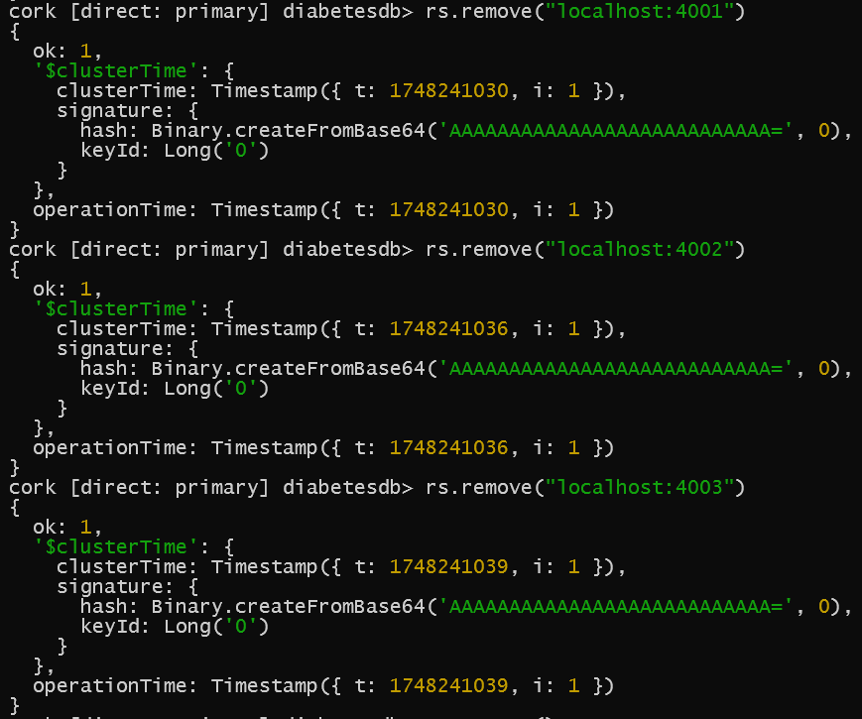
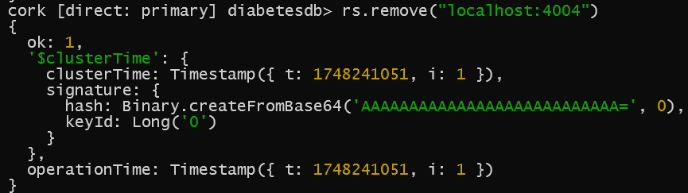
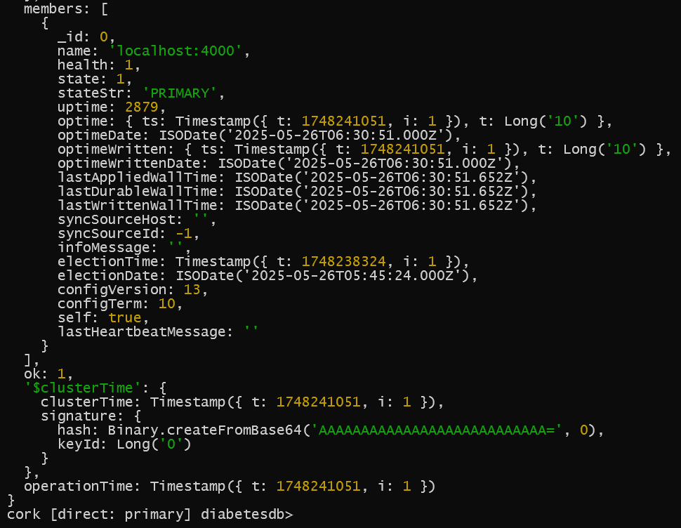
Removing each node except the master
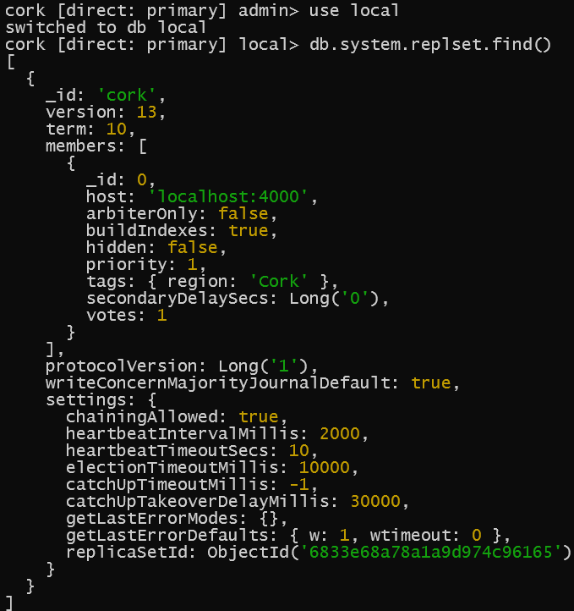
Find master member
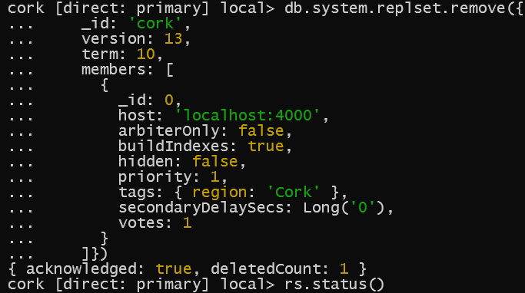
db.system.replset.remove()
Confirmation via deletedCount: 1

