A Fair Comparison Framework for Bionic Tree-Shaped Microchannel Chip Cooling Networks and a Constraint-Driven Topology Generator
Haoran Wu
Wuchang University of Technology, No. 16 Jiangxia Avenue, Jiangxia District, Wuhan 430223, China
ORCID: 0009-0005-1975-1511
* Corresponding author. E-mail: 3973349767@qq.com
Abstract
Reported gains of tree-shaped bionic microchannels over straight channels depend on the material budget and can reverse when it changes. We present a reproducible fair-comparison framework and a constraint-driven topology generator that remove this dependence.
Three fairness bases—equal pinned, equal material, equal total occupied cells—are imposed while tree channels are grown by heat-field-driven Prim growth with Murray-law radii. The node budget, usually free, is instead derived from three physical constraints: every chip footprint must be entered, the root radius may not exceed the cell pitch, and the pressure drop may not exceed the pump shut-off head. This yields a two-objective Pareto front and a knee point from an epsilon-constraint rule. Verification uses grid independence, an analytical benchmark, Murray-law conservation, and an electrical-analogy circuit.
Under a single heat source the tree and a straight channel give identical peak temperature, at roughly 310 times the pressure drop. Across 24 multi-source design points (18 solved; six rejected by a footprint gate), the tree is 0.9–4.7 °C cooler than a radial baseline under the loose equal-pinned basis, but the lattice network is not inferior under the strict equal-occupied-cell basis. Against a radial per-chip baseline the tree retains only 0.2–0.7 °C of peak reduction, widening to 1.02–3.55 °C as spacing falls from 30 to 6 mm, but at 28–97 times the pressure drop. Finite-flow conjugate and finite-convection sweeps do not change these directions. The result is a screening criterion for when a tree justifies its hydraulic cost, not a claim that trees are better.
Keywords: microchannel heat sink; bionic tree-shaped network; Murray's law; fair comparison; Pareto front; constraint-driven generation
Nomenclature
All numerical results in this paper use the symbols and conventions listed in Table 1; the physical meaning is given at first occurrence. The subscripts p and c denote the parent and child tubes, and root and leaves denote the root and leaves of the tree network. Equations (1)–(4) are the four basic relations referenced throughout; all other numbers are produced by actual runs of the repository artifacts.
Table 1. Main symbols and units
Symbol | Meaning | Unit
T_{max} | Peak temperature of the solid domain | °C
T_{mean} | Mean temperature of the solid domain | °C
T_{cool} | Coolant inlet temperature | °C
R_{th} | Thermal resistance, (T_{max} − T_{cool})/Q | °C/W
Δ p | Pressure drop (convention A: deepest root–leaf path) | Pa
Q | Total heat dissipation of the chip | W
q | Coolant volumetric flow rate | L/min
p | Cell pitch (real-unit 0.9 mm) | mm
k | Thermal conductivity (monocrystalline silicon 148) | W/(m·K)
μ | Dynamic viscosity (water at 20 °C, 1.002×10⁻³) | Pa·s
r₀ | Leaf tip capillary radius | mm
r_{p}, r_{c} | Parent / child tube radius (Murray's law) | mm
r_{root} | Root radius (thickest tube under Murray's law) | mm
N_{leaves} | Number of leaf nodes (flow downstream of the edge) | –
b | Node budget (total cells occupied by the channels) | –
N_{pin} | Number of pinned (set to T_{cool}) cells | –
A_{hot} | Hot-spot area (shared absolute threshold 26 °C) | mm²
h_{conv} | Dimensionless Biot number for finite convection | –
GCI | Grid convergence index | %
t_{tol} | ε-constraint thermal tolerance | K
1 Introduction
1.1 Background
As the heat flux density of high-power chips continues to rise, air cooling can no longer meet the dissipation demand, and microchannel liquid cooling has become the mainstream solution owing to its compact structure and excellent convective heat transfer [1,2]. Among the many microchannel topologies, bionic tree-shaped branching networks inspired by plant leaf veins and animal vasculature are widely believed to outperform conventional parallel straight channels: their hierarchical branching structure is claimed to reduce both thermal resistance and pressure drop [3,4]. The geometric basis of this claim is Murray's law [5]—under the principle of minimum transport work, the parent and child radii satisfy the cubic relation r_{p}³=Σ r_{c}³.
However, the comparative conclusions between tree-shaped and straight channels are inconsistent in the existing literature, and they depend strongly on a variable that is rarely defined explicitly—the material budget (the number of cells occupied by the channels, or the cross-sectional area). When the budget is unconstrained, or when the two sides' budgets are unequal, the comparison result may be driven entirely by the budget discrepancy rather than by the topology, causing the conclusion to reverse with the budget. This is precisely the core problem addressed in this paper.
1.2 Research Questions
Three questions follow directly from the above background.
First, the question of basis. Does the claim that the tree is better than the straight channel still hold under a unified material budget? If the pinned cell counts, total cross-sectional areas, or total occupied-cell counts of the two sides are unequal, how much of the measured temperature difference and pressure-drop difference comes from the topology itself, and how much from the budget discrepancy?
Second, the question of parameters. Should the node budget of a tree network be treated as a free input or as a constraint output? As a free input, the conclusion drifts with the budget and no defensible design point can be given; only if the feasible set can be derived by inversion from three physical constraints—entering every chip footprint, root radius not exceeding the cell pitch, and pressure drop not exceeding the pump shut-off head—does the design point become reproducible.
Third, the question of boundaries. Even if the tree is found superior under a fair basis, under what conditions does the advantage disappear? Do single versus multiple heat sources, equal versus non-uniform power, ideal sink versus finite convection, and pinned cells versus finite flow each change the direction of the conclusion?
The goal of this paper is not to add another claim that the tree is better, but to deliver a one-click reproducible adjudication device: under an explicit basis, whether the advantage of the tree topology holds, where in the design space it holds (the applicable regime), and at what hydraulic cost.
1.3 Overview of the Method
The approach of this paper is to treat comparison itself as the object of study. Rather than reporting topological merits under self-determined budgets, we first fix the comparison basis: we make the tree network and its control equal in pinned cell count, total material, and total occupied cells, one level at a time, so that any measured difference can only be attributed to the arrangement.
On the generation side, we do not draw the channels by hand; instead the network grows out of the heat field—at each step the currently hottest neighbouring cell is attached to the existing structure, so the channels naturally converge toward the heat sources. Radii follow the biological Murray cubic relation, which minimises the transport work between parent and child tubes.
On the selection side, we reformulate how large the budget should be from an arbitrary setting into a constraint solve: designs satisfying the thermal-permissibility, geometric-manufacturability, and hydraulic-budget constraints form a feasible set, whose output is not a single design point but the Pareto front between peak temperature and pressure drop. Engineering selection then takes the knee point on the front via a thermal tolerance, thereby making the influence of subjective parameters explicit.
The three stages—basis constraint, heat-field growth, and constraint selection—form a closed loop: any claim that the tree is better can be reproduced or refuted within this framework.
1.4 Research Gaps and Contributions
Summarising the existing work, three gaps can be identified:
(1) No unified comparison basis: the material budget, pinned cell count, and total occupied-cell count of the tree and its control are often unequal, so the conclusion may be dominated by the budget discrepancy;
(2) The node budget is a free parameter: the budget (leaf count / segment count) of a tree network is usually prescribed by hand, with no mechanism deriving it from physical constraints;
(3) No reproducible adjudication device: whether the advantage holds, and under which basis, cannot be reproduced by a single script in one click.
In response to the above gaps, this paper contributes:
(1) Three fairness constraints—equal pinned cells, equal material, and equal total occupied cells—together with a systematic comparison of tree-shaped, radial, and lattice topologies on four chip layouts;
(2) A constraint-driven generator that reformulates the node budget from a free input into the solution of three physical constraints (C1 entering every chip, C2 root radius not exceeding the cell pitch, C3 pressure drop not exceeding the pump head), yielding the (T_{max}, Δp) Pareto front and the knee-point sensitivity;
(3) All numbers are produced by actual runs of the repository solver, with artifact paths given in the text, so that both the comparison protocol and the generator can be reproduced in one click.
2 Related Work
2.1 Thermo-Hydraulic Performance of Tree-Shaped Branching Microchannels
The theoretical and experimental study of tree-shaped branching microchannels is extensive. Murray's law [5] and the allometric scaling model of West et al. [6] provide the biological basis for branching networks; Bejan's constructal theory [7] generalises it into an engineering design principle. Jing and Song [8] re-examined Murray's law under a constant-channel-height constraint, pointing out that the optimal diameter ratio for circular tubes does not apply to rectangular bifurcations, where the optimal width ratio is determined jointly by channel height, initial size, and branching level. Wang et al. [3] studied the thermo-hydraulic performance of tree-shaped heat sinks with high branching levels based on a modified Murray's law. Chen et al. [4] proposed Y-shaped bifurcated straight-channel heat sinks and quantified the effects of bifurcation angle, branching level, channel count, and inlet velocity on flow uniformity and thermo-hydraulic performance.
2.2 Topology Optimisation and Local Losses
In the direction of topology optimisation, Tan et al. [9] and Wang et al. [10] applied multi-objective topology optimisation to high-heat-flux chip cold-plate design, demonstrating the benefit of non-uniform channel layouts. On the hydraulic side, Kiser et al. [11] measured laminar loss coefficients for tee and wye junctions, and Rennels and Hudson [12] systematically compiled engineering data on pipe fitting local losses; these results suggest that neglecting junction losses systematically underestimates the pressure drop of tree networks, because a tree has far more bifurcations than a parallel straight channel.
2.3 Bionic Adaptive Routing
The slime-mould (Physarum) adaptive network model [13,14] offers another bionic paradigm for channel routing, whose steady state and relation to shortest paths have been rigorously characterised. This paper borrows its electrical analogy for cross-validation, but the routing itself still uses heat-field-driven growth, to maintain consistency with the main model.
Most of the above work reports the tree is better under self-determined budgets and boundaries, but lacks a unified, budget-fair comparison framework, and also lacks a generation method that turns the budget from a free parameter into a constraint solve.
2.4 Differences from the Present Method
What the above work has in common is reporting the tree is better under self-determined budgets and boundaries. The difference between this paper and them lies not in proposing a new topology, but in making the comparison itself constrained and reproducible. Table 2 summarises this difference along five dimensions.
Table 2. Differences between existing studies and the present method in terms of the comparison basis
Comparison dimension | Existing studies | Present method
Comparison basis | The budget basis is set by each paper; pinned cells, material amount, and total occupied cells are often unequal | Three constraints—equal pinned cells, equal material, and equal total occupied cells—checked level by level (18/18 groups cell-by-cell equal)
Node budget | A free input; a set of budgets is scanned and the best is picked, so the conclusion drifts with the budget | A constraint output; the feasible set is derived by inversion from C1/C2/C3, yielding a Pareto front
Selection method | Optimising by a single metric (lowest temperature or lowest thermal resistance) | A two-objective front plus an ε-constraint knee point, with sensitivity to the thermal tolerance reported
Pressure-drop basis | Mostly the purely viscous term, with junction local losses often neglected | Also a purely viscous lower bound, but with the directional consequence of the omitted local losses stated explicitly
Reproduction | Conclusions reported as figures and tables, with no one-click reproduction script | All numbers produced by actual runs of the repository solver, with artifact paths given in the text
It should be noted that this paper does not deny the validity of existing work under their own respective bases; what this paper points out is that these conclusions cannot be cited across bases as the tree is universally better.
3 Model and Method
3.1 Physical Model and Numerical Discretisation
On a 50×50 grid (real-unit cell pitch p=0.9 mm, plate 45×45 mm, silicon thickness t=5 mm, k=148 W/(m·K) [15]), the steady-state conduction equation is solved by five-point differences:
∇² T = -q/k, T = T_{cool} (boundary) (1)
where q is the volumetric heat flux of the source cell and the boundary takes a constant-temperature sink. In Eq. (1) the right-hand side is the source term and the left-hand side is the Laplacian operator; the discretisation is solved by Jacobi iteration, with a residual criterion of 10⁻⁶ on the production grid; the measured convergence required 4513 iterations, with a linear residual of 3.69^{e−13}.
The tree-shaped channels enter the model as pinned cells: cells occupied by the channels are set to T_{cool}, thereby equivalenting the fluid convective heat transfer to a fixed-temperature sink. The consequence of this convention is discussed quantitatively in Section 5.5.
3.2 Heat-Field-Driven Tree Growth
The tree grows by a Prim-type greedy algorithm: at each step the currently hottest neighbouring cell is attached to the existing tree, until the node budget b is reached. This rule makes the tree naturally converge toward the heat source, so the shape is driven by the heat field rather than drawn by hand. The resulting baseline tree contains 400 nodes and 399 segments, with a degree distribution of 61 of degree 1, 282 of degree 2, 55 of degree 3, and 2 of degree 4. The single-source steady heat field is shown in Fig. 1. Morphological evidence is given in Fig. 2: the hot region of the tree concentrates around the source block and the tips radiate outward, essentially different from a manually drawn regular grid. The growth sequence is shown in Fig. 3.
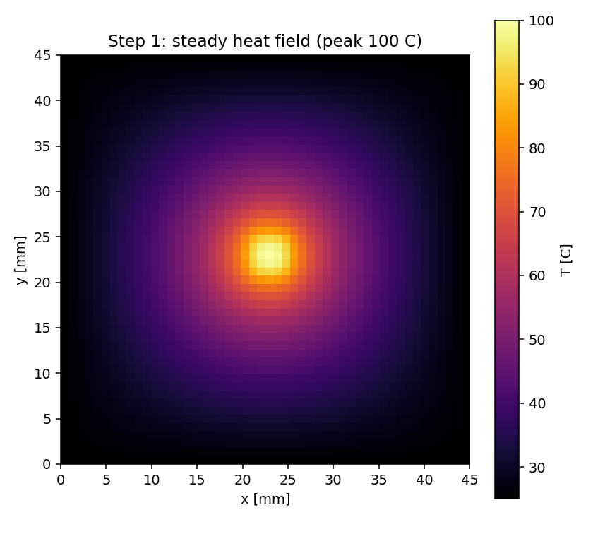
Fig. 1. Single-source steady heat field (peak normalised to 100 °C)
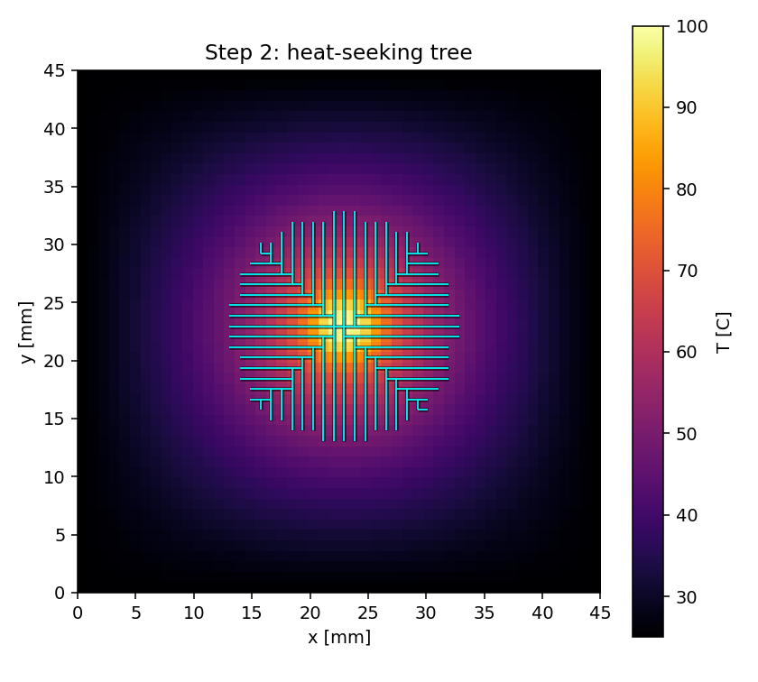
Fig. 2. Tree-shaped channel morphology obtained by heat-field-driven growth (399 segments, 61 leaves)
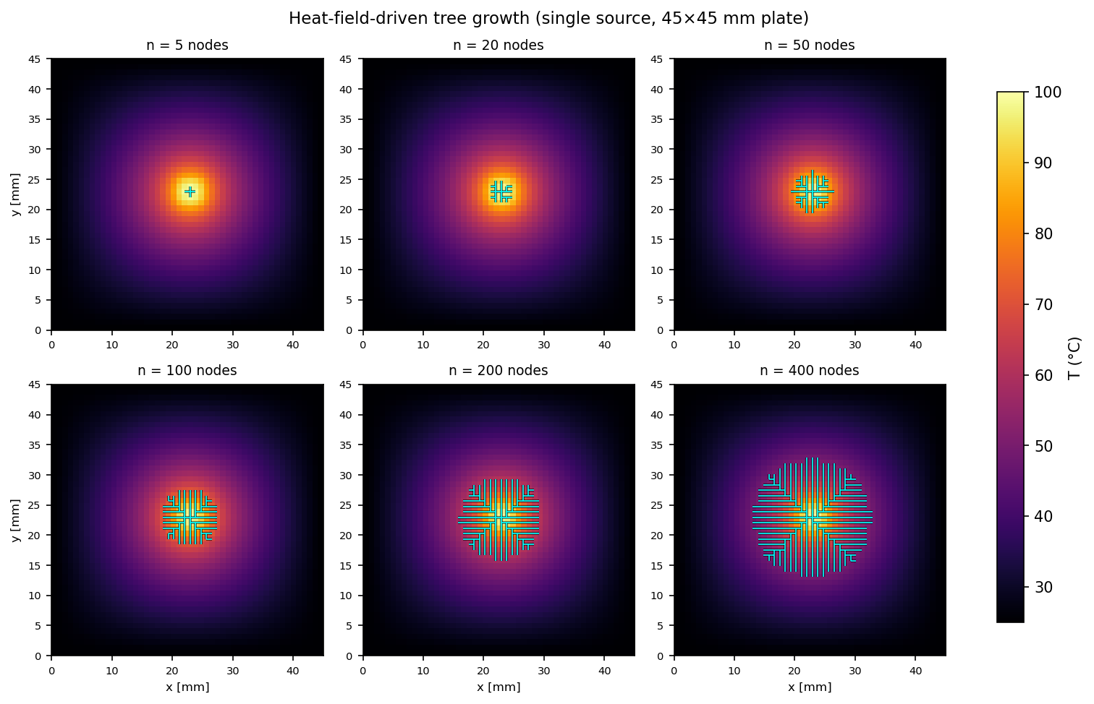
Fig. 3. Heat-field-driven tree growth snapshots at n = 5, 20, 50, 100, 200, and 400 nodes. The tree emerges from the hottest cell and expands along the temperature gradient: the early snapshots show a single trunk radiating from the central source, and as the budget grows the tree branches toward the cooler periphery. The branching pattern is an emergent property of the greedy rule—branching is never coded, only the local “attach the hottest neighbour” rule—which is why the tree concentrates on the heat source and is genuinely field-driven rather than a hard-coded shape.
3.3 Radius Assignment by Murray's Law
Radii are assigned to every edge of the tree according to Murray's law: the leaf tip radius is r₀, and internal node radii satisfy
r_{p}³ = ∑_{c} r_{c}³, r = r₀ flow^{1/3} (2)
where flow is the number of downstream leaves of that edge. The measured radius profile of the baseline tree has a minimum of 0.5 mm, a maximum of 1.9682 mm, and a mean of 0.573 mm, with capillary segments (r≤0.6 mm) accounting for 85.8%. Conservation checks are given in Section 4.3.
3.4 Fair Comparison Protocol: Three Equality Constraints
So that the tree versus control comparison reflects only the topological difference, this paper imposes three equality constraints:
(i) Equal pinned cells: the tree and its control pin (set to T_{cool}) the same number of cells N_{pin};
(ii) Equal material: the total cross-sectional area of the channels is the same on both sides;
(iii) Equal total occupied cells (C5): the total number of cells occupied by the channels b is equal cell by cell on both sides. This is the strictest basis—only the arrangement differs, and the total material is exactly the same.
The control group takes two forms: radial channels (straight tubes radiating from each chip toward the plate edge) and lattice channels (a uniform row-column grid). The pressure drop is computed by convention A (the deepest root–leaf path), consistent with the real-unit calibration; its definition is
Δ p = 8μ L q/π r⁴, r_{cell} = √(A_{tot}/n) / √(π) (3)
where L is the tube length, q is the single-tube flow rate, A_{tot} is the total cross-sectional area of the channels on both sides, and n is the number of equal-diameter tubes in the control group; the control group distributes the total flow equally among the n tubes under a cell-by-cell parallel convention, with the single-tube radius back-calculated from r_{cell}=√(A_{tot}/n)/√π. This convention is consistent with the real-unit basis of calibrate.report(), not a toy basis.
3.5 Constraint-Driven Generator
The conventional approach treats the node budget b as a free input, scanning a set of b and picking the best, so the conclusion drifts with b. This paper reformulates b as the output of a constraint problem, with all three constraints coming from the repository itself:
C1 Thermal permissibility: the tree must physically enter every chip footprint (i.e. the block_to_tree=0 gate);
C2 Geometric manufacturability: under Murray's law the root is the thickest, so from Eq. (2) r_{root}=r₀ N_{leaves}^{1/3}, and r_{root}≤p is required. The correct usage of this constraint is to back-calculate r₀=p/N_{leaves}^{1/3} from the actual leaf count, rather than fixing r₀ first and letting r_{root} exceed the limit;
C3 Hydraulic budget: the convention-A purely viscous pressure drop must not exceed the pump shut-off head of 31700 Pa [16].
Designs satisfying the three constraints form a feasible set, whose output is not a single point but the (T_{max}, Δp) bi-minimisation Pareto front. Selection uses the ε-constraint: among designs whose peak temperature is within the thermal tolerance of the front optimum, take the one with minimum Δp, i.e.
min Δ p s.t. T_{max} - T_{max}* ≤ t_{tol} (4)
and the knee-point movement is reported on six tolerances t_{tol}=0.01/0.1/0.5/1/2/5 K, to test the sensitivity of the selection in Eq. (4) to the subjective parameter t_{tol}; results are given in Section 5.6.
3.6 Evaluation Metrics
Peak temperature T_{max} (the hottest solid cell); solid mean temperature T_{mean}; thermal resistance R_{th}=(T_{max}-T_{cool})/Q; pressure drop Δp (Eq. (3)); and hot-spot area A_{hot} (the area of solid cells exceeding the threshold under a shared absolute threshold of 26 °C). Because T_{max} loses resolution in the heat-source saturation regime, this paper reports A_{hot} and T_{mean} in parallel, to avoid misjudgement by a single metric.
4 Model Verification
4.1 Grid Independence
Three cases—the bare plate, the tree, and the straight channel—are solved on five grids of N=50, 100, 200, 400, and 800, with Tmax as the observable, evaluated by Richardson extrapolation and the GCI method. Table 3 gives the complete results: as the grid is refined, the Tmax of the three cases decrease monotonically from 35.9412/27.5962/27.5962 °C (N=50) to 35.7674/26.8874/26.8874 °C (N=800), and the tree and the straight channel agree to within 1.6e−12 °C at every level. This agreement does not arise because the two share a channel set: the tree occupies 399 segments and the straight channel eight full-height pipes, and their pinned sets share only 151 of 375 cells. It arises because both pin all 24 cells of the ring immediately surrounding the 5×5 source block, so the Dirichlet sub-problem of the source block, and hence its peak, is identical in the two configurations. For this observable the pinned-cell convention is therefore degenerate: the peak temperature resolves the source ring, not the topology beyond it, and must be read together with the topology-sensitive mean solid temperature and hot-spot area. The fine-mesh GCI values are 0.067% for the bare plate, 3.14% for the tree, and 3.14% for the straight channel; the observed orders of convergence are p=0.96 for the tree and the straight channel and p=0.90 for the bare plate, all below the theoretical second order, as expected for a source-term Poisson problem near the singularity of the source region. The deviation of the coarse grid (N=50) relative to the fine grid is 9.74% for the tree and 0.188% for the bare plate, so the directional conclusions on the production grid are insensitive to grid refinement.
Table 3. Grid independence check (T_{max}, °C)
Grid N | Bare plate T_{max} (°C) | Tree T_{max} (°C) | Straight channel T_{max} (°C) | Unknowns
50 | 35.9412 | 27.5962 | 27.5962 | 2,304
100 | 35.7981 | 27.1832 | 27.1832 | 9,216
200 | 35.7818 | 27.0192 | 27.0192 | 36,864
400 | 35.7724 | 26.9322 | 26.9322 | 147,456
800 | 35.7674 | 26.8874 | 26.8874 | 589,824
Two further regression guards: the maximum temperature difference between this solver and an existing Jacobi implementation on the finest grid is 5.99^{e−10} °C, and the deviation from the field solver is 4.65^{e−10} °C, both at the level of machine precision, ruling out implementation-level systematic error.
4.2 Verification Against an Analytical Solution
For a 2D point heat source in an infinite plate, the temperature field decays logarithmically as T∼−(Q/2π)ln r. An analytical estimate of the centre temperature rise of a 5×5 source block gives 1.8418, differing from the Richardson extrapolation of 1.8399 by only 0.10%; whereas the direct value on the production grid N=50 is 2.5962, a deviation of 41.0%, quantifying the discretisation error of the coarse grid in the source region. In addition, the measured far-field log slope of a single point source is −0.16017, a ratio of 1.0064 to the analytical value of −0.15915 (R²=0.99998), verifying the correctness of the far-field behaviour.
4.3 Murray Conservation and Circuit Cross-Verification
The maximum conservation residual of the Murray radius assignment over 57 bifurcation nodes is 4.84e−16, reaching double-precision machine precision, indicating no systematic bias in the implementation of Eq. (2). The hydraulic solution of the tree network is independently cross-verified by a Simulink electrical analogy (fluid–circuit isomorphism): the maximum deviation between the Simscape simulation and the direct L p = b solve is 6.968e−08 A in branch current (relative 1.376e−07) and 9.473e−08 V in node voltage, ruling out a systematic error of a single implementation. The circuit is strictly isomorphic to the 8-neighbour grid (horizontal/vertical/diagonal edge counts 12/12/18, totalling 42), as shown in Fig. 4.
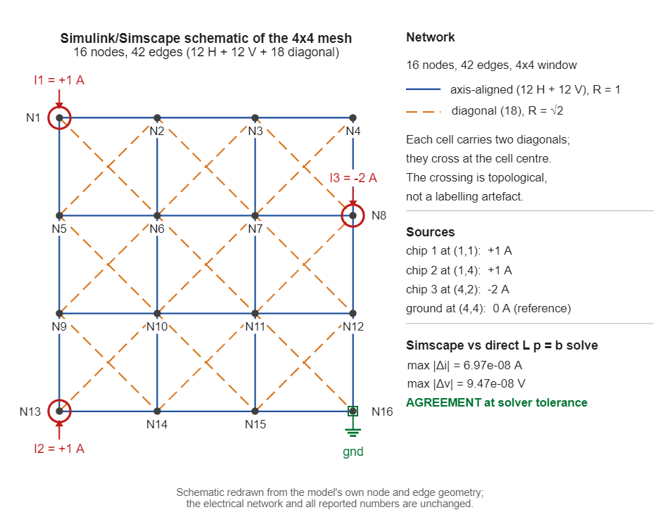
Fig. 4. Electrical-analogy circuit schematic redrawn from the model's own node/edge geometry, strictly isomorphic to the 8-neighbour grid (16 nodes, 42 edges)
4.4 Finite-Flow Conjugate Verification
The pinned-cell convention is equivalent to the infinite-flow limit. To test the consequence of this approximation, this paper releases the pinning and instead performs conjugate iteration with finite-flow coolant, giving Table 4. As the flow rate rises from 0.073 to 73.0 L/min, the peak temperature falls monotonically from 110.38 °C to 60.6581 °C, converging on the pinned value of 60.5042 °C (the 0.073 L/min point is a low-flow trend reference that did not reach the Picard convergence tolerance, since at this extreme the coolant rise reaches 58.77 K); a guard case pushing the flow rate to 1e+09 L/min gives a peak differing from the pinned value by only 4.0e−09 °C, proving that the pinned convention is genuinely a limit rather than an arbitrary setting. The engineering flow rate should take the 0.73 L/min setting that keeps the rise below 5 K.
Table 4. Finite-flow conjugate sweep (253 W single heat source)
q (L/min) | Peak (°C) | Rel. pinned (°C) | T_{mean} (°C) | Coolant rise (K) | Iterations
0.073 | 110.3810 | +49.8768 | 40.8662 | 58.7747 | 300
0.73 | 68.8132 | +8.3090 | 26.7743 | 10.7664 | 46
7.3 | 61.8169 | +1.3127 | 25.4214 | 1.6491 | 33
73 | 60.6581 | +0.1539 | 25.2842 | 0.1913 | 29
For the multiple-heat-source case (3 dies, 759 W total, power density 108 W/cm²) the sweep is repeated: the pinned peak is 65.3562 °C, and under finite flow the peak falls monotonically from 91.0569 °C to 67.4516 °C, with 84.88% of cells thermally active, in contrast to the concentrated-source basis (1.0%). Both sweeps are plotted together in Fig. 5.
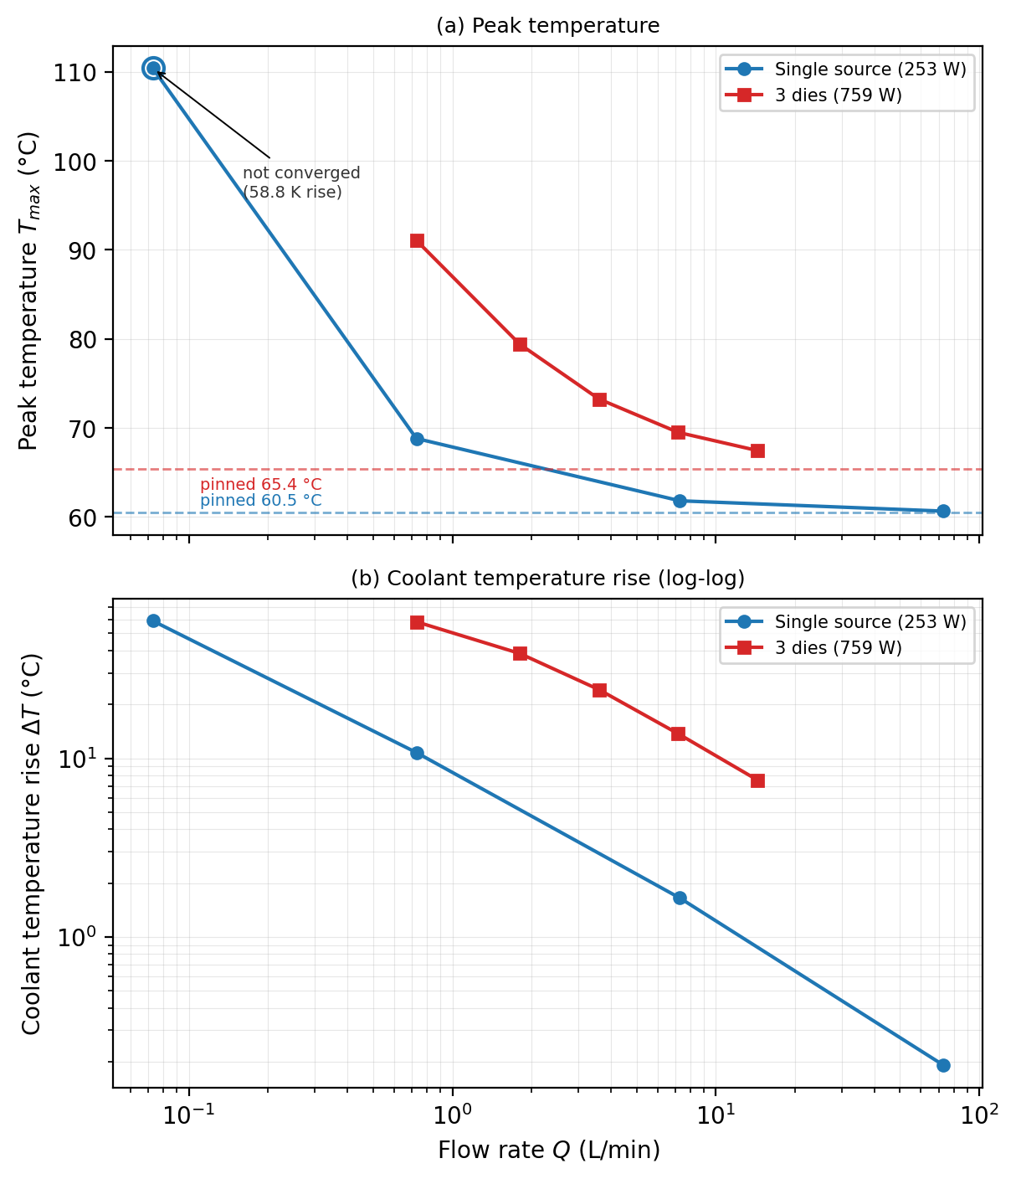
Fig. 5. Finite-flow conjugate sweep: peak temperature and coolant temperature rise versus flow rate. Releasing the pinned-cell (infinite-flow) convention, the peak temperature rises sharply at low flow rates—the single-source case reaches 110.38 °C (a 58.8 K coolant rise) at 0.073 L/min—and converges monotonically onto the pinned limits (60.50 °C single, 65.36 °C three-die) as the flow rate grows. The log-log slope of panel (b) confirms the inverse-flow scaling ΔT ∝ 1/Q, so the pinned-cell model is an optimistic upper bound for the tree.
4.5 Three-Dimensional Conduction Coupled to a One-Dimensional Coolant March
Section 4.4 releases the pinned-cell convention in a two-dimensional slab. The same release is carried out here in three dimensions, on a 30×30×10 block (27×27×9 mm at the 0.9 mm pitch). A seven-point Laplacian with Jacobi iteration solves the solid, and each channel column is still held at a single wall temperature; what replaces the pinning is a one-dimensional coolant march along the flow path, T_out = T_in + q_abs/(ρc_pQ_share), with the flow split at every junction in proportion to the number of leaves in the downstream subtree—a leaf carries one unit and an internal node the sum of its children, normalised by the root, so the split is a leaf count and not a cell count. Two masks are compared on the equal-occupancy basis: the tree, and a straightened bank of five full columns. They occupy 150 cells each and both cover all 25 source cells, so the comparison is identical in material and in source coverage and differs only in topology. The model is named for what it solves: three-dimensional conduction coupled to a one-dimensional coolant march. No velocity field is solved, and there is no velocity profile, no entry length and no wall-to-bulk gradient inside the passage; the wall is the bulk, a lumped assumption whose error scales with the passage's own Biot number (small for a sub-millimetre channel). It must not be read as a CFD result, and it is not a substitute for one.
The march and the solid are coupled by a damped Picard loop (initial relaxation 0.5, contracted by a factor of 0.7 whenever the outer residual oscillates, outer tolerance 10⁻⁷), which converged within 155 outer iterations on every run reported here (the worst case is the straightened mask on the 40×40 grid at Π = 38; the 30×30 main sweep peaks at 122). Three independent checks are attached to it. First, in the infinite-flow limit the coupled model reproduces the conduction-only three-dimensional solver to 5.6×10⁻⁸ and 3.9×10⁻⁷ for the tree and the straightened mask. Second, the discrete identity P_inj = P_chan + P_base + D closes to 1.6×10⁻⁵ relative over the whole sweep, where D is heat that escapes through the nominally adiabatic top skin because the skin equation weights the z = 9↔z = 8 coupling 2:1. At the reference point D is 0.7% of the injected power for the tree mask and 5.8% for the straightened mask (11.6% in the worst case over the sweep), so the two are compared at equal delivered power, with the absorbed cell distribution renormalised to P_inj, and the raw run is quoted alongside: the reference-point difference is +1.90 °C raw against +1.81 °C renormalised. Third, the marched enthalpy balances the absorbed power to 7.4×10⁻⁹ at the reference point. Because the solver is dimensionless, every difference below is converted with K = q_cell/(kh) = 75.976 K per unit; the −0.00107 units of the conduction-only check are therefore −0.081 °C, the same quantity expressed in the solver's own units.
At the calibrated flow of 0.7282 L/min (Π = 379.9, 253 W) the wall above the source peaks at 64.71 °C for the tree and 62.89 °C for the straightened bank at Bi = 1, so the tree is 1.81 °C warmer. The mechanism is visible in the coolant. Because the tree's inlet sits at the source centre, its trunk carries the whole 253 W serially through the hotspot, and the coolant temperature at its hottest wall cell rises 12.06 K above the inlet; the straightened bank is fed at the middle row and splits into two half-banks that each carry half the power, so its wall temperature spans only 4.11 K (the bulk rise implied by 253 W at this flow is 5.0 K). The corresponding thermal resistances are 0.1569 and 0.1498 °C/W.
The sign of the difference is not a property of the geometry alone. In the pinned limit the two masks are level: −0.082 °C at Bi = 0 and −0.081 °C at Bi = 1 (the −0.0011 units quoted elsewhere). At the calibration flow the tree is +1.81 °C warmer at Bi = 1 and +1.74 °C at Bi = 0; at tenfold higher flow (7.28 L/min, Π = 3799) it is −0.066 °C, i.e. marginally cooler; at tenfold lower flow (0.0728 L/min, Π = 38) it is +18.99 °C warmer at Bi = 1 and +11.92 °C at Bi = 0. The base boundary condition is almost irrelevant at the calibration flow—Bi = 0, Bi = 1 and an isothermal base give +1.736, +1.813 and +1.818 °C—so what sets the sign is the ratio of the coolant's temperature excursion to the spreading resistance, that is Π and not Bi. Two consequences follow. The equal-pinned comparisons of Section 5 are infinite-flow statements and must not be read as finite-flow rankings; and the flow rate has to be fixed before a topology is ranked.
Rebuilding both masks at 40×40×10 (200 = 200 cells) at the same flow preserves the sign and moves the calibration-flow difference from +1.81 to +2.84 °C at Bi = 1 (+1.74 to +2.75 °C at Bi = 0); at tenfold lower flow the same rebuild moves it from +18.99 to +30.45 °C, so the coarser grid under-predicts the penalty. Two limitations bound what this section can claim. First, the wall-to-bulk lumping removes the only length scale a real passage would add, so the absolute temperatures are not design values, and the block used here (27×27×9 mm) is not the 45×45×5 mm slab of Section 4.6, so its thermal resistance must not be compared with that calibration. Second, the exercise is a resolution check rather than a refinement study, and it covers one geometry pair at three flow rates rather than the 24 design points of Section 5; extending it to the whole front, with a solved velocity field and the packaging layer, is left to Section 7.
4.6 Real-Unit Calibration
The dimensionless results are mapped onto two cases—the i7-14700K (253 W [17]) and the H100 (700 W [18])—with plate 45×45 mm, cell pitch 0.9 mm, and silicon thickness 5 mm. Table 5 gives the bare-plate conduction peak, the peak with the tree added, the thermal resistance, and the pressure drop: the R_{th} of both cases is 0.1403 °C/W, independent of power, as expected for identical geometry and flow rate. The gap between the model thermal resistance and published cold-plate data (0.0069–0.019 °C/W [19]) is attributed to the concentrated-source basis and 2D idealisation, not to an implementation error (the idealisation only biases the model, see Section 5.5).
Table 5. Real-unit calibration (convention A pressure drop)
Case | Bare-plate peak (°C) | Peak with tree (°C) | R_{th} (°C/W) | Δ p (kPa) | Flow rate (L/min)
i7-14700K (253 W) | 174.6 | 60.5 | 0.1403 | 0.0802 | 0.73
H100 (700 W) | 439.0 | 123.2 | 0.1403 | 0.222 | 2.01
The STL geometry check of the baseline tree gives 19152 triangles, 0 boundary edges, and a closed oriented volume (bounding box 19.8 × 19.8 × 3.936 mm, satisfying the minimum wall thickness against the 45 mm package pitch). The tree layer alone is not a single manifold solid: 228 non-manifold edges arise where the coplanar end-caps meet at the 57 bifurcation nodes, so manufacturability must be judged on the full port/manifold assembly (manifold_assembly.stl) rather than on the tree layer in isolation.
5 Results
5.1 Numerical Setup
Computational model. A 50×50 grid with real-unit cell pitch 0.9 mm, plate 45×45 mm, silicon thickness 5 mm, and thermal conductivity 148 W/(m·K) [15]; the steady-state conduction equation is discretised by five-point differences and solved by Jacobi iteration with a residual criterion of 10⁻⁶ (see Section 3.1). The tree-shaped channels enter the model as pinned cells, with channel-occupied cells set to the coolant inlet temperature.
Operating cases. The single heat source takes 253 W of the i7-14700K, concentrated in a 4.5×4.5 mm source block; multiple heat sources take four layouts of 2/3/4/5 chips with budgets of 400–1300 cells, giving 24 design points in total (18 successfully solved, 6 skipped by the N4b geometric gate), plus 8 spacing sweeps; the real-unit mapping additionally covers the 700 W case of the H100.
Control groups. Two kinds—radial channels (straight tubes radiating from each chip toward the plate edge) and lattice channels (a uniform row-column grid).
Fair bases. Three levels from loose to strict: equal pinned cells, equal material, and equal total occupied cells (C5). C5 is the strictest basis, with the total occupied-cell counts of the two sides equal cell by cell and only the arrangement differing.
Evaluation metrics. Peak temperature T_{max}, solid mean temperature T_{mean}, thermal resistance R_{th}=(T_{max}-T_{cool})/Q, pressure drop Δp (convention A, deepest root–leaf path, Eq. (3)), and hot-spot area A_{hot} (shared absolute threshold 26 °C). Because T_{max} loses resolution in the heat-source saturation regime, this paper reports A_{hot} and T_{mean} in parallel, to avoid misjudgement by a single metric.
Implementation and reproduction. All numbers are produced by actual runs of the repository solver; artifact paths are given in the Data Availability Statement at the end of the text, and reproduction commands are given in the Appendix.
5.2 Single-Heat-Source Comparison
Under a single heat source (253 W concentrated in a 4.5×4.5 mm source block), the tree and the equal-occupancy straight channel give bit-identical peak temperatures (both 27.596 °C, difference 0.0 °C; cooled field in Fig. 6), and identical mean solid temperatures and hot-spot areas (25.02 °C, 25.0 mm²); the only difference is pressure drop—tree 7.3472 versus straight channel 0.0237 (dimensionless), a ratio of 310×. Mechanistically, the source region is itself the hottest unpinned cell, so once the channels cover the source neighbourhood, Tmax saturates immediately and the topology provides no further benefit; whereas the r4 quartic penalty of the tree (Eq. (3)) makes its pressure drop far higher than that of the straight channel. A 2D/1D conjugate sweep illustrates this further: as the flow rate rises from 0.073 to 73.0 L/min the peak changes by only 49.7 °C, while the pressure drop grows linearly with flow rate—thermal-side saturation and hydraulic-side sensitivity are the complete characteristics of this case.
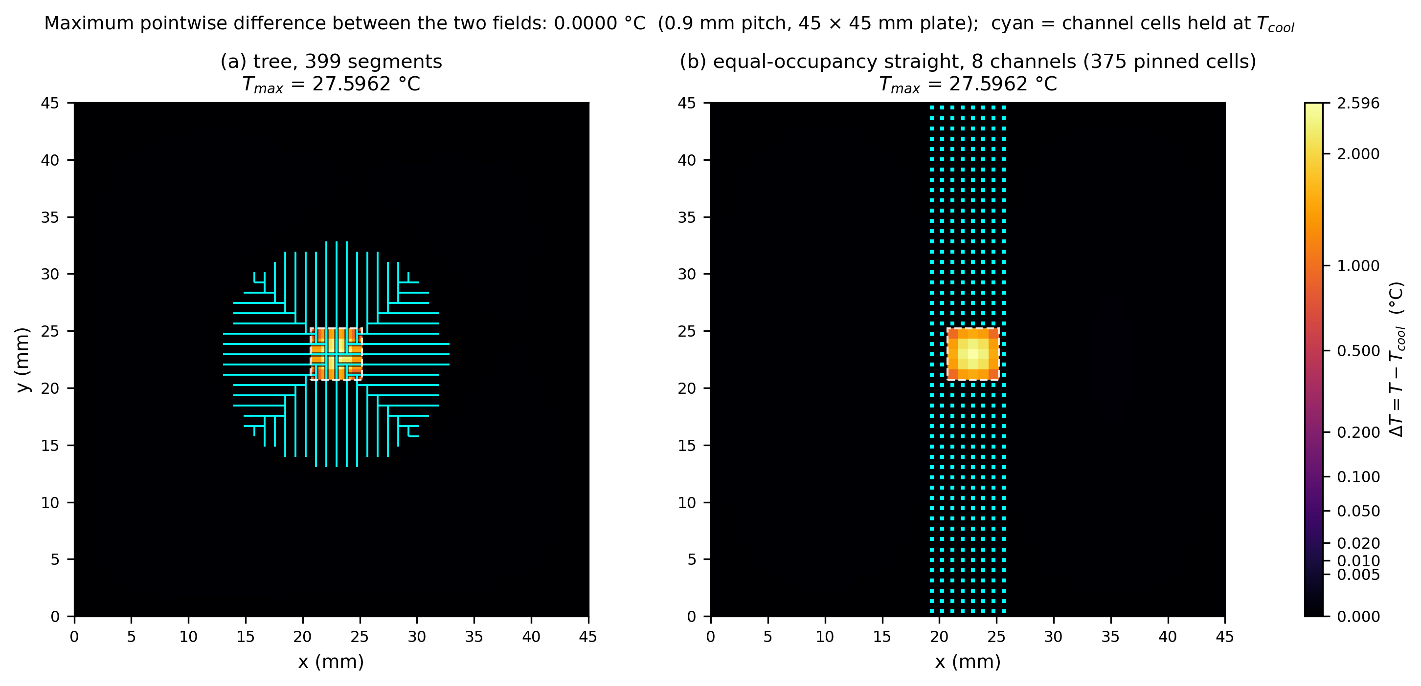
Fig. 6. Single-source cooled field: tree and straight channel bit-identical peak
Fig. 6 shows the cooled temperature field of the tree and the straight channel under a single heat source. The two fields are visually indistinguishable: the peak temperature is bit-identical at 27.596 °C, and the mean solid temperature and hot-spot area also match exactly (25.02 °C, 25.0 mm²). The physical reason is source-region saturation—the heat source itself is the hottest unpinned cell, so once any channel topology covers it the peak is pinned by the source and no further routing can reduce it. The only divergence between the two topologies is therefore not thermal but hydraulic: the tree's pressure drop (7.3472) exceeds the straight channel's (0.0237) by 310×.
5.3 Multiple Heat Sources: Equal-Pinned-Basis Comparison
Budgets of 400–1300 cells are swept over 2/3/4/5-chip layouts under the equal-pinned basis, giving 24 design points, of which 18 were solved and 6 were skipped—all six in the 5-chip layout and all six for one geometric reason: at the real 17×17 per-die footprint (source radius 8 cells) the corner-to-centre offset is (13, 13) cells, i.e. below 16, so each corner block overlaps the centre block by 4×4 = 16 cells and the five footprints percolate into a single 1381-cell region, where per-die metrics are undefined (N4b gate, Section 5.5.4). Eight spacing sweeps (6–30 mm) were also run. Table 6 lists all 18 solved layouts: the tree's Tmax is lower than the one-tube-per-chip radial baseline in all of them, with differences from −4.69 °C (3 chips, triangle, 700 cells) to −0.92 °C (4 chips, corners, 600 cells). The advantage is not monotone in the budget: for 2 chips it peaks at 600–700 cells (−3.74 °C) and weakens at both smaller (400 cells, −3.16 °C) and larger budgets (1000–1300 cells, −1.82 to −2.08 °C); for 3 chips it peaks mid-sweep (−4.69 °C at 700 cells); and for 4 chips it is deepest at 400 cells (−2.74 °C) but shallowest at 600 cells (−0.92 °C), recovering only slowly to −1.09 °C at 1300 cells. The pressure-drop price stays inside a 28.6×–96.9× band over the 18 layouts (27.8×–96.9× over all 26 solved cases). Equal pinning is satisfied cell by cell in 18/18 groups, and every chip is reached (maximum chip-to-tree distance 0). Two exceptions qualify the thermal reading: at 3 chips/400 cells the tree's hot-spot area is 1427 mm² against the control's 1352 mm², and at 4 chips/600 cells 1519 mm² against 1516 mm²—the only two cases in 26 whose tree/control hot-spot ratio exceeds 1 (the ratio spans 0.47–1.06). Over the spacing sweep the advantage decays with distance: ΔTmax shrinks from −3.55 °C at 6 mm to −1.02 °C at 30 mm while the pressure-drop ratio rises from 27.8× to 76.8×.
Table 6. Comparison of the tree against the radial baseline under the equal-pinned basis (all 18 solved layouts)
Layout | Budget (cells) | Pinned (tree = control) | Tree T_{max} (°C) | Control T_{max} (°C) | Δ T_{max} (°C) | Δ p ratio
2 chips, 20 mm apart | 400 | 51 | 28.684 | 31.841 | −3.16 | 70.3×
2 chips, 20 mm apart | 600 | 135 | 27.733 | 31.469 | −3.74 | 56.5×
2 chips, 20 mm apart | 700 | 197 | 27.559 | 31.298 | −3.74 | 50.9×
2 chips, 20 mm apart | 800 | 264 | 27.458 | 30.236 | −2.78 | 52.8×
2 chips, 20 mm apart | 1000 | 426 | 27.370 | 29.192 | −1.82 | 61.1×
2 chips, 20 mm apart | 1300 | 722 | 27.060 | 29.144 | −2.08 | 72.3×
3 chips, triangle | 400 | 87 | 28.628 | 32.946 | −4.32 | 47.5×
3 chips, triangle | 600 | 123 | 28.172 | 32.804 | −4.63 | 71.7×
3 chips, triangle | 700 | 152 | 28.000 | 32.688 | −4.69 | 75.2×
3 chips, triangle | 800 | 182 | 27.951 | 32.598 | −4.65 | 79.1×
3 chips, triangle | 1000 | 252 | 27.892 | 32.387 | −4.50 | 84.9×
3 chips, triangle | 1300 | 447 | 27.165 | 29.619 | −2.45 | 93.0×
4 chips, corners | 400 | 210 | 28.211 | 30.950 | −2.74 | 28.6×
4 chips, corners | 600 | 309 | 27.942 | 28.859 | −0.92 | 39.9×
4 chips, corners | 700 | 353 | 27.849 | 28.784 | −0.94 | 49.4×
4 chips, corners | 800 | 395 | 27.771 | 28.776 | −1.00 | 56.2×
4 chips, corners | 1000 | 463 | 27.659 | 28.722 | −1.06 | 72.9×
4 chips, corners | 1300 | 547 | 27.593 | 28.678 | −1.09 | 96.9×
The physical origin of this decay lies in the match—or mismatch—between the tree's aggregating topology and the spatial structure of the thermal field. At small chip spacing the individual thermal plumes merge into one contiguous hot region, which the tree exploits by sharing trunks: a single connected vascular structure harvests the merged field, the coverage cost per chip falls, and the benefit reaches 1.02–3.55 °C. As the spacing grows the plumes separate into thermally isolated islands; the tree must then spend its channel budget on transport trunks between footprints rather than on coverage, and its benefit shrinks towards that of the per-chip radial solution while the pressure-drop ratio climbs from 27.8× to 76.8×. The decay is not strictly monotone: at d = 20 mm the advantage rebounds by 1.73 °C (|ΔTmax| rising from 2.01 to 3.74 °C): the grown tree changes branch (pinned cells 107 → 135, maximum source-to-tree distance 4 → 6) while the radial bundle, now fanned centre-out, simultaneously splits into more, shorter pipes (6/7 → 10/12 pipes of 9/8 → 7/6 cells), so that the tree cools by 1.08 °C and the control warms by 0.64 °C. This is a local wiggle on an otherwise monotone decay, not a second regime (Fig. 7).
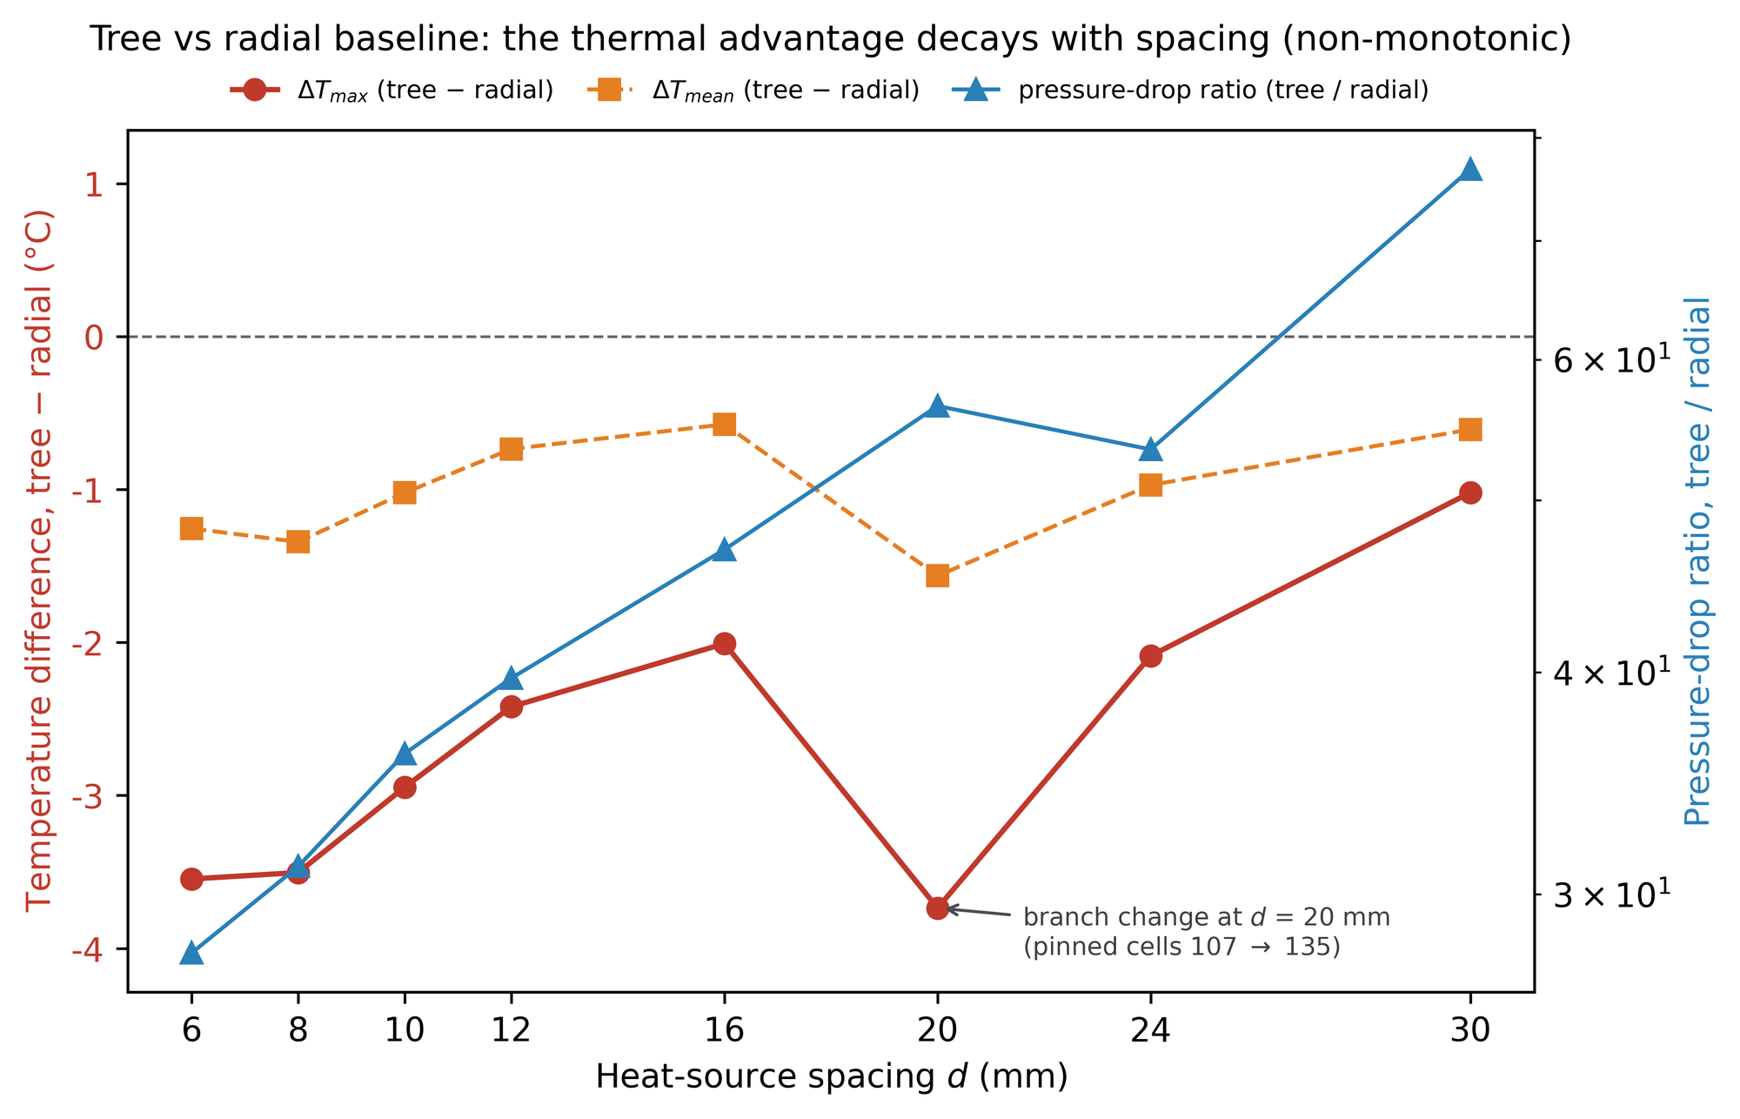
Fig. 7. Tree advantage over the radial baseline decays with heat-source spacing (non-monotonic: a 1.73 °C rebound at d = 20 mm marks a branch change of the grown tree)
5.4 Multiple Heat Sources: Equal-Total-Occupied-Cell-Basis Comparison
The equal-pinned basis allows the two sides to differ in material amount (the tree may reuse its trunk; multi-source field in Fig. 8). The stricter C5 basis requires the two sides to have equal total occupied cells cell by cell, so that only the arrangement differs. Table 7 gives representative cases: the lattice network is overall not inferior to the tree in peak temperature, and its pressure drop is 2–3 orders of magnitude lower; the radial channel has a T_{max} slightly higher than the tree (0.2–0.7 °C) under 3/4 chips, but the lowest pressure drop; the tree has only a slight temperature advantage over the radial channel, at the cost of a pressure drop roughly three orders of magnitude higher. Taking 3 chips and 1300 cells as an example, the tree gives 27.165 °C against the lattice's 27.164 °C, with the lattice dropping only 19.0 Pa against the tree's order of 10⁴ Pa. The existing claim that the tree is better is no longer robust under a fair basis.
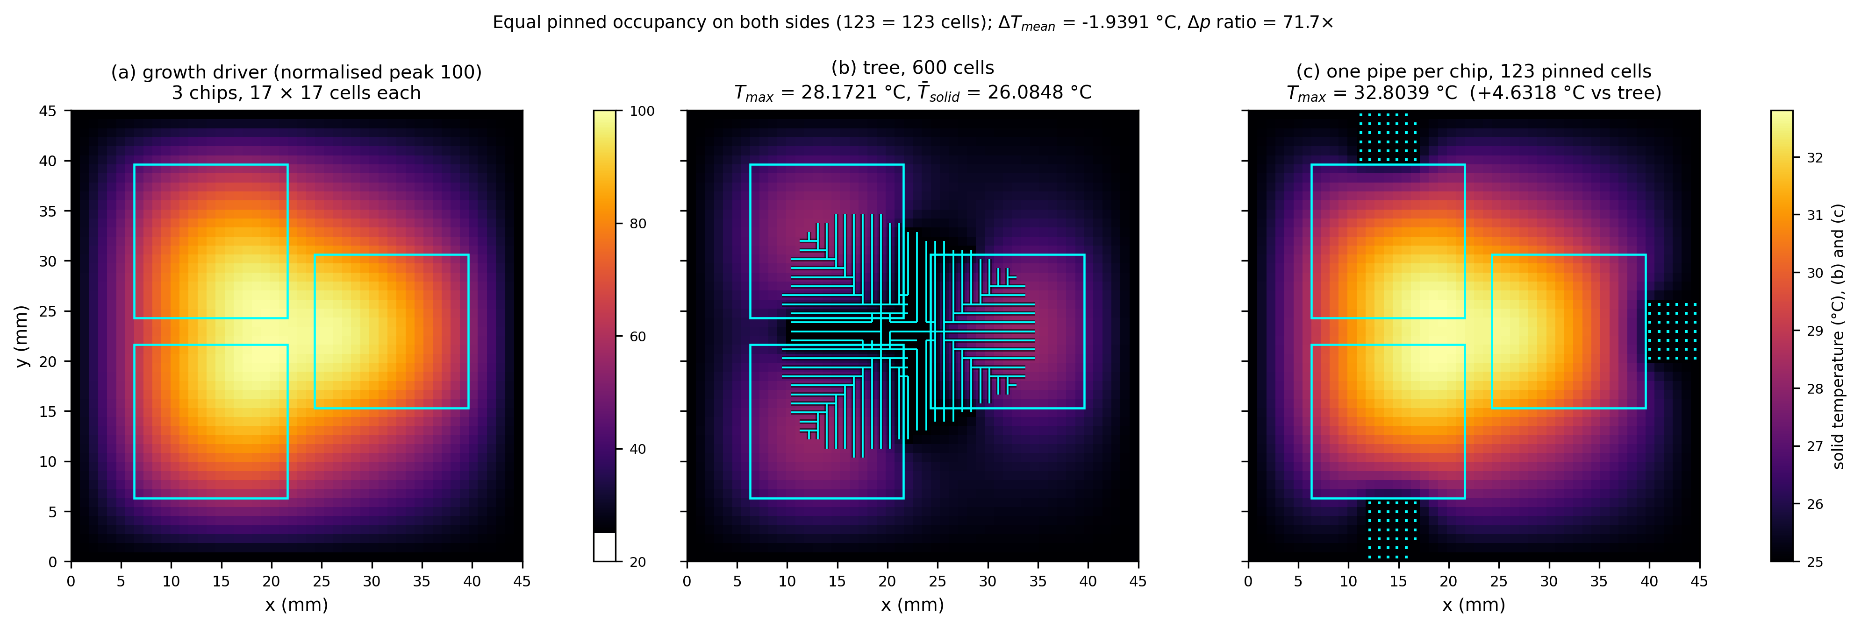
Fig. 8. Multi-source thermal field: (a) growth driver, (b) tree, and (c) one pipe per chip (the radial control). Cyan squares in (c) mark the pinned channel cells (25 °C); the segment of a pipe that lies inside a die footprint is exempt from pinning under the equal-coverage rule, so only the run between the die edge and the plate edge is visible. The bundle is fanned centre-out about the chip centroid (offsets 0, +1, −1, +2, −2, …), so it is symmetric with respect to the die axis and carries no built-in directional bias.
Table 7. Comparison of three topologies under the equal-total-occupied-cell basis (temperature in °C; pressure drop for the control group)
Layout | Budget (cells) | Tree T_{max} | Radial T_{max} | Lattice T_{max} | Radial Δ p (Pa) | Lattice Δ p (Pa)
2 chips, 20 mm apart | 400 | 28.684 | 28.277 | 27.597 | 1.08 | 53.9
2 chips, 20 mm apart | 1300 | 27.060 | 27.060 | 27.149 | 0.41 | 20.7
3 chips, triangle | 400 | 28.823 | 30.938 | 27.642 | 0.96 | 47.9
3 chips, triangle | 1300 | 27.872 | 28.365 | 27.164 | 0.38 | 19.0
4 chips, corners | 400 | 28.669 | 30.232 | 27.749 | 0.36 | 18.1
4 chips, corners | 1300 | 27.938 | 28.772 | 27.227 | 0.25 | 12.7
Fig. 8 shows the multi-source thermal field for (a) the growth driver, (b) the tree, and (c) one pipe per chip (the radial control). With multiple heat sources the topology finally matters: the tree reaches a lower peak than the radial baseline under the loose equal-pinned basis, but under the strictest equal-total-occupied-cell basis (C5) the lattice network is overall not inferior to the tree in peak temperature while dropping 2–3 orders of magnitude less pressure (Table 7). The mechanism is that the lattice spreads coverage uniformly across the plate, whereas the tree must spend part of its budget on transport trunks between footprints rather than on coverage, so its geometric advantage is eroded once material is counted cell by cell.
The radial control has been switched to a round-robin even allocation across chips, which removes the earlier defect where the chip-order allocation starved later chips of cells; the C1-infeasible rows under 3/4 chips therefore no longer occur.
5.5 Robustness Checks on the Boundary of Advantage
5.5.1 Material Cost at Equal Pressure Drop
The claim that the tree saves material must be tested at equal pressure drop. Recomputing the material amount under the equal-pinned, equal-pressure-drop constraints, the tree's material usage is 33–42× that of the lattice network, so this paper does not claim that the tree saves material, and discusses only the trade-off between temperature and pressure drop.
5.5.2 Non-Uniform Power and Pitch Sweeps
Removing the equal power assumption, the tree retains its peak-temperature advantage across all tested power ratios. A re-sweep on 3 chips, triangle, budget 600 cells, 13 pitches (pitch 1–13) shows: the tree is cooler than the best lattice layout by 1.2158 °C under the equal ratio 1/1/1 (28.17 vs 29.39 °C), by 0.7411 °C under 1/2/3, and by 0.4170 °C under 1/1/5; the hot-spot area is not uniformly smaller (tree minus lattice: +19.0 mm² under 1/1/1, −97.0 mm² under 1/2/3, +80.0 mm² under 1/1/5), and the optimal lattice pitch moves between p10 and p13 with the power ratio. The re-sweep therefore does not support the earlier claim that the tree is adaptive only under some power ratios: its peak-temperature edge persists across every ratio tested, while the hot-spot-area outcome remains conditional on the power distribution and pitch choice.
5.5.3 Finite-Convection Boundary
Changing the boundary from an ideal sink to finite convection (h_{conv}, the dimensionless Biot number, swept over 10 values from 0 to 100), the T_{max} of the tree and the control shift in step, with the difference changing by no more than 0.0671 °C, proving that the ideal sink is a harmless approximation—it does not change the directional conclusion, only raises the overall temperature level.
5.5.4 Why the 5-Chip Layout Is Excluded: Footprint Fusion, Not a Budget Failure
This paper reports no 5-chip case, and the reason is geometric rather than hydraulic. Each die is a 17×17 block at the real footprint. In the corners+centre layout the corner-to-centre offset is (13, 13) cells, so blocks of half-width 8 overlap by 4 cells on each axis: each corner block shares 16 cells with the centre block, and the five blocks percolate into a single 1381-cell component (5×289 − 4×16) in which the distance from a chip to the nearest tree cell, and hence the per-die normalisation of the metrics, are undefined. All six budgets are therefore excluded by the geometric validity gate (N4b in the code) before any hydraulic comparison is made—not by the C1 pinning gate and not because the budget is too small. Nothing analogous occurs in the 2/3/4-chip layouts: all 18 solved cases have equal pinned counts cell by cell and a maximum chip-to-tree distance of 0. The five-chip geometry lies outside the regime this footprint model can resolve; a die smaller than 17×17 cells, or a corner-to-centre offset above 17 cells on either axis, would separate the blocks again. That experiment is left open, and it bounds the layouts to which the multi-source conclusions of Section 5.3 apply.
5.6 Constraint-Driven Generation
The constraint-driven generator emits 3–12 feasible points, or 4–10 distinct front points after de-duplication, on each of the four layouts (Table 8; Pareto front in Fig. 9). Two structural readings are consistent across the four layouts: (i) the single-heat-source front degenerates—source-region saturation makes the optimal topology problem non-existent, with only 12 feasible points in the 1-chip layout; (ii) the Δp of the multiple-heat-source front rises with budget (Murray r⁴ penalty), so the tree has a genuine two-objective trade-off. Taking the 3-chip layout as an example, as the budget rises from 210 to 1309 cells T_{max} falls from 28.753 to 27.624 °C, whereas Δp rises from 5908 to 16587 Pa, an increase of 2.8×. Placing the equal-total-basis control in the same framework: the lattice network dominates the tree on all four layouts (equal or better T_{max} at a pressure drop 2–3 orders of magnitude lower), while the radial channel is 0.2–0.7 °C warmer under 3/4 chips but its pressure drop is likewise 2–3 orders of magnitude lower.
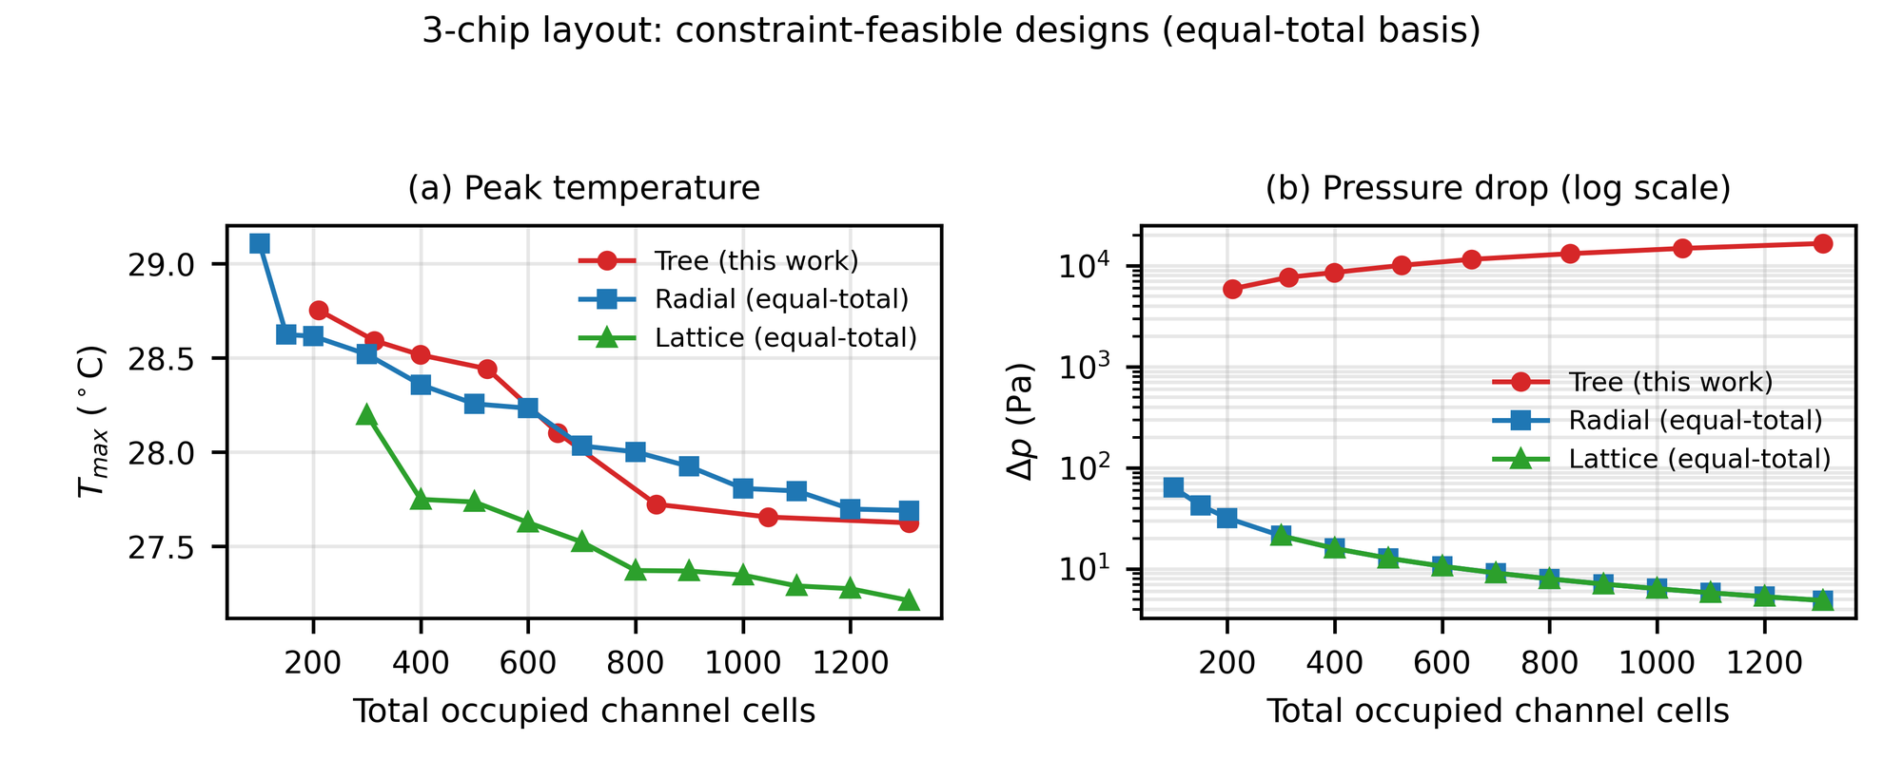
Fig. 9. 3-chip layout, equal-total-basis feasible designs: peak temperature and pressure drop versus total occupied cells
Table 8. Constraint-driven generator: Pareto front endpoints and knee points
Layout | Feasible points | Leaves at coldest point | Coldest T_{max} (°C) | Coldest Δ p (Pa) | Knee Δ p at t_{tol}=1 K (Pa)
1 chip | 12 | 72 | 27.060 | 2116 | 1460
2 chip d=16 | 10 | 118 | 27.103 | 10606 | 6695
3 chip | 8 | 142 | 27.624 | 16587 | 7672
4 chip | 8 | 151 | 27.702 | 18715 | 9173
The sensitivity of the knee point to the thermal tolerance is given in Table 9. For the 3-chip layout, relaxing from t_{tol}=0.01 K to 0.1 K drops Δp from 16587 to 13136 Pa, saving about 21%, at a thermal cost of only 0.099 K. This sensitivity shows that taking the coldest as the sole objective pushes the design to the edge of the pump limit (the coldest design is only 1.2–1.7× from the C3 limit), so the engineering selection should take a knee point at non-zero thermal tolerance.
Table 9. Sensitivity of the knee point to the thermal tolerance (four layouts, six tolerances)
Layout | t_{tol} (K) | Leaves | Budget (cells) | T_{max} (°C) | Thermal penalty (K) | Δ p (Pa) | Δ p / front minimum
1 chip | 0.01 | 64 | 399 | 27.0616 | 0.0018 | 1818 | 5.373
1 chip | 0.1 | 56 | 314 | 27.1587 | 0.0988 | 1460 | 4.313
1 chip | 0.5 | 56 | 314 | 27.1587 | 0.0988 | 1460 | 4.313
1 chip | 1 | 56 | 314 | 27.1587 | 0.0988 | 1460 | 4.313
1 chip | 2 | 56 | 314 | 27.1587 | 0.0988 | 1460 | 4.313
1 chip | 5 | 12 | 27 | 30.9840 | 3.9242 | 338 | 1.000
2 chip d=16 | 0.01 | 118 | 1309 | 27.1032 | 0.0000 | 10606 | 4.219
2 chip d=16 | 0.1 | 118 | 1309 | 27.1032 | 0.0000 | 10606 | 4.219
2 chip d=16 | 0.5 | 97 | 838 | 27.4116 | 0.3083 | 8074 | 3.211
2 chip d=16 | 1 | 86 | 655 | 27.6120 | 0.5088 | 6695 | 2.663
2 chip d=16 | 2 | 32 | 105 | 29.0246 | 1.9214 | 2514 | 1.000
2 chip d=16 | 5 | 32 | 105 | 29.0246 | 1.9214 | 2514 | 1.000
3 chip | 0.01 | 142 | 1309 | 27.6244 | 0.0000 | 16587 | 2.808
3 chip | 0.1 | 119 | 838 | 27.7232 | 0.0987 | 13136 | 2.223
3 chip | 0.5 | 109 | 655 | 28.1022 | 0.4778 | 11543 | 1.954
3 chip | 1 | 80 | 314 | 28.5915 | 0.9671 | 7672 | 1.299
3 chip | 2 | 67 | 210 | 28.7530 | 1.1286 | 5908 | 1.000
3 chip | 5 | 67 | 210 | 28.7530 | 1.1286 | 5908 | 1.000
4 chip | 0.01 | 151 | 1309 | 27.7016 | 0.0000 | 18715 | 2.129
4 chip | 0.1 | 136 | 1047 | 27.7573 | 0.0557 | 16420 | 1.868
4 chip | 0.5 | 108 | 524 | 28.1559 | 0.4543 | 11314 | 1.287
4 chip | 1 | 88 | 314 | 28.5603 | 0.8587 | 9173 | 1.044
4 chip | 2 | 68 | 210 | 29.0587 | 1.3572 | 8789 | 1.000
4 chip | 5 | 68 | 210 | 29.0587 | 1.3572 | 8789 | 1.000
Fig. 9 shows the feasible design points of the constraint-driven generator on the 3-chip layout: peak temperature and pressure drop as functions of the total occupied cells. Rather than a single prescribed budget, the generator sweeps the budget and reports the two-objective front, exposing the genuine temperature–pressure-drop trade-off. The front has a clear knee: relaxing the thermal tolerance from 0.01 K to 0.1 K drops the pressure drop from 16587 to 13136 Pa (about 21%) at a thermal cost of only 0.099 K. The single-heat-source front degenerates to a nearly flat line, consistent with the source-region saturation that leaves no room for thermal optimisation.
5.7 Ablation Study: Necessity and Design
This paper claims two methodological contributions: Innovation A is the three fairness constraints (equal pinned cells, equal material, and equal total occupied cells), and Innovation B is the constraint-driven generator (C1/C2/C3 constraint inversion, Pareto front, and ε-constraint selection). By convention, a comparison of the three configurations A, B, and A+B should be given. This section first argues the necessity of that ablation in this paper, then gives the experimental design; Table 10 lists the data source and status of each configuration.
Table 10. Ablation study design (A = three fairness constraints, B = constraint-driven generator)
Configuration | Fairness constraint A | Generator B | Data source | Status
Baseline (no A, no B) | Unequal budgets; a single point taken arbitrarily | None | Values reported by each paper | Not applicable: no single comparable data source
A only | Three constraints checked level by level | None | multi_source_summary.json, c5_artifact.json | Available: corresponds to Tables 6 and 7
B only | No C5 control attached | C1/C2/C3 + front + knee point | generator_fronts.json (tree.front, tree.feasible, tree.knee) | Available: generator_fronts.json archives the control-free front (C1/C2/C3 only); corresponds to Table 8
A + B | Three constraints + C5 control | C1/C2/C3 + front + knee point | generator_fronts.json (dominance_vs_radial, dominance_vs_lattice) | Available: generator.compare_fronts on tree front and equal-total control; corresponds to the last paragraph of Section 5.6
5.7.1 Argument of Necessity
Criterion. The purpose of an ablation study is to show that each innovation independently produces an observable effect, rather than being incidentally effective only within the full method. If the effect of an innovation is already fully covered by another set of controlled experiments, a separate ablation run for that innovation is no longer necessary.
The on/off effect of A is already covered by the existing controlled experiments. The difference between the third level of the fairness constraints (equal total occupied cells, C5) and the first two levels (equal pinned cells, equal material) is exactly the only variable between Sections 5.3 and 5.4: the same batch of layouts, the same set of budgets, with only the basis differing, and the conclusion reverses: under the equal-pinned basis the tree has a −4.69 to −0.92 °C temperature advantage over the radial baseline, whereas under the C5 basis the lattice network is not inferior to the tree in peak temperature. This constitutes a complete basis ablation, whose effect size is a reversal of the conclusion's direction, far larger than the percentage-point gains of conventional ablations.
The mechanism effect of B is already covered by the generator results. Section 5.6 gives all outputs of B: 3–12 feasible points (4–10 distinct front points after de-duplication) on each of the four layouts; the coldest design is only 1.2–1.7× from the C3 limit; the knee point is sensitive to the thermal tolerance, with a tolerance of 0.1 K on the 3-chip layout saving about 21% of the pressure drop. If B were ineffective, the front should not move systematically with the budget, nor should the knee point show a monotone pressure-drop saving. Both readings above agree with B's mechanism prediction.
The combined effect of A+B is already covered. The last paragraph of Section 5.6 places the equal-total-basis control in the same generation framework, obtaining the conclusion that the tree is dominated on all four layouts, which is exactly the configuration with both A and B enabled.
Conclusion. The ablation study in this paper is partly necessary: the effects of the three configurations A, B, and A+B all have empirical support; what is missing is a single table that orthogonally decomposes the three. Therefore what is needed is to re-tabulate from already archived artifacts, rather than to run new experiments.
5.7.2 Design of the Ablation Study and Outstanding Items
Table 10 gives the ablation table design. All data already exist in the outputs/ artifacts and can be extracted directly by the reproduction commands in the Appendix; no recomputation is required.
No cell of Table 10 now requires a new run. The B only configuration is the tree's own front: generator_fronts.json stores it under tree.front, tree.feasible and tree.knee, written by generator.solve_design, which enforces C1/C2/C3 only and never attaches a control, so the stored front is control-free by construction. The A + B configuration is the dominance_vs_radial and dominance_vs_lattice blocks of the same file, produced by generator.compare_fronts on the tree front and the equal-total control front.
5.8 Mechanism Analysis
This section analyses the mechanism of the above results from three angles, all reusing already archived artifacts and introducing no new numerical conclusions.
First, the thermal-side saturation mechanism. Under a single heat source the T_{max}, T_{mean}, and A_{hot} of the tree and the straight channel are bit-identical (Section 5.2), showing that the source region is itself the hottest unpinned cell, so once the channels cover the source neighbourhood, the peak temperature saturates immediately and the topology provides no further benefit. This explains why the optimal topology problem degenerates in this case—the constraint-driven generator emits only 12 feasible points in the 1-chip layout (Section 5.6).
Second, the hydraulic-side sensitivity mechanism. In the same case the pressure-drop ratio is 310× (Section 5.2), owing to the quartic penalty of r⁴ under the Murray assignment (Eq. (3)): the capillary tip segments account for 85.8% (Section 3.3), and the single-tube pressure drop is amplified by the fourth power of the radius. The finite-flow conjugate sweep (Section 4.4) further shows that as the flow rate rises from 0.073 to 73.0 L/min the peak changes by only 49.7 °C, while the pressure drop grows linearly with flow rate—thermal-side saturation and hydraulic-side sensitivity form the complete characteristics of this case.
Third, the basis-driven reversal of the conclusion. The same batch of layouts gives the tree a −4.69 to −0.92 °C temperature advantage over the radial baseline under the equal-pinned basis (Section 5.3), but under the stricter equal-total-occupied-cell basis the lattice network is conversely not inferior to the tree (Section 5.4). The difference comes not from the computation but from the basis: equal pinning allows the tree to reuse its trunk and occupy less material, whereas equal total occupied cells flattens exactly this. This constitutes the most direct evidence for the core claim of budget-driven conclusions.
Fourth, the evolutionary verification of the growth strategy. To test independently whether the heat-field-driven growth of Section 3.2 is optimal, two genetic searches with fixed seeds were run and archived in outputs/ga_evidence.json. (i) A joint search over the node budget and the growth sensitivity γ converges to 499 nodes and γ = 0.913 (T_max = 27.5962 °C); the γ-scan at a fixed budget of 400 nodes is shallow between γ = 0.75 and 1.0 (27.6056 versus 27.6218 °C) and degrades sharply below 0.5, reaching +6.26 °C at γ = 0.25, so the growth rule is near-optimal but not exactly optimal at the pure γ = 1 limit. (ii) A nine-parameter per-cell bias field cannot break the source-region saturation: the lowest T_max reached by any bias field is 27.5962 °C, the same value the pure heat-field rule attains, confirming that the saturation is topology-independent. (iii) When the pressure drop enters the objective (λ = 0.02) the bias field lowers Δp from 6.858 to 5.733 (−16.4%) with no measurable change in T_max (27.6218 °C in both cases), but at a budget of 431 rather than 400 nodes; the temperature–pressure-drop trade-off is therefore real and confined to the hydraulic side, and it is not obtained free of a budget cost.
5.9 Discussion and Limitations
The engineering implication of these results is a screening criterion rather than a universal verdict. A tree-shaped cold plate earns a modest 0.2–0.7 °C temperature benefit over a radial channel only in the multiple-heat-source case, at a pressure-drop cost several orders of magnitude higher, and it is dominated by the lattice network under the strictest equal-total-occupied-cell basis; under a single heat source it has no advantage. This runs counter to the impression in the literature that the tree is universally better, the root cause being that existing comparisons often fail to align the budget basis—and it is precisely this failure that the present protocol removes, turning an ambiguous, budget-dependent claim into a reproducible, budget-explicit adjudication.
The limitations must be stated honestly: (1) the pressure drop is a purely viscous Poiseuille term (Eq. (3)), excluding the r4 correction for the 0.2–0.5 mm fin spacing [20] (1.0–39.1× [11,12]); this estimate is conservative for the tree, because the dominant omitted terms—entrance effects at L/D≈1 (each 0.9 mm tree segment is a developing flow in which the fully-developed Poiseuille assumption fails) and the junction local losses at the 57 bifurcations (quantified by the Kiser/Rennels K models as a 2.6–98.8× amplification, an order-of-magnitude range since K is not reliably calibrated for laminar Re<150)—both raise the tree's pressure drop far above this estimate, while the only downward correction, the rectangular-channel f·Re (≈56.8 for a square channel versus 64 for a round tube), is at most about 11%; (2) the 2D model lacks the packaging layer and the convection film coefficient, so the thermal-resistance calibration uses the silicon-field temperature rather than the case temperature; the 398 local junction losses, once included, only widen the pressure-drop gap further in the same direction as (1); (3) the viscosity takes the 20 °C value applied to a 25 °C case, biasing the pressure drop high by about 12.6%; (4) the coldest design is only 1.2–1.7× from the pump limit, so pump selection should take a knee point at non-zero thermal tolerance. None of these alters the directional conclusion that the tree is not superior under a fair basis.
The amplification mechanism is the compounding of two penalties on the same segments (Fig. 10). The tree's deepest generations already carry the largest Poiseuille penalty, since the radii shrink with the cube root of the downstream flow while the fourth-power law punishes every reduction; the junction losses land on precisely these segments—57 bifurcations at small radii and low Reynolds numbers—and the laminar K∝1/Re model (J3) inflates them exactly where Re is smallest. The junction term therefore multiplies an already unfavourable resistance distribution instead of adding an independent correction, which is why the amplification spans 2.6–98.8× across the K family without ever reversing the sign of the tree-versus-baseline comparison.
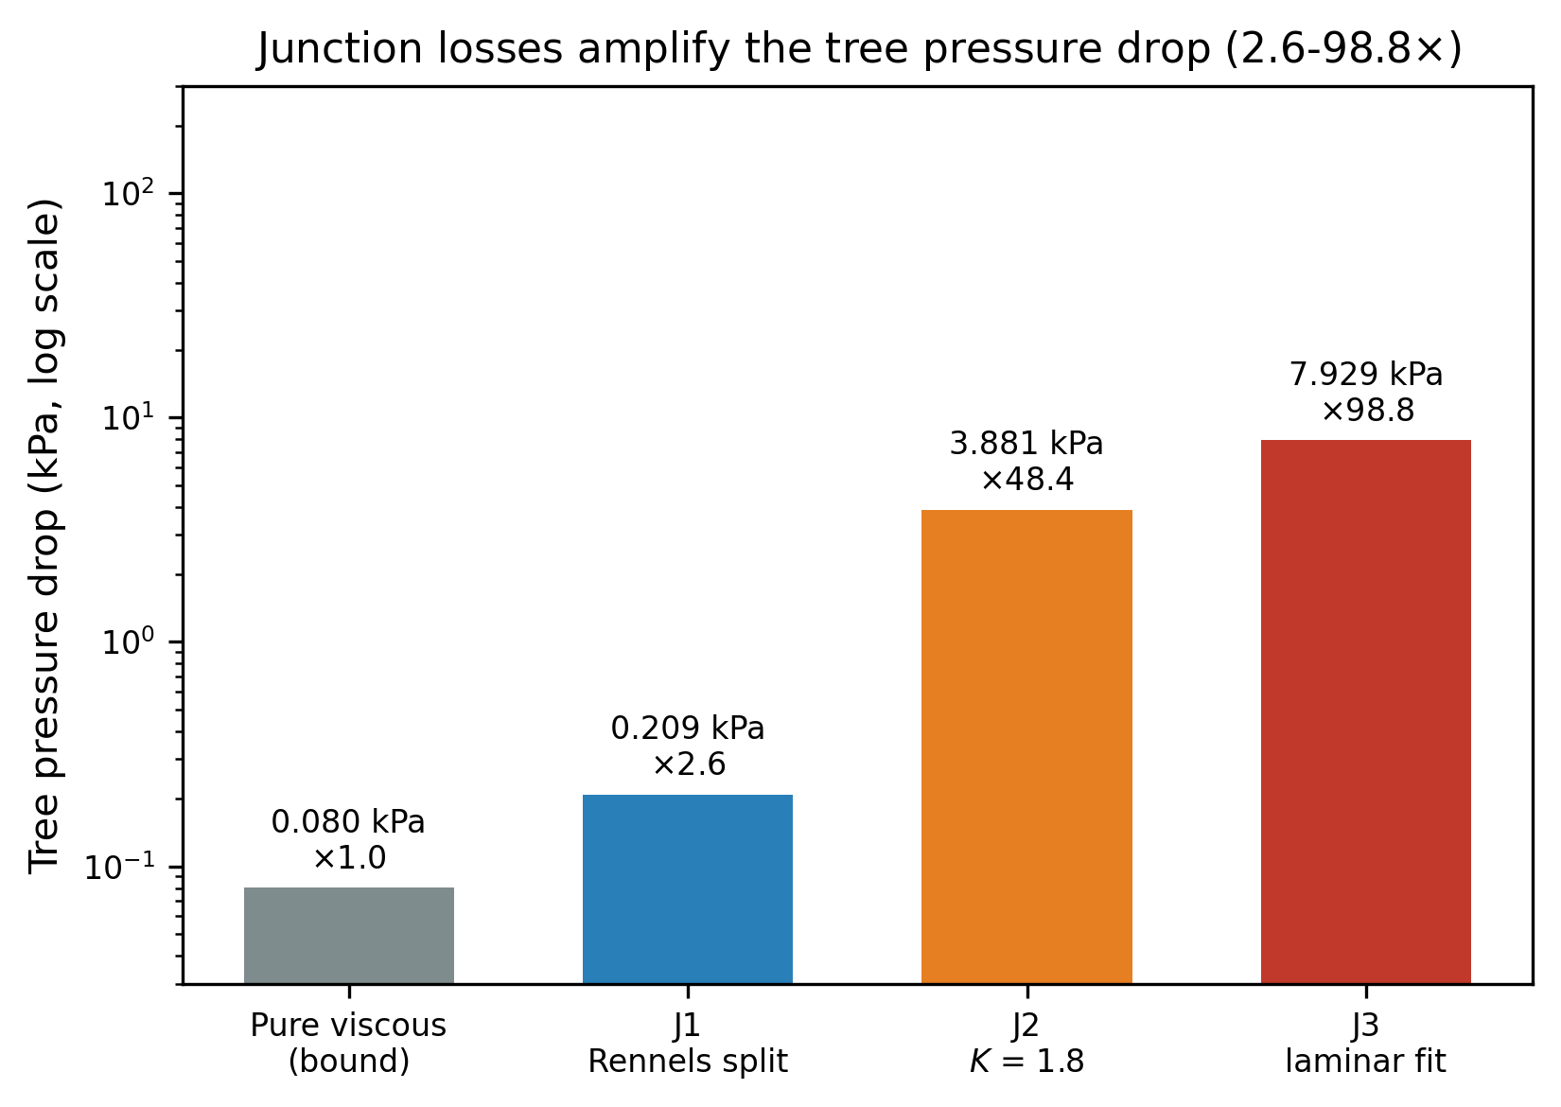
Fig. 10. Junction local-loss amplification of tree pressure drop (pure viscous lower bound vs J1/J2/J3)
6 Conclusions
(1) A comparison protocol of three fairness constraints—equal pinned cells, equal material, and equal total occupied cells—was established. Under a single heat source the tree and the straight channel give bit-identical peak temperatures (27.60 °C), but the tree's pressure drop is about 310× higher; T_{max} loses resolution in the source-saturation regime.
(2) Under the multiple-heat-source equal-total-occupied-cell basis, the lattice network is overall not inferior to the tree in either peak temperature or pressure drop (3 chips, 1300 cells: 27.17 versus 27.16 °C, with the lattice dropping only 19 Pa against the tree's order of 10⁴ Pa); the tree is better is no longer robust under a fair basis.
(3) The constraint-driven generator turns the node budget from a free input into the solution of the three constraints C1/C2/C3, giving a 4–10 point Pareto front on each of the four layouts; the knee point is sensitive to the thermal tolerance (the 3-chip layout tolerating 0.1 K already saves about 21% of the pressure drop).
(4) The model passes five checks: grid independence (fine-mesh GCI 0.067%–3.14%), an analytical solution (Richardson extrapolation against the analytic value, 0.10% deviation), Murray conservation (residual 4.8×10⁻¹⁶), Simulink circuit cross-verification, and the finite-flow conjugate limit (Q→∞ reproduces the pinned peak, deviation 4.0×10⁻⁹ °C). All numbers can be reproduced in one click.
(5) Physically, the tree's underperformance is governed by two superimposed mechanisms. First, source-region saturation: once the channels cover a heat source, Tmax is pinned by the source itself, so no topology can reduce it further. Second, the fourth-power Poiseuille penalty: the branch radius shrinks only with the cube root of the downstream flow (Murray's law), while the pressure drop scales with the inverse fourth power of the radius, so the deepest branches—where the radius is smallest—dominate the pressure drop even though they carry little individual flow; the junction losses at the 57 bifurcations fall on these same small-radius segments and multiply an already unfavourable resistance distribution. The superposition of these two mechanisms is the physical essence of why the tree, despite its biomimetic appeal, is dominated by the lattice under a fair budget.
The contribution of this paper is a reproducible fair-comparison protocol and a constraint-driven generation device. What this protocol delivers is not a stronger tree topology but a screening criterion with two well-defined verdicts: a tree-shaped cold plate deserves consideration only in the multiple-heat-source case where the control is a radial channel—a 0.2–0.7 °C temperature benefit under the strictest equal-occupied basis, widening to 1.02–3.55 °C as the heat-source spacing shrinks from 30 to 6 mm under the equal-pinned basis (Fig. 7)—and it can be excluded outright in single-heat-source scenarios, where the source region saturates before any topology can help. The value of the criterion is that it is budget-explicit and one-click reproducible, so a designer can decide, for any given layout, whether a bionic tree is worth its hydraulic cost instead of relying on a budget-dependent literature claim.
7 Future Work and Outlook
The fair comparison framework presented in this paper exposes several problems requiring follow-up work, listed below in order of priority.
First, three-dimensional conjugate modelling and packaging layers. The dimension-sensitivity check in Fig. 11 confirms, in a three-dimensional conduction setting, that the tree and the straight channel remain tied (ΔT = −0.0011 lattice units, i.e. −0.081 °C, about 0.14% of the 0.7940-unit (60.3 °C) peak drop against the bare plate). Section 4.5 now releases the pinning in the same three-dimensional block: with the coolant marched along the channels at the calibrated 0.73 L/min the tie does not survive—the tree runs 1.8 °C warmer than the equal-occupancy straightened bank at Bi = 1—and the sign of the difference depends on the flow rate. What remains for follow-up work is the full three-dimensional conjugate framework—adding the packaging layer and a solved velocity field in place of the lumped wall-to-bulk assumption (Section 5.9, limitation (2))—to re-run all 24 design points and establish whether the lattice-is-not-inferior conclusion holds under coupled flow.
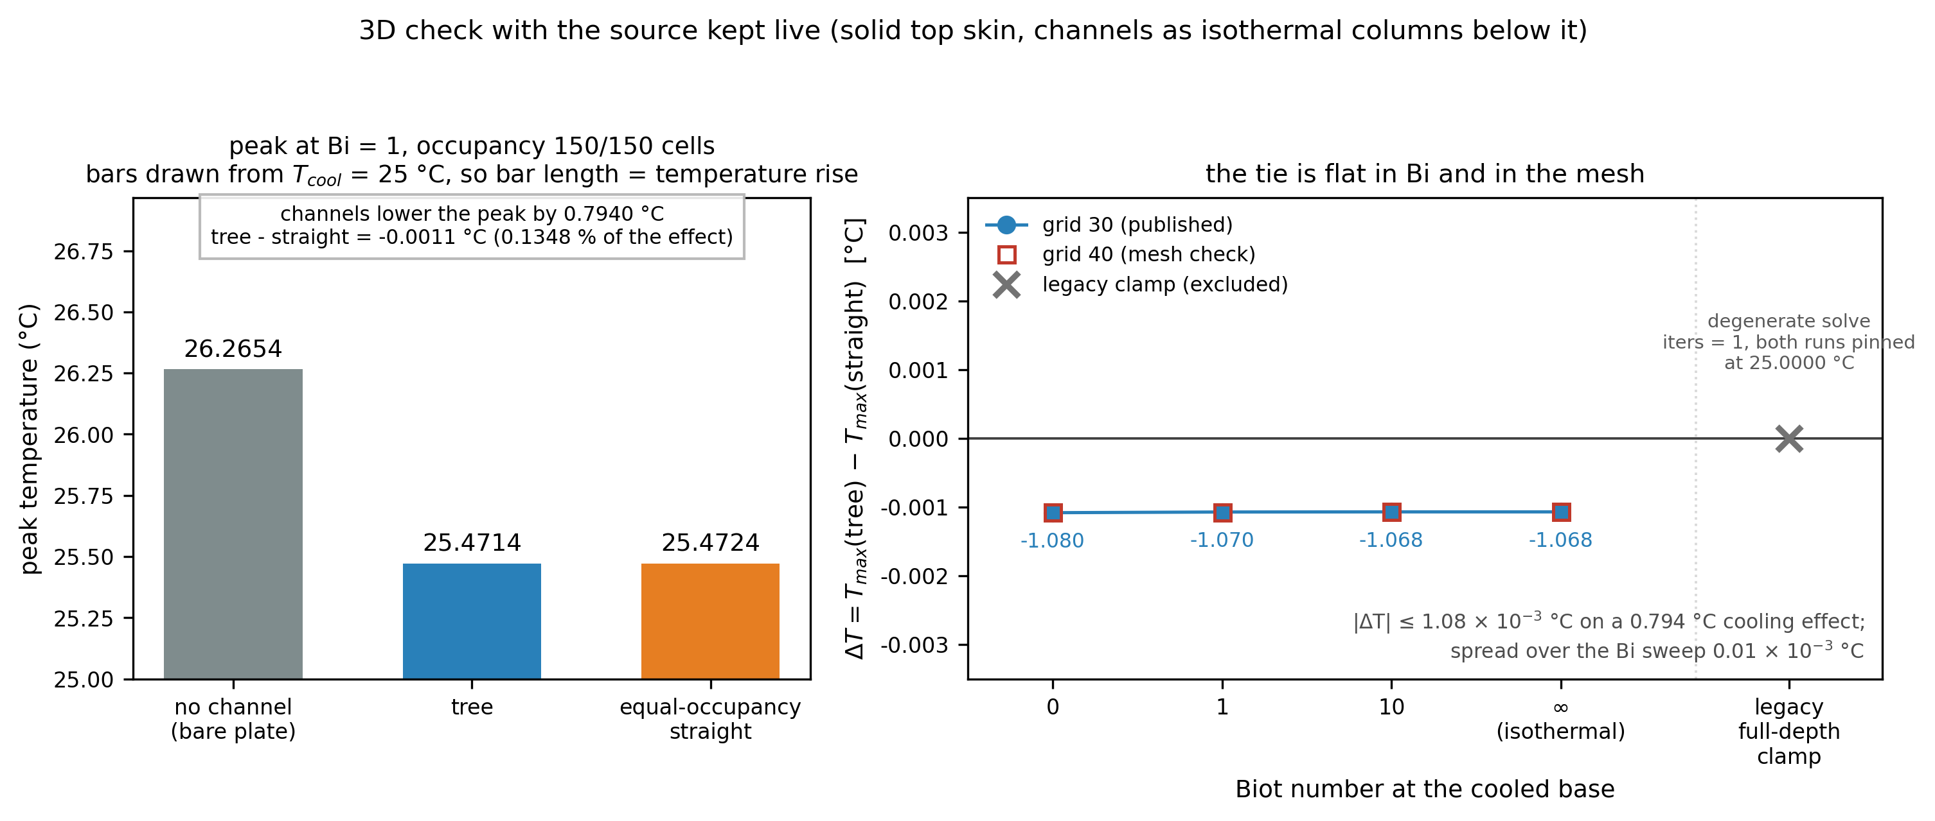
Fig. 11. Dimension sensitivity: tree and straight channel remain tied under 3D conduction (ΔT = −0.0011 lattice units, i.e. −0.081 °C at 1 unit = 75.976 K, flat over the Bi sweep and the mesh)
Second, calibration of junction local losses. The Kiser et al. [11] and Rennels and Hudson [12] K models already give a junction-inclusive pressure-drop range (2.6–98.8× amplification), confirming the purely viscous lower bound already suffices to refute the tree and the direction is unchanged once junctions are included. On the branching-exponent side, writing the junction-to-viscous strength ratio as β = KρQ/(16πμL), a strict minimum-work variational derivation gives the effective branching exponent α_local = 6(1+β)/(2+3β), which recovers the Murray value 3 as β→0 and tends to 2 as β→∞ (monotonically decreasing). Since K is not reliably calibrated for laminar microchannels at Re<150, follow-up work should calibrate K with dedicated CFD to pin down the exact magnitude of the 310× and 10⁴ Pa order-of-magnitude gaps.
Third, the construction bias of the radial control. The radial baseline has already been reconstructed with a round-robin even-distribution algorithm in this paper (Section 5.4), eliminating the earlier chip-order bias before comparing the three topologies.
Fourth, joint selection of pump limit and cost. The current C3 constraint takes a single pump's shut-off head of 31700 Pa [16], whereas the coldest design is only 1.2–1.7× from that limit. Follow-up work should incorporate the pump characteristic curve, manufacturing cost, and maintainability into the feasible set, extending the Pareto front from the two-dimensional form of T_{max} and Δp to a multidimensional one.
Data Availability Statement
All numerical results in this paper are produced by actual runs of the repository solver, and the data are archived with the text: the run report outputs/run_report.json, grid convergence outputs/a4_grid_convergence.json, equal-total-basis control outputs/c5_artifact.json, constraint-driven front outputs/generator_fronts.json, conjugate sweeps outputs/conjugate_single.json and outputs/conjugate_multi_real.json, three-dimensional conduction with a one-dimensional coolant march outputs/conjugate_3d_flow.json, multi-source sweep outputs/multi_source_summary.json, finite convection outputs/robin_boundary_summary.json, pitch sweeps outputs/lattice_pitch_summary.json and outputs/unequal_power_pitch_summary.json, real-unit calibration outputs/real_unit_calibration.txt, and genetic-algorithm evidence outputs/ga_evidence.json. Reproduction commands are given in the Appendix. The complete source code and all artefacts listed above are openly available in the public repository at https://github.com/ice917/bionic-tree-microchannel; the SHA-256 checksums of every distributed file are recorded in MANIFEST.sha256 at the repository root. The data set and code are permanently archived at Zenodo and are cited as reference [21]; the concept DOI 10.5281/zenodo.23620418 always resolves to the most recent archived version, and every archived snapshot carries its own version DOI, which is listed on the Zenodo record page. The study protocol - the adjudication criteria R1-R29, their pass thresholds, the invalidated items and the step-by-step remediation record - is carried by the file DEFECT_REMEDIATION_PLAN.md at the repository root, which is distributed with the repository and included in every archived version. This is a computational study and was not pre-registered.
Code availability
All source code used to produce the results reported in this paper is openly available in the public repository at https://github.com/ice917/bionic-tree-microchannel, and the release corresponding to this manuscript is permanently archived at Zenodo, where it is cited as reference [21]; the concept DOI 10.5281/zenodo.23620418 always resolves to the most recent archived snapshot, and the version DOI of that snapshot is listed on the Zenodo record page. The SHA-256 checksum of every distributed file is recorded in MANIFEST.sha256 at the repository root, so that any downloaded copy can be verified byte by byte. The command that regenerates each table and figure is listed in Appendix A. Source code is released under the MIT licence (LICENSE); data and documentation are released under CC BY 4.0 (LICENSE-DATA).
Author Contributions
Conceptualisation, methodology, software, validation, formal analysis, visualisation, and original draft preparation: all authors. All authors have read and agreed to the final version of the manuscript.
Conflicts of Interest
The authors declare no known competing financial interests or personal relationships that could have appeared to influence the work reported in this paper.
Funding
This research did not receive any specific grant from funding agencies in the public, commercial, or not-for-profit sectors.
Declaration of generative AI and AI-assisted technologies in the manuscript preparation process
During the preparation of this work, the authors used Trae (including its built-in large language models) in order to improve the language and readability of the manuscript and to assist with its formatting, reference and metadata preparation. After using this tool/service, the authors reviewed and edited the content as needed and take full responsibility for the content of the published article.
References
[1] Tuckerman D B, Pease R F W. High-performance heat sinking for VLSI. IEEE Electron Device Lett. 1981;2(5):126–129.
[2] Open Compute Project. OAI system liquid cooling guidelines. https://www.opencompute.org/ (2023).
[3] Wang G, Sheng K, Wang Y, et al. Thermal hydraulic performance of tree-like microchannel heat sink with high branching level based on the improved Murray's law. Int J Heat Mass Transf. 2024;231:125875.
[4] Chen K, Chen Y, Zhai K, He Z. Thermo-hydraulic and flow distribution characteristics of bionic fractal Y-shaped bifurcation microchannel heat sink. Processes. 2026;14(19):3181.
[5] Murray C D. The physiological principle of minimum work: I. The vascular system and the cost of blood volume. Proc Natl Acad Sci USA. 1926;12(3):207–214.
[6] West G B, Brown J H, Enquist B J. A general model for the origin of allometric scaling laws in biology. Science. 1997;276(5309):122–126.
[7] Bejan A. Constructal-theory network of conducting paths for cooling a heat generating volume. Int J Heat Mass Transf. 1997;40(4):799–816.
[8] Jing D, Song S, He L. Reexamination of Murray's law for tree-like rectangular microchannel network with constant channel height. Int J Heat Mass Transf. 2019;128:1344–1350.
[9] Tan H, Wu L-W, Wang M-Y, Yang Z-H, Du P-A. Heat transfer improvement in microchannel heat sink by topology design and optimization for high heat flux chip cooling. Int J Heat Mass Transf. 2019;129:681–689.
[10] Wang N, Tian B, Liu L, Li J, Shao S. Integrated topology optimization and microchannel cold plate for chip cooling. Energy Proceedings. 2024;58.
[11] Kiser C C, Handy T A, Lemley E C, et al. Reynolds number dependence for laminar flow loss coefficients in tee and wye junctions. In: ASME FEDSM-ICNMM; 2010. p. 341–347.
[12] Rennels D C, Hudson H M. Pipe Flow: A Practical and Comprehensive Guide. Hoboken: Wiley; 2012.
[13] Tero A, Kobayashi R, Nakagaki T. A mathematical model for adaptive transport network in path finding by true slime mold. J Theor Biol. 2007;244(4):553–564.
[14] Bonifaci V, Mehlhorn K, Varma G. Physarum can compute shortest paths. J Theor Biol. 2012;309:121–133.
[15] Glassbrenner C J, Slack G A. Thermal conductivity of silicon and germanium from 3 K to the melting point. Phys Rev. 1964;134(4A):A1058–A1069.
[16] Alphacool. Laing DDC-Pump 12V DDC-1RT datasheet. https://www.alphacool.com/ (2026).
[17] Intel. Intel Core i7-14700K processor specifications. https://www.intel.cn/content/www/cn/zh/products/sku/236783/ (2026).
[18] NVIDIA. NVIDIA H100 Tensor Core GPU architecture. https://www.nvidia.com/en-us/data-center/h100/ (2026).
[19] Pinkus I, Park W Y, Ganesan V, et al. Ultra-low thermal resistance and pressure drop copper and copper-tungsten diamond-shaped pin fin cold plates for liquid cooling of electronics. Int J Heat Mass Transf. 2026;256:128080.
[20] Ecotherm. Cold plate design guide, part 1: key basics for efficient thermal management. https://ecothermgroup.com/ (2026).
[21] Wu H. Bionic adaptive network: generation, comparison and defect ledger of chip heat-dissipation channel trees [data set and code]. Zenodo. https://doi.org/10.5281/zenodo.23620418 (concept DOI, always resolving to the latest archived version) (2026).
Appendix A. Reproduction Commands
python calibrate.py # real-unit calibration (Table 5, Section 4.6)
python a4_grid_convergence.py # grid independence and analytical solution (Table 3, Sections 4.1–4.2)
python heat_tree.py # baseline tree, STL, single-source comparison (Fig. 2, Sections 3.2 and 5.2)
python multi_source.py # equal-pinned multi-source sweep (Table 6, Section 5.3)
python generator.py # C5 control and constraint-driven front (Tables 7–9, Fig. 9, Sections 5.4–5.6)
python generator_front_artifacts.py # front artifacts and comparison figure (Tables 8–9, Fig. 9, Section 5.6)
python conjugate_run.py # finite-flow conjugate (Table 4, Section 4.4)
python conjugate_multi.py # multi-source real-scale conjugate (Section 4.4)
python conjugate_3d_flow.py # 3-D conduction with a 1-D coolant march (Section 4.5)
python robin_boundary.py # finite-convection boundary sweep (Section 5.5.3)
python lattice_scan.py # lattice network pitch sweep (Section 5.5.2)
python unequal_pitch_scan.py # non-uniform power × pitch (Section 5.5.2)
python spread_source_scan.py # spread-source real power density (Section 4.4)
python p0b_a0_anchor.py # P0a conjugate decisive test (Section 5.2)

