Dangers of High School Athletics

Duran, S., Torres, I., Ponce, A., Corrales, E.

Anatomy and Physiology

Desert Mirage High School, Thermal

March 2, 2018

Abstract

* in progress

**Context of the Problem (Topic)**

Athleticism has been an essential part of today’s culture and society. As all star athletes influence tomorrows youth, do the risks taken by so many young children outweigh the possible life changing side affects of participating in such sports.

**Purpose of the Study**

The purpose of the study is to analyze how dangerous athleticism can be for Desert Mirage athletes and how it can impact their future careers. Students need to be aware of the dangers in-order for them decide whether they want to do something that can potentially impact them.

**Significance of the Study**

The significance of the study is to determine whether athleticism at Desert Mirage can impact an athletes health and mental behavior. Since there are no census to in the United States to determine how dangerous high school athletics can be, it would be reasonable if one is made.

**Question**

Have any students from Desert Mirage High School suffered any traumas, injuries, and or mental health issues as a result from participating in their sport.

**Hypothesis**

A small percentage of Desert Mirage High School athletes will suffer from an injury or concussion that will affect them significantly.

**Assumptions**

The following assumptions were made regarding the study: a) all athletes that attend Desert Mirage High School must participate in the sports competitively. (b) Not all Desert Mirage athletes will participate in a survey due to lack of interest.

**Definition of Terms**

Desert Mirage: High School located in the Coachella Valley Unified School District

**Variables**

Independent: The athletes participating in sports.

Dependent: The type pf sport being played by the athlete.

Extraneous: How coaches train their athletes.

**Participants**

Coaches and athletes.(No names are to be given due to future concerns)

**Instruments**

One of instrument that will be used to collect data for the study is existing online documents and records. We will be collecting quantitative data. We will also be using a student’s questionnaire. We want to know their attitudes towards the dangers of athleticism in high school. In this questionnaire the subjects will respond to the questions by marking answer sheet. The one clear advantage to using a questionnaire it can be given to a large number of people. The instrument will be a survey that will be administered by an online tool. The survey will be given to as much athletes as possible; with all athletes participants taking the survey at the any time. We will be using close ended questions. The close ended questions are easy to use, score, and code for analysis. This is due to the fact that all subjects respond to the same options.

**Research Design**

The research design that will be used is a questionnaire. We are interested in how athletics have impacted Desert Mirage athletes physical and mental healths.

**Data Analysis**

I will be using descriptive statistics to analyze the data. This is a simple mathematical procedure that serves to amplify, summarize, and organize relatively large amount of numerical data. There are three basic categories of descriptive statistics, all of which are frequently used by teacher – researchers. These are: (1) Measures of central tendency, (2) Measures of dispersion, and (3) Measures of relationship. (Melter, A., C., 2009.)

**Strengths**

The following strengths apply to the study:

* Some coaches are aware of the dangers.

**Weakness**

The following weaknesses apply to the study:

* There aren’t many athletes.
* Not many athletes will participate.
* Subject Mortality – some of these students have family problems and prefer the dangers of their sport.

Unfortunately one of these threats (history) can not be minimized.

**Summary**

The goal of the researcher project is not blame but to have Desert Mirage High School coaches be aware of the dangers of high school athleticism in certain sports. There are many changes that can be implemented in-order to make high school athleticism safer for a student’s future. High schools and their coaches must realize that not everything must be done the old way and that improvements must be made in-order to progress.

**Survey Questions**

1. What sports do you participate in?
2. Football
3. Soccer
4. Swimming
5. Volleyball
6. Track and field
7. Tennis
8. Baseball
9. Golf
10. Basketball
11. Wrestling
12. Cross Country
13. Have you have had any head traumas as a result of playing your sport?
14. True
15. False
16. Don’t know
17. Have you had any concussions as a result of playing in your sport?
18. True
19. False
20. Don’t know
21. Have you had any physical injuries that have effected you as a result of playing your sport?
22. True
23. False
24. Don’t know
25. I’m not in a physically demanding sport
26. Have you had any sudden bursts of anger or frustration since becoming involved in sports?
27. True
28. False
29. Don’t know

# Has your performance in education been negatively changed ever since becoming an athlete?

1. True
2. False
3. Don’t know

# Are you dedicated to your sport?

1. True
2. False
3. Are you well informed of the possible risk that can impact you due to your participation?
4. Yes
5. No
6. Little

# Are you being trained properly to avoid such harms?

1. True
2. False
3. Don’t know
4. Have you had any of these symptoms after becoming an athlete and after any injury?
5. Headaches
6. Dizziness
7. Nausea/vomiting
8. Sleep disturbance
9. Fatigue
10. Poor concentration
11. Taking longer to think
12. Blurred vision
13. Restlessness
14. Other Difficulties

Dangers of High School Athletics

Athletes are always in danger of suffering many physical injuries that can effect them in their near future. Other potential risk can include psychological traumas or mental disorders. This can sometimes be troubling since a great number of youth idealize and try to follow in the footsteps of many famous athletes. If not guided and informed correctly these young athletes are at the possible risk of developing long term effects that could negatively impact their future lives and careers. This research paper will analyze whether the athleticism being taught at Desert Mirage High School has negatively impacted the athletes at this school. Students need to be aware of the possible dangers in-order to decide whether they want to do something that can potentially affect them for the rest of their life. Questions like are athletes being trained properly in-order to avoid such injuries have to be asked? If so, what kind of changes can be considered and implemented in-order to improve the life’s of these athletes?

. While many may say that it’s just part of the sport, its ignorant to think that there will be no serious long term consequences to their physical and mental health. Not every sport is the same and one can me more dangerous than the other. For example, football can be very risky since about every part of the participating athlete’s body gets impacted by another athletes body in one way or another, leaving them severely hurt for weeks or months and sometimes forever. For soccer the impacts are mostly from the soccer-ball itself, but even those impacts can be dangerous mainly when the impact is directed at their heads. Even though athletes can train and avoid major hits to their bodies, it would be naive to think that these problems can be solved in such a simple manner. “Chronic traumatic encephalopathy (CTE) is the term used to describe brain degeneration likely caused by repeated head traumas” (“Chronic traumatic encephalopathy”, 2016). “It’s also caused by run-in-the-mill hits that happen dozens of times a game” (“Adam Ruins Everything”, 2016). This happens mostly in impact sports specially in football. “The brain is bound by the same laws of physics as everything else and thus will move until something stops it, namely, the skull, this is called a concussion. And even a minor one, has a serious affect on your brainbox” (“Dnews”, 2016). Every tackle and uncontrolled fall can potentially cause CTE or mTBI since teenagers are more likely to brush these small hits off and continue with their day without consulting any professional help.

* data collection (struggles with athletes)

The data was collected via an online tool named “Survey Monkey” which analyzed and accumulated all the data from the questions answered by the athletes. Not all Desert Mirage athletes were willing to participate in the survey even though the survey only took around one minute to complete and the survey was available to them at all times with their smart-phone devices. They seemed to be bothered with such simple task. Some athletes that participated in the survey skipped some questions either because it didn’t apply to them or gave up answering the question, either way their motivation is not clear. The data collected by the online tool gathered around [enter number] from a variety of athletes and their answers may not fully represent their sport as a whole due to the low count participants.

Each question was designed to provide the team with the most information from only ten questions.

Question #1:

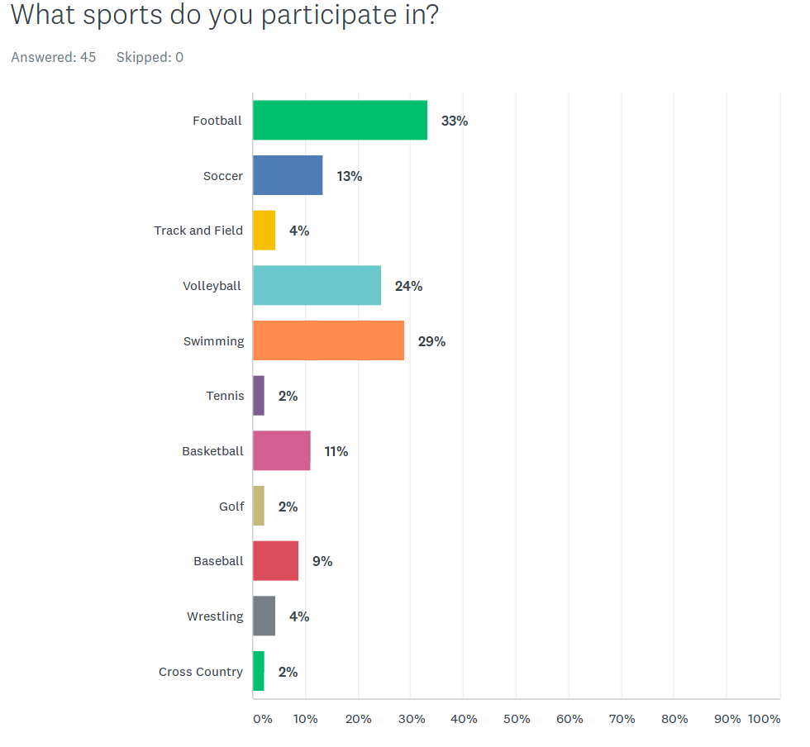This data table represents the percentage of what sports the athletes are and were involved in. This question is important because it will provide a basis to which sport might be the most harmful in Desert Mirage. With the problem of a great number of athletes ignoring the online survey, the results aren’t as representative of the sport as wanted. Nevertheless, the purpose of the study is to find out if there are any dangers in Desert Mirage athletics.

Question #2:

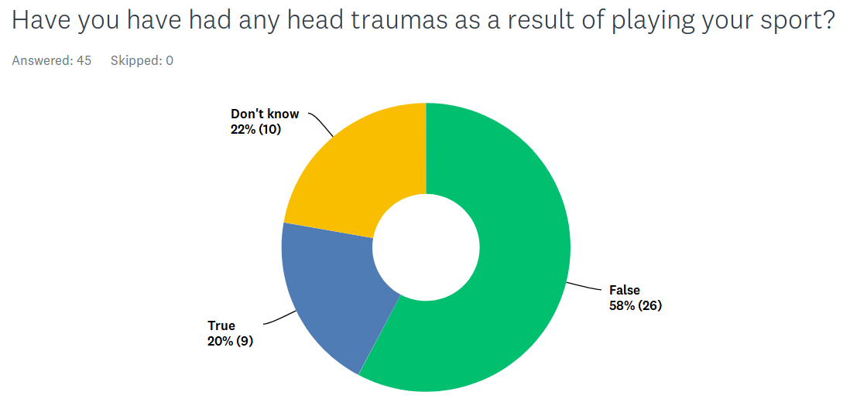The second question asked if any of the athletes have had any head traumas as a result of playing their sport.

Question #3:

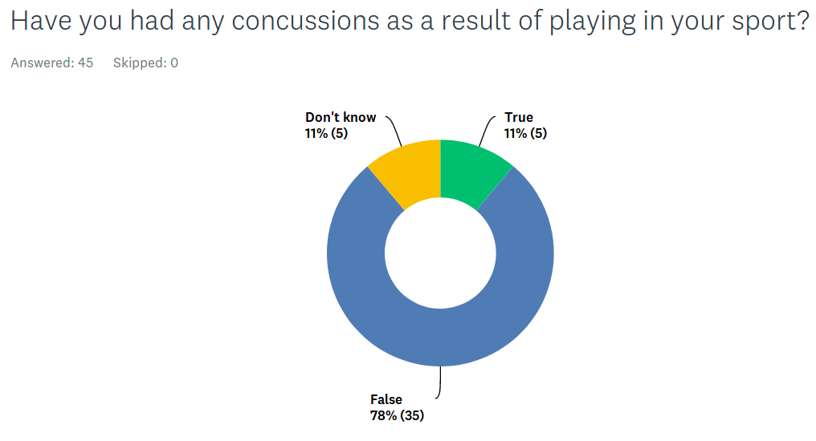

The third question asked if any of the athletes had any concussions as a result of playing their sport.

Question #4:

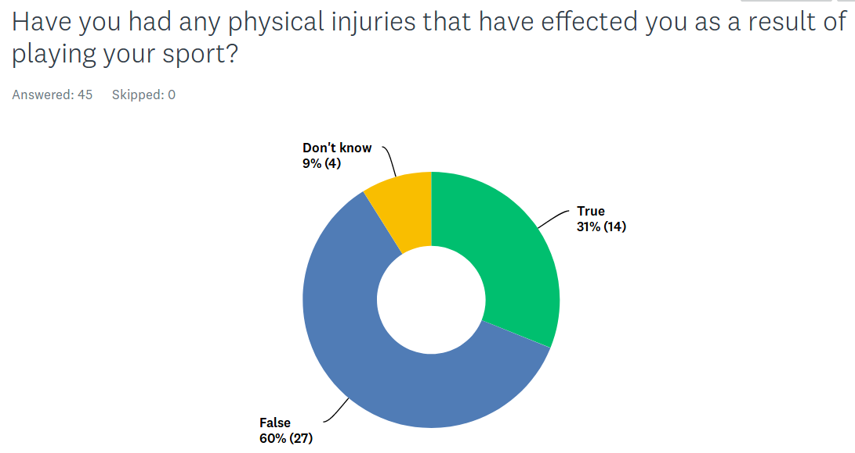The fourth question asked if any of the athletes had any physical injuries that have affected them greatly as a result of playing in their sport.

Question #5:

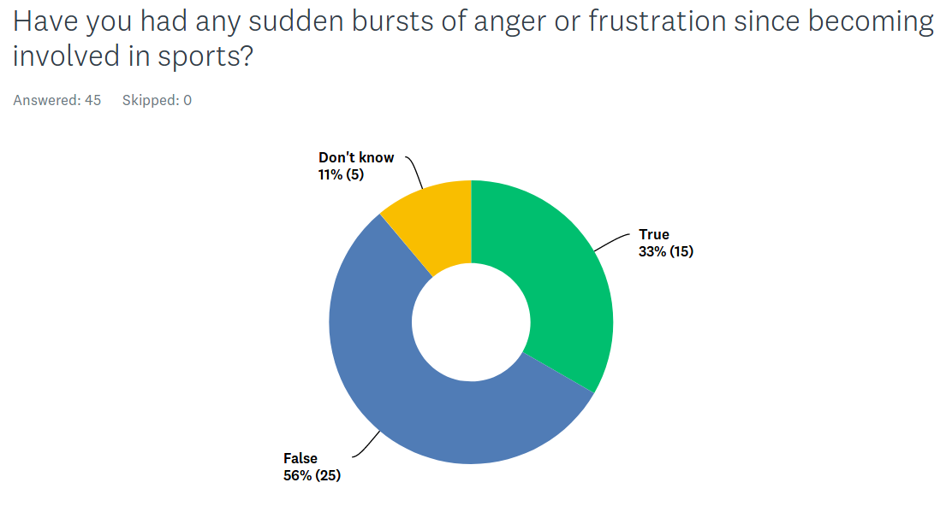The fifth question asked about their mental and emotion condition with the question of id any of them have has any sudden burst of anger or frustration since being involved in sports.

Question #6:

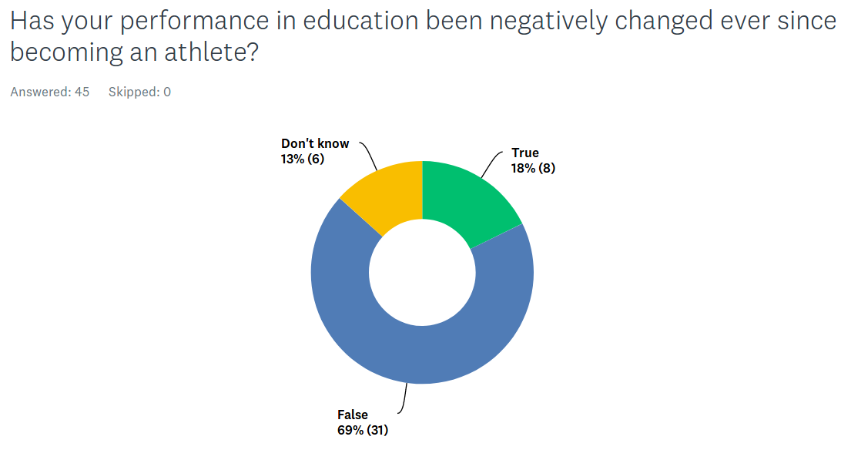The sixth question asked about their performance in school has diminished since becoming an athlete.

Question #7:

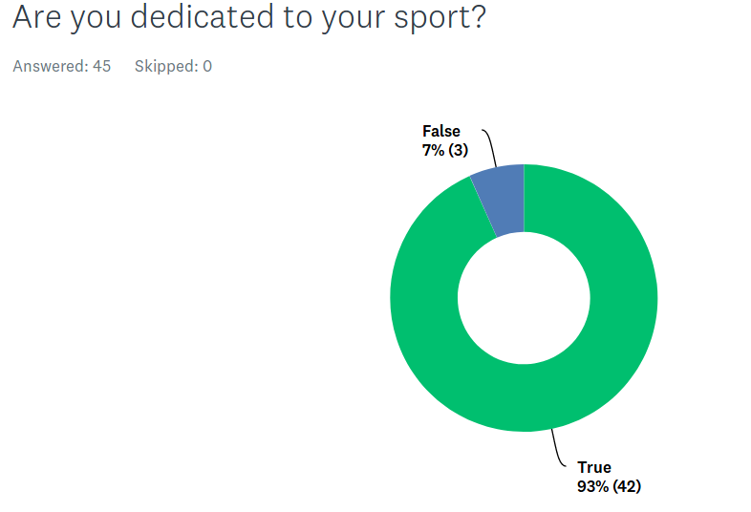The seventh question was whether the athletes were committed to their training and sport.

Question #8:

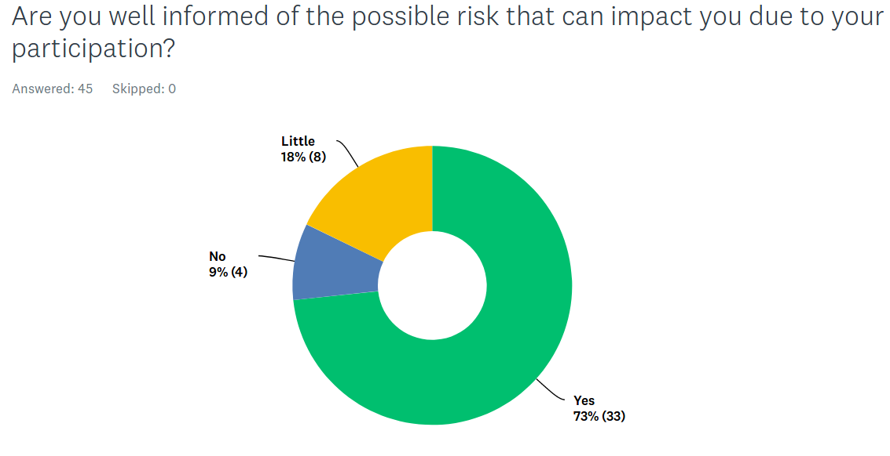The eighth question asked whether the athletes were informed of the possible consequences/side effects of participating in their sport might bring upon them.

Question #9;

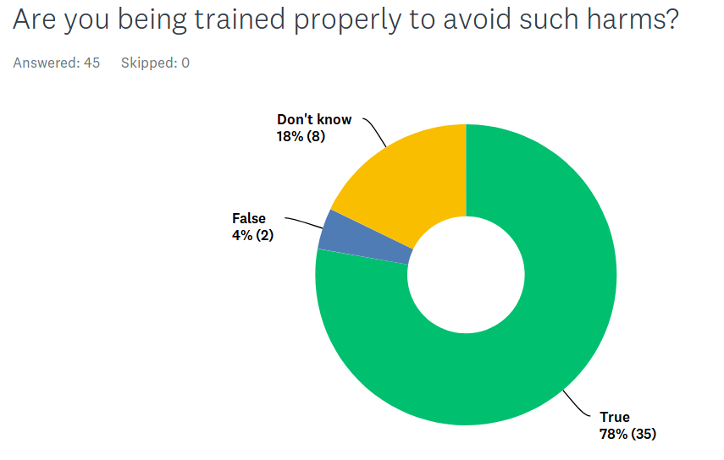The ninth question asked whether athletes were being trained properly by their coach and whether they even know if their being trained for the prevention of such injuries.

Question #10:

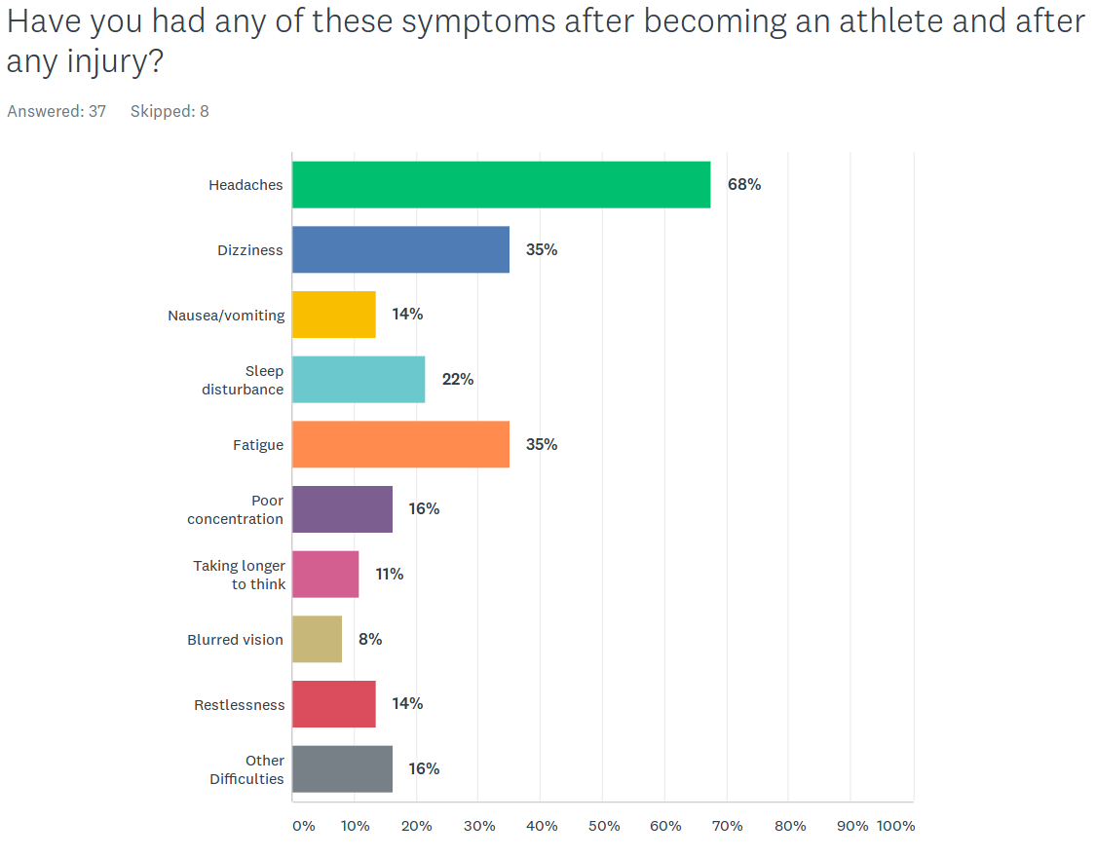The tenth question asked whether any of the athletes experienced any symptoms as a result of participating in their sports and after any injury they experienced.

The significance of the study is to determine whether athleticism at Desert Mirage can impact an athletes health and mental behavior. There are no census to in the United States to determine how dangerous athletics can be.

Have any students from Desert Mirage High School suffered any traumas, injuries, and or mental health issues as a result from playing their sport.

A small percentage of Desert Mirage High School students will suffer from an injury or concussion that will affect them significantly.

Bibliography

Chronic traumatic encephalopathy. (2016, April 20). Retrieved from https://www.mayoclinic.org/diseases-conditions/chronic-traumatic- encephalopathy/symptoms-causes/syc-20370921

Dnews. (2016, February 07). How Repeated Concussions Damage Your Brain Forever. Retrieved from https://www.youtube.com/watch?v=AaHObVz9U44

TrueTv. (2016, August 26). Adam Ruins Everything - Football's Brain Injury Problem is Even Worse Than You Realize. Retrieved from https://www.youtube.com/watch?v=EdyLK0ZqFks

* The Hidden Dangers of Competitive Sports. (2009, September 24). Retrieved from https://www.life360.com/blog/the-hidden-dangers-of-competitive-sports/