PROJECT PLAN
Domain-Specialized SAM 3 Models for Nanostructure Detection, Instance Segmentation, and Core-Shell Metrology
Item | Current Plan
Project Lead | Mengkun Tian, Ph.D.
Primary Domain Data | Prof. Lyu’s nanostructure TEM images
Additional Data | Synthetic TEM images
Extended Data | Approximately 300–500 screened Kaggle and in-house MCF SEM/TEM/STEM source images
Primary Output | Six SAM 3 checkpoints (.pt) plus an optional user-specific checkpoint
Annotation Format | COCO instance segmentation with one final object mask per annotated instance
Scientific Focus | Accurate prediction of isolated and overlapping nanostructures

1. Executive Summary
The objective of this project is to develop six independently saved SAM 3 checkpoints for accurate nanostructure detection and instance segmentation in electron-microscopy images. Four morphology-specialized expert models will focus on rod, sphere, cube, and core-shell structures from Prof. Lyu’s research group. A fifth model will be adapted to an extended microscopy dataset assembled from screened Kaggle and in-house MCF SEM/TEM/STEM images. A sixth universal model will be trained on the balanced combination of the Lyu-group datasets and the extended microscopy dataset.
The specialist checkpoints will use the same underlying SAM 3 architecture but will be intentionally biased through their training distributions, hard-negative examples, overlap emphasis, prompts, augmentation, confidence thresholds, and morphology-specific evaluation criteria. This permits each model to specialize without requiring a different network architecture for every morphology.
The core-shell model has an additional scientific objective. It will separately segment the core and the outer-particle boundary, pair the two regions, and quantify whether the core is geometrically centered. The analysis will report core-to-shell center displacement in pixels and nanometers, normalized displacement, displacement direction, and shell-thickness uniformity.
The initial dataset is expected to contain approximately 500-900 (200-400 from Lyu’s real&synthesized + 300-500 Kaggle&MCF) images. Because SAM 3 is a large foundation model, the recommended training strategy is staged and parameter-efficient: establish a zero-shot baseline, train the detector and segmentation heads, then selectively adapt the final vision-encoder blocks or LoRA (Low-Rank Adaptation) adapters. Full end-to-end fine-tuning will be considered only if the independent dataset becomes substantially larger and validation results justify it.
Image cleaning is required because many microscopy images contain scale bars, labels, or text. Also, we need to remove large clusters of nanostructures where human being cannot recognize. The cleaning pipeline will use one final cleaned image and the final COCO instance annotation. When an overlay crosses a particle boundary, an expert may manually reconstruct the missing shape before texture restoration. If the obscured structure is too ambiguous, the affected particle or image should be excluded from supervised training.
Simplified annotation principle
Cleaning produces a restored image. Annotation produces the final scientific instance mask. No additional restoration-stage mask channels are required. Core-shell remains a special scientific case because the final core and outer-particle regions must both be segmented.

2. Project Objectives

2.1 Primary Objectives
1. Detect all relevant nanostructure instances in SEM/TEM/STEM images.
2. Generate a separate segmentation mask and bounding box for each object.
3. Resolve separated particles, touching particles, and partially overlapping particles.
4. Develop morphology-specialized checkpoints for rods, spheres, cubes, and core-shell structures.
5. Develop an extended microscopy model and a combined universal model.
6. Quantify morphology and core-shell geometry from predicted masks.
7. Integrate trained checkpoints with AnyLabeling and the CVEM workflow.

2.2 Main Scientific Outputs
- Object count and confidence score.
- Instance mask and bounding box for each particle.
- Rod length, width, axis, aspect ratio, and orientation.
- Sphere diameter, equivalent diameter, Feret diameter, circularity, and area.
- Cube side-length estimates, orientation, projected area, and corner quality.
- Core and outer-particle masks for core-shell particles.
- Core-shell center displacement, direction, normalized offset, and shell-thickness statistics.
- COCO-format prediction exports for downstream training and analysis.

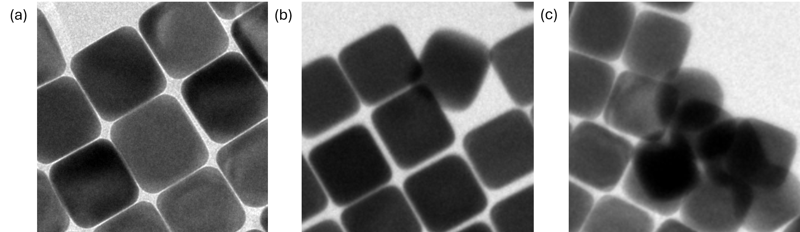
Figure 1. Representative nanostructure overlap conditions used to define segmentation difficulty: (a) well-separated particles; (b) moderate overlap, in which one particle partially overlaps three neighboring particles; and (c) severe aggregation, in which individual particle boundaries cannot be reliably distinguished by a human annotator.

3. SAM 3 Architecture Relevant to This Project
SAM 3 is a unified promptable concept-segmentation model that detects, segments, and tracks matching objects from text concepts, visual exemplars, points, boxes, or related prompts. Its published design contains an image-level detector and a memory-based video tracker that share a visual backbone. Recognition and localization are decoupled through a presence head, which helps determine whether the requested concept is present. [1]
For this project, the static-image detector pathway is the primary component. The video tracker may remain unused or frozen unless the project later expands to tilt series or time-dependent microscopy. The overall architecture is summarized in Figure 2.
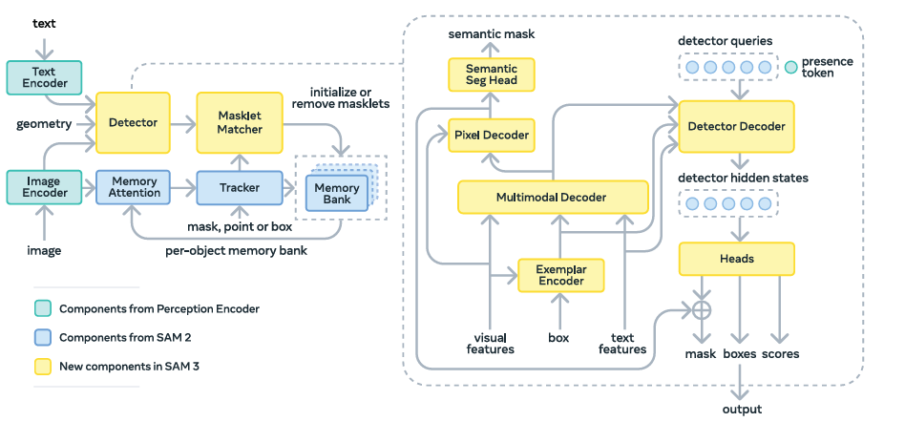
Figure 2. SAM 3 architecture. New components are shown in yellow, SAM 2 components (Ravi et al., 2024) in blue, and Perception Encoder (PE) components (Bolya et al., 2025) in cyan. Reproduced from Figure 10 in Carion et al. [1].
Component | Role in This Project
Input adaptation | Converts grayscale SEM/TEM/STEM images to the input representation expected by the pretrained backbone, initially by three-channel replication.
Vision/perception encoder | Extracts multi-scale image features; initially mostly frozen to reduce overfitting.
Prompt encoding | Represents text, geometric prompts, or visual exemplars such as “rod nanoparticle.”
Prompt-image fusion | Conditions image features on the target morphology or concept.
Image-level object decoder | Uses object queries to locate multiple matching instances.
Presence/classification head | Predicts whether the requested concept is present and reduces false positives.
Bounding-box head | Produces one candidate box for each detected instance.
Instance-mask head | Produces an individual segmentation mask for each detected particle.
Video tracker | Not required for the initial static-image workflow.

The expert models do not require different fundamental architectures. Each checkpoint becomes specialized because it is fine-tuned with a different target dataset, prompt distribution, negative set, overlap distribution, augmentation policy, and model-selection metric.

4. Why SAM 3 Is a Suitable Starting Point
- It combines object detection and instance segmentation, allowing multiple touching or overlapping particles to be identified as separate objects.
- Text and exemplar prompts support morphology-specific expert models while retaining a shared architecture.
- Pretrained features and official fine-tuning tools reduce data and development requirements.
- Separate expert checkpoints improve class-specific performance, while a universal model provides broader coverage and supports downstream morphology measurements.
Expected microscopy-domain challenges include nonuniform support-film background, contamination, detector artifacts, scale bars, text, focus-related reflection, Bragg-contrast variation, uneven brightness within particles, weak particle boundaries, dense clusters, and projection overlap.

5. Proposed Six-Checkpoint System
Checkpoint | Primary Training Domain | Main Bias and Output
sam3_rod_expert.pt | Prof. Lyu’s rods | Rod localization under orientation and overlap; axis, length, width, aspect ratio, and orientation.
sam3_sphere_expert.pt | Prof. Lyu’s spheres | Separation of touching/overlapping spheres; diameter, Feret diameter, circularity, and count.
sam3_cube_expert.pt | Prof. Lyu’s cubes | Edge and corner preservation under blur, tilt, projection, and overlap.
sam3_core_shell_expert.pt | Prof. Lyu’s core-shell structures | Core and outer-particle segmentation, pairing, center offset, and shell-thickness analysis.
sam3_extended_microscopy.pt | Screened Kaggle plus MCF data | Broad microscopy adaptation across structures, substrates, backgrounds, artifacts, and instruments.
sam3_nanostructure_universal.pt | Balanced combination of all datasets | Unified multi-class detection and segmentation across the full project domain.

An optional user-specific checkpoint may be developed for a distinct sample system, such as a dataset containing severe particle aggregation and strongly nonuniform background. The following are proposed workflow
1. Start from the same official SAM 3 base checkpoint.
2. Optionally create one shared microscopy-domain adaptation checkpoint from all cleaned microscopy images.
3. Branch the shared checkpoint into the four Lyu morphology experts and the extended microscopy model.
4. Train the final universal model from the shared microscopy checkpoint using a class-balanced combined dataset.
5. Do not initialize the universal model from only one morphology expert, because that would introduce unnecessary class bias.
6. Save the resolved configuration, dataset version, preprocessing version, random seed, and validation threshold with every .pt file.

6. Dataset Sources and Design

6.1 Data Sources
- Prof. Lyu’s real TEM images: highest-priority scientific domain.
- Synthetic TEM images: controlled particle morphology, contrast, density, orientation, and overlap.
- Screened Kaggle datasets: a library of nanostructures but need data cleaning.
- In-house MCF SEM/TEM/STEM images: extended background, instrument, artifact, and morphology diversity.
- Optional customized user datasets: for future MCF user personal dataset

6.2 Dataset Size and Independence
The initial target is approximately 200-400 (from Lyu’s real + synthesized) + 300-500 (Kaggle + MCF) independent source images before augmentation. Image count alone is not sufficient; specimen, synthesis batch, microscope session, magnification, and source-image diversity must also be tracked. Therefore it is necessary to include the Kaggle dataset + MCF dataset containing thousands of particles.

6.3 Required Annotation Structure
- Use COCO instance-segmentation format or a directly convertible format.
- Every physical particle must have a unique instance ID, category, bounding box, area, and final segmentation mask.
- Overlapping particles must remain separate instances rather than being merged into a connected component.
- Images containing no target instances should be included as hard negatives.
- For standard rod, sphere, and cube particles, retain one final object mask per particle.
- For core-shell particles, retain two scientifically required final regions: the core and the outer-particle boundary. The shell ring can be calculated as the outer region minus the core.
- No restoration-stage visible, inferred, or overlay masks are required in the final training dataset.

6.4 Recommended Overlap Distribution
Stratum | Share | Definition | Primary Use
No overlap | 25–30% | Particles fully separated | Baseline shape and boundary learning
Moderate overlap | 55–65% | Each target touches or overlaps approximately one or two neighbors | Primary scientific focus
Severe overlap | 10–15% | Clusters involving approximately three to five overlapping particles | Challenge set and future improvement

7. Image Cleaning and Restoration
Final dataset structure
The cleaning process outputs one restored image. The annotation process outputs the final COCO instance masks. Temporary removal selections are not additional model inputs or targets.

7.1 Cleaning Principle
The final dataset should remain simple: (1) one cleaned microscopy image; (2) one final COCO object mask per ordinary particle instance; and (3) the two final core/outer regions required for core-shell analysis.
Temporary selections used to remove text or a scale bar are processing tools only and do not become additional SAM 3 training outputs. The restoration method should depend on what the removed overlay originally covered.

7.2 Case 1: Background-Only Region Is Removed
This is the lowest-risk restoration case. The particle geometry does not need to be predicted.

Recommended Methods
- Uniform or slowly varying background: Telea fast-marching inpainting, Navier–Stokes/PDE interpolation, total-variation reconstruction, low-order polynomial surface fitting, or Poisson interpolation.
- Background with repeated texture or detector noise: constrained nearest-neighbor patch replacement, PatchMatch, or local texture synthesis.
- Background with frequency structure: DCT-sparse reconstruction, local power-spectrum matching, or a TEM-adapted LaMa/partial-convolution model if classical methods are insufficient.
- Final matching: adjust local mean, variance, brightness gradient, noise power, and blur to match nearby background.
Recommended default
Start with Telea or smooth-surface reconstruction for small overlays. Use constrained PatchMatch or DCT/power-spectrum matching when the local background contains noticeable texture. A learned model is optional.

7.3 Case 2: Particle Interior Is Removed but the Particle Boundary Remains Visible
This case does not require prediction of the missing particle shape because the external boundary is still known. The main problem is restoration of the internal particle intensity and texture.
- Restrict source texture to visible regions of the same particle whenever possible.
- Use same-particle nearest-neighbor patch sampling or constrained PatchMatch.
- Use local directional interpolation when the particle contains directional contrast.
- Match local brightness, contrast, blur, noise, and frequency content to the surrounding particle.
- For approximately uniform particles, fit a low-frequency intensity surface and add statistically matched particle noise.
- Use a TEM-adapted partial-convolution or LaMa model only when classical methods consistently fail.
Scientific limitation
The reconstructed contrast is a plausible estimate rather than recovered experimental information. It should not be interpreted as proof of the original lattice, diffraction contrast, defects, or composition.

7.4 Case 3: Both Particle and Background Are Removed
This is the most difficult case because the overlay crosses the particle boundary. The missing particle geometry must be determined before texture can be restored.

Recommended Human-Assisted Method
1. Inspect the visible particle boundary and surrounding morphology.
2. Manually complete the missing particle shape when the geometry is reasonably inferable.
3. Produce the one final completed particle mask that will be used in COCO annotation.
4. Use the completed mask to divide the removed area into particle and background subregions.
5. Fill the particle subregion using same-particle or morphology-matched particle texture.
6. Fill the background subregion using neighboring background texture and statistics.
7. Blend the reconstructed regions at the particle boundary while preserving a physically plausible edge.
8. Review the cleaned image and final object mask together.

Morphology-Specific Shape Guidance
- Sphere: fit a circle or ellipse to the visible arc; avoid forcing perfect circularity when the projection is visibly distorted.
- Rod: continue the centerline, width, side edges, and end-cap geometry.
- Cube: extend visible straight edges and preserve parallelism, corner location, and projection tilt.
- Core-shell: complete the outer boundary and core boundary separately only when enough evidence remains. If the hidden geometry is ambiguous, exclude the particle from centering metrology.
Large or ambiguous occlusion
Expert manual reconstruction is acceptable when the morphology is clear enough to support a defensible completion. If a large fraction is hidden and multiple shapes are equally plausible, exclude the affected particle rather than forcing a label.

7.5 Removal of Highly Overlapped Nanostructures or Unwanted Regions
Some images contain extremely dense aggregates in which individual particle boundaries cannot be reliably recognized or annotated, even by an experienced reviewer. Other regions may contain contamination, damaged areas, preparation artifacts, or structures that are outside the intended training scope. These regions should not be assigned uncertain instance labels. This removal procedure is intended only for unresolvable aggregates or clearly unwanted regions; moderate and interpretable overlap should remain in the dataset because it is a primary training target.

Recommended Procedure
1. Identify and outline the region. Manually draw a boundary around the unresolvable aggregate or unwanted area, including a small margin sufficient to remove blurred or contaminated edge pixels.
2. Confirm that removal is justified. Verify that the region cannot be annotated as separate particle instances and that no clearly recognizable target particle should be retained.
3. Remove the selected content. Delete the selected region from the working image while preserving all unaffected pixels outside the outline.
4. Reconstruct the background. Use nearby background as the source. For a smooth background, use Telea, PDE/TV, or surface fitting. For textured background, use constrained PatchMatch, local patch synthesis, or a TEM-adapted background inpainting model.
5. Match local image statistics. Adjust the reconstructed area to match the surrounding mean intensity, variance, brightness gradient, blur, noise level, and local spatial-frequency content.
6. Review the result. Confirm that the fill has no visible seams, repeated patch patterns, artificial particle-like features, or abrupt changes in brightness and noise.
7. Accept, rework, crop, or exclude. If the region is too large, intersects valid particles, or cannot be filled without introducing artificial structure, crop the affected area or exclude the image from supervised training.
Annotation rule: after an unresolvable or unwanted region has been removed and replaced with background, the reconstructed area is treated as background and no particle annotation is created inside that area. Images requiring extensive reconstruction should not dominate the primary real-data validation or test sets.
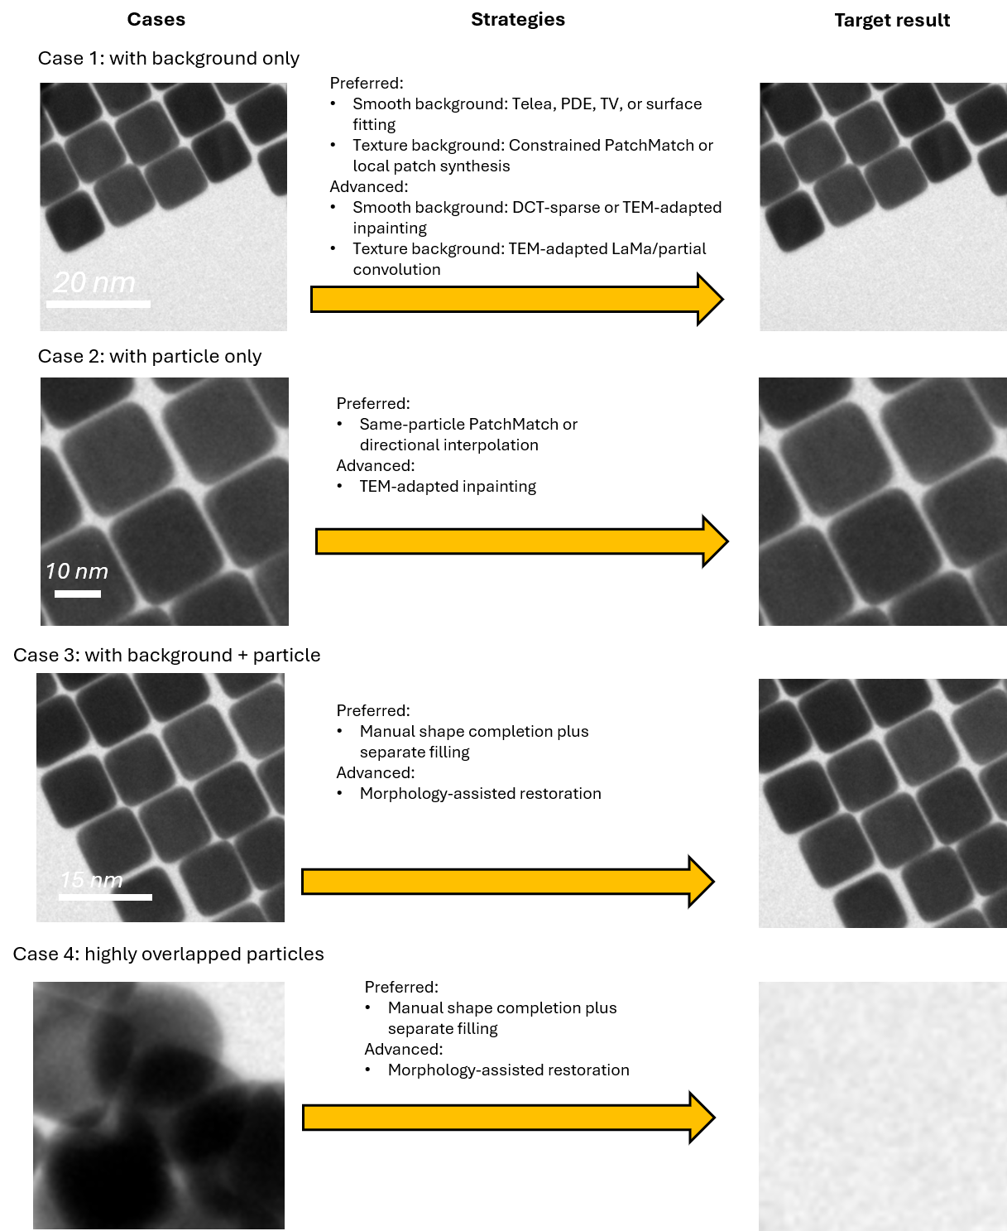
Figure 3. Four data-cleaning cases, recommended restoration strategies, and intended results: Case 1, removal of an overlay from background only; Case 2, removal from the particle interior; Case 3, removal across both a particle and the background; and Case 4, removal of a highly overlapped or unwanted nanostructure region followed by background reconstruction.

7.6 Restoration Method Decision Table
Original Content | Preferred First Method | Escalation | Human Action
Smooth background | Telea, PDE, TV, or surface fitting | DCT-sparse or TEM-adapted inpainting | Visual acceptance review
Textured background | Constrained PatchMatch or local patch synthesis | TEM-adapted LaMa/partial convolution | Select valid source texture if needed
Particle interior only | Same-particle PatchMatch or directional interpolation | TEM-adapted inpainting | Confirm boundary remains intact
Particle and background | Manual shape completion plus separate filling | Morphology-assisted restoration | Required shape review
Highly overlapped or unwanted region | Manually outline and remove the region; reconstruct the background with surface fitting, TV/Telea, or constrained patch synthesis according to the surrounding texture | TEM-adapted background inpainting or controlled synthetic background replacement; crop or exclude the image if a defensible reconstruction is not possible | Confirm that the region is not reliably annotatable; review the reconstructed background and exclude the case if valid particles are affected

7.7 Main Data-Cleaning Workflow
1 | Preserve the original file — Keep the source image unchanged. Pixel size will be supplied by the registration spreadsheet.
2 | Mark text or scale bar — Create a temporary removal selection manually or with a detector; it is not a SAM 3 target.
3 | Classify affected content — Background only, particle interior only, particle plus background, highly overlapped/unwanted region, or too ambiguous to restore.
4 | Restore by case — Use the method hierarchy above; manually complete interrupted particle boundaries, or remove and reconstruct unresolvable/unwanted regions as background.
5 | Create the final annotation — Save one final instance mask per particle; retain core and outer regions only for core-shell.
6 | Quality control — Inspect seams, brightness, texture, edges, copied motifs, artificial particles, and annotation alignment.
7 | Accept, rework, or exclude — Prevent heavily reconstructed examples from dominating the real validation or test set.

7.8 (Optional Workflow): Simulated Scale-Bar and Text Restoration Study
This optional study can determine which restoration methods work best before cleaning the complete dataset.
1 | Select clean images — Choose microscopy images without existing overlays and retain them as known references.
2 | Generate realistic overlays — Vary scale-bar width, font, brightness, anti-aliasing, orientation, and location.
3 | Create three placement groups — Place overlays over background, particle interior, and particle boundary plus background.
4 | Apply candidate restoration methods — Test Telea/PDE/TV, PatchMatch, DCT-sparse methods, and optional learned inpainting.
5 | Compare with the clean reference — Measure local intensity error, edge continuity, noise-spectrum similarity, and visual artifacts.
6 | Test downstream stability — Run SAM 3 or a baseline segmenter and measure how much restoration changes detection and masks.
7 | Select a method by case — Use separate preferred methods for the three content classes rather than one universal method.
8 | Optional compact restoration model — Train a small partial/gated-convolution U-Net only if classical methods are insufficient.

If a learned restoration model is used, it remains separate from SAM 3 and outputs only the restored grayscale image. The final particle annotation remains a single manually reviewed COCO mask; no extra segmentation branches are required.

8. Data Augmentation
- Horizontal and vertical flipping
- No shear is allowed because it will change the nanostructure morphology!.
- Rotations, including arbitrary orientation for rods and cubes.
- (optional) Moderate brightness, contrast, gamma, and local illumination variation.
- (optional) Moderate edge softening and contrast reversal only when supported by the real domain.

9. Tentative Fine-Tuning Strategy
Stage | Trainable Components | Frozen Components | Purpose
0. Baseline | None | All | Measure zero-shot performance and failure modes.
1. Head adaptation | Fusion/detector layers, presence/classification, box and mask heads | Vision and language encoders | Learn microscopy-specific localization and masks with limited overfitting.
2. Partial vision adaptation | Stage 1 plus final vision blocks or LoRA | Early/mid vision blocks, language encoder, tracker | Adapt higher-level features to microscopy contrast and morphology.
3. Optional broader tuning | Additional vision blocks at low learning rate | Language encoder and tracker generally remain frozen | Use only when grouped validation confirms consistent gain.

9.1 Optimization Principles
- Use AdamW and mixed precision.
- Use gradient accumulation and checkpointing as required by GPU memory.
- Use early stopping and select checkpoints on a real validation set.
- Use class-balanced and overlap-balanced sampling.
- Include hard negatives from other morphology datasets and artifacts.
- Oversample moderate and severe overlaps during training but report them separately.
- Keep canonical prompts simple and consistent, with controlled synonyms.
- Save a separate confidence threshold for each checkpoint.
- Maintain the same evaluation splits across expert and universal models.

9.2 To be continued… (will complete this part after testing)

10. Expert-Specific Training Design

10.1 Rod Expert
Positive examples should span aspect ratio, length, width, orientation, contrast, truncation, curvature tolerance, and overlap. Hard negatives should include elongated contamination, scratches, support-film edges, text remnants, cubes viewed obliquely, and touching spheres.

10.2 Sphere Expert
Training should emphasize touching and partially overlapping circles across size and contrast. Hard negatives should include pores, contamination spots, hollow artifacts, core regions, text dots, and round detector defects.

10.3 Cube Expert
Training should cover edge blur, corner truncation, tilt, projected rhombi, partial occlusion, and overlap. Hard negatives should include platelets, rectangles from text, support-film boundaries, rods with flat ends, and block-like contamination.

10.4 Core-Shell Expert
The model must predict the final core region and the final outer-particle region. Training should include centered and off-centered cores, weak and strong contrast, nonuniform shells, partial overlap, and solid-particle hard negatives. Contrast is useful but cannot be the only cue.

10.5 Extended Microscopy Model
This model should learn broad SEM/TEM/STEM domain features from screened Kaggle and MCF data, including substrates, contamination, detector artifacts, nonuniform background, and diverse particle morphologies.

10.6 Universal Model
The universal checkpoint should be trained on a balanced combination of all Lyu-group and extended datasets. Sampling should prevent common classes or large source datasets from dominating.

11. Core-Shell Geometry and Metrology
The core-shell network should perform segmentation; geometry should be calculated by transparent post-processing.

11.1 Required Predictions
- Final outer-particle mask.
- Final core mask.
- Confidence score for each region.
- Pairing between a core and its containing outer particle.

11.2 Measurements
- Pixel displacement: d_px = sqrt((x_core − x_shell)^2 + (y_core − y_shell)^2)
- Physical displacement: d_nm = d_px × nm_per_pixel
- Equivalent outer radius: R_eq = sqrt(A_outer / π)
- Normalized offset: e = d_px / R_eq
- Direction: θ = atan2(y_core − y_shell, x_core − x_shell)
- Shell ring: outer-particle mask minus core mask
- Shell-thickness profile: radial distance between core and outer boundaries as a function of angle
Report the mean shell thickness, standard deviation, coefficient of variation, and minimum/maximum thickness. For visibly elliptical particles, an ellipse-fitted center and axis-normalized displacement should also be considered.

12. Evaluation Plan
Evaluation Area | Metrics | Required Stratification
Detection | Box AP50, AP50:95, precision, recall, false positives/image | Morphology, data source, density, overlap
Instance segmentation | Mask AP, Dice, IoU, boundary F1 | Isolated, moderate overlap, severe overlap
Counting | Absolute and relative count error | Density and overlap
Rod metrology | Length, width, aspect-ratio, orientation error | Size and overlap
Sphere metrology | Diameter, Feret diameter, circularity, area error | Size and overlap
Cube metrology | Side length, corner error, area, orientation error | Tilt and overlap
Core-shell metrology | Pairing, center-offset, thickness-profile error | Centered/off-centered and overlap
Cleaning validation | Restoration error and downstream segmentation change | Cleaning case and method

Comparison Requirements:
- Compare every morphology expert with the universal model on the same class-specific holdout set.
- Report Prof. Lyu, synthetic, Kaggle, and MCF results separately.
- Report results before and after image cleaning when possible.
- Select confidence thresholds using validation data only.
- Review merged particles, split particles, missed small particles, artifact false positives, poor boundaries, and overlap failures.
- Keep heavily restored images out of the primary scientific test set whenever sufficient clean data exist.

13. End-to-End Project Workflow
1 | Data inventory — Collect and catalogue Prof. Lyu, synthetic, Kaggle, and MCF images.
2 | External-data screening — Check licensing, duplication, annotation quality, and microscopy-domain relevance.
3 | (skip for Lyu’s)Image cleaning — Remove text and scale bars using the three-case workflow.
4 | Expert review — Manually restore interrupted particle geometry and reject ambiguous cases.
5 | Final annotation — Create COCO instance masks with independent annotations for overlaps.
6 | Grouped splitting — Separate train, validation, and test by source image, specimen, batch, and session.
7 | Baseline — Measure official SAM 3 zero-shot performance.
8 | Shared adaptation — Optionally train a microscopy-domain starting checkpoint.
9 | Expert training — Train rod, sphere, cube, and core-shell checkpoints.
10 | Extended training — Train the screened Kaggle/MCF microscopy checkpoint.
11 | Universal training — Train the balanced combined checkpoint.
12 | Calibration and evaluation — Select thresholds and report morphology/overlap/source-specific results.
13 | Metrology — Calculate morphology and core-shell measurements.
14 | Integration — Export checkpoints, COCO results, configs, reports, and AnyLabeling/CV4EM notebooks.

14. Project summary
This project aims to develop six domain-specialized SAM 3 checkpoints for accurate detection and instance segmentation of nanostructures in electron-microscopy images. Four expert models will be trained separately for Prof. Lyu’s rod-shaped, spherical, cubic, and core-shell nanostructures. A fifth model will be adapted to an extended microscopy dataset assembled from screened Kaggle and in-house MCF SEM/TEM/STEM images. A sixth universal model will be trained on the balanced combination of the Lyu-group datasets and the extended microscopy dataset.
Each expert checkpoint will use the same base architecture but will be intentionally biased toward its target domain through morphology-specific positive examples, hard negatives, prompts, overlap distributions, augmentations, confidence thresholds, and evaluation criteria. The training data will emphasize both isolated particles and partially overlapping particles, with moderate one- or two-neighbor overlap as the primary scientific focus.
Before training, scale bars and text will be removed through a content-aware cleaning workflow. Background-only regions will be restored using classical interpolation, texture synthesis, DCT/TV methods, or optional TEM-adapted inpainting. Particle-interior regions will be restored using texture from the same particle or morphology-matched regions. When an overlay crosses a particle boundary, an expert will manually complete the missing particle geometry before the particle and background textures are restored separately. The final dataset will contain the cleaned image and the final COCO object annotations; no additional restoration-stage mask outputs will be required.
The SAM 3 training strategy will be staged to control overfitting. The image-level detector and prediction heads will be adapted first while most of the vision encoder and language encoder remain frozen. The final vision-encoder blocks or LoRA adapters will then be adapted at a lower learning rate if validation results demonstrate a consistent benefit. Every checkpoint will be saved independently with its resolved configuration, dataset version, preprocessing version, and evaluation threshold.
The core-shell expert will predict final core and outer-particle masks. A separate geometry module will calculate core-to-shell center displacement in pixels and nanometers, normalized offset, displacement direction, and shell-thickness uniformity. The completed system will support both visual instance segmentation and quantitative nanostructure metrology.

15. Editable Parameters
Parameter | Current Draft Value | Editable Decision
Number of primary checkpoints | 6 | Keep / revise
Lyu specialist classes | Rod, sphere, cube, core-shell | Edit definitions
Extended microscopy model | Kaggle + MCF SEM/TEM/STEM | Confirm sources
Universal model | Lyu + extended balanced combination | Confirm weighting
Estimated source images | 500–900 | Enter final count
Synthetic images per class | 50–100 initially | Enter final target
Moderate-overlap share | 55–65% | Enter final target
Severe-overlap share | 10–15% | Enter final target
Training image size | Determined by particle pixel size | Enter tiling plan
Primary holdout | Prof. Lyu’s real data | Confirm split
Cleaning output | Cleaned image + final COCO mask | Confirm
Boundary-intersecting overlays | Manual shape completion | Confirm review process
Optional restoration benchmark | Simulated text/scale bars | Enable / defer
Fine-tuning method | Heads first, then final vision blocks/LoRA | Confirm after baseline
Core-shell center definition | Outer-mask centroid or fitted ellipse center | Select method

16. References
1. Carion, N., Gustafson, L., Hu, Y.-T., Debnath, S., Hu, R., Suris, D., Ryali, C., Alwala, K. V., Khedr, H., Huang, A., Lei, J., Ma, T., Guo, B., Kalla, A., Marks, M., Greer, J., Wang, M., Sun, P., Rädle, R., Afouras, T., Mavroudi, E., Xu, K., Wu, T.-H., Zhou, Y., Momeni, L., Hazra, R., Ding, S., Vaze, S., Porcher, F., Li, F., Li, S., Kamath, A., Cheng, H. K., Dollár, P., Ravi, N., Saenko, K., Zhang, P., and Feichtenhofer, C. SAM 3: Segment Anything with Concepts. arXiv:2511.16719, 2025.
2. Meta AI. SAM 3 official repository and custom-dataset training guide, facebookresearch/sam3, including README_TRAIN.md.
3. Ravi, N., Gabeur, V., Hu, Y.-T., Hu, R., Ryali, C., Ma, T., Khedr, H., Rädle, R., Rolland, C., Gustafson, L., Mintun, E., Pan, J., Alwala, K. V., Carion, N., Wu, C.-Y., Girshick, R., Dollár, P., and Feichtenhofer, C. SAM 2: Segment Anything in Images and Videos. arXiv:2408.00714, 2024.
4. Bolya, D., Huang, P.-Y., Sun, P., Cho, J. H., Madotto, A., Wei, C., Ma, T., Zhi, J., Rajasegaran, J., Rasheed, H., Wang, J., Monteiro, M., Xu, H., Dong, S., Ravi, N., Li, D., Dollár, P., and Feichtenhofer, C. Perception Encoder: The Best Visual Embeddings Are Not at the Output of the Network. arXiv:2504.13181, 2025.
5. Telea, A. An Image Inpainting Technique Based on the Fast Marching Method. Journal of Graphics Tools, 9(1), 25–36, 2004.
6. Barnes, C., Shechtman, E., Finkelstein, A., and Goldman, D. B. PatchMatch: A Randomized Correspondence Algorithm for Structural Image Editing. ACM Transactions on Graphics, 2009.
7. Liu, G., et al. Image Inpainting for Irregular Holes Using Partial Convolutions. ECCV, 2018.
8. Suvorov, R., et al. Resolution-Robust Large Mask Inpainting with Fourier Convolutions. WACV, 2022.
9. Bertalmio, M., Bertozzi, A. L., and Sapiro, G. Navier–Stokes, Fluid Dynamics, and Image and Video Inpainting. CVPR, 2001.
10. Rudin, L. I., Osher, S., and Fatemi, E. Nonlinear Total Variation Based Noise Removal Algorithms. Physica D, 1992.
11. Yu, J., Lin, Z., Yang, J., Shen, X., Lu, X., and Huang, T. S. Free-Form Image Inpainting with Gated Convolution. ICCV, 2019.
12. Wohlberg, B. SPORCO: A Python Package for Standard and Convolutional Sparse Representations. Proceedings of the 15th Python in Science Conference, 2017.

17. Reference Guide to Restoration Methods
The methods below are the techniques named in the Preferred First Method and Escalation columns of the decision table. A preferred method is the simpler, more conservative starting option. An escalation method is considered only when the first method produces unacceptable smoothing, seams, texture mismatch, broken particle boundaries, or poor downstream segmentation. GitHub links are included only where a relevant repository could be verified; community implementations are labeled as such.
Method | Plain-English meaning | Basic principle | Best use and main caution | Code / GitHub
Telea fast-marching inpainting | A fast method that fills a hole from its boundary toward the center. | Nearby known pixels are combined using distance, direction, and local-gradient weights. | Good for small text or scale bars on smooth background. It can blur particle edges or fine texture. | OpenCV: cv2.inpaint / INPAINT_TELEA
Navier-Stokes / PDE inpainting | A mathematical method that continues visible brightness lines and edges through a missing area. | Partial differential equations propagate image intensity and edge direction from known pixels into the hole. | Useful for narrow gaps and simple edge continuation. It does not understand particle morphology. | OpenCV: cv2.inpaint / INPAINT_NS
Total-variation (TV) reconstruction | A conservative reconstruction that favors smooth regions while retaining major edges. | An optimization balances agreement with visible pixels against a penalty on unnecessary intensity variation. | Useful for smooth background. It may over-smooth weak boundaries, noise, or internal TEM contrast. | PyLops TV examples/toolkit
Surface fitting | Fits a smooth mathematical brightness surface to the pixels around the removed area. | A plane, polynomial, spline, or radial-basis surface is estimated from nearby background and evaluated inside the hole. | Good for gradual background gradients. It restores low-frequency brightness but not realistic fine texture by itself. | SciPy interpolation/optimization
Poisson interpolation or blending | Blends a filled patch into its surroundings so brightness and gradients change smoothly at the boundary. | A gradient-domain optimization reduces visible seams between the inserted region and the original image. | Best used as a finishing/blending step rather than as the only method for recovering particle structure. | OpenCV seamlessClone toolkit
Nearest-neighbor patch replacement | Copies a small clean image patch that resembles the area surrounding the hole. | Candidate patches are compared by intensity, gradient, or texture similarity; the closest match is selected. | Useful for repeated background texture. Source regions must be restricted to avoid copying unrelated particles. | Custom workflow; OpenCV building blocks
PatchMatch | A fast method for finding similar patches elsewhere in an image. | Random initialization, propagation, and random search approximate the nearest-neighbor patch field. | Useful for repeated texture and object removal. It can copy wrong structures or create repeated motifs. | Community Python implementation (not official)
Local patch synthesis | Builds a missing texture from several small neighboring patches rather than copying one large block. | Small compatible patches are sampled and blended to match local intensity, noise, and texture statistics. | Useful for random background texture. It cannot independently determine a hidden particle shape. | No single verified reference repository; custom implementation or manual workflow.
DCT-sparse or sparse reconstruction | Rebuilds the image from a small set of important spatial-frequency or dictionary components. | An optimization finds sparse coefficients that reproduce visible pixels and estimate the missing region. | Useful for smooth or compressible texture. It may produce ringing or overly regular patterns at particle edges. | SPORCO sparse-optimization toolkit
Same-particle PatchMatch | A constrained PatchMatch search that borrows texture only from the visible part of the same particle. | Patch candidates outside the selected particle are rejected before nearest-neighbor matching. | Useful when the particle boundary is intact. It is less reliable when the particle texture is strongly nonuniform. | PatchMatch core; same-particle constraint is custom
Directional interpolation | Continues image information along a visible direction, such as a rod axis, edge, or fringe direction. | The dominant local orientation is estimated and intensities are interpolated along that direction. | Useful for rods or directional contrast. It performs poorly where several orientations intersect. | No single verified reference repository; custom implementation or manual workflow.
Partial-convolution inpainting | A neural network that calculates convolutions using only valid pixels around a hole. | Masked convolutions are renormalized, and the valid region expands through successive network layers. | Useful for irregular masks and medium-sized holes. It requires representative training data and can still guess incorrectly. | NVIDIA partial convolution
Gated-convolution inpainting | A neural network that learns how much information to accept at every location and feature channel. | A learned gate dynamically separates useful context from missing or unreliable pixels. | Useful for free-form holes and TEM-specific paired training. Generative losses may introduce plausible but false structure. | Official DeepFill/gated-convolution code
LaMa | A neural inpainting model designed for large masks and long-range structure. | Fast Fourier convolutions provide an image-wide receptive field, allowing distant context to guide the fill. | Useful for large text blocks, long scale bars, and periodic texture. Fine-tune and validate on TEM/SEM data to limit hallucination. | Official LaMa repository
TEM-adapted inpainting | Any inpainting network that has been trained or fine-tuned on paired clean and artificially corrupted TEM/SEM images. | The model learns microscopy-specific background, noise, particle texture, and boundary patterns from known clean targets. | Useful when classical methods fail. It is an umbrella approach, not a single algorithm, and requires strict validation. | Choose and adapt LaMa, partial convolution, or gated convolution
Manual shape completion plus separate filling | A reviewer first completes the missing particle outline, then particle and background areas are restored separately. | The completed outline divides the hole into particle and background subregions before texture filling and blending. | Useful when an overlay crosses a recognizable particle boundary. Do not force completion when several shapes are equally plausible. | No single verified reference repository; custom implementation or manual workflow.
Morphology-assisted restoration | Restoration guided by an expected shape, such as a sphere, rod, cube, or nested core-shell geometry. | The fill is constrained by fitted geometry, a manually completed outline, or a morphology-specific segmentation prediction. | Useful when shape is predictable. An incorrect shape assumption directly produces an incorrect reconstruction. | No single verified reference repository; custom implementation or manual workflow.
Controlled synthetic replacement | Replaces an unrecoverable real region with a synthetic particle or synthetic background whose content is fully known. | The synthetic object is composited with matched scale, contrast, blur, and noise, and its exact mask is retained. | Useful for training augmentation, not for real-particle measurements or the primary real-data test set. | No single verified reference repository; custom implementation or manual workflow.
Exclusion or cropping | Removes an uncertain particle, region, or image instead of inventing a reconstruction. | No recovery is attempted when the available evidence is insufficient for a defensible result. | Safest for severe ambiguity, large missing core-shell regions, or fills that would affect valid particles. | No single verified reference repository; custom implementation or manual workflow.

