Ramicane and Capomulin were the only drugs to reducer tumor size over the course of the study.

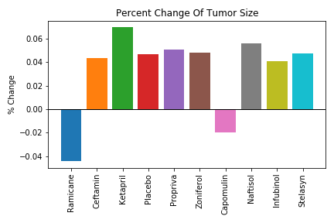

Ramicane and Capomulin were also responsible for the highest survival rate for test mice.

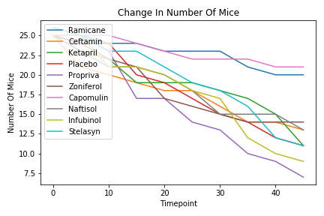

Ramicane and Capomulin also had the lowest instances of new metastatic sites.

