## NPC商店的编辑方法

首先npc商店中所有出售物品必须在物品配置文件propItem.txt设为可以出售，方法是这个文件的dwshopAble列设为1.

给npc添加交易功能，一下以给新手指导员添加纸片为例子

1. 通过名字找到npc的配置：

在character.txt.txt中查找“新手指导员”，

找到IDS_CHARACTER_INC_000704 新手指导员

在character.inc中查找IDS_CHARACTER_INC_000704，

找到MaFl_Helper_ver12为代号的npc

MaFl_Helper_ver12 //??? ??? ???

{

setting

{

AddMenu( MMI_DIALOG );

AddMenu( MMI_NPC_BUFF );

// ( SKILL ID, ????, ??? ???? ??, ?? ??, ????(ms) )

SetBuffSkill( SI_ASS_HEAL_PATIENCE, 10, 1, 200, 3600000 );

SetBuffSkill( SI_ASS_CHEER_QUICKSTEP, 10, 1, 200, 3600000 );

SetBuffSkill( SI_ASS_CHEER_HASTE, 10, 1, 200, 3600000 );

SetBuffSkill( SI_ASS_CHEER_CATSREFLEX, 10, 1, 200, 3600000 );

SetBuffSkill( SI_ASS_CHEER_CANNONBALL, 10, 1, 200, 3600000 );

SetBuffSkill( SI_ASS_CHEER_MENTALSIGN, 10, 1, 200, 3600000 );

SetBuffSkill( SI_ASS_CHEER_HEAPUP, 10, 1, 200, 3600000 );

SetBuffSkill( SI_ASS_CHEER_BEEFUP, 10, 1, 200, 3600000 );

SetBuffSkill( SI_ASS_CHEER_ACCURACY, 10, 1, 200, 3600000 );

SetBuffSkill( SI_ASS_CHEER_BEEFUP, 1, 1, 200, 3600000 );

SetBuffSkill( SI_GEN_ADDEXP_LV01, 1, 1, 200, 3600000 );

SetBuffSkill( SI_GEN_ADDDROP_LV01, 1, 1, 200, 3600000 );

SetImage

(

IDS_CHARACTER_INC_000703

);

m_szDialog= "MaFl_Helper.txt";

}

SetName

(

IDS_CHARACTER_INC_000704

);

}

添加交易菜单：在setting中添加AddMenu(MMI_TRADE);

添加交易页签：与setting平行的位置

AddVendorSlot( 0,

IDS_CHARACTER_INC_000743

);

第一位表示页签编号，之后在添加物品时会用到。第二位为页签名称在character.txt.txt中可以找到对应关系。

添加交易物品：在setting中添加AddVendorItem

AddVendorItem( 0, IK3_ULTIMATE, -1, 200, 200, 100 );

第一个参数就是前面提到的页签编号，这些物品配置在此页签中。

第二个参数对应物品类型，对应propItem.txt中的dwItemKind3，如设置成IK3_ULTIMATE就会把propItem.txt中的dwItemKind3为IK3_ULTIMATE的物品包含进去。

第三个参数是职业限制对应propItem.txt中的dwItemJob，-1为无限制，设为有职业则过滤掉其他职业。

第三个和第四个参数是物品等级，对应propItem.txt中的dwItemLV，只包含在此等级之间的物品。

第五个参数是贩卖个数。

配置好的“新手指导员”

MaFl_Helper_ver12 //??? ??? ???

{

setting

{

AddMenu( MMI_DIALOG );

AddMenu( MMI_NPC_BUFF );

AddMenu(MMI_TRADE);

// ( SKILL ID, ????, ??? ???? ??, ?? ??, ????(ms) )

SetBuffSkill( SI_ASS_HEAL_PATIENCE, 10, 1, 200, 3600000 );

SetBuffSkill( SI_ASS_CHEER_QUICKSTEP, 10, 1, 200, 3600000 );

SetBuffSkill( SI_ASS_CHEER_HASTE, 10, 1, 200, 3600000 );

SetBuffSkill( SI_ASS_CHEER_CATSREFLEX, 10, 1, 200, 3600000 );

SetBuffSkill( SI_ASS_CHEER_CANNONBALL, 10, 1, 200, 3600000 );

SetBuffSkill( SI_ASS_CHEER_MENTALSIGN, 10, 1, 200, 3600000 );

SetBuffSkill( SI_ASS_CHEER_HEAPUP, 10, 1, 200, 3600000 );

SetBuffSkill( SI_ASS_CHEER_BEEFUP, 10, 1, 200, 3600000 );

SetBuffSkill( SI_ASS_CHEER_ACCURACY, 10, 1, 200, 3600000 );

SetBuffSkill( SI_ASS_CHEER_BEEFUP, 1, 1, 200, 3600000 );

SetBuffSkill( SI_GEN_ADDEXP_LV01, 1, 1, 200, 3600000 );

SetBuffSkill( SI_GEN_ADDDROP_LV01, 1, 1, 200, 3600000 );

AddVendorItem( 0, IK3_ULTIMATE, -1, 200, 200, 100 );

SetImage

(

IDS_CHARACTER_INC_000703

);

m_szDialog= "MaFl_Helper.txt";

}

SetName

(

IDS_CHARACTER_INC_000704

);

AddVendorSlot( 0,

IDS_CHARACTER_INC_000743

);

}

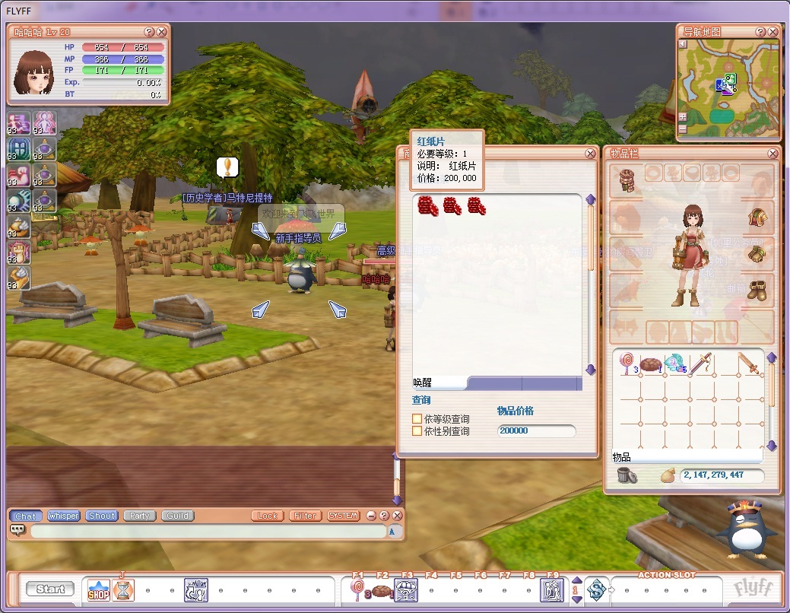

红纸片商城编辑方法

MaFl_Waforu //??? ?? ???

{

setting

{

AddMenu( MMI_DIALOG );

AddMenu( MMI_TRADE );

SetVenderType(1);

AddVenderItem2(0, II_SYS_SYS_SCR_BXMKNT120SET);

AddVenderItem2(0, II_SYS_SYS_SCR_BXMBLA120SET);

AddVenderItem2(0, II_SYS_SYS_SCR_BXFKNT120SET);

AddVenderItem2(0, II_SYS_SYS_SCR_BXFBLA120SET);

AddVenderItem2(1, II_SYS_SYS_SCR_BXMRIN120SET);

AddVenderItem2(1, II_SYS_SYS_SCR_BXMBIL120SET);

AddVenderItem2(1, II_SYS_SYS_SCR_BXFRIN120SET);

AddVenderItem2(1, II_SYS_SYS_SCR_BXFBIL120SET);

AddVenderItem2(2, II_SYS_SYS_SCR_BXMJST120SET);

AddVenderItem2(2, II_SYS_SYS_SCR_BXMRAG120SET);

AddVenderItem2(2, II_SYS_SYS_SCR_BXFJST120SET);

AddVenderItem2(2, II_SYS_SYS_SCR_BXFRAG120SET);

AddVenderItem2(3, II_SYS_SYS_SCR_BXMPSY120SET);

AddVenderItem2(3, II_SYS_SYS_SCR_BXMELE120SET);

AddVenderItem2(3, II_SYS_SYS_SCR_BXFPSY120SET);

AddVenderItem2(3, II_SYS_SYS_SCR_BXFELE120SET);

//SetMusic();

SetImage

(

IDS_CHARACTER_INC_000696

);

m_szDialog= "MaFl_Waforu.txt";

}

SetName

(

IDS_CHARACTER_INC_000697

);

AddVendorSlot( 0,

IDS_CHARACTER_INC_000231

);

AddVendorSlot( 1,

IDS_CHARACTER_INC_000232

);

AddVendorSlot( 2,

IDS_CHARACTER_INC_000233

);

AddVendorSlot( 3,

IDS_CHARACTER_INC_000234

);

}

与普通商店一样要添加AddMenu( MMI_TRADE );

兑换商店必须加上SetVenderType(1);参数固定是1.

AddVendorSlot( 0,

IDS_CHARACTER_INC_000231

);

的作用跟普通商店一样

AddVenderItem2(0, II_SYS_SYS_SCR_BXMKNT120SET);

第一个参数是页签编号，第二个参数是兑换物品id，需要红纸片的数量配置在propItem.txt中的dwReferValue1列。