Job Pack Assistant × ICB MES
Integration Investigation & Architecture Recommendation
Item | Detail
Document type | BA Investigation & Architecture Recommendation
Author | Senior Business Analyst / Solution Architect (Claude, on behalf of Michael)
Date | 5 July 2026
Status | Draft v0.1 — pending Discovery inputs from Simeon (see Open Questions Register)
Audience | Business users, BAs, and Claude Code Agents. Written in plain English.
Maintained source | docs/job-pack/JOB_PACK_INTEGRATION_INVESTIGATION.md in the icb-platform repo (this Word copy is for circulation; the Markdown version has live diagrams)
Naming convention: Simeon's solution is called the Job Pack Assistant throughout. The Manufacturing Execution System is the MES.

Contents

In Word: right-click the table and choose Update Field to fill in page numbers.

1. Executive Summary
Summary. Simeon (Production Planner and SME) has built a valuable AI-assisted tool on his laptop using Claude Code. From observation, it assembles Job Packs (collating job documents, drawings and supporting paperwork for a production job) and finds/organises manufacturing drawings. It exists only on his laptop, is not in Git, and is evolving weekly. The MES (v1.40.0, Phase 1 live) has no knowledge of it today.
Recommendation. A staged hybrid (Option 5, delivered via the Graduation Model):
- Protect first — get the Job Pack Assistant into its own private GitHub repository this week. Urgent regardless of any integration decision.
- Understand second — run Discovery on the real code and prompts (questionnaire + packaged copy).
- Connect through a contract, not a merger — the two systems agree on a small, stable contract: a shared document location, a naming standard keyed on job number, and (later) one or two simple read-only data feeds from the MES.
- Graduate stable features over time — once a Job Pack function is repeatable and no longer changing, Code Agents turn it into a small service the MES can call with a button. Simeon keeps innovating upstream in Claude Code, unblocked.
Reason. This is the only approach that scores well on all seven of ICB's stated goals at once: it removes the laptop single-point-of-failure immediately, keeps Simeon as owner and SME without slowing him down, never couples the fast-moving experimental tool to MES release discipline, and gives Code Agents a clean, well-defined seam to build against.
Next step. Send Simeon the packaging instructions, create the icb-jobpack private repository, and get answers to the top open questions in Section 11.

The one-paragraph analogy
The Job Pack Assistant today is a skilled craftsman with a well-organised toolbox, not a vending machine. Simeon sits down, talks to Claude Code, and excellent Job Packs come out — but there is no button anyone else can press. Integrating it into the MES therefore does NOT mean bolting the toolbox onto the MES. It means: (a) making sure the toolbox can't be lost (Git), (b) agreeing which shelf the finished work goes on so the MES can always find it (shared document store + naming standard), and (c) over time, turning the most repeatable jobs into vending-machine buttons (small services) — while the craftsman keeps inventing new tools.

2. Phase 1 — Discovery
Discovery is partially complete. This section separates what we know (with evidence) from what we assume (flagged) and what we must ask (Section 11). Nothing is guessed silently — every assumption is labelled. Items marked * in figures are assumptions to verify.

2.1 What we know (confirmed facts)
# | Fact | Evidence
F1 | The Job Pack Assistant assembles Job Packs — collates job documents, drawings and supporting paperwork into a complete pack for a production job | Directly observed by Michael
F2 | It finds and organises manufacturing drawings for a job | Directly observed by Michael
F3 | Simeon operates it by typing into Claude Code — no separate app or screen | Directly observed by Michael
F4 | The code/prompts exist only on Simeon's laptop; not in GitHub; actively evolving | Assignment brief
F5 | Simeon is the business owner and primary SME and intends to keep enhancing it | Assignment brief
F6 | The MES repo contains no trace of the Job Pack Assistant — no docs, handoffs or code references | Repo-wide search, 5 Jul 2026
F7 | The MES already provisions an ANTHROPIC_API_KEY and a FILE_STORE setting in its environment config | backend/.env.example; README
F8 | The MES is a FastAPI + React system on an on-prem server (192.168.0.251), PostgreSQL 16, with an established ADR governance practice | README; docs/adr/
F9 | Simeon is already an MES user (Materials/Planning/Stores role) and receives all pre-job CC emails | README
Why F3 matters most. Because Simeon types into Claude Code, the Job Pack Assistant is best understood as a workflow: instruction files (e.g. CLAUDE.md), possibly skills, helper scripts, prompts and folder conventions — with Claude Code as the engine. There is very likely no callable program the MES could invoke today. This single fact rules out any “just call it via API” quick win and shapes every option in Section 4.

2.2 Business view (what problem it solves)
A Job Pack is the bundle of paperwork the shop floor needs to build one job: job card, manufacturing drawings, bill of materials, specifications, and quality/inspection sheets. At ICB (refrigerated truck bodies) a pack plausibly includes chassis details, body drawings, insulation specs, fridge-unit documentation, the signed pre-job card and QC checklists — to be confirmed (Q1–Q4).
Question | Current answer | Confidence
What problem does it solve? | Manual, slow, error-prone assembly of Job Packs and hunting for the right drawing revisions | Assumed — confirm Q1
Who uses it? | Simeon only (possibly outputs used by production floor) | Assumed — confirm Q2
How often? | Unknown — plausibly per production job | Ask — Q3
Which processes depend on it? | Likely the handoff from Planning to Production (after Pre-Job Confirmed) | Assumed — confirm Q4
Business value | Time saved per pack; fewer wrong-drawing errors on the floor; captured SME knowledge | Quantify — Q5

2.3 Functional view
Confirmed: Job Pack assembly (F1) and drawing finding/organising (F2). Not yet confirmed: whether it also extracts data from drawings/PDFs, answers questions about documents, generates new documents (cover sheets, checklists), or handles revisions (Q6–Q9).

2.4 Technical view (high level only)
Item | Status
Programming language | Unknown — likely Python and/or shell scripts orchestrated by Claude Code (Q10)
Framework | Likely none — Claude Code is the runtime; confirm from packaged copy
Folder structure | Unknown — visible in packaged copy
Local storage / database | Unknown — likely plain folders; any database would be significant (Q11)
External libraries | Unknown — visible in packaged copy
Claude prompts / instructions | Almost certainly the core intellectual property — CLAUDE.md, skills, prompt files (Q12)
AI workflow | Interactive: Simeon converses with Claude Code per job (Q13)
Configuration / dependencies | Claude Code subscription on Simeon's laptop; local file access (Q14)
Key BA point: in this solution, the prompts ARE the business logic. They encode Simeon's tribal knowledge about what a correct Job Pack contains. Versioning and protecting the prompts matters as much as protecting any code.

2.5 Document management view
All unknown — this is the highest-value Discovery area, because documents are where the two systems will first meet. Questions Q15–Q21 cover: where documents and drawings live today, file formats, naming standards, how drawing revisions are managed, relationships between files, and where finished packs are stored. Loose business files in the MES repo (MRP, Truck Register, Inventory workbooks) suggest ICB documents currently live in scattered locations — reinforcing the need for one agreed document home.

2.6 Ownership and governance model (recommended)
Asset | Owner | Notes
Business process (pack content & correctness) | Simeon | He is SME; this must not change
Documents & drawings (masters) | ICB (business) | Today effectively Simeon's laptop — must move to a shared, backed-up location
AI prompts / skills / instructions | Simeon (author), in icb-jobpack repo | Versioned in Git; Michael as repo admin for continuity
Source code (helper scripts) | Simeon (author), with Code Agent help | Same repo
Integration contract | Michael (BA lead); changes agreed by both sides | Small, documented, versioned
Graduated Job Pack services (future) | MES team / Code Agents; business rules still owned by Simeon | Simeon signs off behaviour; Code Agents own the code
Future enhancements | Simeon proposes and builds; contract-crossing changes need Michael's agreement | Keeps Simeon fast AND the MES safe
Governance principles (plain English):
- Simeon's repo is his workshop. He can change anything, any time, without asking — as long as the contract (document location, naming standard, data feed formats) is honoured.
- The contract is the only thing the MES depends on. The MES never reads Simeon's prompts, never calls his scripts directly, never assumes his folder layout.
- Contract changes are rare and deliberate — agreed between Simeon and Michael, written down, versioned (same discipline as the MES's existing ADR practice).
- A bus-factor rule: at least Michael (admin) has repo access, and packs must be reproducible from the repo + documented steps — not only from Simeon's memory.

3. Phase 2 — Current (As-Is) Workflow
Based on observed facts F1–F3 plus stated context. Steps marked * are assumptions to verify with Simeon.
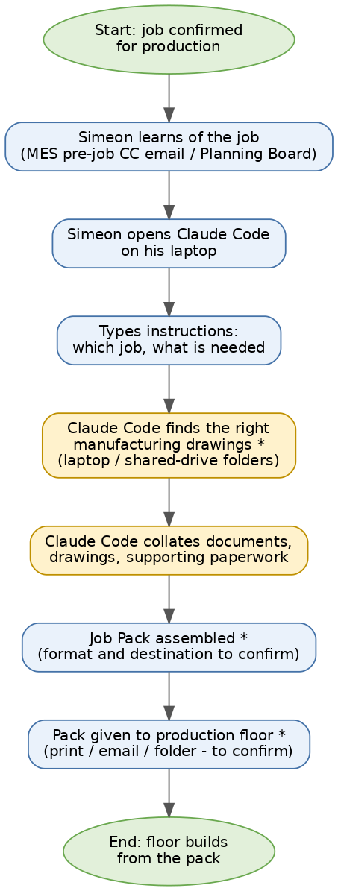
Figure 1 — As-Is workflow: how a Job Pack is produced today
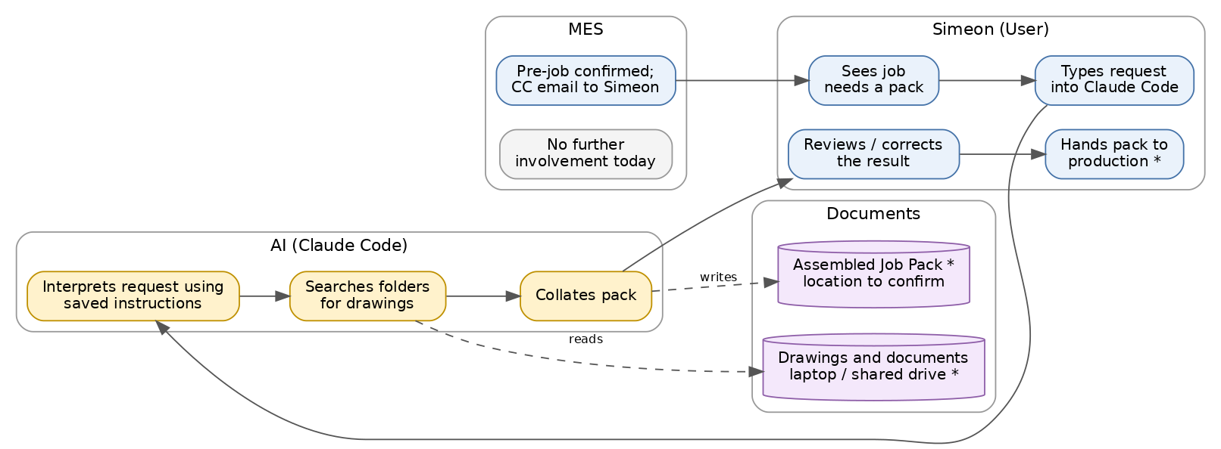
Figure 2 — As-Is swim-lanes: User / AI / Documents / MES
What the swim-lanes reveal: the MES's involvement ends at the CC email; the Job Pack world is invisible to it. There is no shared document location, no link from an MES job to its pack, and everything after Pre-Job Confirmed depends on one person and one laptop.

3.1 As-Is pain points (BA assessment)
# | Pain point | Impact
P1 | Whole capability lives on one laptop — theft, failure or Simeon's absence stops it | Critical
P2 | No version control — an accidental prompt edit can silently break pack quality, with no way back | High
P3 | MES and Job Pack are blind to each other — job data likely retyped*; MES cannot show pack status | High
P4 | Tribal knowledge is now encoded in prompts nobody else has read | High
P5 | No agreed naming/storage standard for drawings and packs — consistency risk as ICB scales | Medium

4. Phase 3 — Integration Options
Six options were evaluated objectively. Ratings: Good / Workable / Poor.

Option 1 — Keep fully independent; MES just links to it
Aspect | Assessment
Advantages | Zero effort; zero disruption to Simeon; nothing to build
Disadvantages | Fixes none of the pain points P1–P5; laptop risk remains; no data sharing; MES stays blind
Cost / Risk / Maintenance | Cost: none. Risk: HIGH — the status quo IS the risk. Maintenance: none
Scalability / future development | Poor — one person, one laptop; nobody else can build on it
Ease for Simeon / for Code Agents | Simeon: perfect. Code Agents: nothing to work with

Option 2 — MES calls the Job Pack Assistant through an API
Aspect | Assessment
Advantages | Best end-user experience; pack status visible in MES
Disadvantages | NOT POSSIBLE TODAY — there is no API to call (fact F3). Claude Code is an interactive tool on a laptop, not a server. Would require converting the whole solution into a service first — a big-bang rebuild while it is still changing weekly
Cost / Risk / Maintenance | Cost: high (a rebuild disguised as an integration). Risk: high — rebuilding a moving target. Maintenance: high
Scalability / future development | Good once it exists, but every Simeon experiment would then need deployment discipline
Ease for Simeon / for Code Agents | Simeon: poor — loses his conversational workflow. Code Agents: clear target but unstable requirements
Verdict: right destination for SOME functions, wrong first move. This becomes the end state of the Graduation Model, not the starting point.

Option 3 — Convert the whole solution into a shared service
Same fundamental problem as Option 2 — a full conversion of an actively-evolving, prompt-driven workflow — plus one more: an AI-conversation workflow (“look at this odd job, use judgement”) does not convert cleanly into a fixed service. The parts that DO convert cleanly are the repeatable ones — which is exactly what the Graduation Model harvests gradually. Cost: high. Risk: high. Ease for Simeon: poor.

Option 4 — Embed all functionality directly into the MES
Aspect | Assessment
Advantages | One system, one repo, one deploy; deepest possible integration
Disadvantages | Simeon stops iterating independently — every prompt tweak becomes an MES release; couples ICB's most experimental work to its most disciplined codebase; contradicts the stated goal (“the goal is not simply to merge Simeon's work into the MES”)
Cost / Risk / Maintenance | Highest on all three — and slows both systems
Ease for Simeon / for Code Agents | Simeon: worst option for him. Code Agents: familiar repo but constant churn from prompt changes

Option 5 — Hybrid: independent evolution + narrow agreed interfaces (RECOMMENDED)
Simeon's solution keeps evolving independently in its own repo. The two systems meet only at a small, stable contract:
- A shared document store — packs and drawings live in an agreed server location (the MES already has a FILE_STORE concept), not on a laptop.
- A naming standard — everything keyed on the MES job number, so either system can find any job's documents.
- (Later) one or two data feeds — the Assistant reads job details from the MES's existing read-only APIs instead of retyping; the MES shows a link/status for the pack.
Aspect | Assessment
Advantages | Fixes P1–P5 in stages; Simeon keeps full speed; MES gets reliability; smallest thing that can possibly work at each step
Disadvantages | Two repos to administer; light discipline around the contract; MES sees the pack via files/links before it gets a true API
Cost / Risk / Maintenance | Cost: low, spread over phases. Risk: low — each step small and reversible. Maintenance: low — contract is tiny by design
Scalability / future development | Grows via graduation; both sides unblocked
Ease for Simeon / for Code Agents | Simeon: keeps his exact workflow, gains a safety net. Code Agents: clean seam, clear small work packages

Option 6 — The Graduation Model (Option 5 + a growth path)
Option 5 answers “how do they coexist?” but not “how does this scale beyond Simeon?”. Option 6 adds the growth path: stable features graduate. When a Job Pack function has stopped changing and is demonstrably repeatable, Code Agents extract it into a small Job Pack service on the MES server, with an MES button in front of it. Simeon's Claude Code workshop remains the R&D lab for everything not yet stable. This is not a seventh architecture — it is Option 5 with a decision rule for when Option 2/3 thinking becomes appropriate, feature by feature. It is the recommended overall approach.

4.1 Options comparison summary
Criterion | 1 Indep. | 2 API now | 3 Service | 4 Embed | 5/6 Hybrid
Cost | Good | Poor | Poor | Poor | Good
Risk | Poor | Poor | Poor | Poor | Good
Maintenance | Good | Poor | Poor | Poor | Good
Scalability | Poor | Good | Workable | Good | Workable, then Good
Future development | Workable | Poor | Poor | Workable | Good
Ease for Simeon | Good | Poor | Poor | Poor | Good
Ease for Code Agents | Poor | Workable | Workable | Workable | Good
Fixes laptop risk (P1) | No | Yes | Yes | Yes | Yes
Recommendation | No | Not yet | No | No | YES

5. Phase 4 — GitHub Strategy

5.1 The urgent part (independent of any architecture decision)
The Job Pack Assistant must be in Git THIS WEEK. Every day it exists only on one laptop, ICB risks losing a business capability to a coffee spill. This step commits nobody to anything — it is insurance.

5.2 Repository options
Option | Pros | Cons | Recommendation
A. Own private repo (icb-jobpack) | Simeon works freely without MES rules (CI, reviews, release tags); clear ownership; small and understandable; Code Agents can be pointed at it in isolation | Second repo to administer; cross-repo contract doc needed | RECOMMENDED
B. Folder inside icb-platform (monorepo) | One repo, one place to look | Daily experiments inside a production codebase with CI and branch protection — friction for Simeon, noise for the MES; blurs ownership; violates the “don't merge” goal | No
C. Git submodule | Version pinning of one repo inside another | Notoriously confusing even for engineers; ICB's maintainers are BAs and business users; the MES needs Simeon's OUTPUTS, not his code — nothing to pin | No
D. Two repos + a written contract | All benefits of A, plus an explicit versioned statement of how the systems meet | The contract must be kept current (it is one short document) | RECOMMENDED (A + D together)
Plain-English reason: repositories should split where ownership and pace of change split. Simeon changes things daily and owns his workshop; the MES changes through releases and is owned by the platform team. Same building, different rooms, one shared corridor (the contract).

5.3 Release and compatibility management
- icb-jobpack releases: lightweight. Simeon works on main; known-good states get a tag (e.g. jobpack-v0.3). No CI required initially; Code Agents can add simple checks later.
- Compatibility: the MES never depends on icb-jobpack code, so there is no version coupling in code. The only shared artefact is the contract document (INTEGRATION_CONTRACT.md, in both repos), versioned v1, v2… Any change to locations, naming or feeds increments the version and needs both Simeon's and Michael's agreement.
- Graduated services (later) live in the MES repo and follow normal MES release discipline — because by definition they have stopped changing quickly.
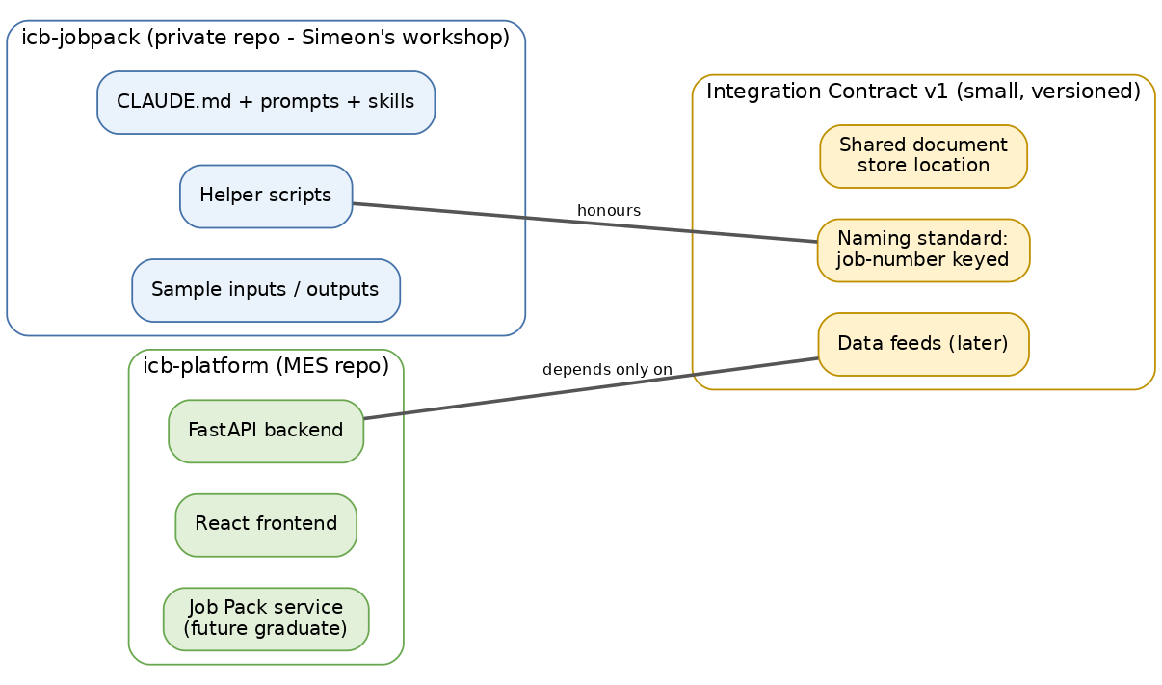
Figure 3 — Two repositories meeting only at a small versioned contract

6. Phase 5 — Future Development Model
Two workflows will coexist, deliberately — they serve different kinds of change.
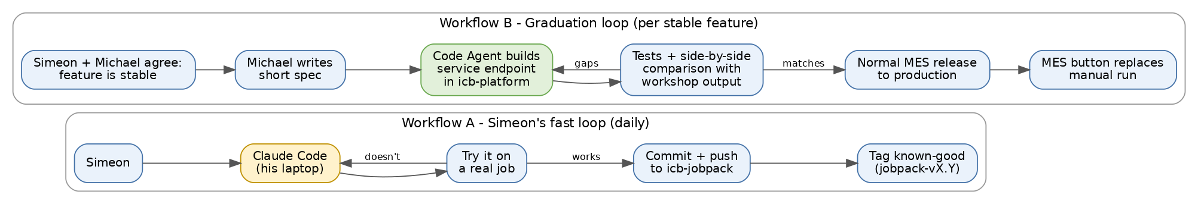
Figure 4 — Workflow A (Simeon's daily loop) and Workflow B (graduation per stable feature)
Workflow A — Simeon's fast loop (daily). What changes for Simeon: ONE habit — push to GitHub at the end of a session. Claude Code can do the commit and push for him when he asks; it becomes part of the conversation (“save today's work”).
Workflow B — Graduation loop (occasional). Simeon and Michael agree a feature is stable; Michael writes a short spec; a Code Agent builds it as a Job Pack service endpoint in icb-platform; output is compared side-by-side with Simeon's workshop version; on a match it ships in a normal MES release and an MES button replaces the manual run for that feature.
Workflow C — Contract change (rare). Either side needs a change (new folder, feed or naming) → Simeon and Michael discuss → contract updated and version bumped → both sides adjust, Code Agents assisting.

Division of labour
- Simeon: owns pack correctness, invents improvements, pushes his repo, flags features ready to graduate.
- Michael (BA): owns the contract, writes graduation specs, prioritises the roadmap.
- Claude Code Agents: package/repo setup, discovery on the code, building graduated services, tests, MES UI links.
- MES team process: normal releases for anything that lands in icb-platform.

7. Phase 6 — Recommended (To-Be) Architecture
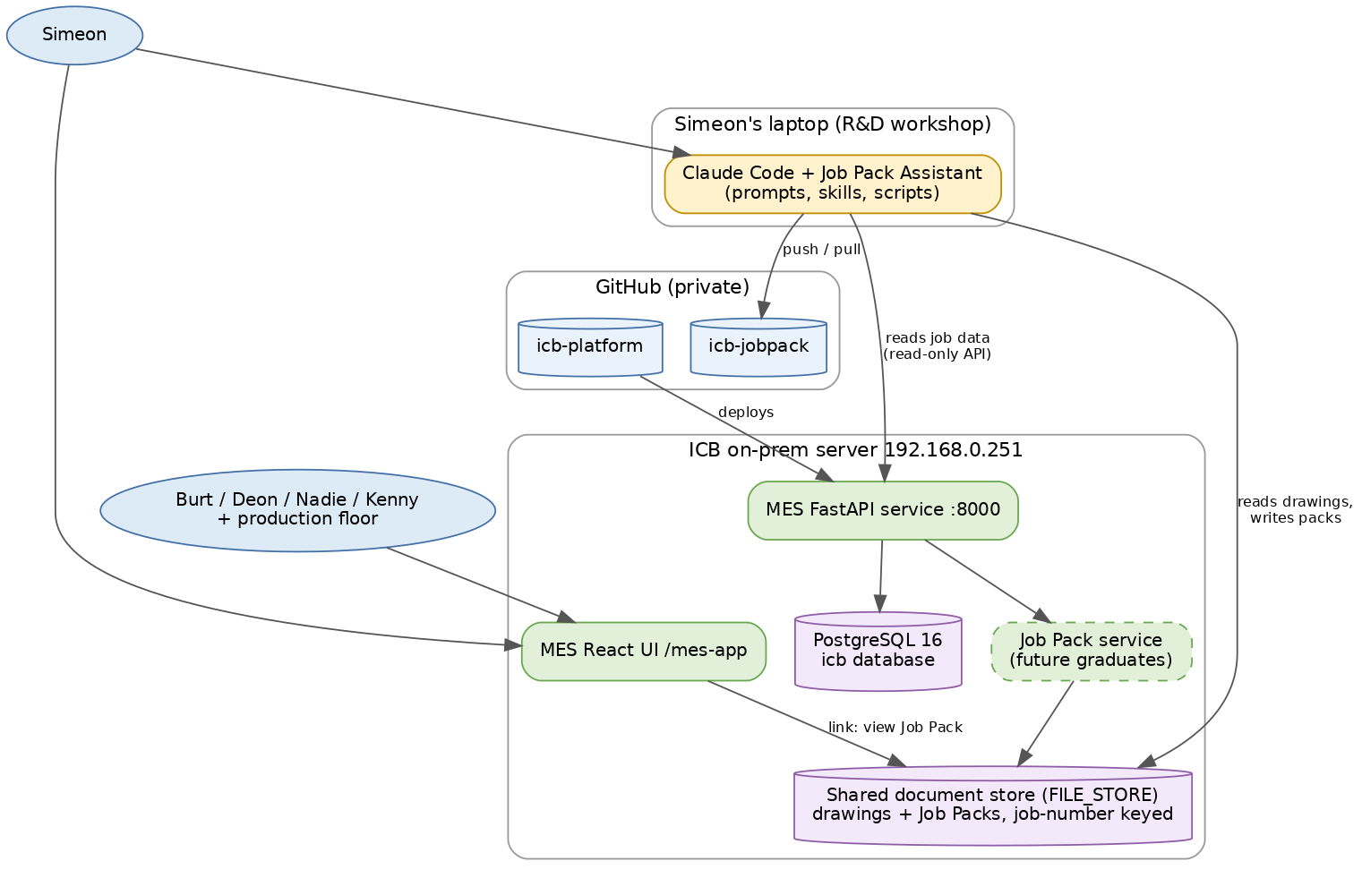
Figure 5 — To-Be system architecture
Figure 6 — Data flow at first integration: job data flows down, pack links flow back
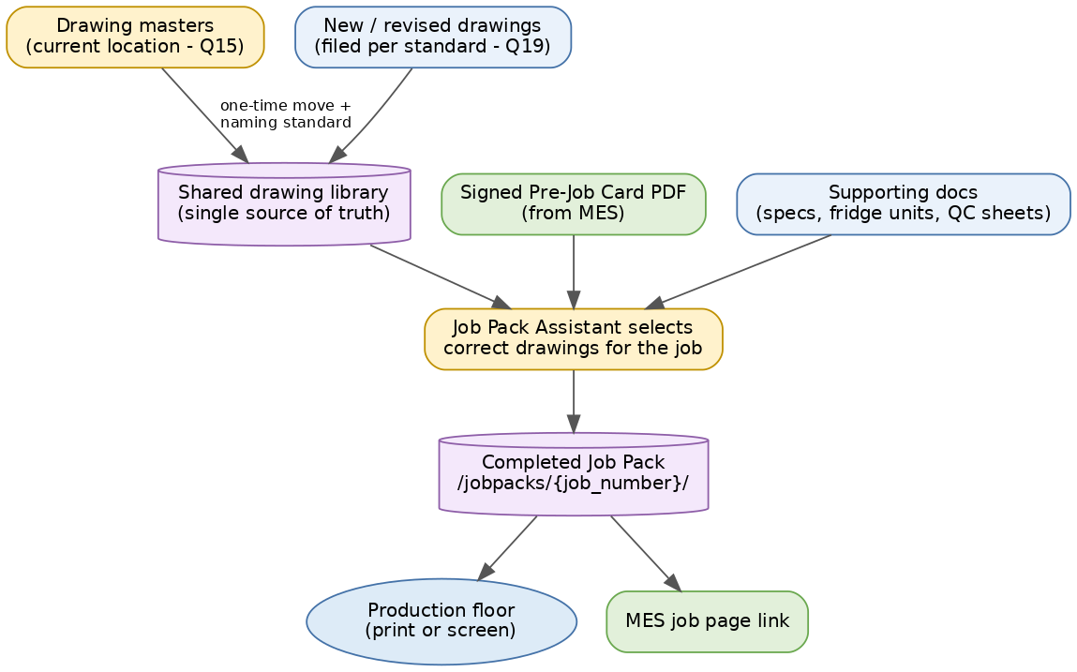
Figure 7 — Document flow: one drawing library, packs keyed by job number

7.1 AI interaction (per pack)
- Simeon: “Build the pack for job 2026-114”
- Claude Code calls the MES read-only API → job details, body spec, chassis
- Claude Code searches the shared drawing library → matching drawings, correct revisions
- Claude Code applies Simeon's rules (prompts/skills) and writes the assembled pack to /jobpacks/2026-114/
- Claude Code reports: “Pack ready — 14 documents, 2 warnings”; Simeon reviews, corrects, approves

7.2 Deployment (high level)
Note the asymmetry — it is intentional. icb-jobpack deploys nowhere; it is a safety net and collaboration point. Only graduated features enter the deployment pipeline, via the MES repo (tagged release, runbook deploy to the on-prem server).

8. Phase 7 — Risks and Mitigations
# | Risk | L | I | Mitigation | Phase
R1 | Single point of failure — laptop lost/broken, capability gone | M | Crit | Private GitHub repo + shared document store; packs reproducible from repo | 0
R2 | Knowledge loss — Simeon unavailable; nobody else can produce packs | M | Crit | Prompts versioned in Git; Discovery documents the workflow; graduated features run without him | 0–2, 4
R3 | Local-only development — improvements never leave the laptop | H | H | The one-habit change: push at end of session; Michael monitors repo activity | 0
R4 | Version conflicts — pack built with old job data or old prompt logic | M | M | Job data pulled live from MES API (no retyping); known-good tags; contract versioning | 3–4
R5 | Document consistency — two copies of drawings drift apart | H | H | One shared drawing library as single source of truth; naming standard; laptop copies are caches, never masters | 2
R6 | AI prompt management — prompts are business logic but invisible/unversioned | H | H | Prompts live in the repo; changes visible in Git history; known-good tags allow rollback | 0
R7 | Security — customer/job data through AI tooling; API keys on a laptop | M | M | Private repos; .gitignore secrets from day one; keys via env not files; read-only MES account for the assistant; ICB network/VPN only | 0, 3
R8 | Future maintainability — workshop grows into an unmaintainable tangle | M | M | Graduation discipline: business-critical things get rebuilt clean by Code Agents with tests; workshop stays experimental by definition | 4
R9 | Integration drag — contract becomes heavyweight and slows Simeon | L | M | Contract deliberately tiny (location + naming + feeds); Michael guards its size | —
R10 | MES over-dependence too early — MES relies on packs before process is stable | L | M | MES shows links/status only (informational) until a feature graduates with tests | 3–4
L = likelihood, I = impact (H high, M medium, L low, Crit critical). Phase = roadmap phase that addresses it.

9. Phase 8 — Implementation Roadmap
Figure 8 — Five-phase roadmap

Phase 0 — Protect (this week)
Item | Detail
Objectives | Remove the laptop single-point-of-failure
Deliverables | Packaged copy of the project (see packaging instructions); private icb-jobpack repo with code/prompts pushed; secrets excluded; Michael as second admin
Business value | Insurance for an existing business capability — highest value-to-effort step in this whole plan
Dependencies | Simeon's 30–60 minutes; GitHub organisation access (Q22)
Complexity | Low
Code Agent involvement | Low — help Simeon package, create repo, write .gitignore, first push

Phase 1 — Discover (weeks 1–2)
Item | Detail
Objectives | Replace the assumptions in this report with facts
Deliverables | Completed questionnaire; Code Agent inventory of the repo (what exists, what it does, plain-English summary); updated As-Is workflow; v1.0 of this report
Business value | Informed decisions; captured tribal knowledge
Dependencies | Phase 0; Simeon interview (~1 hour)
Complexity | Low–Medium
Code Agent involvement | Medium — read the packaged code and produce the inventory

Phase 2 — Shared document standard (weeks 2–4)
Item | Detail
Objectives | One agreed home for drawings and packs; naming standard keyed on job number
Deliverables | Integration Contract v1; drawing library on the ICB server/share; migration of masters; Simeon's tool re-pointed at the shared store
Business value | Ends document drift (R5); makes packs findable by anyone; prerequisite for everything after
Dependencies | Phase 1 (current locations/formats — Q15–Q21); server storage decision with Marnus (Q23)
Complexity | Medium (mostly agreement, some file moving)
Code Agent involvement | Medium — folder structure, migration scripts, updating Simeon's prompts/scripts to new paths

Phase 3 — First integration: links and data (weeks 4–6)
Item | Detail
Objectives | Stop retyping job data; make packs visible from the MES
Deliverables | Assistant reads job details from existing MES read-only APIs (/api/production-jobs); MES job detail page shows a Job Pack link and simple ready/not-ready status; read-only MES account for the assistant
Business value | Fewer transcription errors; production floor and office see pack status without asking Simeon
Dependencies | Phase 2; small MES change (one link/status field)
Complexity | Medium
Code Agent involvement | High — MES UI/API work is theirs; plus wiring the assistant's data fetch

Phase 4 — Graduation (ongoing, feature by feature)
Item | Detail
Objectives | Turn stable, repeatable functions into MES-callable services with tests
Deliverables | Per feature: short spec → Job Pack service endpoint in icb-platform → side-by-side output comparison with Simeon's version → MES button
Business value | Pack assembly works even without Simeon at the keyboard; scales to more jobs/branches; quality locked in by tests
Dependencies | Phase 3; per-feature stability agreement (Simeon + Michael)
Complexity | Medium–High per feature
Code Agent involvement | Very high — they build, test and maintain each graduated service

10. Final Recommendation
Adopt Option 5/6 — the Hybrid with Graduation Model — delivered through the five-phase roadmap above.
Criterion | How this approach delivers
Simplicity | Each step is small; the only new concept is a one-page contract
Maintainability | Fast-changing things stay in the workshop; slow-changing things get tests and releases; nothing is coupled that shouldn't be
Scalability | Graduated services scale beyond one person; the workshop keeps feeding them
Ease of use | Simeon's daily experience unchanged plus one push habit; other users get MES buttons/links, no new tools
Long-term business value | Tribal knowledge captured in Git; capability survives people and laptops; MES becomes the single pane of glass
Supportability by Code Agents | Clean seam, small specs, two well-defined repos — ideal Code Agent work packages
Simeon stays SME, MES not slowed | The core design goal: his repo is his workshop, the MES depends only on the contract
Trade-offs accepted, stated plainly:
- Two repositories instead of one — mild admin overhead, in exchange for decoupled speed.
- The MES's view of packs is shallow at first (a link and a status, not deep data) — in exchange for not rebuilding a moving target.
- Graduation takes discipline — someone (Michael) must keep judging what is stable enough to graduate; skipping this judgement is how workshops become unmaintainable production systems.
- Some duplication during transition — while a feature graduates, Simeon's version and the service version briefly coexist; the side-by-side comparison is the safety mechanism, then the manual version retires.
What we explicitly rejected and why: merging into the MES (kills Simeon's speed, contradicts the brief), an immediate API conversion (nothing callable exists — fact F3), submodules (complexity without benefit for a business-user team), and doing nothing (the laptop is the risk).

11. Phase 9 — Open Questions Register
No question below has been silently assumed. Where the report needed a working assumption, it is marked * in figures and 'Assumed' in tables, and traced here. Phase 0 (Protect) needs only Q12/Q14/Q22 and should not wait for the rest.
# | Question | Why it matters | Ask | Blocks
Q1 | What exactly does a finished ICB Job Pack contain (document list)? | Defines scope, contract content, graduation specs | Simeon | Ph 2
Q2 | Who consumes the packs — floor supervisors, QC, stores? Printed or on-screen? | Output format and MES link design | Simeon | Ph 3
Q3 | How often is a pack produced; how long with/without the assistant? | Quantifies business value; prioritises graduation | Simeon | Ph 1
Q4 | At what exact MES workflow point is a pack needed (Pre-Job Confirmed? Scheduled? Chassis received?) | Placement of the MES link/status and future trigger | Simeon + Deon | Ph 3
Q5 | What goes wrong when a pack is wrong? Examples? | Business case evidence; QC checks for graduated services | Simeon | Ph 1
Q6 | Does it extract data from drawings/PDFs (dimensions, part numbers)? | Distinct capability with its own graduation path | Simeon | Ph 1
Q7 | Does it answer plain-English questions over documents? | Ditto | Simeon | Ph 1
Q8 | Does it generate new documents (cover sheets, checklists)? | Ditto | Simeon | Ph 1
Q9 | How are drawing revisions handled — how does it know which revision is current? | Highest-risk quality question in the whole process | Simeon | Ph 2
Q10 | What is in the project folder — scripts, in what language? | Sizing Code Agent discovery work | Packaged copy | Ph 1
Q11 | Any local database or index, or plain folders? | Migration complexity to shared store | Packaged copy | Ph 2
Q12 | Where do prompts/instructions live (CLAUDE.md, skills, other)? | The core IP to version and protect | Packaged copy | Ph 0
Q13 | Fresh conversation per pack, or saved commands/skills re-run? | Separates repeatable (graduatable) parts from judgement parts | Simeon | Ph 4
Q14 | Which Claude Code plan/account? Any MCPs/extensions installed? | Licensing, security, reproducibility on a second machine | Simeon | Ph 0
Q15 | Where do drawing masters live today (laptop, shared drive, both)? | Single-source-of-truth design | Simeon | Ph 2
Q16 | File formats in play (PDF, DWG, XLSX, images)? | Storage and viewer decisions; MES link behaviour | Simeon | Ph 2
Q17 | Current naming convention for drawings and packs, if any? | Contract naming standard starts from current practice | Simeon | Ph 2
Q18 | Where do finished packs go today; are old packs kept? | History/audit requirements for the shared store | Simeon | Ph 2
Q19 | Who files new/revised drawings; how do they reach Simeon? | Upstream process for the drawing library | Simeon + eng. | Ph 2
Q20 | Any customer-confidential documents needing restrictions? | Shared-store permissions design | Simeon + Michael | Ph 2
Q21 | Rough volume: how many drawings/documents in the library? | Storage sizing; migration effort | Simeon | Ph 2
Q22 | Does ICB have a GitHub organisation; who administers it? | Phase 0 mechanics | Michael | Ph 0
Q23 | Server storage available for the shared document store? | Phase 2 infrastructure | Marnus | Ph 2

