# Features

1. Like the LRU algorithm that it always obsolete the old files.(To mark they are COMPLETED)
2. Unlike traditional spool directory, modifying files while they are opened are acceptable.

# How to use

1. put the jar package under the directory ***${FLUME_HOME}/plugins.d,*** and ensure that the file ***bin/flume-ng*** load it.

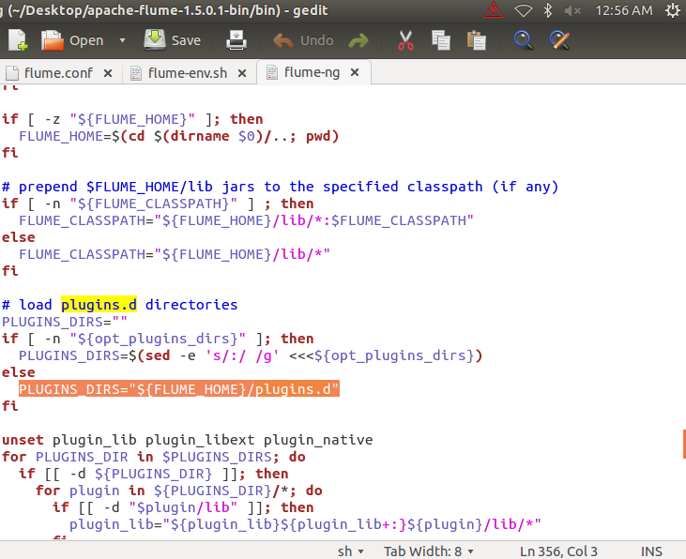

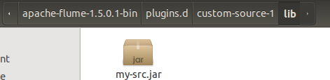

1. Set ***flume.conf*** as follows,

# channel setting

agent1.channels.ch1.type = memory

# source setting

agent1.sources.src-1.type = com.hp.flume.plugins.source.SpoolDirectorySource

agent1.sources.src-1.channels = ch1

agent1.sources.src-1.spoolDir = /home/lucheng/Desktop/httpd-2.4.10/logs

agent1.sources.src-1.fileHeader = true

# sink setting

agent1.sinks.log-sink1.channel = ch1

agent1.sinks.log-sink1.type = logger

#agent setting

agent1.channels = ch1

agent1.sources = src-1

agent1.sinks = log-sink1

1. Start flume.