

**_______________________________**

**Player List**

**Advanced C++/OOP– CSCI4526**

**Benjamin Placzek 00650430 Professor Alice Fischer Computer Science**

**University New Haven**

**3/26/2021**

What am I testing?

CList.cpp CList.hpp and Player unit test

Terminal Output Before Adding the Template:

You can add Players:

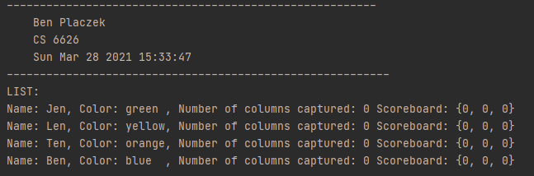

You can remove a Player and the list remains unbroken and functional

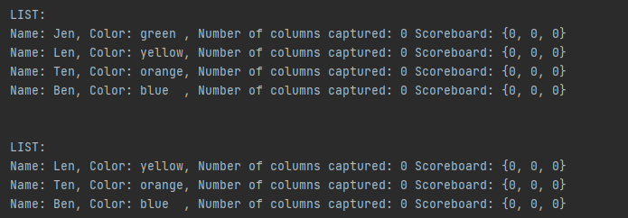

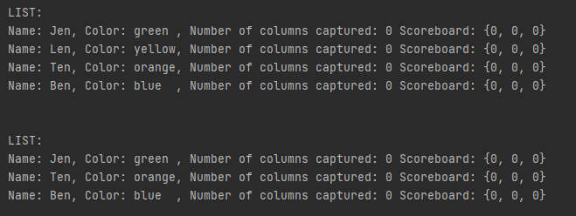

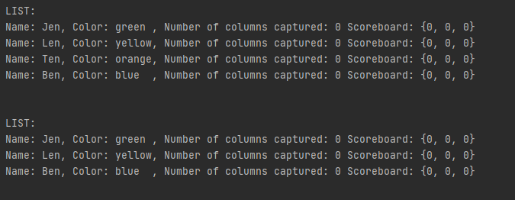

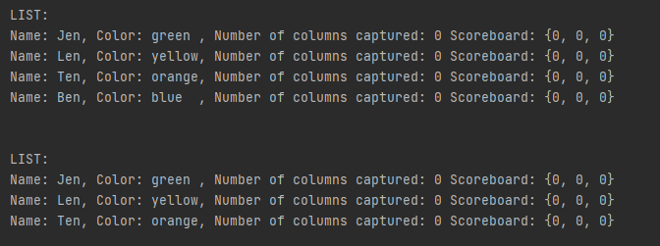

After removing all of the players, you can add Players again.

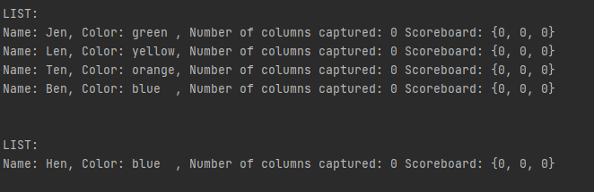

next can progress around the circle and reach the first player again

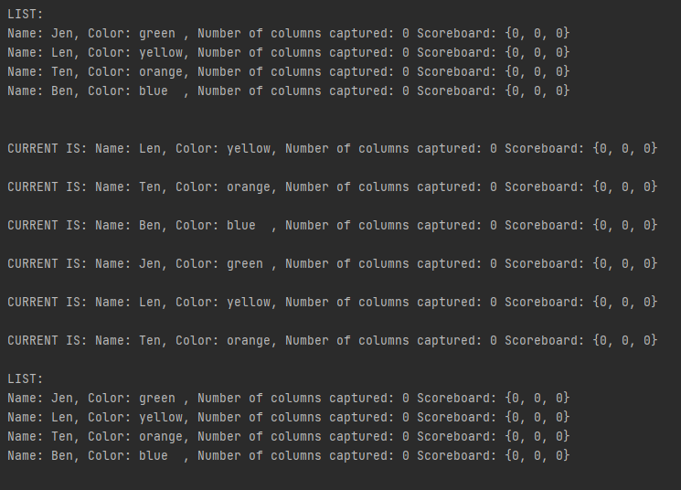

printing empty CList

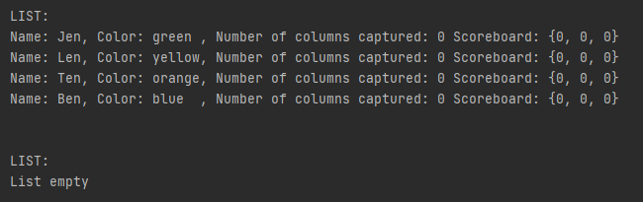

Terminal Output after adding the template: