Git for Beginners

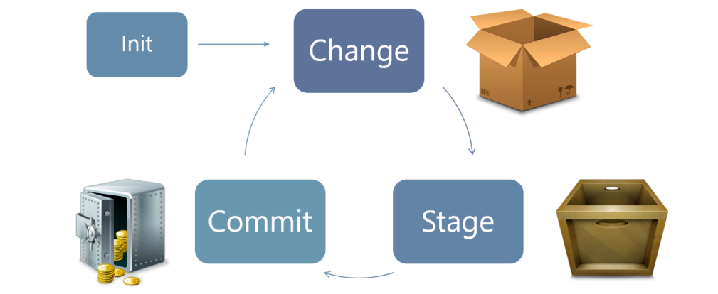

# Installation

Git: [www.git-scm.com/downloads](http://www.git-scm.com/downloads)   
Sublime Text 2: <http://www.sublimetext.com/2>  
GitPad: <https://github.com/github/gitpad>

# Git configuration

$ git config --global user.name “<your name>”  
$ git config --global user.email “<your email address>”  
(MAC and LINUX) $ git config --global --add color.ui true

# Changing Text Editors

(Windows) GitPad: <https://github.com/github/gitpad>  
(Mac) $ git config --global core.editor “open –t –W”  
(Linux) $ git config --global core.editor “<editor of choice>”

# References and resources

Git homepage: <http://git-scm.com/>   
GitHub training: <http://training.github.com/resources/videos/>   
Try Git in browser: <http://try.github.com/>   
Commit messages: <http://who-t.blogspot.sg/2009/12/on-commit-messages.html>  
<http://robots.thoughtbot.com/5-useful-tips-for-a-better-commit-message>  
<http://stackoverflow.com/questions/15324900/standard-to-follow-when-writing-git-commit-messages>  
<http://stackoverflow.com/questions/2530060/can-you-explain-what-git-reset-does-in-plain-english>  
Inner workings of Git: <http://eagain.net/articles/git-for-computer-scientists/>

# Overview

|  |  |  |  |
| --- | --- | --- | --- |
| **BACKUPS** | **MULTIVERSE** | **TIME TRAVEL** | **COLLABORATION** |
| Create Repositories  $ git init | Patch Mode  $ git add –p  $ git commit –p | Move Through Time  $ git checkout | Remote Repositories |
| Add and Track Files $ git add | Multiple Dimensions  $ git branch | Undo Things  $ git revert | Workflow, Revisited |
| Ignore Things gitignore | Move Between Worlds $ git checkout | **Really** Undo Things  $ git reset | Cloning Repositories |
| Save Your Work  $ git commit | Bring Things Together  $ git merge |  | GitHub |
| Commit Messages | Fix Conflicts |  | Push and Pull |
| View History  $ git log |  |  |  |
| See Changes  $ git diff |  |  |  |