DBIM Header & Footer Compliance Report

Detected Branding Regions
Status: VISUAL EVIDENCE
Detected branding elements highlighted with compliance status boxes.
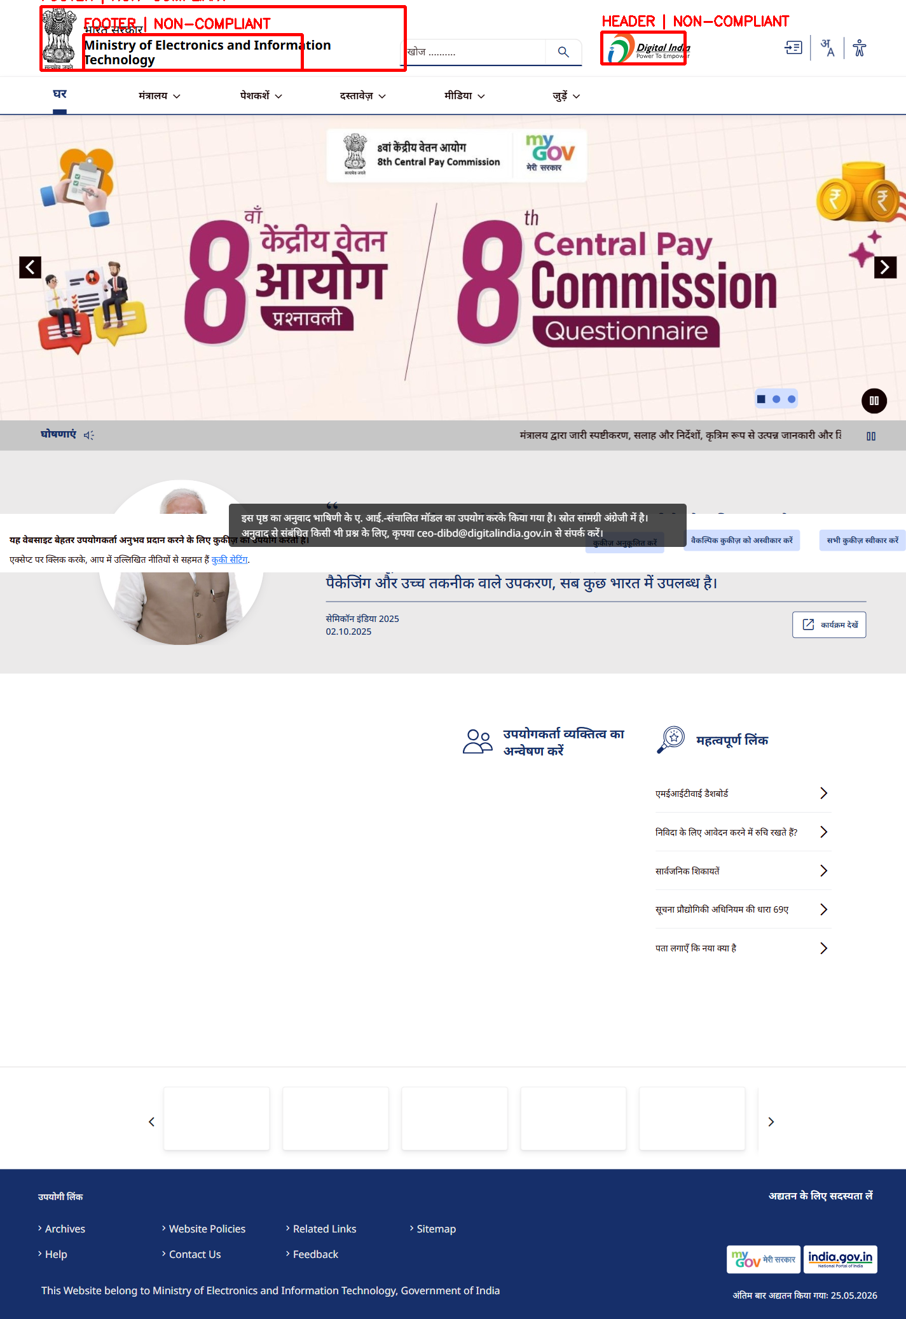

Rule 21 - Website Naming
Status: COMPLIANT
RULE 21: PASSED
Detected website title:
Home | Ministry of Electronics and Information Technology
Detected organization keywords:
ministry
Reason:
The website title clearly
indicates an official government
organization structure.
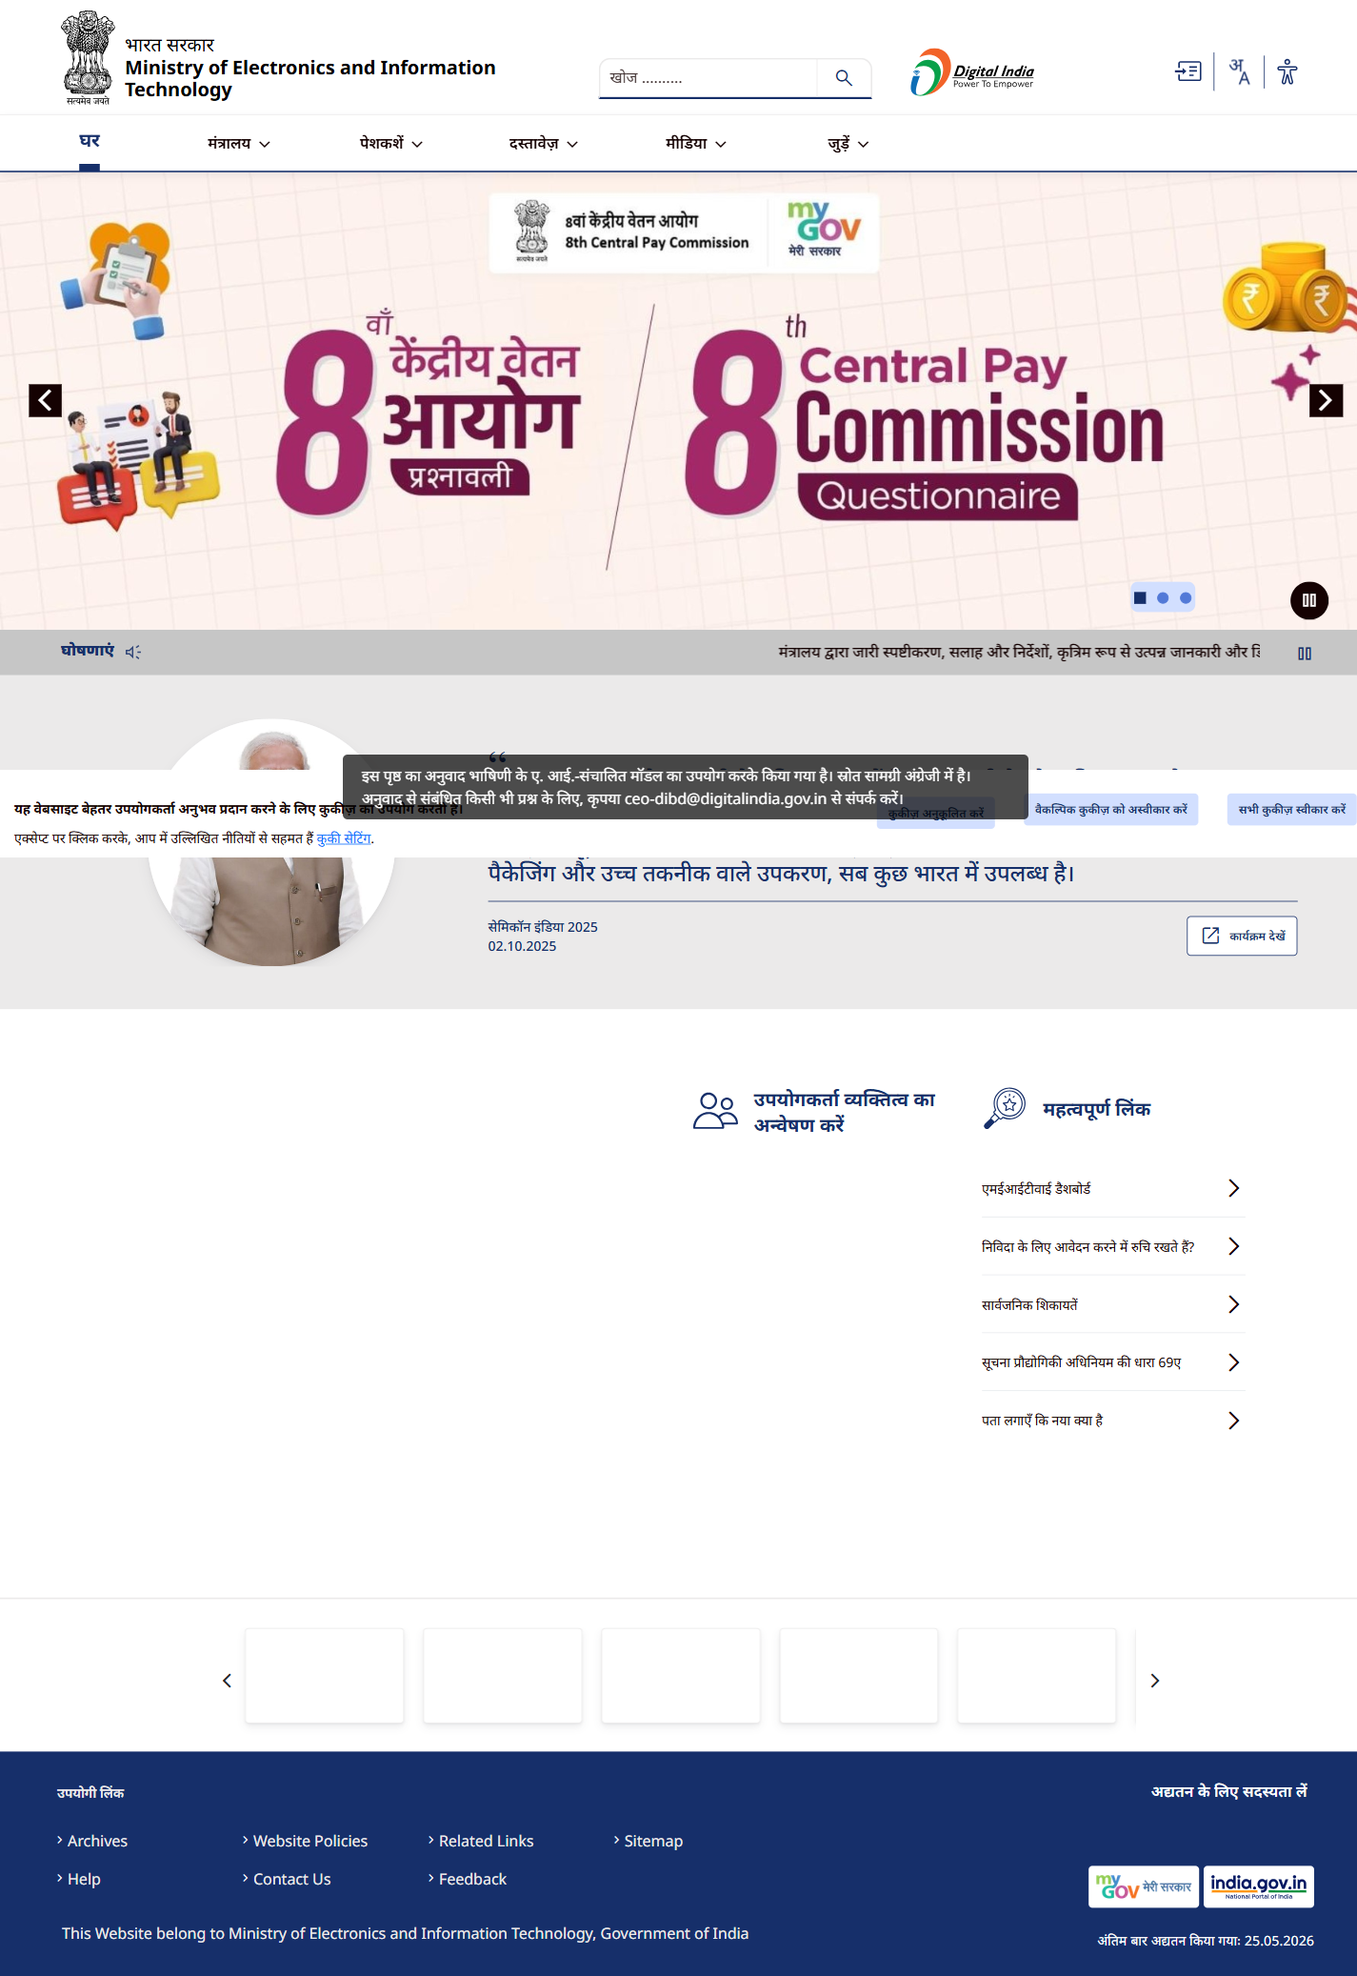

HEADER Branding Element 0
Status: NON-COMPLIANT
RULE 20: FAILED
Intrinsic aspect ratio:
2.16
Rendered aspect ratio:
2.62
Reason:
The branding element appears
horizontally stretched, which changes the
original logo/emblem proportions.
RULE 22: PASSED
Detected contrast ratio:
5101.0
Reason:
The branding element remains
clearly visible against the
background.
RULE 19: PARTIALLY VERIFIABLE
Reason:
Automated systems cannot fully
verify whether the emblem/logo
originates from an officially
authorized government source.
RULE 23: PARTIALLY VERIFIABLE
Reason:
Full DBIM structural conformity
requires manual verification of
header/footer layout standards.
Detected location:
top header region
Detected selector:
header img
Rendered dimensions:
131 x 50


FOOTER Branding Element 1
Status: NON-COMPLIANT
RULE 20: FAILED
Intrinsic aspect ratio:
4.94
Rendered aspect ratio:
5.73
Reason:
The branding element appears
horizontally stretched, which changes the
original logo/emblem proportions.
RULE 22: PASSED
Detected contrast ratio:
5101.0
Reason:
The branding element remains
clearly visible against the
background.
RULE 19: PARTIALLY VERIFIABLE
Reason:
Automated systems cannot fully
verify whether the emblem/logo
originates from an officially
authorized government source.
RULE 23: PARTIALLY VERIFIABLE
Reason:
Full DBIM structural conformity
requires manual verification of
header/footer layout standards.
Detected location:
top header region
Detected selector:
[class*='logo']
Rendered dimensions:
573 x 100
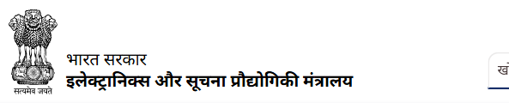

FOOTER Branding Element 2
Status: NON-COMPLIANT
RULE 20: FAILED
Intrinsic aspect ratio:
4.79
Rendered aspect ratio:
6.14
Reason:
The branding element appears
horizontally stretched, which changes the
original logo/emblem proportions.
RULE 22: PASSED
Detected contrast ratio:
5101.0
Reason:
The branding element remains
clearly visible against the
background.
RULE 19: PARTIALLY VERIFIABLE
Reason:
Automated systems cannot fully
verify whether the emblem/logo
originates from an officially
authorized government source.
RULE 23: PARTIALLY VERIFIABLE
Reason:
Full DBIM structural conformity
requires manual verification of
header/footer layout standards.
Detected location:
top header region
Detected selector:
[class*='logo']
Rendered dimensions:
344 x 56
