DBIM Logo Compliance Report
Automated DBIM logo auditing report generated using the AI-powered compliance engine.

Logo 0
Status: COMPLIANT
FORMAT CHECK: PASSED
Detected format:
svg
Reason:
Logo format follows DBIM rules.
FILE SIZE CHECK: PASSED
Detected size:
29.7 KB
Reason:
Logo file size is compliant.
PROPORTION CHECK: PASSED
Reason:
Logo proportions are preserved.
CONTRAST CHECK: PASSED
Reason:
The logo maintains sufficient
visual contrast.
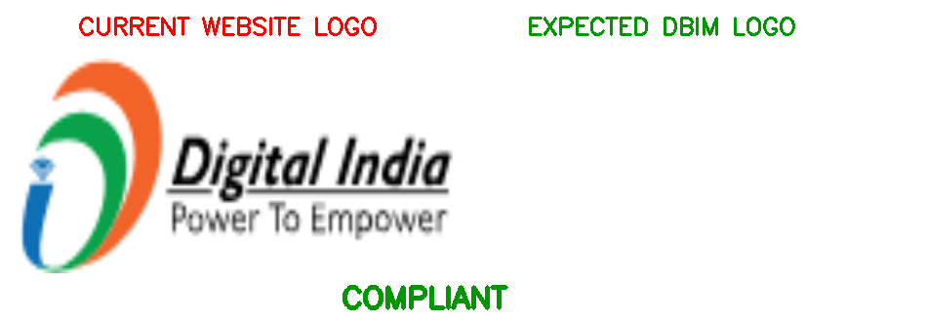

Logo 1
Status: NON-COMPLIANT
FORMAT CHECK: PASSED
Detected format:
jpg
Reason:
Logo format follows DBIM rules.
FILE SIZE CHECK: FAILED
Detected size:
136.8 KB
Maximum allowed:
100 KB
Reason:
Logo file size exceeds DBIM limits.
PROPORTION CHECK: PASSED
Reason:
Logo proportions are preserved.
CONTRAST CHECK: PASSED
Reason:
The logo maintains sufficient
visual contrast.
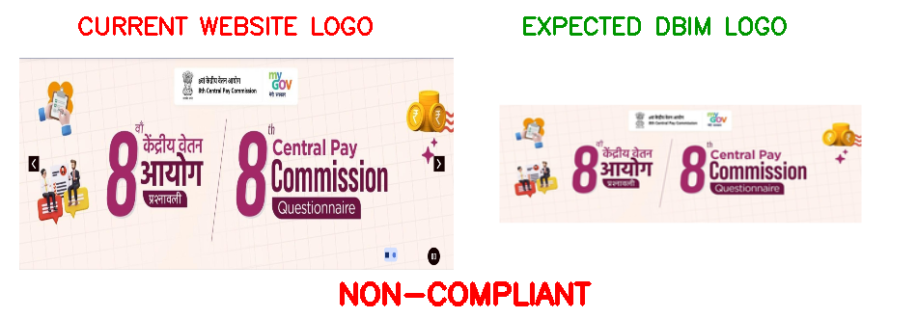

Logo 2
Status: NON-COMPLIANT
FORMAT CHECK: PASSED
Detected format:
png
Reason:
Logo format follows DBIM rules.
FILE SIZE CHECK: FAILED
Detected size:
129.42 KB
Maximum allowed:
100 KB
Reason:
Logo file size exceeds DBIM limits.
PROPORTION CHECK: FAILED
Intrinsic dimensions:
475x
410
Rendered dimensions:
259x
260
Reason:
The logo appears stretched or
compressed during rendering.
CONTRAST CHECK: PASSED
Reason:
The logo maintains sufficient
visual contrast.
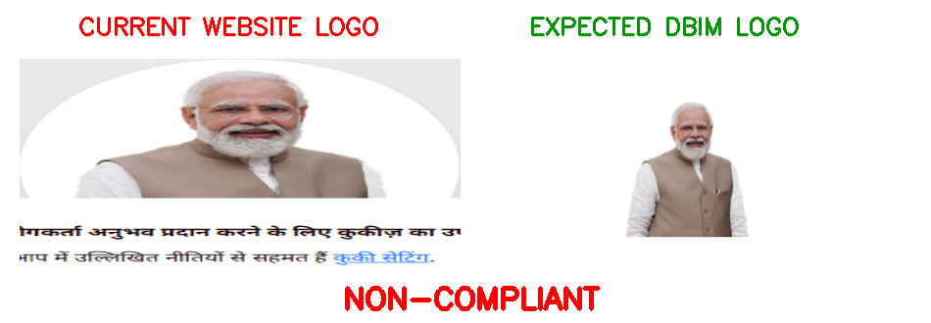

Logo 3
Status: NON-COMPLIANT
FORMAT CHECK: FAILED
Detected format:
unknown
Allowed formats:
PNG, JPG, JPEG, SVG, WEBP
Reason:
Logo format is not compliant with
DBIM requirements.
FILE SIZE CHECK: PASSED
Detected size:
3.81 KB
Reason:
Logo file size is compliant.
PROPORTION CHECK: FAILED
Intrinsic dimensions:
256x
65
Rendered dimensions:
100x
40
Reason:
The logo appears stretched or
compressed during rendering.
CONTRAST CHECK: FAILED
Reason:
The logo does not maintain sufficient
contrast against the background.
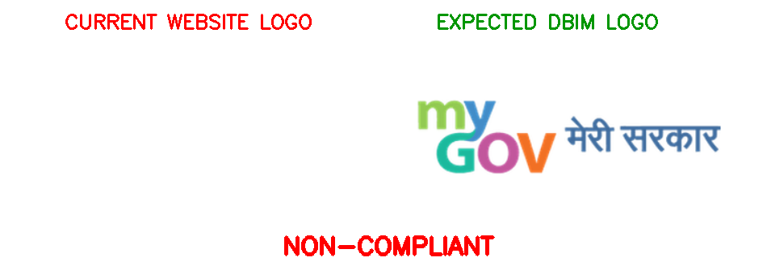

Logo 4
Status: COMPLIANT
FORMAT CHECK: PASSED
Detected format:
svg
Reason:
Logo format follows DBIM rules.
FILE SIZE CHECK: PASSED
Detected size:
22.72 KB
Reason:
Logo file size is compliant.
PROPORTION CHECK: PASSED
Reason:
Logo proportions are preserved.
CONTRAST CHECK: PASSED
Reason:
The logo maintains sufficient
visual contrast.
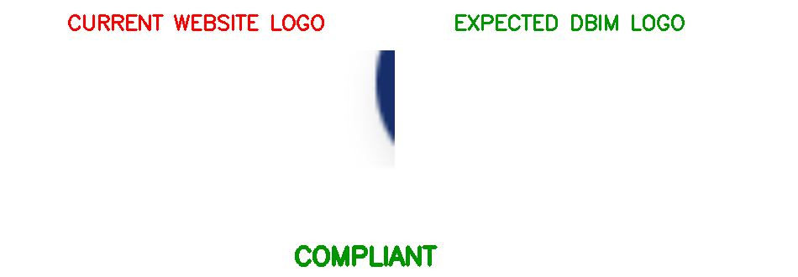

Logo 5
Status: NON-COMPLIANT
FORMAT CHECK: PASSED
Detected format:
png
Reason:
Logo format follows DBIM rules.
FILE SIZE CHECK: PASSED
Detected size:
20.34 KB
Reason:
Logo file size is compliant.
PROPORTION CHECK: FAILED
Intrinsic dimensions:
1425x
93
Rendered dimensions:
1424x
92
Reason:
The logo appears stretched or
compressed during rendering.
CONTRAST CHECK: PASSED
Reason:
The logo maintains sufficient
visual contrast.
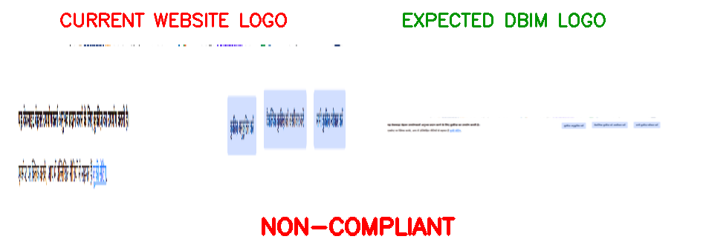

Logo 6
Status: COMPLIANT
FORMAT CHECK: PASSED
Detected format:
png
Reason:
Logo format follows DBIM rules.
FILE SIZE CHECK: PASSED
Detected size:
2.96 KB
Reason:
Logo file size is compliant.
PROPORTION CHECK: PASSED
Reason:
Logo proportions are preserved.
CONTRAST CHECK: PASSED
Reason:
The logo maintains sufficient
visual contrast.
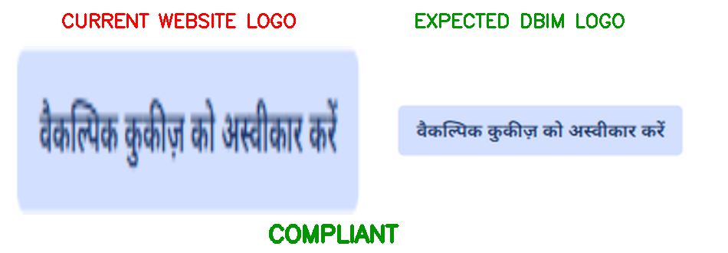

Logo 7
Status: COMPLIANT
FORMAT CHECK: PASSED
Detected format:
png
Reason:
Logo format follows DBIM rules.
FILE SIZE CHECK: PASSED
Detected size:
2.29 KB
Reason:
Logo file size is compliant.
PROPORTION CHECK: PASSED
Reason:
Logo proportions are preserved.
CONTRAST CHECK: PASSED
Reason:
The logo maintains sufficient
visual contrast.
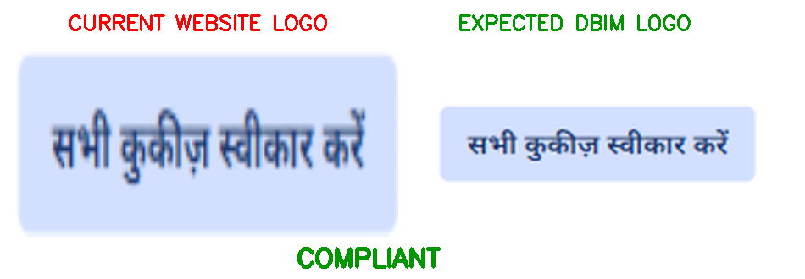

Logo 8
Status: COMPLIANT
FORMAT CHECK: PASSED
Detected format:
png
Reason:
Logo format follows DBIM rules.
FILE SIZE CHECK: PASSED
Detected size:
63.07 KB
Reason:
Logo file size is compliant.
PROPORTION CHECK: PASSED
Reason:
Logo proportions are preserved.
CONTRAST CHECK: PASSED
Reason:
The logo maintains sufficient
visual contrast.
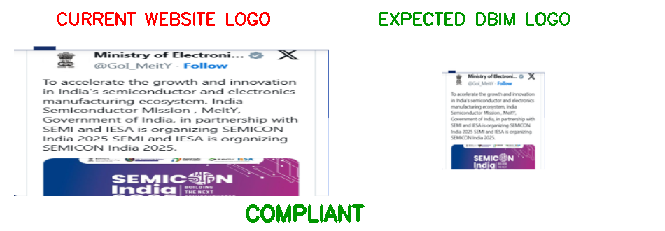

Logo 9
Status: COMPLIANT
FORMAT CHECK: PASSED
Detected format:
png
Reason:
Logo format follows DBIM rules.
FILE SIZE CHECK: PASSED
Detected size:
40.09 KB
Reason:
Logo file size is compliant.
PROPORTION CHECK: PASSED
Reason:
Logo proportions are preserved.
CONTRAST CHECK: PASSED
Reason:
The logo maintains sufficient
visual contrast.
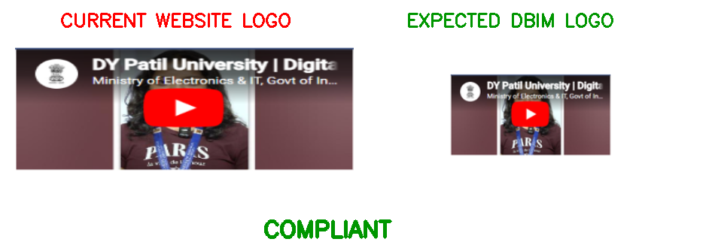

Logo 10
Status: COMPLIANT
FORMAT CHECK: PASSED
Detected format:
png
Reason:
Logo format follows DBIM rules.
FILE SIZE CHECK: PASSED
Detected size:
36.9 KB
Reason:
Logo file size is compliant.
PROPORTION CHECK: PASSED
Reason:
Logo proportions are preserved.
CONTRAST CHECK: PASSED
Reason:
The logo maintains sufficient
visual contrast.
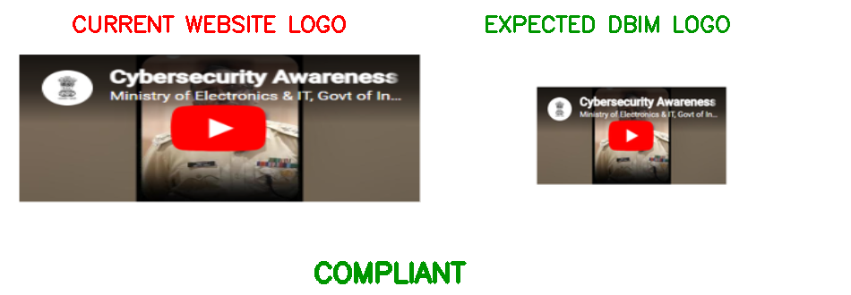

Logo 11
Status: COMPLIANT
FORMAT CHECK: PASSED
Detected format:
png
Reason:
Logo format follows DBIM rules.
FILE SIZE CHECK: PASSED
Detected size:
32.9 KB
Reason:
Logo file size is compliant.
PROPORTION CHECK: PASSED
Reason:
Logo proportions are preserved.
CONTRAST CHECK: PASSED
Reason:
The logo maintains sufficient
visual contrast.
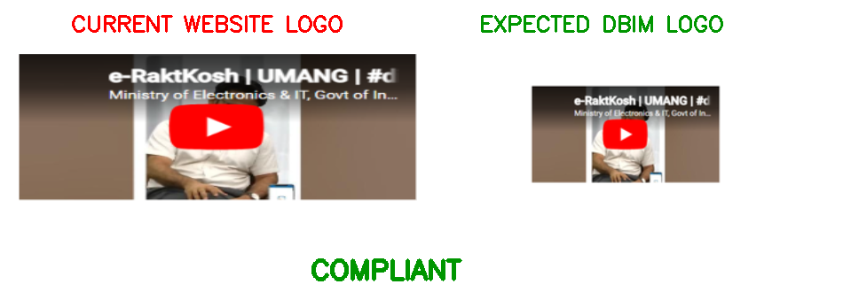

Logo 12
Status: COMPLIANT
FORMAT CHECK: PASSED
Detected format:
png
Reason:
Logo format follows DBIM rules.
FILE SIZE CHECK: PASSED
Detected size:
38.19 KB
Reason:
Logo file size is compliant.
PROPORTION CHECK: PASSED
Reason:
Logo proportions are preserved.
CONTRAST CHECK: PASSED
Reason:
The logo maintains sufficient
visual contrast.
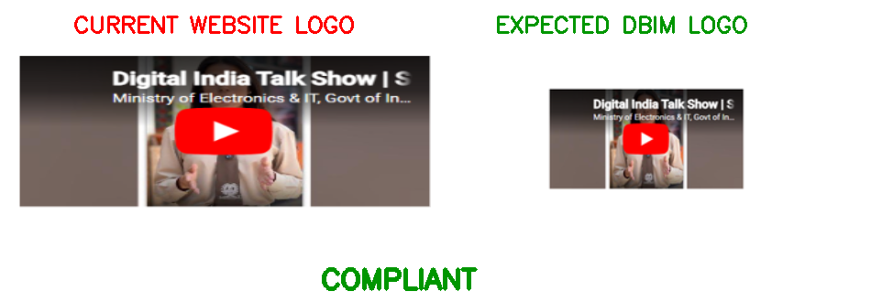

Logo 13
Status: COMPLIANT
FORMAT CHECK: PASSED
Detected format:
png
Reason:
Logo format follows DBIM rules.
FILE SIZE CHECK: PASSED
Detected size:
35.4 KB
Reason:
Logo file size is compliant.
PROPORTION CHECK: PASSED
Reason:
Logo proportions are preserved.
CONTRAST CHECK: PASSED
Reason:
The logo maintains sufficient
visual contrast.
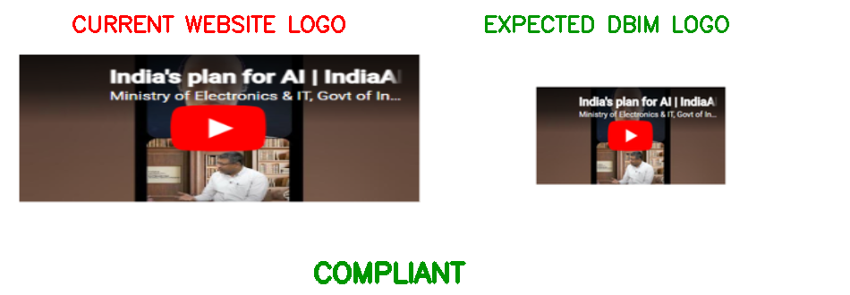

Logo 14
Status: NON-COMPLIANT
FORMAT CHECK: PASSED
Detected format:
png
Reason:
Logo format follows DBIM rules.
FILE SIZE CHECK: FAILED
Detected size:
188.53 KB
Maximum allowed:
100 KB
Reason:
Logo file size exceeds DBIM limits.
PROPORTION CHECK: PASSED
Reason:
Logo proportions are preserved.
CONTRAST CHECK: PASSED
Reason:
The logo maintains sufficient
visual contrast.
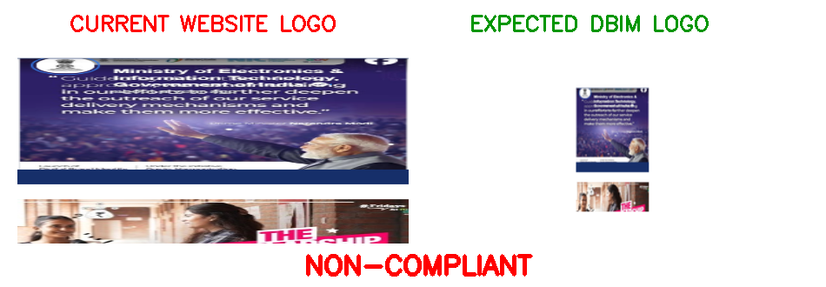

Logo 15
Status: COMPLIANT
FORMAT CHECK: PASSED
Detected format:
png
Reason:
Logo format follows DBIM rules.
FILE SIZE CHECK: PASSED
Detected size:
91.41 KB
Reason:
Logo file size is compliant.
PROPORTION CHECK: PASSED
Reason:
Logo proportions are preserved.
CONTRAST CHECK: PASSED
Reason:
The logo maintains sufficient
visual contrast.
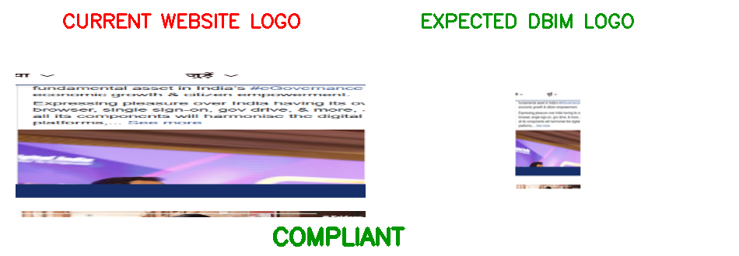

Logo 16
Status: COMPLIANT
FORMAT CHECK: PASSED
Detected format:
png
Reason:
Logo format follows DBIM rules.
FILE SIZE CHECK: PASSED
Detected size:
73.79 KB
Reason:
Logo file size is compliant.
PROPORTION CHECK: PASSED
Reason:
Logo proportions are preserved.
CONTRAST CHECK: PASSED
Reason:
The logo maintains sufficient
visual contrast.
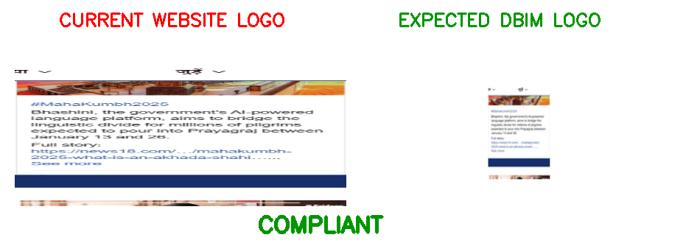

Logo 17
Status: COMPLIANT
FORMAT CHECK: PASSED
Detected format:
png
Reason:
Logo format follows DBIM rules.
FILE SIZE CHECK: PASSED
Detected size:
84.05 KB
Reason:
Logo file size is compliant.
PROPORTION CHECK: PASSED
Reason:
Logo proportions are preserved.
CONTRAST CHECK: PASSED
Reason:
The logo maintains sufficient
visual contrast.
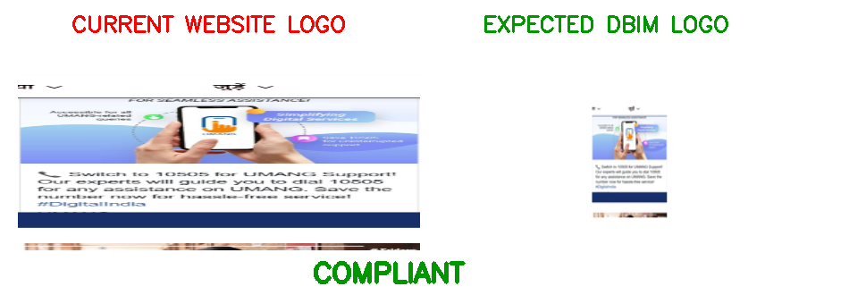

Logo 18
Status: COMPLIANT
FORMAT CHECK: PASSED
Detected format:
png
Reason:
Logo format follows DBIM rules.
FILE SIZE CHECK: PASSED
Detected size:
13.43 KB
Reason:
Logo file size is compliant.
PROPORTION CHECK: PASSED
Reason:
Logo proportions are preserved.
CONTRAST CHECK: PASSED
Reason:
The logo maintains sufficient
visual contrast.
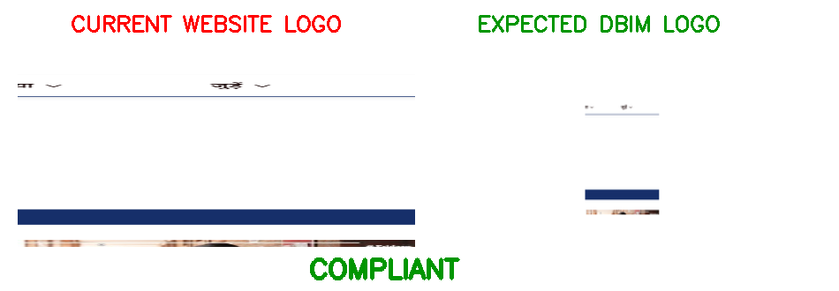

Logo 19
Status: NON-COMPLIANT
FORMAT CHECK: PASSED
Detected format:
png
Reason:
Logo format follows DBIM rules.
FILE SIZE CHECK: FAILED
Detected size:
169.87 KB
Maximum allowed:
100 KB
Reason:
Logo file size exceeds DBIM limits.
PROPORTION CHECK: PASSED
Reason:
Logo proportions are preserved.
CONTRAST CHECK: PASSED
Reason:
The logo maintains sufficient
visual contrast.
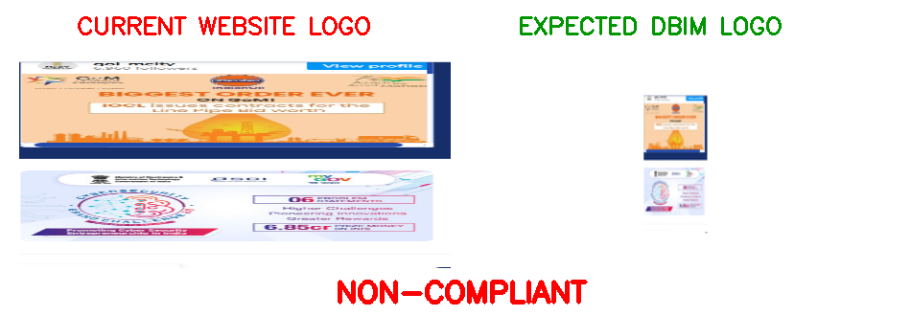

Logo 20
Status: NON-COMPLIANT
FORMAT CHECK: PASSED
Detected format:
png
Reason:
Logo format follows DBIM rules.
FILE SIZE CHECK: FAILED
Detected size:
157.63 KB
Maximum allowed:
100 KB
Reason:
Logo file size exceeds DBIM limits.
PROPORTION CHECK: PASSED
Reason:
Logo proportions are preserved.
CONTRAST CHECK: PASSED
Reason:
The logo maintains sufficient
visual contrast.
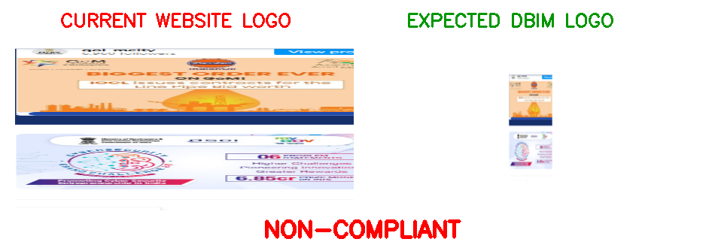

Logo 21
Status: NON-COMPLIANT
FORMAT CHECK: PASSED
Detected format:
png
Reason:
Logo format follows DBIM rules.
FILE SIZE CHECK: FAILED
Detected size:
146.54 KB
Maximum allowed:
100 KB
Reason:
Logo file size exceeds DBIM limits.
PROPORTION CHECK: PASSED
Reason:
Logo proportions are preserved.
CONTRAST CHECK: PASSED
Reason:
The logo maintains sufficient
visual contrast.
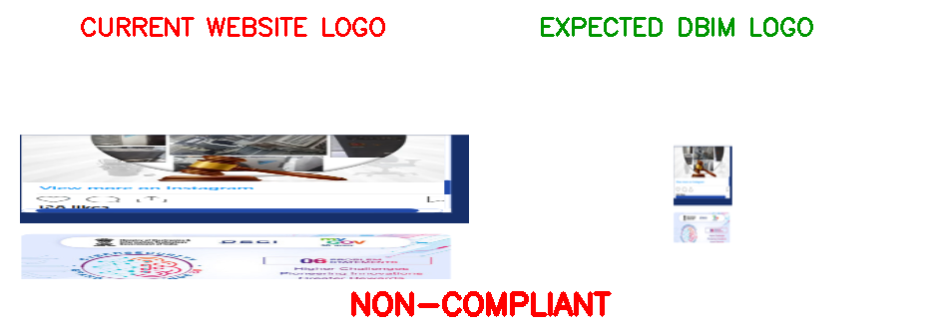

Logo 22
Status: NON-COMPLIANT
FORMAT CHECK: PASSED
Detected format:
png
Reason:
Logo format follows DBIM rules.
FILE SIZE CHECK: FAILED
Detected size:
136.37 KB
Maximum allowed:
100 KB
Reason:
Logo file size exceeds DBIM limits.
PROPORTION CHECK: PASSED
Reason:
Logo proportions are preserved.
CONTRAST CHECK: PASSED
Reason:
The logo maintains sufficient
visual contrast.
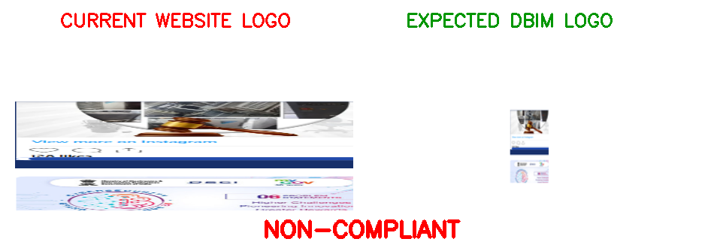

Logo 23
Status: NON-COMPLIANT
FORMAT CHECK: PASSED
Detected format:
png
Reason:
Logo format follows DBIM rules.
FILE SIZE CHECK: FAILED
Detected size:
125.08 KB
Maximum allowed:
100 KB
Reason:
Logo file size exceeds DBIM limits.
PROPORTION CHECK: PASSED
Reason:
Logo proportions are preserved.
CONTRAST CHECK: PASSED
Reason:
The logo maintains sufficient
visual contrast.
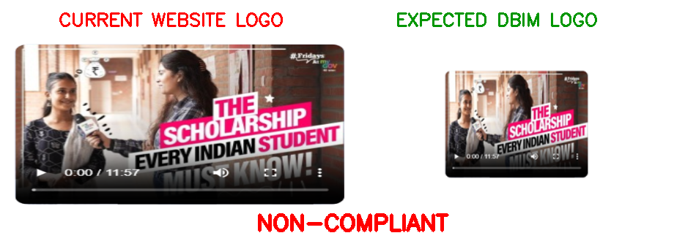

Logo 24
Status: COMPLIANT
FORMAT CHECK: PASSED
Detected format:
png
Reason:
Logo format follows DBIM rules.
FILE SIZE CHECK: PASSED
Detected size:
18.05 KB
Reason:
Logo file size is compliant.
PROPORTION CHECK: PASSED
Reason:
Logo proportions are preserved.
CONTRAST CHECK: PASSED
Reason:
The logo maintains sufficient
visual contrast.
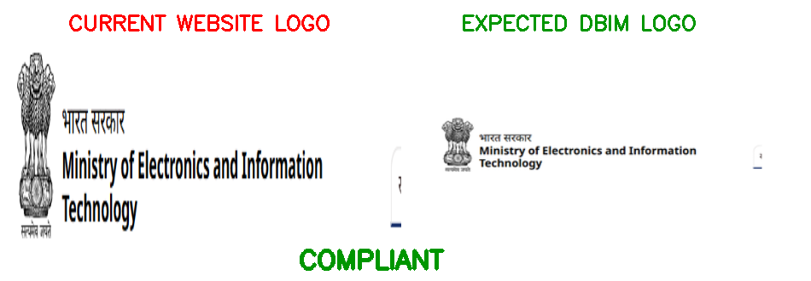

Logo 25
Status: COMPLIANT
FORMAT CHECK: PASSED
Detected format:
png
Reason:
Logo format follows DBIM rules.
FILE SIZE CHECK: PASSED
Detected size:
7.23 KB
Reason:
Logo file size is compliant.
PROPORTION CHECK: PASSED
Reason:
Logo proportions are preserved.
CONTRAST CHECK: PASSED
Reason:
The logo maintains sufficient
visual contrast.
