DBIM A4.1.2 HOMEPAGE STRUCTURE AUDIT
Generated: 2026-05-27 15:36:10.066849
Audit methodology: semantic + content-based heuristics, document-relative bounding boxes.

Header Section
STATUS: COMPLIANT
Reason: Structured header with navigation and identity controls present.
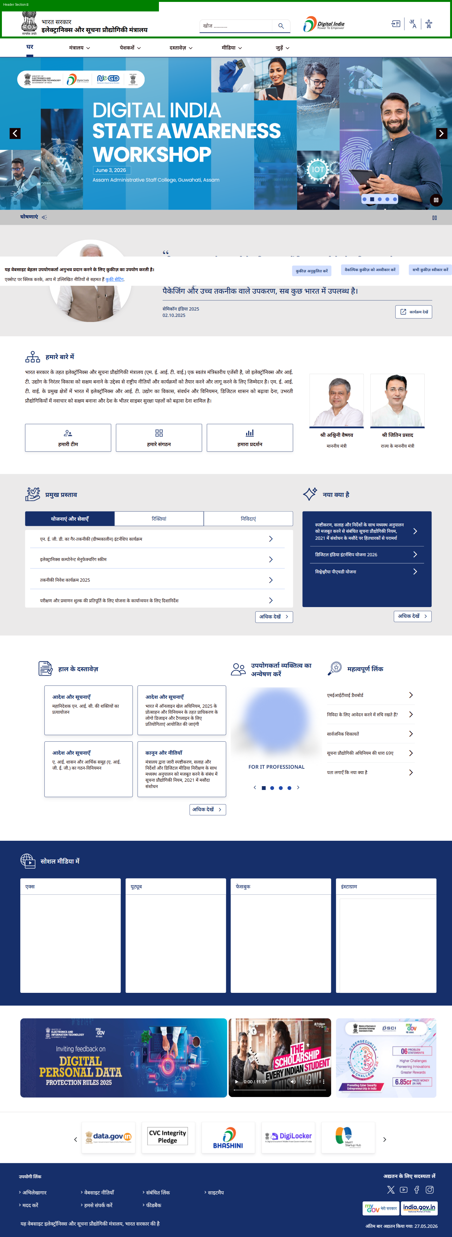

Top Banner Carousel
STATUS: COMPLIANT
Reason: Large visual hero/banner area for schemes/announcements present.
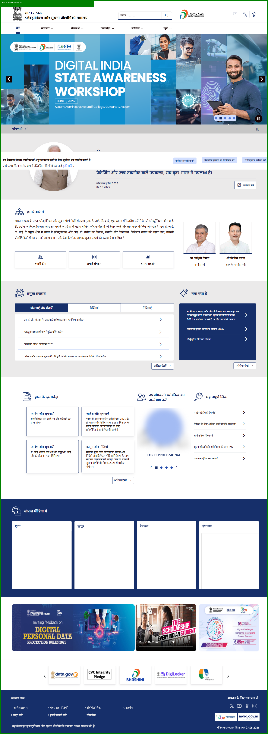

Announcements Ticker
STATUS: NON-COMPLIANT
Reason: No announcement ticker or notice strip detected.
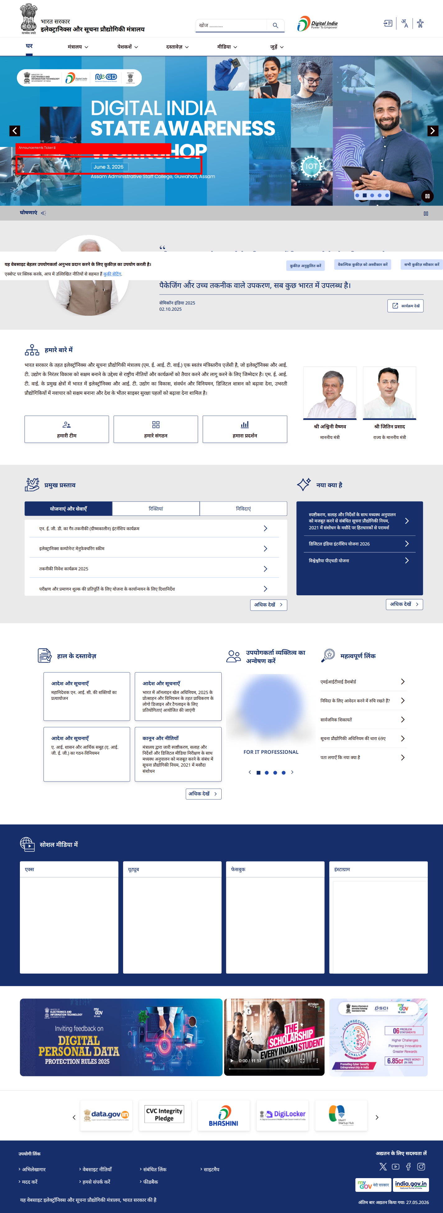

PM Quote Section
STATUS: COMPLIANT
Reason: Leadership/quote section with official communication detected.
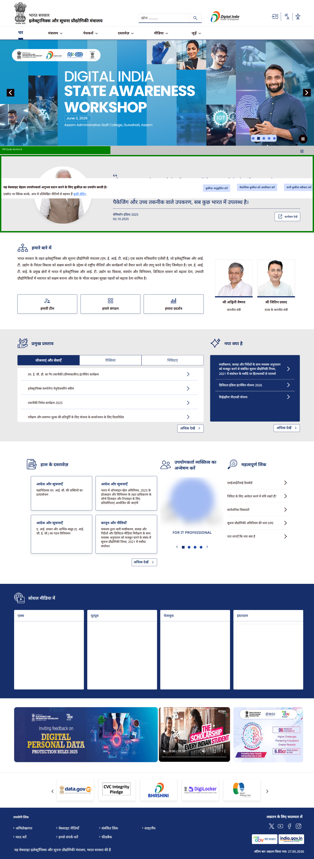

Ministry Department Section
STATUS: NON-COMPLIANT
Reason: No ministry/department introduction section detected.
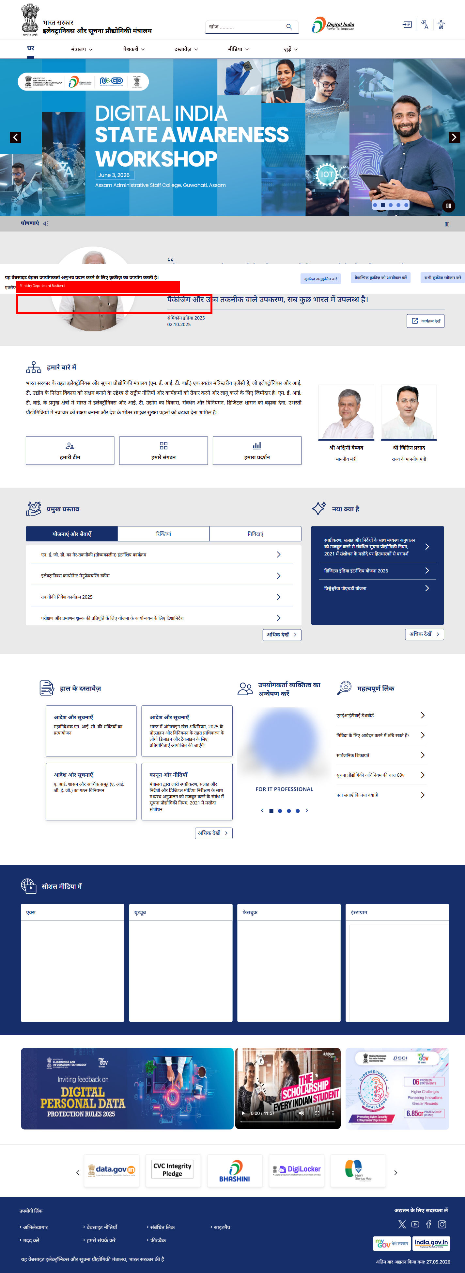

What's New Section
STATUS: COMPLIANT
Reason: Latest updates/news section detected.
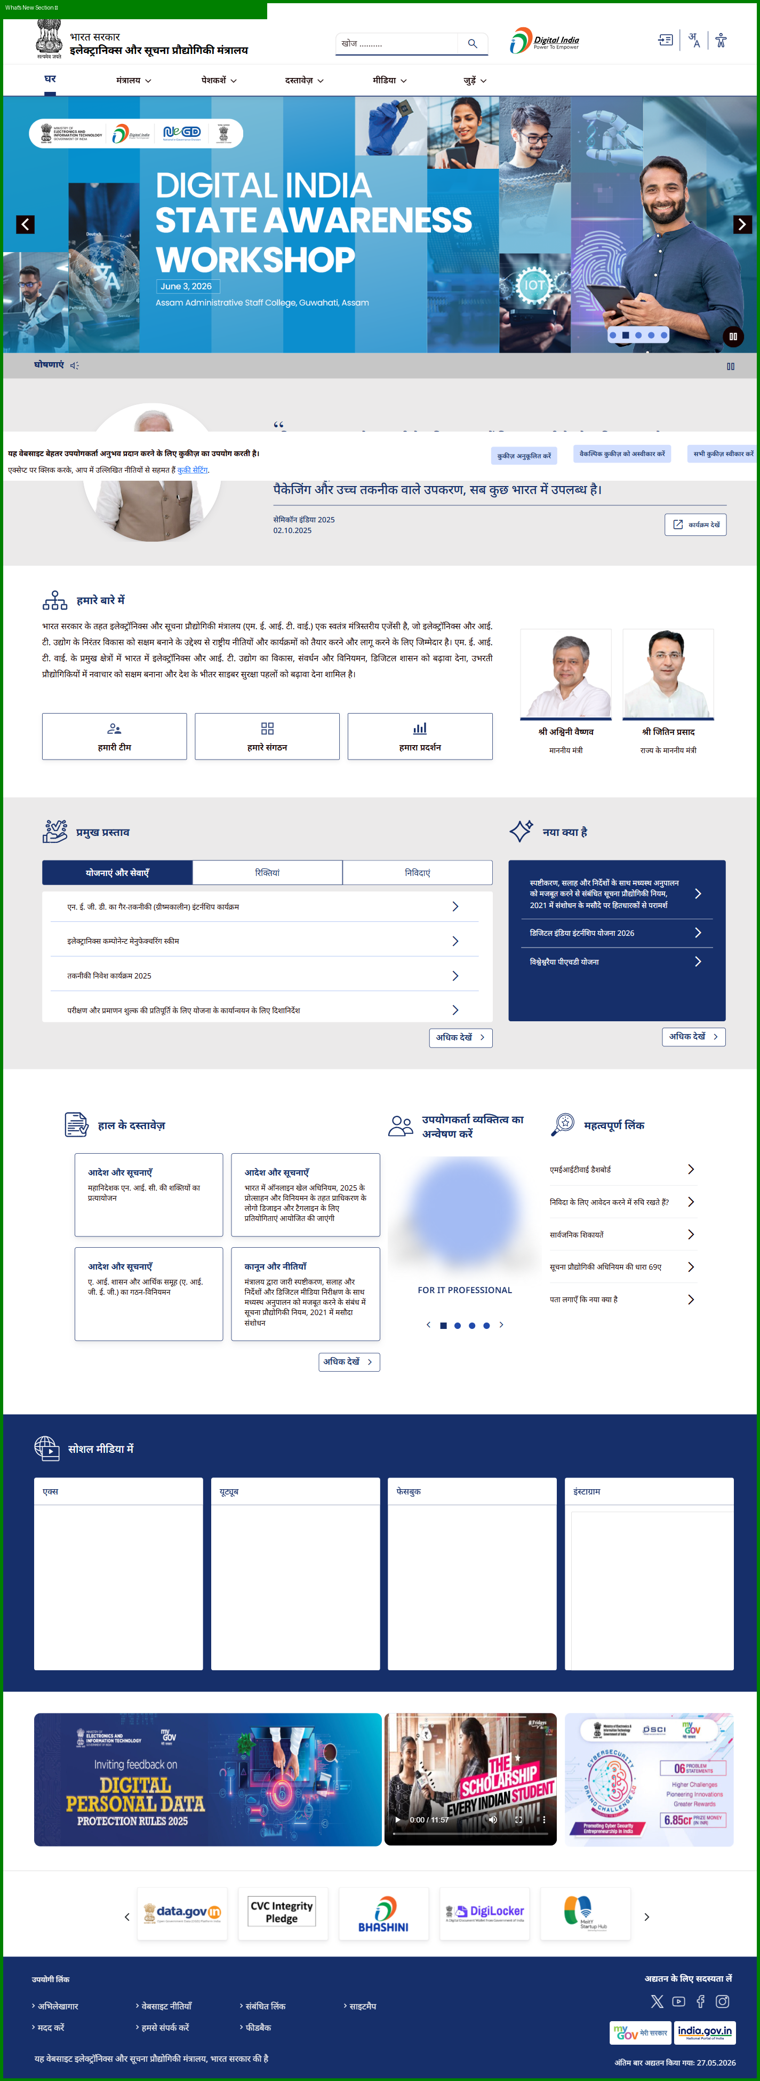

Recent Documents Section
STATUS: COMPLIANT
Reason: Recent documents/report links present.
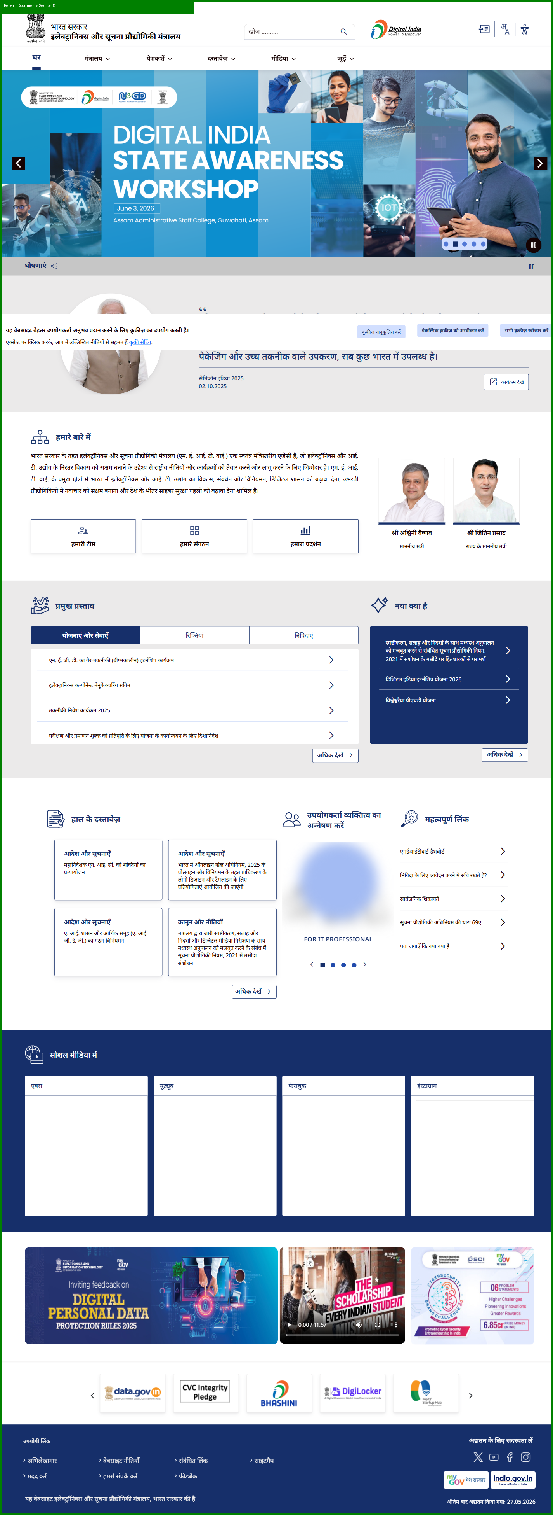

Important Links Section
STATUS: NON-COMPLIANT
Reason: No important links section detected.
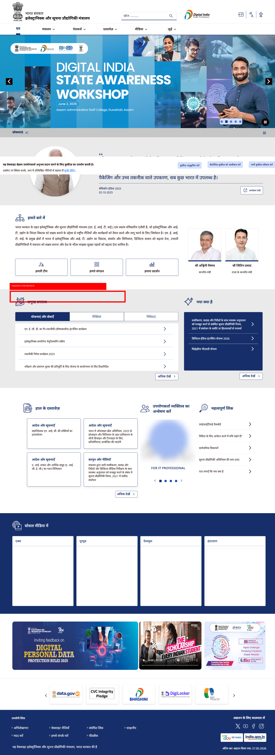

User Persona Section
STATUS: COMPLIANT
Reason: Persona-oriented navigation/content section detected.
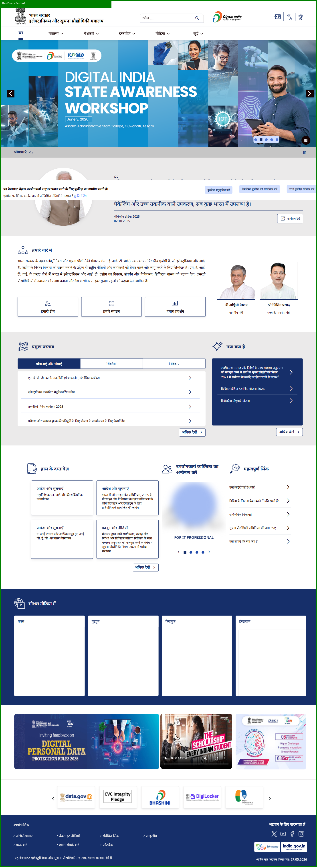

Citizen Engagement Section
STATUS: COMPLIANT
Reason: Citizen engagement / social media integration present.
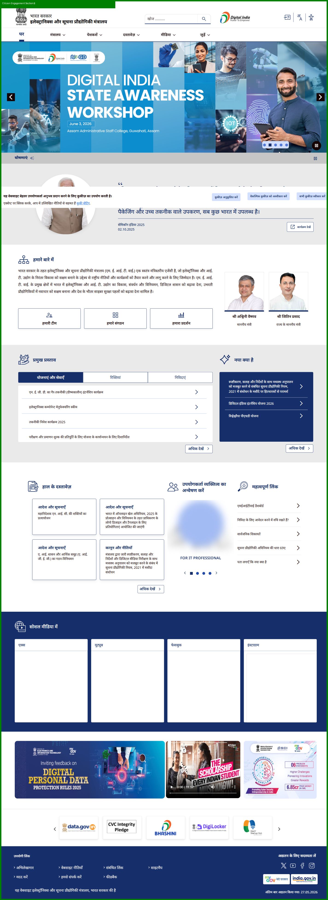

Infographics Section
STATUS: COMPLIANT
Reason: Infographics / visual information section detected.
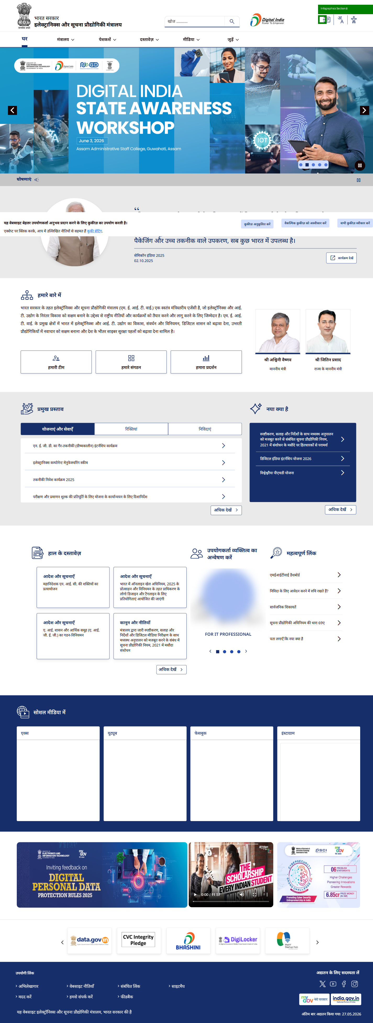

Footer
STATUS: COMPLIANT
Reason: Structured footer with organizational/policy information present.
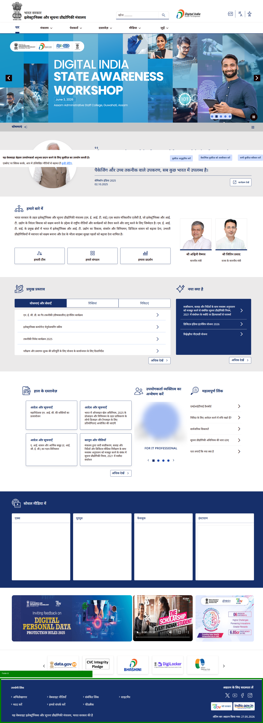

FINAL VERDICT
Overall Homepage Structure Status: COMPLIANT
Compliant Sections: 9/12

