DBIM Annexure A.2 Audit Report
User persona and audience-oriented design compliance audit.

Persona Navigation
STATUS: NON-COMPLIANT
RULE: Persona Navigation
STATUS: NON-COMPLIANT
Reason:
No role-oriented navigation
structures targeting specific
user personas were detected.
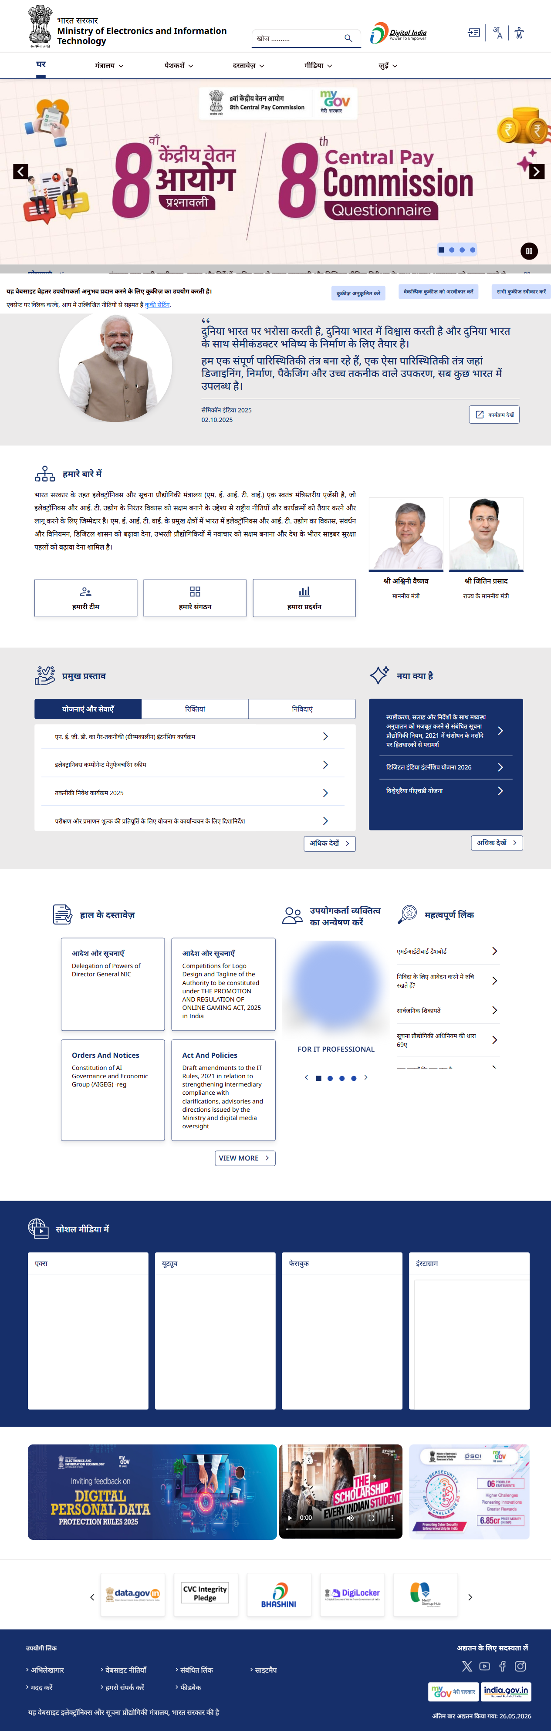

Persona-Oriented Sections
STATUS: NON-COMPLIANT
RULE: Persona-Oriented Sections
STATUS: NON-COMPLIANT
Reason:
No persona-oriented service/content
sections were detected.


Persona Imagery
STATUS: NON-COMPLIANT
RULE: Persona Imagery
STATUS: NON-COMPLIANT
Reason:
No persona-oriented imagery
was detected.


