DBIM Annexure A.3 Audit Report
Structured CMS tagging and discoverability compliance audit.

A.3.1 Information-Type Tagging
STATUS: NON-COMPLIANT
RULE: Information-Type Tagging
STATUS: NON-COMPLIANT
Reason:
No structured CMS category labels,
chips, badges, or metadata tags
representing information types
were detected.
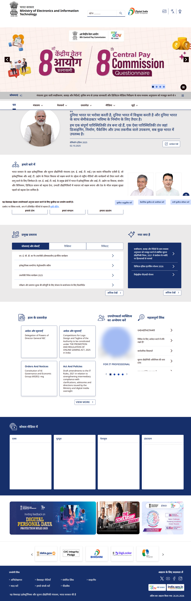

A.3.2 Persona-Based Tagging
STATUS: NON-COMPLIANT
RULE: Persona-Based Tagging
STATUS: NON-COMPLIANT
Reason:
No persona-oriented navigation,
cards, or structured user-group
sections were detected.


Search Discoverability
STATUS: COMPLIANT
RULE: Search Discoverability
STATUS: COMPLIANT
Reason:
Search functionality supporting
content discoverability was
detected.
Evidence:
Search input detected with
placeholder:
'खोज ..........'
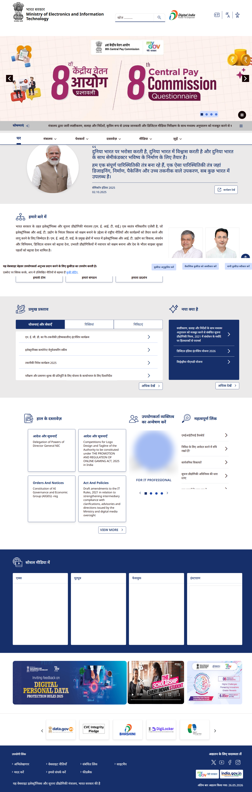

Breadcrumb Navigation
STATUS: NON-COMPLIANT
RULE: Breadcrumb Navigation
STATUS: NON-COMPLIANT
Reason:
No breadcrumb navigation
structures were detected.


