OFFICIAL DBIM SECTION A.4.1.2 STRUCTURAL COMPLIANCE REPORT
Audit Target URL: https://xn--m1bdba5a7gresc7dsa.xn--11b7cb3a6a.xn--h2brj9c/
Execution Timestamp: 2026-05-27 16:34:53
Evaluation Standard: Digital Brand Identity Manual (DBIM) Checklist Specification v2.5

Sequence Check i: Homepage Header Section

INTENT:
Mandated under DBIM Section 5.4.1. Must remain sticky while scrolling, house the official dual emblem lockups, an active search box container, and user typography scaling accessibility controls.
STATUS: COMPLIANT

MEASURED METRICS:
Parameter | Measured Result
DOM Selector | header, .site-header, #header, [class*='header' i]
Visibility | VISIBLE
Bounding Box | 1440x120px at (0, 0)
Content Rules | Search bar verified | Accessibility/Language controls found

FINDINGS:
PASSED: The 'Homepage Header Section' component was successfully located and rendered on the page.

VISUAL PROOF:

Sequence Check ii: Top Banner Carousel

INTENT:
Mandated under Section 7.4. Requires full-width central publishing system core banner allocations constrained exactly to standard dimensional footprints: 1800x338px, 1800x500px, or 1800x600px.
STATUS: COMPLIANT

MEASURED METRICS:
Parameter | Measured Result
DOM Selector | .carousel, .slider, [class*='banner' i], [id*='hero' i], [class*='hero' i]
Visibility | VISIBLE
Bounding Box | 1440x529px at (0, 181)
Content Rules | Full-width CCPS banner dimensions verified

FINDINGS:
PASSED: The 'Top Banner Carousel' component was successfully located and rendered on the page.

VISUAL PROOF:


Sequence Check iii: Announcements Ticker

INTENT:
Enforces vital user informational delivery pipelines. Delivers immediate visibility over live updates, time-sensitive public service notices, vacancies releases, or tender updates.
STATUS: COMPLIANT

MEASURED METRICS:
Parameter | Measured Result
DOM Selector | .ticker, .marquee, [class*='ticker' i], [class*='announcement' i], marquee
Visibility | VISIBLE
Bounding Box | 2346x24px at (612, 674)
Content Rules | Live ticker animation detected

FINDINGS:
PASSED: The 'Announcements Ticker' component was successfully located and rendered on the page.

Sequence Check iv: PM Quote Section

INTENT:
Features high-resolution authorized imagery of leadership with transparent source background profiles alongside localized event text strings wrapped inside type-compliant darker background palettes.
STATUS: COMPLIANT

MEASURED METRICS:
Parameter | Measured Result
DOM Selector | [class*='pm-' i], [class*='quote' i], [id*='pm' i], .minister-quote
Visibility | VISIBLE
Bounding Box | 1440x350px at (0, 710)
Content Rules | PM portrait graphic found

FINDINGS:
PASSED: The 'PM Quote Section' component was successfully located and rendered on the page.

VISUAL PROOF:
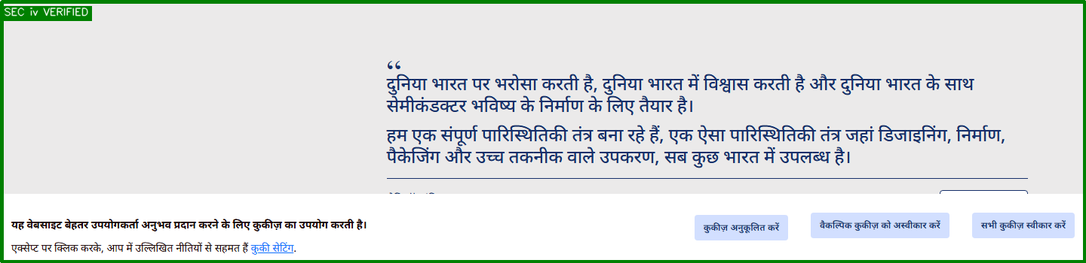

Sequence Check v: Ministry/Department Section

INTENT:
The primary semantic branding statement component container layer. Expresses divisional functionality clearly with explicit quick-routing navigational controls to subordinate offices portals.
STATUS: COMPLIANT

MEASURED METRICS:
Parameter | Measured Result
DOM Selector | .about-ministry, .introduction, [class*='about' i], #about-section, [id*='about' i]
Visibility | VISIBLE
Bounding Box | 1440x434px at (0, 1060)
Content Rules | Layout boundary mapping successful.

FINDINGS:
PASSED: The 'Ministry/Department Section' component was successfully located and rendered on the page.

VISUAL PROOF:
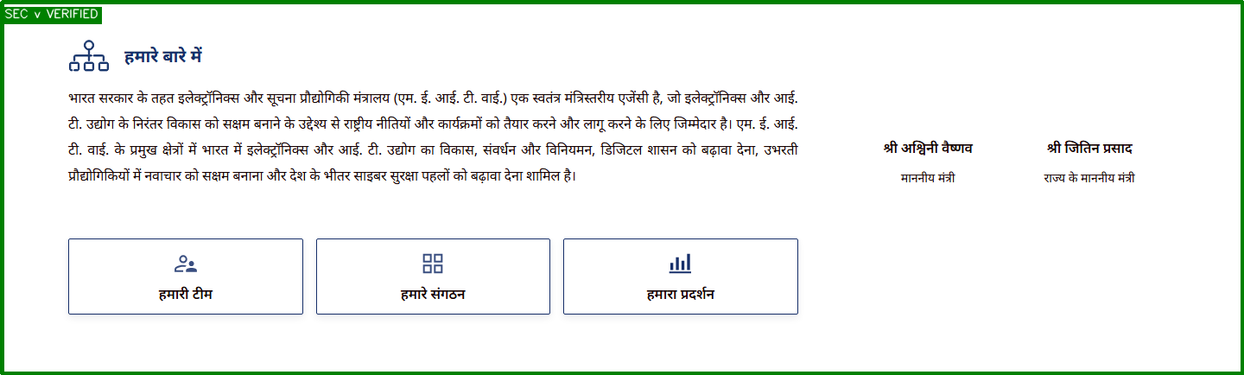

Sequence Check vi: Key Offerings Section

INTENT:
Central citizen action panel. Highlights a tabbed grid containing vacancies, tenders, or schemes. Must restrict initial views to the 5 most recent nodes with an explicit 'View More' button pointer.
STATUS: NON-COMPLIANT

MEASURED METRICS:
Parameter | Measured Result
DOM Selector | .key-offerings, .schemes-tenders, [class*='offering' i], #services-grid, [class*='service' i]
Visibility | MISSING
Bounding Box | N/A

FINDINGS:
FAILED: The 'Key Offerings Section' container element is missing or not visible.

REMEDIATION:
Ensure the component exists in the DOM matching selector: .key-offerings, .schemes-tenders, [class*='offering' i], #services-grid, [class*='service' i].
Fix: Re-engineer dynamic dashboard queries to cap list items records at 5 entries max and hook a bold stylized action link redirection anchor targeting the main documents index.

Sequence Check vii: What's New Section

INTENT:
Exposes real-time structural feeds indexing fresh programmatic content changes across organizational layers, accompanied by standard layout navigation modifiers controls elements.
STATUS: COMPLIANT

MEASURED METRICS:
Parameter | Measured Result
DOM Selector | .whats-new, .latest-updates, [class*='news' i], [id*='notice' i], [class*='update' i]
Visibility | VISIBLE
Bounding Box | 319x18px at (1061, 3951)
Content Rules | Layout boundary mapping successful.

FINDINGS:
PASSED: The 'What's New Section' component was successfully located and rendered on the page.

VISUAL PROOF:

Sequence Check viii: Recent Documents Section

INTENT:
Fosters organizational clarity and transparency. Displays a structured repository indexing newly published files formats, legislative bills, research data sets, and policy forms.
STATUS: COMPLIANT

MEASURED METRICS:
Parameter | Measured Result
DOM Selector | .recent-docs, .publications, [class*='document' i], #downloads-list, [class*='download' i]
Visibility | VISIBLE
Bounding Box | 116x42px at (1246, 962)
Content Rules | Layout boundary mapping successful.

FINDINGS:
PASSED: The 'Recent Documents Section' component was successfully located and rendered on the page.

VISUAL PROOF:


Sequence Check ix: User Persona Section

INTENT:
Enforces user-centric accessibility mapping frameworks. Separates layout views matching specific target audience personas (e.g., Student, Corporate, Researcher) to prevent layout density roadblocks.
STATUS: COMPLIANT

MEASURED METRICS:
Parameter | Measured Result
DOM Selector | .user-persona, .persona-selection, [class*='persona' i], [id*='persona' i]
Visibility | VISIBLE
Bounding Box | 289x54px at (728, 2037)
Content Rules | Layout boundary mapping successful.

FINDINGS:
PASSED: The 'User Persona Section' component was successfully located and rendered on the page.

VISUAL PROOF:


Sequence Check x: Important Links Section

INTENT:
Provides prioritized interface paths pointing toward high-volume public target applications, internal portals, tracking forms, or cross-departmental utility platforms.
STATUS: COMPLIANT

MEASURED METRICS:
Parameter | Measured Result
DOM Selector | .important-links, .quick-links, .hyperlinks-grid, [class*='links' i]
Visibility | VISIBLE
Bounding Box | 764x60px at (60, 3829)
Content Rules | Layout boundary mapping successful.

FINDINGS:
PASSED: The 'Important Links Section' component was successfully located and rendered on the page.

VISUAL PROOF:

Sequence Check xi: Citizen Engagement Section

INTENT:
Consolidates social media communication feeds. Aggregates live outreach streams (X, YouTube, Facebook) into responsive multi-tab widget layouts to maintain public interaction channels.
STATUS: COMPLIANT

MEASURED METRICS:
Parameter | Measured Result
DOM Selector | .citizen-engagement, .social-media-feeds, .social-feed-container, [class*='social' i]
Visibility | VISIBLE
Bounding Box | 1440x519px at (0, 2661)
Content Rules | Social media widget streams embedded

FINDINGS:
PASSED: The 'Citizen Engagement Section' component was successfully located and rendered on the page.

VISUAL PROOF:
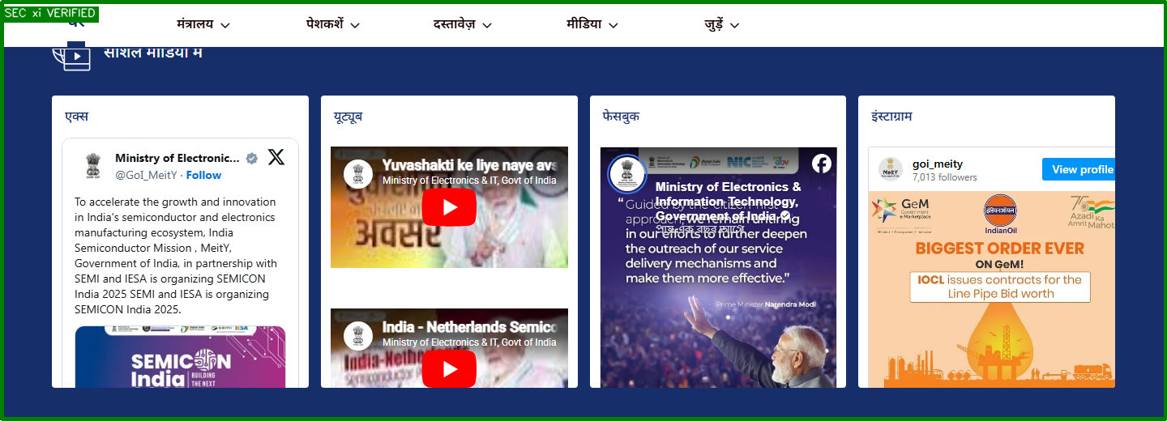

Sequence Check xii: Central Posts Section

INTENT:
Displays central graphic templates published dynamically from the CCPS core framework, bound exactly to standard dimensions: 960x244px layout envelopes profiles.
STATUS: NON-COMPLIANT

MEASURED METRICS:
Parameter | Measured Result
DOM Selector | .central-posts, .ccps-posts, [class*='posts-grid' i]
Visibility | MISSING
Bounding Box | N/A

FINDINGS:
FAILED: The 'Central Posts Section' container element is missing or not visible.

REMEDIATION:
Ensure the component exists in the DOM matching selector: .central-posts, .ccps-posts, [class*='posts-grid' i].
Fix: Set strict stylesheet width/height sizing caps matching the 960x244px bounding constraints and link content directly to the parent content distribution engine API.

Sequence Check xiii: Infographics Section

INTENT:
Visualizes complex data sets, program trackings, and metrics achievements using high-visibility information design grids vectors to improve public document parsing speeds.
STATUS: NON-COMPLIANT

MEASURED METRICS:
Parameter | Measured Result
DOM Selector | .infographics, .data-visuals, [class*='infographic' i], [class*='gallery' i]
Visibility | MISSING
Bounding Box | N/A

FINDINGS:
FAILED: The 'Infographics Section' container element is missing or not visible.

REMEDIATION:
Ensure the component exists in the DOM matching selector: .infographics, .data-visuals, [class*='infographic' i], [class*='gallery' i].
Fix: Construct a localized graphic gallery block featuring compressed, high-contrast visual vectors equipped with full alternative aria-text descriptive strings labels.

Sequence Check xiv: Footer Carousel

INTENT:
Displays a horizontal strip carousel framing authorized logos, related internal commissions links, state portals, and associated initiatives identifiers icons.
STATUS: NON-COMPLIANT

MEASURED METRICS:
Parameter | Measured Result
DOM Selector | footer .carousel, .footer-logos, [class*='partner' i], [class*='sponsor' i]
Visibility | MISSING
Bounding Box | N/A

FINDINGS:
FAILED: The 'Footer Carousel' container element is missing or not visible.

REMEDIATION:
Ensure the component exists in the DOM matching selector: footer .carousel, .footer-logos, [class*='partner' i], [class*='sponsor' i].
Fix: Embed an auto-scrolling graphic strip component restricted to clean monochromatic or approved colored emblem shapes linking back to verified external parent domains.

Sequence Check xv: Footer Details Section

INTENT:
Mandated under Rule 25. Standardizes persistence criteria formatting across all sub-pages, requiring direct links mapping to Archives, Sitemap, Policies, Help, and live Last Updated parameters.
STATUS: COMPLIANT

MEASURED METRICS:
Parameter | Measured Result
DOM Selector | footer, .site-footer, #footer, [class*='footer' i]
Visibility | VISIBLE
Bounding Box | 1440x49px at (0, 661)
Content Rules | Rule 25 Metadata Links Verified: 0/6

FINDINGS:
PASSED: The 'Footer Details Section' component was successfully located and rendered on the page.

VISUAL PROOF:

