DBIM UNIFIED GLOBAL COMPLIANCE REPORT
Automated evidence matrix evaluating portal structure, asset bandwidth files, and component designs against official rules.

Section Clause 10.1.1 - Page Loading Speed Performance
GLOBAL COMPLIANCE STATUS: NON-COMPLIANT
Audit Observations Diagnostic Findings:
Velocity Breach: Response boundaries exceeded standard thresholds. Server optimization required.
Verified Component / Parameter Target | Measured Compliance State Metric
Time to First Byte (TTFB) | 579 ms (Limit <= 800ms)
DOM Content Loaded Event | 1315 ms (Limit <= 2500ms)
Full Document Load Event | 4071 ms (Limit <= 4000ms)
Network Transfer Size Payload | 1.26 KB
Visual Proof (Cropped Reference Element Execution Capture):


Section Clause 10.1.2 - Media Lazy Loading Implementation
GLOBAL COMPLIANCE STATUS: NON-COMPLIANT
Audit Observations Diagnostic Findings:
Unoptimized Resource Loading: Below-fold media assets are fetching eagerly, stalling network rendering pipe bounds.
Verified Component / Parameter Target | Measured Compliance State Metric
Total Discovered Images Below Fold | 4
Lazy-Attribute Managed Nodes | 2
Lazy Loading Coverage Ratio | 50.0% (Target >= 70%)
Visual Proof (Cropped Reference Element Execution Capture):


Section Clause A.4.1.1 - Single-Page Ministry Department Tile Routing Map
GLOBAL COMPLIANCE STATUS: NON-COMPLIANT
Audit Observations Diagnostic Findings:
Layout Violation: Landing workspace lacks structural card grid tiles mapping subordinate divisions or portals.
Verified Component / Parameter Target | Measured Compliance State Metric
Resolved Header Document Outline | H1 Root Presence: true | H2 Nested Presence: true
Identified Interactive Tile Components | 1
Visual Proof (Cropped Reference Element Execution Capture):
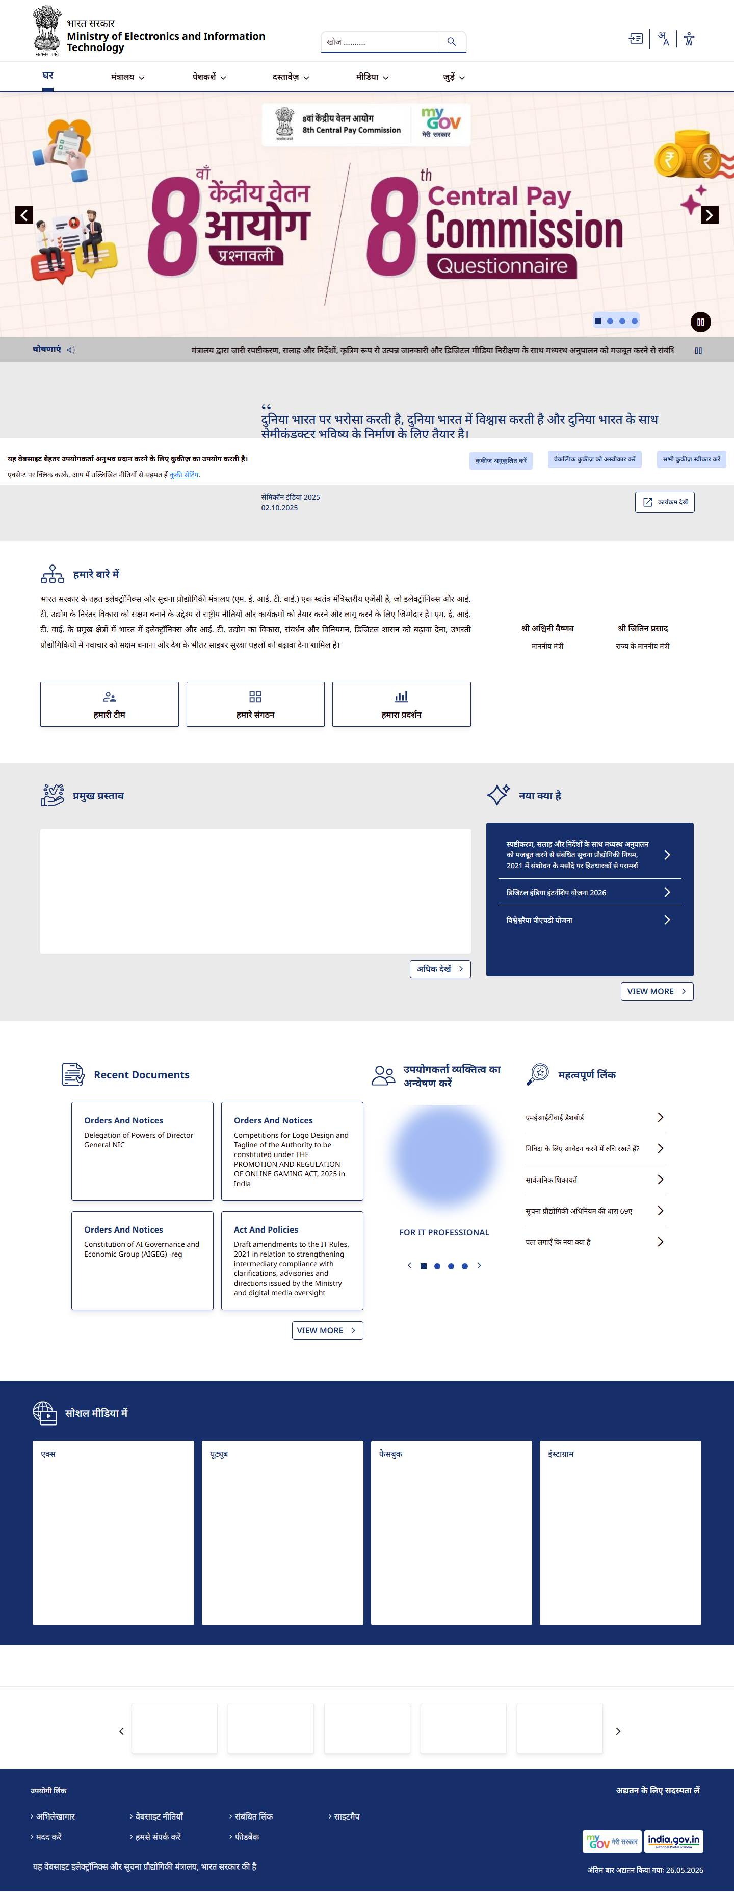

Section Clause 6.1 (Imagery) - Image Asset #0 (STANDARD_CONTENT) Compliance Tracker
GLOBAL COMPLIANCE STATUS: COMPLIANT
Audit Observations Diagnostic Findings:
प्रोग्रामीकीय रूप से Isolated item analyzed under standard imagery processing filters.
Verified Component / Parameter Target | Measured Compliance State Metric
Rule 34 Decoded File Extension | SVG (Approved Format)
Rule 37 Profile Aspect Scale Factor | Not Applicable (Generic Content Graphic Asset)
Visual Proof (Cropped Reference Element Execution Capture):


Section Clause 6.1 (Imagery) - Image Asset #1 (STANDARD_CONTENT) Compliance Tracker
GLOBAL COMPLIANCE STATUS: COMPLIANT
Audit Observations Diagnostic Findings:
प्रोग्रामीकीय रूप से Isolated item analyzed under standard imagery processing filters.
Verified Component / Parameter Target | Measured Compliance State Metric
Rule 34 Decoded File Extension | SVG (Approved Format)
Rule 37 Profile Aspect Scale Factor | Not Applicable (Generic Content Graphic Asset)
Visual Proof (Cropped Reference Element Execution Capture):


Section Clause 6.1 (Imagery) - Image Asset #2 (HIGH_RESOLUTION) Compliance Tracker
GLOBAL COMPLIANCE STATUS: COMPLIANT
Audit Observations Diagnostic Findings:
प्रोग्रामीकीय रूप से Isolated item analyzed under standard imagery processing filters.
Verified Component / Parameter Target | Measured Compliance State Metric
Rule 34 Decoded File Extension | JPG (Approved Format)
Rule 37 Profile Aspect Scale Factor | Not Applicable (Generic Content Graphic Asset)
Visual Proof (Cropped Reference Element Execution Capture):


Section Clause 6.1 (Imagery) - Image Asset #3 (STANDARD_CONTENT) Compliance Tracker
GLOBAL COMPLIANCE STATUS: COMPLIANT
Audit Observations Diagnostic Findings:
प्रोग्रामीकीय रूप से Isolated item analyzed under standard imagery processing filters.
Verified Component / Parameter Target | Measured Compliance State Metric
Rule 34 Decoded File Extension | PNG (Approved Format)
Rule 37 Profile Aspect Scale Factor | Not Applicable (Generic Content Graphic Asset)
Visual Proof (Cropped Reference Element Execution Capture):
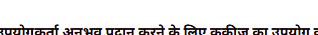

Section Clause 6.1 (Imagery) - Image Asset #4 (THUMBNAIL) Compliance Tracker
GLOBAL COMPLIANCE STATUS: COMPLIANT
Audit Observations Diagnostic Findings:
प्रोग्रामीकीय रूप से Isolated item analyzed under standard imagery processing filters.
Verified Component / Parameter Target | Measured Compliance State Metric
Rule 34 Decoded File Extension | PNG (Approved Format)
Rule 37 Profile Aspect Scale Factor | Not Applicable (Generic Content Graphic Asset)

Section Clause 6.1 (Imagery) - Image Asset #5 (HEADSHOT) Compliance Tracker
GLOBAL COMPLIANCE STATUS: NON-COMPLIANT
Audit Observations Diagnostic Findings:
प्रोग्रामीकीय रूप से Isolated item analyzed under standard imagery processing filters.
Verified Component / Parameter Target | Measured Compliance State Metric
Rule 34 Decoded File Extension | PNG (Approved Format)
Rule 37 Profile Aspect Scale Factor | Aspect Proportion Ratio: 5.88 (Aspect Layout Violation)

Section Clause 6.1 (Imagery) - Image Asset #6 (THUMBNAIL) Compliance Tracker
GLOBAL COMPLIANCE STATUS: COMPLIANT
Audit Observations Diagnostic Findings:
प्रोग्रामीकीय रूप से Isolated item analyzed under standard imagery processing filters.
Verified Component / Parameter Target | Measured Compliance State Metric
Rule 34 Decoded File Extension | PNG (Approved Format)
Rule 37 Profile Aspect Scale Factor | Not Applicable (Generic Content Graphic Asset)

Section Clause 6.1 (Imagery) - Image Asset #7 (HEADSHOT) Compliance Tracker
GLOBAL COMPLIANCE STATUS: NON-COMPLIANT
Audit Observations Diagnostic Findings:
प्रोग्रामीकीय रूप से Isolated item analyzed under standard imagery processing filters.
Verified Component / Parameter Target | Measured Compliance State Metric
Rule 34 Decoded File Extension | PNG (Approved Format)
Rule 37 Profile Aspect Scale Factor | Aspect Proportion Ratio: 4.56 (Aspect Layout Violation)

Section Clause 6.1 (Imagery) - Image Asset #8 (THUMBNAIL) Compliance Tracker
GLOBAL COMPLIANCE STATUS: NON-COMPLIANT
Audit Observations Diagnostic Findings:
प्रोग्रामीकीय रूप से Isolated item analyzed under standard imagery processing filters.
Verified Component / Parameter Target | Measured Compliance State Metric
Rule 34 Decoded File Extension | UNKNOWN (Banned Asset Layout Type Exception Code 34)
Rule 37 Profile Aspect Scale Factor | Not Applicable (Generic Content Graphic Asset)

Section Clause 6.1 (Imagery) - Image Asset #9 (THUMBNAIL) Compliance Tracker
GLOBAL COMPLIANCE STATUS: COMPLIANT
Audit Observations Diagnostic Findings:
प्रोग्रामीकीय रूप से Isolated item analyzed under standard imagery processing filters.
Verified Component / Parameter Target | Measured Compliance State Metric
Rule 34 Decoded File Extension | SVG (Approved Format)
Rule 37 Profile Aspect Scale Factor | Not Applicable (Generic Content Graphic Asset)

Section Clause Annexure D - 21 - Rule 21 - Portal Naming & Semantics Classification
GLOBAL COMPLIANCE STATUS: COMPLIANT
Audit Observations Diagnostic Findings:
Portal structural header labeling complies perfectly with state executive identity blueprints.
Verified Component / Parameter Target | Measured Compliance State Metric
Extracted Document DOM Title | Home | Ministry of Electronics and Information Technology
Semantic Alignment Validation Check | Passed Official Verification
Visual Proof (Cropped Reference Element Execution Capture):


Section Clause Annexure D - 25 - Rule 25 - Footer Lineage & Mandatory Metadata
GLOBAL COMPLIANCE STATUS: NON-COMPLIANT
Audit Observations Diagnostic Findings:
Violation: Footer region lacks critical required structural transparency tags or metadata blocks.
Verified Component / Parameter Target | Measured Compliance State Metric
Footer DOM Container Resolved | Yes (Node Active)
Discovered MandatoryPointers | None Found
Coverage Matrix Score | 0 of 8 core parameters verified
Visual Proof (Cropped Reference Element Execution Capture):
