FINAL LOGO / ICON COMPLIANCE REPORT
2026-05-22 15:16:21

Requirement 46

Logo Detection
STATUS: COMPLIANT
Visible website logo detected.
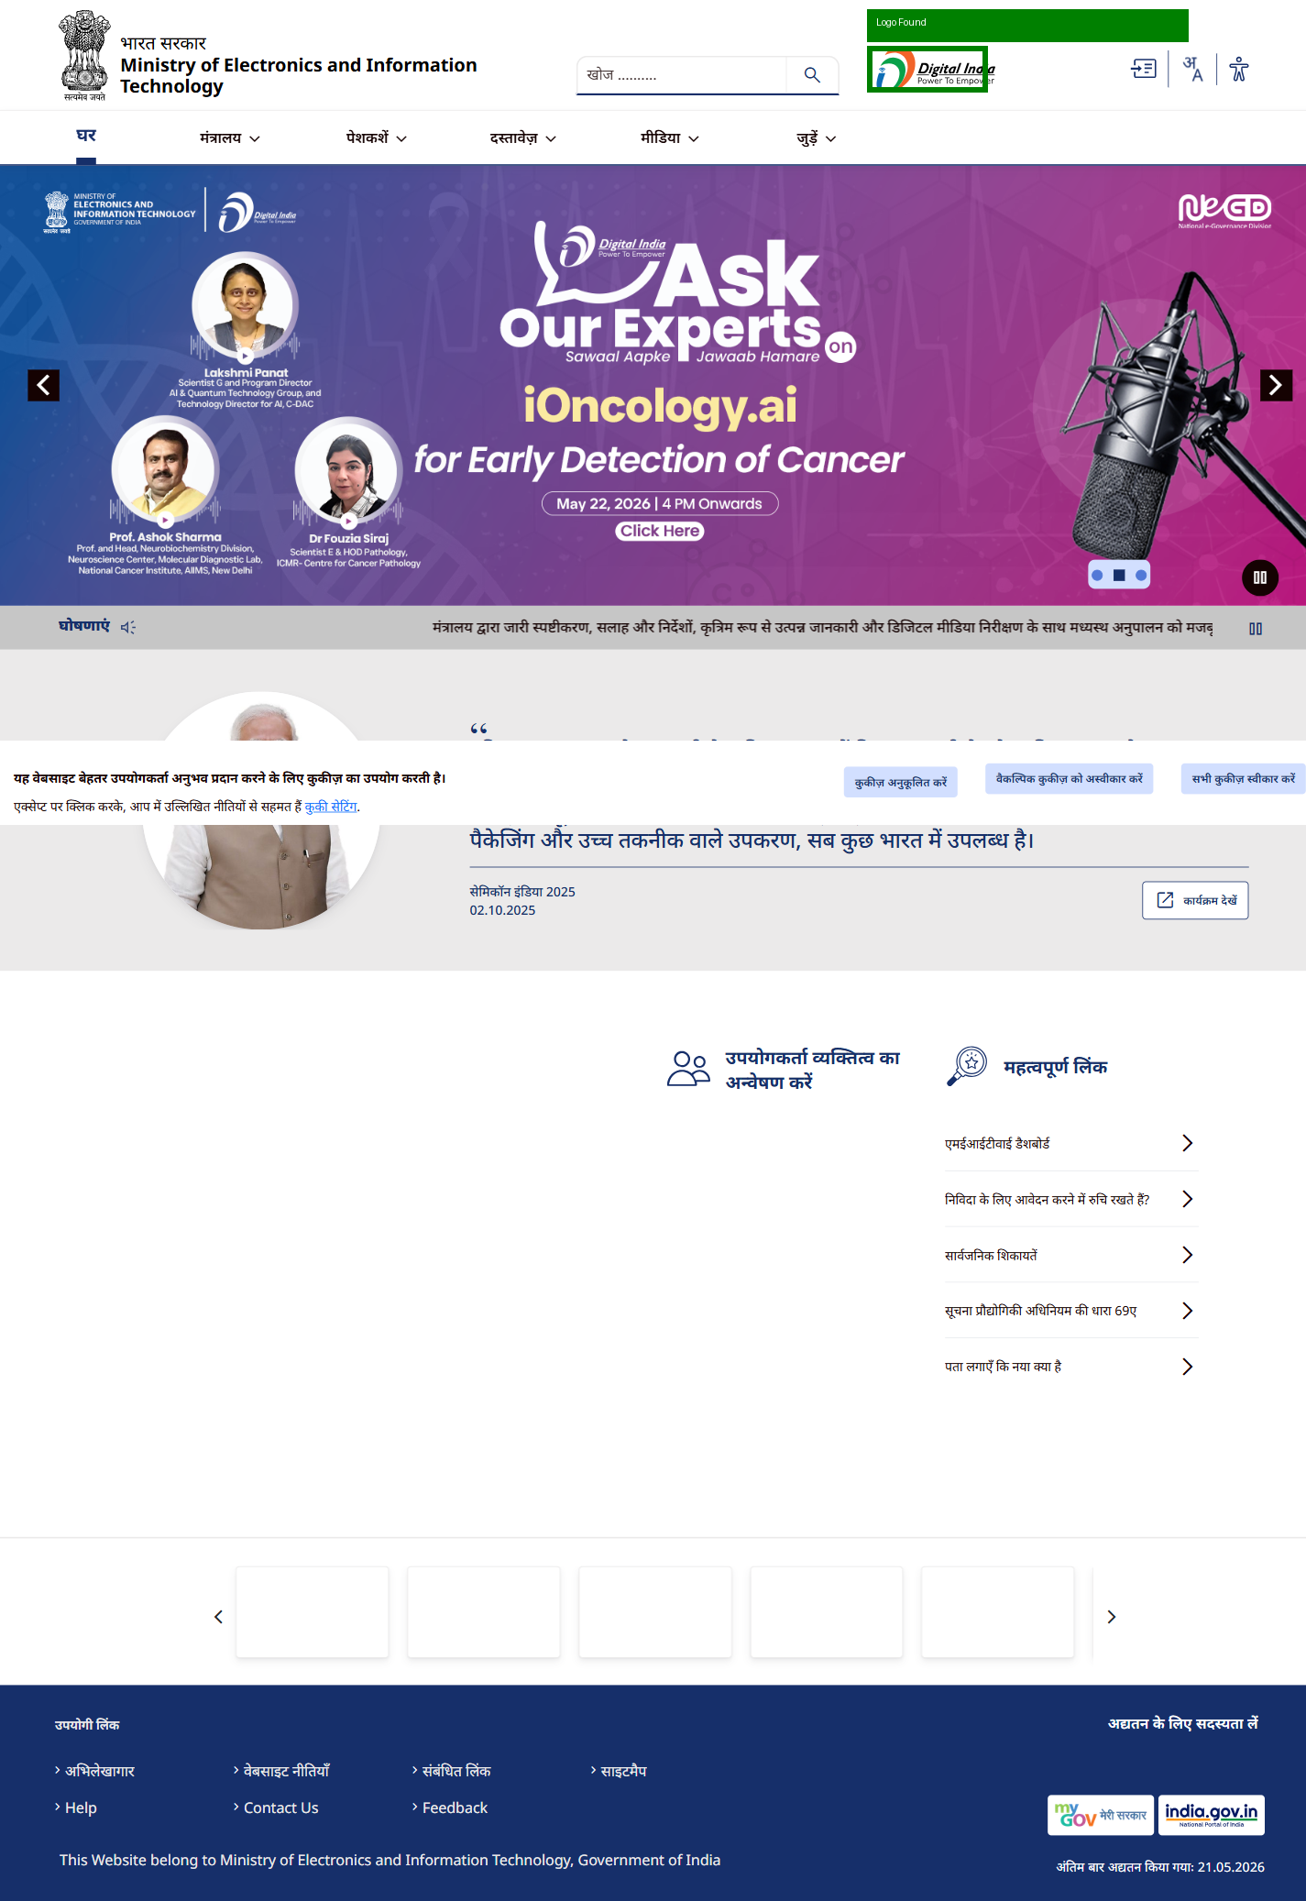

Responsive Logo
STATUS: COMPLIANT
Logo visible in mobile viewport.
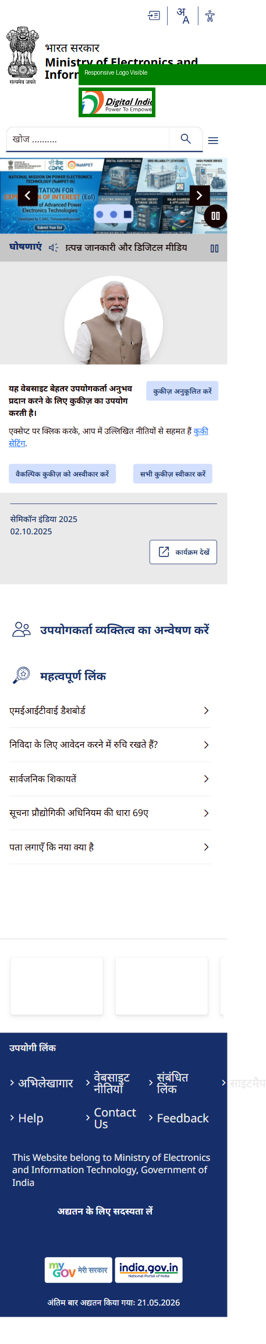

Requirement 47

Favicon Detection
STATUS: COMPLIANT
Favicon detected.
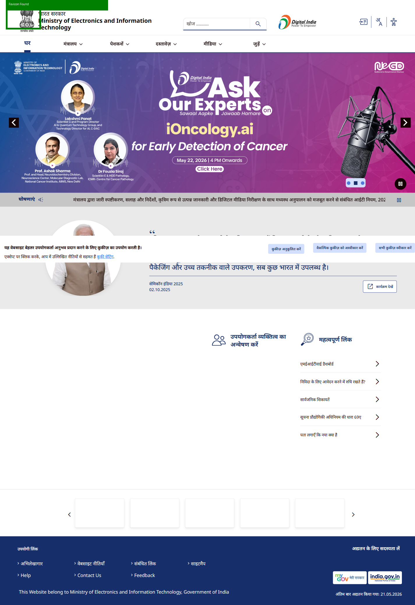

Requirement 48

Icon Detection
STATUS: COMPLIANT
16 icons detected.
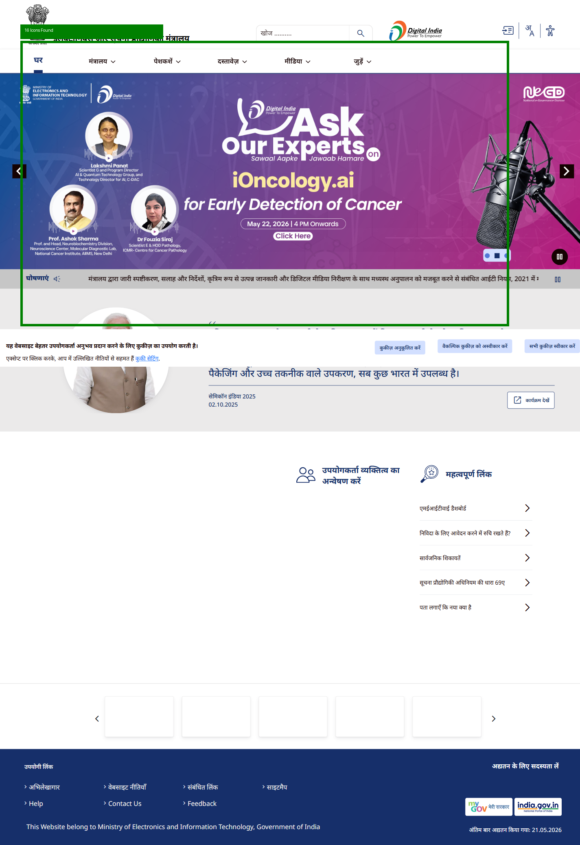

Broken Images
STATUS: COMPLIANT
No broken images detected.
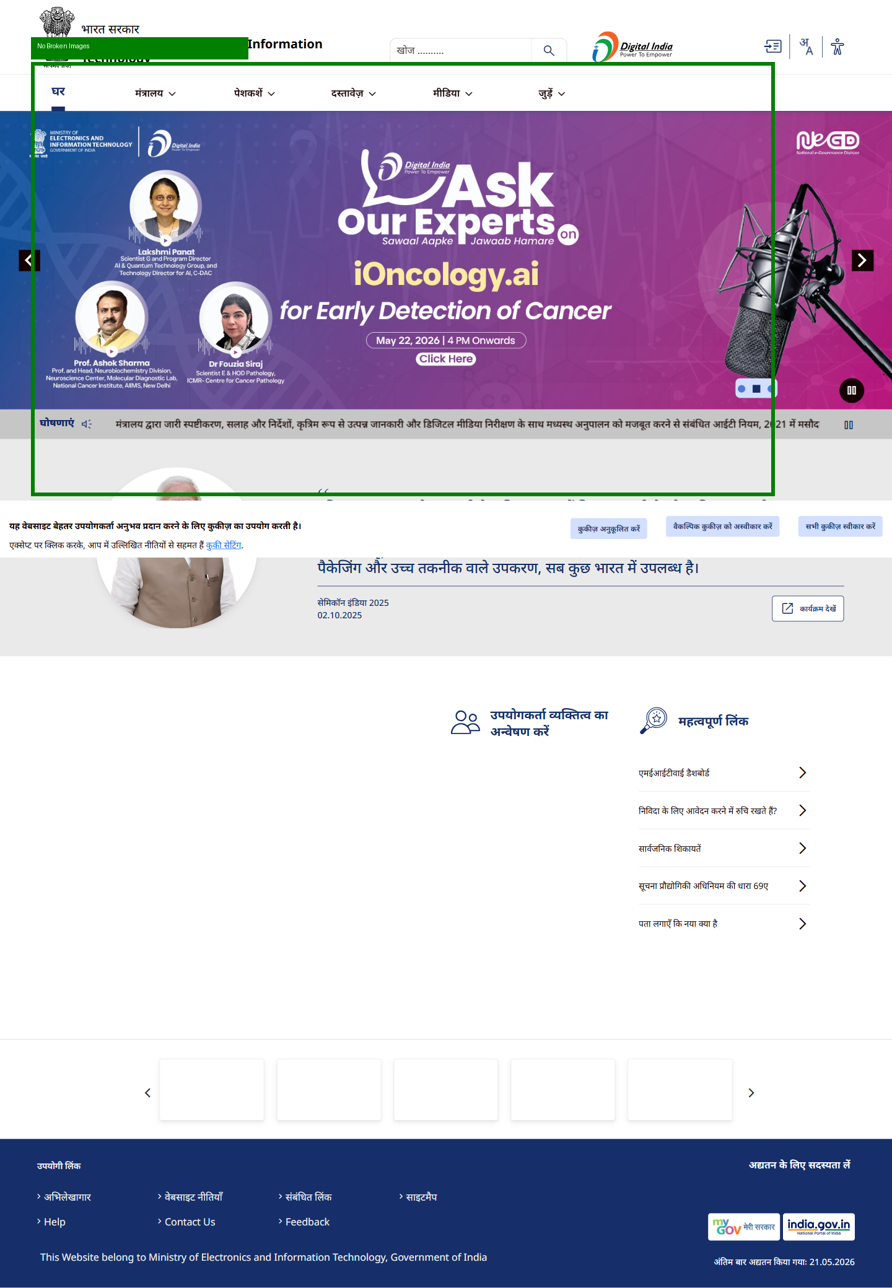

Alt Text Validation
STATUS: NON-COMPLIANT
Some images missing alt text.
