FINAL DBIM SEARCH REPORT
Generated On: 2026-05-22 17:06:40

Requirement 43

Search Bar Detection
STATUS: COMPLIANT
REASON: Search bar detected.
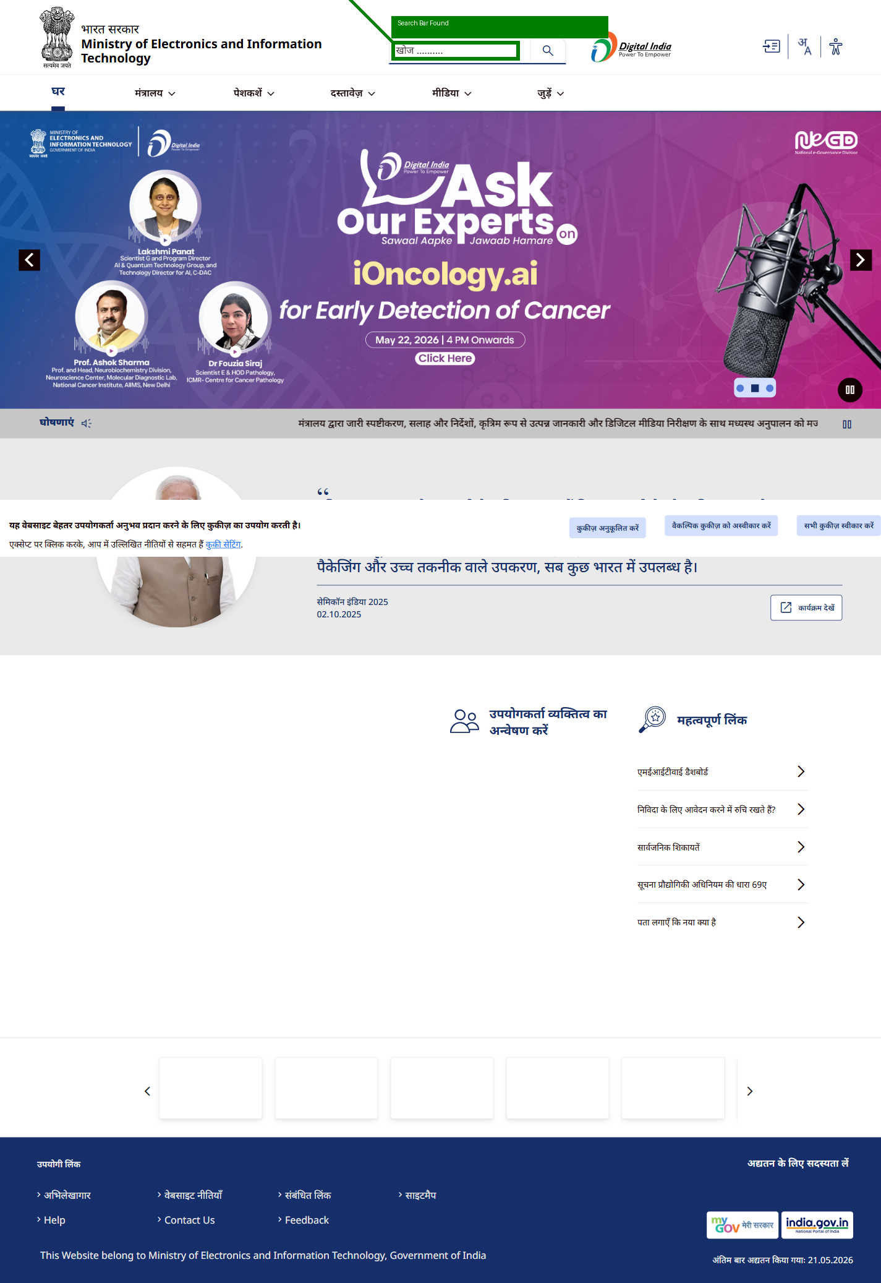

Search Query Input
STATUS: COMPLIANT
REASON: Query input successful.
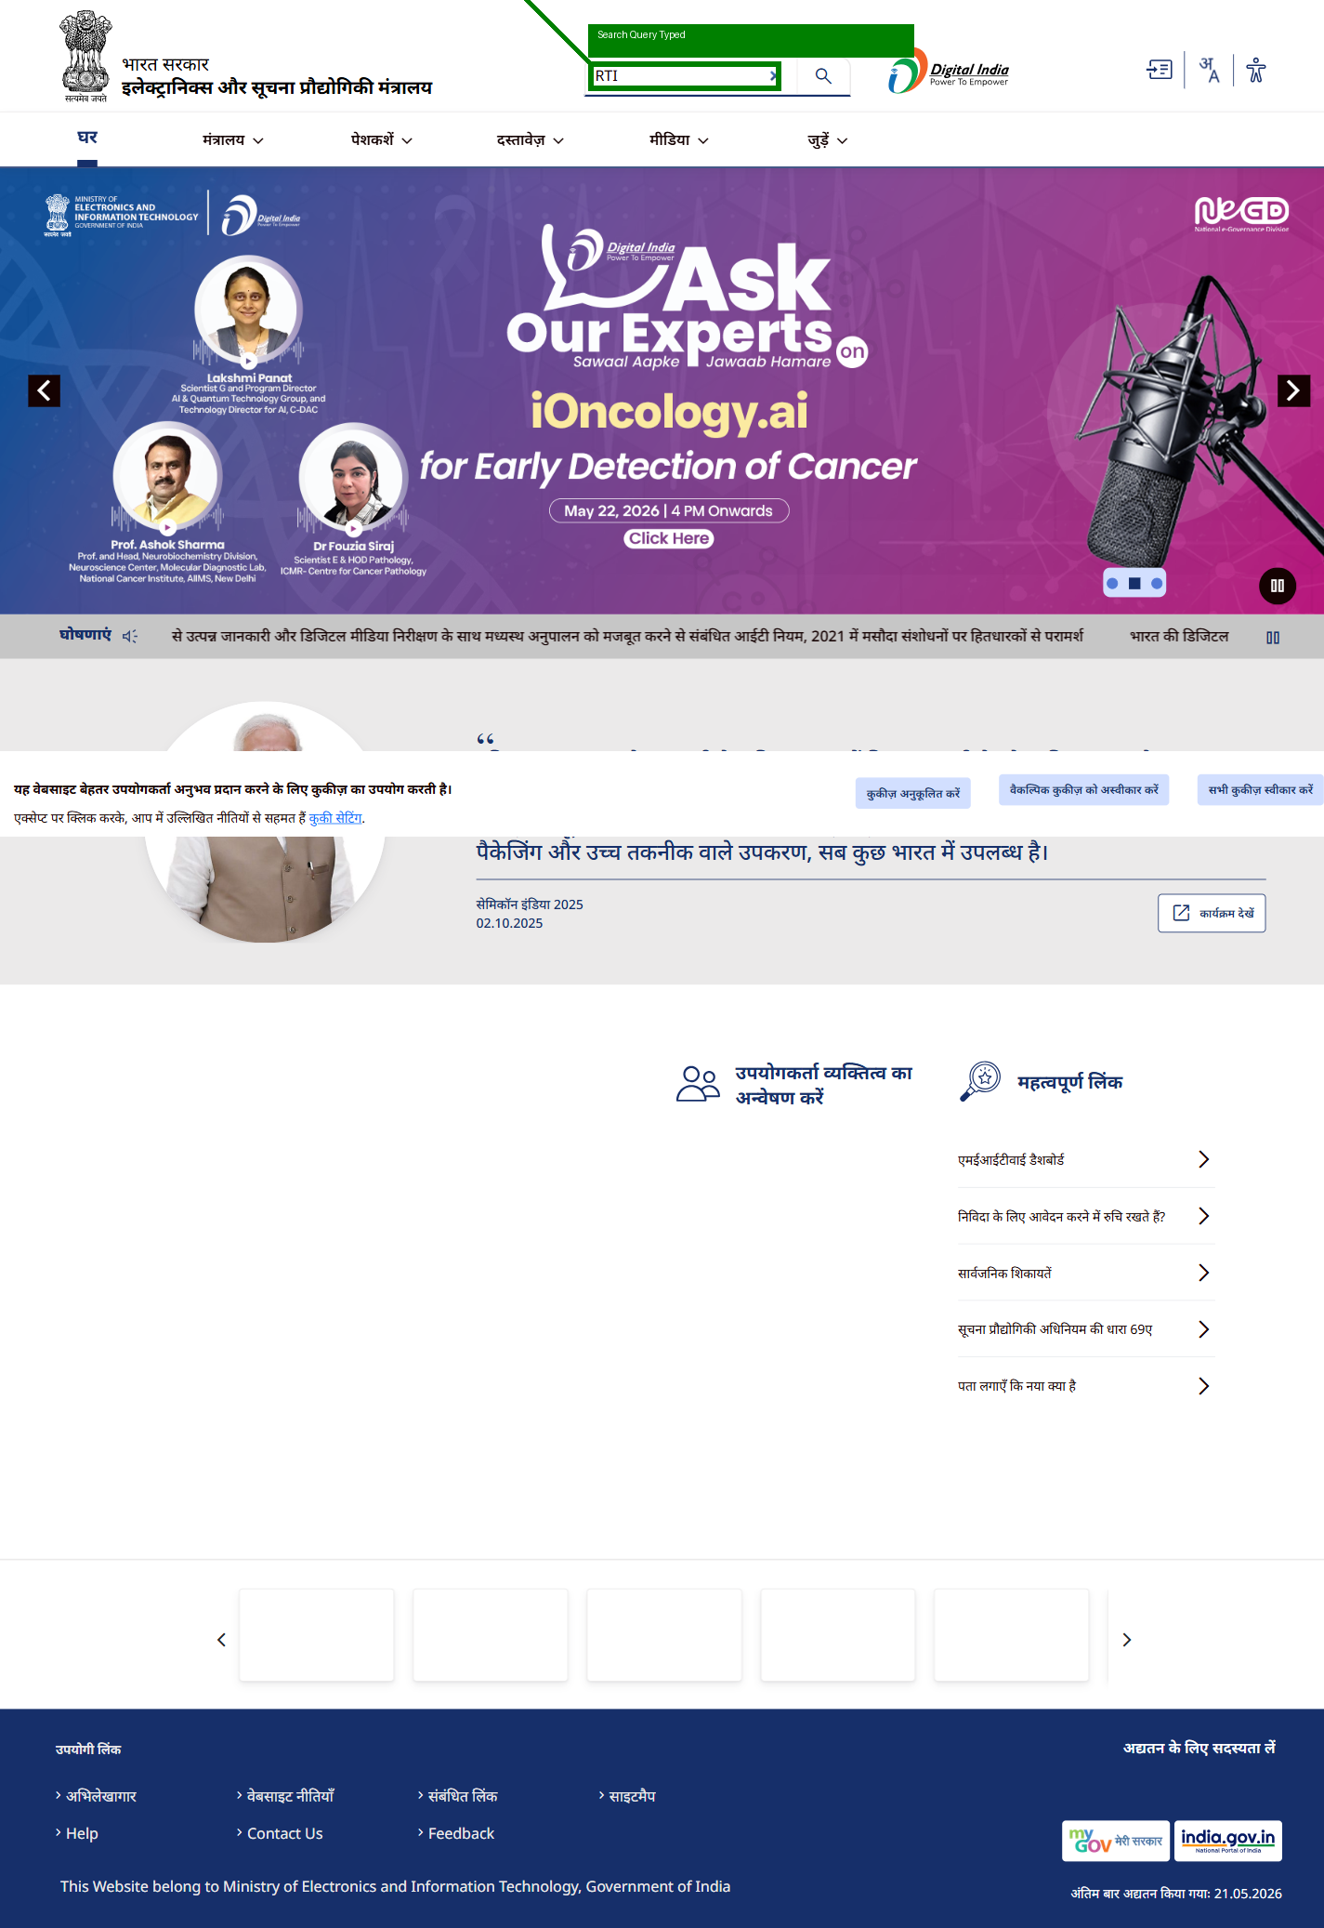

Autocomplete
STATUS: COMPLIANT
REASON: Autocomplete suggestions detected.
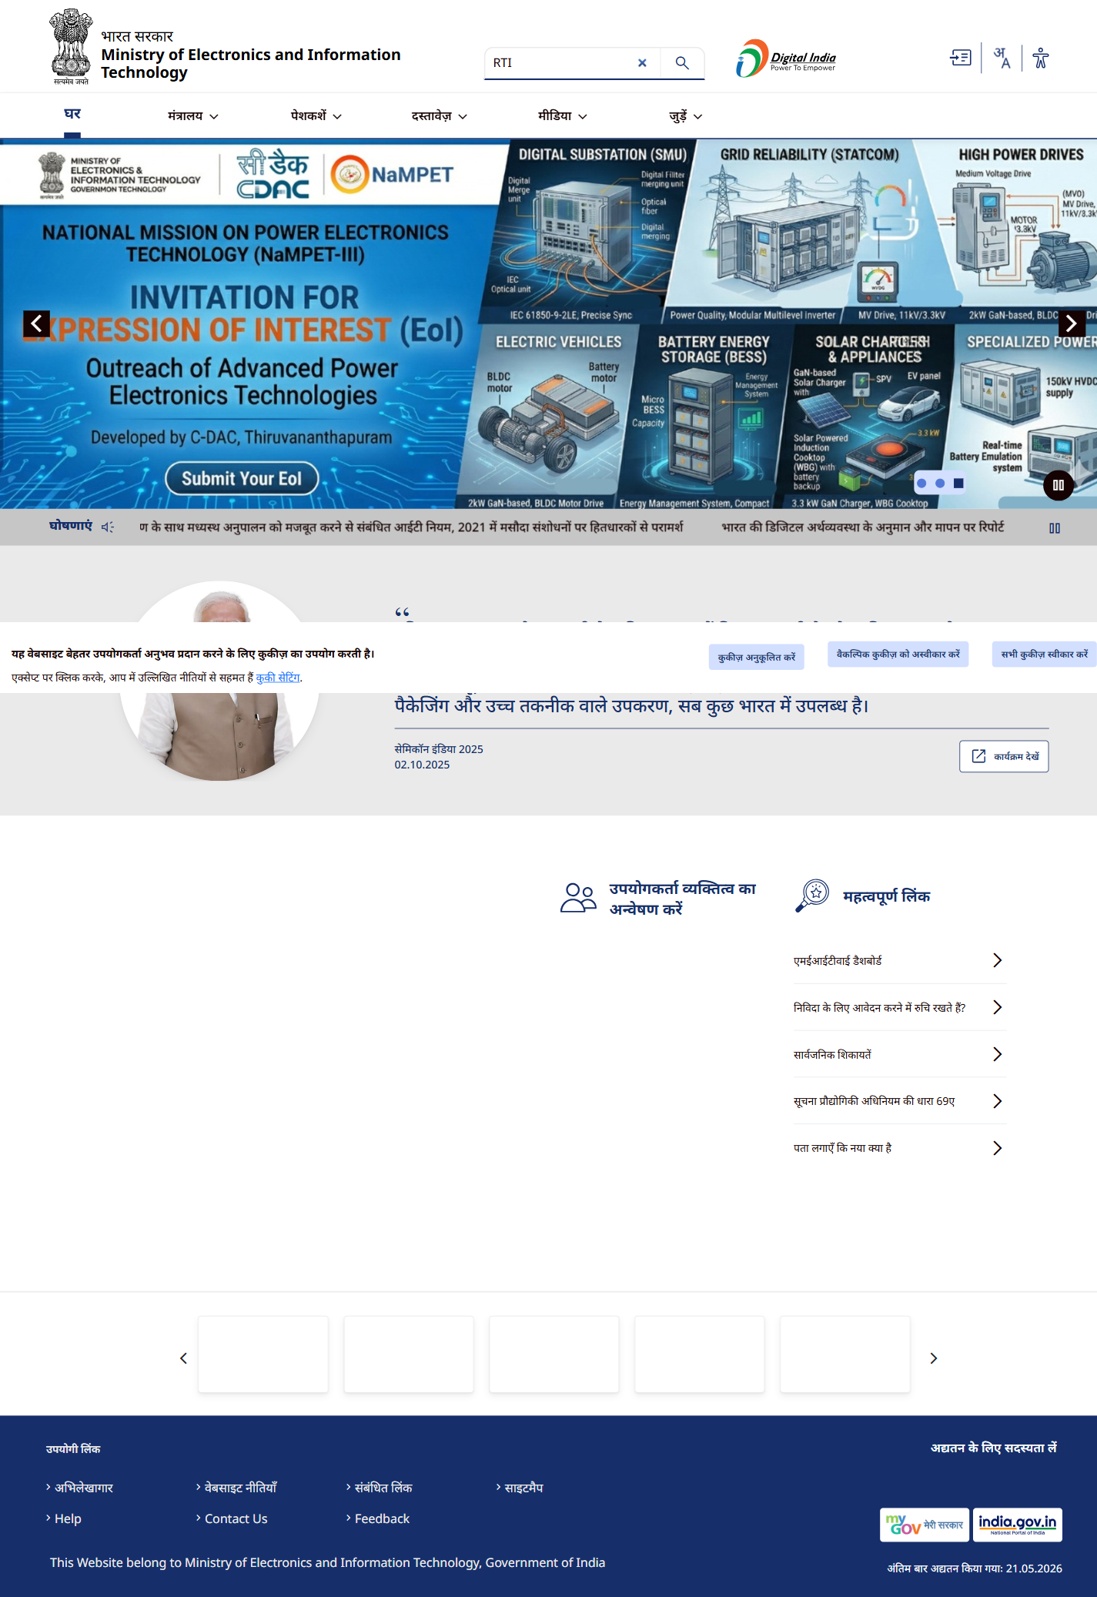

Search Results
STATUS: NON-COMPLIANT
REASON: No meaningful page change detected after search query.
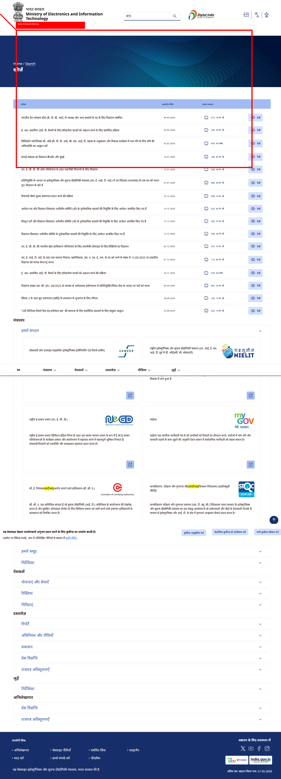

Empty Query Handling
STATUS: COMPLIANT
REASON: Empty query handled properly.
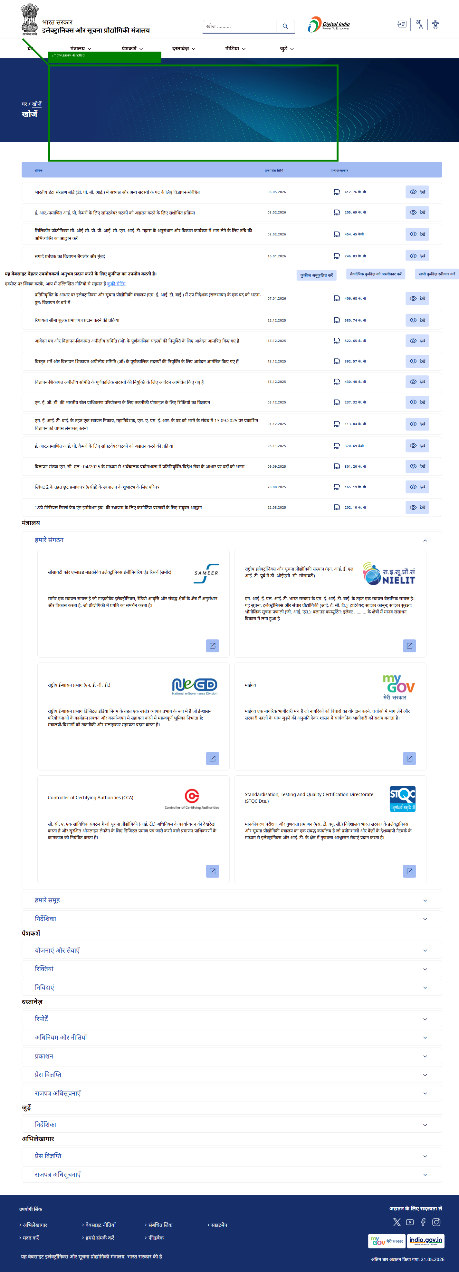

Requirement 44

PDF Searchability
STATUS: COMPLIANT
REASON: Search results contain downloadable PDF/report content.
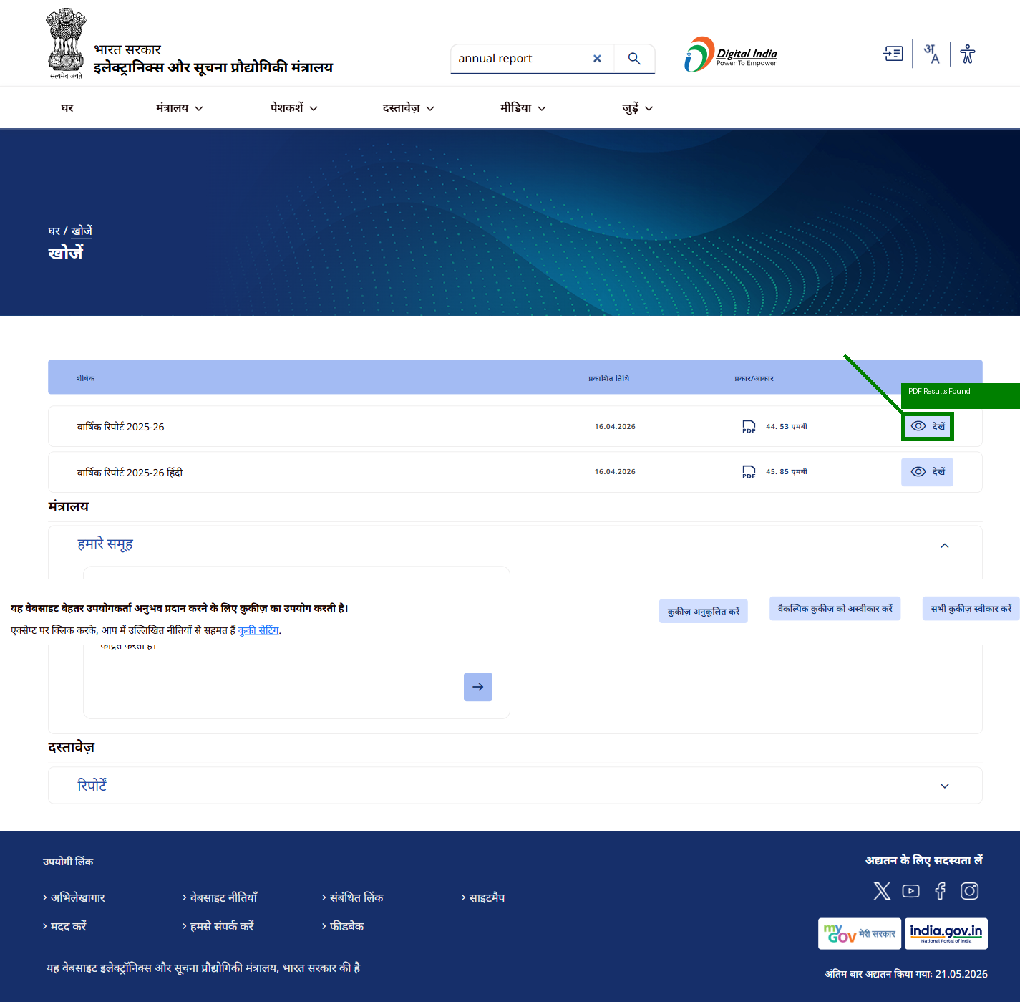

Image Metadata
STATUS: COMPLIANT
REASON: Image metadata detected.
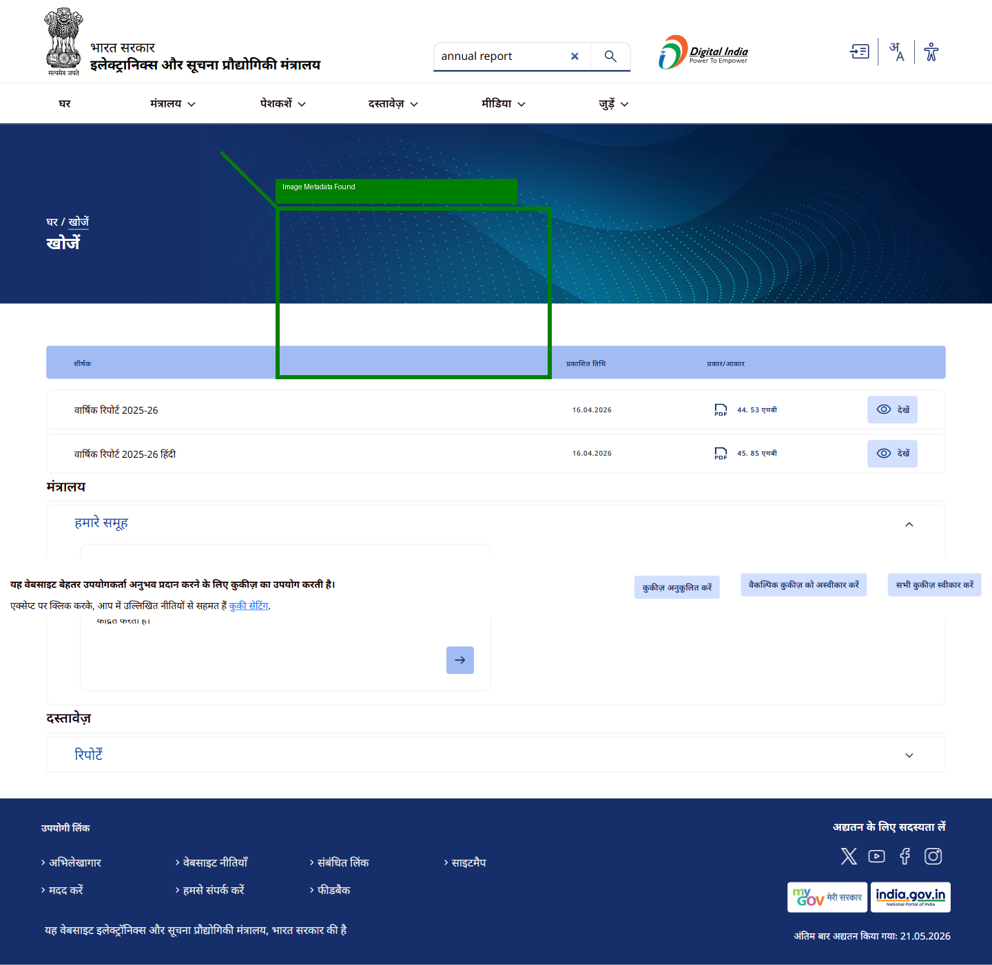

Requirement 45

Meta Description
STATUS: COMPLIANT
REASON: Meta description detected.
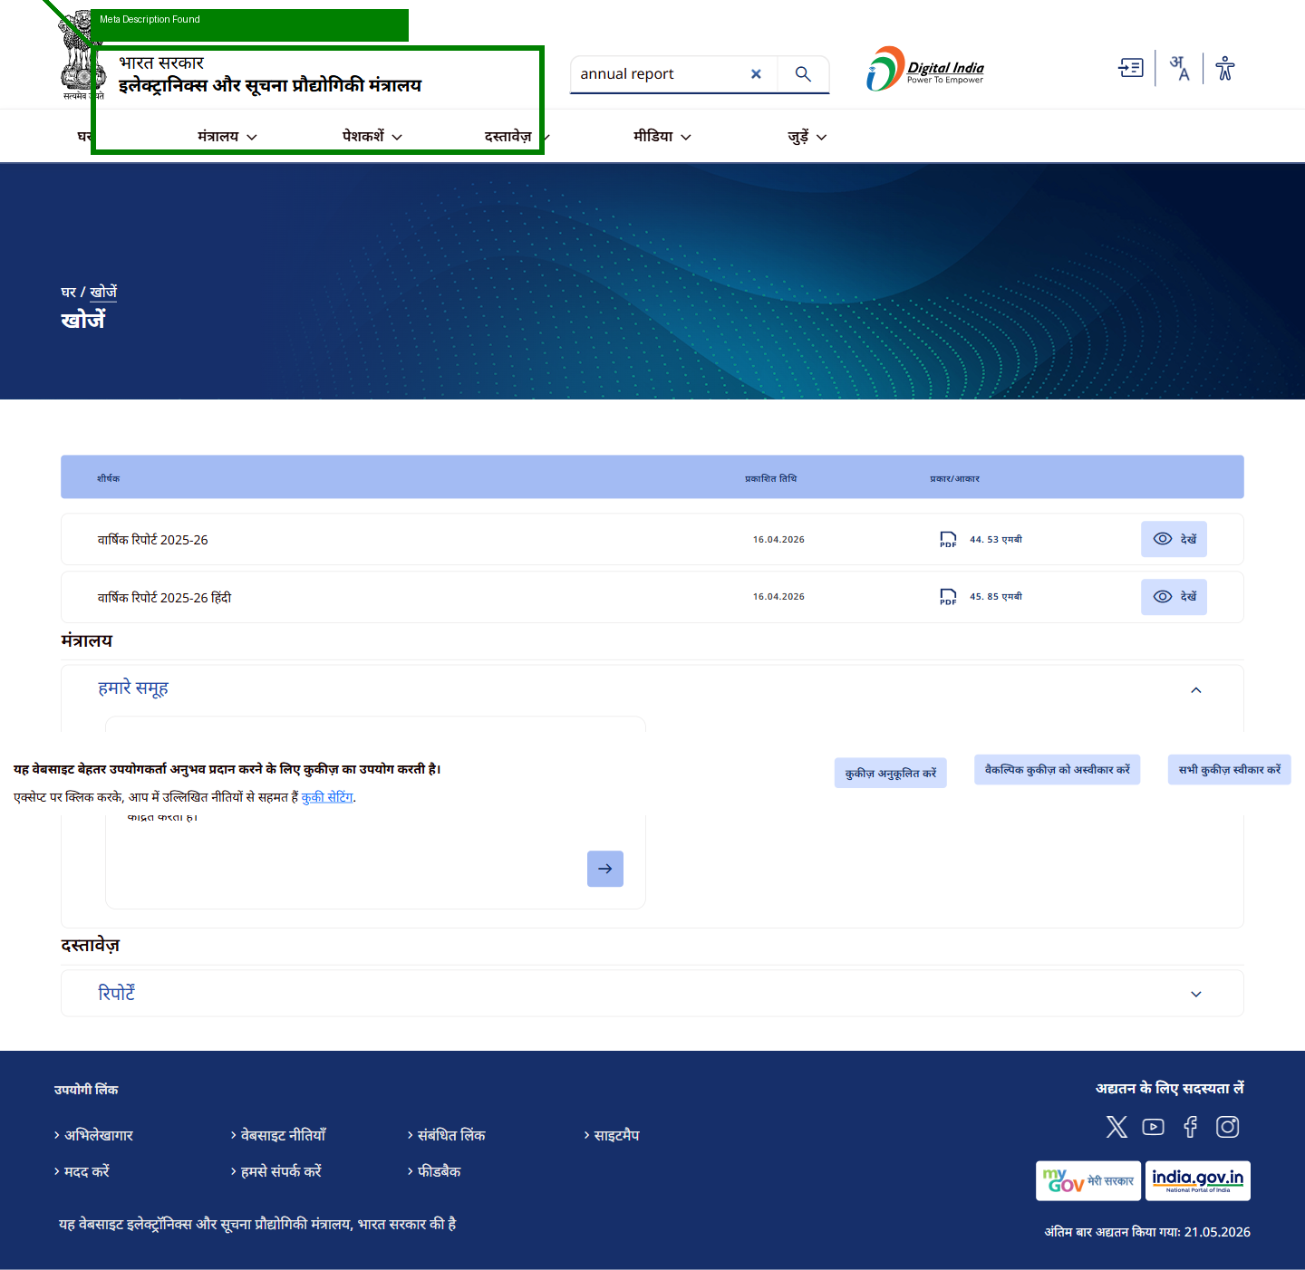

Meta Keywords
STATUS: NON-COMPLIANT
REASON: Meta keywords missing.
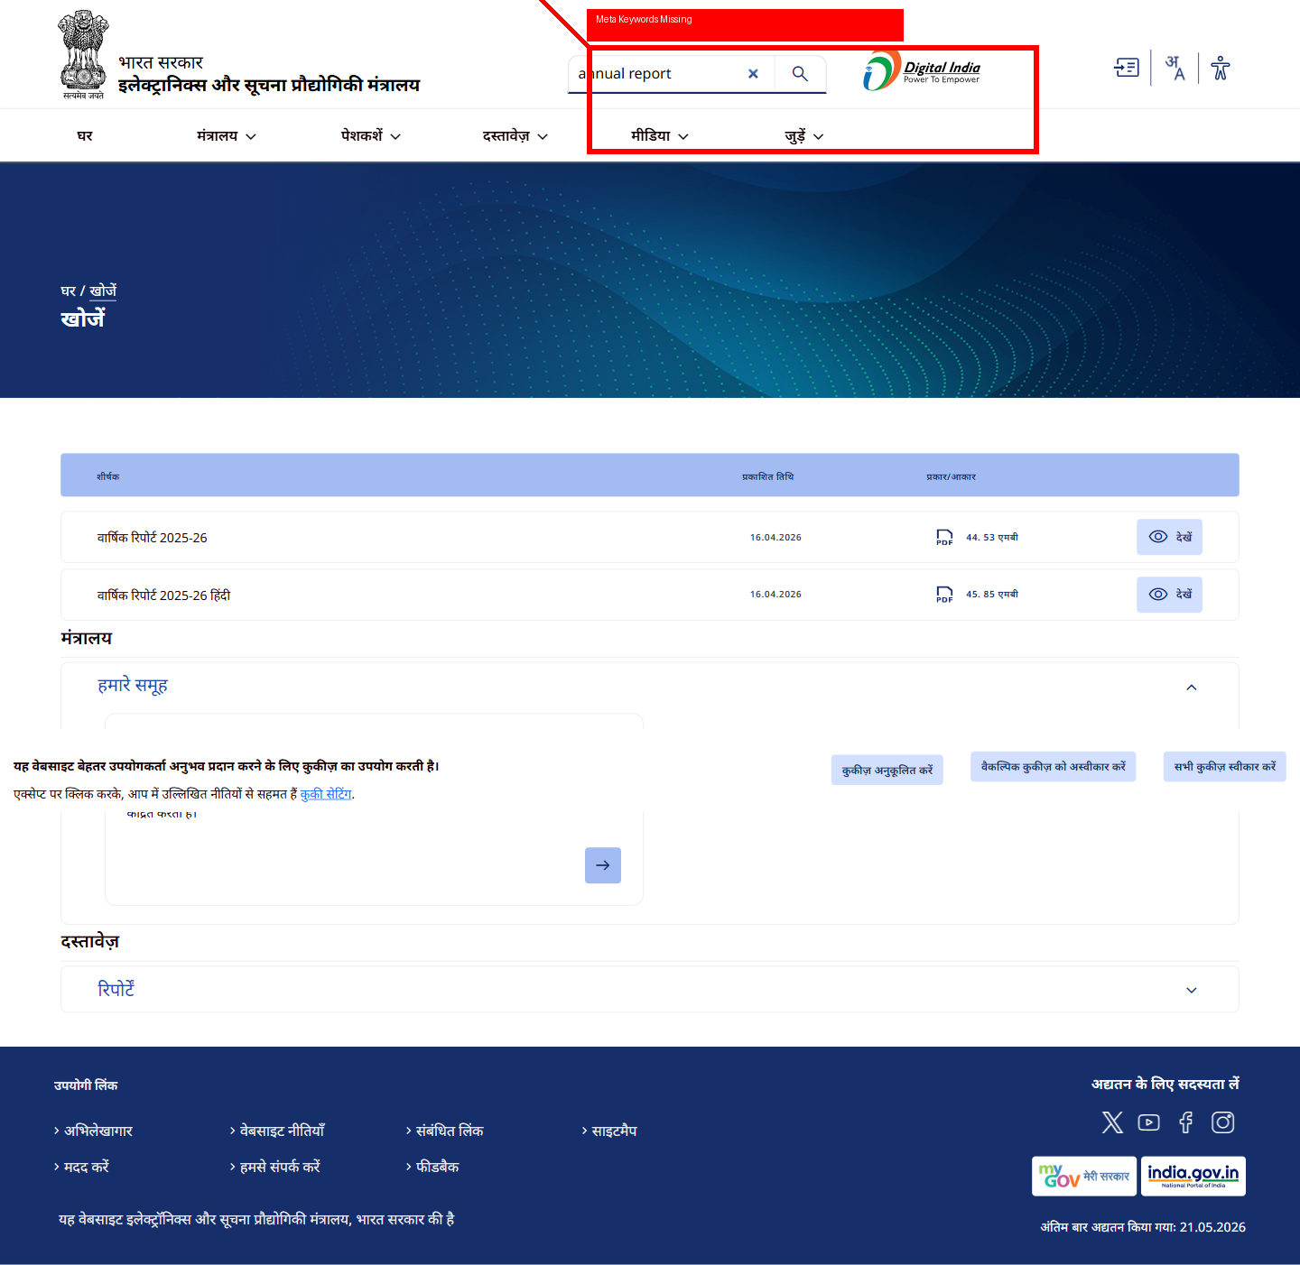

Categorization / Filtering
STATUS: NON-COMPLIANT
REASON: Filtering/categorization missing.
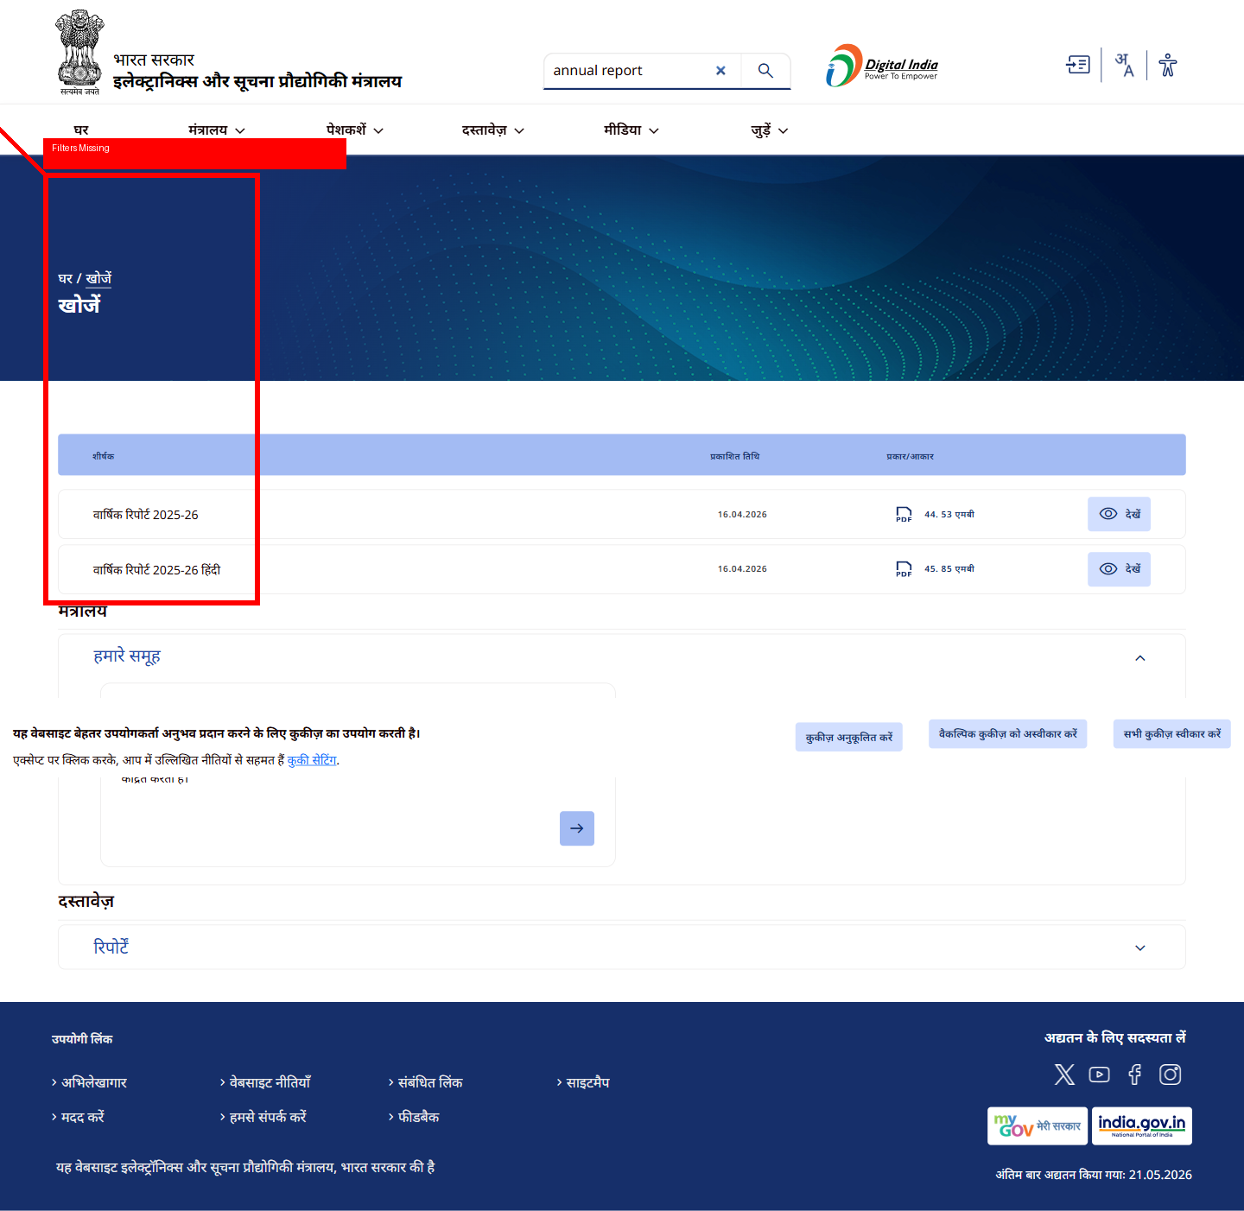

FINAL VERDICT
WEBSITE STATUS: NON-COMPLIANT

