DBIM ICONOGRAPHY COMPLIANCE REPORT
2026-05-25 11:10:23

Icon 0
STATUS: NON-COMPLIANT
Mixed icon style detected (line)
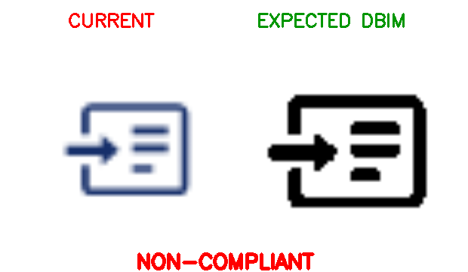
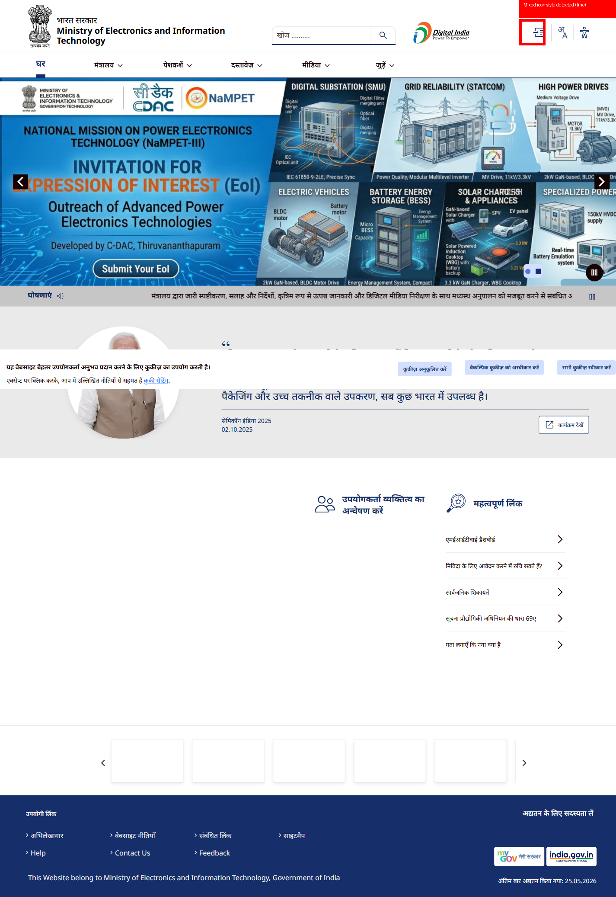

Icon 1
STATUS: NON-COMPLIANT
Mixed icon style detected (line)
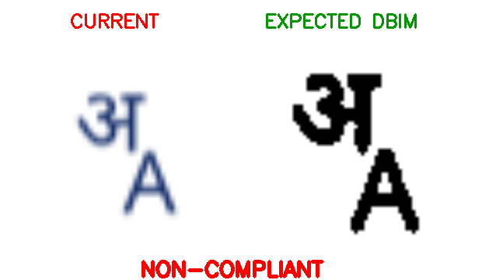
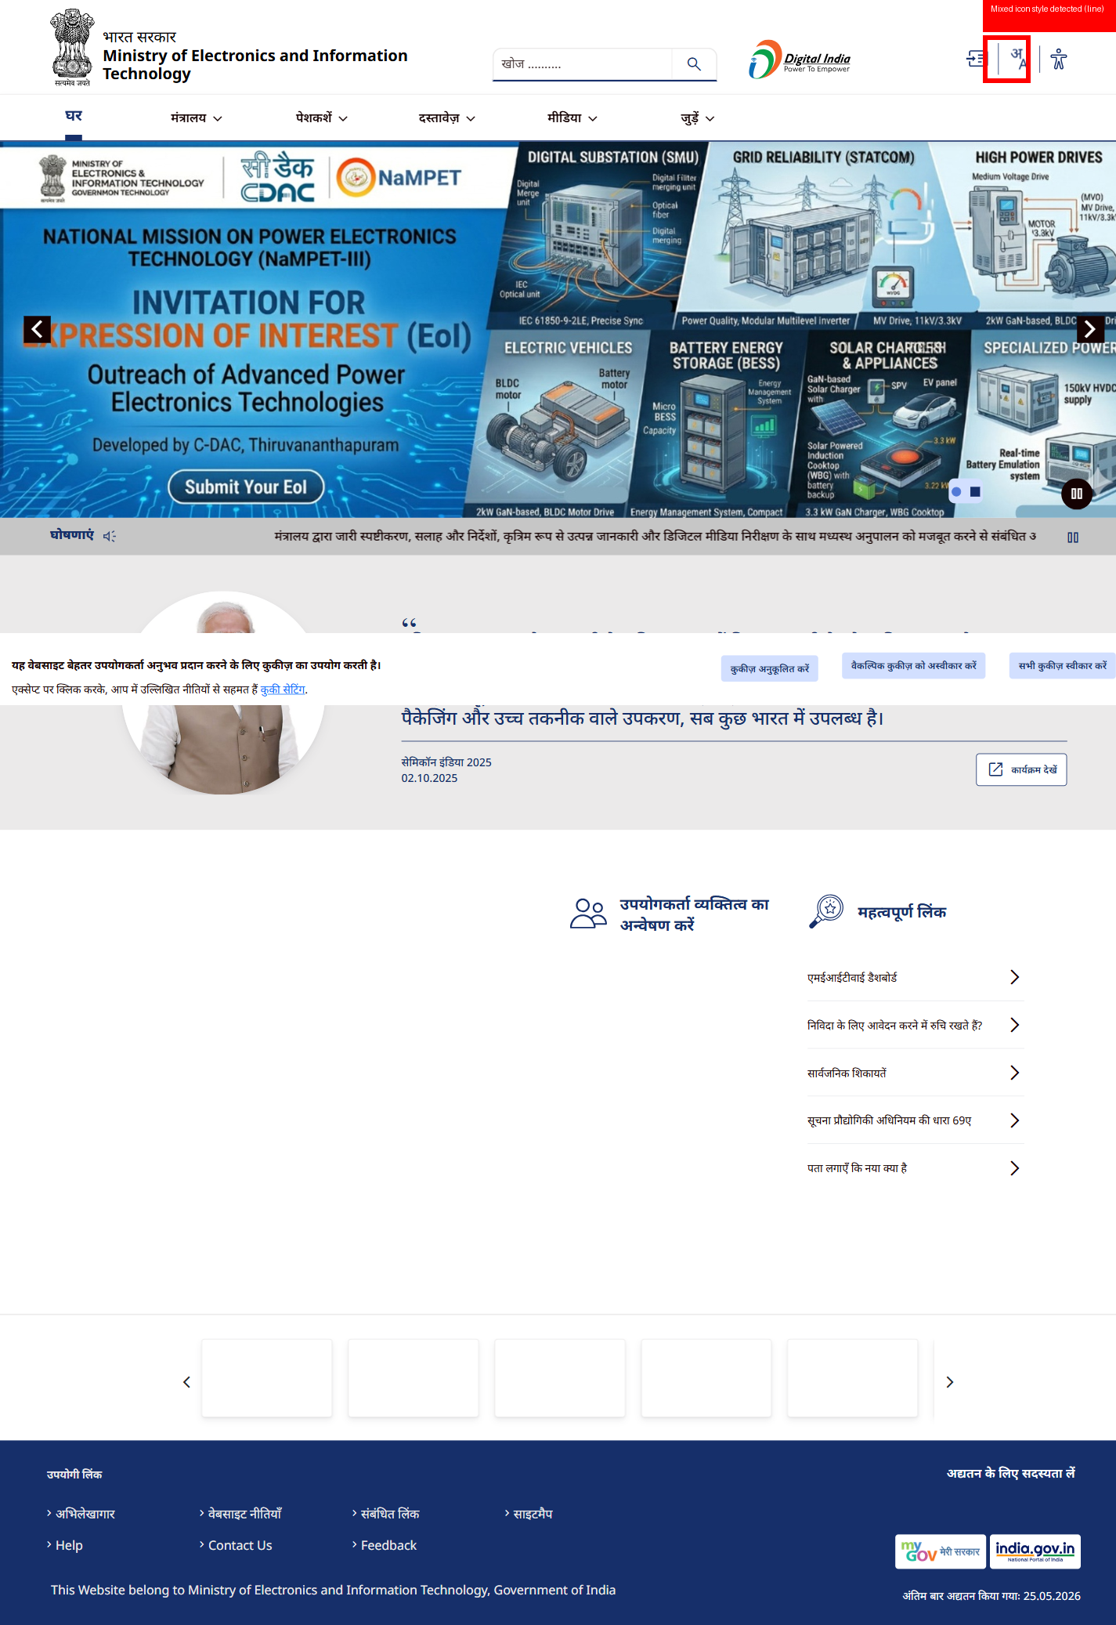

Icon 2
STATUS: COMPLIANT
Icon follows DBIM guidelines for style, size, alignment, contrast and proportion.
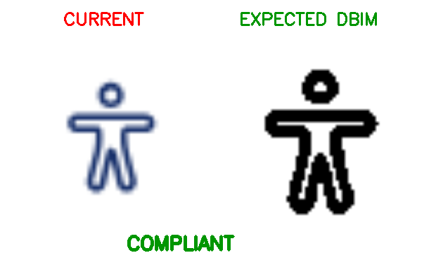
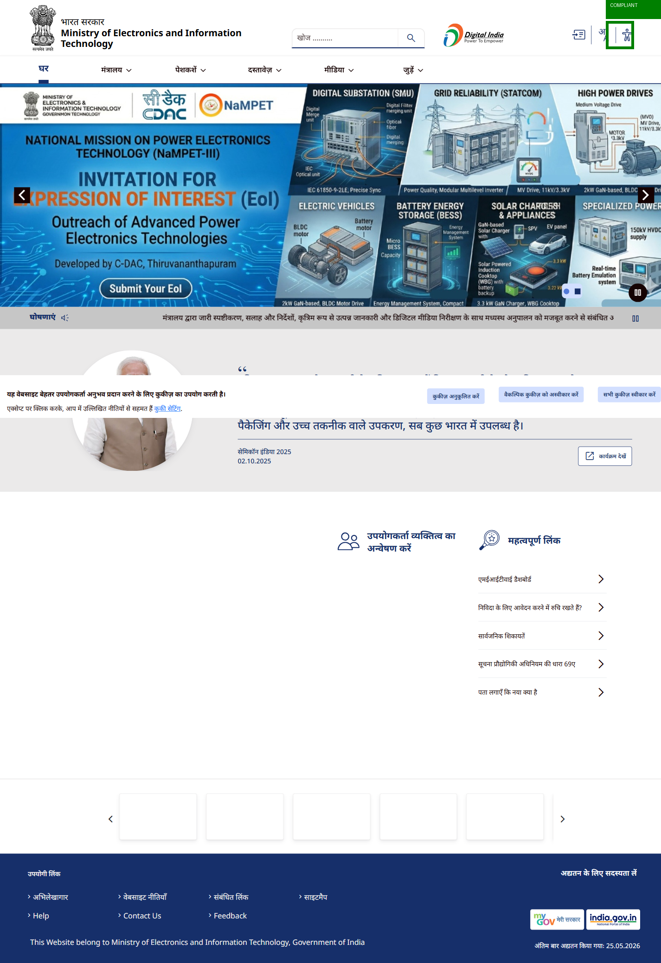

Icon 3
STATUS: NON-COMPLIANT
Detected size: 57x100 px (Expected: 24,32,48,64)
Aspect ratio 0.57 outside DBIM range
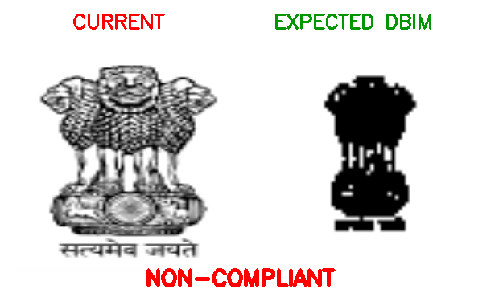
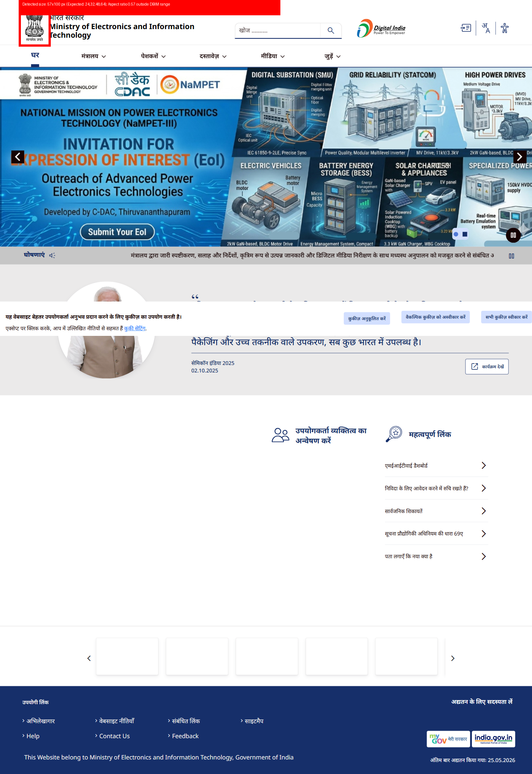

Icon 4
STATUS: COMPLIANT
Icon follows DBIM guidelines for style, size, alignment, contrast and proportion.
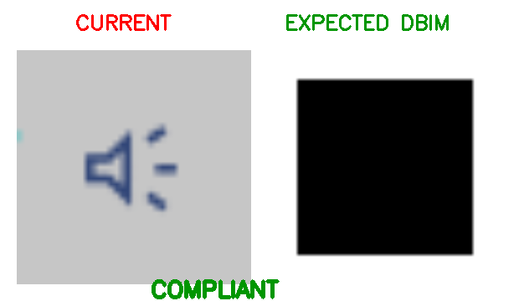
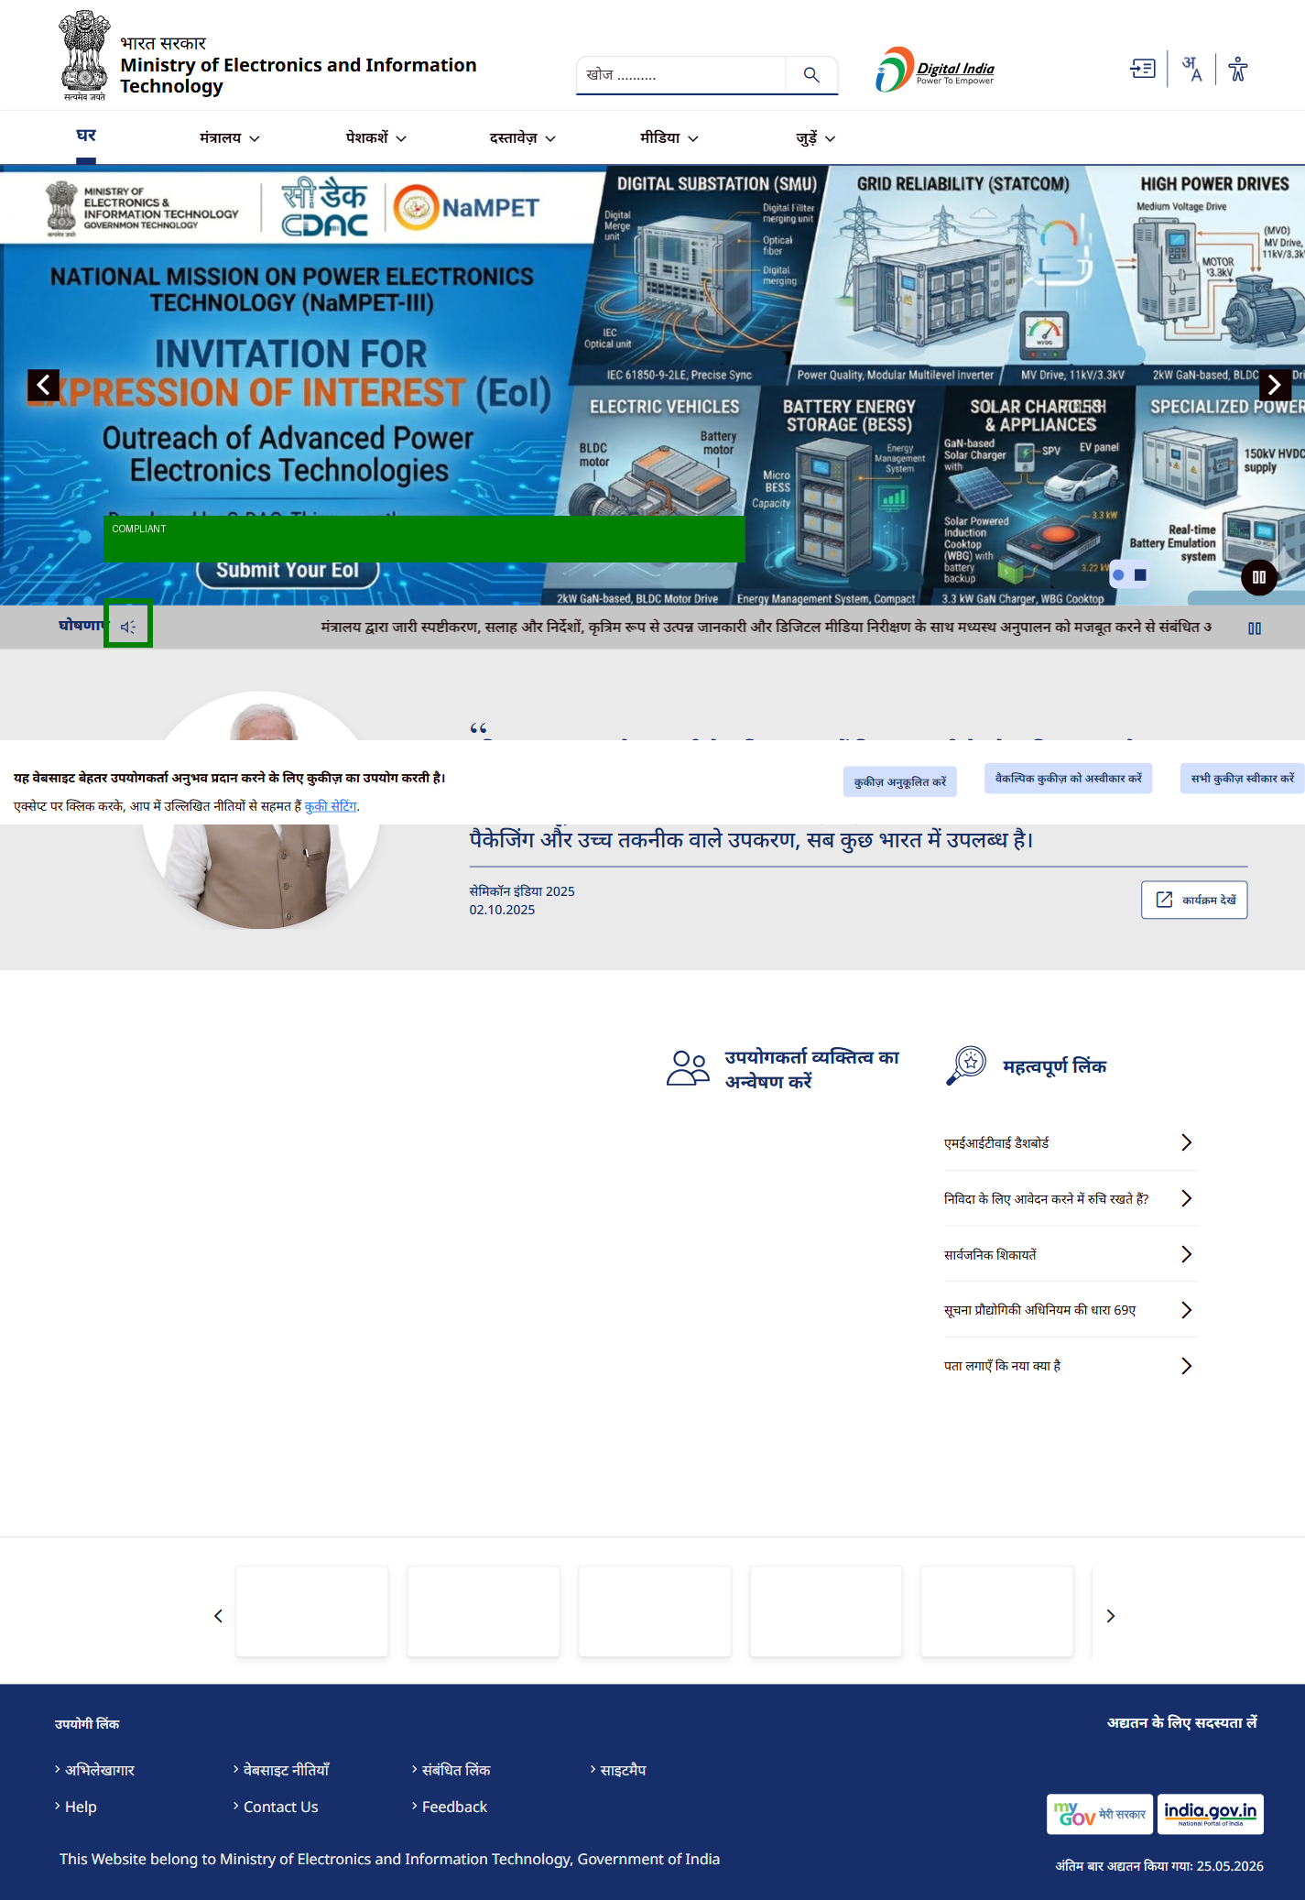

Icon 5
STATUS: COMPLIANT
Icon follows DBIM guidelines for style, size, alignment, contrast and proportion.
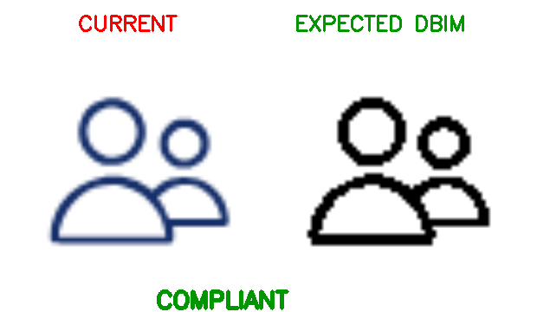
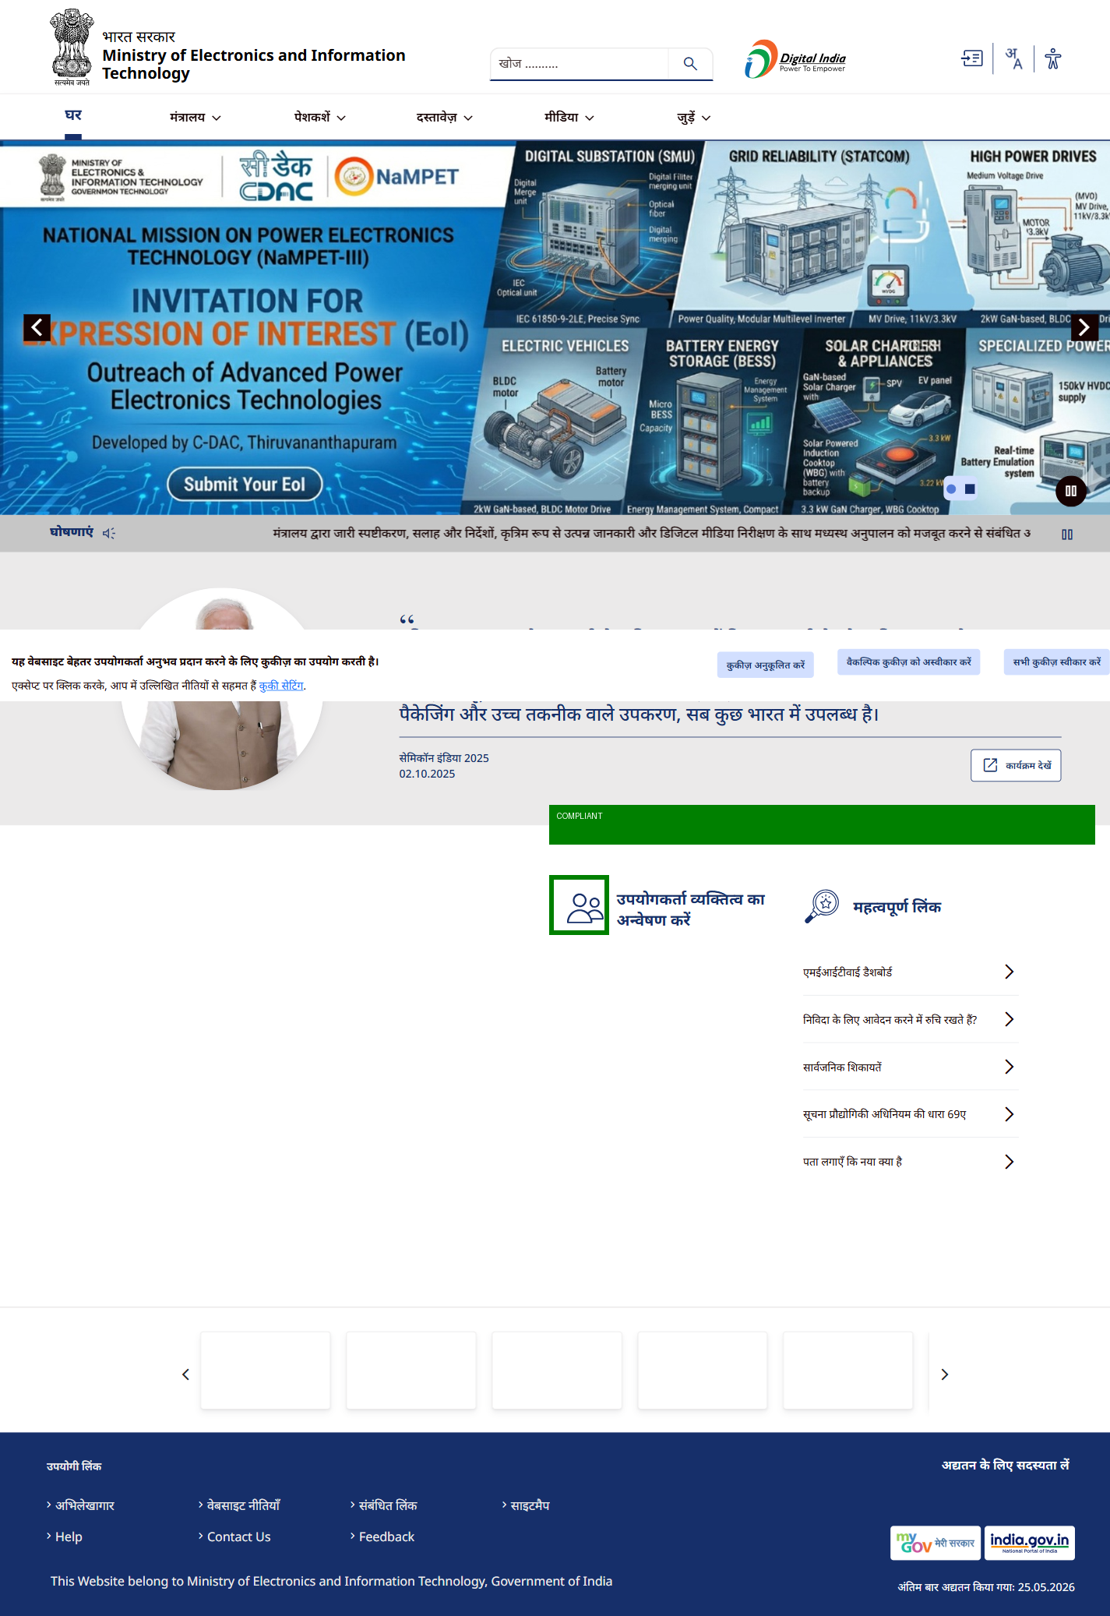

Icon 6
STATUS: COMPLIANT
Icon follows DBIM guidelines for style, size, alignment, contrast and proportion.
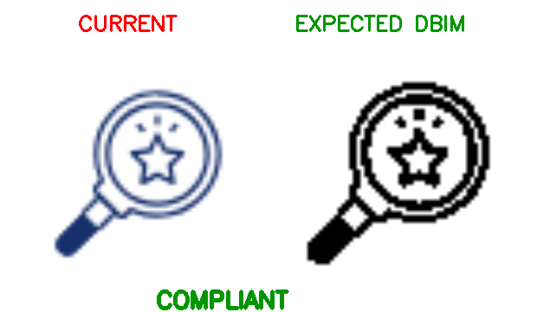
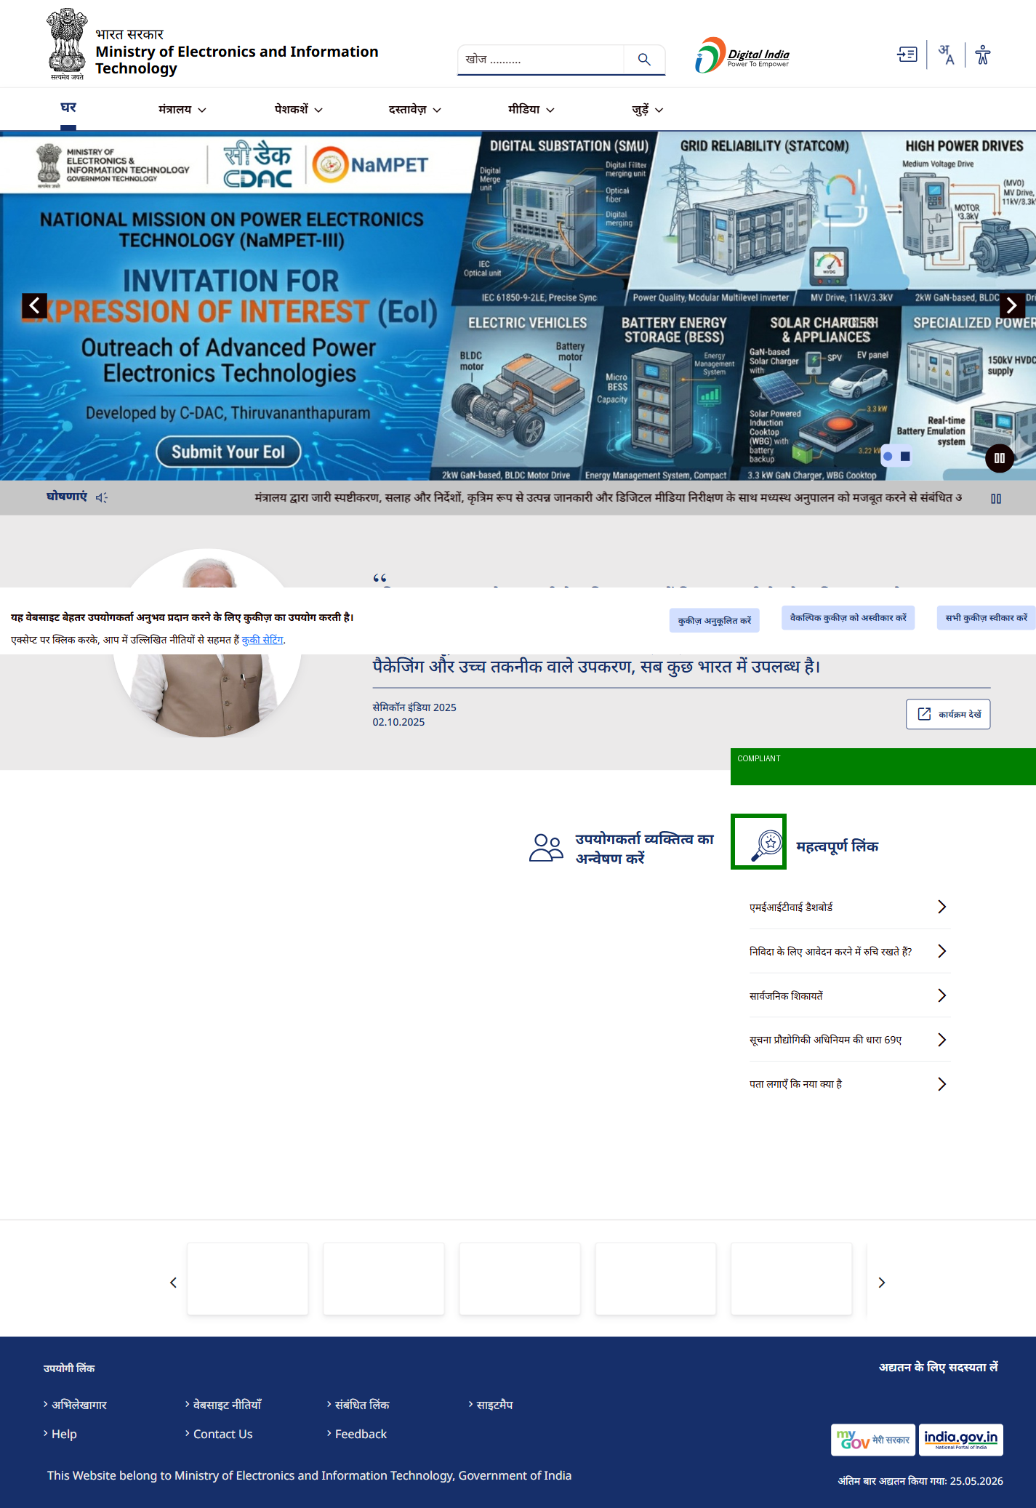

Icon 7
STATUS: NON-COMPLIANT
Mixed icon style detected (line)



Icon 8
STATUS: NON-COMPLIANT
Detected size: 46x39 px (Expected: 24,32,48,64)
Icon not properly centered
