DBIM ICONOGRAPHY COMPLIANCE REPORT
2026-05-25 11:51:05

Icon 0
STATUS: COMPLIANT
Original asset and rendered display comply with DBIM guidelines for style, size, proportion, alignment and contrast.
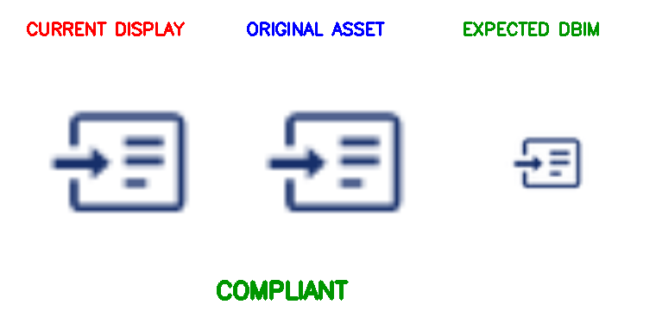
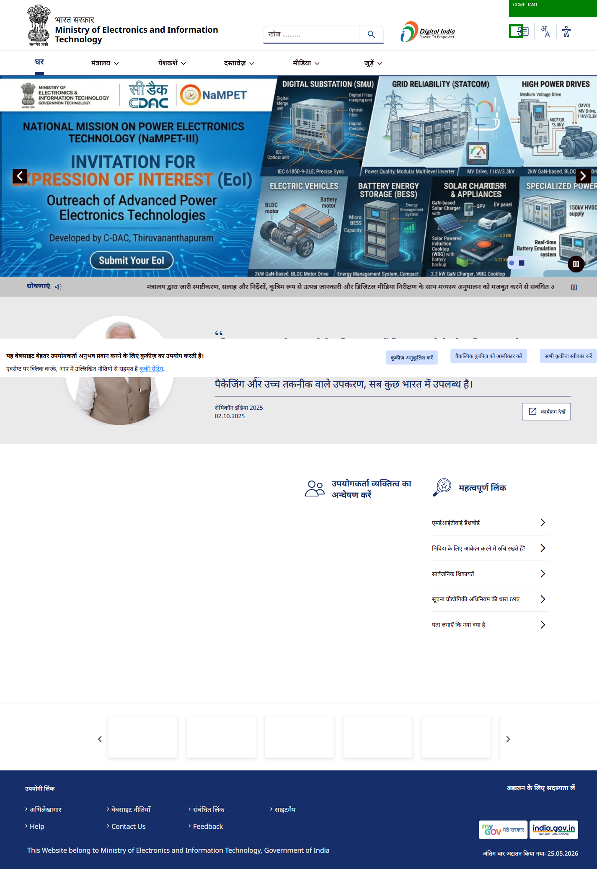

Icon 1
STATUS: COMPLIANT
Original asset and rendered display comply with DBIM guidelines for style, size, proportion, alignment and contrast.
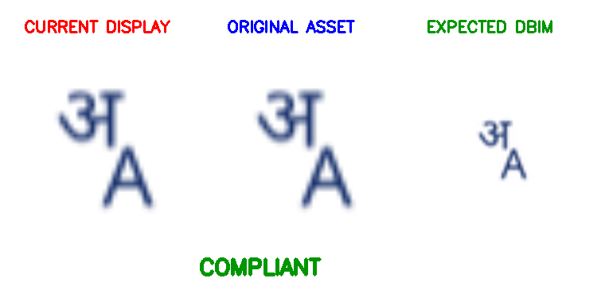
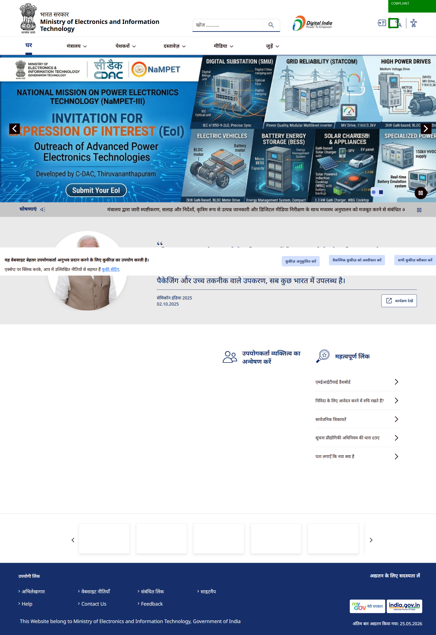

Icon 2
STATUS: NON-COMPLIANT
Detected style: filled; Expected dominant style: line
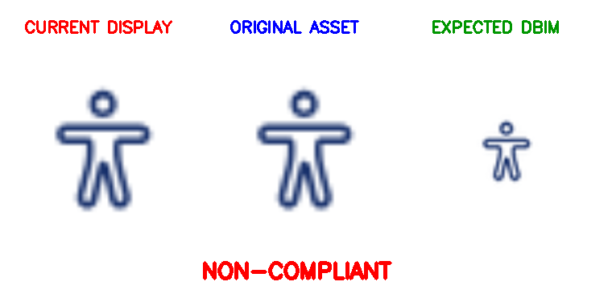
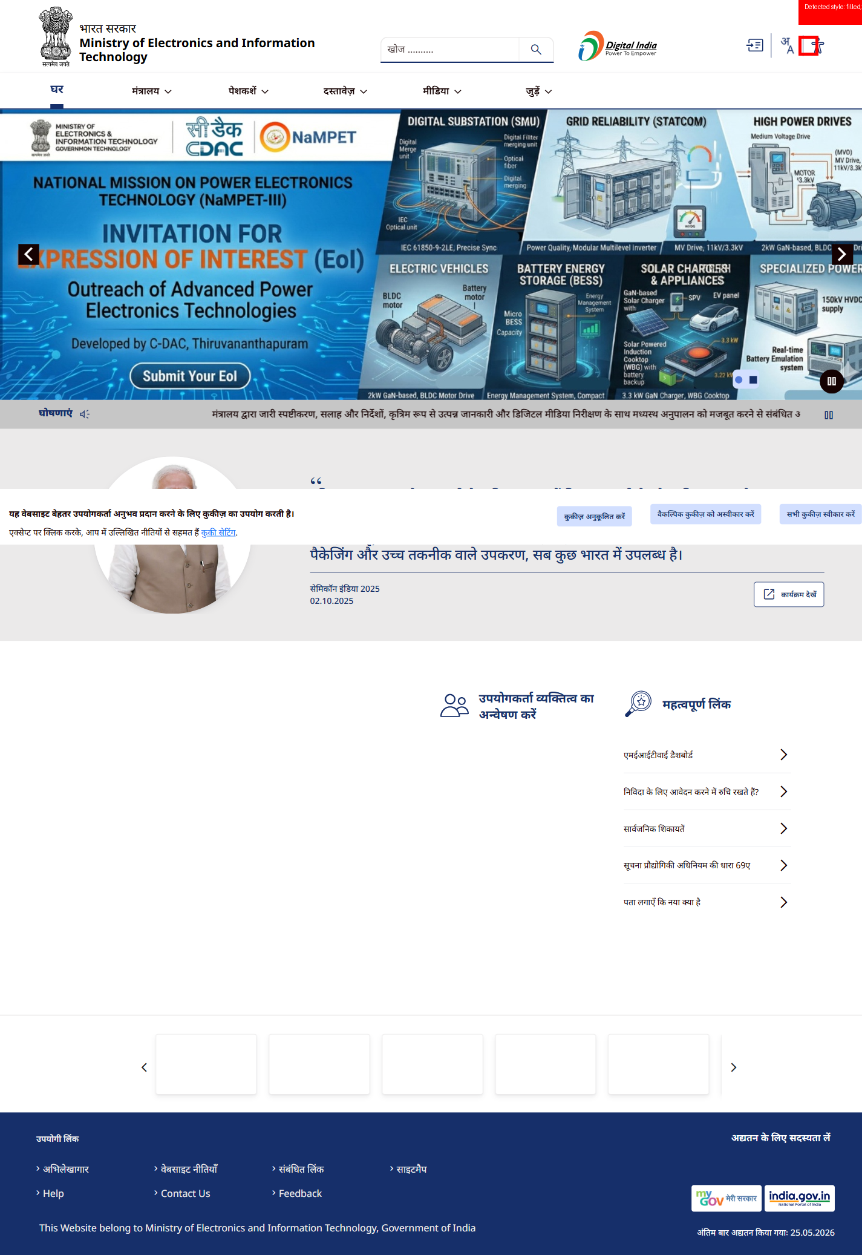

Icon 3
STATUS: NON-COMPLIANT
Detected style: filled; Expected dominant style: line
Rendered size: 57x100 px; Expected DBIM sizes: 24x24,32x32,48x48,64x64
Rendered aspect ratio: 0.57; Icon appears stretched
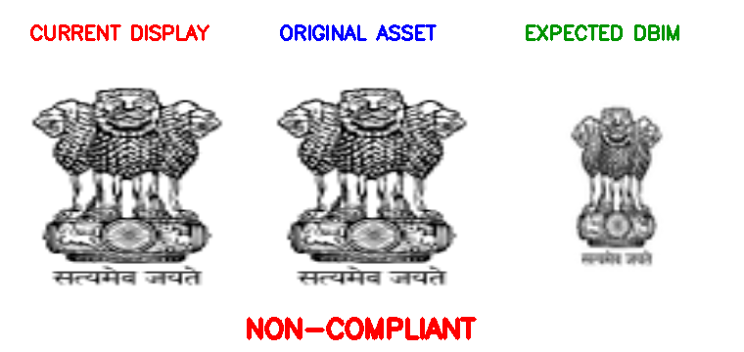
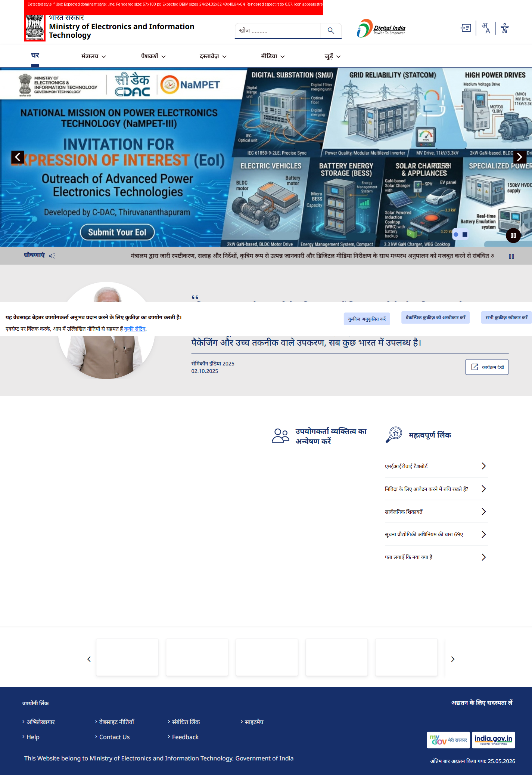

Icon 4
STATUS: NON-COMPLIANT
Detected style: filled; Expected dominant style: line
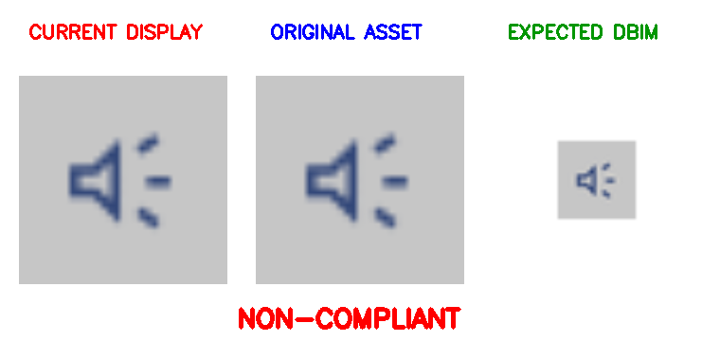
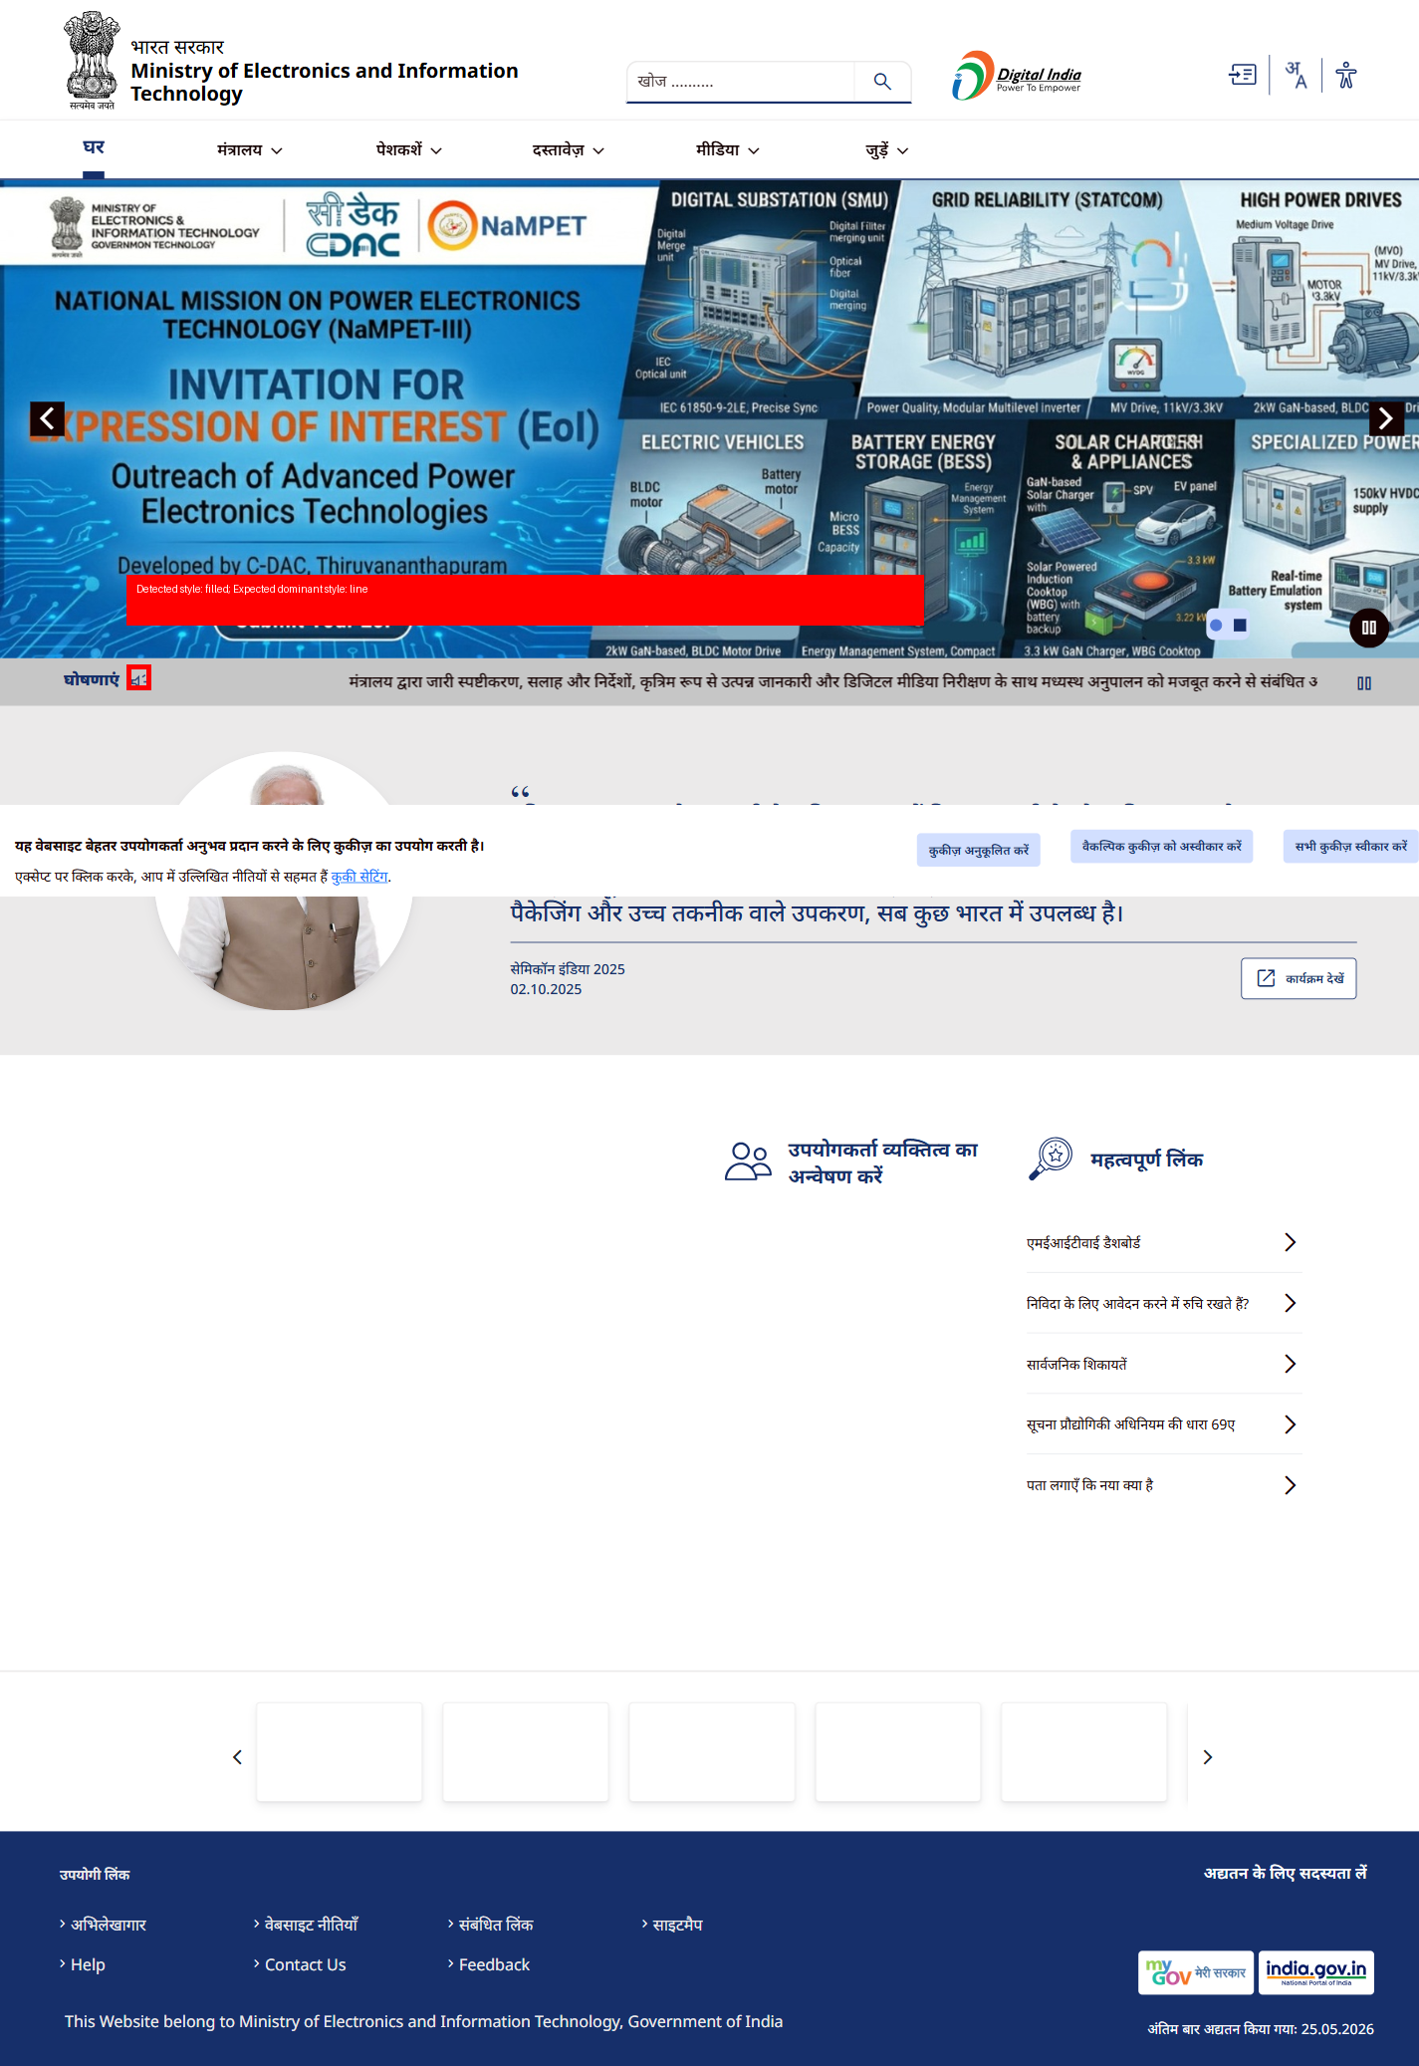

Icon 5
STATUS: NON-COMPLIANT
Detected style: filled; Expected dominant style: line
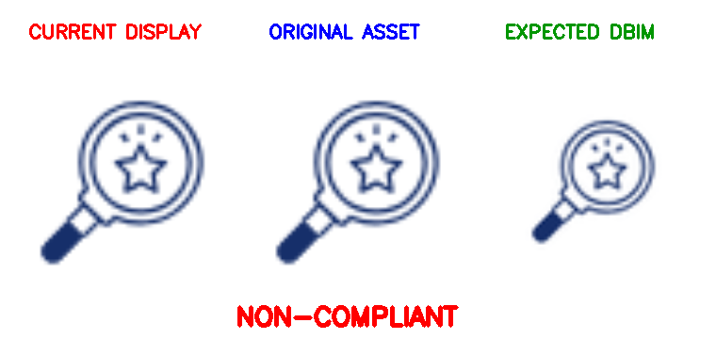
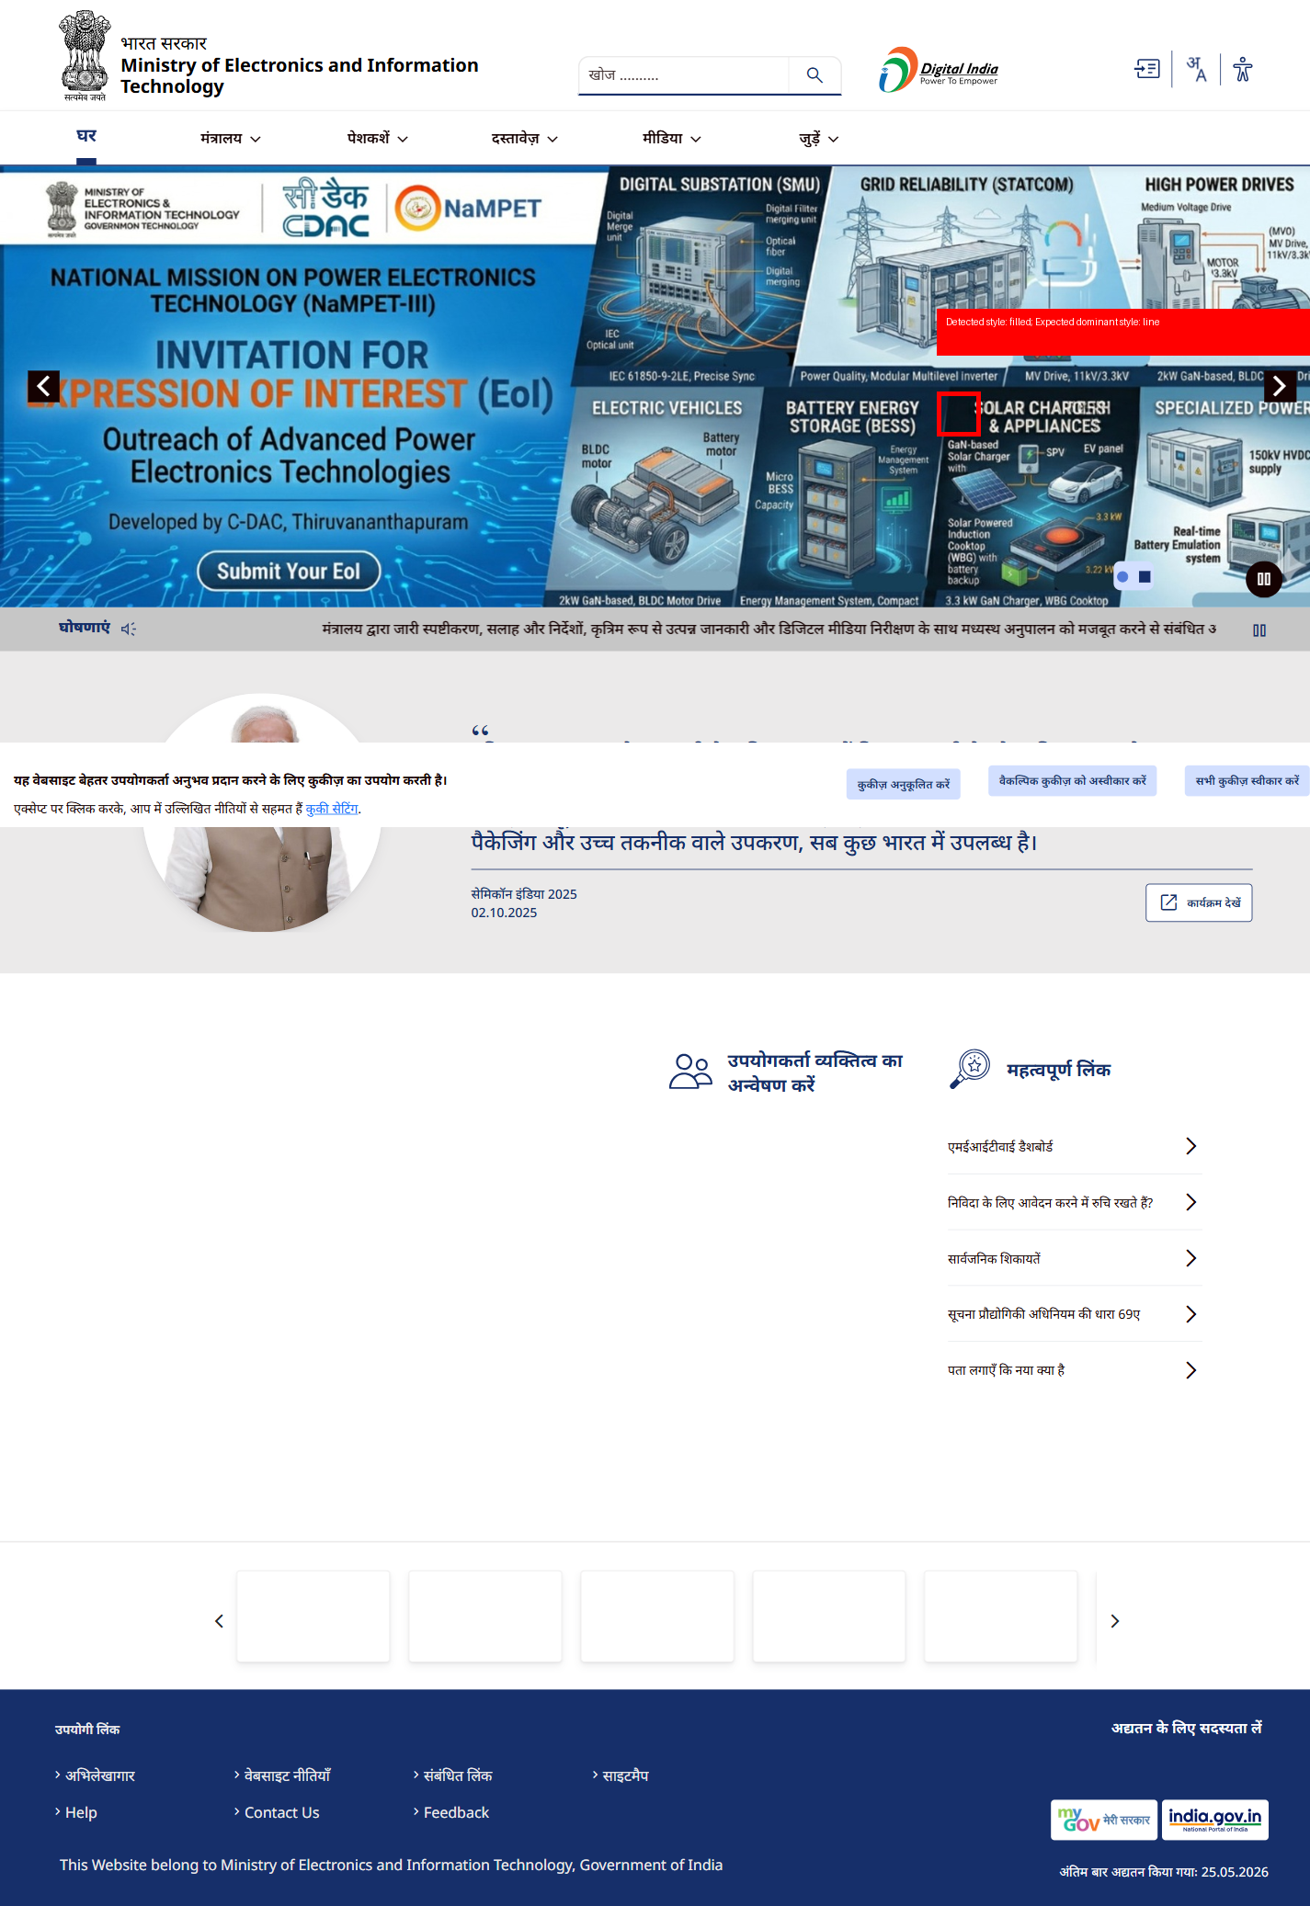

Icon 6
STATUS: NON-COMPLIANT
Rendered size: 131x50 px; Expected DBIM sizes: 24x24,32x32,48x48,64x64
Rendered aspect ratio: 2.62; Icon appears stretched
Icon content not properly centered
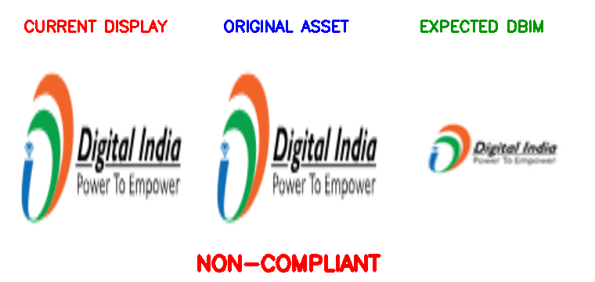
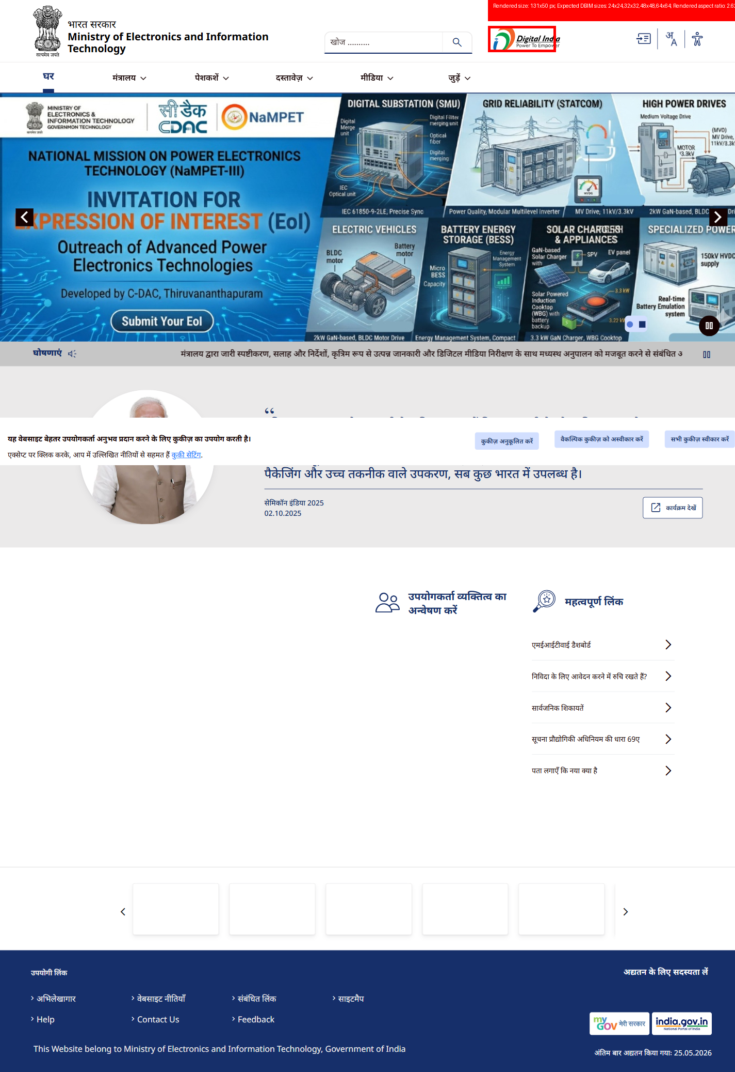

Icon 7
STATUS: NON-COMPLIANT
Rendered size: 100x40 px; Expected DBIM sizes: 24x24,32x32,48x48,64x64
Rendered aspect ratio: 2.5; Icon appears stretched
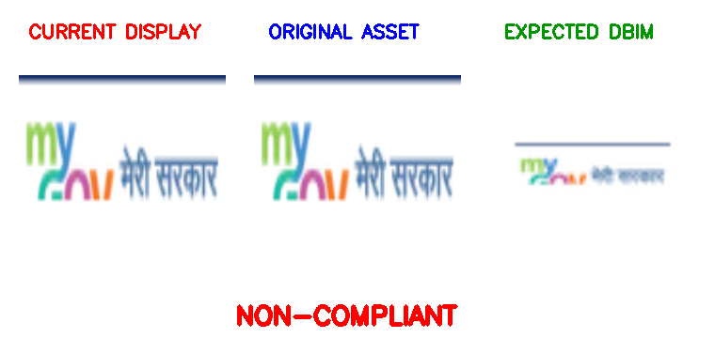
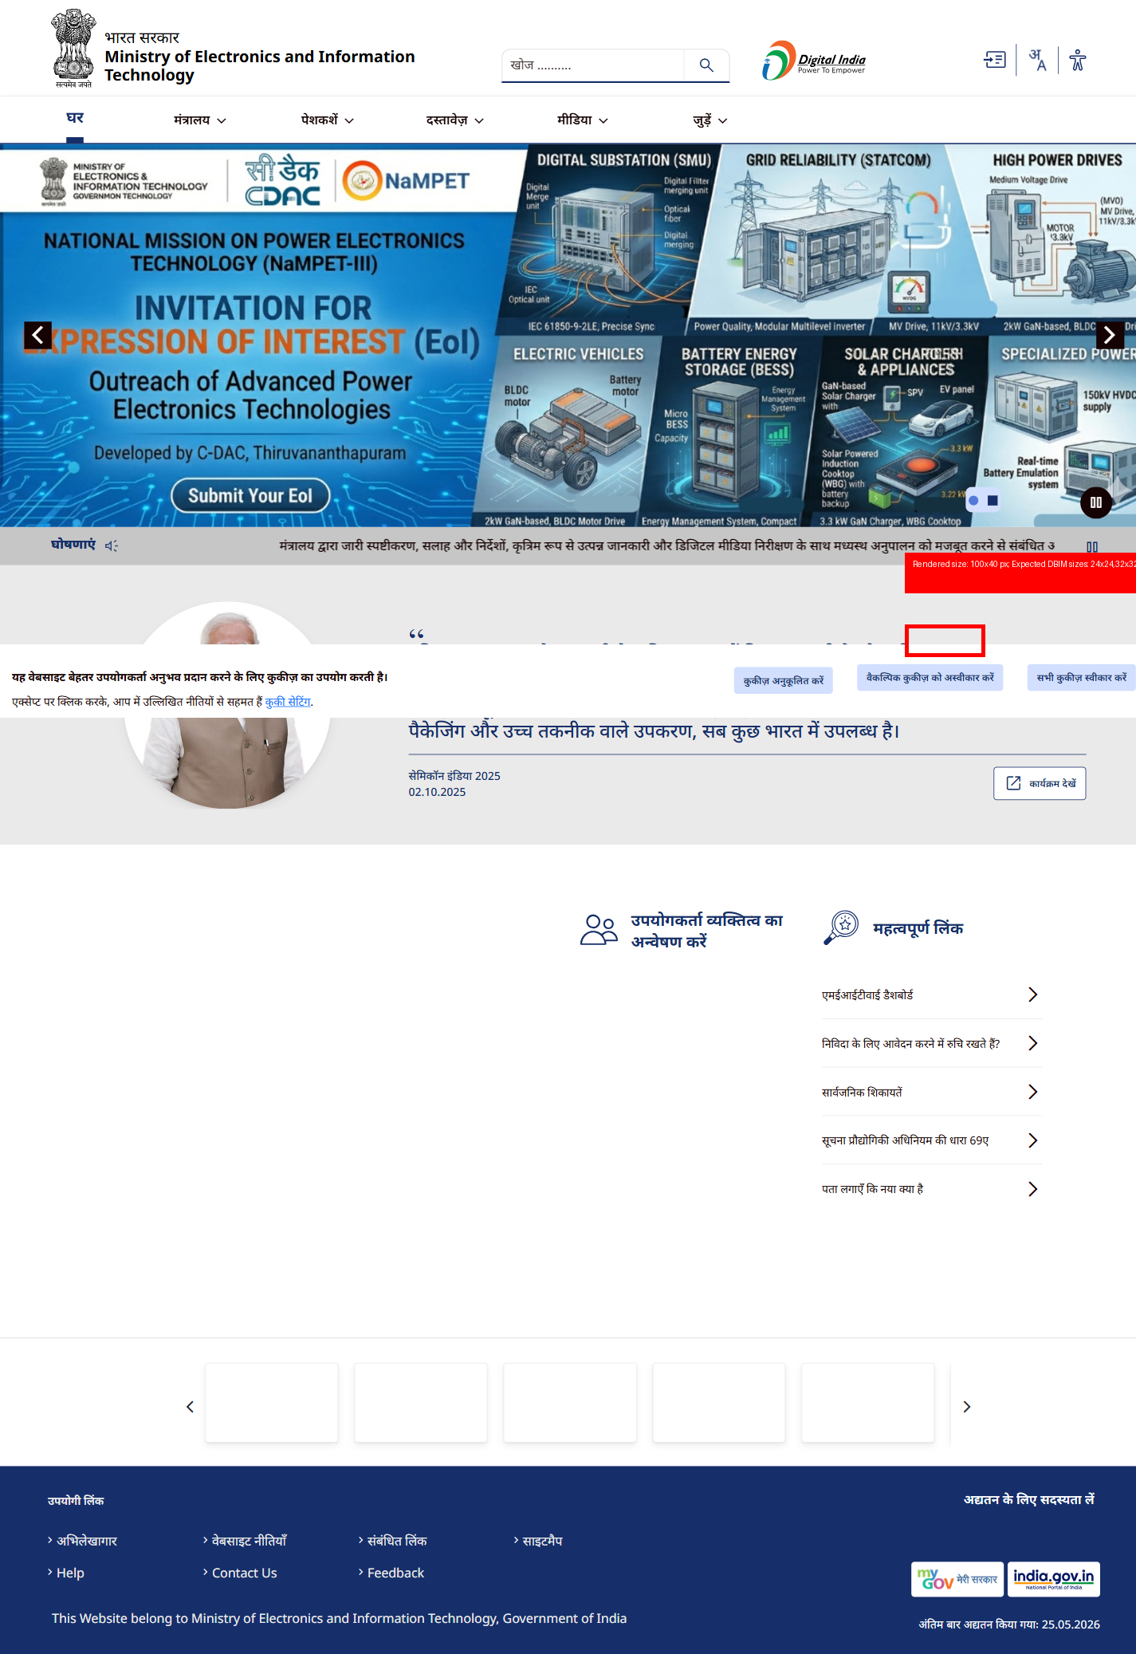

Icon 8
STATUS: COMPLIANT
Original asset and rendered display comply with DBIM guidelines for style, size, proportion, alignment and contrast.



Icon 9
STATUS: NON-COMPLIANT
Detected style: filled; Expected dominant style: line
Rendered size: 46x39 px; Expected DBIM sizes: 24x24,32x32,48x48,64x64
Icon content not properly centered
