DBIM ICONOGRAPHY COMPLIANCE REPORT
2026-05-25 11:57:00

Icon 0
STATUS: COMPLIANT
Original asset and rendered display comply with DBIM guidelines for style, size, proportion, alignment and contrast.
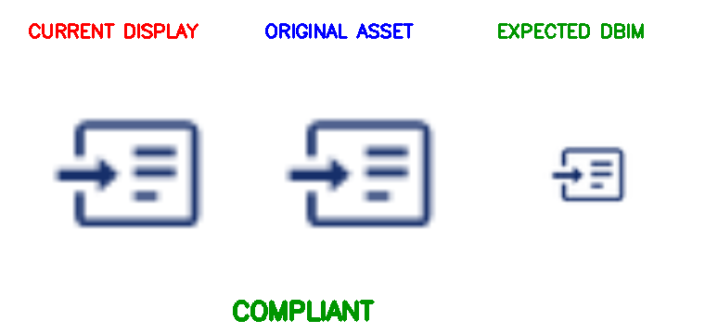
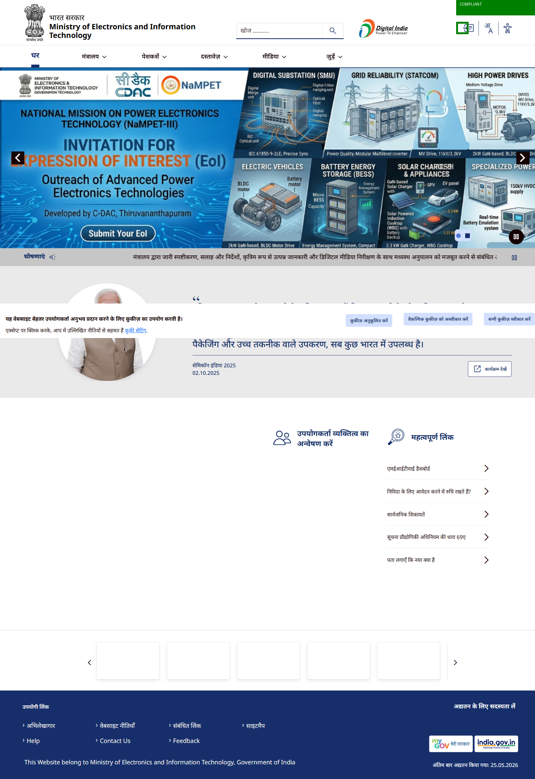

Icon 1
STATUS: COMPLIANT
Original asset and rendered display comply with DBIM guidelines for style, size, proportion, alignment and contrast.
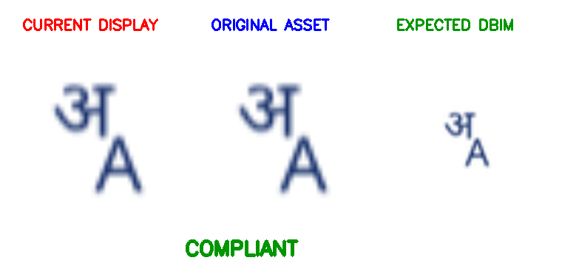
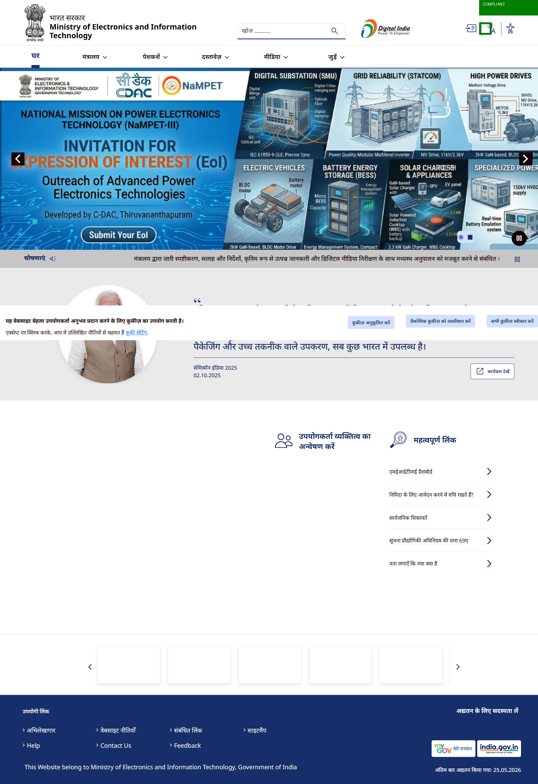

Icon 2
STATUS: NON-COMPLIANT

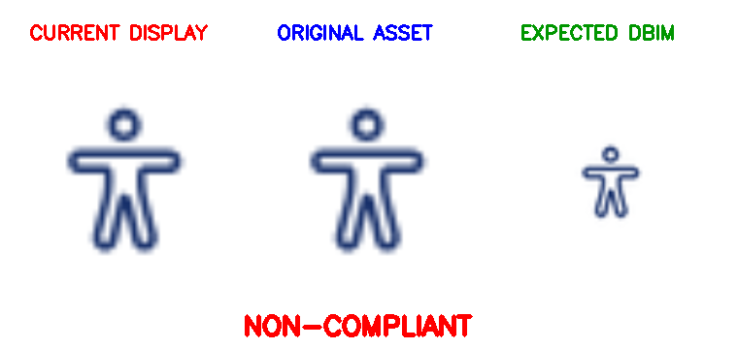
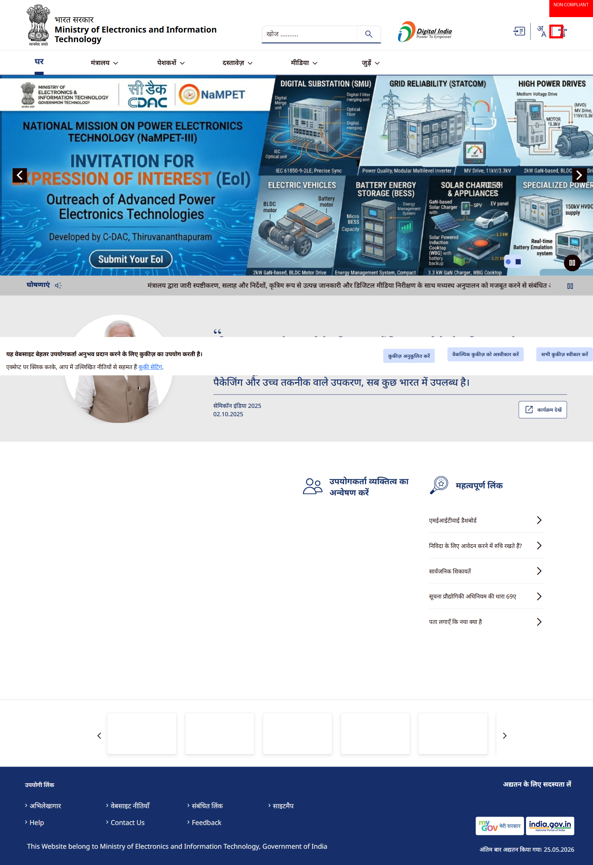

Icon 3
STATUS: NON-COMPLIANT

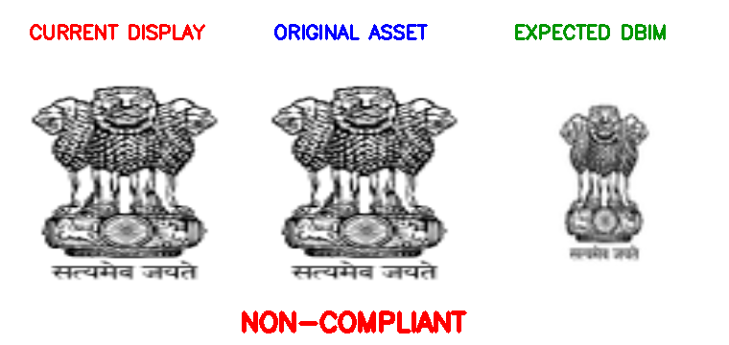
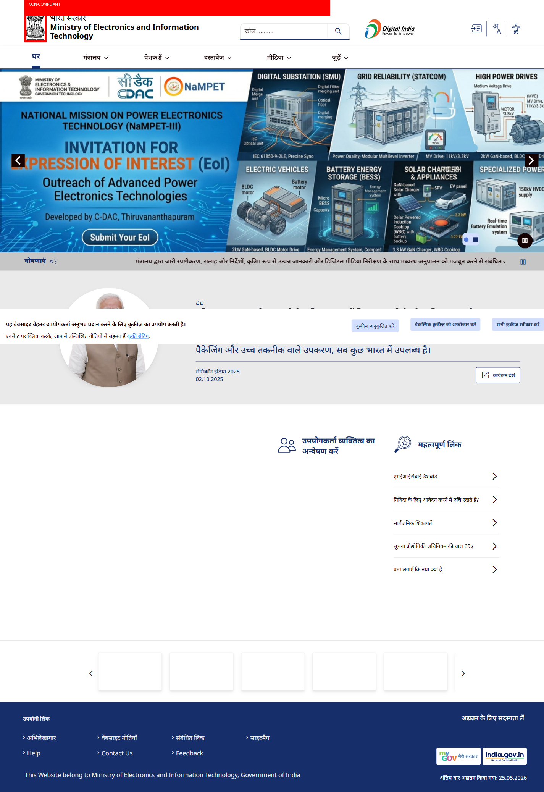

Icon 4
STATUS: NON-COMPLIANT

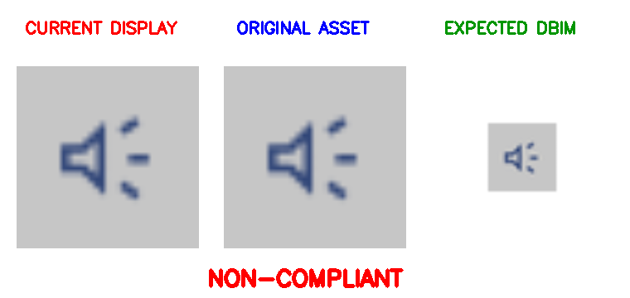
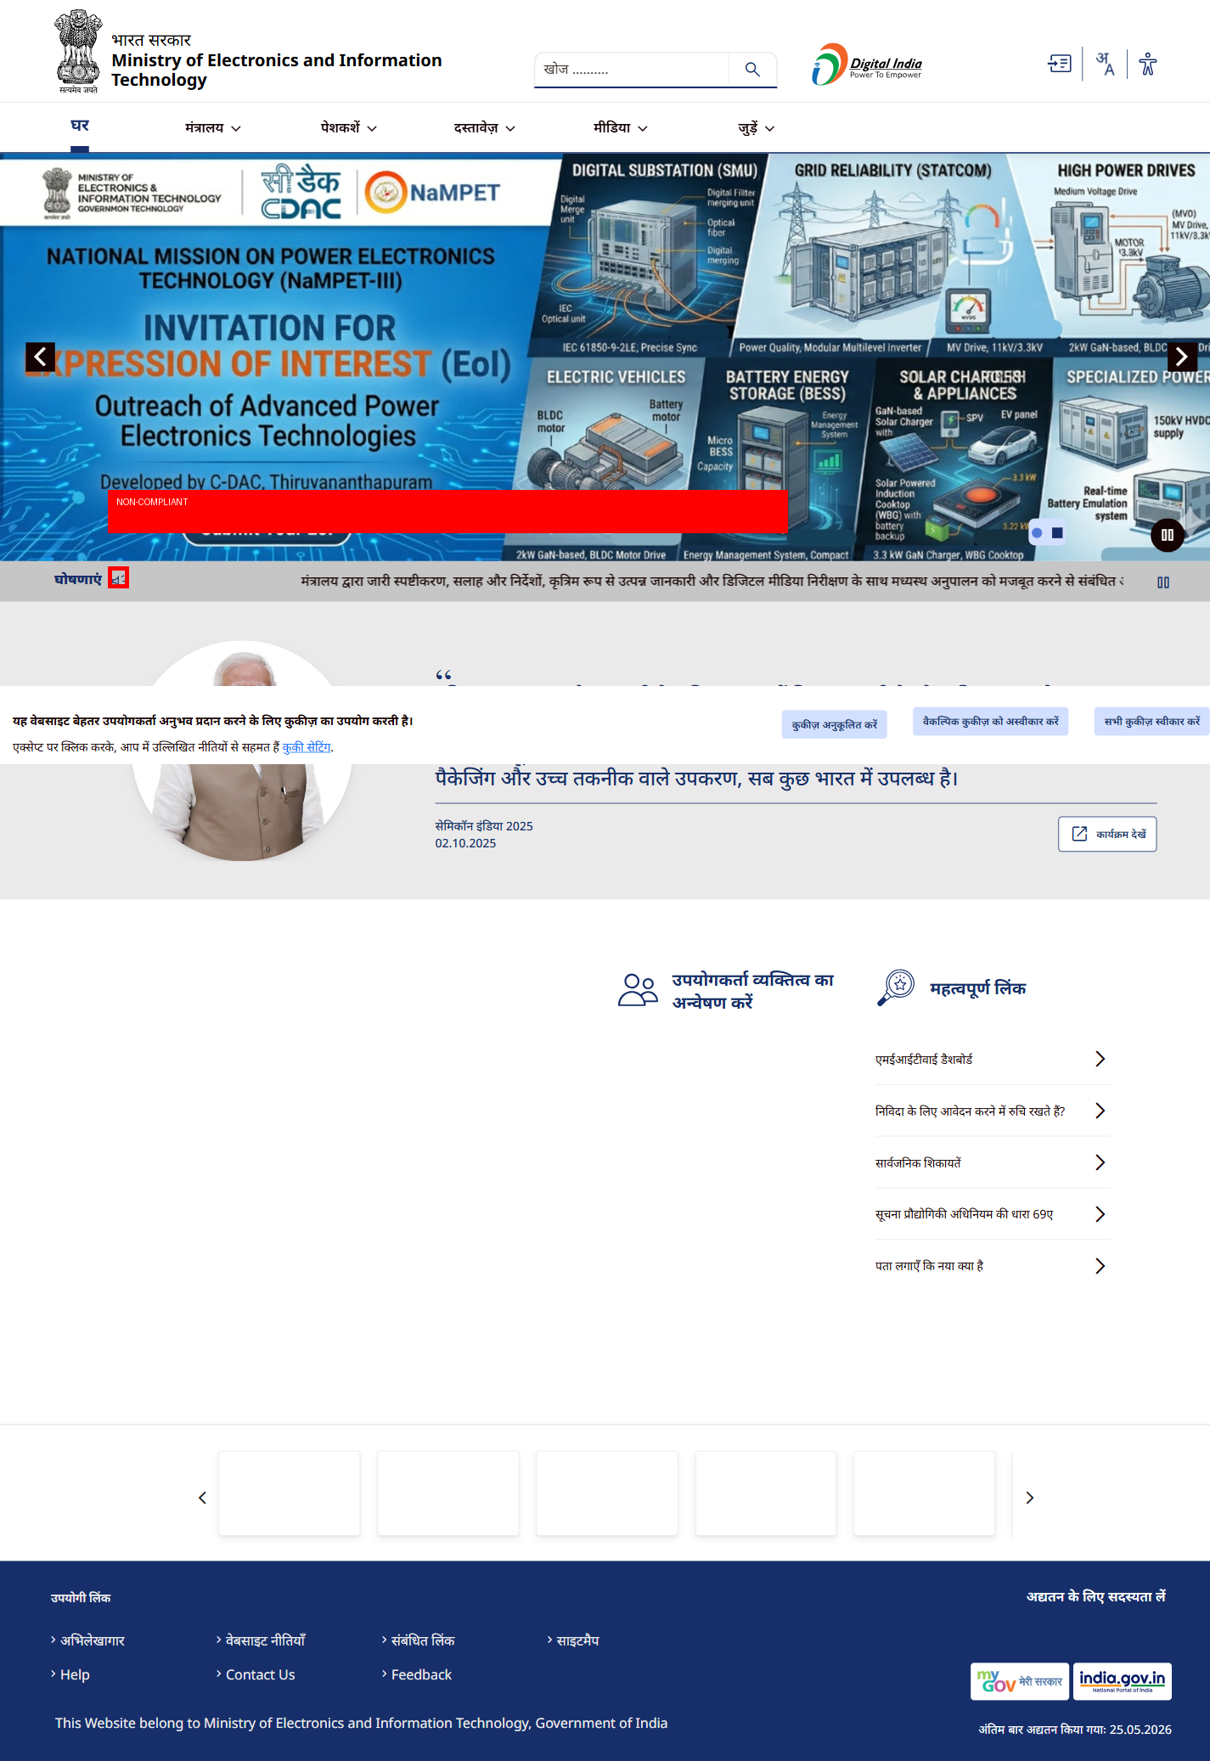

Icon 5
STATUS: NON-COMPLIANT

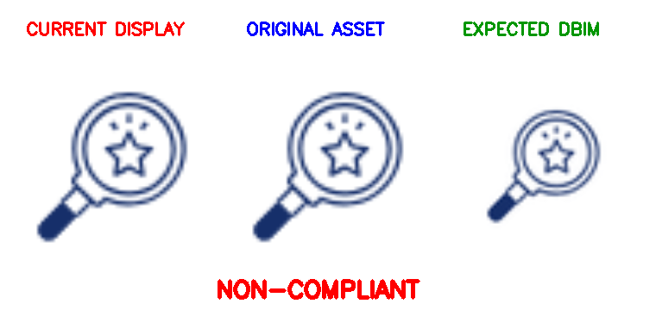
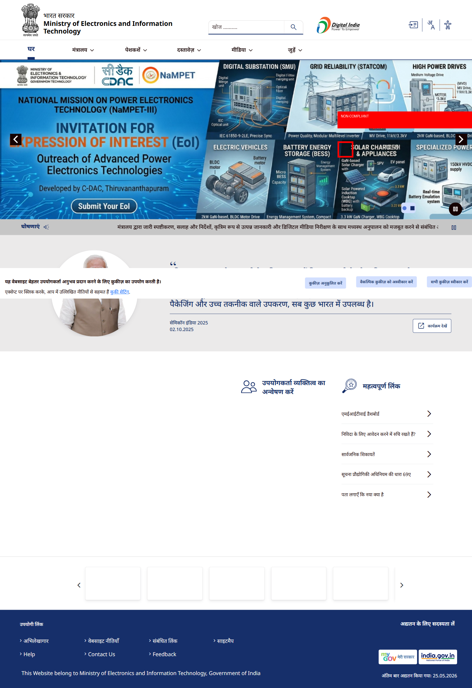

Icon 6
STATUS: NON-COMPLIANT

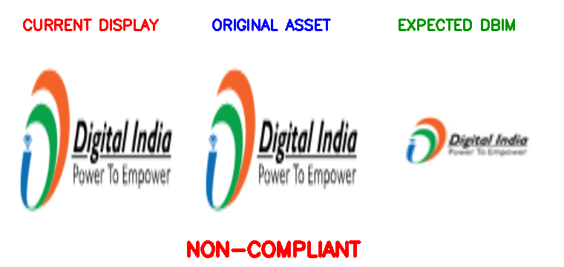
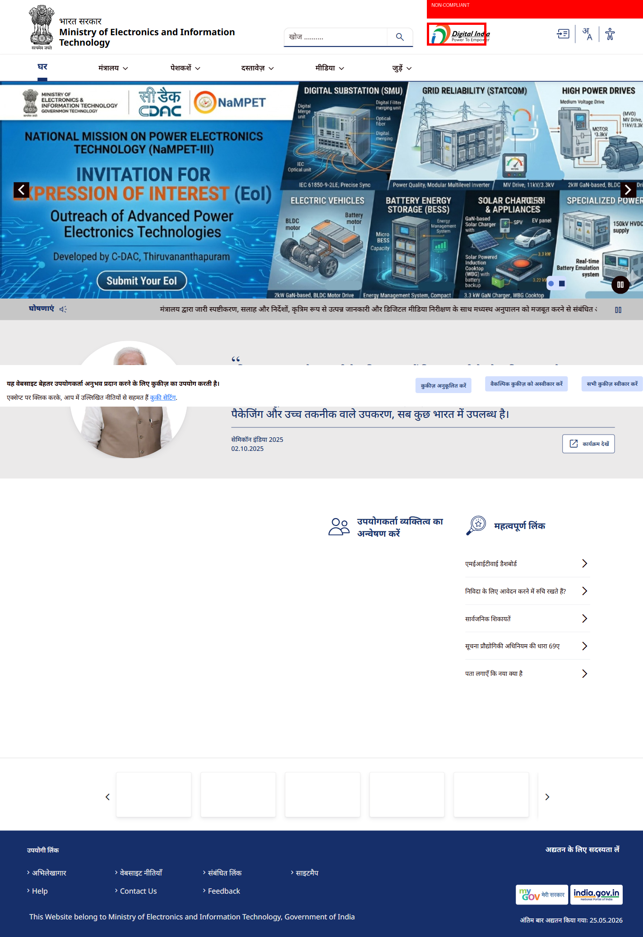

Icon 7
STATUS: NON-COMPLIANT

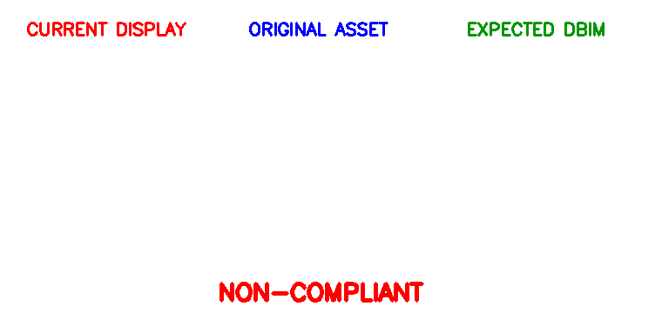
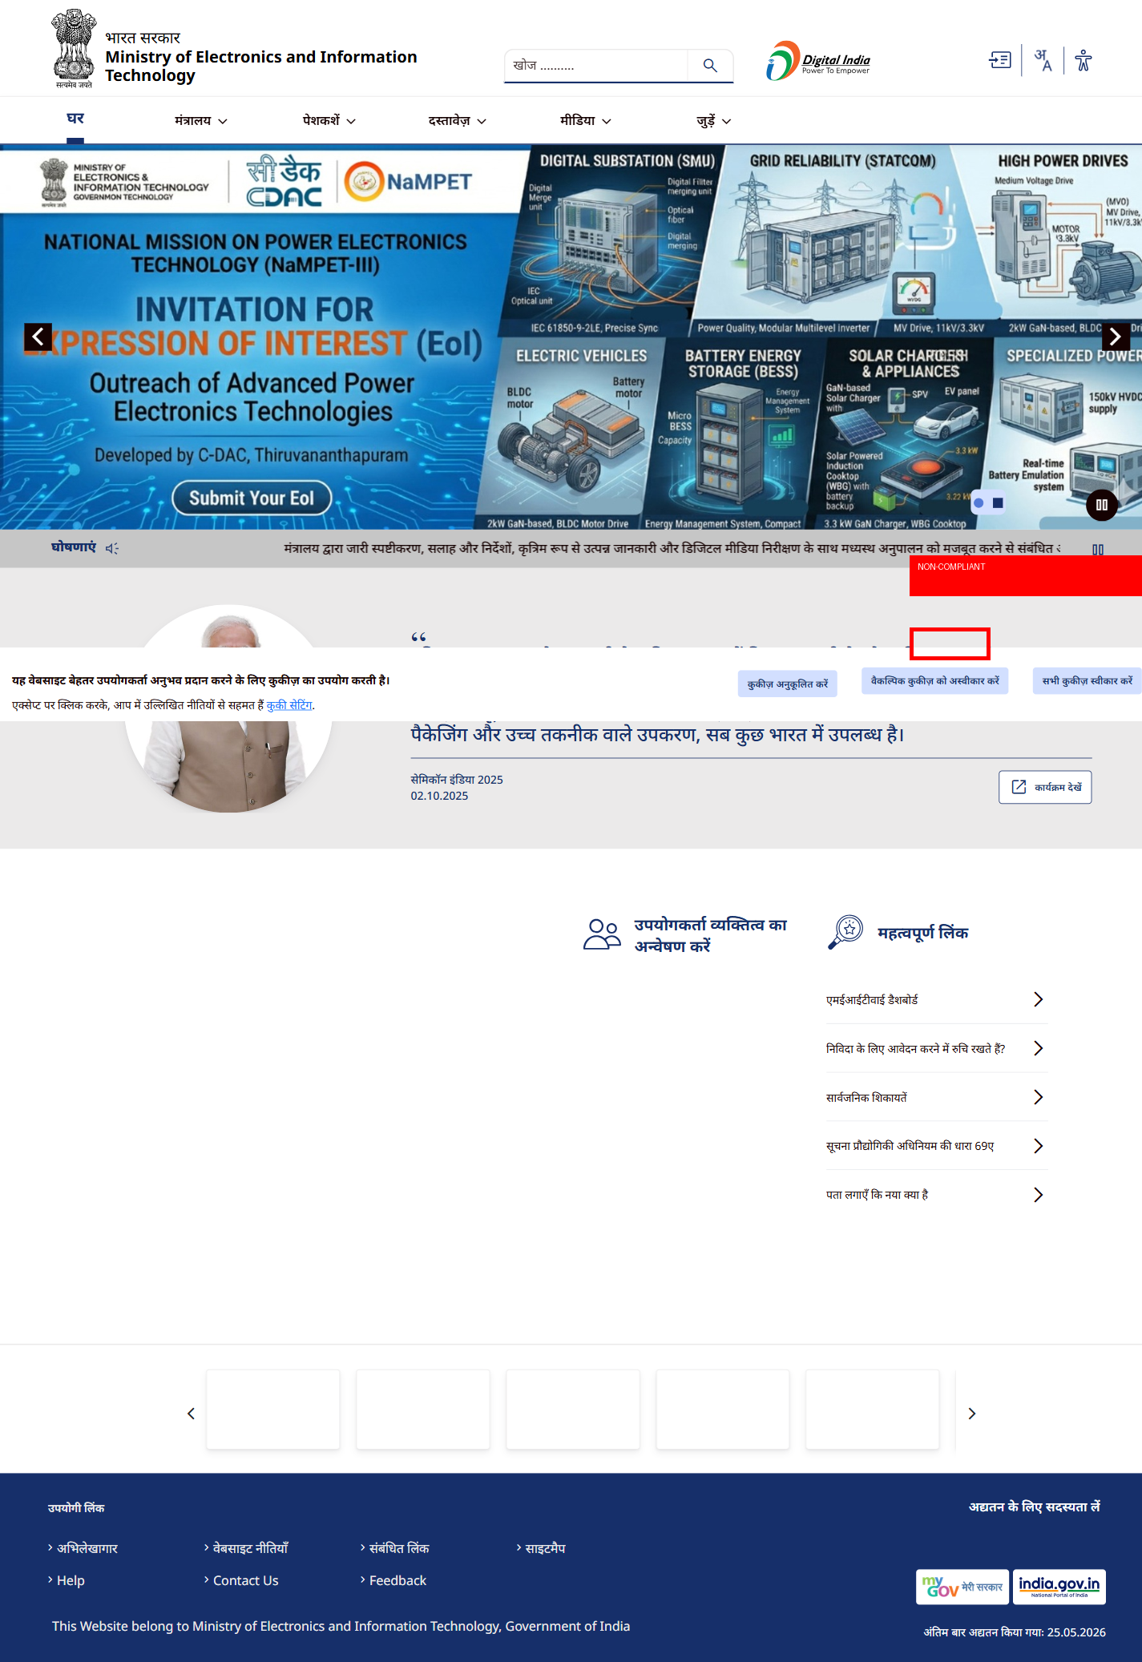

Icon 8
STATUS: NON-COMPLIANT

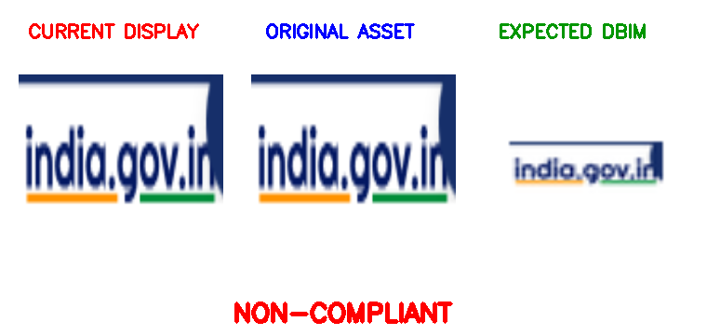
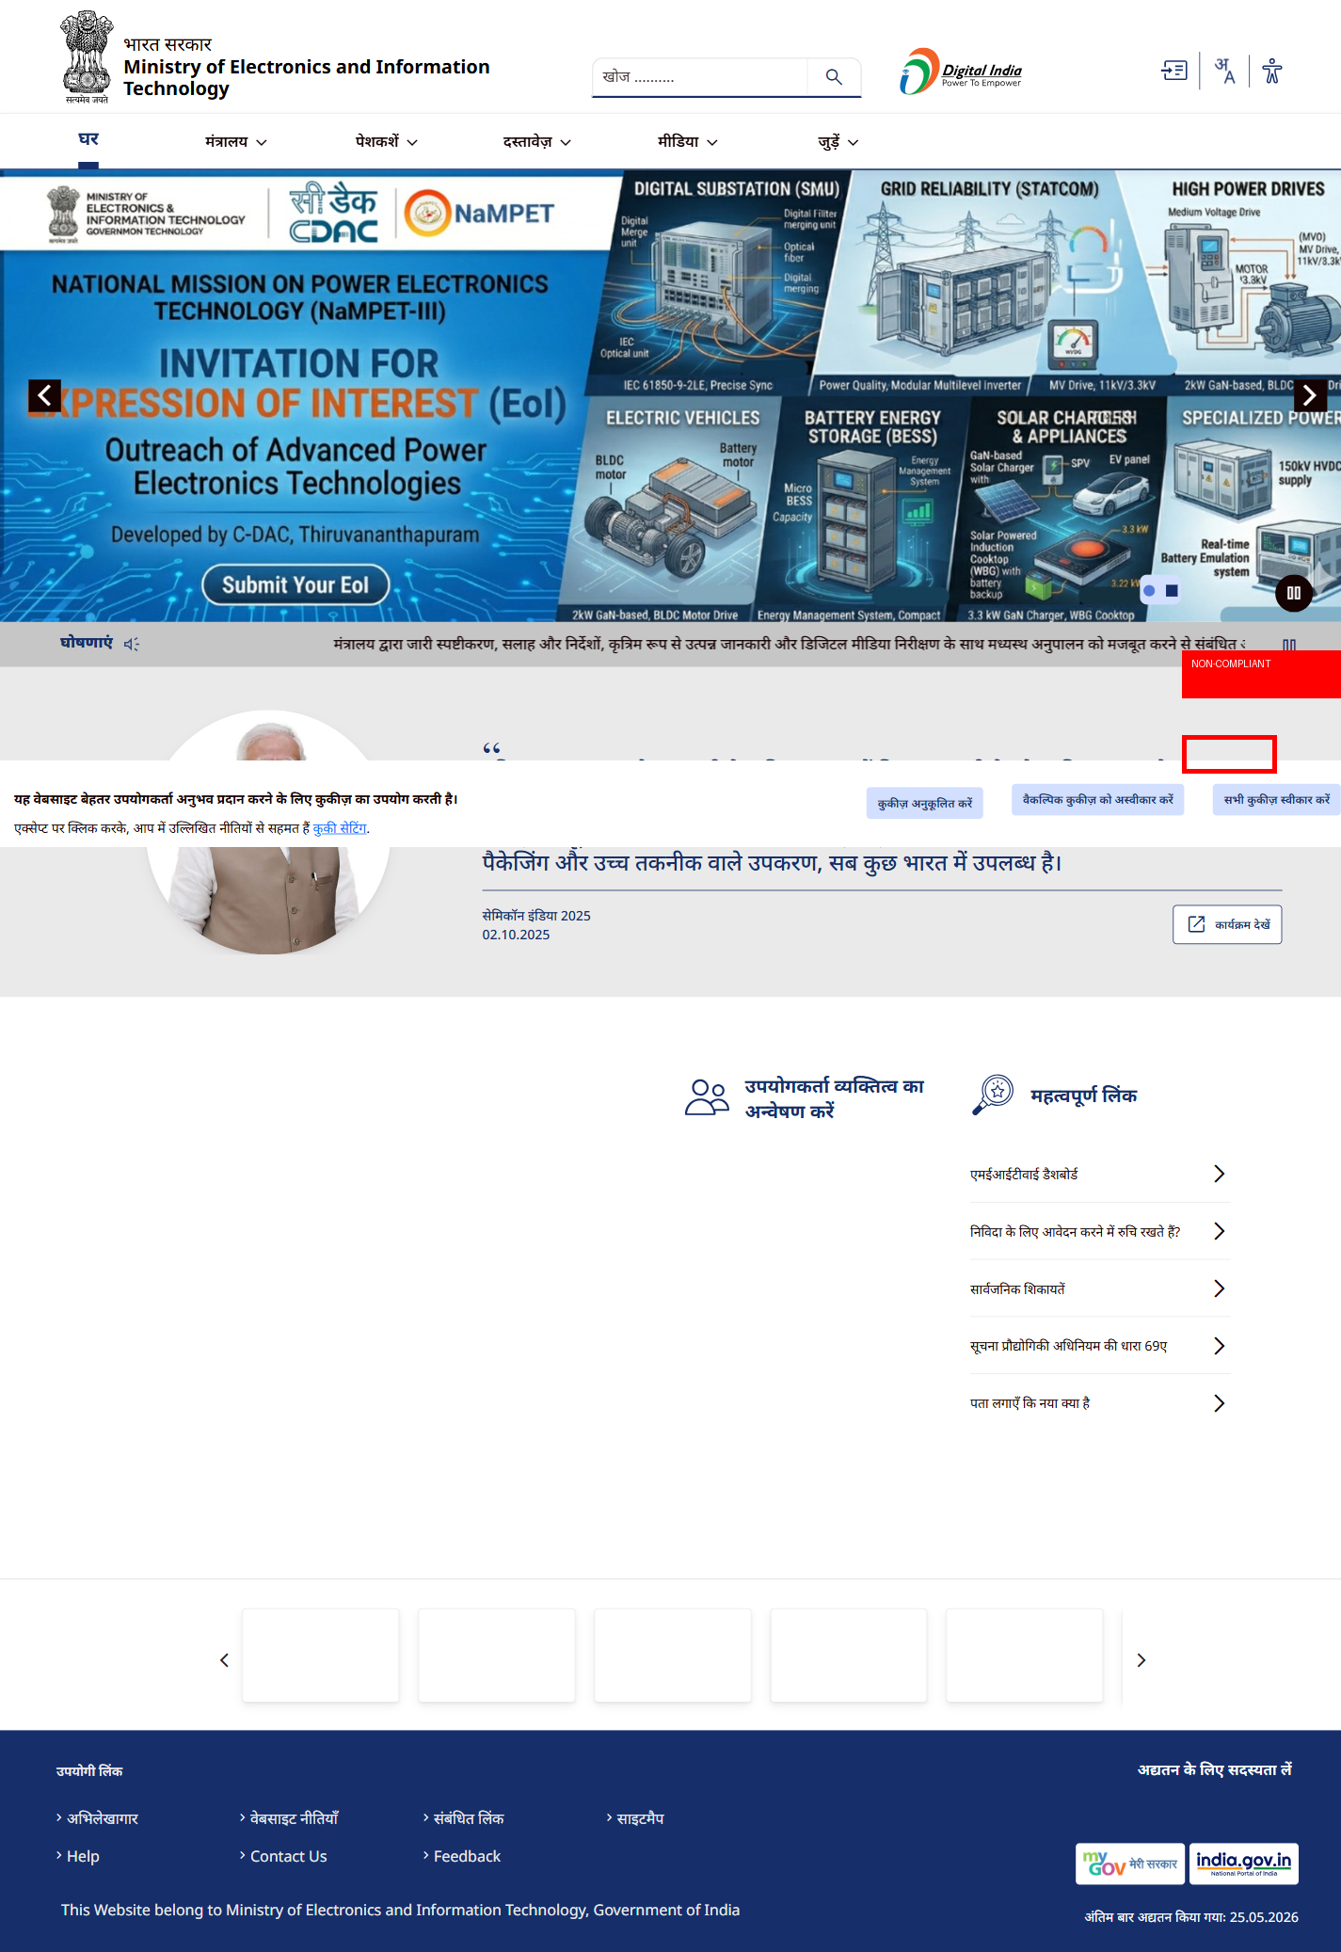

Icon 9
STATUS: COMPLIANT
Original asset and rendered display comply with DBIM guidelines for style, size, proportion, alignment and contrast.



Icon 10
STATUS: NON-COMPLIANT

