DBIM PERFORMANCE ENHANCEMENT REPORT

10.1.1 - Page Loading Speed
STATUS: NON-COMPLIANT
Website loading speed exceeds recommended DBIM threshold.
Metric | Value
TTFB | 3011 ms
DOM Load | 3050 ms
Full Load | 3050 ms
Transfer Size | 598 bytes
Encoded Body | 298 bytes
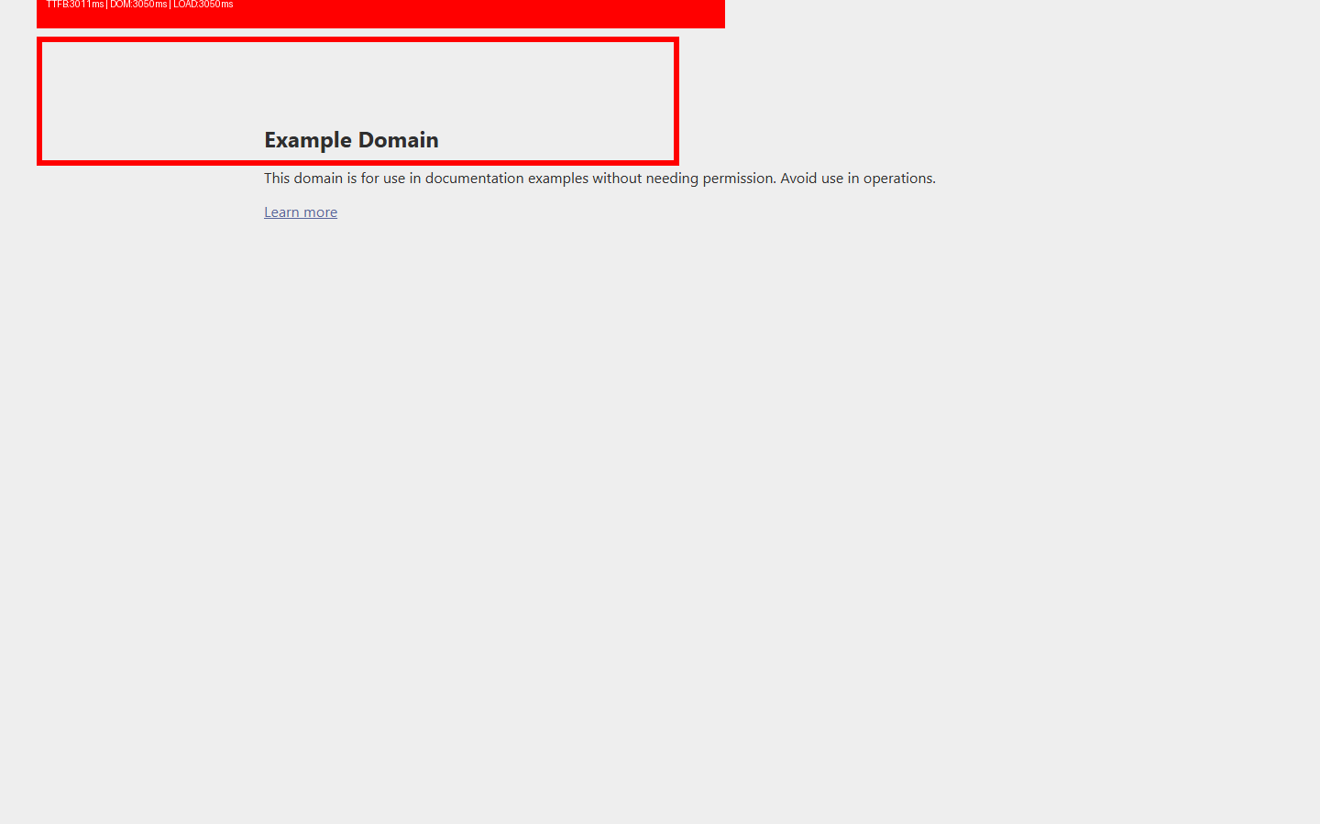

10.1.2 - Lazy Loading
STATUS: COMPLIANT
Lazy loading coverage is sufficient.
Metric | Value
Visible Images | 0
Below-fold Images | 0
Lazy-loaded Below-fold Images | 0
Coverage | 0%

10.1.3 - Critical Rendering Optimization
STATUS: COMPLIANT
Critical rendering path optimized.
Metric | Value
Total Scripts | 0
Async | 0
Deferred | 0
Modules | 0
Head Blocking External | 0
Blocking Ratio | 0%

10.1.4 - Browser Caching
STATUS: COMPLIANT
Caching strategy implemented properly.
Metric | Value
Resources | 0
Cached | 0
Cache Coverage | 0%

10.2.1 - Interaction Responsiveness
STATUS: COMPLIANT
Website interactions are responsive.
Metric | Value
Max Long Task | 0 ms
Long Task Count | 0
Observer Supported | True

10.2.2 - Mobile Responsiveness
STATUS: COMPLIANT
Website adapts correctly to mobile viewport.
Metric | Value
Page Width | 390px
Viewport Width | 390px
Overflow | NO
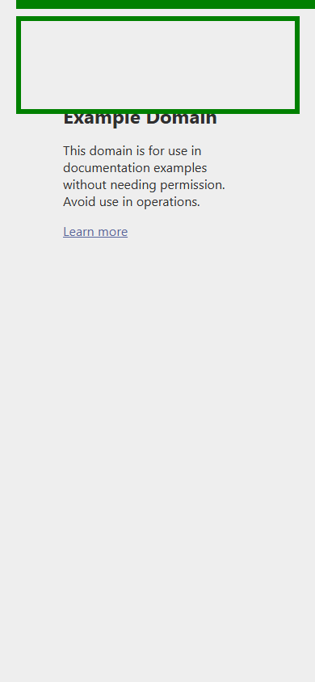

10.3.1 - Visual Stability
STATUS: COMPLIANT
Visual layout stability acceptable.
Metric | Value
CLS Score | 0
Shift Events | 0
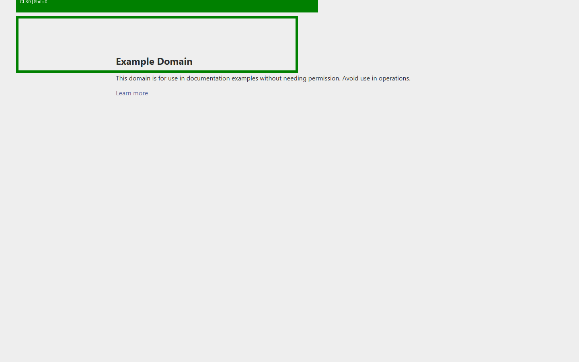

10.3.2 - Image Optimization
STATUS: COMPLIANT
Optimized image formats used.
Metric | Value
Total | 0
WEBP | 0
AVIF | 0
Legacy | 0
Oversized Images | 0
Optimization Coverage | 0%
Oversized Ratio | 0%

10.4.1 - Third-party Script Minimization
STATUS: COMPLIANT
Limited third-party dependency.
Metric | Value
Third-party Domains
Count | 0

10.4.2 - CDN Usage
STATUS: NON-COMPLIANT
No CDN usage detected.
Metric | Value
Detected CDNs | None

10.4.3 - Performance Monitoring
STATUS: NON-COMPLIANT
No monitoring tools detected.
Metric | Value
Monitoring Tools | None

10.5 - Analytics Integration
STATUS: NON-COMPLIANT
No analytics integration detected.
Metric | Value
Analytics Platforms | None

