DBIM LOGO / ICON AUDIT REPORT

WEBSITE OPENED
Website loaded successfully.
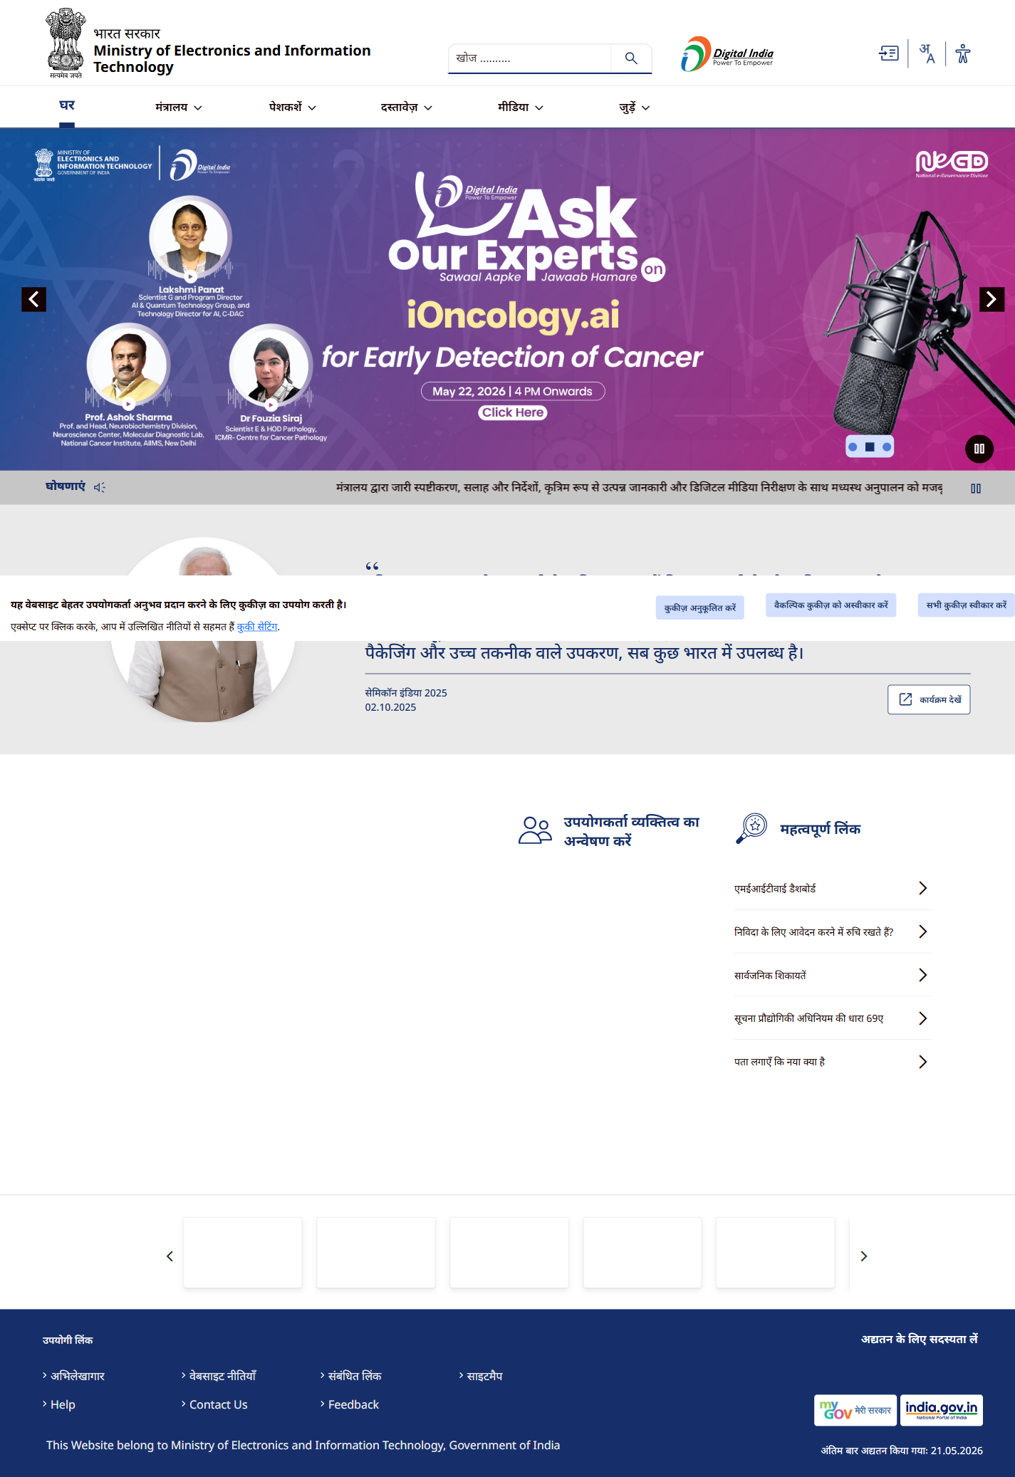

LOGO DETECTED
Logo visible in header.
