DBIM SEARCH COMPLIANCE REPORT

WEBSITE OPENED
Website loaded successfully.
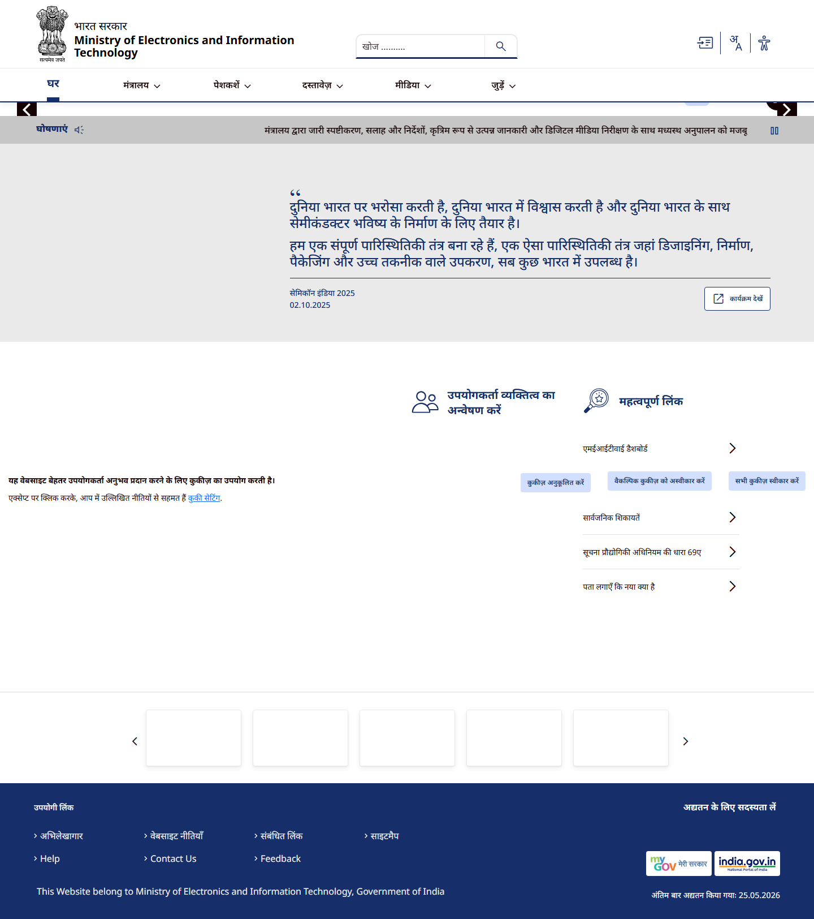

REQ 43 - SEARCH DETECTED
Search bar found.
